ST.
QUENTIN

Surveyors Town Planners Engineers

PLANNING REPORT

COMBINED PLANNING SCHEME AMENDMENT AND PLANNING PERMIT APPLICATION

38-42 MAINSAIL DRIVE & 124 PEARL BAY PASSAGE, ST LEONARDS

August 2015

CONTENTS

1. EXECUTIVE SUMMARY .................................................................................................................. 3

2. INTRODUCTION ................................................................................................................................ 5

3. SUBJECT SITE .................................................................................................................................. 6

4. PROPOSAL DETAILS....................................................................................................................... 8

4.1 The Amendment ........................................................................................................................... 8

5. PLANNING POLICY CONTEXT .................................................................................................... 10

6. STRATEGIC ASSESSMENT OF THE AMENDMENT ............................................................... 11

6.1 Why is an Amendment required? ............................................................................................... 11

6.2 How does the Amendment implement the objectives of planning in Victoria? ........................ 11

6.3 How does the Amendment address the environmental effects and any relevant social and economic effects? ................................................................................................................................... 11
6.4 Does the amendment address relevant bushfire risk? ............................................................... 11

6.5 Does the Amendment comply with the requirements of any Minister’s Direction applicable to
the Amendment? .................................................................................................................................... 12

6.6 How does the Amendment support or implement the State Planning Policy Framework? ...... 12

6.6 How does the Amendment support or implement the Local Planning Policy Framework? ...... 12

6.7 Does the Amendment make proper use of the Victoria Planning Provisions?........................... 12

6.8 How does the Amendment address the views of any relevant agency? .................................... 13

6.9 Does the amendment address relevant requirements of the Transport Integration Act 2010? 13

6.10 What impact will the new planning provisions have on the resource and administrative costs of the responsible authority? ................................................................................................................. 13
7. STRATEGIC ASSESSMENT OF PLANNING PERMIT APPLICATION.................................. 14

 | 7.1 | Proposal Details .......................................................................................................................... 14
 | 7.2 | Planning Permit Triggers ............................................................................................................. 14
 | 7.3 | Referral Requirements ................................................................................................................ 14
8. | 7.4 | Planning Controls and Assessment ............................................................................................. 14  CONCLUSION .................................................................................................................................. 17

1. EXECUTIVE SUMMARY

This report has been prepared in support of a combined Planning Scheme Amendment and Planning Permit Application request relating to land at 38-42 Mainsail Drive and 124 Pearl Bay Passage, St Leonards (the Subject Site). This report is submitted on behalf of the applicant, Barwon Water.

The combined Amendment Request and Planning Permit Application can be considered by the
City of Greater Geelong pursuant to Section 96A of the Planning & Environment Act 1987.

The purpose of the Amendment Request is fourfold:

1. To re-zone approximately 1,426sqm of land that is currently contained within the Public Use Zone Schedule 1 (PUZ1) to a General Residential Zone Schedule 2, and apply Design and Development Overlay Schedule 14 (DDO14) to that land, to facilitate the creation of two residential lots.

2. To re-zone approximately 138sqm of land that is currently contained within the Public Use Zone Schedule 1 (PUZ1) to a Public Park and Recreation Zone, to facilitate the creation of a public open space reserve to be vested in Council.

3. To re-zone part of an existing Barwon Water Reserve (Reserve No 2 PS526864F) from General Residential Zone to Public Use Zone Schedule 1 (PUZ1), to more accurately reflect the current and intended future use of the land (Service & Utility).

4. To re-zone an existing Council Open Space Reserve (Reserve No 1 PS526864F) from General Residential Zone to Public Park and Recreation Zone (PPRZ), to more accurately reflect the current and intended future use of the land (Public Recreation and Open Space).

The purpose of the Planning Permit Application is to seek approval for the subdivision of land into (2) lots, the partial removal of a reservation pursuant to Section 24A of the Subdivision Act 1988, the creation of two (2) reservations, the creation of a Sewerage Easement pursuant to Section 23 of the Subdivision Act 1988, the removal of native vegetation and associated works.

The specific components of this Combined Application are graphically depicted overleaf

This report supports and justifies the combined Planning Scheme Amendment and Planning
Permit Application by detailing:

• The site and its context;
• The proposed Amendment and its performance against the relevant Strategic Assessment
Guidelines.
• The proposed Planning Permit Application and its performance against State and Local
Planning Policy as well as applicable Zone, Overlay and Particular Provisions.

This Planning Report should also be read in conjunction with the following technical assessments that have been prepared in support of the Combined Application:

Aboriginal Cultural Heritage Due Diligence Assessment Ochre Imprints March 2015
Infrastructure Servicing Report STQC March 2015
Flora and Fauna Assessment Okologie March 2015
Tree Health and Hazard Risk Assessment Lets Talk About Trees March 2015
Traffic Impact Assessment Civil and Traffic Consulting June 2015

38-42 Mainsails Drive. St Leonards

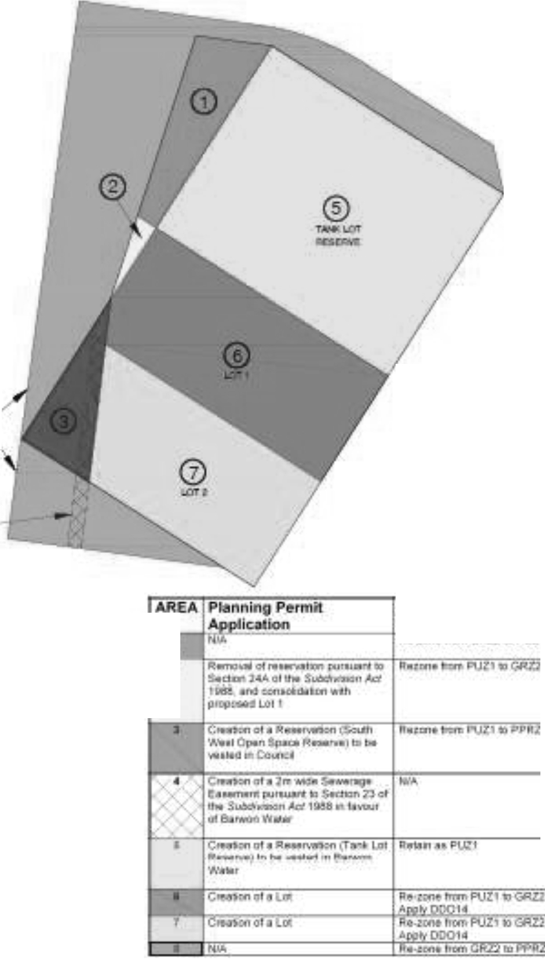Graphic Depiction of Combined Amendment Request and Planning Permit Application

®
·QUENTIN



PI \Jns. ScMtM
Amondmcmt
' l;e., Al I I "fT.::.J '» U-1!--
:r

The proposal involves a combined Planning Scheme Amendment Request and Planning Permit
Application pursuant to Section 96A of the Planning and Environment Act 1987.

Proposal | Planning Scheme Amendment  Re-zone part of the subject site from Public Use Zone  Schedule 1 (PUZ1) to General Residential Zone Schedule  2 (GRZ2)  Re-zone part of the subject site from Public Use Zone Schedule 1 (PUZ1) to Public Park and Recreation Zone (PPRZ)  Re-zone part of the subject site from General Residential Zone Schedule 2 (GRZ2) to Public Use Zone Schedule 1 (PUZ1)  Re-zone part of the subject site from General Residential Zone Schedule 2 (GRZ2) to Public Park and Recreation Zone (PPRZ)  Apply Design and Development Overlay Schedule 14 (DDO14) to part of the subject site  Planning Permit Application  Subdivision of land to create (2) lots, the partial removal of a reservation pursuant to Section 24A of the Subdivision Act 1988, the creation of two (2) reservations, the creation of a Sewerage Easement pursuant to Section 23 of the Subdivision Act 1988, the removal of native vegetation  and associated works.
Amendment Applicant | Barwon Water
Location of Subject Site | 38-42 Mainsail Drive, St Leonards  124 Pearl Bay Passage, St Leonards
Title Details | Lot 1 TP853261  Lot RES1 PS526864  Lot RES2 PS526864
Restrictions / Covenants | N/A
Land Size | Approx. 4,000sqm
Current Zone | Part Public Use Zone Schedule 1 (PUZ1)  Part General Residential Zone Schedule 2 (GRZ2)
Current Overlays | Part Design and Development Overlay Schedule 14  (DDO14)

The subject site is approximately 4,000sqm in area and is bounded by Pearl Bay Passage to the north, Mainsail Drive to the east, Harbour Way to the south and Halyard Terrace to the west. The site topography is relatively flat.

The key findings of the technical assessments carried out in support of this combined application describe the attributes of the site:

Cultural Heritage:
• There are no areas of cultural heritage sensitivity on the property;
• A CHMP is not a mandatory requirement under the Aboriginal Heritage Act 2006 for the proposed rezoning and subdivision of the study area. While the activity would constitutes a
high impact activity under r.46 (1a&b) if it involves the subdivision of 3 or more lots, it does not occur in an area of Cultural Heritage Sensitivity.

Traffic:
• There are no traffic management, safety or operational grounds that would impede this development, subject to the relocation of the bus stop approximately 28m north-east along Mainsail Drive. Public Transport Victoria (PTV) have given approval in-principal for the bus stop relocation.

Urban Services:
• There are no servicing constraints to the development of the proposed two new lots.

Ecology:
• No remnant patches or scattered indigenous trees were recorded on site.
• The subject site is highly modified and comprises planted native vegetation around the boundary, interspersed with exotic vegetation in cleared areas and surrounding site infrastructure.
• Remnant vegetation is limited to a scattered cover (<5%) of shrubs and grasses under planted vegetation.
• A planning permit is required for the removal of native vegetation. An assessment under the guidelines in not required as the site does not support any remnant patches or scattered indigenous trees.

Arboriculture:
• All trees are located around the perimeter fence, and are approximately 35 – 40 years of age.
• The species are typical of the species used throughout the 1970’s for wind break and
boundary planting throughout Victoria on public assets.
• No specimens have any outstanding attributes, and most are in a heavy state of decline.

38-42 Mainsails Drive. St Leonards
- QUENTIN

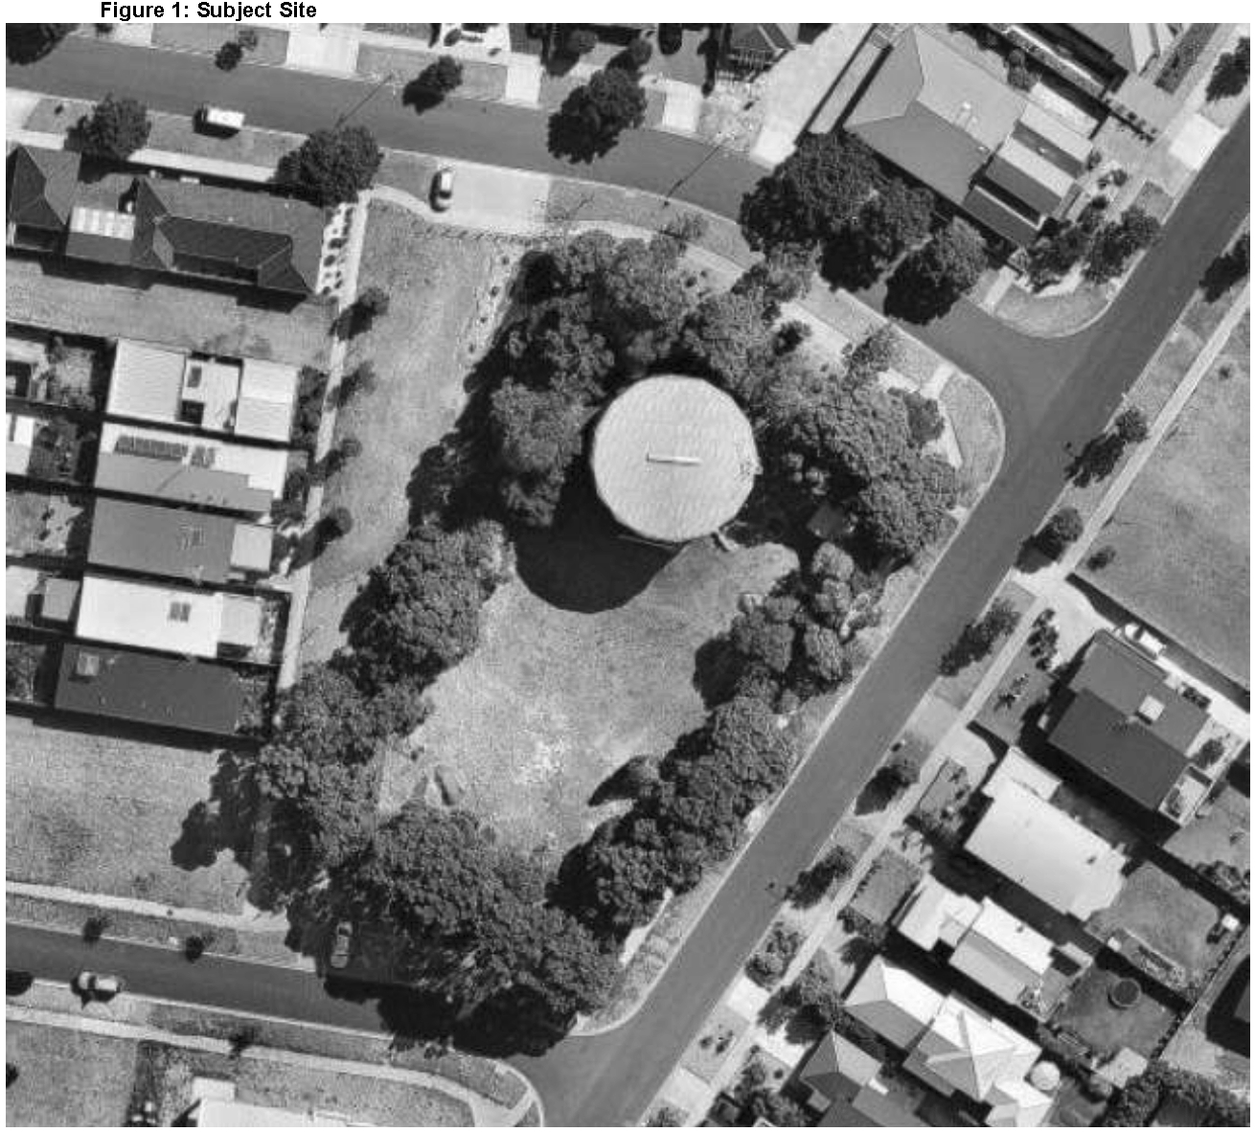

4. PROPOSAL DETAILS

4.1 The Amendment
The amendment proposes to:

• Re-zone part of the subject site (proposed lots) from Public Use Zone Schedule 1 (PUZ1)
to General Residential Zone Schedule 2 (GRZ2)

• Re-zone part of the subject site (proposed Council Open Space Reserve) from Public
Use Zone Schedule 1 (PUZ1) to Public Park and Recreation Zone (PPRZ)

• Re-zone part of the subject site (Barwon Water Tank Reserve) from General Residential
Zone Schedule 2 (GRZ2) to Public Use Zone Schedule 1 (PUZ1)

• Re-zone part of the subject site (Existing Council Open Space Reserve No 1 PS526864) from General Residential Zone Schedule 2 (GRZ2) to Public Park and Recreation Zone (PPRZ)

• Apply Design and Development Overlay Schedule 14 (DDO14) to part of the subject site
(proposed lots)

The General Residential Zone Schedule 2 is considered the most appropriate zone to facilitate development of the site for standard residential lots that generally respects the existing neighbourhood character.

The Public Park and Recreation Zone is considered the most appropriate zone to apply to land that does / is intended to serve a public recreation and open space function.

The Public Use Zone Schedule 1 (PUZ1) is considered the most appropriate zone to apply to land that serves a Service & Utility function.

Design and Development Overlay Schedule 14 (DDO14) introduces a Permit trigger for the construction of a dwelling which is more than 7.5 metres above natural ground level. As this requirement is applicable to all surrounding land, its’ application to the land proposed to be re- zoned as part of this combined application is considered appropriate.

The Permit Application
A Planning Permit application is sought to facilitate the creation of two (2) residential allotments. Each of the proposed lots is in excess of 500sqm in area. Lot sizes in the area typically range from 300sqm up to 1,000sqm. As such it is submitted that a proposed lot size of greater than
500sqm will facilitate future residential development that respects the neighbourhood character of the area.

The Planning Permit application also seeks approval for approval the partial removal of a reservation pursuant to Section 24A of the Subdivision Act 1988. Barwon Water have advised that the reserve in question was given to Barwon Water as part of a land swap between Council and the Sea Change Estate developer in 2004. The overall land holdings (i.e. the reserve in question and the land currently contained within the Public Use one) was originally set aside for 2 tanks. Investigations undertaken by Barwon Water have determined that it is more cost-effective to increase the size of distribution and transfer mains in the area than to provide additional storage. Therefore, a second tank (and the land initially proposed to accommodate it) is not required.

The Planning Permit application also seeks approval for the creation of two (2) reservations. One reservation is proposed to encompass the existing Barwon Water storage tank in the north of the

site. This proposed reservation reflects the ongoing use of the land by Barwon Water for service and utility functions. The second reservation is proposed to encompass a triangle of land in the south west corner of the site. This triangle of land physically “presents” as part of the larger open space reserve to the west (i.e. Reserve No1. PS526864), and Council has advised that this land should be created as a public open space reserve and vested in Council as part of the current Combined Application.

The Planning Permit application also seeks approval for the creation of a 2m wide Sewerage Reserve within Reserve No 1. PS526864 and within the proposed triangular open space reserve described above. The proposed Sewerage Easement is required to service the 2x proposed residential allotments.

The Planning Permit application also seeks approval for the removal of Native Vegetation. The native vegetation proposed to be removed is all of the native vegetation located on the land proposed to be re-zoned and converted into residential lots. While some of this native vegetation may be retained by future owners / occupiers, for the purpose of this application it is assumed that it is to be removed.

A Plan of Subdivision is included within this submission at Appendix 1. A Clause 56 Assessment is included within this submission at Appendix 2.

5. PLANNING POLICY CONTEXT
The following outlines those planning policies which are relevant to the proposal and the locale which need to be considered in the assessment of the application. These include the State Planning Policy Framework and the Local Planning Policy Framework including Council’s Municipal Strategic Statement and local policies. A review of relevant strategic documents has also been undertaken.

State Planning Policy Framework
We have reviewed the State Planning Policy Framework (SPPF) within the Greater Geelong
Planning Scheme and identify the following Clauses are particularly relevant to the proposal:

• Clause 11.02-1 Supply of urban land (Planning for urban growth should consider opportunities for the consolidation, redevelopment and intensification of existing urban areas neighbourhood character and landscape considerations)

• Clause 12.01-1 Protection of biodiversity (Ensure strategic planning avoids and minimises significant impacts, including cumulative impacts, of land use and development on Victoria’s biodiversity).
• Clause 16.01 Residential development (Increase the supply of housing in existing urban areas by facilitating increased housing yield in appropriate locations, including under- utilised urban land).

• Clause 19.03-2 Water supply, sewerage and drainage (plan for the provision of water supply, sewerage and drainage services that efficiently and effectively meet State and community needs and protect the environment).

Local Planning Policy Framework
Local Planning Policy Framework (LPPF) is comprised of the Municipal Strategic Statement
(MSS) and local polices.

Municipal Strategic Statement
The Greater Geelong Municipal Strategic Statement identifies a number of local planning issues for development within the municipality. Of most relevance to the consideration of this application are the following clauses:

• Clause 21.06-3 Urban Consolidation (To provide for the consolidation of existing urban areas in a managed way AND Providing for incremental change in the General Residential Zone (Schedule 2) areas AND Ensure that development is responsive to the established character of the area)

• 21.06-4 Neighbourhood Character (Retain existing vegetation wherever possible,
particularly vegetation that contributes to the municipality’s tree canopy).

• 21.14 The Bellarine Peninsula – St Leonards (Encourage development which respects the coastal landscape setting of St Leonards by…..Ensuring that development allows for the protection of significant vegetation and/or planting around buildings and has minimal impact on roadside vegetation).

6. STRATEGIC ASSESSMENT OF THE AMENDMENT

6.1 Why is an Amendment required?
Part of the Subject Site is currently contained within the Public Use Zone Schedule 1 (PUZ1). Barwon Water has identified that part of the subject site is surplus to the ongoing operational needs of Barwon Water and no longer required to be set aside for a public purpose. The surrounding land is contained within a General Residential Zone Schedule 1 (GRZ2).

The Amendment is required to enable surplus to the ongoing operational needs of Barwon Water to be re-zoned commensurate with the zoning of immediately surrounding land.

Part of the subject site is currently contained within the General Residential Zone Schedule 2 (GRZ2). Council and Barwon Water have identified that this land use zoning does not accurately reflect the existing or intended future public / service and utility use of various parts of the site. As such, the Amendment is required to ensure that the zoning of the various parts of the subject site accurately reflect its’ current and intended future public / service and utility use.

6.2 How does the Amendment implement the objectives of planning in
Victoria?
The Amendment is considered to implement the objectives of planning in Victoria, in particular by:
• Providing for the orderly subdivision of the Subject Site in a manner that is responsive to its particular characteristics, opportunities and constraints;
• Securing a pleasant and safe living environment through an appropriate consideration of and response to surrounding landscape character.
• Protecting public utilities and other assets

6.3 How does the Amendment address the environmental effects and any relevant social and economic effects?
Environmental Effects
The subject site is not affected by any Environmental Overlays. The subject site is highly modified and comprises planted native vegetation around the boundary, interspersed with exotic vegetation in cleared areas and surrounding site infrastructure. Remnant vegetation is limited to a scattered cover (<5%) of shrubs and grasses under planted vegetation. A planning permit is required for the removal of native vegetation however an assessment under the guidelines in not required as the site does not support any remnant patches or scattered indigenous trees.

Given the extent and nature of existing remnant vegetation, the Amendment is not anticipated to have any adverse environmental impacts.

Social and Economic Effects
The Amendment is anticipated to result in positive social and economic effects by facilitating the creation of two appropriately sized lots within an established urban area, thereby assisting to achieve applicable urban consolidation objectives, by formally creating a public open space reserve, and by ensuring that an appropriate public land use zoning applies to publically accessible areas of open space.

6.4 Does the amendment address relevant bushfire risk?
The Subject Land is not affected by the Bushfire Management Overlay. The Amendment does not create or expand a settlement in an area at risk from bushfire.

6.5 Does the Amendment comply with the requirements of any Minister’s
Direction applicable to the Amendment?
The Amendment complies with the following Ministerial Directions:
• Form and Content of Planning Schemes (Section 7[5] direction)
• Strategic Assessment of Amendments (Direction No. 11)

With reference to Ministerial Direction No. 1, Barwon Water advises that the subject site has not been used as a depot or fuel storage, nor has there been chemical dosing at the site.

6.6 How does the Amendment support or implement the State Planning Policy
Framework?
The Amendment supports and implements Clause 11.02-1 (Supply of Urban Land) by re-zoning a site that presents an appropriate opportunity to consolidate an existing urban area.

The Amendment supports and implements Clause 11.03-1 (Open Space Planning) by assisting in the creation of a diverse and integrated network of public open space.

The Amendment supports and implements Clause 12.01-1 (Protection of Biodiversity) by avoiding significant impacts on established biodiversity values. The site does not support any remnant patches or scattered indigenous trees.

The Amendment supports and implements Clause 16.01 (Residential Development) by acting to increase the supply of housing in an existing urban area through the development of under- utilised urban land.
.
The Amendment supports and implements Clause 19.03-2 (Water supply, sewerage and drainage) by ensuring sufficient area is retained within the Public Use Zone to provide water supply services that meet projected community needs.

6.6 How does the Amendment support or implement the Local Planning Policy
Framework?
The Amendment supports and implements Clause 21.06-3 (Urban Consolidation) by providing an opportunity for the consolidation of the existing urban area of St Leonards in a managed way which is responsive to the established character of the area.

The Amendment supports and implements Clause 21.08-4 (Open Space) by contributing to the development of a comprehensive, safe and accessible open space network.

The Amendment supports and implements Clause 21.06-4 Neighbourhood Character and Clause
21.14 (the Bellarine Peninsula) be providing for the retention of existing vegetation that
contributes to the areas’ established character.

6.7 Does the Amendment make proper use of the Victoria Planning
Provisions?
The Amendment seeks to re-zone surplus land from Public Use Zone Schedule 1 (PUZ 1) to General Residential Zone Schedule 1 (GRZ1), to facilitate the subdivision of the land involving the creation of lots that generally respects the existing neighbourhood character.

As it is a stated purpose of the General Residential Zone to “encourage development that respects the neighbourhood character of the area”, the application of the General Residential Zone is considered to constitute a proper and appropriate use of the Victoria Planning Provisions. The Amendment seeks to apply the Design and Development Overlay Schedule 14 (DDO14) to that part of the site not currently affected by this Overlay. As DDO14 applies consistently to all

land in the immediate vicinity of the subject site, the application of DDO14 is considered to constitute a proper and appropriate use of the Victoria Planning Provisions.

The Amendment seeks to re-zone land that is and/or intended to be use for Public Utilities & Services and Public Open Space purposes respectively to Public Use Zone Schedule 1 (PUZ1) and Public Park and Recreation Zone (PPRZ).

Given the nature of the existing / proposed public utility and open space uses, the application of the Public Use Zone Schedule 1 (PUZ1) and the Public Park and Recreation Zone (PPRZ) is considered to constitute a proper and appropriate use of the Victoria Planning Provisions

6.8 How does the Amendment address the views of any relevant agency?
The views of relevant agencies will be addressed as part of the exhibition process.

6.9 Does the amendment address relevant requirements of the Transport
Integration Act 2010?
The amendment is not likely to have a significant impact on the transport system.

6.10 What impact will the new planning provisions have on the resource and administrative costs of the responsible authority?
The Amendment is unlikely to have a significant impact on the resources and administration costs of the responsible authority.

7. STRATEGIC ASSESSMENT OF PLANNING PERMIT APPLICATION

The following assessment assumes that the provisions of the Greater Geelong Planning Scheme have been altered in accordance with this Amendment request.

7.1 Proposal Details

The Planning Permit Application seeks approval for Subdivision of land to create two (2) lots, partial removal of a reservation pursuant to Section 24A of the Subdivision Act 1988, removal of native vegetation and associated works

7.2 Planning Permit Triggers

Use | Development |  | Subdivision |  | Other
N/A |  | Clause 32.08-2 (GRZ)  – a permit is required to subdivide land |  | Clause 52.02 – a permit is required  before a person proceeds under Sections 23 and 24A of the Subdivision Act 1988  Clause 52.17-2 - a permit is required to remove, destroy or lop native vegetation, including dead native Vegetation

7.3 Referral Requirements
The below table details those Referral Authorities to whom notice of this application must be given, in accordance with Section 55 of the Act. It is considered that no additional referral or notice of this application is required.

Kind of Application | Referral Authority
Subdivision | The relevant water, drainage or sewerage authority  The relevant electricity supply or distribution authority  The relevant gas supply authority  Country Fire Authority

7.4 Planning Controls and Assessment

7.4.1 General Residential Zone Schedule 1 (GRZ2)
The subject site is partly contained within the Public Use Zone Schedule 1 (PUZ1) and partly contained within the General Residential Zone Schedule 2 (GRZ2). Within the General Residential Zone Schedule 2 (GRZ2) a permit is required to subdivide land (Clause 32.08-2).

An application to subdivide land must meet the requirements of Clause 56. A detailed Clause 56
Assessment, demonstrating how the proposed subdivision achieves the relevant standards and objectives of Clause 56, is submitted in support of this application (refer to Appendix 2).

In addition to implementing the State and Local Planning Policy Frameworks, it is also the purpose of the General Residential Zone to provide a diversity of housing types and moderate housing growth in locations offering good access to services and transport.

The subdivision as shown on the submitted plans provides for future residential development at a densities that is generally in accordance with established neighbourhood character. In particular, the arboriultural assessment confirms that the proposed subdivision layout provides for the ongoing retention of sounds trees and trees with short to medium term retention value on site. These trees contribute to established neighbourhood character.

On this basis it is considered that the proposal furthers the purposes of the zone and appropriately addresses the relevant decision guidelines of the General Residential Zone.

7.4.2 Public Use Zone
Within the Public Use Zone a permit is required to subdivide land (Clause 36.01-2). This application is made by the relevant public land manager (i.e. Barwon Water).

In addition to this application, the specific comments of the public land manager will be sought and provided via the formal referral process. In this manner the proposal will appropriately address the relevant decision guidelines of Clause 36.01-4.

7.4.3 Design and Development Overlay Schedule 14 (DDO14)
Pursuant to Section 3 of Schedule 14, a permit is not required to subdivide land.

7.4.4 Easements, Restrictions and Reserves
Pursuant to Clause 52.02, a permit is required a permit is required before a person proceeds:

Under Section 23 of the Subdivision Act 1988 to (in this case) create an easement:
As noted earlier in this report, the is Planning Permit application seeks approval for the creation of a 2m wide Sewerage Reserve within Reserve No 1. PS526864 and within the triangular open space reserve. The proposed Sewerage Easement is required to service the 2x proposed residential allotments.

Under Section 24A of the Subdivision Act 1988 to (in this case) to remove a reservation:
As noted earlier in this report, the reserve in question was given to Barwon Water as part of a land swap between Council and the Sea Change Estate developer in 2004. The overall land holdings (i.e. the reserve in question and the land currently contained within the Public Use one) was originally set aside for 2 tanks. Investigations undertaken by Barwon Water have determined that it is more cost-effective to increase the size of distribution and transfer mains in the area than to provide additional storage. Therefore, a second tank (and the land initially proposed to accommodate it) is not required.

7.4.5 Native Vegetation
Pursuant to Clause 52.17-2 a permit is required to remove, destroy or lop native vegetation, including dead native vegetation.

Remnant vegetation on site is limited to a scattered cover (<5%) of shrubs and grasses under planted vegetation. An assessment under the Guidelines for the removal of this vegetation in not required as the site does not support any remnant patches or scattered indigenous trees.

As noted previously in this report, the native vegetation proposed to be removed is all of the
native vegetation located on the land proposed to be re-zoned and converted into residential lots. While some of this native vegetation may well be retained by future owners / occupiers, for the purpose of this application it is assumed that it is to be removed.

Given its extent and condition it is submitted that the vegetation in question makes a negligible contribution to Victoria’s biodiversity.

7.4.6 Public Open Space
Pursuant to Clause 52.01 the proposed subdivision does not trigger a public open space contribution. However, Council has instructed that 138sqm of land should be vested in Council as a public open space reserve as part of the current Planning Permit Application.

Barwon Water have obtained 3 agent appraisals for the two realisable lots, before and after removal of the proposed Council Open Space Reserve (see below). The average valuation of the Council Open Space Reserve is $25,833.

 | ‘Before’ Valuation |  | ‘After’ Valuation
 | Lot 1 - 733m2 | Lot 2 - 713m2 | Lot 1 - 724m2 | Lot 2 - 584m2 | Value of  Reserve
Neville  Richards | $200,000 -  $220,000 | $200,000 -  $220,000 | $200,000 -  $220,000 | $170,000 -  $185,000 | $30,000 -  $35,000
N.H. Abbey | $160,000 -  $170,000 | $190,000 -  $200,000 | $160,000 -  $170,000 | $170,000 -  $180,000 | $20,000
GC  Downard | $210,000 -  $225,000 | $215,000 -  $230,000 | $210,000 -  $225,000 | $190,000 -  $205,000 | $25,000
Average | $190,000 -  $205,000 | $201,667 -  $216,667 | $190,000 -  $205,000 | $176,667 -  $190,000 | $25,833

It is proposed that the value of the proposed public open space reserved be “banked” with the City of Greater Geelong and offset against future public open space contribution liabilities for other Barwon Water land development projects. Barwon Water has identified that the following sites / projects that may trigger public open space contributions:

• Thornhill Drive, Highton (~25 lots)
• Scenic Drive, Highton (~45+ lots)
• Newcomb Street, Drysdale (~10 lots)
• Ash Road, Leopold (~8 lots)
• Lonsdale Street, South Geelong (superlots)

7.4.7 General Provisions – Clause 65 Decision Guidelines
Before deciding on an application or approval of a plan, the responsible authority must
Consider (selected as appropriate):

• The matters set out in Section 60 of the Act.
• The State Planning Policy Framework and the Local Planning Policy Framework, including the Municipal Strategic Statement and local planning policies.
• The purpose of the zone, overlay or other provision.
• Any matter required to be considered in the zone, overlay or other provision.
• The orderly planning of the area.
• The effect on the amenity of the area.

The relevant matters set out in Section 60 of the Act are addressed variously throughout this report and will be addressed as the application moves through the formal referral and exhibition process. The performance of the proposal against the relevant provisions of the SPPF & LPPF is addressed in Sections 5 and 6 of this report. The proposed subdivision is generally consistent
with the purpose of the General Residential Zone. The preceding sections of this report address the performance of the proposed subdivision against Clause 56.

This report demonstrates how the application will result in a safe, pleasant and orderly subdivision layout that is responsive to the particular characteristics of the site and its surrounds, and will contribute to the amenity of the locality more generally.

8. CONCLUSION

As this report demonstrates, the combined Planning Scheme Amendment and Planning Permit Application complies with an implements the applicable policy directions of the State and Local Planning Policy Framework, and meets the applicable performance criteria set out in the Greater Geelong Planning Scheme.

The combined application is anticipated to have positive social and economic effects by providing for the orderly subdivision of the Subject Site in a manner that is responsive to its particular characteristics, opportunities and constraints, by applying appropriate land use zones to land
used for utility and open space purposes, and by securing a pleasant and safe living environment through the appropriate consolidation of an established urban area.

It is considered that the proposed Planning Scheme Amendment and Planning Permit application to facilitate the subdivision of the Subject Site as detailed in this report is sound and strategically justified. On this basis, it is respectfully requested that Council seek Ministerial Authorisation to prepare a Planning Scheme Amendment.

