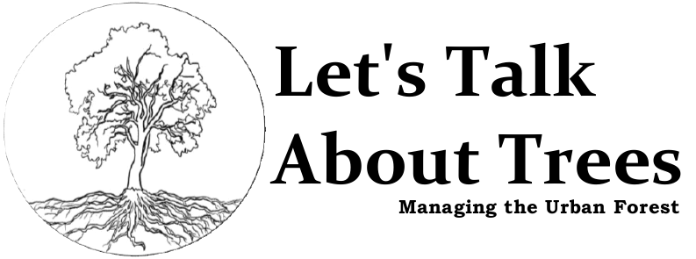

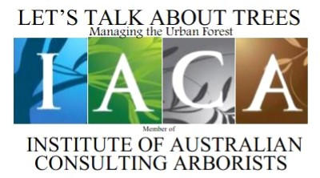

CLIENT DETAILS

Barwon Water
Co/- Tony Belcher
Strategic Projects Coordinator
Po Box 659
GEELONG, Vic, 3220

Phone 03 5226 2534

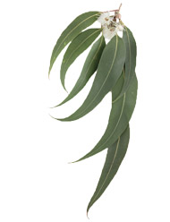

Arboricultural Assessment for:

38 – 42 Mainsail Drive,
ST LEONARDS,
Matthew Branagh
Diploma of Horticulture – Arboriculture ACAS,
Advanced Cert Horticulture,
Advanced Cert Aroriculture,
Cert IV Business Management, Certificate of Arboricultural Consulting, Trade Qualification in Gardening and Landscaping

PO Box 660,
DRYSDALE Vic, 3222
Ph 0468 874233
ABN 20 625 418 599
arborist@letstalkabouttrees.com.au

VICTORIA 3223

Tree Health and Hazard Risk Assessment

This report has been commissioned by:

Barwon Water

In reference to:
Tree Management, Health and Retention Value, in view of Planning for development of the site.

Date: March 2015

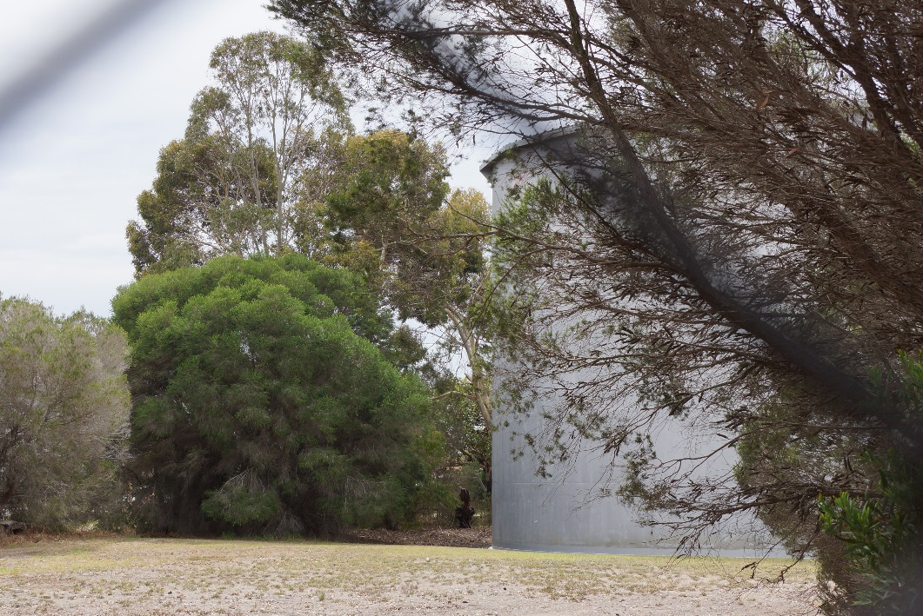

© 2015, Let’s Talk About Trees
Version 1.3 (Final)

Table of Contents

1.0 Key Objectives 4
2.0 Methodology 4
3.0 Observations / Discussions 5
3.1 General Observations 5
3.2 Discussion 12
4.0 Conclusion 13
Option 1 13
Option 2 14
5.0 Recommendation 15
6.0 Appendices 16
6.1 Photographs 16
6.2 Site Detail 18
6.3 Structural Root Zone & Tree Protection Zone. 20
6.4 Tree Protection Zone Encroachment Examples 21
6.5 Tree Protection Zone (TPZ) Signs 22
6.6 Tree Protection Zone (TPZ) Example 23
6.7 Indicative Stages in Development 24
7.0 References 26
8.0 Terms and Limitations of the Report 27

1.0 Key Objectives

This report has been commissioned by Barwon Water, for the undertaking of a visual tree assessment and determining the protective measures, health and retention value of trees located on a parcel of land known as 38 – 42 Mainsail Drive, St Leonards, Victoria 3223

It is to determine the health of trees on site, determine retention value and give protective measures in order that they can be managed in the safest manner.

2.0 Methodology

The inspection for this report was performed on site, on the 16th of March 2015, by Matthew Branagh level 5 Consulting Arborist from Let’s Talk About Trees.

A ground-based Visual Tree Assessment was performed on the trees, in line with modern Arboricultural Practices and Principles, many years of education, practical experience, AS 4970 – 2009 – Protection of Trees on Development Sites and AS 4373 – 2007 – Pruning of Amenity Trees.

All photographs were taken at the time of the inspection, and shall be used within this report for referencing or identification purposes.

3.0 Observations / Discussions

3.1 General Observations
The allotment contains no remnant native vegetation.

All specimens are native and two specimens, be they very poor specimens, are planted specimens of Melaleuca lanceolata – Moonah which is an indigenous species to the St Leonards area.

The reserve is located on the Bellarine Peninsula within the suburb of St Leonards. The current use of the reserve is a water supply tank.

All trees are located around the perimeter fence, and are approximately 35 – 40 years of age. The species are typical of the species used throughout the 1970’s for wind break and boundary planting throughout Victoria on public assets.

All trees with the exception of 15 trees are located within the reserve. These 15 trees are located around the reserve on nature strips.

75 trees were identified by the scope of this report.

No trees on the reserve were identified as specimens with significance.

No specimens have any outstanding attributes, and most are in a heavy state of decline.

The detail of all trees is outlined in the following table.

Trees can be further referenced in the pictures within the appendix.
The pictures show the general state of the trees on the reserve and support the comments of each tree within the field data collection table.

FIELD INSPECTION DATA
No. | Identification | Est. Age Yrs | ULE | Health | Structure | Significance | Hazard | TPZ (m) | Comment
1 | Eucalyptus leucoxylon – Yellow Gum | M | M | F | P | M | L | 2 | A mature tree with a bifurcated structure. Sound at inspection.
2 | Melaleuca armillaris – Honey Myrtle | M | M | G | P | L | L | 4 | Multi stemmed at ground level, with poor form and condition. Past failed branch wounds and pruning wounds evident.  POOR SPECIMEN WITH LOW RETENTION VALUE
3 | Agonis flexuosa – Willow Myrtle | SM | S | PP | P | L | M | N/A | Failed tree with a single main stem remaining, effectively a dead stump.  NOT A SOUND TREE FOR RETENTION
4 | Melaleuca armillaris – Honey Myrtle | M | S | P | P | L | H | 5 | Trifurcated at ground level, tree has failed structurally.  RECOMMENDED REMOVAL
5 | Eucalyptus lehmannii – Busy Yate | M | S | P | P | L | M | 2 | Tree was multi stemmed. One branch is remaining growing from the stump. The tree is made up of one limb on a failing stump which over hangs the boundary fence.  RECOMMENDED REMOVAL
6 | Agonis flexuosa – Willow Myrtle | SM | M | P | P | L | L | 3 | Multi stemmed poor specimen lopped in the past at 1.5m above ground level. Upper canopy is completely epicormic.  RETAINABLE WITH MAINTENANCE - MEDIUM TERM RETENTION
7 | Eucalyptus lehmannii – Busy Yate | M | M | P | P | L | M | 4 | 50% failing tree. Remaining limbs over hang the boundary  fence. Failing tree will not recover from past failings and will  always carry a failure risk.  RECOMMENDED REMOVAL
8 | Agonis flexuosa – Willow Myrtle | SM | S | P | P | L | L | 3 | Poor specimen stunted in growth, thinning in canopy. Dying tree with little retention value.  NO LONG TERM RETENTION VALUE
9 | Eucalyptus platypus - Moort | M | M | F | F | L | L | 3 | Upright multi stemmed tree – dead limbs from lower trunk. Past branch failing evident. Tree has a poor structure however safe at time of inspection.  RETAINABLE WITH MAINTENANCE - MEDIUM TERM RETENTION
10 | Melaleuca armillaris – Honey Myrtle | M | S | P | P | L | H | N/A | Failed tree Requires removal.  REMOVAL REQUIRED
No. | Identification | Est. Age Yrs | ULE | Health | Structure | Significance | Hazard | TPZ | Comment
11 | Eucalyptus lehmannii – Busy Yate | M | S | P | P | L | M | 2.5 | Tree has many past branch pruning stubs, Bifurcated poor form and a very low retention value.  LOW RETENTION VALUE
12 | Eucalyptus spathulata – Narrow Leaved Peppermint | SM | M | F | P | L | L | 2.9 | Tall upright tree with poor stem taper. Tree has no lateral limbs to 7m high. Resulting in poor structure. Poor specimen of the species with a low retention value.  LOW RETENTION VALUE
13 | Agonis flexuosa – Willow Myrtle | SM | S | P | P | L | L | N/A | Tree has had the upper canopy removed, little evident regrowth. Poor specimen.  REMOVAL RECOMMENDED
14 | Melaleuca armillaris – Honey Myrtle | M | S | P | P | L | M | 3.6 | Poor specimen stunted in growth. Open spreading canopy with a high failure potential.  Could be managed with maintenance however would have a short retention value.  SHORT TERM RETENTION WITH MAINTENANCE
15 | Eucalyptus platypus - Moort | M | M | F | F | L | M | 4.1 | Multi stemmed at 1.2m above the ground. Many past pruning wounds evident in the lower canopy, is a poor quality tree with an open spreading crown. High failure risk potential due to structure however sound at inspection.  LOW RETENTION VALUE
16 | Melaleuca armillaris – Honey Myrtle | M | S | P | P | L | M | 3.7 | Previously lopped to 1.2m  Now a poor specimen with a high failure risk potential.  LOW RETENTION VALUE
17 | Eucalyptus lehmannii – Busy Yate | M | P | P | P | L | L | 2 | 50% failed canopy at 1m above ground level. Unsound tree with a high future failure risk.  RECOMMENDED REMOVAL
18 | Eucalyptus lehmannii – Busy Yate | M | M | F | P | L | M | 4.2 | Poor specimen multi stemmed with many past pruning wounds and past failed stems.  The tree is outside the main fenced area and growing in the open public space.  LOW RETENTION VALUE
19 | Eucalyptus leucoxylon – Yellow Gum | SM | M | F | P | L | M | 5.2 | Sound at inspection. Upright trifurcated structure tree has poor form. One limb grows very low and extends over the footpath to the adjacent roadway of Harbour drive.  The tree is outside the main property fence in the public space.  LOW RETENTION VALUE
20 | Agonis flexuosa – Willow Myrtle | SM | S | P | P | L | L | 2 | Previously pruned at 1.2m above the ground, the upper canopy of this tree is epicormic, has poor form and structure and little to no retention value.  RECOMMENDED REMOVAL
21 | Eucalyptus platypus - Moort | M | M | G | P | L | L | 2 | This tree in the past has been removed 0.5m above the ground to a stump. It has regenerated with 10 leaders. It has a poor form and structure and shows a lot of deadwood throughout its epicormic canopy.  It has little to no retention value.  RECCOMMENDED REMOVAL
No. | Identification | Est. Age Yrs | ULE | Health | Structure | Significance | Hazard | TPZ | Comment
22 | Eucalyptus lehmannii – Busy Yate | M | S | P | P | L | H | N/A | A failed pruned stump with pone small limb remaining.  This tree has no retention value.  RECCOMMENDED REMOVAL
23 | Melaleuca armillaris – Honey Myrtle | M | S | P | P | L | M | 3.1 | This tree has a bifurcated stunted low growing form with a crack in the lower canopy.  The tree has a low retention value.  RECOMMENDED REMOVAL
24 | Agonis flexuosa – Willow Myrtle | SM | S | P | P | L | L | N/A | This tree in the past has been removed 0.5m above the ground to a stump. It has regenerated with multiple leaders. It has a poor form and structure and shows a lot of deadwood throughout its epicormic canopy.  It has little to no retention value.  RECCOMMENDED REMOVAL
25 | Eucalyptus platypus - Moort | M | M | F | P | L | M | 4.9 | Multi stemmed specimen sound at inspection.  Tree has a low retention value.  SHOULD BE CONSIDERED FOR REMOVAL
26 | Melaleuca armillaris – Honey Myrtle | M | S | P | P | L | L | N/A | Failed tree reshooting from a stump. Tree has no retention value.  RECCOMMEDED REMOVAL
27 | Eucalyptus leucoxylon – Yellow Gum | SM | L | G | F | M | L | 4.4 | Sound tree in fair condition.  One of the few trees in this report which is sound at inspection with a retention value.
28 | Agonis flexuosa – Willow Myrtle | SM | S | P | P | P | L | 2 | Multi stemmed specimen sound at inspection.  Tree has a low retention value.  SHOULD BE CONSIDERED FOR REMOVAL
29 | Eucalyptus lehmannii – Busy Yate | M | M | F | P | L | M | 3.7 | This tree is outside the main fenced area. It has been previously pruned at 0.5m above the ground.  It is now multi stemmed and in fair condition with high limb failure potential.  Tree should be considered for removal post site development.  SHOULD BE CONSIDERED FOR REMOVAL
30 | Eucalyptus lehmannii – Busy Yate | M | M | F | P | L | M | 2.9 | Tree shows past limb removal wounds at 0.5m above the ground level.  It has a heavily biased canopy lean toward the rear yard of a neighbouring allotment.  NOT RECOMMENDED FOR RETENTION
31 | Eucalyptus lehmannii – Busy Yate | M | M | F | P | L | M | 3.5 | Past large pruning wound 0.5m above ground level. Resultant canopy now epicormic. This tree carries a high failure risk potential.  NOT RECOMMENDED FOR RETENTION POST DEVELOPMENT
No. | Identification | Est. Age Yrs | ULE | Health | Structure | Significance | Hazard | TPZ | Comment
32 | Eucalyptus leucoxylon – Yellow Gum | SM | M | F | P | L | M | 5.2 | Past large upper canopy failings evident in this tree. Tree has an open spreading crown and a trifurcated upper canopy structure with included bark.  The tree is outside the main fenced compound in the public open space.  TREE HAS LOW RETENTION VALUE
33 | Melaleuca armillaris – Honey Myrtle | M | M | G | P | L | M | 2 | Tree is located outside the main fenced area, It is multi stemmed from its lower canopy and shows past stem failings from its upper canopy. Sound at inspection but does not have a high long term retention value.  LOW LONG TERM RETENTION VALUE
34 | Eucalyptus leucoxylon – Yellow Gum | M | M | G | F | L | L | 3.1 | Tree is located outside the main fenced area. It has a low spreading crown and shows signs of insect borer in its lower trunk.  Tree is sound at the time of inspection however, has a low long term retention value has.  LOW LONG TERM RETENTION VALUE
35 | Melaleuca armillaris – Honey Myrtle | M | S | P | P | L | L | N/A | Failed at ground level. Trees canopy is 100% shooting epicormic from ground level.  NO RETENTION VALUE RECOMMENDED REMOVAL
36 | Eucalyptus platypus - Moort | M | L | G | F | L | L | 4.1 | Bifurcated tree, both leaders have a biased lean into the property.  Tree was sound at inspection and has a medium failure potential.  SHORT TERM RETENTION VALUE
37 | Eucalyptus lehmannii – Busy Yate | M | M | G | F | L | L | 2 | Multi stemmed from lower trunk. Tree has deadwood throughout the canopy.  LOW LONG TERM RETENTION VALUE
38 | Eucalyptus spp. | D | D | D | D | D | D | 2 | Dead Tree  TREE REQUIRES REMOVAL
39 | Agonis flexuosa – Willow Myrtle | SM | M | S | P | L | L | N/A | Removed at ground level in the past. Weak structural form with a canopy that predominantly epicormic and thinning.  LOW RETENTION VALUE
40 | Melaleuca armillaris – Honey Myrtle | M | M | F | F | L | L | 4.9 | Multi stemmed at ground level. The tree has poor form with a thinning canopy. It is a declining specimen, which was sound at inspection.  LOW RETENTION VALUE
41 | Agonis flexuosa – Willow Myrtle | SM | M | S | P | L | L | N/A | Removed at ground level in the past. Weak structural form with a canopy that predominantly epicormic and thinning.  LOW RETENTION VALUE
42 | Melaleuca armillaris – Honey Myrtle | M | L | G | F | L | L | 2 | Tree with mature crown in good condition. Tree sound at inspection with good health.  GOOD RETENTION VALUE
No. | Identification | Est. Age Yrs | ULE | Health | Structure | Significance | Hazard | TPZ | Comment
43 | Melaleuca lanceolata - Moonah | SM | M | F | P | M | L | 2 | Multi stemmed from 0.5m above the ground. An indigenous native with past pruning wounds at about 1m high in its canopy.  Tree is partly epicormic.  Tree has retention value as a screening shrub.  RETENTION VALUE IN THIS TREE
44 | Corymbia citriodora – Lemon Scented Gum | SM | L | G | F | M | L | 2 | Tall upright specimen with sparse thing canopy, tree has poor form but a sound structure.  MEDIUM RETENTION VALUE
45 | Eucalyptus leucoxylon – Yellow Gum | SM | L | G | F | L | L | 6.4 | Tree in the past has been reduced to a stump of 0.5m, now has X 5 epicormic leaders. At inspection the tree was sound in health and showed no signs of declining health.  MEDUM RETENTION VALUE
46 | Agonis flexuosa – Willow Myrtle | SM | M | G | P | L | L | 2 | Stunted tree with poor form in sound health.  LOW RETENTION VALUE
47 | Dead Stump | D | D | D | D | D | D | N/A | REMOVAL REQUIRED
48 | Eucalyptus lehmannii – Busy Yate | M | S | P | P | L | M | N/A | Regenerated stump, low retention value.  RECOMMENDED REMOVAL
49 | Melaleuca armillaris – Honey Myrtle | M | M | F | P | L | M | N/A | Multi stemmed tree from ground level. Deadwood throughout the trees canopy. The tree has a large dead scaffold which requires removal.  LOW RETENTION VALUE
50 | Eucalyptus leucoxylon – Yellow Gum | SM | M | P | P | L | M | 4.1 | Tree coppiced to a 1m high stump in the past. Is now epicormic in canopy which is mature in size. It has an open spreading crown with evident past limb failings.  LOW RETENTION VALUE
51 | Eucalyptus viminallis – Manna Gum | M | S | P | P | M | L | 3.8 | Failed upper crown in this tree, Phellinus fungi fruits are evident on main stem.  Dead and part failed upper canopy.  LOW RETENTION VALUE
52 | Eucalyptus lehmannii – Busy Yate | M | M | F | P | L | M | 2 | A mature tree which hangs 70% over the boundary fence and into the adjoining street.  Tree has deadwood in its canopy.  LOW RETENTION VALUE
53 | Eucalyptus leucoxylon – Yellow Gum | SM | M | G | G | M | L | 2 | Upper canopy has deadwood. The main stem shows Phellinus fungi fruiting bracts indicating decay in the main structure of the tree. The tree is sound at inspection and shows good condition. This sound condition is long term expected to decline as the fungi continues to inoculate the tree.  MEDIUM RETENTION VALUE
No. | Identification | Est. Age Yrs | ULE | Health | Structure | Significance | Hazard | TPZ | Comment
54 | Melaleuca armillaris – Honey Myrtle | M | S | P | P | L | M | N/A | Regenerated stump forming a multi stemmed tree with poor structure.  LOW RETENTION VALUE
55 | Melaleuca armillaris – Honey Myrtle | M | S | P | P | L | M | N/A | Regenerated stump with poor weak growth.  LOW RETENTION VALUE
56 | Dead Stump | D | D | D | D | D | D | N/A | Dead Tree  REMOVAL RECOMMENDED
57 | Eucalyptus lehmannii – Busy Yate | M | M | F | P | L | L | 3.7 | Lower canopy pruned from tree. Many dead branch stubs at the base. Poor specimen.  LOW RETENTION VALUE
58 | Eucalyptus leucoxylon – Yellow Gum | SM | M | F | P | L | L | 2.2 | Bifurcated poor form with a stunted canopy.  LOW RETENTION VALUE
59 | Dead Stump | D | D | D | D | D | D | N/A | DEAD STUN Removed at ground level in the past. Weak structural form with a canopy that predominantly epicormic and thinning.  LOW RETENTION VALUE
60 | Regen.  Stump | M | D | D | D | D | D | N/A | DEAD STUMP  RECOMMENDED REMOVAL
61 | Eucalyptus leucoxylon – Yellow Gum | SM | M | F | F | M | L | 4.1 | DEAD STUMP  RECOMMENDED REMOVAL
62 | Melaleuca armillaris – Honey Myrtle | M | M | F | F | L | L | 2 | Poor specimen stunted in growth. Leaning in habit.  LOW RETENTION VALUE
63 | Eucalyptus platypus - Moort | M | M | F | P | L | L | 2.9 | Removed and lopped to lower trunk in the past.  Poor branch attachment, this tree is a medium future failure risk.  REMOVAL RECOMMENDED
64 | Eucalyptus lehmannii – Busy Yate | M | M | P | F | L | L | 3.6 | Tree is bifurcated and in poor health. Dead lower canopy stubs from past branch removals.  LOW RETENTION VALUE
65 | Melaleuca armillaris – Honey Myrtle | M | S | P | P | L | M | 9.3 | Failed tree leaning over site shed.  RECOMMENDED REMOVAL
66 | Melaleuca lanceolata - Moonah | Y | M | F | P | M | L | 2 | Young multi stemmed specimen, not in good structural condition. Multi stemmed from ground level. Not a good specimen of a planted indigenous native.  LOW RETENTION VALUE
67 | Agonis flexuosa – Willow Myrtle | SM | S | P | P | L | L | 2 | Specimen in poor health with poor structure, many dead branch stubs at the base of the tree.  REMOVAL RECOMENDED
68 | Eucalyptus lehmannii – Busy Yate | M | M | F | P | L | M | 4.2 | Many dead branch stubs at the base of this tree, two leaders form the canopy, both are over weighted branches with a high failure risk.  LOW RETENTION VALUE

3.2 Discussion

Of the 76 trees none hold a high significance to the site or the local area.
Management of the trees should follow the comments made in the comments box of the table, and high consideration should be given to the removal of many of the trees pre development of the site. Many trees are in poor condition as a result of past pruning of the trees. It should be noted that these trees were never intended to have a useful life as an amenity tree. They were planted as a break of trees to screen around the land use assets. In the past the trees have been pruned to allow maintenance around their bases and heavily pruned, in many cases lopped to encourage the trees to thicken in canopy and provide an aesthetic barrier between the site and the surrounding suburb.

Over the past decade management in this way has not been undertaken. As a result the trees have developed with long leaders which are poorly attached to the parent stump. As these develop they become over weighted and form a poor tree structure. The result is an increased number of tree deaths and limb failings. This is very evident when looking at the plantation today.

Further impact and decline is caused by the drought conditions of the past decade where rainfall has been at a minimum. It can now be reasonably expected that the recent return to around normal rain fall in the area will cause the trees to return to a typical growth pattern. This will cause an increase in foliage mass and an increase in limb weight. This in turn will add further weight stresses to limbs which have poor attachments and it can be expected that without management the failure rates and tree deaths within the plantation will continue to increase.

For this reason the useful life expectancy of trees which appear sound in health has been diminished. In many instances limb failure and early tree death is inevitable and cannot be reversed.

4.0 Conclusion
It is my opinion that two viable options for the plantation trees exist.

Option 1

He trees be retained in their current location and extensive pruning of their canopies be undertaken in order to return the epicormic scaffolds to a ‘hedged’ managed state.

This is a return to the past maintenance practices of the sight in the 80’s and 90’s. In this manner the tree failures can be reduced as the over weighted limbs are managed and as a result less limb failure risk will be associated to the site.
In undertaking this management, dead trees should be removed as should all trees which are stunted and performing poorly.

The area beneath the trees should be mulched to a depth of a minimum 10cm, and the much laid from the boundary fence into the reserve for a distance which covers the entire root zone of the trees. This root zone is based on the tree protection zone detailed in the table within this report for each tree.

The plantation should then be in fill planted using a suitable species for the area.

If this option is undertaken a further report may wish to be commissioned detailing the management of the trees intensity of pruning and suitable replacement species.

Option 2

Option 2 is to remove the trees of the allotment, retaining and undertaking pruning management of a selected few trees should some of the sounder trees be desired for retention.

As stated earlier no trees on the site have a high retention value, and removal is based on eliminating the risks associated to the failing site assets.

As they stand the trees have a short useful life expectancy as a group. Some trees with the removed competition of the rest of the trees, and improved growing conditions through mulching and pruning management could have their useful life expectancies extended to 20 years.

The trees located outside the main reserve on the public space are in
much better condition than those within the reserve.

Some of these trees require management for sound retention, others are
young and recently planted; the table reflects these tree values.

Recommendation
The recommendation of this report are as follows;

The future land use and development of the site should be determined.

The tree assets should be considered in the future site use and where required removed and managed in order to achieve the desired outcomes.

In development it is possible to impact trees and retain them post development. This is certainly the more common approach when developing on sites which have a tree occupancy pre development. However in this instance the trees were established as a purpose asset, and that was an ornamental use.

The early use of the trees as ornamental specimens has meant that they were managed in a way which has not resulted in sound assets at maturity. This has resulted in a poor selection when looked at from a retention of arboricultural assets perspective.

The two suggested options I believe are sound; either return the trees to their previous use as a pruned and managed vegetation screen, or remove them and begin the new land use with new plantings appropriate for the decided land use.

This in turn will develop into a value added resource for the allotment.

In retention, if final design drawings are completed and trees over hang the building envelopes they may require trimming. This will be determined post design and impact assessment.

All trees should be managed to meet the requirements of AS 4970 – 2009 Protection of Trees on Development Sites, and AS 4373—2007 Pruning of Amenity Trees. This should be done using this report, AS 4970 – 2009 Protection of Trees on Development Sites AS 4373—2007 Pruning of Amenity Trees.

All works carried out on the trees should be undertaken by a qualified arborist as per the guideline of Australian Standard AS4970 – 2009 Protection of Trees on Construction Sites.

Further tree management reports may be required in retention of specimens on this allotment. This may also be desired for tree selection in replacement plantings.

6.0 Appendices

6.1 Photographs

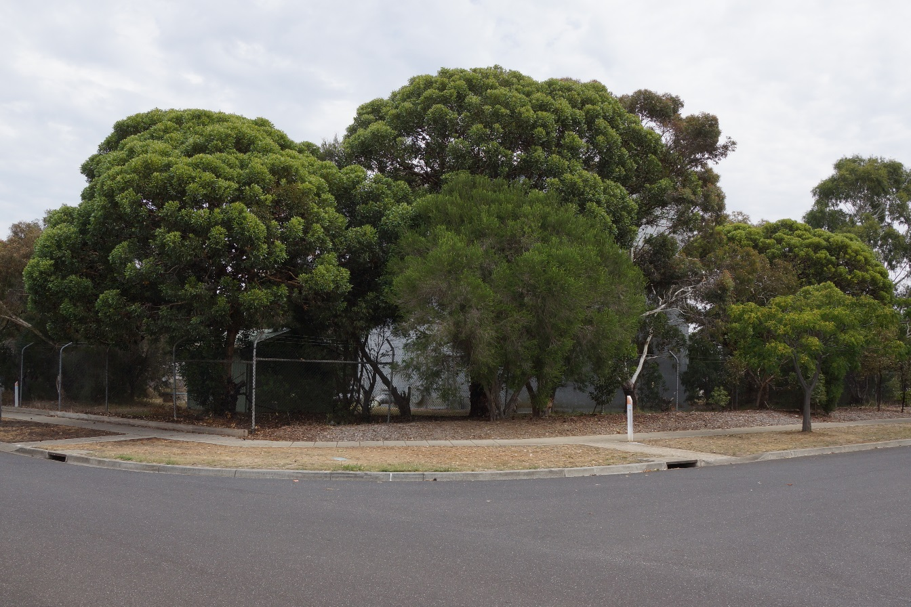

Site Overview
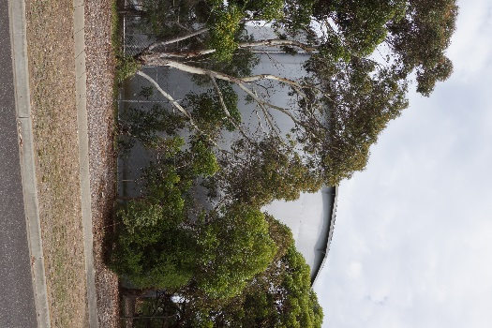

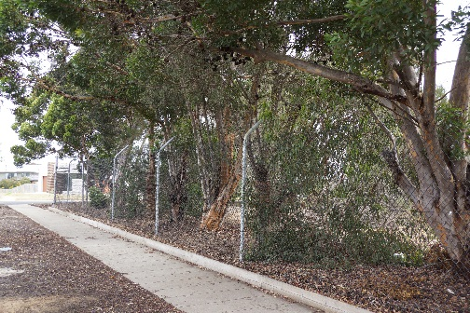
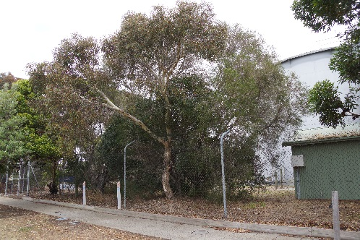

Tree 1

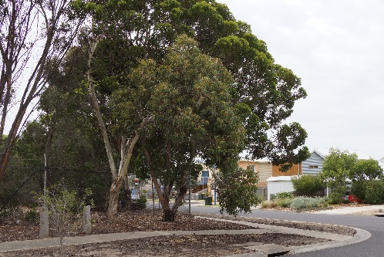
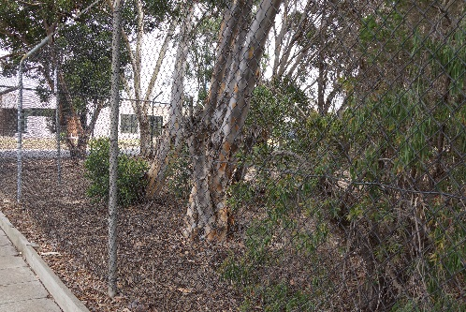

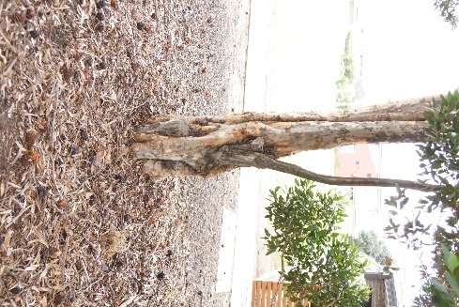
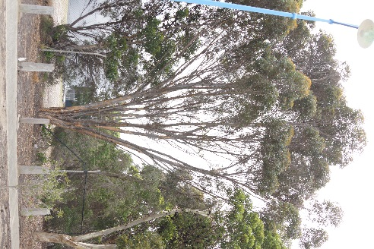
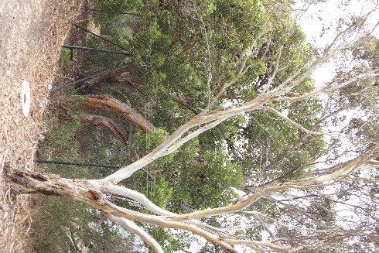
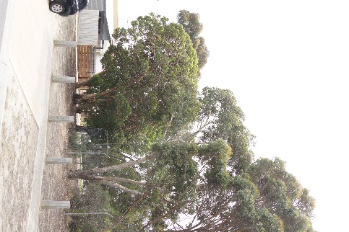

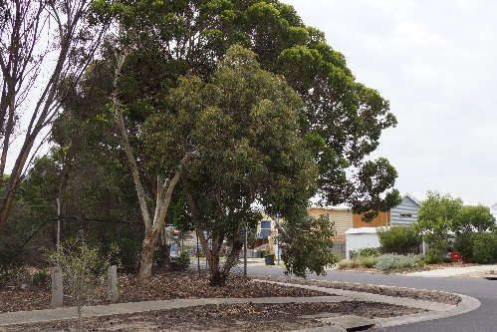
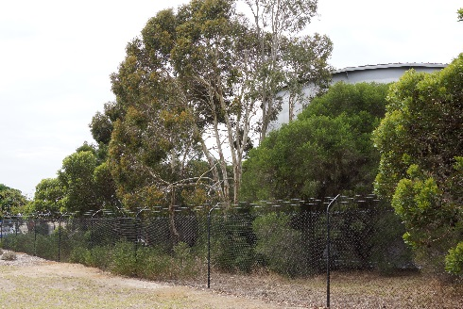

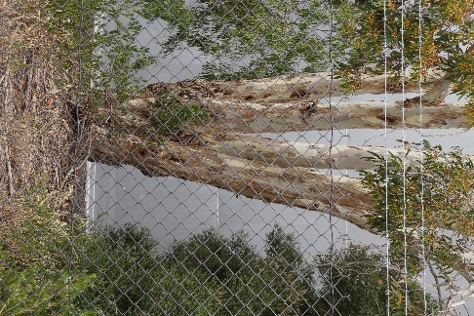
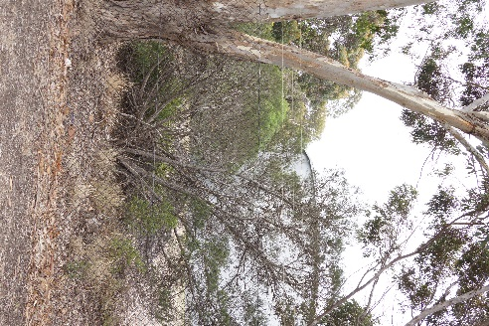
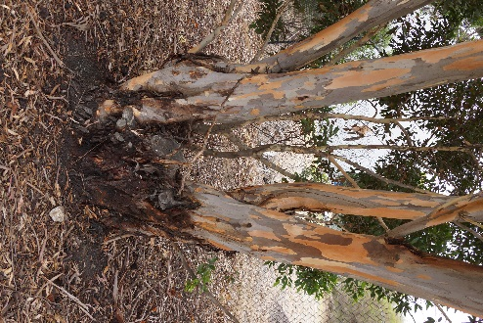
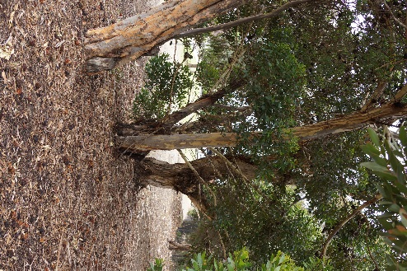

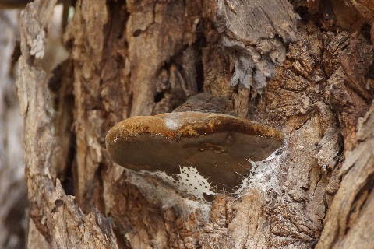
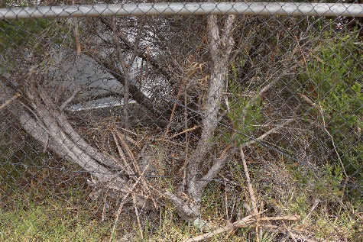
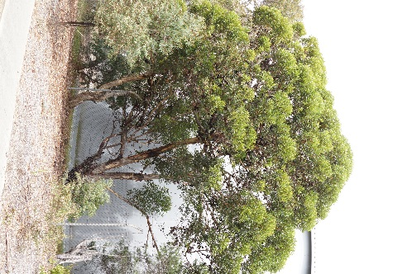

6.2 Site Detail

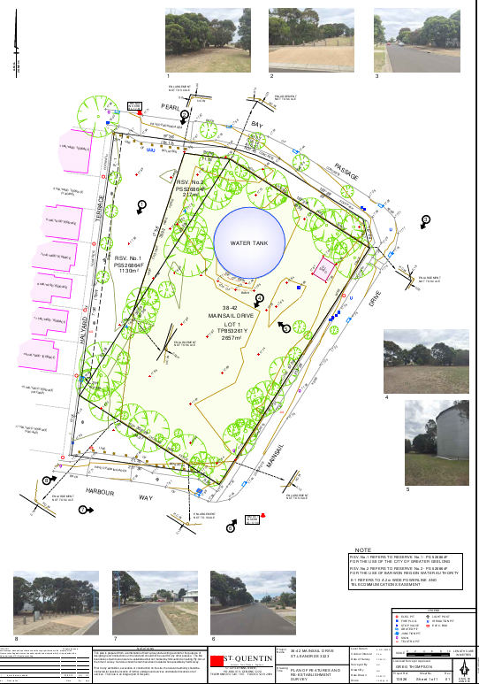

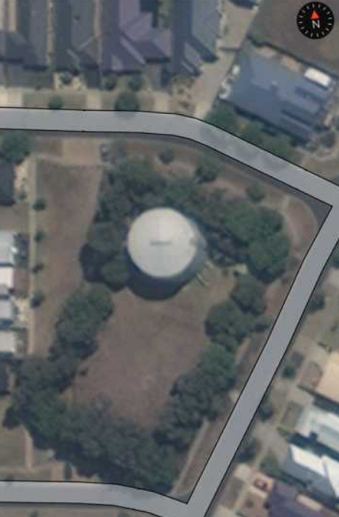
75
74
73
72
71
70
69
68
67
66
65
64
63
61
60
62
59
58
57
56
55
54
53
52
51
50
49
48
47
46
45
44
43
42
41
40
39
38
37
36
35
34
33
31
32
12
10
17
16
15
13
14
11
9
7
8
30
29
28
27
26
25
24
23
22
21
20
19
18
6
5
4
3
1
2

6.3 Structural Root Zone & Tree Protection Zone.
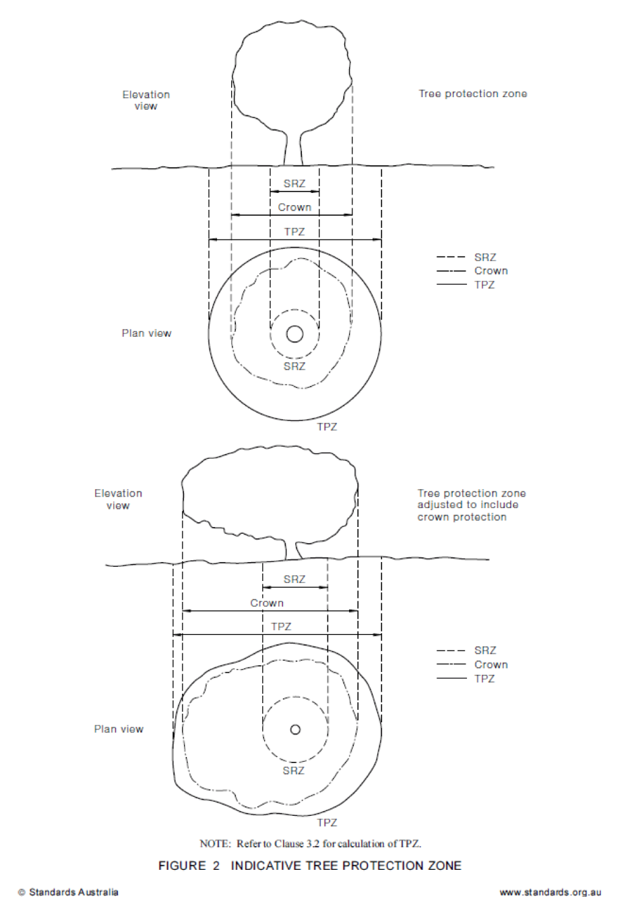

6.4 Tree Protection Zone Encroachment Examples
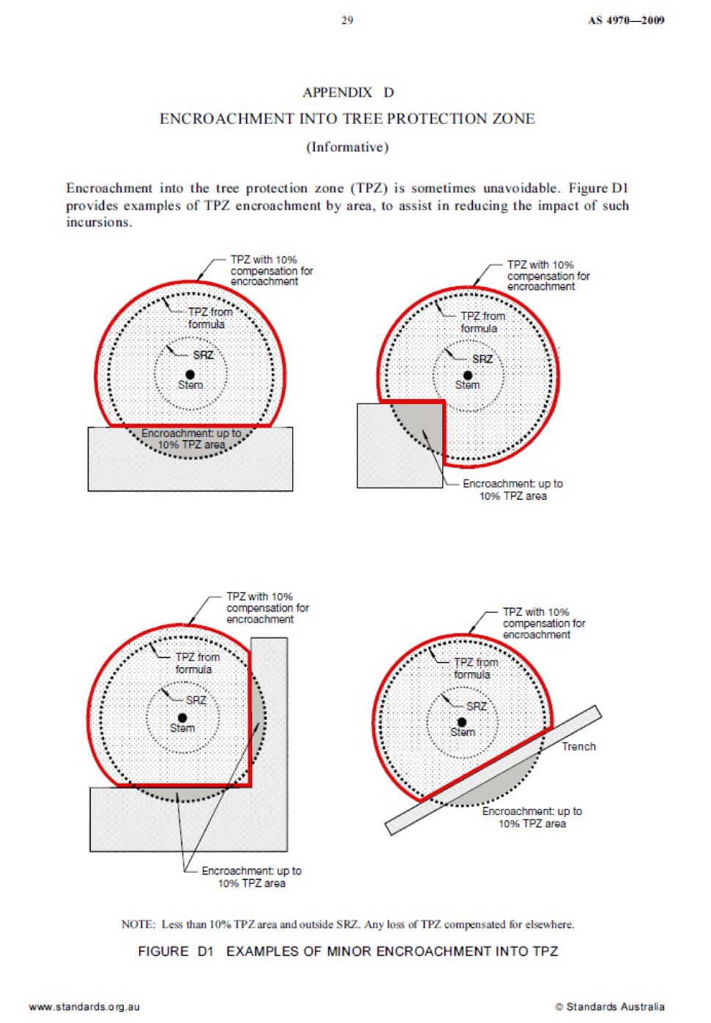

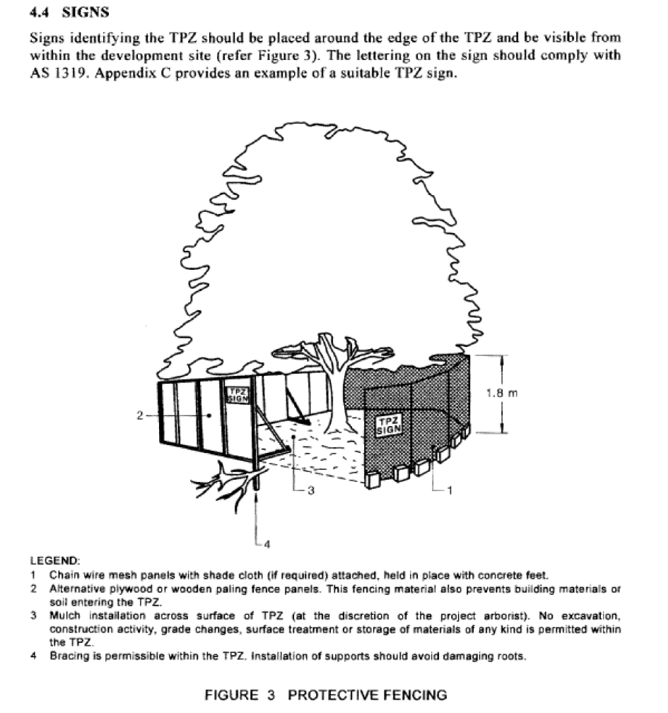
6.5 Tree Protection Zone (TPZ) Signs

(Extract from AS4970 – 2009 Protection of trees on Development sites)

6.6 Tree Protection Zone (TPZ) Example
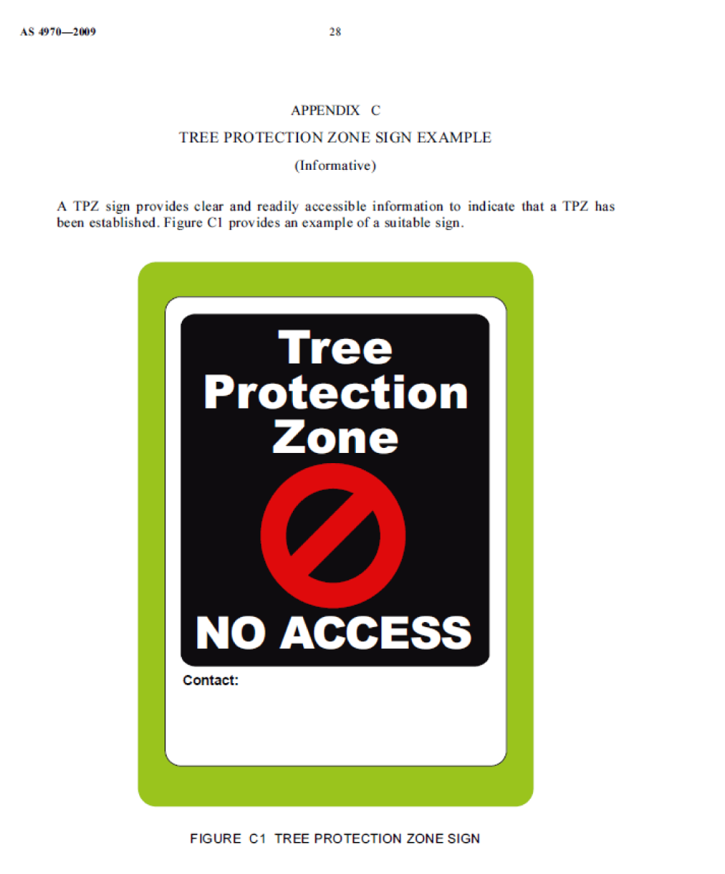

(Extract from AS4970 – 2009 Protection of trees on Development sites)

6.7 Indicative Stages in Development

Stage in Development | Tree Management Process
Stage in Development | Matters for Consideration | Actions and Certificates
Planning (Sections 2 and 3)
Site acquisition | Legal constraints
Detail surveys | Council plans and policies  Planning instruments and controls  Heritage  Threatened species | Existing trees accurately plotted on survey plan.
Preliminary tree assessment | Hazard/risks  Tree retention value | Evaluate trees suitable for retention and mark on plan  Provide preliminary arboricultural report and indicative TPZs to guide development layout.
Preliminary development design | Condition of trees  Proximity to buildings  Location of services  Roads  Level changes  Building operations space  Long-term management | Planning selection of trees for retention  Design review by proponent  Design modifications to minimise impact to trees.
Development submission | Identify trees for retention through comprehensive arboricultural impact assessment of proposed construction.  Determine tree protection measures.  Landscape design. | Provide arboricultural impact assessment including tree protection plan (drawing) and specification.
Development approval | Development controls  Conditions of consent | Review consent conditions relating to trees.
Pre-construction (Sections 4 and 5)
Initial site preparation | State based OHS requirements for tree work  Approved retention/removal  Refer to AS 4373 for the requirements on the pruning of amenity trees  Specifications for tree protection measures. | Compliance with conditions of consent.  Tree removal/tree retention/transplanting  Tree pruning  Certification of tree removal and pruning.  Establish/delineate TPZ  Install protective measures  Certification of tree protection measures.

Stage in Development | Tree Management Process
Stage in Development | Matters for Consideration | Actions and Certificates
Construction (Sections 4 and 5)
Site establishment | Temporary infrastructure  Demolition, bulk earthworks, hydrology | Locate temporary infrastructure to minimise impact on related trees.  Maintain protective measures  Certification of tree protection measures.
Construction work | Liaison with site manager, compliance  Deviation from approved plan | Maintain or amend protective measures  Supervision and monitoring
Implement hard and soft landscape works | Installation of irrigation services  Control of compaction work  Installation of pavement and retaining walls | Remove selected protective measures as necessary  Remedial tree works  Supervision and monitoring
Practical completion | Tree vigour and structure | Remove all remaining tree protection measures  Certification of tree protection
Post Construction (Section 5)
Defects liability / maintenance period | Tree vigour and structure | Maintenance and monitoring  Final remedial tree works  Final certification of tree condition

Notes:
- Owing to variations in planning legislation, this Table is a general indication of the process only
- Certification of tree protection and condition should be carried out by the project Arborist.

Extract from Australian Standard 4970 – 2009 – Protection of Trees on Development Sites.

The above Table shows clearly the process of tree protection on development sites as set out in the Australian Standard. It can also serve as a guide to the set up and management of new and replacement plantings.

This Table should be followed in the management of all trees on development sites.

Depending on the stage of the project you are undertaking, the type of project you are undertaking and specific other requirements of various planning departments, in some instances additional reports may be required.

The above Table serves as an indicative guide to the process of managing and protecting trees.

7.0 References

1. | Victoria’s Native Vegetation Management Framework (Draft) – DSE Victoria
2. | Australian Standard® AS4970-2009, Protection of trees on development sites, 2009, Sydney
3. | Australian Standard® AS4373-2007,Pruning of Amenity Trees, 2007, Sydney
4. | Alex L. Shigo, A New Tree Biology. 1986. USA
5. | Alex L. Shigo, Modern Arboriculture. 1991. USA
6. | Richard W. Harris, Arboriculture. Integrated management of Landscape Trees, Shrubs and Vines. Second Edition. 1992. USA.
7. | Keith Rushforth, Tree Planting and Management. 1987. USA
8. | David Jones and Roger Elliot, Pests, diseases and ailments of Australian Plants. 1995. Australia
9. | Frances Bodkin, Encyclopaedia Botanica. 1990. Australia
10. | Raven, Evert and Eichhorn, Biology of plants. 1991. USA.
11. | Ivan Holliday, Australian Trees, 1995. Australia
12. | Leon Costermans, Native Trees and Shrubs of South-Eastern Australia, 1996, Australia
 | 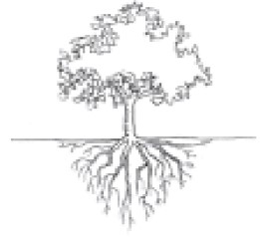
Writings within the report are of the author’s personal knowledge and belief. The information and knowledge released in the report when referenced should be referenced to
Matt Branagh, Dip.App.ScI – Horticulture/Arboriculture – Let’s Talk About Trees.

8.0 Terms and Limitations of the Report

- Any legal information in the report has been provided to Let’s Talks About Trees by an external source and it is assumed to be correct. All references to property title and/or control or ownership of land are assumed to be correct as Let’s Talk About Trees has been advised.

- Great care has been taken in sourcing information for this report so as it is correct. Let’s Talk About Trees cannot be responsible for information provided which is not directly under control of its staff.

- No Let’s Talk About Trees employee shall be required to give testimony or attend court for any matter in relation to this report, unless further contractual arrangements have been made.

- This report must not be altered in any shape or form. It has been written as a whole document and is intended for use as a whole document. Any changes or modifications to this report not undertaken Let’s Talk About Trees by shall render this report invalid in its entirety.

- In no way is this report biased or weighted. The content of the report is written in the full, honest opinion of the Let’s Talk About Trees Consulting Arborist.

- No diagrams, pictures, graphs or other reference material in this report is said to be to scale or value unless stipulated. All measurements and values are made to the best of the author’s ability at the time of reporting and should be checked before using as final measurements for whatever reason.

- This report is developed around the information provided by our client in the project brief. Only issues covered by the project brief are discussed in this report.

- All details, information and advice contained in this report have been researched and referenced. Where no reference is included, it is the author’s learned opinion, experience and observations.

This report is written under full copyright.
No Section may be reproduced for any reason whatsoever,
Unless with the written permission of Let’s Talk About Trees

