Planning and Environment Act 1987

Greater Geelong PLANNING SCHEME

AMENDMENT C348

EXPLANATORY REPORT

Who is the planning authority?
This Amendment has been prepared by the City of Greater Geelong, which is the planning authority for this Amendment.
The Amendment has been made at the request of Links Investco No 1 Pty Ltd.

Land affected by the Amendment
The Amendment applies to freehold land located at 1-5 Ballarat Road, North Geelong (refer to Figure 1).
The land affected by the Amendment includes all land within Lot S31 on Plan of Subdivision 647500.

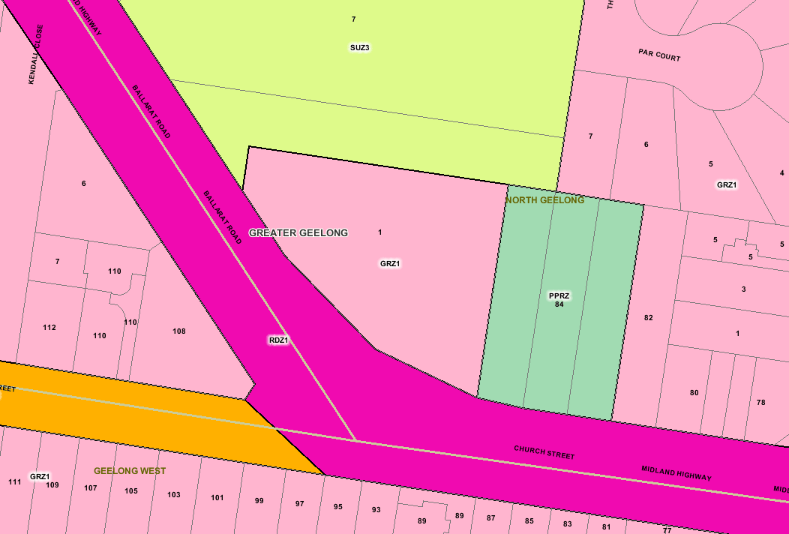
Subject Land
Figure 1: Subject Land source: land.vic.gov.au

What the Amendment does
The Amendment seeks to rezone that part of the land that is currently located within the Special Use Zone – Schedule 3 (SUZ3) to General Residential Zone – Schedule 1 (GRZ1).
The Amendment also proposes to:
- remove Development Plan Overlay – Schedule 9 (DPO) from the land being rezoned;
- remove the Land Subject to Inundation Overlay from the existing GRZ1 portion of the land; and
- apply an Environment Audit Overlay (EAO) to the land to be rezoned.

Strategic assessment of the Amendment

Why is the Amendment required?
The existing vehicle access to the GRZ1 land needs to traverse land within the SUZ3. Given that any residential use of the land will need to obtain access to Ballarat Road over the SUZ3 portion of the land, which would be prohibited by the Planning Scheme, an Amendment is required to align the zone and title boundaries.

How does the Amendment implement the objectives of planning in Victoria?
The Amendment achieves the objectives of planning in Victoria pursuant to Section 4 of the Planning and Environmental Act 1987 insofar as it will:
- Provide for the fair, orderly, economic and sustainable use, and development of land;
- Secure a pleasant, efficient and safe working, living and recreational environment for all Victorians and visitors to Victoria.
The Amendment seeks to apply consistent zone and overlay provisions across the entire site to enable existing residential zoned land to be developed.

How does the Amendment address any environmental, social and economic effects?
The Amendment will have no environmental effect.
The Amendment will facilitate the future development of the land that has potential to provide social and economic benefit. Any potential effects will be considered as part of a future planning permit application.

Does the Amendment address relevant bushfire risk?
No bushfire risk had been identified in relation to the proposed re-zoning.

Does the Amendment comply with the requirements of any Minister’s Direction applicable to the Amendment?
The contents of Ministerial Direction No. 11 Strategic Assessment Guidelines has been utilised in the preparation of this explanatory report.
The Amendment complies with the Ministerial Direction on The Form and Content of Planning Schemes under Section 7(5) of the Planning and Environmental Act 1987.

How does the Amendment support or implement the State Planning Policy Framework and any adopted State policy?
The Amendment is consistent with the State Planning Policy Framework as follows:
Clause 11.04-2 Housing choice and affordability

This policy supports development which contributes in a positive way to improving housing stock choice and affordability. In this case rezoning will facilitate future development of the existing GRZ1 land and assist in achieving broad housing objectives.

How does the Amendment support or implement the Local Planning Policy Framework, and specifically the Municipal Strategic Statement?
Local planning policies support the proposed Amendment insofar as it will facilitate the development of existing residential zoned land. Clause 21.06 Settlement and Housing, supports growth in existing areas throughout the Greater Geelong Region. The Amendment supports the overall theme of Council planning policies which encourage consolidation and housing diversity in established areas.

Does the Amendment make proper use of the Victoria Planning Provisions?
The General Residential Zone – Schedule 1 is the appropriate zone to enable the future residential development of the subject land. It will overcome the prohibition currently associated with the use of the existing Ballarat Road access for residential purposes.
Development Plan Overlay – Schedule 9 is not applicable to land that does not form part of the redeveloped Geelong Golf Course project and as such it has been deleted.
The Amendment extends the application of the Environmental Audit Overlay to the whole site. The Environmental Audit Overlay will ensure that potentially contaminated land is suitable for any future sensitive use. .
The Land Subject to Indundation Overlay which applies to the existing GRZ1 portion of the land is redundant now that a subsequent Special Building Overlay has been applied to the entire site to address stormwater flooding issues.
The Amendment complies with the Ministerial Direction on The Form and Content of Planning Schemes under section 7 (5) of the Planning and Environmental Act 1987.

How does the Amendment address the views of any relevant agency?
VicRoads has been consulted in relation to the Amendment, and has advised it would not support any change to the location of the existing access point to Ballarat Road, removing the option of relocating the access to the GRZ1 portion of the site.

Does the Amendment address relevant requirements of the Transport Integration Act 2010?
No requirements of the Transport Integration Act are relevant to this Amendment.

Resource and administrative costs

What impact will the new planning provisions have on the resource and administrative costs of the responsible authority?
The re-zoning of the land and changes to overlays will have no impact on the administrative costs of the responsible authority.

Where you may inspect this Amendment
The Amendment is available for public inspection, free of charge, during office hours at the following places:
Greater Geelong City Council, Customer Service Centre, Ground Floor, 100 Brougham Street, Geelong, and ‘Have Your Say’ section of the City’s website at: www.geelongaustralia.com.au/Accessing_council/Public_comment_-_Your_Say
The Amendment can also be inspected free of charge at the Department of Transport, Planning, and Local Infrastructure website at: http://www.delwp.vic.gov.au/planning/publicinspection

Submissions
Any person who may be affected by the Amendment may make a submission to the planning authority.
Submissions about the Amendment must be received by 18 July 2016
A submission must be sent via mail or email to:
The Co-ordinator, Strategic Implementation Unit,
City of Greater Geelong
P O Box 104
GEELONG VIC 3220 or by email to strategicplanning@geelongcity.vic.gov.au

Panel hearing dates
In accordance with clause 4(2) of Ministerial Direction No.15 the following panel hearing dates have been set for this Amendment:
- directions hearing: Week commencing 22 August 2016.
- panel hearing: Week commencing 22 September 2016.

