To: Peter Smith – Coordinator Strategic Implementation
From: Ian McCartney – Senior Strategic Planner
Subject: Proposed EAO – 530 Bacchus Marsh Road, Lara
Application: Amendment C345 – Reports Council and Other
File number: C-345
Purpose
The purpose of this report is to consider a recommendation from the Environment Protection Authority that Council apply an Environmental Audit Overlay to the property at 530 Bacchus Marsh Road Lara.
Summary
- The Environment Protection Authority Victoria (EPA) has written to Council recommending it amend the Planning Scheme to apply an Environmental Audit Overlay (EAO) to 530 Bacchus Marsh Road Lara.
- The subject land, which has an area of 2.82 ha, is occupied by a detached house and various outbuildings. The EPA’s concern arises from its prior use as a truck repair business which resulted in contaminated soil from discarded industrial waste.
- The EPA believes that whilst the owner has made some attempts to clean up the polluted soil, there would be legacy pollution on the premises. It is concerned that any future sensitive use could be affected by this contamination and application of an EAO will ensure such issues are addressed in the future.
- This report addresses the pros and cons of applying an EAO and recommends the EPA proposal be agreed to.
Recommendation
That Council resolves to exhibit an amendment to the Greater Geelong Planning Scheme to apply an Environmental Audit Overlay to the property situated at 530 Bacchus Marsh Road, Lara, subject to the Minister for Planning providing authorisation for the preparation of the Amendment.
Background
The Environment Protection Authority (EPA) has written to Council recommending it amend the Planning Scheme to apply an Environmental Audit Overlay (EAO) to 530 Bacchus Marsh Road, Lara. A copy of the EPA’s letter is Appendix 1. The EPA advises it has issued an Official Warning to the owners of the property for their failure to clean up contamination resulting from its previous use as a truck repair business. It believes that, whilst some attempts have been made to clean up the pollution, the likelihood is that legacy pollution of the soil and potentially the groundwater would remain.
The subject land has an area of 2.82 ha and is currently occupied by a detached house and various outbuildings as shown in the aerial photograph at Appendix 2. Visual evidence of the previous use also exists.
The land falls within a Rural Living zone as shown in Appendix 3.
The EPA’s concern is that the contamination issues need to be adequately addressed in the event the site is developed for a sensitive use in the future.
Discussion
In the Rural Living zone, there are a number of discretionary sensitive uses for which a permit could be sought in the future e.g dwellings, education centre, childcare, hospital.
Application of an Environmental Audit Overlay to the land in the Planning Scheme would mean that before any new sensitive use could commence or any buildings or works in association with a sensitive use commences either:
- A certificate of environmental audit must be issued for the land in accordance with Part IXD of the Environment Protection Act 1970, or
- An environmental auditor appointed under the Environment Protection Act 1970 must make a statement in accordance with Part IXD of that Act that the environmental conditions of the land are suitable for the sensitive use.
On the one hand it may be contended that the prospect of a permit being sought and approved on the subject land for intensive sensitive uses is not high because:
- The site is currently relatively remote from urban areas.
- The site falls within the 1000 metres buffer to the Geelong Ring Road Employment Precinct aimed at discouraging sensitive uses; and
- Local Planning Policy Clause 22.04 aims to discourage intensive urban activities and uses which attract a substantial number of visitors in the Rural Living Zone.
On the other hand, this general area is expected to see very considerable urban growth both in the short term (Lara West) and potentially in the longer term if the development at Lovely Banks proceeds.
In addition, it would be most unfortunate if the subject land was offered for sale and a new owner decided to construct a new dwelling on the land without even being aware of the existing contamination issue.
On balance, introduction of an EAO to the subject land is considered to be the most prudent course of action and will alert any future owners about the contamination issue.
Application of the EAO will result in no immediate imposition on the existing owners and will only trigger the need for a planning permit in the circumstances set out above.
It is proposed that a Section 20(2) exemption be sought from the requirement to publish a newspaper notice about this amendment because the amendment will only affect the current landowner and not the surrounding community.
Environmental Implications
The amendment will produce a positive environmental outcome in that any residual contamination from the previous industrial use will need to be adequately addressed and if necessary remedial action taken prior to the land being used for a sensitive use.
Financial Implications
The proposal has no financial implication for Council other than the costs associated with the processing of this amendment.
Policy/Legal/Statutory Implications
The Amendment is consistent with Clause 13.03-1 Use of contaminated and potentially contaminated land and Clause 21.02 CoGG Sustainable Growth Framework which refers to restoring Geelong’s natural systems and the need to “dispose of waste responsibly”. It is also consistent with the purpose of the Environmental Audit Overlay at Clause 45.03 of the Planning Scheme.
Alignment to City Plan
The amendment supports the overall thrust of the Sustainable Built and Natural Environment strategic direction of City Plan.
Officer Direct or Indirect Interest
No Council Officers have a direct or indirect interest, in accordance with the Section 80 (c) of the Local Government Act, to which this amendment relates.
Risk Assessment
There are no risks to Council associated with this amendment. Failure to act on the EPA recommendation could expose Council and a future owner to legal and cost implications if the land is developed for a sensitive use without contamination issues being addressed.
Social Considerations
The Amendment has no social implications.
Human Rights Charter
The Amendment will not impact on basic human rights, freedoms and responsibilities as set out in the Charter.
Consultation and Communication
The owners of the land affected by the amendment have been made aware of the EPA recommendations. Formal notice of exhibition of the amendment will be given to the owners which will enable them to make a submission and appear before an Independent Panel appointed by the Minister for Planning.

Appendix 1 – EPA Letter

Appendix 2 – Aerial Image
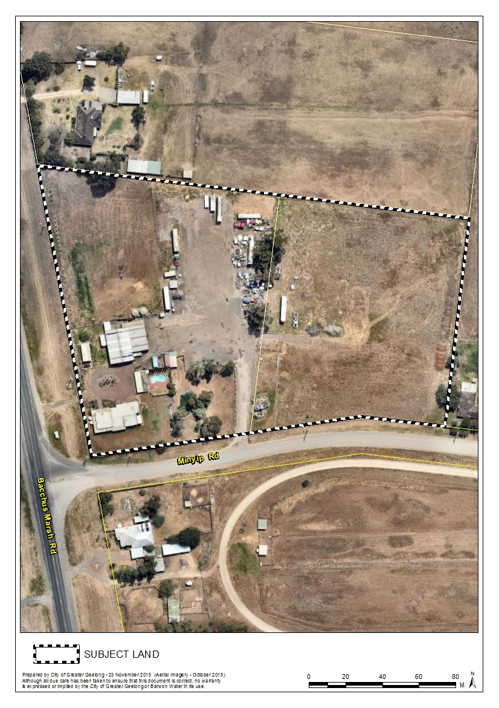
Appendix 3 – Zoning Map
