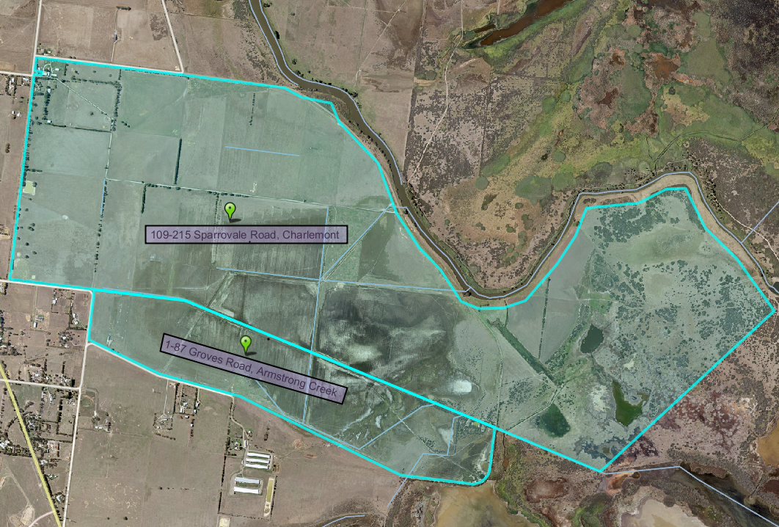
Groves Road
Barwon Heads Road

