Planning and Environment Act 1987

GREATER GEELONG PLANNING SCHEME

AMENDMENT C356

Planning Permit Application 1027/2016

EXPLANATORY REPORT

Who is the planning authority?
This amendment has been prepared by the Greater Geelong City Council which is the planning authority for this amendment.
The amendment has been made at the request of Tract Consultants on behalf of Angelo Martucci. .

Land affected by the amendment
The amendment applies to part of the land located at 42 – 44 Ponds Drive and 60 Forest Road North, Lara. See Figure 1 below.
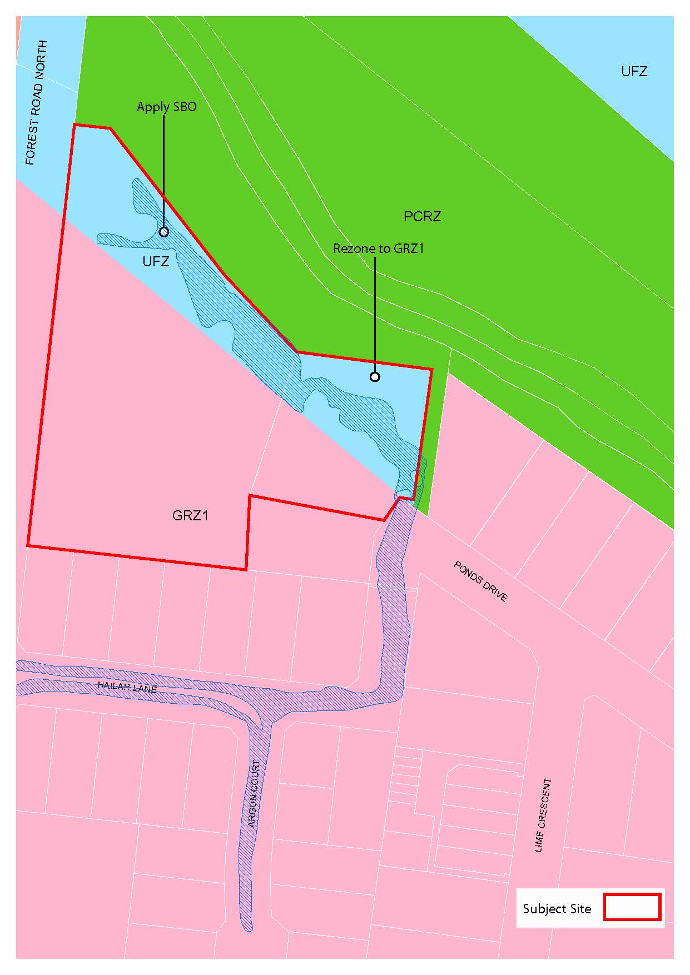
The Amendment is a combined planning permit application and planning scheme amendment under section 96A of the Act.
The planning permit application applies to 42 – 44 Ponds Drive Lara.

What the amendment does
The amendment proposes to rezone part of the properties at 42 - 44 Ponds Drive Lara and 60 Forest Road North, Lara from Urban Floodway Zone to General Residential Zone Schedule 1 and apply a Special Building Overlay to part of the land.
The Planning Permit Application seeks approval for a five lot subdivision and for the construction of 4 double storey dwellings at 42-44 Ponds Drive, Lara. The permit is also seeking to remove restriction on title (Lot 1 PS431989M and Lot 2 PS431989M).

Strategic assessment of the amendment

Why is the amendment required?
The Amendment is required to enable both properties to be more fully developed for residential purposes.
The Special Building Overlay (SBO) will ensure the development is compatible with any drainage constraints.

How does the amendment implement the objectives of planning in Victoria?
The Amendment implements the objectives of planning in Victoria, contained in Section 4 of the Planning and Environment Act 1987, in the following ways:
- Provides for the fair, orderly, economic and sustainable use and development of land as it facilitates a coordinated development in a strategically identified location and in a responsible manner through the implementation of appropriate zone and overlay controls.
- Provides for the protection of natural resources by introducing the Special Building Overlay which allows for planning intervention at the development process to maintain the passage of the floodwater and protect water quality.
- Secures and provides a pleasant and safe recreational environment for all Victorians and visitors to Lara.
- Seeks to balance the present and future interests of all Victorians by facilitating appropriate development and producing a high quality urban environment for existing and future residents.

How does the amendment address the environmental effects and any relevant social and economic effects?

Social:
The proposal is expected to deliver positive social effects for the area. The Amendment adds to the supply of developable residential land and promotes infill development within the Lara Township. The proposal will promote residential development within an existing residential area.

Economic:
The proposal will generate economic benefits through direct and indirect employment opportunities throughout the construction phase.

Environmental:
In order to ensure that all possible environmental and cultural impacts of the development have been addressed, specialist advice has been sought. Drainage and Cultural Heritage Management Plan (CHMP) reports accompany the application.

Does the amendment address relevant bushfire risk?
The land is not within a bushfire prone area and will not increase bushfire risk.

Does the amendment comply with the requirements of any Minister’s Direction applicable to the amendment?
The contents of Ministerial Direction No 11 Strategic Assessment Guidelines have been utilised in the preparation of this Explanatory Report.
The Amendment is consistent with the Ministerial Direction on the Form and Content of Planning Schemes under Section 7(5) of the Planning and Environment Act 1987.

How does the amendment support or implement the State Planning Policy Framework and any adopted State policy?
The amendment is consistent with the objectives of the State Planning Policy Framework (SPPF) and supports its implementation by:
Clause 11 Settlement
This clause states that ‘Planning is to anticipate and respond to the needs of existing and future communities through provision of zoned and serviced land for housing, employment, recreation and open space, commercial and community facilities and infrastructure’.
This clause also identifies planning is to recognise the need for, and as far as practicable contribute towards ‘diversity of choice’.
This clause also states that planning ‘is to facilitate sustainable development that takes full advantage of existing settlement patterns’.
Clause 11 includes reference to the G21 Regional Growth Plan.
Clause 11.07-1 provides an overarching objective to ‘optimise infrastructure and consolidate growth’. This clause includes the strategy to ‘support the growth of Bannockburn, Colac, Drysdale/ Clifton Springs, Lara, Leopold, Ocean Grove and Torquay/Jan Juc as district towns building on existing and planned infrastructure’.
Clause 11.07-6 provides an overarching objective to ‘allow communities to live, work and participate locally’. This clause includes the strategy to ‘facilitate infill development in Central Geelong and West Fyans and around activity areas within urban Geelong and district towns’.
The Amendment is consistent with the objectives and strategies of the G21 Regional Growth Plan.
Clause 13 Environmental Risks
This clause states that planning ‘should adopt a best practice environmental management and risk management approach which aims to avoid or minimise environmental degradation and hazards’. This clause also states that planning ‘should identify and manage the potential for the environment, and environmental changes, to impact upon the economic, environmental or social well-being of society’.
This Amendment demonstrates appropriate mitigation measures and responses to floodplain and drainage management by applying the Special Building Overlay (SBO).
Clause 14 Natural Resource Management
Clause 14.02 aims ‘to assist the protection and, where possible, restoration of catchments, waterways, water bodies, groundwater, and the marine environment’. This clause has an overarching strategy to ‘ensure land use and development proposals minimise nutrient contributions to waterways and water bodies and the potential for the development of algal blooms’ and ‘ensure planning is coordinated with the activities of catchment management authorities’.
This Amendment has been designed cognisant of the flood conditions and surrounding natural waterway.
Clause 15 Built Environment and Heritage
This clause states that planning ‘should ensure all new land use and development appropriately responds to its landscape, valued built form and cultural context, and protect places and sites with significant heritage, architectural, aesthetic, scientific and cultural value’.
A comprehensive Cultural Heritage Management Plan (CHMP) has been prepared which provides an agreed approach to developing the site in a manner that is acceptable to the Wathaurung Aboriginal Corporation including management measures and contingency plans.
This clause also relates to sub clause 15.01-5 which has an objective ‘to recognise and protect cultural identity, neighbourhood character and sense of place’.
This Amendment respects its cultural context and also existing character of the area.
Clause 16 Housing
This clause states that planning ‘should provide for housing diversity, and ensure the efficient provision of supporting infrastructure’ and ‘planning for housing should include providing land for affordable housing’. This clause also supports sub-clause 16.01-1 with an objective to ‘promote a housing market that meets the community needs’.
This Amendment will meet the community needs by providing infill housing lots and promote affordable housing options.
Clause 19 Infrastructure
The relevant sections of this clause relate to the objective in Clause 19.03-2 “to plan for the provision of water supply, sewerage and drainage services that efficiently and effectively meet State and community needs and protect the environment”. This Amendment will provide satisfactory infrastructure requirements to meet this objective.

How does the amendment support or implement the Local Planning Policy Framework, and specifically the Municipal Strategic Statement?
The Amendment is consistent with the Local Planning Policy Framework and supports its implementation by:
Clause 21.02- City of Greater Geelong Sustainable Growth Framework
This clause outlines a number of principles to ensure development is sustainable and meets the needs of the present community without compromising the ability of future generations to meet their own needs.
Clause 21.06- Settlement and Housing
Clause 21.06 discusses the importance of urban consolidation and providing settlement in areas that are well serviced and that have the capacity to accommodate sustainable development. The rezoning of the land from Urban Floodway Zones (UFZ) to General Residential Zone Schedule 1 (GRZ1) will assist in meeting urban consolidation objectives. Clause 21.06 also discusses the importance of development to respect neighbourhood character. The amendment will support the existing character of the urban area and provide consistency of zoning in the area.
Clause 21.13 - Lara
This clause outlines the importance of Lara to provide an adequate supply of residential land to meet the needs of the local and surrounding population. The Lara Structure Plan supports the rezoning of this land for residential purposes.

Does the amendment make proper use of the Victoria Planning Provisions?
The Amendment makes proper use of the Victoria Planning Provisions by using the most effective tools to achieve the strategic objectives, namely the application of the General Residential Zone Schedule 1 and Special Building Overlay. The amendment ensures the land is consistent with planning controls within the surrounding area.

How does the amendment address the views of any relevant agency?
All relevant agencies have been consulted in the preparation of the Amendment and conditions have been included on the permit as requested by the agencies.

Does the amendment address relevant requirements of the Transport Integration Act 2010?
No requirements of the Transport Integration Act are relevant to this amendment.

Resource and administrative costs

What impact will the new planning provisions have on the resource and administrative costs of the responsible authority?
The Amendment will have no impact on the resources and administrative costs of the responsibility authority.

Where you may inspect this Amendment
The amendment is available for public inspection, free of charge, during office hours at the following places:
Greater Geelong City Council, Customer Service Centre, Ground Floor, 100 Brougham Street. GEELONG – 8.00am to 5.00pm weekdays
‘Amendments’ section of the City’s website www.geelongaustralia.com.au/amendments/
The Amendment can also be inspected free of charge at the Department of Environment, Land, Water and Planning website at www.delwp.vic.gov.au/public-inspection .
Submissions
Any person who may be affected by the Amendment may make a submission to the planning authority.
Submissions about Amendment C356 should be received by Monday 13th March 2017 and addressed to:
The Coordinator
Strategic Implementation
City of Greater Geelong
- either by mail to: PO Box 104, GEELONG VIC 3220
- or by email to: strategicplanning@geelongcity.vic.gov.au
- or lodged online at: www.geelongaustralia.com.au/amendments/
- Further information
- For further information about Amendment C356 please contact the Strategic Implementation Unit at the City of Greater Geelong on (03) 5272 4820 or via email strategicplanning@geelongcity.vic.gov.au

Panel hearing dates
In accordance with clause 4(2) of Ministerial Direction No.15 the following panel hearing dates have been set for this amendment:
- directions hearing: week commencing 24 April 2017.
- panel hearing: week commencing 15 May 2017.

