GREATER GEELONG PLANNING SCHEME AMENDMENT C338 & PLANNING PERMIT 1418/2015

COMBINED REZONING AND SUBDIVISION PERMIT

SURPLUS BARWON WATER LAND
176-194 THORNHILL ROAD, HIGHTON

Submission to the Independent Panel

Panel: Brett Davis (Chair)
Date: 27 June 2017
Presented by: Peter Smith, Coordinator Strategic Implementation
Leanne Stockley, Town Planner
on behalf of City of Greater Geelong

Contents
INTRODUCTION 4
The amendment 4
The permit 4
The main issues 4
Summary of Council’s submission 4
SITE AND CONTEXT 6
Geelong and Highton context 6
Local Site context 7
Existing zoning 9
Existing Overlays 10
BACKGROUND 10
Chronology of events 11
Application and supporting documents 12
The proposed amendment 12
The proposed planning permit 12
CONSIDERATION OF THE PROPOSAL 15
Strategic Assessment 15
Which residential zone is the most appropriate? 15
Why is Design and Development Overlay ( DDO14) proposed? 17
Compliance with VC133 17
EXHIBITION AND SUBMISSIONS 18
Council resolution to prepare and exhibit an Amendment 18
Ministerial Authorisation 18
Exhibition 18
Submissions received 18
Council Delegate Resolution regarding the submissions 20
RESPONSE TO ISSUES RAISED IN SUBMISSIONS 21
Updates and revised Planning Permit 21
Layout and density of proposed subdivision and super lots 21
Potential for student housing 22
Removal of mature gum trees from the site 22
Traffic and car parking 23
Shared pathway connections 24
Noise and dust from removal of water storage basin and construction 24
Request to re-name section of Thornhill Road 24
EPA comments and conditions 25
Future sensitive uses in vicinity of high pressure gas pipeline 26
CONCLUSION 28
APPENDICES 29
Appendix 1 - Response to Strategic Assessment Guidelines 30
Appendix 2 – Authorisation for C338 from the Minister’s delegate 33
Appendix 3 – Revised Planning Permit (Post Exhibition Version 21-6-17) 35
Appendix 4 – Gas Pipeline Maps 54

INTRODUCTION
- This submission has been prepared by the Planning Authority, the City of Greater Geelong, and seeks the Panel’s support for Amendment C338 and Planning Permit 1418/2015.

The amendment
- The land subject to the amendment (“the subject land”) is 176 – 194 Thornhill Road, Highton. The site is owned by Barwon Water and has partly been identified as surplus.
- The proposal is to remove the water storage basin from the southern half of the land and rezone it from Public Use Zone 1 to General Residential Zone 1 with a Design and Development Overlay (DDO14). The northern basin is to be retained and this section of the site is not proposed for rezoning.

The permit
- The planning permit application seeks approval for: a staged multi-lot subdivision of the land and removal of native vegetation, and buildings and works for the construction of a public access path.

The main issues
- The main issues that have come out of objecting submissions from local residents include: the density of the subdivision and super lots; potential for student housing; removal of gum trees; traffic and car parking; shared pathway; noise and dust from the basin removal and street naming.
- The main issues raised in submissions from authorities include: pedestrian crossing of Thornhill Road; contaminated land assessments; pump station noise; decommissioning of the water basin and sensitive land uses near the gas pipeline.

Summary of Council’s submission
- The structure of this submission is to initially take the Panel through the site context, background and describe in more detail what is proposed. We will then move to the consideration of the proposal (including against the strategic assessment guidelines) and describe the formal exhibition process. The final part of our the submission is a response to the issues raised in submissions to the amendment and permit including an update on work that has been undertaken to address issues in the lead up to the Panel hearing.
- We submit that the rezoning of the site is strategically justified being located within the urban boundary of the Geelong Ring Road and warrants a zone that will allow residential development that can capitalise on the site’s location in an established residential area and close to schools, university, hospital and the Highton and Waurn Ponds activity centres.
- We support the permit application to subdivide the land into conventional lots and super lots that will have potential for development into medium density housing. We believe the revised set of permit conditions that will be tabled address the key issues raised by authorities and local residents.

SITE AND CONTEXT

Geelong and Highton context
- The subject land is located in Highton on the south-west edge of Geelong, approximately 8.1km street distance from the Geelong CBD, abutting the Geelong Ring Road to the west and south (see Figure 1). The land is elevated at approx. 80 metres above sea level with views towards the south west around to the north east.
- The land is in close proximity to major education and medical institutions including two campuses of Christian College secondary school, the Marcus Oldham Agricultural College, the Epworth Hospital and Deakin University. It is approximately 2.5km by road to the Highton Shopping Centre (a neighbourhood activity centre) and 2.7km to the Waurn Ponds Shopping Centre (a sub regional activity centre).
Figure 1 - Subject land in context of Geelong and Highton (with contours)

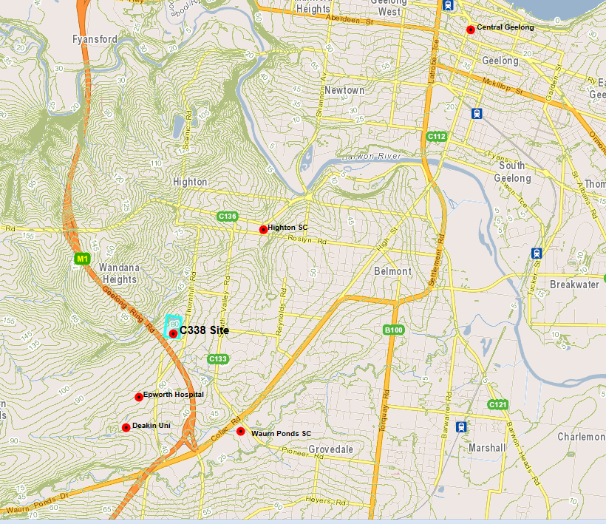

Local Site context
- The subject land contains a disused concrete water storage basin as shown in Figure 2 below and Figure 3 on next page. The western half of the site is an open grassed area with planted trees along access tracks to the second basin which is north of the subject land. The eastern part of the site contains the batter slopes of the eastern edge of the basin and underground water pipes and infrastructure.
- The land use to the east and south is residential, to the north is the second water basin and to the west is the pipe track, Geelong Ring Road and farmland. The land has a frontage to the east west portion of Thornhill Road with a row of trees planted just inside the site boundary fence.
- High voltage electricity transmission lines and a high pressure gas pipeline are close to the western edge of site in the Ring Road reserve and pipe track.
Figure 2 - Photo of disused basin
(Source: Ground Science Pty Ltd, GeoTech Report 2015)

Figure 3 - Aerial Photo of Subject Land
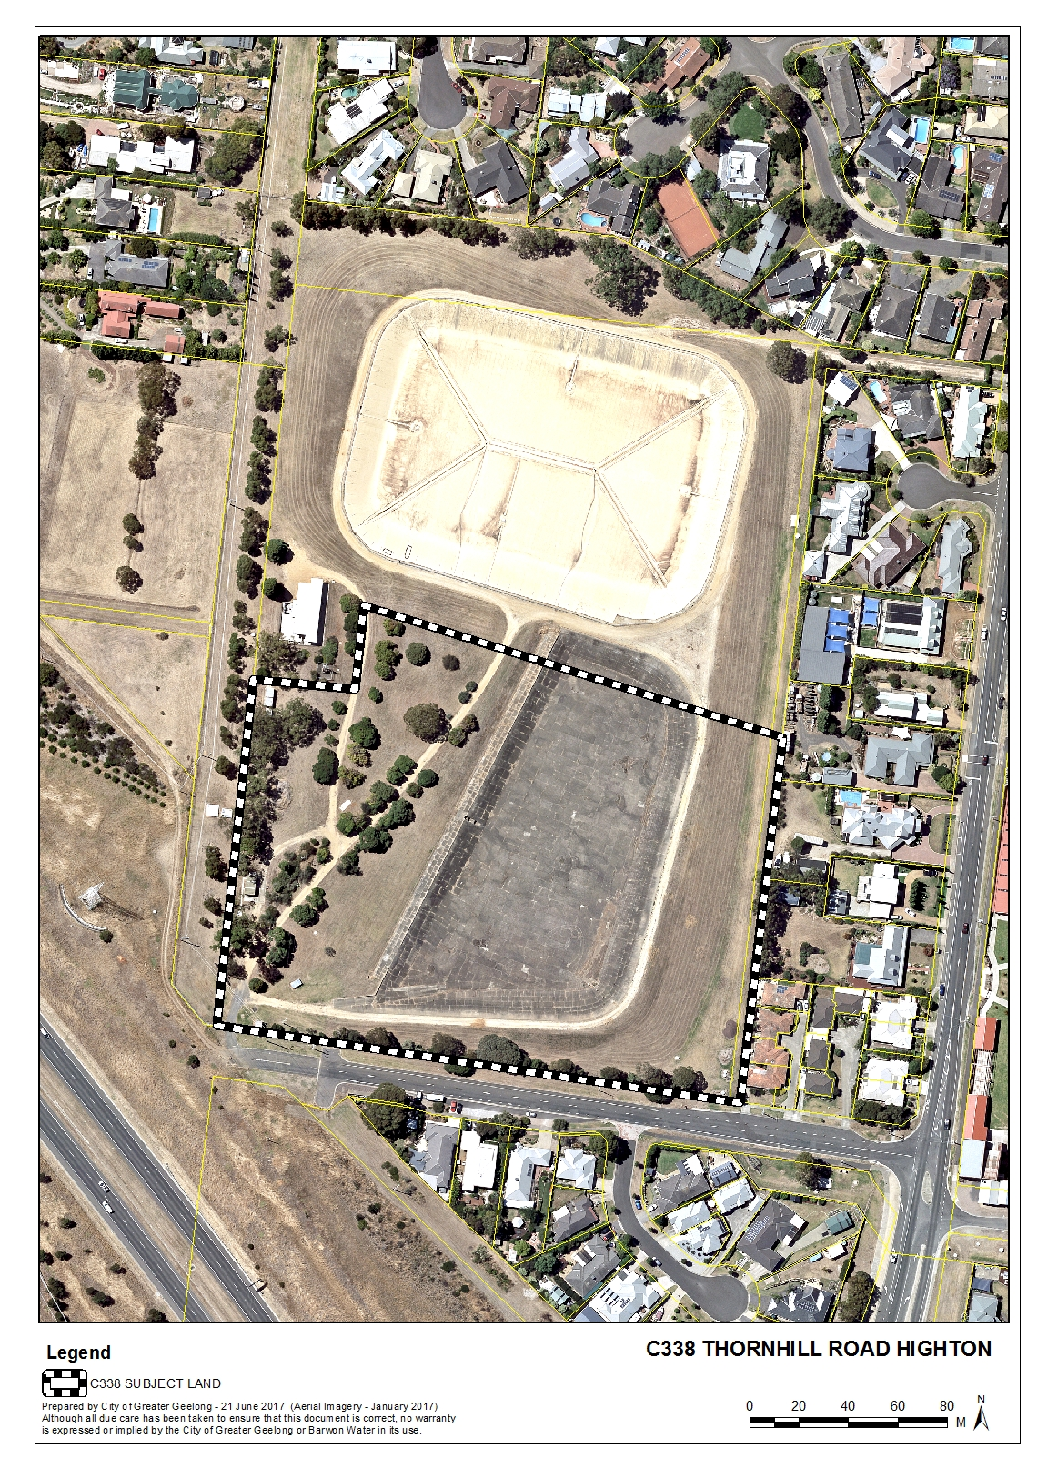

Existing zoning
- The zoning of the area is shown in Figure 4. The subject land is zoned Public Use Zone and the immediately surrounding land is zoned General Residential Zone and Road Zone.
Figure 4 - Existing Zoning
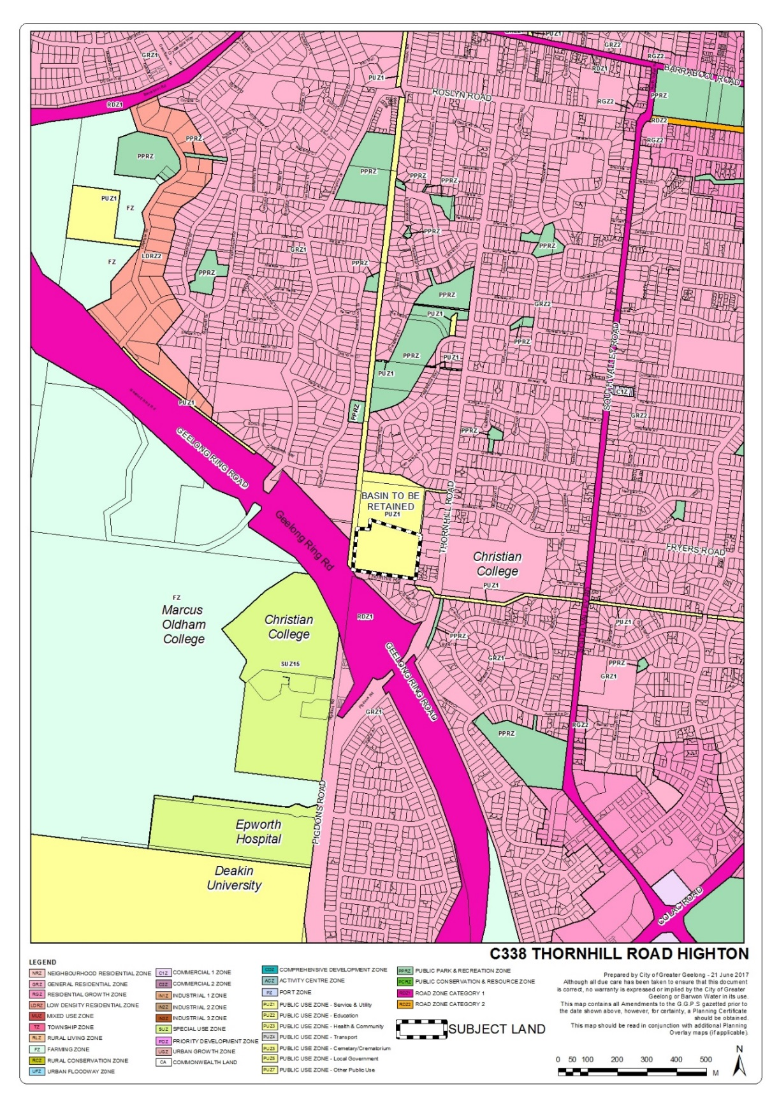

Existing Overlays
- The subject land is not affected by any overlays. Figure 5 below shows the existing overlays affecting the surrounding areas including the SBO, DDO14 and HO.
Figure 5 – Existing Overlays Map

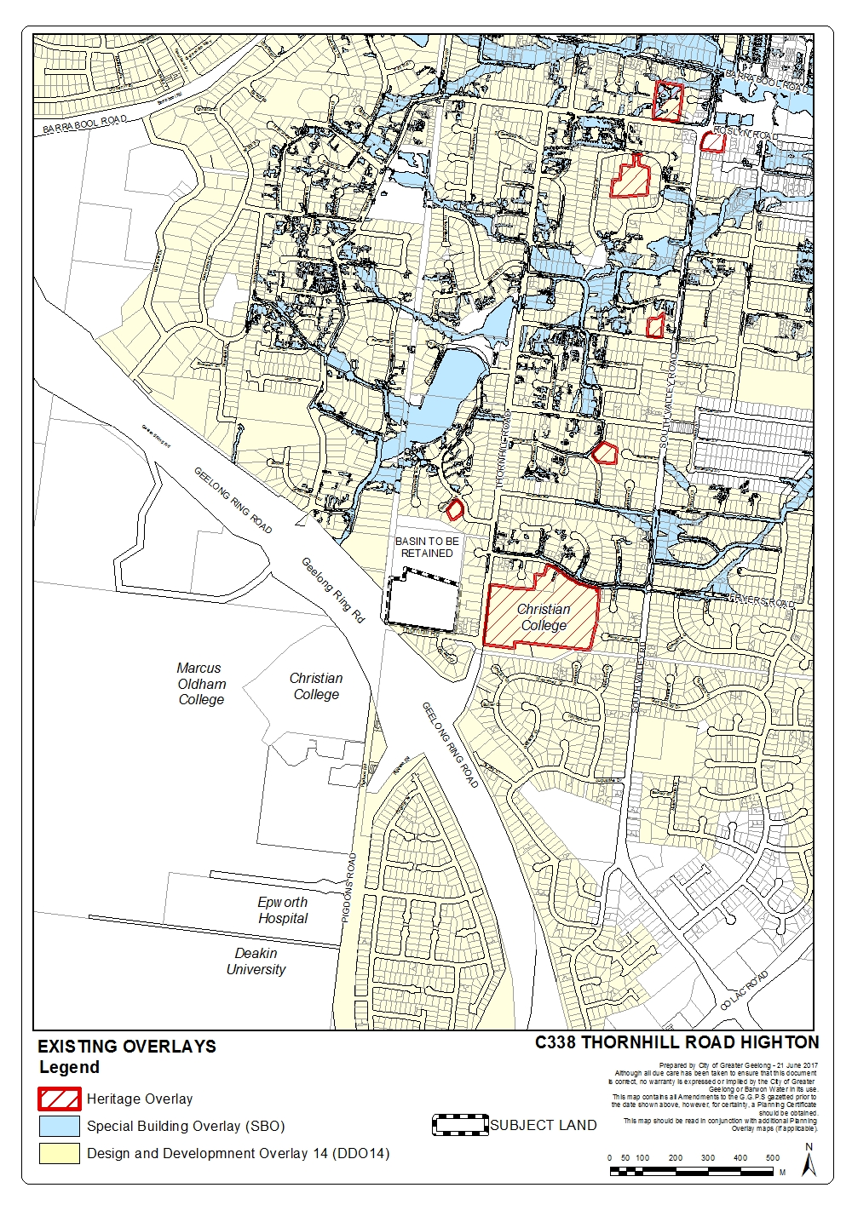
BACKGROUND

Chronology of events
- As requested in the Panel Directions, the following is a brief chronology of the key events relating to the rezoning and permit application for the site:
5 Aug 2015 – meeting on stormwater drainage - CoGG, Barwon Water and SMEC
19 Aug 2015 –pre-application meeting - CoGG, Barwon Water and SMEC
27 Oct 2015 - SMEC on behalf of Barwon Water submit a combined planning scheme amendment and planning permit application
27 Nov 2015 – CoGG seeks comments and draft planning permit conditions from internal and external agencies and departments
Dec 2015 – Mar 2016 – Comments received from CoGG officers / external agencies
8 April 2016 – CoGG request more details on stormwater drainage system
10 Aug 2016 – Meeting between CoGG, Barwon Water and SMEC to resolve drainage and open space issues
12 Oct 2016 – SMEC submits amended subdivision application plans and pipe track plan
Jan 2017 – SMEC submits final revised application, plans and technical reports submitted
10 Jan 2017 – Council’s delegate resolves to support preparation and exhibition of the amendment and permit and request Ministerial authorisation
12 Jan 2017 – Minister’s delegate authorises amendment preparation and exhibition
2 Mar to 3 Apr 2017 – Public Exhibition
5 May 2017 - Council’s delegate considers a report on submissions and resolves to refer submissions to a Panel
5 May 2017 - CoGG writes to Planning Panels Victoria and requests that a Panel be appointed
26 May 2017 – Panel issues timetable and directions
27 June 2017 - Panel hearing

Application and supporting documents
- In October 2015, SMEC consultants on behalf of Barwon Water submitted a combined planning scheme amendment and planning permit application for land at 176-194 Thornhill Road, Highton.
- The application was accompanied by a Planning Report with the following additional information and technical reports:
- Appendix A Certificate Of Title
- Appendix B Site Analysis Plan
- Appendix C Subdivision Concept Plan
- Appendix D Landscape Master Plan
- Appendix E Preliminary Transport Assessment
- Appendix F Ecology & Cultural Heritage Assessment
- Appendix G Tree Removal Plan
- Appendix H Geotechnical Investigation Report
- Appendix I Land Contamination Report 1
- Appendix J Stormwater Management Plan
- Appendix K Clause 56 Assessment

The proposed amendment
- The amendment seeks maps changes only to rezone the southern half of the land from PUZ1 to General Residential Zone 1 and apply the Design and Development Overlay (Schedule 14).

The proposed planning permit
- The Planning Permit Assessment Report prepared by Ms Stockley, the CoGG Town Planner dealing with the permit application describes the proposal as follows:
- “The application seeks approval to subdivide the land for residential development and remove native vegetation. In association with the subdivision, the applicant has undertaken to complete the construction of a pedestrian access path from the development site north to Roslyn Road, through the applicant’s land that contains underground water infrastructure, otherwise known as the Pipe Track.
- The subdivision will create 30 residential allotments, varying in size from 413sqm to 685sqm. Lot frontages vary from 12.5m through to 18m.
- In addition, the subdivision concept plan provides for two “super lots” which front Thornhill Road and have a combined area of 5100sqm. It is expected that the super lots will be the subject of further application to develop the land for multiple dwellings.
- The subdivision stormwater discharge will be serviced by a detention basin in the south east corner of the site, with land to the east boundary of the site to be retained as a reserve, encumbered by Barwon Water infrastructure.
- To the north-west corner of the subdivision area, a pumphouse building will be retained in the “balance” lot, which will also cater for the retention of the northern basin, for the continued used of Barwon Water, until such time as the infrastructure becomes surplus. At that time, it is expected that the northern basin will also be developed for residential land”.
- A copy of the exhibited subdivision concept plan is in Figure 6.

Figure 6 – Subdivision Concept Plan

CONSIDERATION OF THE PROPOSAL

Strategic Assessment
- Minister’s Direction No. 11 requires a planning authority to evaluate and discuss how an amendment addresses a number of strategic considerations. What should be considered as part of the Direction is explained in the DELWP Practice Note 46 (May 2017): “Strategic Assessment Guidelines for preparing and evaluating planning scheme amendments.” The exhibited Explanatory Report includes a Strategic Assessment and this is the basis for the response to the Strategic Assessment Guidelines provided in Appendix 1.

Which residential zone is the most appropriate?
- The residential area of Highton to the east of the subject land is zoned General Residential Zone - Schedule 2 (GRZ2) while to south and west the General Residential Zone – Schedule 1 (GRZ1) applies. The activity centres of Highton and Waurn Ponds are surrounded by Residential Growth Zone – Schedule 2 (RGZ2) within 400 metres walking distance of the activity centres. See Figure 7 below.

Figure 7 - Map of Residential Zones /Schedules in the area
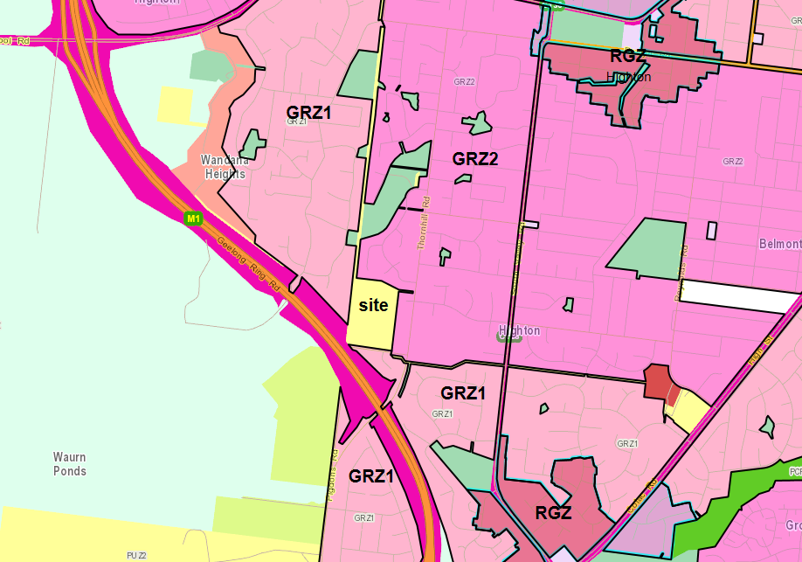

- Clause 21.06-3 Urban consolidation was updated in 2014 by amendment C300 which implemented the State Government’s new residential zones across Greater Geelong. It and a number of other planning scheme clauses provide guidance on which residential zones should be applied to meet Geelong’s housing objectives. Clause 21.06-3 reads as follows:
Objectives
- To provide for the consolidation of existing urban areas in a managed way.
- To encourage an appropriate range of development densities.
- To improve accessibility to urban services.
Strategies
- Manage urban consolidation and housing change across the municipality, by:
- Accommodating medium and high density housing in Key Development Areas (as defined by the maps included in this clause).
- Maximising opportunities for housing within Increased Housing Diversity Areas (as defined in Clause 22.63 Increased Housing Diversity Areas) by accommodating;
  - high density housing in the activity centres consistent with their primary commercial and retail role; and
  - medium density housing in residential areas with more intensive development being located closest to the core of activity centres.
- Supporting appropriate medium density housing in the General Residential Zone (Schedule 1) areas.
- Providing for incremental change in the General Residential Zone (Schedule 2) areas.
- Limiting change in the Neighbourhood Residential Zone areas.
- Encourage medium density housing in the Mixed Use Zone.
- Require retirement accommodation to be located within urban areas, preferably within close proximity to existing or proposed activity centres and public transport facilities.
- The GRZ2 schedule is titled “Incremental Change Areas” and seeks to limit the intensity of residential development through a 9 metre height limit and two variations to Clause 54 &55 (ResCode) being one canopy tree per dwelling and 60 sq metres of private open space.
- The GRZ1 schedule is titled “General Residential Area” and has no variations.
- The subject land is on the border between GRZ1 and GRZ2. Given it is a relatively large site and is generally free of any particular neighbourhood or garden character it is considered appropriate to rezone it to the less restrictive GRZ1. This is Council’s usual approach when rezoning larger infill sites or greenfield sites in the municipality. Another recent example is the former CSIRO site which is surrounded by GRZ2 but is proposed to be rezoned to GRZ1 (Amendment C251).
- The land doesn’t meet the criteria to be nominated as either a Key Development Area or Increased Housing Diversity Arta and be rezoned Residential Growth Zone.

Why is Design and Development Overlay ( DDO14) proposed?
- DDO14 triggers a planning permit for dwellings over 7.5 metres in height and has an objective: “To ensure that the siting, height and visual bulk of dwellings achieves a reasonable sharing of views between properties to significant landscape features such as the coast (ocean and foreshore), Corio Bay, Barwon River, Central Geelong, Barrabool Hills and the You Yangs.” Given the elevated nature of the subject land and the surrounding residential areas being subject to DDO14 it is considered appropriate to apply the overlay.

Compliance with VC133
- The Panel directed that Council address how the amendment complies with VC133 on the form and content of planning schemes. The Explanatory Report for VC133 has been reviewed and as C338 is only a map amendment there do not appear to be any implications arising from VC133.

EXHIBITION AND SUBMISSIONS

Council resolution to prepare and exhibit an Amendment
- On 10 January 2016 Council’s delegate (Peter Bettess -Director Planning and Development) considered a report on the proposal and made the following decision:
That Council, under delegation, resolves to:
- Support the preparation and exhibition of Amendment C338 to the Greater Geelong Planning Scheme to:
- Rezone the southern part of 176-194 Thornhill Road, Highton (the subject land) from Public Use Zone Schedule 1 to General Residential Zone Schedule 1
- Apply Design and Development Overlay Schedule 14 to the subject land
- Consider and exhibit a draft Planning Permit 1418/2015 for a 32 lot subdivision of the subject land and removal of native vegetation concurrently with the Amendment in accordance with the Section 96A of the Planning and Environment Act.
- Request the Minister for Planning to authorise the preparation and exhibition of Amendment C338 and Planning Permit Application 1418/2015.

Ministerial Authorisation
- The Minister’s delegate authorised the amendment preparation and exhibition on 12 January 2017 – see Appendix 2.

Exhibition
- The amendment and permit were exhibited from 2 March 2017 to 3 April 2017.
- Letters and an information sheet were mailed to 168 owners and occupiers of properties next to the rezoning site and the pipe track which is proposed for a shared pathway. Letters were also sent to relevant government and service authorities and prescribe Ministers.
- Notices were published in the Independent Newspaper on 24 February 2017, the Geelong Advertiser on 25 February 2017 and the Government Gazette on 2 March 2017.

Submissions received
- As a result of public exhibition of the proposal a total of 17 submissions were received. Of these 2 submissions were in support, 7 submissions objected and 8 submissions provided comment or no objection. One submission included a petition signed by 10 people concerned at student housing and loss of gum trees.
- The map in Figure 8 shows the location of submitters in the vicinity of the subject land.
Figure 8 - Map showing location of submitters
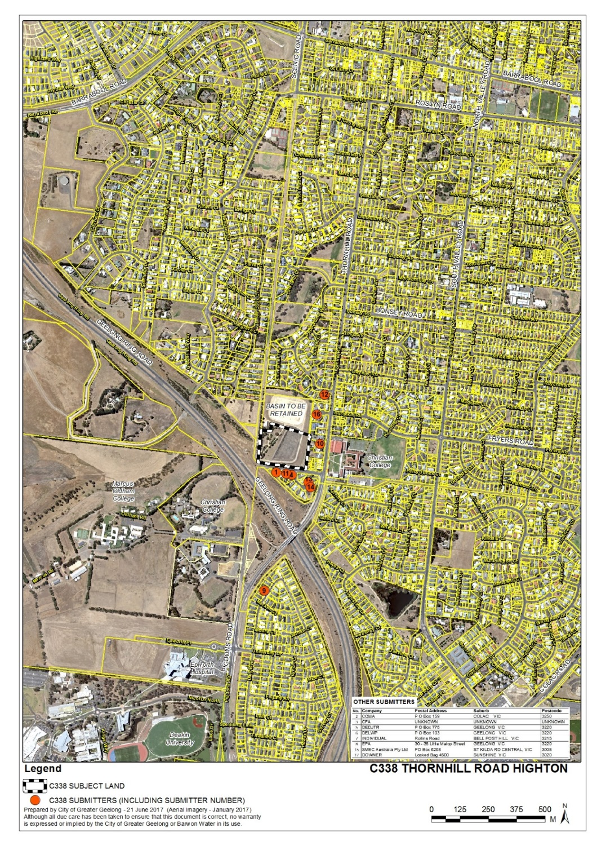

Council Delegate Resolution regarding the submissions
- On 5 May 2017 Council’s delegate considered a report on the submissions and made the following decision:
That Council having considered all submissions to Amendment C338 resolves to:
1) Request the Minister for Planning to appoint an Independent Panel under Part 5 of the Planning and Environment Act 1987 to consider submissions relating to the amendment;
2) Refer all submissions to a Panel; and
3) Submit to the Panel its response to the submissions as outlined in this report.

RESPONSE TO ISSUES RAISED IN SUBMISSIONS

Updates and revised Planning Permit
- A revised planning permit has been prepared and generally agreed upon by SMEC / Barwon Water. The revised permit is in Appendix 3 and will be referred to during the course of this next part of our submission.
- The following response to the issues raised is taken from the Council delegate report of 5 May 2017. Updates and a description of further action taken in the lead up to the panel hearing are shown in blue text.

Layout and density of proposed subdivision and super lots
What is the issue?
- Two submitters raised concerns at the small size of lots in the subdivision and higher density housing not being in keeping with the neighbourhood character. Concerns have also been raised about future development of the super lots with a submitter concerned that investors could rent out units causing cars to be parked in Thornhill Rd and if 2-3 storey units were built they would overlook her garden. A question is asked if the super lots could be placed at back of subdivision?
Council officer response
- The area surrounding the proposed subdivision site does include some larger lots particularly on the main north-south section of Thornhill Road. However, there is also a unit development south east of the site and smaller lots to the south in the Conway Court area. As such it is considered the subdivision is not at odds with neighbourhood character and will provide a greater diversity of lot sizes which is encouraged by various state and local planning policies.
- The two super lots on Thornhill Road are considered to be well located. Further planning permits will generally be required if the super lots are to be developed for multiple dwellings (e.g. apartment or townhouses) or other non-residential uses permitted in the residential zone (except limited “as of right uses”). The DDO14 will also trigger a planning permit for any building over 7.5 metres in height.
- This means that the nearby residents will most likely have an opportunity to consider future plans for development of these sites as part of future planning permit applications.

Potential for student housing
What is the issue?
- A number of submitters are concerned that either the super lots could be developed for student housing or students could rent out houses in the new subdivision. Concerns relate to potential social issues, traffic and parking problems.
Council officer response
- The planning permit application being considered as part of this proposal is to subdivide land and does not seek permission for student accommodation. If a purpose built facility was proposed in the future for student accommodation it would most likely be categorised as group accommodation or a residential building and would require a planning permit. Issues around traffic and parking could be further considered in response to a specific proposal.
- Students are entitled to buy or rent out houses built in the proposed subdivision and the planning system does not discriminate against this. It would only be if the houses contained excessive numbers of rooms or were turned into boarding houses that there may be a need for further approval. Car parking and traffic issues that may arise would be managed by Council as with any other residential area.

Removal of mature gum trees from the site
What is the issue?
- Submitters are concerned at the loss of mature trees from the site as a result of the development.
Council officer response
- The planning permit seeks removal of trees from the site. Given the large amount of earthworks and construction activity and the location of trees close to the boundary it would be difficult to retain many of the exiting trees. However, Council officers will ask the applicant to further consider if this is possible.
- We sought comment on retention of the trees from SMEC (for Barwon Water) who advised “we would prefer to continue with the current proposal – i.e. removal of all trees along Thornhill Road. As outlined in the supporting reports, they are planted and no planning permit is required for their removal. In terms of aesthetic value, as part of the Thornhill Road upgrade we will be planting a significant amount of street trees, as well as street trees internal to the site and any future landscaping of the MD super lots. This will provide amenity benefits for the adjoining neighbours in terms of streetscape aesthetics”.
- Council officers agree that proposed landscaping and street tree planting will help offset the loss of mature trees and eventually soften the impact of the re-development of the site.

Traffic and car parking
What is the issue?
- Submitters have raised concerns about traffic congestion (particularly at school pick up times), additional traffic problems caused by 32 lots plus 2 medium density sites, traffic at junction of Thornhill/Pigdon roads and the impact on Conway Court residents due to volumes of traffic that will be generated in Thornhill Road.
- There are also some parking concerns with a submitter commenting that Thornhill Road (east west portion) is already congested particularly during peak school times, Christian College students parking along the section of road and potential student accommodation or medium density housing on the super lots adding to on street parking problems.
Council officer response
- A preliminary transport assessment prepared by SMEC Urban (Oct 2015) was submitted with the rezoning and permit application. The assessment found:
“the development generated traffic will not impact on the operation of the existing unsignalised intersection of Thornhill Road / Augustine Rd (i.e. east-west section of Thornhill Rd) as the additional traffic is negligible compared to the capacity of the intersection” (SMEC 2015 p.20.)
- Council’s traffic engineer reviewed the report and found that the 32 lot subdivision will generate 200 – 350 vehicle trips per day, which can be absorbed into the local road network.
- With regards to parking, Council’s traffic engineer recommends some indented parking bays be provided on the north side of Thornhill Rd, as the existing bicycle lane is not wide enough to be converted to a parking lane. This can be incorporated into Condition 12 of the planning permit which requires upgrading of Thornhill Road across the full frontage of the site including footpath, kerb and channel, road pavement construction, lighting etc.
- Condition 12 of the planning permit has been revised to include a requirement for indented parking.
- This additional on-street parking may help alleviate the parking issues of concern to the submitters.

Shared pathway connections
What is the issue?
- A submitter suggests a shared user path should go via a new overpass over the Geelong Ring Road linking the educational and health establishments (Epworth, Deakin, Christian College Senior Campus).
Council officer response
- There is already a pathway along the northern edge of Thornhill Road/Pigdons Road including where the road crosses the Geelong Ring Road, hence another overpass is not required.

Noise and dust from removal of water storage basin and construction
What is the issue?
- Residents are concerned about the impact on them and their properties from the removal of the basin and construction of the subdivision. Concerns include dust and wind blown soil, noise and vibrations.
Council officer response
- The planning permit includes a Construction Environment Management Plan to be prepared and approved prior to any works commencing. This condition can be tightened to include specific reference to the demolition and removal of the water basin.
- “Associated Works” has been included in the permit preamble to cover earth works required to remove the basin and prepare land for subdivision. Condition 5 has been amended to include reference to the works to remove the water basin, in response to submissions.

Request to re-name section of Thornhill Road
What is the issue?
- Submitters raise concern at confusion caused by the east west section of road being called Thornhill Road alongside the main north south road.
Council officer response
- Council officers believe the road should be re-named and will investigate how this can be done in conjunction with the subdivision.
- The SMEC Traffic Assessment calls the east-west section of road Augustines Road and includes the following note:
“NOTE: There is a discrepancy in the road naming of the east-west road that abuts the southern boundary of the subject land. This road is called “Augustines Road” by Google Maps and Open Street Map, which are the main map references used by the SMEC Traffic and Transport Team. It is understood that Land Victoria and Planning Maps Online call this same stretch of road “Thornhill Road”. It is further noted that individual properties are addressed to Thornhill Road within this stretch of road. Notwithstanding these observations, please note that this Traffic Assessment report refers to this road as “Augustine’s Road” throughout this report because of the map references used by Google and Open Street Map.”
- Augustines Road may not be the best name for this section of road as it could be confused with Augustine Drive in another part of Highton.
- A new Condition 7(f) has been included to require an “Indicative street naming layout plan” as part of the construction plans that are to be submitted prior to the commencement of works on the subdivision.
Pedestrian refuge crossing on Thornhill Road
What is the issue?
- The submission from the Department of Economic Development, Jobs, Transport and Resources (DEDJTR) recommends a pedestrian refuge crossing on Thornhill Rd on north side of Augustine Dve to connect from proposed shared path to existing path and Christian College to the development.
Council officer response
- Council officers believe a formalised crossing of Thornhill Road may have merit. A possible site could be the existing splitter island just south of the intersection. Council officers will discuss this further with the applicant and DEDJTR prior to a Panel hearing and may include an additional permit condition.
- This matter was discussed between CoGG, DEDJTR and SMEC and a new condition 7 (g) has been included to require a new pedestrian crossing point and refuge south of the intersection.

EPA comments and conditions
What is the issue?
- The EPA makes a number of comments and suggestions on issues including contaminated land assessments, pump station noise and decommissioning of the water storage basin. These issues are as documented in Appendix 4.

Council officer response
- In relation to the level of assessment required on soil contamination, Council officers believe sufficient investigation has been undertaken to satisfy Ministerial Direction No.1 and the Practice Note. The Preliminary Site Investigation (by Environmental Site Assessments, reference ESA/179/2015) has been provided in support of the application and concludes the site should be suitable for a residential (sensitive) reuse.
- The suggested additional permit conditions from the EPA will be further reviewed in the lead up to a Panel hearing.
- In relation to pump station noise a new Condition 63 has been included 63. “Noise from the pump station must not exceed the recommended levels as set out in Noise from Industry in Regional Victoria (NIRV; EPA Publication 1411, 2011).”
- The other EPA recommended conditions have been included as conditions 81-84.

Future sensitive uses in vicinity of high pressure gas pipeline
What is the issue?
- A submission by Downer for AusNet Services refers to a gas transmission pipeline (Pipeline Licence 99) that traverses along the western boundary of the site.
- The submission offers no objection to the proposed rezoning as per C338 and consequent subdivision as per PP 1418-2015, provided a number of conditions are met to AusNet Services' satisfaction.
Council officer response
- The recommended conditions are already part of the exhibited planning permit. However, upon closer review it is considered that one of the conditions may be difficult to achieve as it controls future land use rather than relating to subdivision.
- The condition reads as follows:
“The development or the usage of the land, which may result in T2 (High Density) or S (Sensitive) Location Class as per AS 2885.1 (such as Aged Care, hospitals, child care, school, commercial centres or areas of congregation) shall not be permitted within the measurement length of Pipeline Licence 99, unless a Safety Management Study as per the requirements of AS 2885.1-2012 and in conjunction with AusNet Services is carried out by the applicant to identify and mitigate the threats to the pipeline”
- Council officers intend to achieve this condition through a Section 173 Agreement over the site and will re-draft the permit conditions accordingly.
- Maps of the gas transmission pipeline are provided in Appendix 4.
- Condition 80 has been included to require a Section 173 Agreement to cover the issues raised by Downer for Ausnet Services in relation to the pipeline.

CONCLUSION
- We submit the amendment and subdivision permit will have an overall net community benefit by rezoning a surplus and disused government site for residential infill development. It is considered to be a strategically located site in proximity to a range of services and employment opportunities. We believe we have demonstrated that the impacts on adjoining residents can be appropriately managed by the proposed permit conditions and on this basis we respectfully seek the Panel’s support for the proposal.

APPENDICES

Appendix 1 - Response to Strategic Assessment Guidelines

Why is the Amendment required?
Barwon Water has completed an extensive review of its property assets and has identified the subject land as surplus and wishes to sell it for private use and development. The land is currently within the Public Use Zone 1 (PUZ1), Service and Utility, and the appropriate underlying zones and overlays need to be applied to before sale.
How does the Amendment implement the objectives of planning in Victoria?
Section 4 of the Act sets out the objectives of planning in Victoria. Those that are directly related to this Amendment are:
- To provide for the fair, orderly, economic and sustainable use and development of land.
- To secure a pleasant, efficient and safe working, living and recreational environment for all Victorians and visitors to Victoria.
- To protect public utilities and other assets and enable the orderly provision and coordination of public utilities and other facilities for the benefit of the community.
- To facilitate development in accordance with the objectives set out in the points above.
- To balance the present and future interests of all Victorians.”
How does the Amendment address any environmental, social and economic effects?
An assessment of the site’s ecological and Aboriginal cultural heritage identified minimal areas of significance. High levels of land modification have occurred through the construction of the basins on site, likely destroying any Aboriginal archaeological deposits which may have been present.
Areas of remnant native vegetation across the entire subject site are limited to small fragmented patches of the Grassy Woodland Ecological Vegetation Class (0.391ha in total). An impact assessment of the development on the identified EVC has been undertaken and identifies biodiversity offsets which will need to be contributed.
Noise from the nearby Geelong Ring Road has been assessed by acoustic experts and reviewed by Vic Roads. It has been determined that noise levels are just under those which would require the installation of noise walls.
Does the Amendment address relevant bushfire risk?
The western portion of the site (being a strip of land approximately 35 metres wide) is identified as a Bushfire Prone Area in the State wide mapping. This means any building permits for dwellings would need to ensure appropriate BAL ratings. However, the land is not subject to a Bushfire Management Overlay and the Geelong Ring Road should act as a fire break for any grassland fires that may occur on the farmland further west. The CFA provided initial comments to the effect that the site constitutes a low bushfire hazard but has requested conditions be placed on the permit requiring fire hydrants.
Does the Amendment comply with the requirements of any Minister’s Direction applicable to the amendment?
The amendment complies with applicable Minister’s Directions. The amendment is consistent with the Minister’s Direction on the Form and Content of Planning Schemes under section 7(5) of the Act, which directs that planning schemes may only include land in a Public Use Zone if the land is Crown land, or is owned by, vested in or controlled by a Minister, government department, public authority or municipal council. As the land will be released/on sold by Barwon Water, it is appropriate to remove the PUZ from the land.
Potentially contaminated land has been considered in accordance with Ministerial Direction No.1 and the General Practice Note on Potentially Contaminated Land (June 2005). A Land Contamination Investigation of the site by Environmental Site Assessments identified that the land is suitable for residential development and other sensitive land uses.
How does the Amendment support or implement the State Planning Policy Framework and any adopted State policy?
The amendment implements Clause 11.07 Geelong (G21) Regional Growth Plan by enabling the land to be used and developed consistent with established planning for the surrounding area. The amendment supports:
- Clause 11.02 Urban Growth, by ensuring a sufficient supply of land is available for residential uses.
- Clause 11.04-2 Housing Choice and Affordability, by providing a diversity of housing in defined locations that cater for different households and areas close to jobs and services.
- Clause 14.02-3 Water Conservation, by ensuring that water resources are managed in a sustainable way.
- Clause 16.01 Housing, by providing additional residential land for infill development.
How does the Amendment support or implement the Local Planning Policy Framework, and specifically the Municipal Strategic Statement?
The amendment supports:
- Clauses 21.06-2 Urban Growth, by limiting urban sprawl and maintaining land supply.
- Clause 21.06-3 Urban Consolidation, by providing for the consolidation of existing urban areas, encouraging a range of densities and accessibility to urban services.
Does the Amendment make proper use of the Victoria Planning Provisions?
The amendment makes proper use of the Victoria Planning Provisions, applying relevant zones and overlays consistent with the surrounding land. The retention of remaining Barwon Water land within the Public Use Zone 1 is also consistent with Planning Practice Note No.2 – Public Land Zones.
The amendment has regard to the newly introduced Fast Track Government Land (FTGL) Service, which seeks to facilitate the orderly management of government or publically owned land. No other government authorities have expressed interest in acquiring this land, therefore it is appropriate to rezone and sell the surplus land.

Appendix 2 – Authorisation for C338 from the Minister’s delegate

Appendix 3 – Revised Planning Permit (Post Exhibition Version 21-6-17)

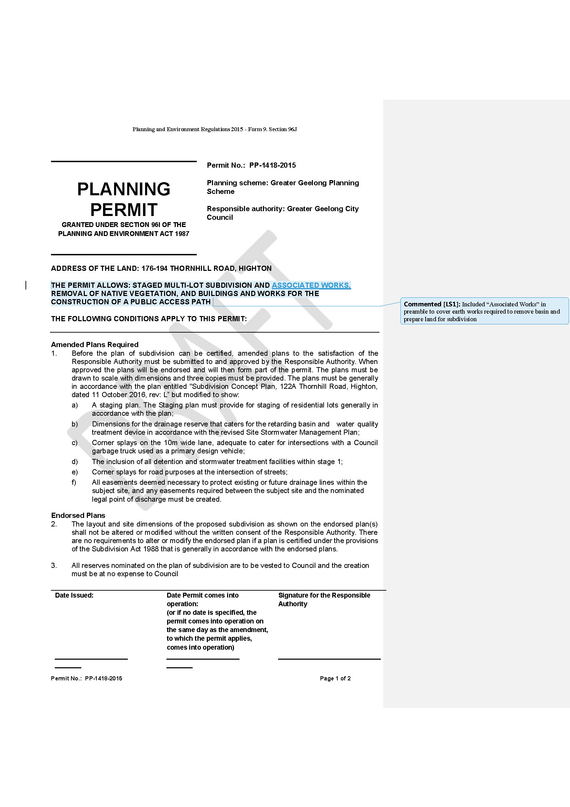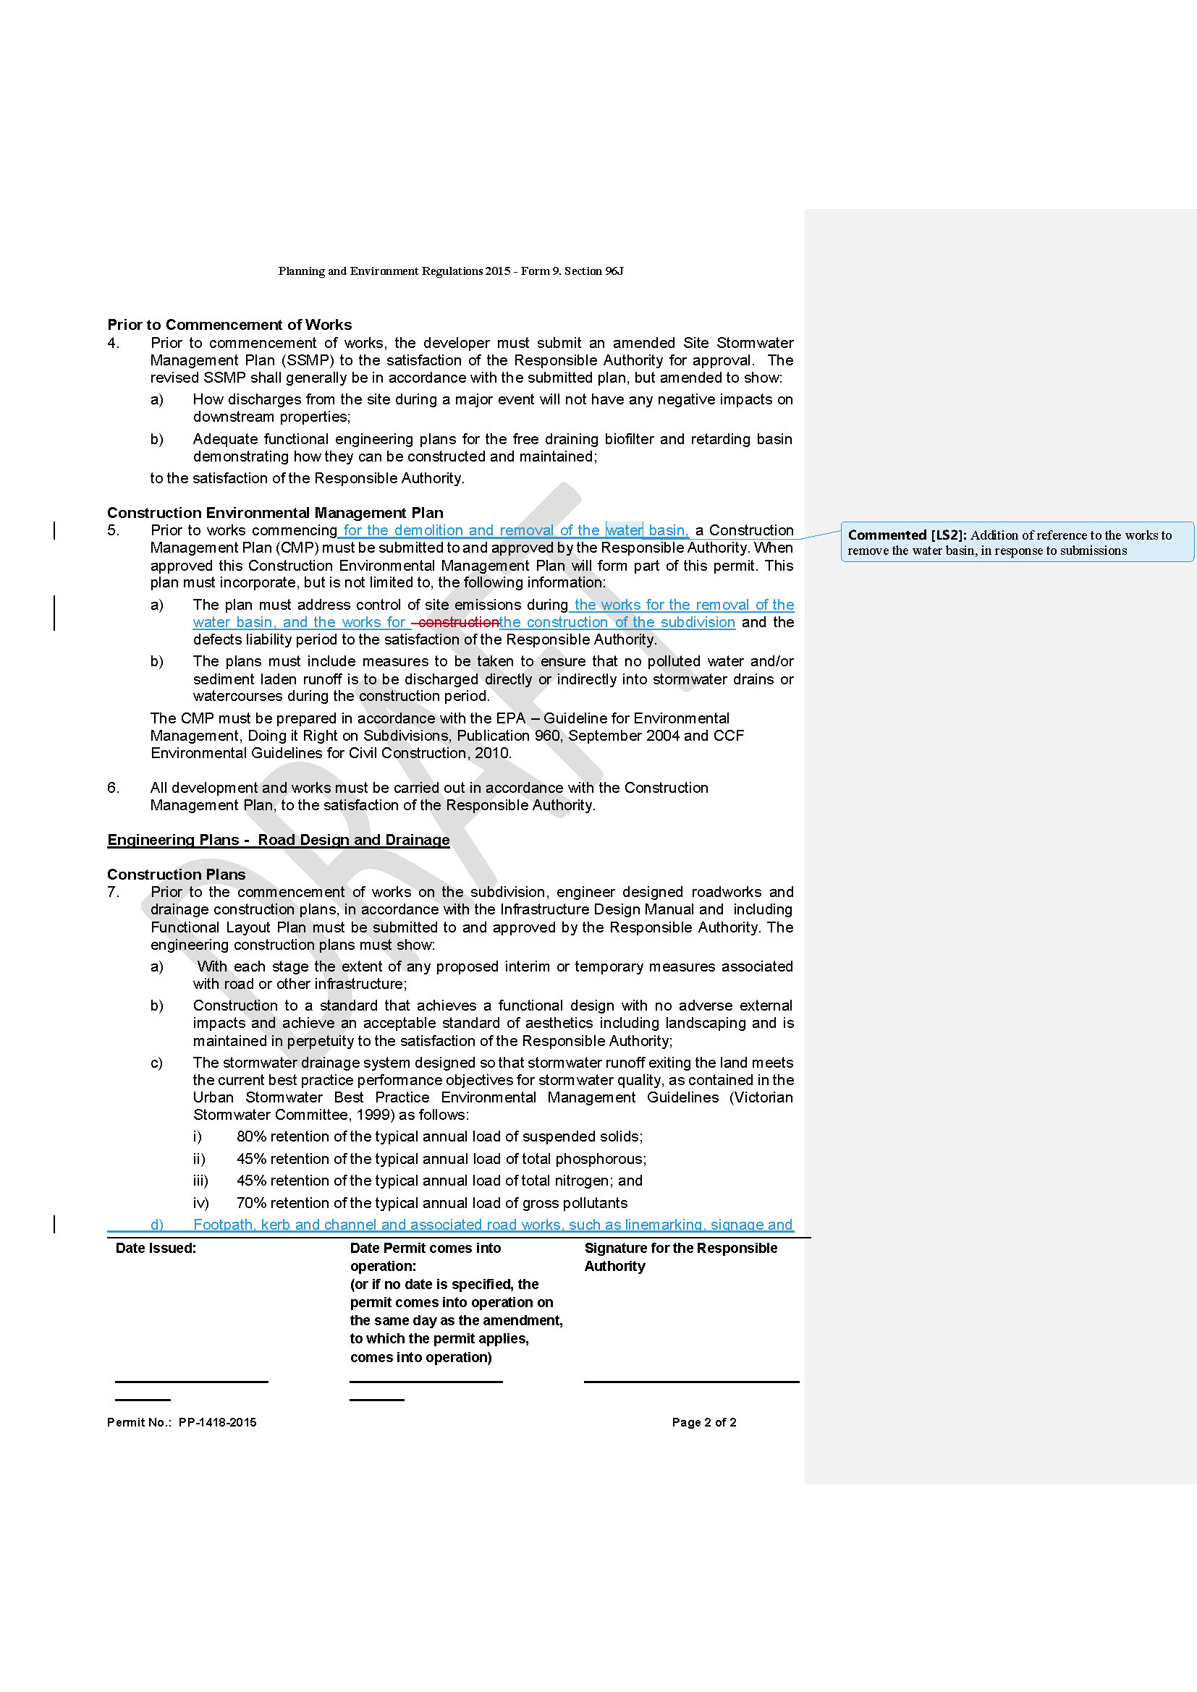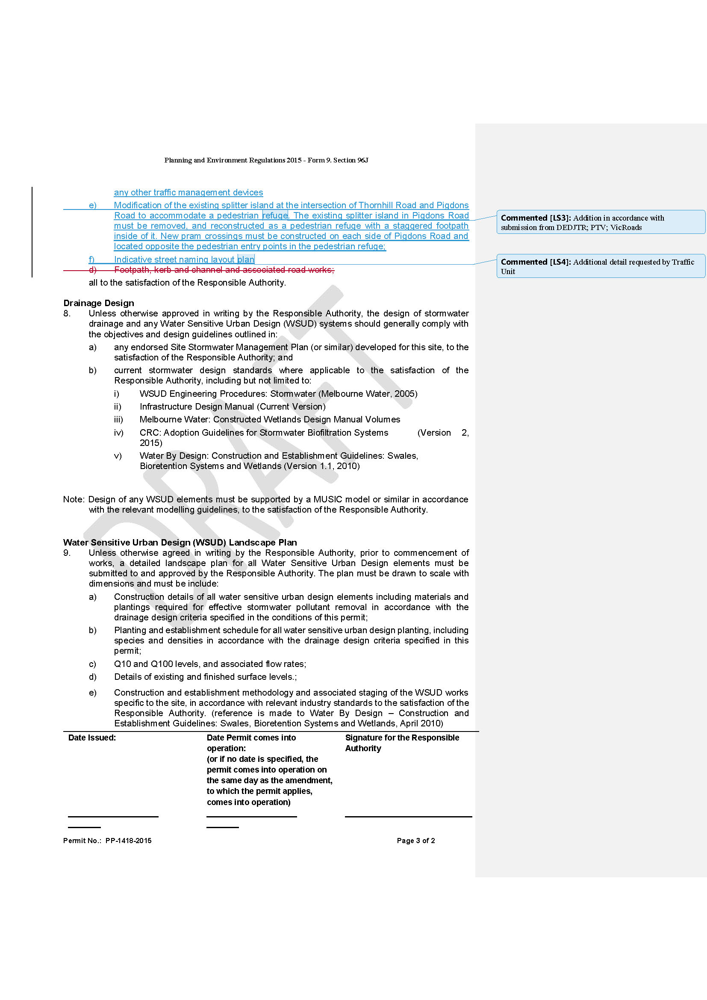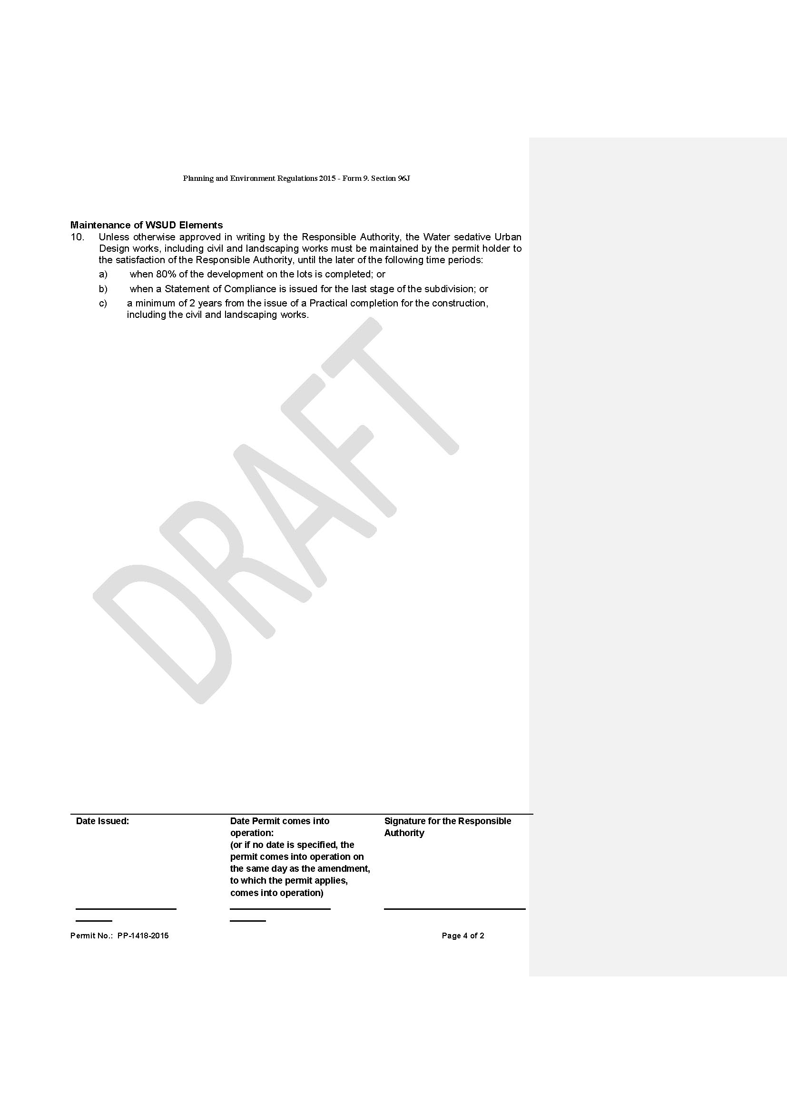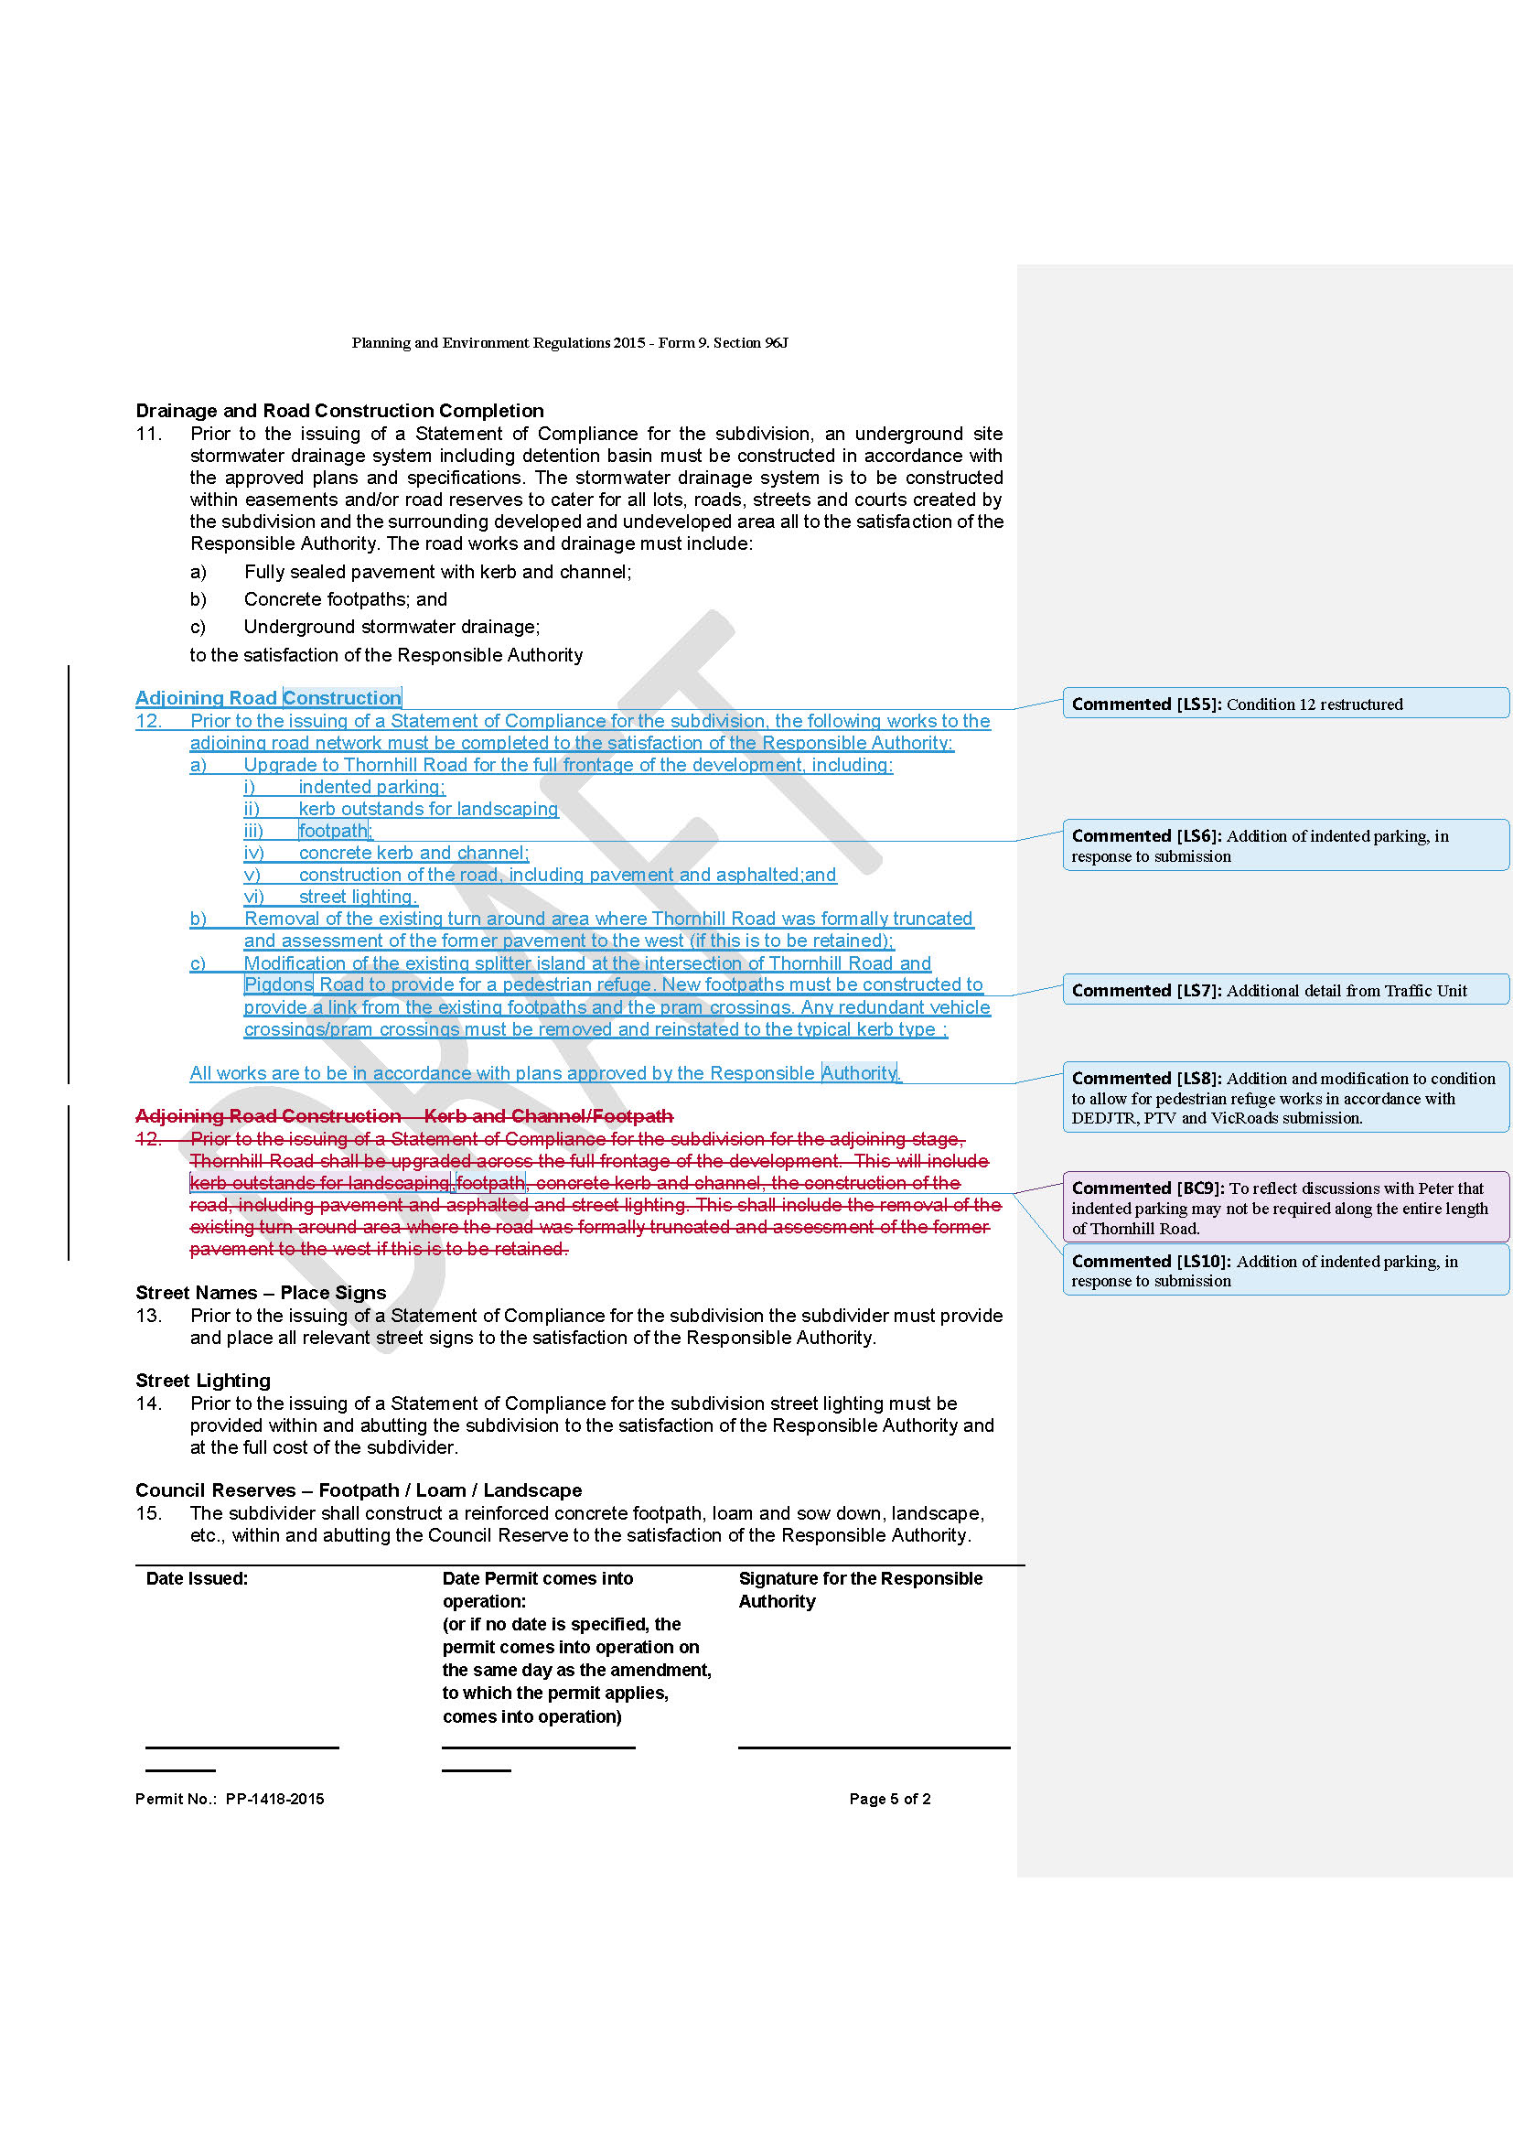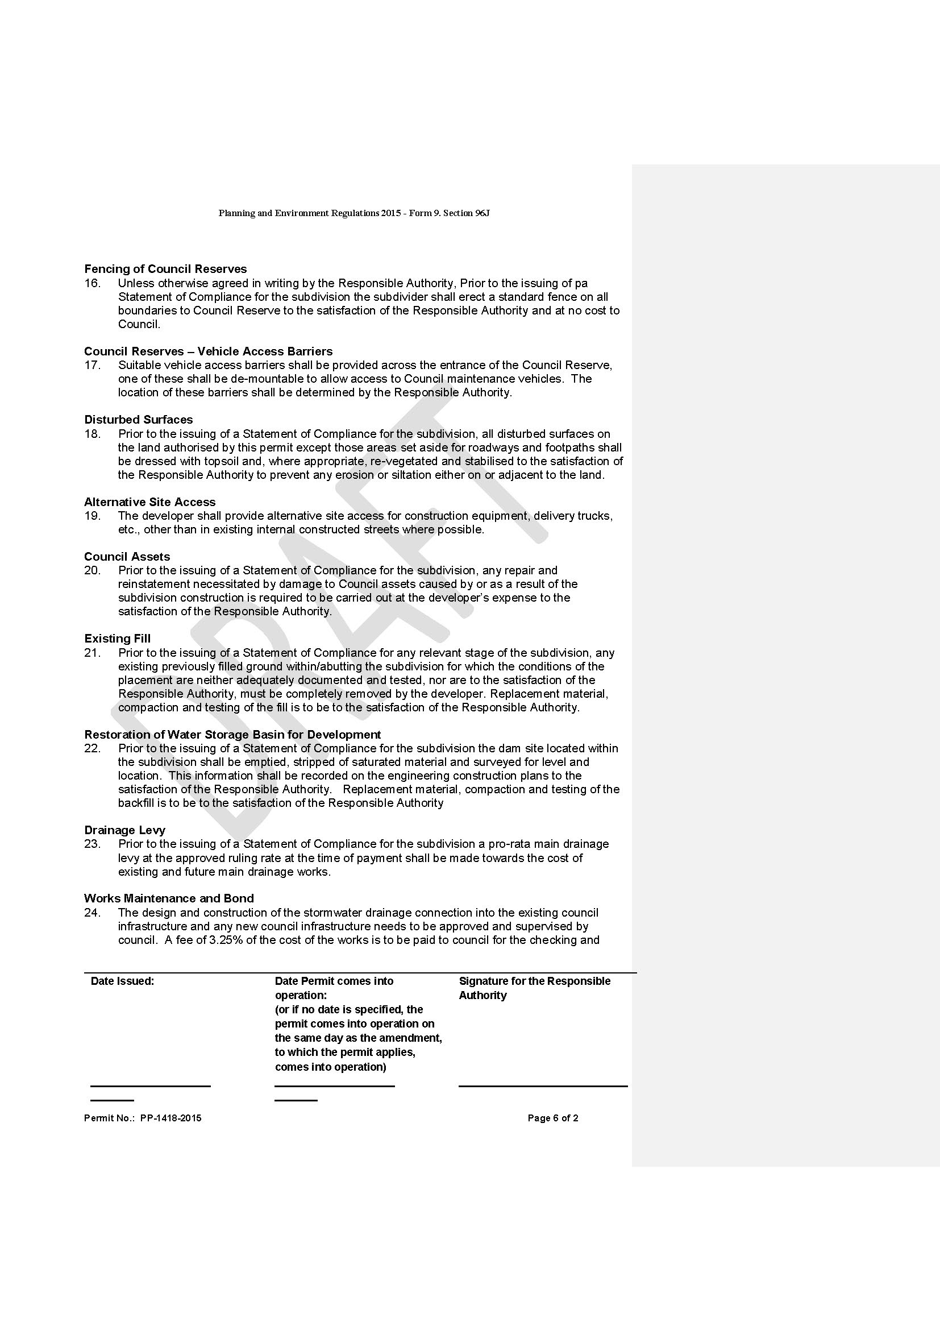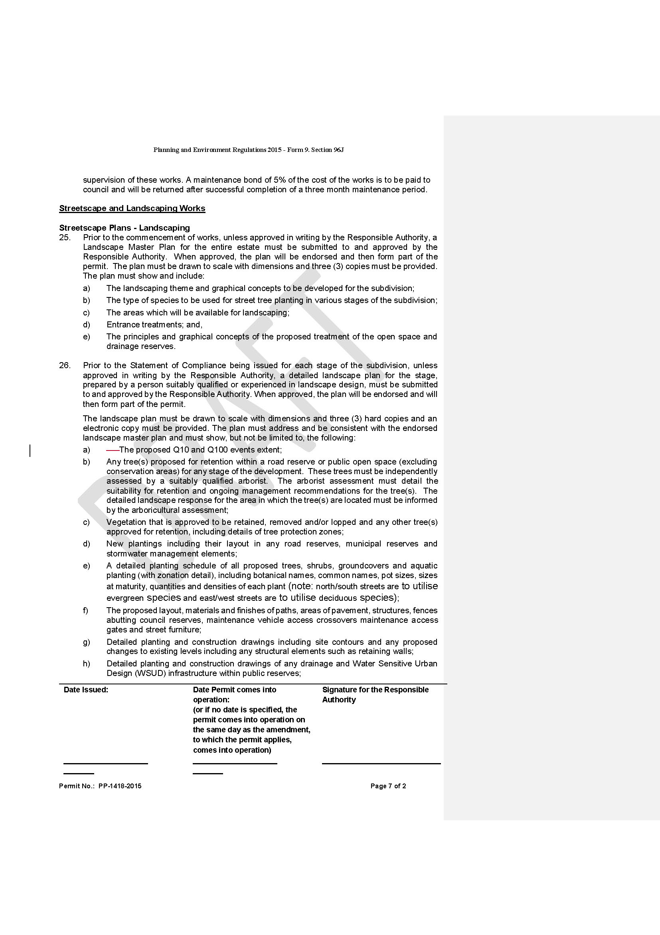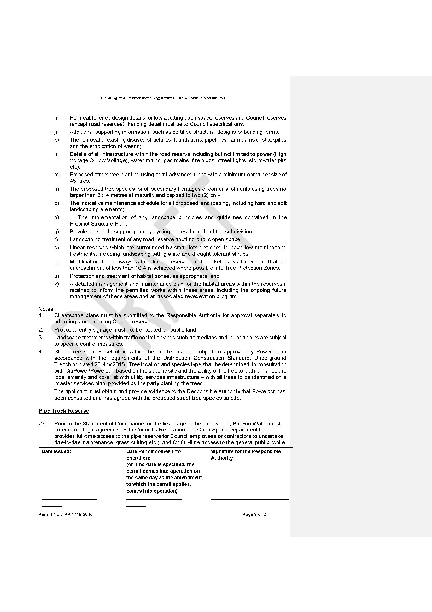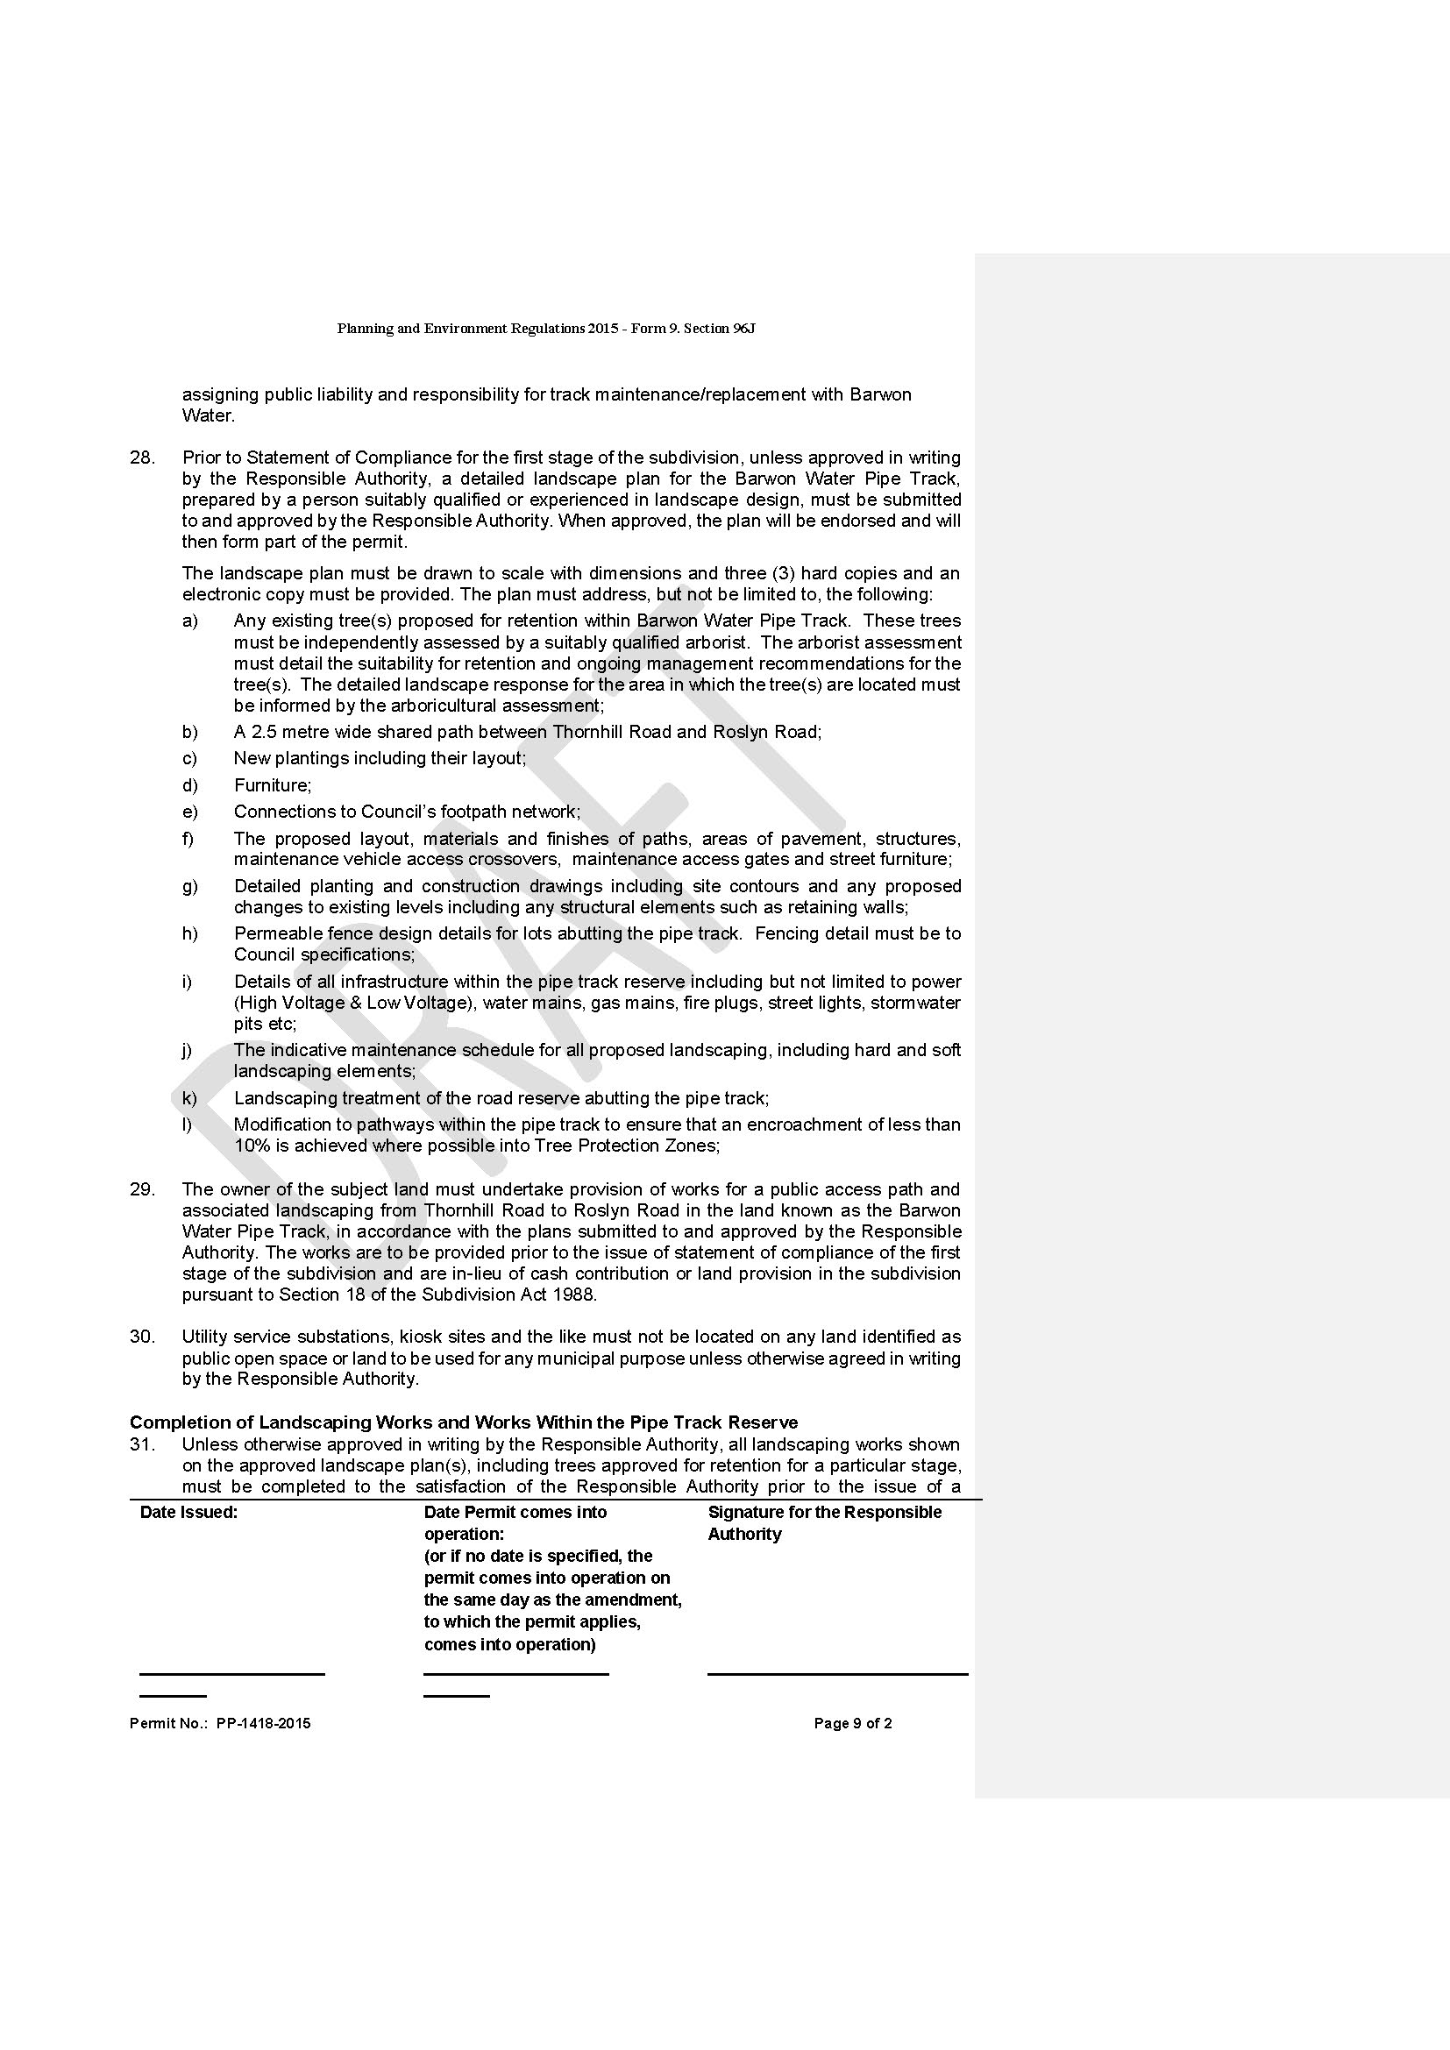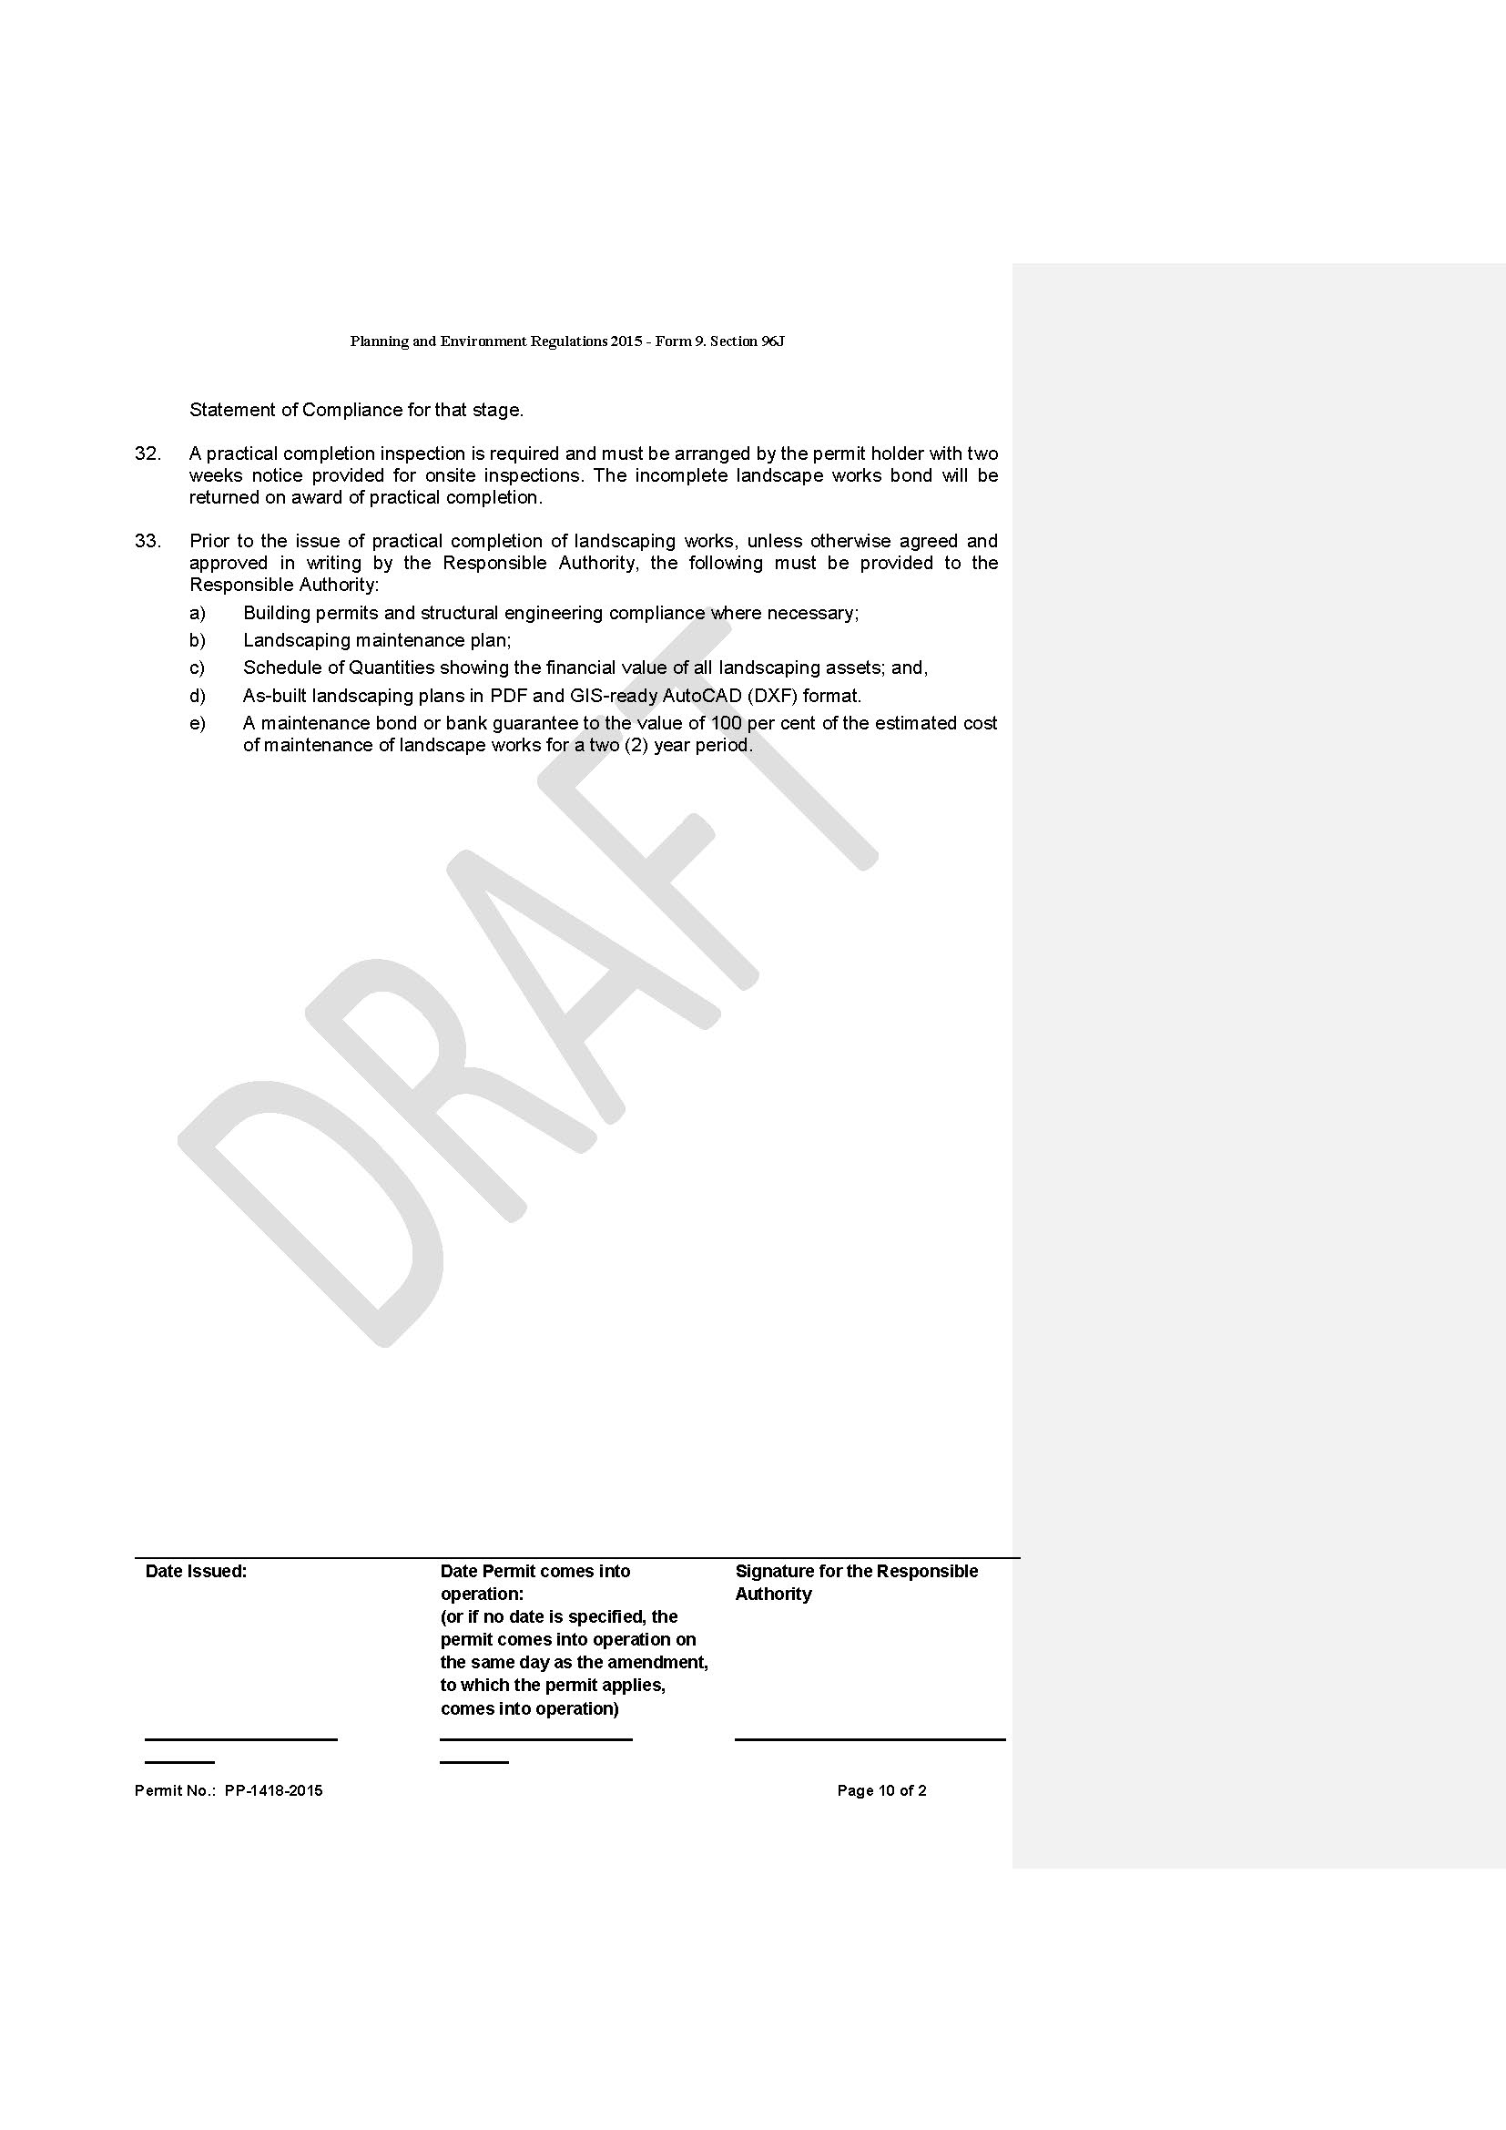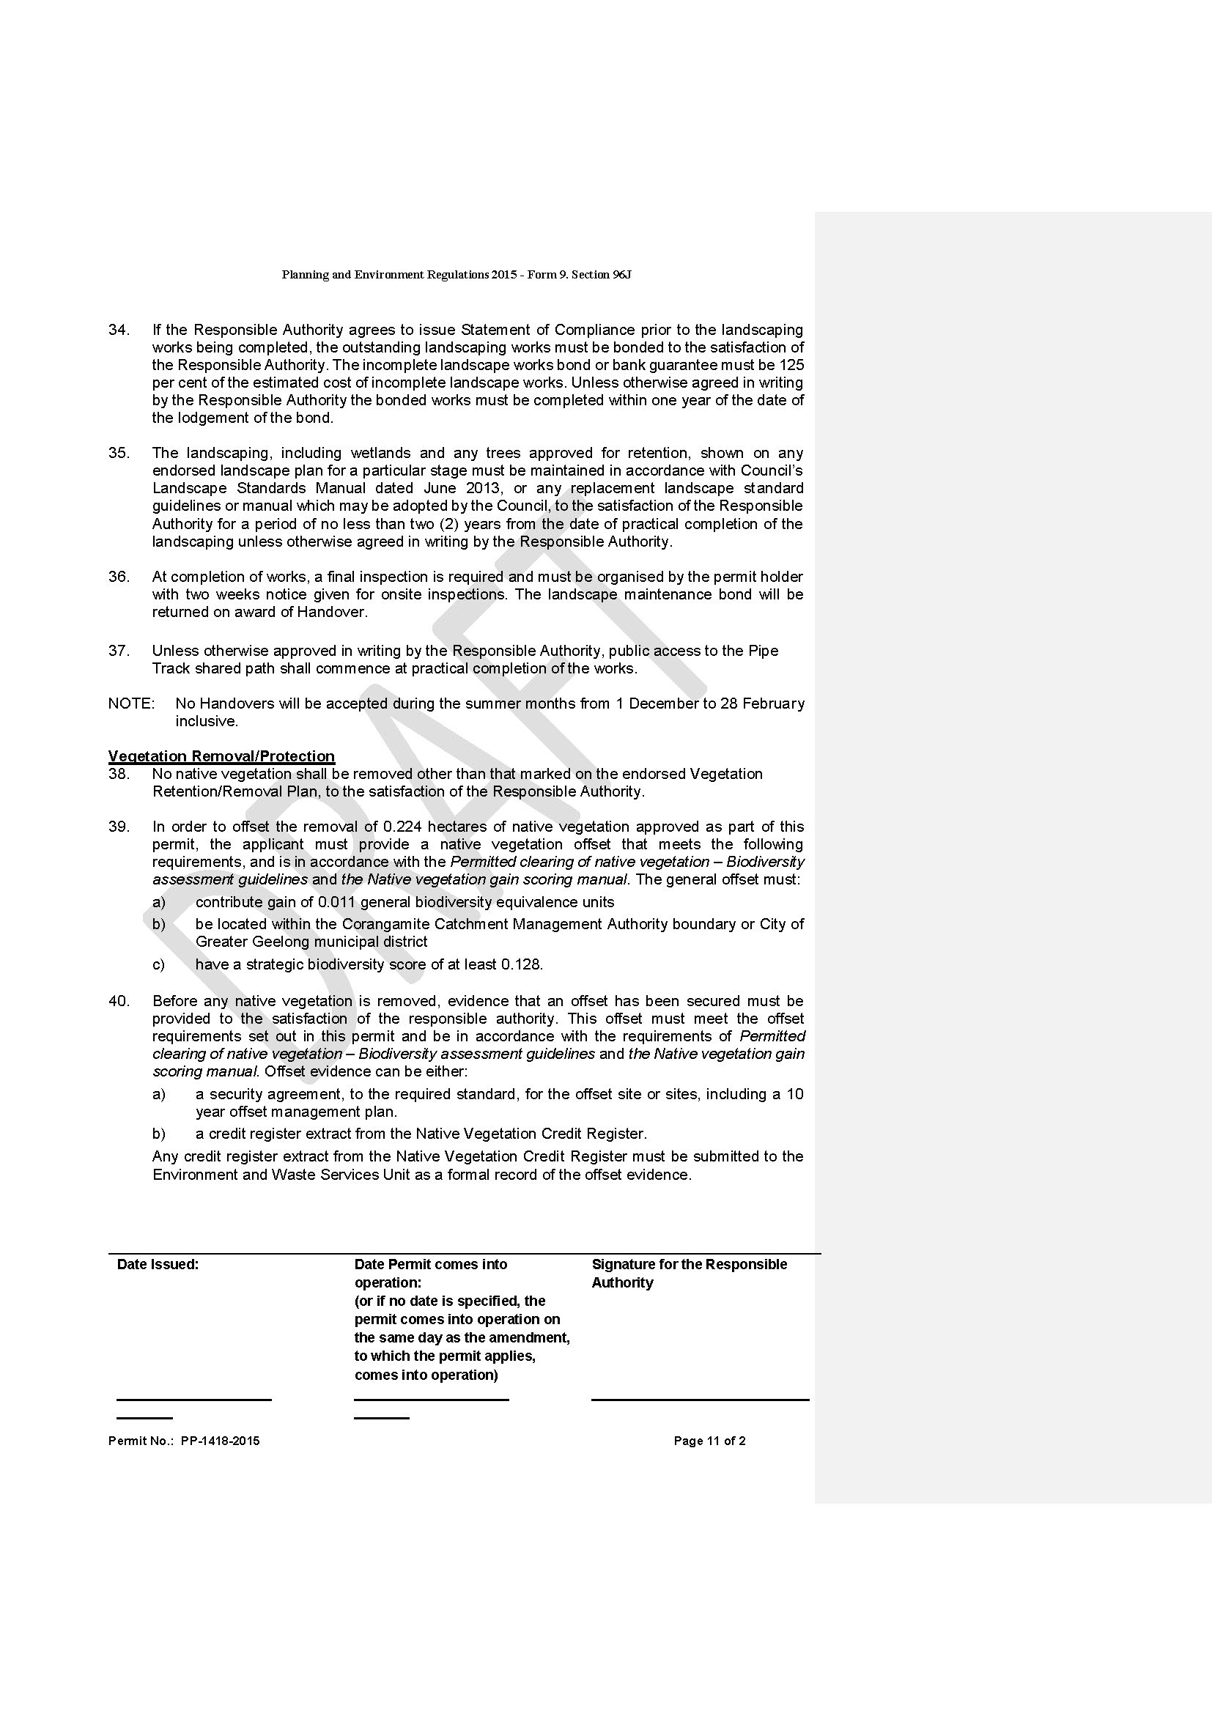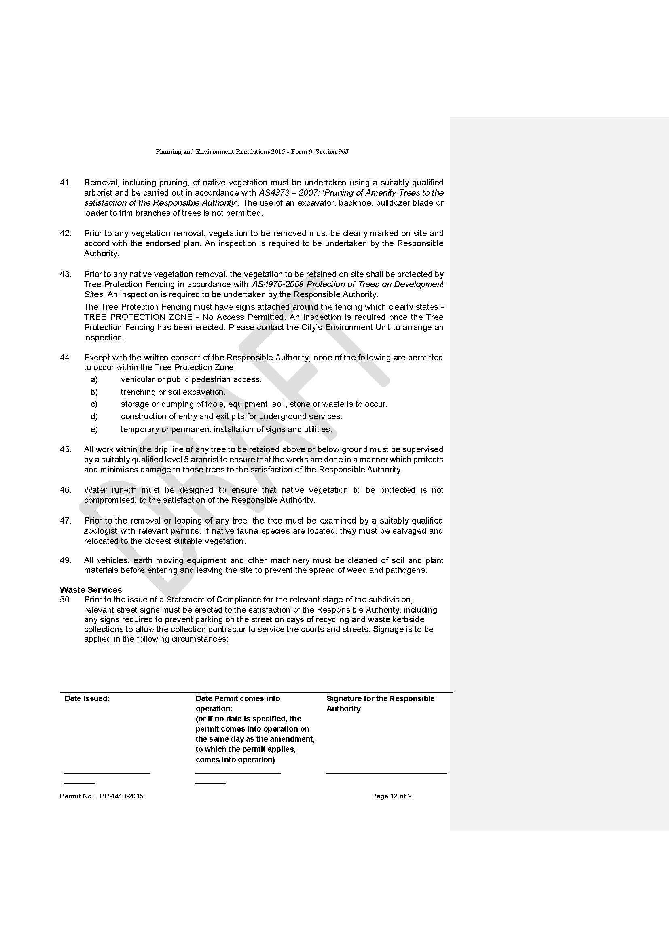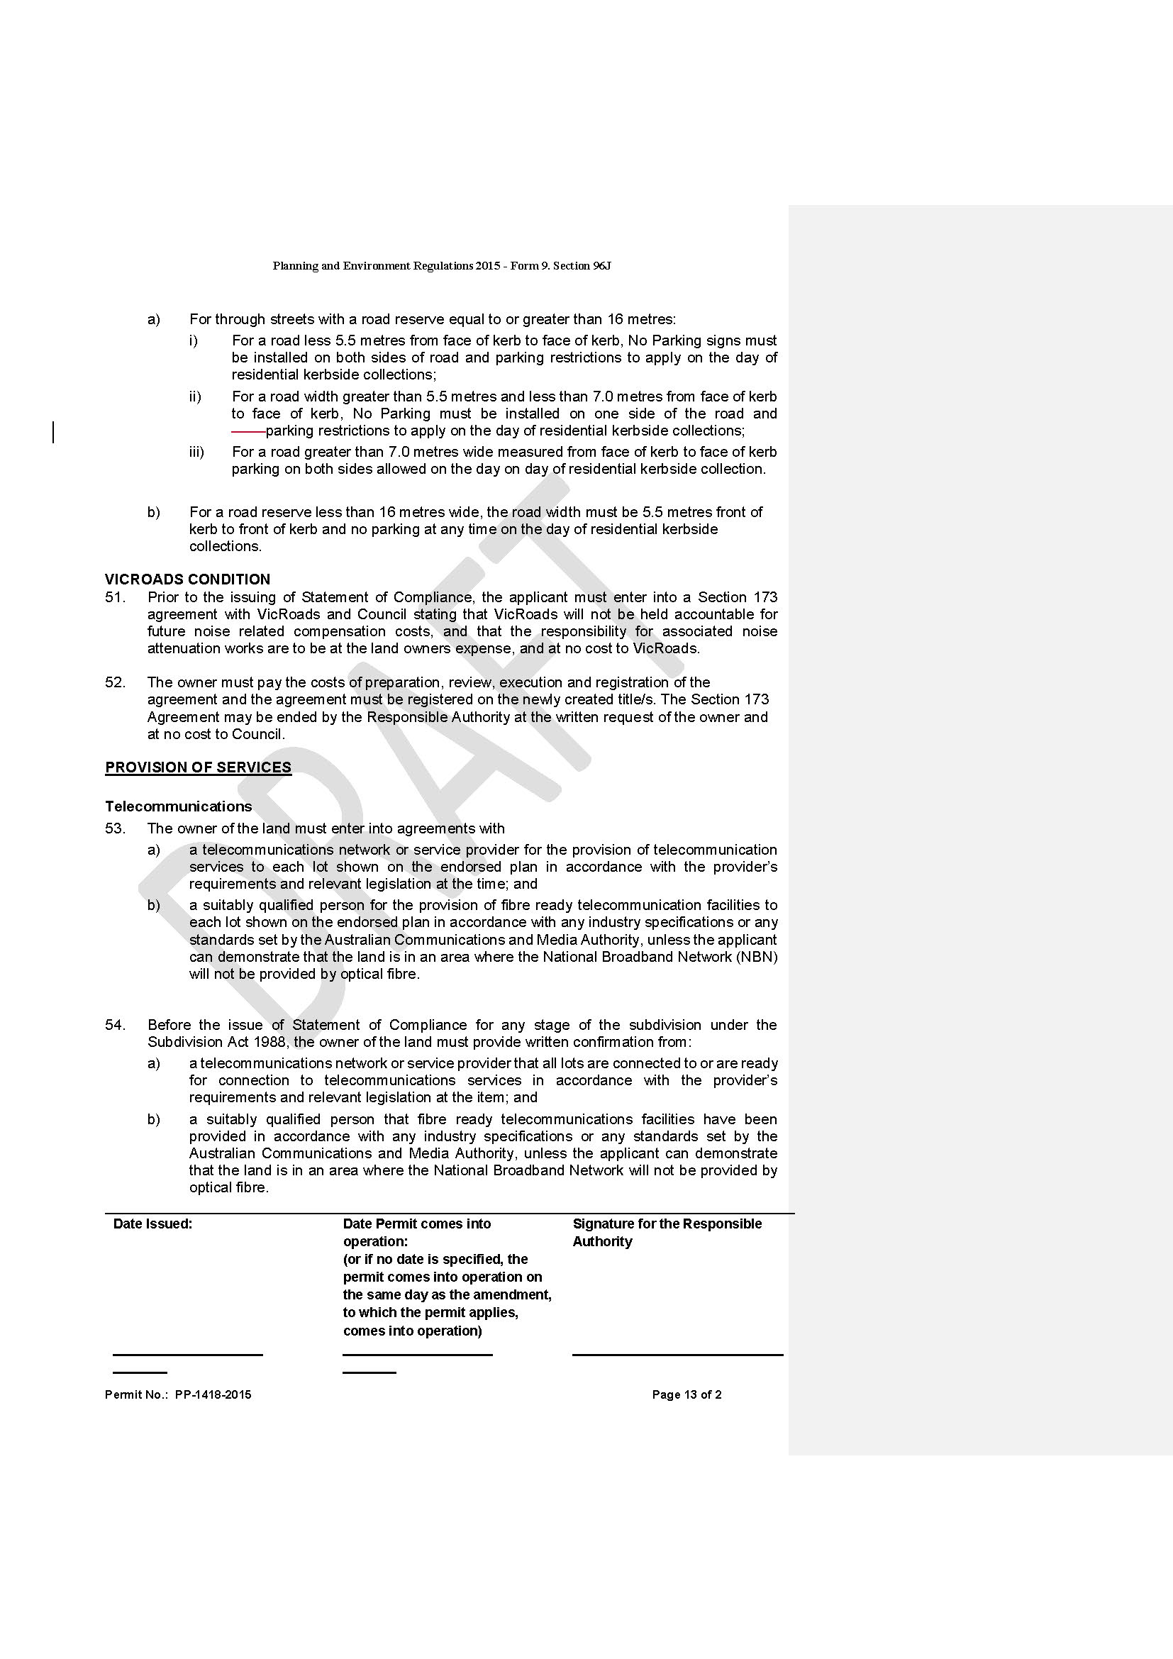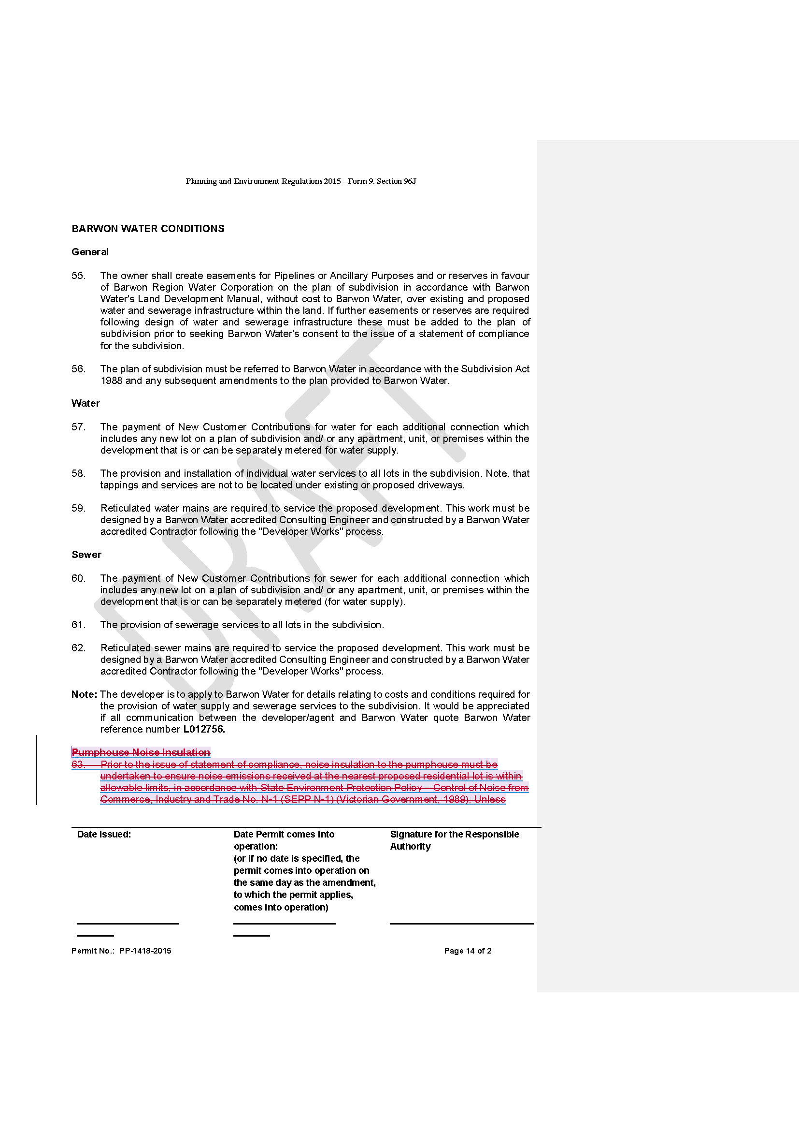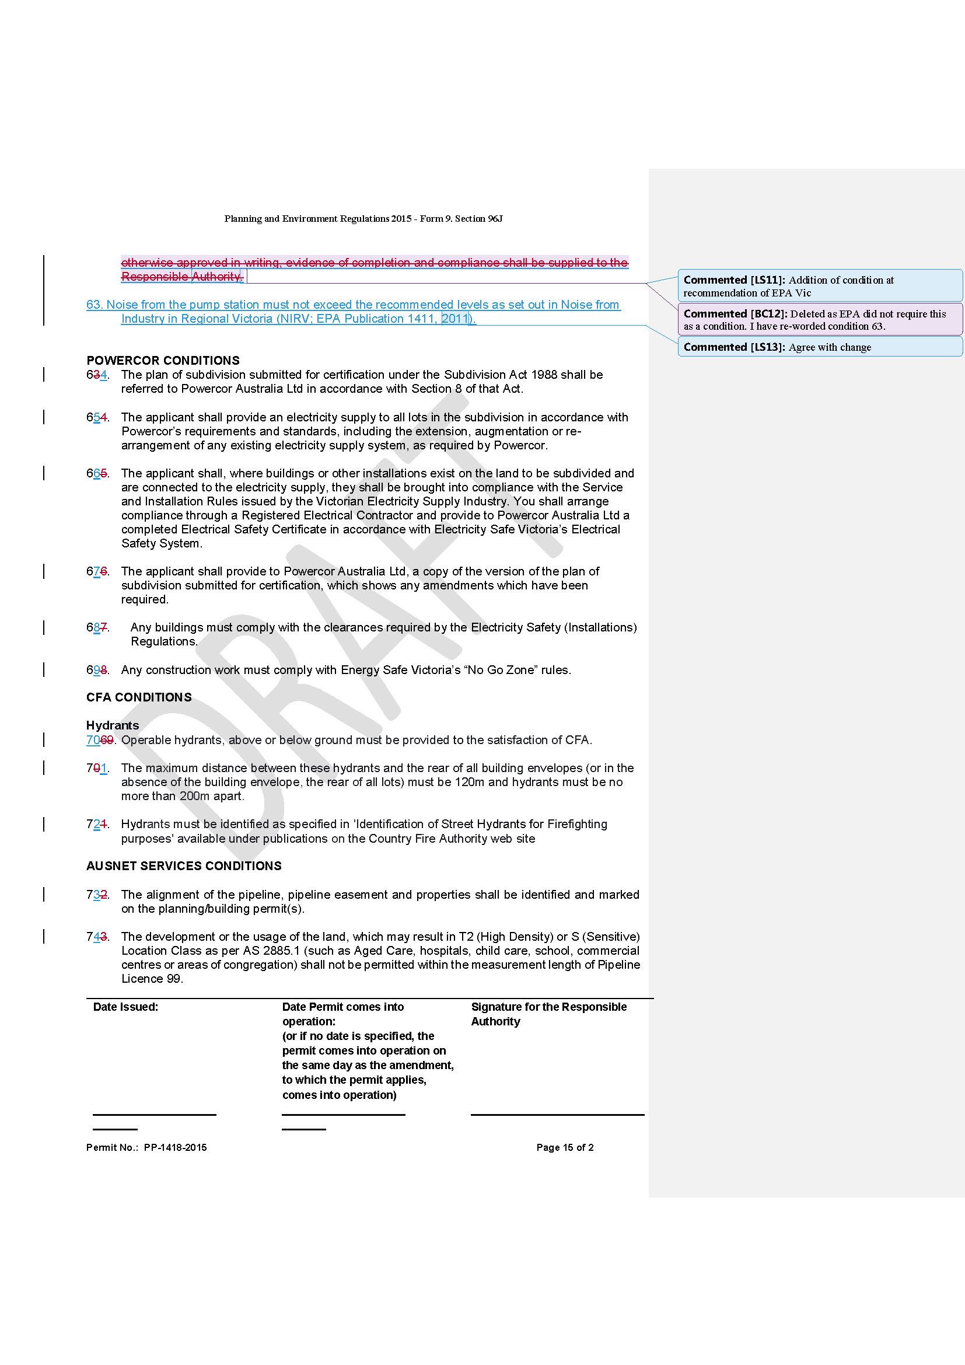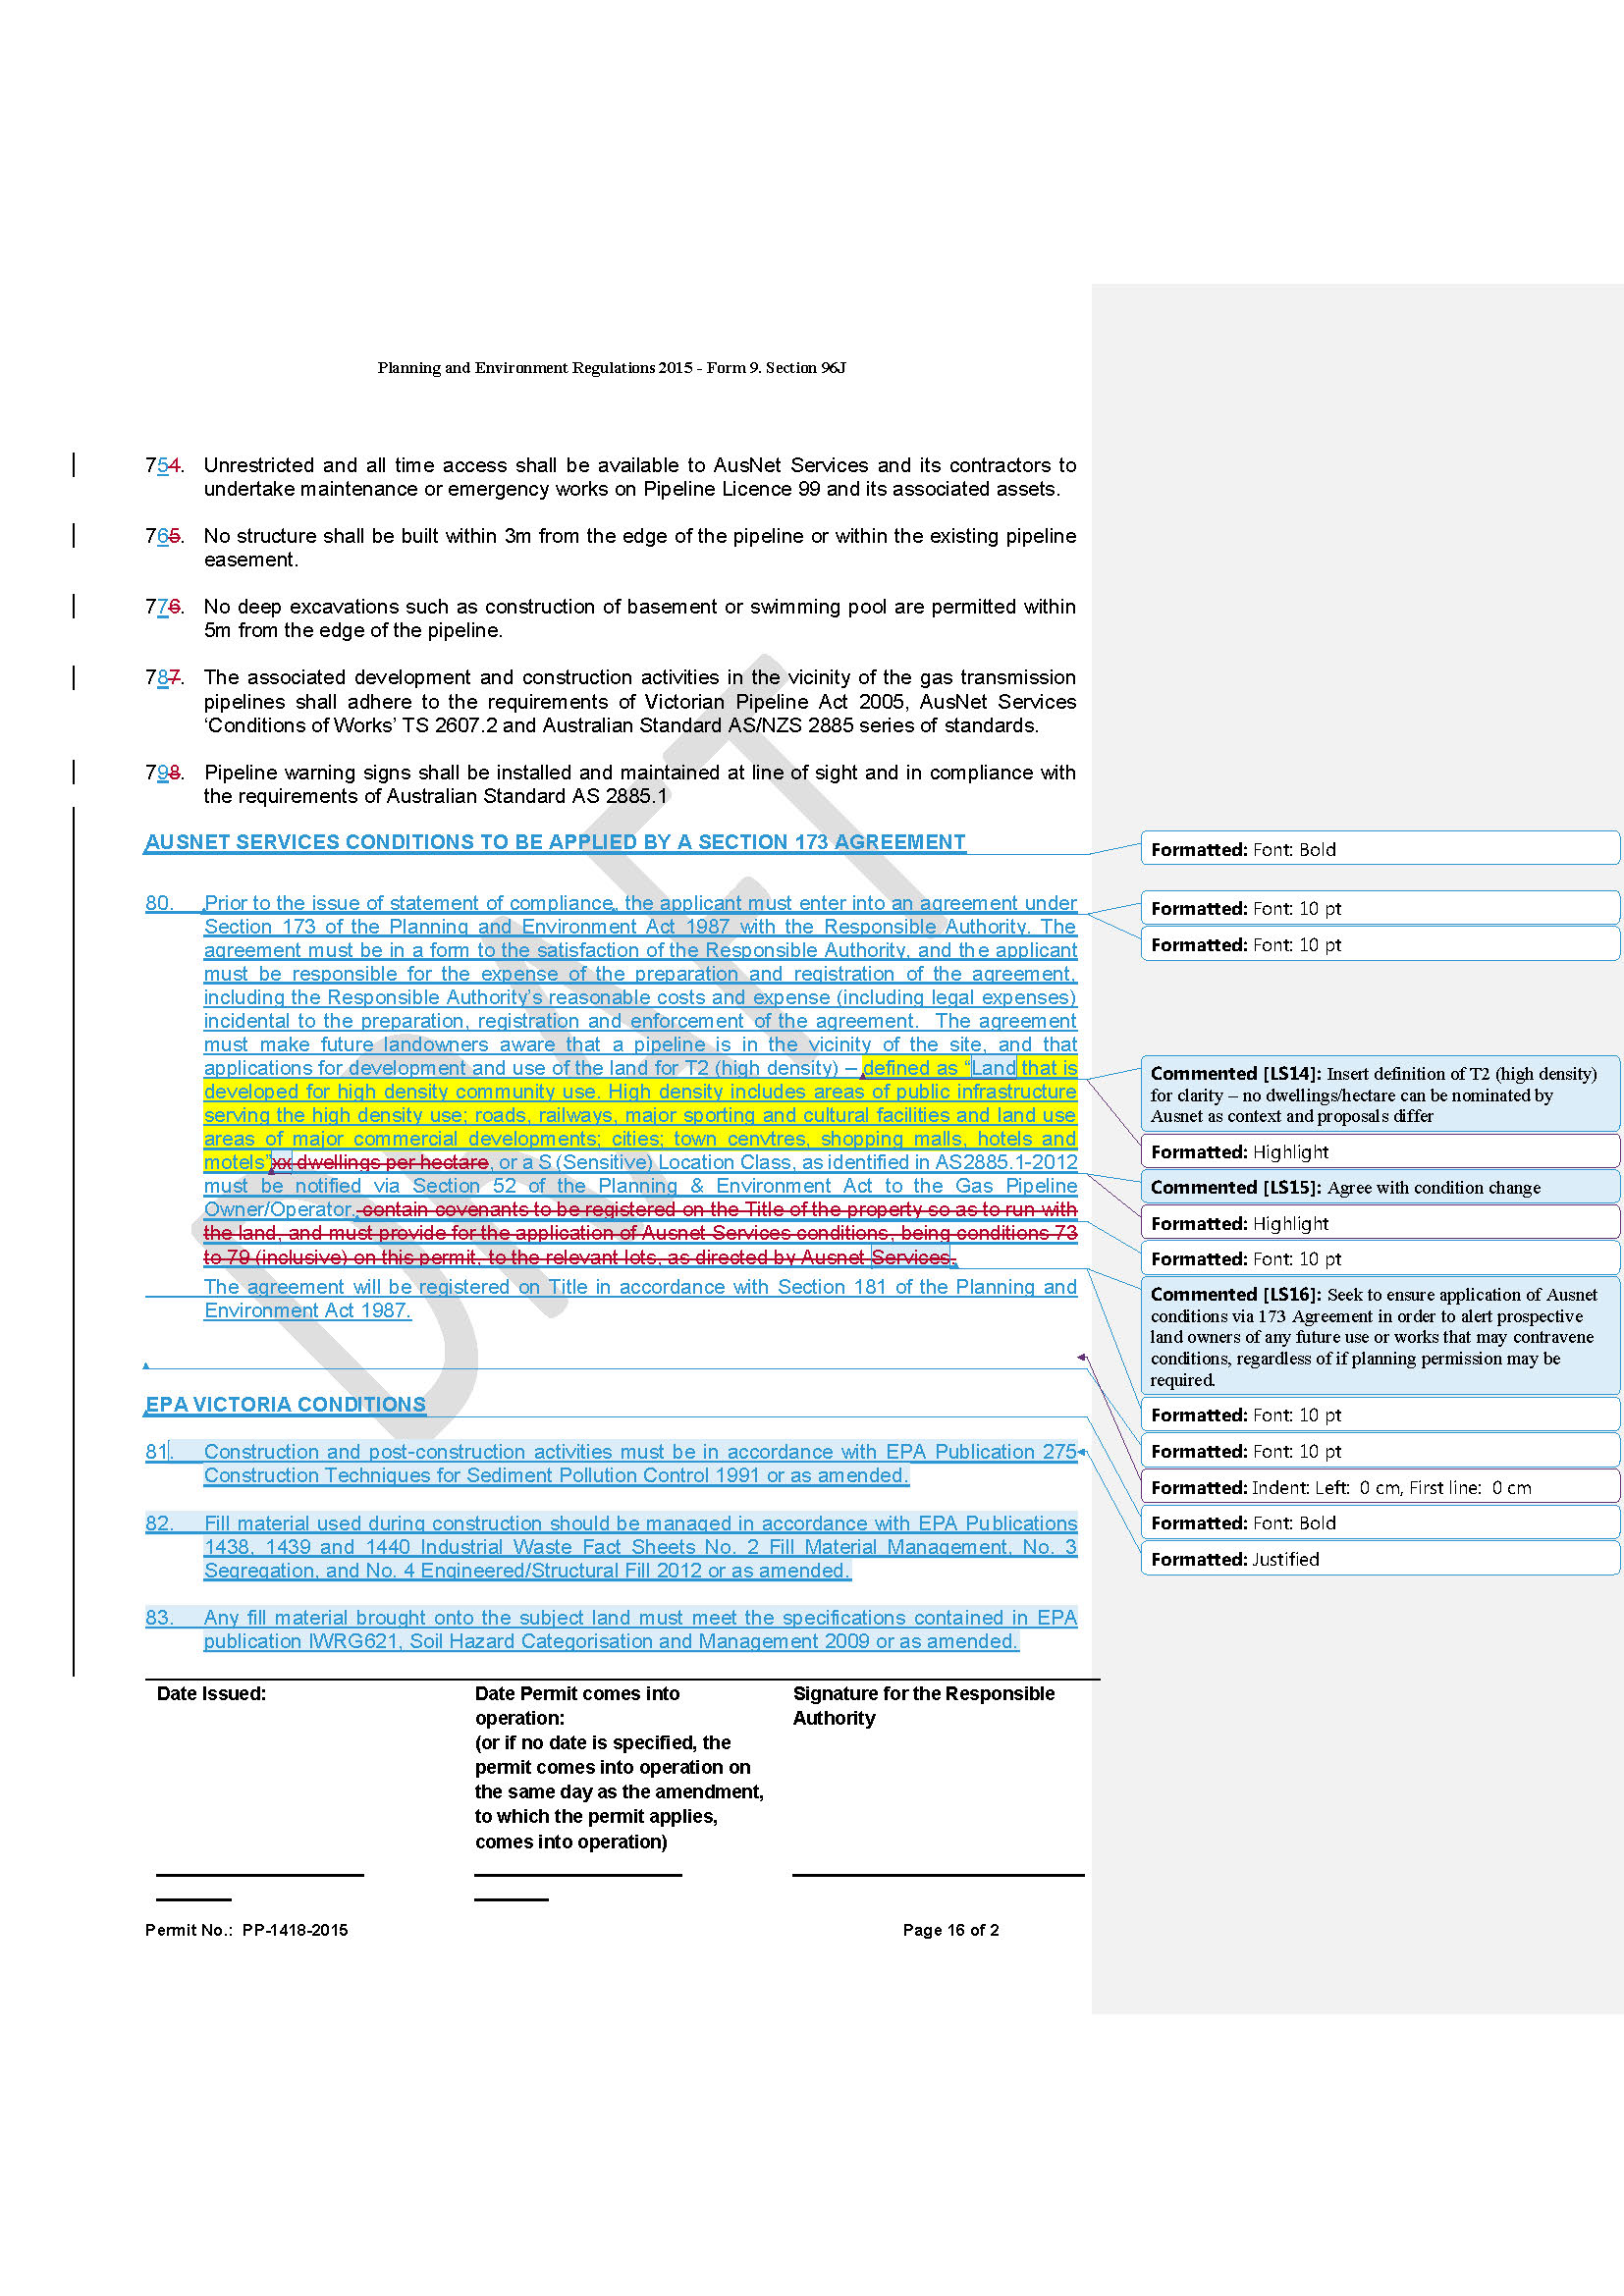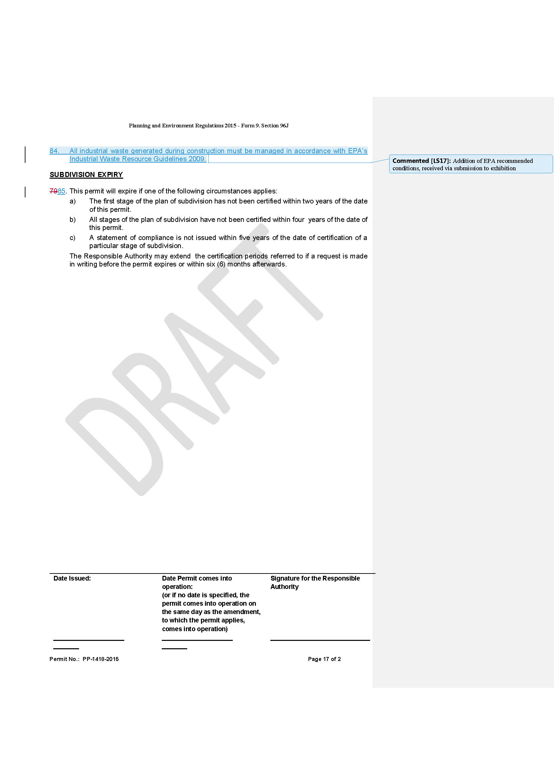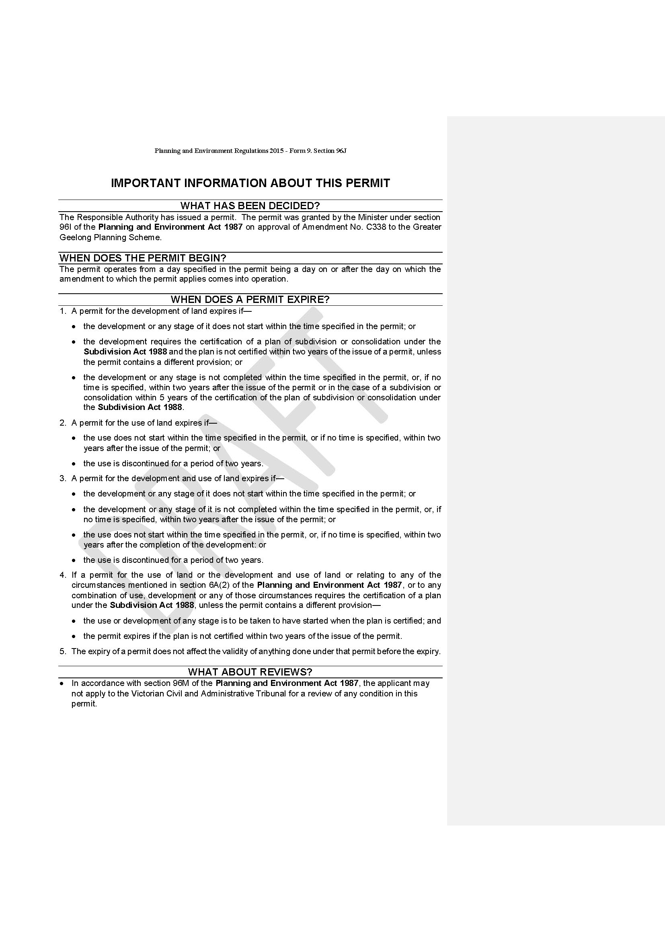

Appendix 4 – Gas Pipeline Maps

