Planning and Environment Act 1987

GREATER GEELONG PLANNING SCHEME

AMENDMENT C332

Planning Permit ApplicAtion 1303/2015

EXPLANATORY REPORT

Who is the planning authority?
This amendment has been prepared by the Greater Geelong City Council which is the planning authority for this amendment.
The amendment has been made at the request of TGM Group Pty Ltd on behalf of the Barwon Region Water Corporation.

Land affected by the amendment
The amendment applies to the land at 42 Leather Street, Breakwater and 350 Boundary Road, Breakwater, as shown on the below map:
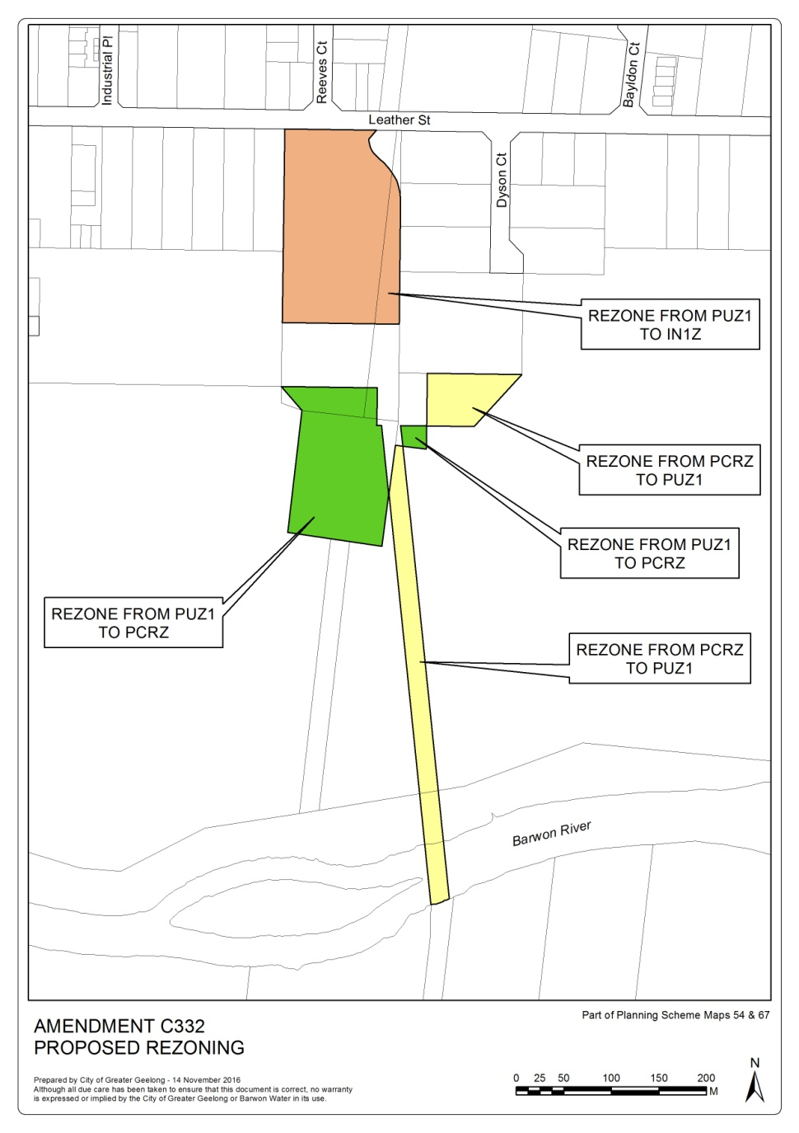
The overall area of the land is approximately 65 hectares, consisting of six titles.
The amendment is a combined planning permit application and planning scheme amendment under section 96A of the Act.
The planning permit application also applies to 42 Leather Street, Breakwater and 350 Boundary Road, Breakwater.

What the amendment does
The amendment proposes to:
- Rezone part of 42 Leather Street Breakwater and part of 350 Boundary Road Breakwater from the Public Use Zone 1 to the Public Conservation and Resource Zone;
- Rezone part of 42 Leather Street Breakwater and part of 350 Boundary Road Breakwater from the Public Conservation and Resource Zone to the Public Use Zone 1;
- Rezone part of 42 Leather Street Breakwater and part of 350 Boundary Road Breakwater from the Public Use Zone 1 to the Industrial 1 Zone; and
- Apply the Design and Development Overlay Schedule 20 to the land being zoned Industrial 1 Zone.
The amendment therefore will make changes to planning scheme zone map numbers 54 and 67, and planning scheme overlay maps Design and Development Overlay 54 and 67.
The planning permit application seeks approval for:
- A multi-lot subdivision, associated buildings and works and removal, variation and creation of reserves and easements.
The planning permit is attached as a separate document to this Explanatory Report.
The amendment is supported by a Section 173 Agreement stating the land to be rezoned Industrial 1 Zone must not be used for a Child care centre.

Strategic assessment of the amendment

Why is the amendment required?

The amendment is required is facilitate the subdivision and development of part of the land for industrial purposes consistent with the broader industrial context of Breakwater. The amendment is also required to establish land for Barwon Water to maintain and develop utilities to service the Greater Geelong community.

How does the amendment implement the objectives of planning in Victoria?
The amendment will implement Victoria’s planning objectives by providing for the orderly, economic and sustainable use and development of land for industrial purposes in an established industrial precinct. The amendment therefore helps secure a pleasant, efficient and safe working environment.
The amendment protects Barwon Water assets enabling the orderly provision and coordination of public utilities for the benefit of the community. The amendment also provides for the protection of the Barwon River floodplain and Ovoid Sewer Aqueduct.

How does the amendment address any environmental, social and economic effects?
The proposed amendment is supported by a Flora and Fauna assessment which identifies that there are no Federal Environment Protection and Biodiversity Conservation Act or State Flora and Fauna Guarantee Act implications. The amendment is also supported by a Environmental Site Assessment which did not identify soil contamination or groundwater conditions that would prevent the site use for commercial or industrial purposes subject to soil management conditions.
The TGM Stormwater Management Plan proposes use of the existing wetland system located south of the site within property owned by Barwon Water. The proposed outfall to cater for future industrial development will be designed to minimise impact on the waterway.
The amendment will not affect the Barwon River Ovoid Sewer Aqueduct which is listed on the Victorian Heritage Register. Because the concurrent subdivision is within the buffer distance of the Aqueduct a permit has been issued by Heritage Victoria to safeguard the structure from stormwater runoff.
The proposal will add to the limited supply of industrial land within the existing serviced Breakwater Industrial Precinct. It will also establish land for the ongoing maintenance and development of public utilities to continue to serve the Geelong community.

Does the amendment address relevant bushfire risk?
A significant portion of the subject land is located within a designated bushfire area, though this does not include the land to be rezoned for industrial purposes. The application was referred to the Country Fire Authority (CFA) who note the Barwon River floodplain represents low to moderate fire risk.
The CFA consider managing fire risk is warranted and recommend implementation of a reticulated fire hydrant service plan. This is conditioned on the planning permit together with other standard subdivision requirements.

Does the amendment comply with the requirements of any Minister’s Direction applicable to the amendment?
The amendment is consistent with the Ministerial Direction regarding the form and content of Planning Schemes under section 7(5) of the Act and Ministerial Direction No. 11 – Strategic Assessment of Amendments.
The amendment is required to consider Ministerial Direction No. 1 Potentially Contaminated Land given the Industrial 1 Zone allows a sensitive use (i.e. Child care centre) to be established (whether or not subject to the grant of a permit). Council and Barwon Water have agreed to enter into a Section 173 Agreement stating the land must not be used as a Child care centre in the absence of a certificate of environmental audit or statement. The Agreement will be signed and registered on title as part of the amendment process, thereby satisfying Ministerial Direction No. 1.
The land to be rezoned to PCRZ may ultimately be used as public open space. The Landserv Environmental Site Assessment 16 June 2015 did not identify indications of soil or surface water contamination that would normally be of concern for such a use. Ministerial Direction No. 1 does not define public open space as a sensitive use. The Landserv findings together with advice from Barwon Water that it is of the opinion that sufficient information has been provided to satisfy Section 12 of the Planning and Environment Act, satisfy Council’s consideration of Direction No. 1.

How does the amendment support or implement the State Planning Policy Framework and any adopted State policy?
The amendment is consistent with the intent of the State Planning Policy Framework and supports its implementation by:
- Clause 11.02-1 Supply of Land – To ensure ongoing land supply is supported by infrastructure.
- Clause 11.07-1 Planning for Growth – To optimise infrastructure and consolidate growth.
- Clause 13.01-1 Floodplain Management – To assist in the protection of the flood storage of floodways and waterways.
- Clause 17.02-1 Industrial Land Development – To ensure availability of land for industry;
- Clause 19.03-2 Industrial Land Development – To plan for the provision of water supply, sewerage and drainage services that efficiently and effectively meet State and community needs and protect the environment.
- Clause 19.03-3 Stormwater – To reduce the impact of stormwater on bays and catchments.

How does the amendment support or implement the Local Planning Policy Framework, and specifically the Municipal Strategic Statement?
The amendment is consistent with the Local Planning Policy Framework including:
- Clause 21.05-2 Waterways – To protect, maintain and enhance waterways, rivers, wetlands and groundwater; and to reduce the amount of runoff from urban development and improve the quality of stormwater runoff entering waterways, estuarine and marine waters.
- Clause 21.05-7 Flooding – To protect floodplains, and to minimise the potential for damage and risks to public safety and property from flooding.
- Clause 21.07-1 Economic Development & Employment – To provide a diverse range of appropriately located, well serviced industrial land which meets the needs of a range of industry types and minimises land use conflicts.

Does the amendment make proper use of the Victoria Planning Provisions?
The amendment makes proper use of the Victoria Planning Provisions.
The selection of the Industrial 1 Zone for the portion of land fronting Leather Street and above the Barwon River floodplain is an efficient use of land for industrial purposes. This zone is consistent with the surrounding precinct which seeks to provide for manufacturing industry, the storage and distribution of goods and associated uses.
Applying the Design and Development Overlay Schedule 20 to the land being rezoned Industrial 1 is consistent with its application to all industrial zones in the municipality. The DDO20 will ensure future buildings and works permit applications respond to a range of design objectives and requirements.
The reorganisation of lands zoned Public Use - Service and Utility and Public Conservation and Resource reflects on-going ownership and management by Barwon Water. The Public Conservation and Resource Zone is also the appropriate zone to facilitate any future transfer for parkland use. Barwon Water plans to establish a 66-hectare park around the heritage listed Barwon River Ovoid Sewer Aqueduct.

How does the amendment address the views of any relevant agency?
As the landowner and proponent Barwon Water are supportive of the amendment. The Corangamite Catchment Management Authority considers the stormwater management plan adequately meets the Authority’s requirements.
Other agencies have recommended planning permit conditions as appropriate.

Does the amendment address relevant requirements of the Transport Integration Act 2010?
The amendment will have no adverse impact on the transport system as defined in Section 3 of the Transport Integration Act 2010.

Resource and administrative costs

What impact will the new planning provisions have on the resource and administrative costs of the responsible authority?
The change of zones and introduction of the Design and Development Overlay Schedule 20 will have minimal impact on Council resources.

Where you may inspect this Amendment
The amendment is available for public inspection, free of charge, during office hours at the following places:
Greater Geelong City Council, Customer Service Centre, Ground Floor, 100 Brougham Street. GEELONG – 8.00am to 5.00pm weekdays
‘Amendments’ section of the City’s website www.geelongaustralia.com.au/amendments/
The Amendment can also be inspected free of charge at the Department of Environment, Land, Water and Planning website at www.delwp.vic.gov.au/public-inspection .
Submissions
Any person who may be affected by the Amendment may make a submission to the planning authority.
Submissions about Amendment C332 should be received by Monday 24 April 2017 and addressed to:
The Coordinator
Strategic Implementation
City of Greater Geelong
- either by mail to: PO Box 104, GEELONG VIC 3220
- or by email to: strategicplanning@geelongcity.vic.gov.au
- or lodged online at: www.geelongaustralia.com.au/amendments/

Panel hearing dates
In accordance with clause 4(2) of Ministerial Direction No.15 the following panel hearing dates have been set for this amendment:
- Directions hearing: week beginning 19 June 2017
- Panel hearing: week beginning 17 July 2017
Further information
For further information about Amendment C332 please contact the Strategic Implementation Unit at the City of Greater Geelong on (03) 5272 4820 or via email strategicplanning@geelongcity.vic.gov.au

