Planning and Environment Act 1987

GREATER GEELONG PLANNING SCHEME

AMENDMENT C358

EXPLANATORY REPORT

Who is the planning authority?
This amendment has been prepared by the Greater Geelong City Council, which is the planning authority for this amendment.
The amendment has been made at the request of Sincock Planning on behalf of Mr Frank Furnari and Mr Steven Li.

Land affected by the amendment
The amendment applies to the land at 55, 57 & 59 Kilgour Street and 322-328 Moorabool Street Geelong, as red lined below:
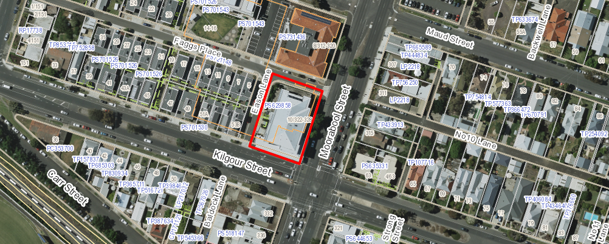

What the amendment does
The amendment rezones the land from the General Residential Zone Schedule 1 to the Mixed Use Zone.

Strategic assessment of the amendment

Why is the amendment required?
The subject site is currently zoned General Residential Zone Schedule 1 and this prohibits the use of the commercial tenancies at the lower level for an office or shop use. The amendment is required to facilitate the broader potential of the land as the three tenancies have been vacant for an extended period. This would be facilitated by the Mixed Use Zone.

How does the amendment implement the objectives of planning in Victoria?
The amendment implements the objectives of planning in Victoria as follows:
- To provide for the fair, orderly, economic and sustainable use, and development of land;
The amendment rezones land within Central Geelong but outside of the core retail area and the proposed Mixed Use Zone provides greater flexibility for the use of the existing commercial tenancies. The zone is appropriate for a small mixed use proposal that abuts residentially zoned land. The tenancies have been vacant for an extended period and the Mixed Use Zone provides the flexibility for small scale offie or boutique shop uses that would enhance the street frontage activity and provide life at the ground floor of the building
- To secure a pleasant, efficient and safe working, living and recreational environment for all Victorians and visitors to Victoria;
The amendment would allow the tenancies to be used for a small number of boutique uses including shop, office, food and drink premises or medical centre, and these uses would be less detrimental to the residential neighbours than the convenience restaurant use that was originally approved with extended opening hours. These uses permitted by the zone are likely to operate with fewer hours and less customers, therefore maintaining a high quality residential environment for upper levels and nearby residents.
The amendment will provide for a pleasant, efficient and safe working and living environment for the broader community within the neighbourhood via greater street activity and will provide the opportunity for boutique commercial uses that are pleasant and enjoyable places to work and live.
- To balance the present and future interests of all Victorians.
The subject site is developed specifically for commercial tenants within Central Geelong and the rezoning enables the spaces to be used for a small range of more flexible commercial uses that will enhance the site and liven the activity around the ground floor of the building. The rezoning will give the owners greater flexibility in their search for tenants.

How does the amendment address any environmental, social and economic effects?
The land has no environment significance, nor will the amendment have any environmental effects.
The amendment will assist to maintain and enhance the social and economic vibrancy of the area by the provision of ground floor flexible spaces in a purpose built building. The amendment will therefore add to the range of commercial services that can be accommodated within the building, creating greater employment opportunities and enhancing the amenity of the area.
The use of the land for apartments ‘as-of-right’ will not be affected. The building upper levels are owned by Loddon Mallee Housing Services and provide accommodation in 30 apartments. The proposed Mixed Use Zone allows non-residential uses without a permit such as shop, office and food and drink premises (subject to floor area limits), which could be established in an apartment. The scale of any such use would be minor and not considered to cause amenity impacts to apartment residents.

Does the amendment address relevant bushfire risk?
The land is not identified as being subject to bushfire risk and therefore does not necessitate the incorporation of measures to minimise risk.

Does the amendment comply with the requirements of any Minister’s Direction applicable to the amendment?
The amendment is consistent with the Ministerial Direction regarding the form and content of Planning Schemes under section 7(5) of the Act and Ministerial Direction No. 11 – Strategic Assessment of Amendments.

How does the amendment support or implement the State Planning Policy Framework and any adopted State policy?
The amendment is consistent with the State Planning Policy Framework as follows:
Clause 11.01 Activity Centres
The objectives of Clause 11.01 include to build up activity centres as a focus for high-quality development, activity and living, and to encourage the concentration of major retail, residential, commercial, administrative, entertainment and cultural developments into activity centres which provide a variety of land uses and are highly accessible to the community. The amendment is consistent with this clause as the small scale of the ground floor tenancies will not compete with the Central Geelong Retail Core.
Clause 17 Economic Development
Clause 17.01 seeks to encourage development which meet the communities’ needs for retail, entertainment, office and other commercial services and provides net community benefit in relation to accessibility, efficient infrastructure use and the aggregation and sustainability of commercial facilities, whilst the strategy seeks to locate commercial facilities in existing centres. The proposal is consistent with this clause as it provides for potential small office, retail, medical of food and drink premises within a purpose built commercial tenancy.

How does the amendment support or implement the Local Planning Policy Framework, and specifically the Municipal Strategic Statement?
Clause 21.07 Economic Development and Employment
Clause 21.07 identifies that there is a need to ensure a mix of commercial uses in activity centres and to protect the retail hierarchy identified in the Geelong Retail Strategy. The small area of the three tenancies – at a total of 225.05m², will have no impact on the retail hierarchy and is policy neutral when assessed against this policy.
Given that the building upper levels will also be rezoned to the Mixed Use Zone there are a limited range of commercial uses allowable as-of-right, subject to floor area limits. The most relevant uses include shop, office and food and drink premises, though permits would be required for car parking exemptions. Without ground level exposure, shops and food premises are highly unlikely, while small offices or specialist medical clinics would be more suited though still unlikely. Any office or medical use is not considered to affect the retail hierarchy.
Clause 21.09 Central Geelong
The Central Geelong strategy defines the boundaries of Central Geelong and divides it into precincts. The site is located in the ‘Residential’ precinct where the key land use is inner city living. The proposed Mixed Use Zone sits within the residential suite of zones and is therefore complimentary to the primary purpose of the precinct. The apartment complex will continue to function primarily as a residential use.
Clause 22.03 Assessment Criteria for Retail Planning Applications
This policy sets out retail assessment criteria which are to be used as a basis for considering applications for new or expanded retail floor space. The amendment seeks to allow a greater range of ground floor commercial tenancy uses. However given the very minor total floor area of 225.05m², any adverse economic impact to the Geelong Retail Hierarchy would be negligible.
Assessment against this Clause has not considered the increase in retail floor space available in the three upper apartment levels.

Does the amendment make proper use of the Victoria Planning Provisions?
The Mixed Use Zone is the appropriate zone to support viable use of the ground floor tenancies while recognising the existing apartment complex above. The purpose of the Mixed Use Zone includes to provide for housing at higher densities and a range of commercial uses.

How does the amendment address the views of any relevant agency?
The amendment will not introduce any referral requirements into the planning scheme and the views of the relevant agencies will be taken into account when the amendment is placed on exhibition.

Does the amendment address relevant requirements of the Transport Integration Act 2010?
The amendment is not expected to have a significant impact on the transport system as defined by Section 3 of the Transport Integration Act 2010.

Resource and administrative costs

What impact will the new planning provisions have on the resource and administrative costs of the responsible authority?
The amendment will have negligible impact on the resource and administrative costs of the Greater Geelong City Council as the responsible authority.

Where you may inspect this Amendment
The amendment is available for public inspection, free of charge, during office hours at the following places:
Greater Geelong City Council, Customer Service Centre, Ground Floor, 100 Brougham Street. GEELONG – 8.00am to 5.00pm weekdays
‘Amendments’ section of the City’s website www.geelongaustralia.com.au/amendments/
The Amendment can also be inspected free of charge at the Department of Environment, Land, Water and Planning website at www.delwp.vic.gov.au/public-inspection .
Submissions
Any person who may be affected by the Amendment may make a submission to the planning authority.
Submissions about Amendment C358 should be received by Monday 12 June 2017 and addressed to:
The Coordinator
Strategic Implementation
City of Greater Geelong
- either by mail to: PO Box 104, GEELONG VIC 3220
- or by email to: strategicplanning@geelongcity.vic.gov.au
- or lodged online at: www.geelongaustralia.com.au/amendments/

Panel hearing dates
In accordance with clause 4(2) of Ministerial Direction No.15 the following panel hearing dates have been set for this amendment:
- Directions hearing: week beginning 17 July 2017
- Panel hearing: week beginning 7 August 2017
Further information
For further information about Amendment C358 please contact the Strategic Implementation Unit at the City of Greater Geelong on (03) 5272 4820 or via email strategicplanning@geelongcity.vic.gov.au

