Planning Scheme Amendment C353

Beckley Park, 40 Broderick Road, Corio

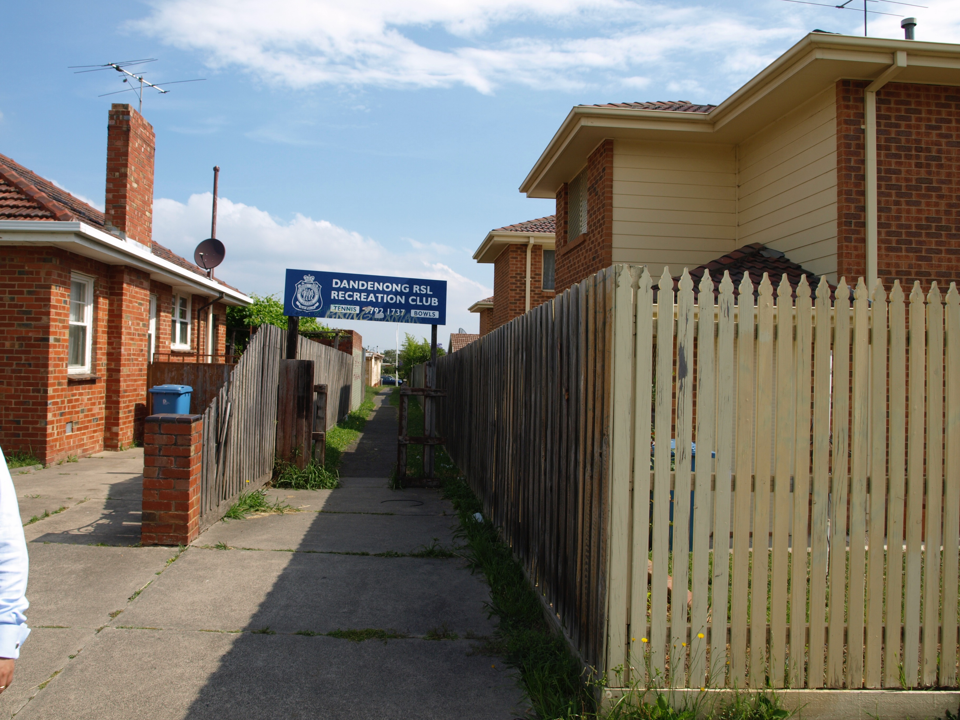
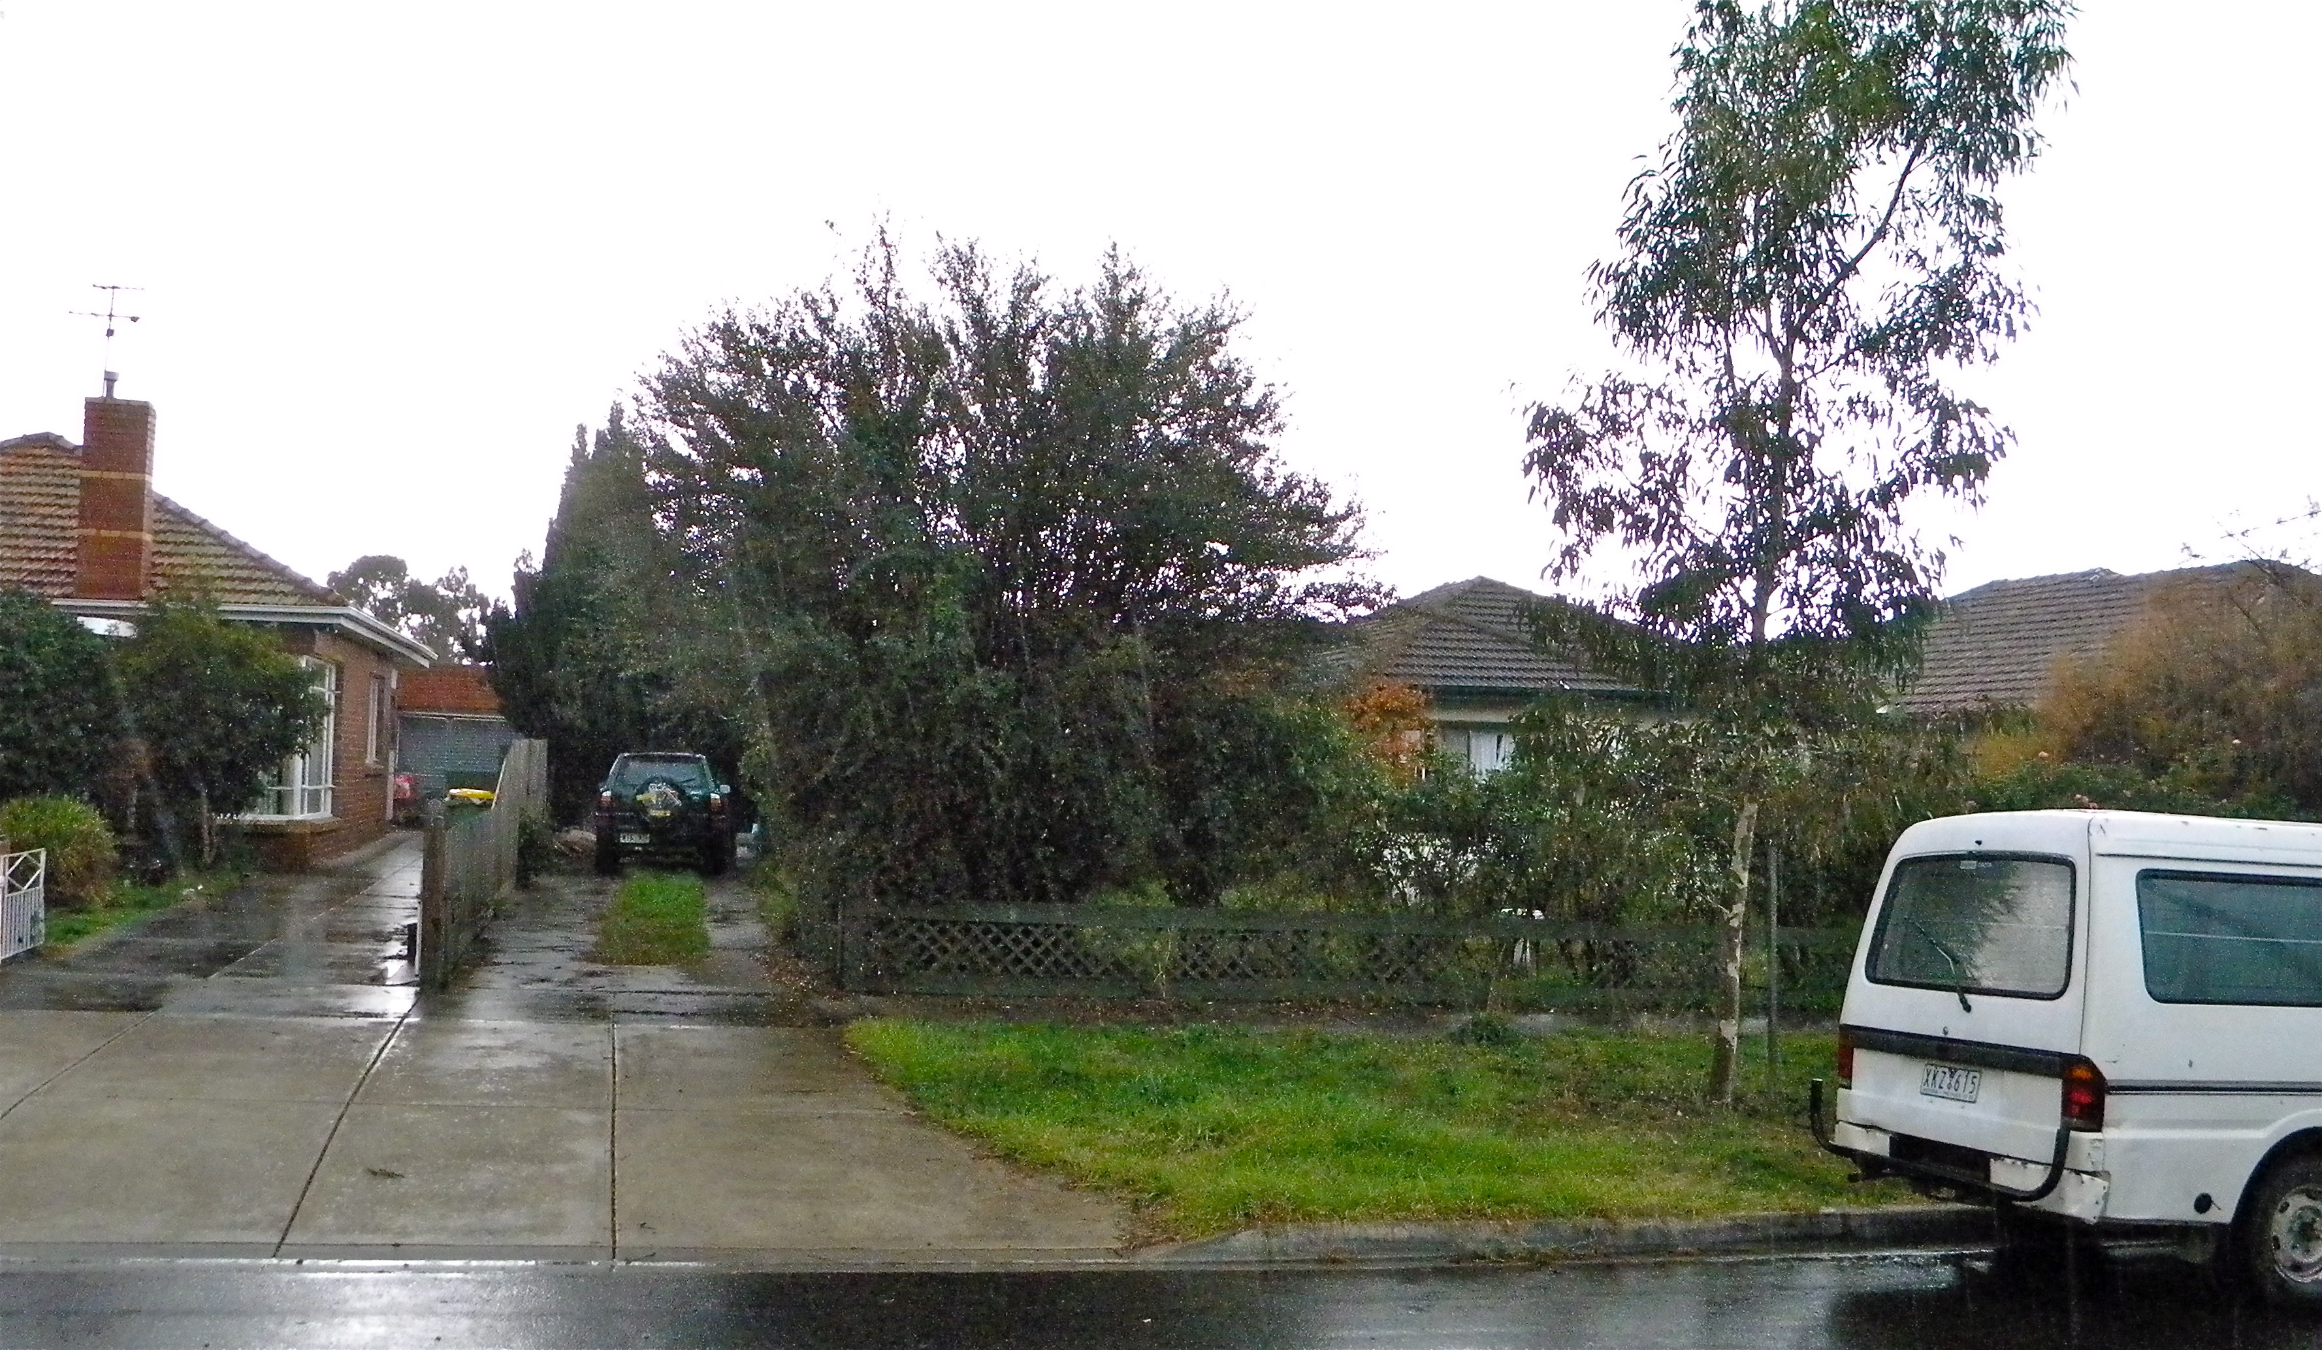
Submission on behalf of the applicant
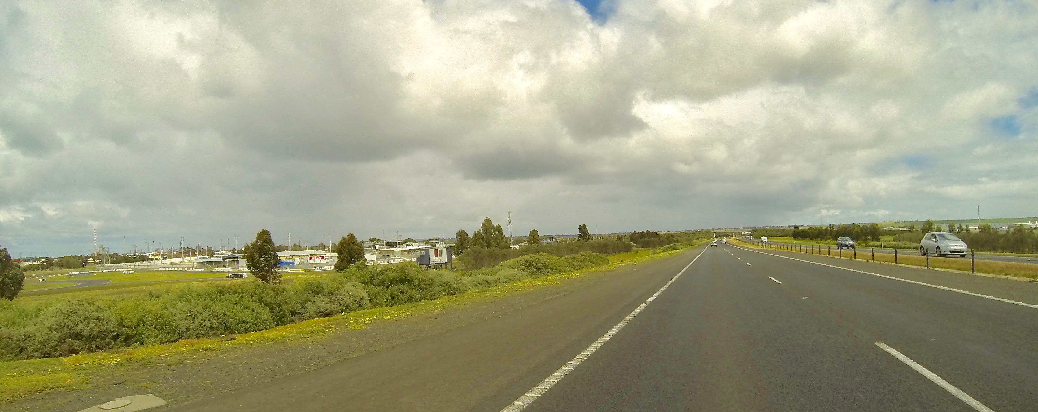

For consideration by the City of Greater Geelong

November 2016

Introduction
Jewell Partnership has been commissioned by TOM Assets in conjunction with the Beckley Park Committee of Management Incorporated (‘the Committee’) to lodge this planning scheme amendment request. The amendment seeks to vary the provisions of the City of Greater Geelong Planning Scheme (‘the planning scheme’) as it relates to the Special Use Zone (Schedule 4) to enable the consideration of major promotional signage. The Committee has been in discussions with the Land Management Policy section of DELWP to facilitate this outcome.
The purpose of this report is to provide detail on the proposed planning scheme amendment and relevant planning considerations. The report provides an outline of the existing conditions of the site and surrounds, as well as the relevant planning provisions of the Greater Geelong Planning Scheme, with specific reference to the Council’s key guiding policies, objectives and controls relevant to this proposal.
A planning scheme amendment is necessary as the Special Use Zone at Clause 37.01-5 applies the Category 3 set of controls to advertising signs. This control applies to the Special Use Zone (Schedule 4) unless the schedule states otherwise. This amendment request seeks to insert a site specific provision that places land at Beckley Park in the Category 2 control. Under this different Category, major promotional signage can be considered for a planning permit. The changes proposed are limited to Beckley Park.
The proposal is not without precedent. A similar planning scheme amendment was undertaken to the Greater Bendigo Planning Scheme (Amendment C165 - approved 30 June 2011). This amendment has particular parallels with what is now sought as the land in question was in the Public Park and Recreation Zone (PPRZ) and the Schedule to the zone was altered to vary the Advertising Sign Category for the relevant site (the Barrack Reserve, Heathcote).
The subject site has many attributes that correspond with the siting guidance provided for major promotion signs at Clause 52.05-6. The surrounds to the site cannot be said to have a strong built form. The site is remote from sensitive land-uses. There are no heritage or vegetation issues. The planning scheme or strategic studies do not identify this as being a gateway location or having important vistas.
Approval of the planning scheme amendment will allow the consideration of a planning application for signage. An indicative layout and sign details accompanies this request. Approval of this amendment will not pre-determine any future assessment of a planning application which must be judged on its merits.

Subject Site and Surrounds
Beckley Park is the home of the Geelong Harness Racing Club, Geelong Greyhound Racing club, Geelong Karting club and Beckley Park Community market. It comprises a large irregular parcel of land which contains various sporting and vehicle courses. It is bounded to the north by the Geelong Ring Road, to the east by the Princes Highway and to the south and west by Broderick Road.
Land to the south east (on the corner of Broderick Road and the Princes Highway) contains an Aldi Supermarket and a residential estate. Land on the east side of the Princes Highway contains bulky goods highway related businesses. Land to the north across the Geelong Ring Road is currently undeveloped but has been designated for future industrial development.
The subject site is largely level. Embankments are found along the interface with the Geelong Ring Road. The diverge between the Princes Highway and the Ring Road involves substantial earthworks and raised road pavements. The Broderick Road overpass across the Ring Road creates a significant visual barrier.
Land to the north east is used as the Princess Highway and Geelong Ring Road interchange. The subject site is an island site surrounded on three sides by significant road systems with extensive reserves.

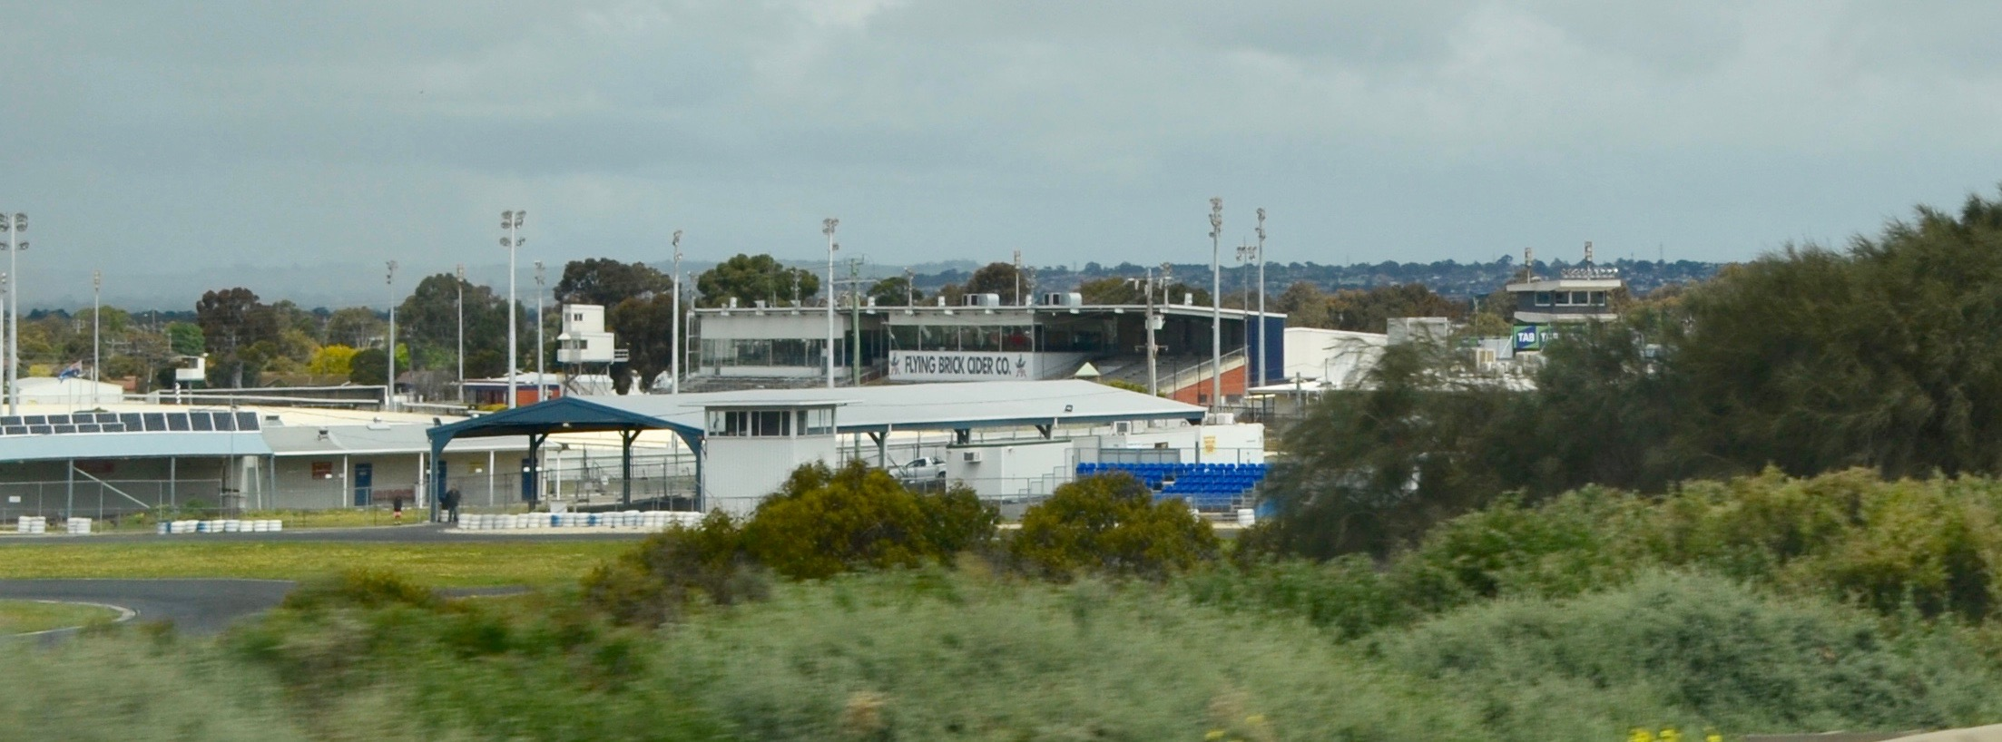
Beckley Park viewed from the Ring Road

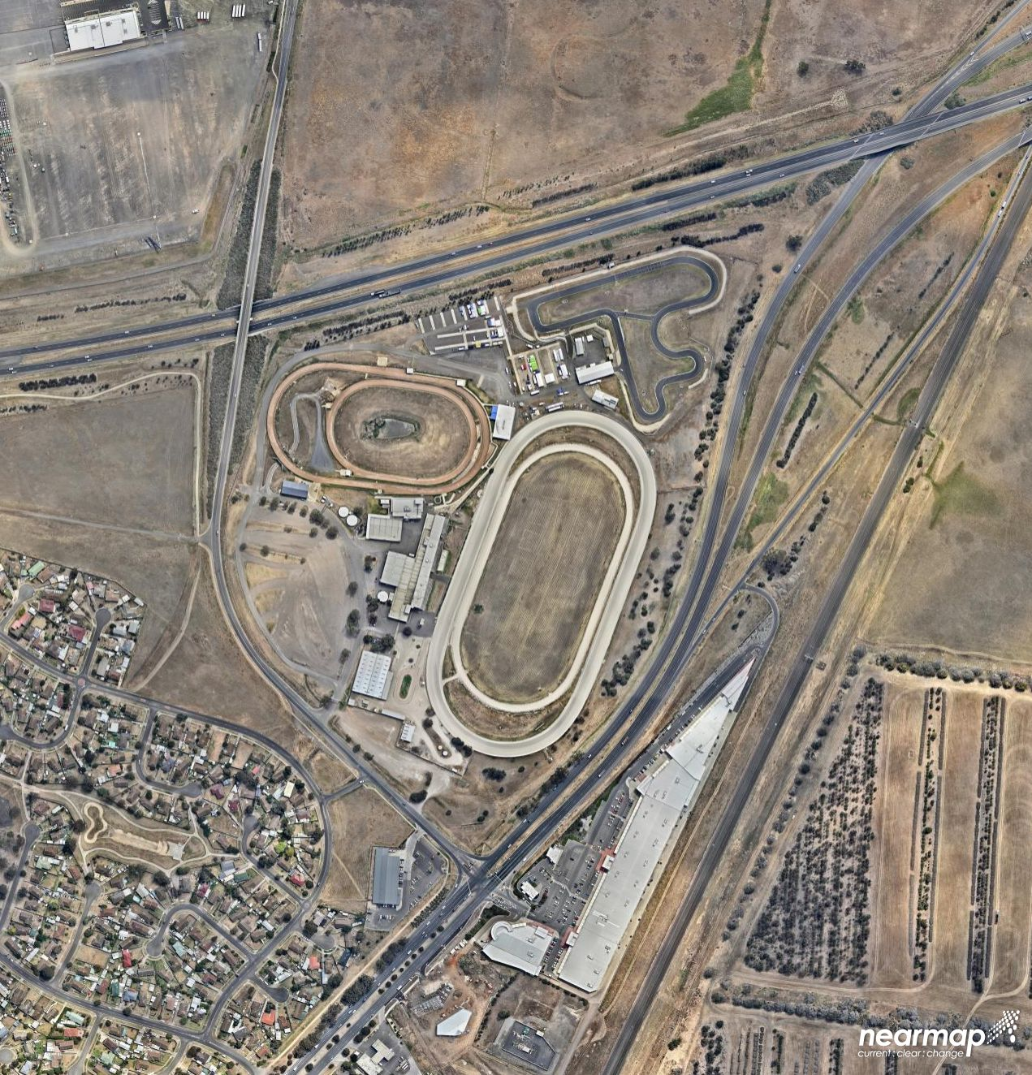
C
D
B
A
Future Industrial
Established Residential
Commercial
Bulky Goods / Highway Sales
B
A
C
D
BRODERICK ROAD
PRINCESS HWY
RING ROAD

Current Planning Scheme Controls

3.1 Zoning
The subject site is located within the Special Use Zone (Schedule 4). The zoning provisions are found at Clause 37.01 of the planning scheme. The Purpose of the zone is:
- To implement the State Planning Policy Framework and the Local Planning Policy Framework, including the Municipal Strategic Statement and local planning policies.
- To recognise or provide for the use and development of land for specific purposes as identified in a schedule in this zone.
Clause 37.01-5 sets out the provisions relating to Advertising signs. This control states that the advertising sign requirements are at Clause 52.05. The Special Use Zone is in Category 3 unless a schedule to this zone specifies a different zone (none currently exists). The Category 3 provisions are found at Clause 52.05-9. The Category applies to ‘High amenity areas’ with a Medium limitation classification. Major promotion signs (ie. promotion signs with an area above 18m²) are prohibited.
The Schedule 4 to the Special Use Zone relates to the ‘Geelong Showgrounds and Racecourse’. The Purpose of the control is:
- To encourage the use and development of the Geelong Showgrounds and Racecourse for a range of entertainment, recreational, commercial and community activities.
- To encourage a variety of uses of the land and buildings within the Geelong Showgrounds and Racecourse facility in order to enable its usage throughout the year.
- To ensure that the combination of uses, their hours of operation and the form of any development do not prejudice the amenity of surrounding areas.
The first two Objectives relate specifically to the Geelong Showgrounds and Racecourse. The third Objective relates to use and hours or operation. Of note the land use conditions around Beckley Park are very different to those adjacent the Geelong Showgrounds and the Racecourse. Further comment is provided in Section 7.3.
The subject site is not affected by any Overlay controls.

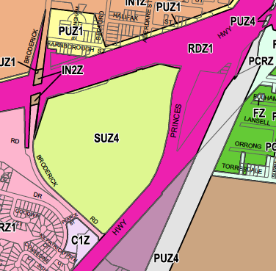

Subject Site - SUZ4, abuts a Road Zone on three sides

3.2 Particular and General provisions
The particular and general provisions within the Greater Geelong Planning Scheme relevant to this proposal include:
- Clause 52.05 Advertising Signs
- Clause 65 Decision Guidelines
Pursuant to Clause 52.05, an application to display an animated or electronic sign within 60 metres of a freeway or arterial road declared under the Road Management Act must be referred in accordance with Section 55 of the Planning and Environment Act 1987 to the referral authority specified in Clause 66.03 or a schedule to that Clause. Any planning for an electronic sign must therefore be referred to VicRoads for assessment.

Clause 52.05-6 specifically relates to Major Promotion Signs. The purpose of this clause states:

- To achieve high quality visual standards for the siting of major promotion signs.
- To ensure that the signs are not detrimental to the appearance of their surroundings or the safe and efficient operation of the route through the application of consistent planning controls.

When determining the effect of a proposed major promotion sign, the following locational principles must be taken into account:

- Major promotion signs are encouraged in commercial and industrial locations in a manner which compliments or enhances the character of the area.
- Major promotion signs are discouraged along forest and tourist roads, scenic routes or landscaped sections of freeways.
- Major promotion signs are discouraged within open space reserves or corridors and around waterways.
- Major promotion signs are discouraged where they will form a dominant visual element from residential areas, within a heritage place or where they will form a dominant visual element from residential areas within a heritage place or where they will obstruct significant view lines.
- In areas with a strong built form character, major promotion signs are encouraged only where they are not a dominant element in the streetscape and except for transparent feature signs (Such as neon signs), are discouraged from being erected on the roof of a building.

The provisions of Clause 73 provide definitions for Outdoor Advertising Signs. The following sign definitions are considered to be relevant to the proposal:
Advertisement area - The total area of an advertisement. If the advertisement does not rotate or move, the area is one side only.
Electronic sign - A sign that can be updated electronically. It includes screens broadcasting still or moving images.
Major promotion sign - A sign which is 18 square metres or greater that promotes goods, services, an event or any other matter, whether or not provided, undertaken or sold or for hire on the land or in the building on which the sign is sited.

Relevant Planning Policies and Controls

4.1 State Planning Policy Framework
The State Planning Policy Framework is outlined at Clauses 11-19 of the Greater Geelong Planning Scheme. In essence, State Planning Policy seeks to encourage development and appropriate land use changes and the sustainable use of land within Victoria. In general terms, the State Planning Policy Framework provides limited guidance to assist in the assessment of applications for the display of advertising signs. The strategies and design principles of Clause 15.01-1, seek to create good quality urban environments. Strategies include:
- Promote good urban design to make the environment more liveable and attractive.
- Ensure transport corridors integrate land use planning, urban design and transport planning and are developed and managed with particular attention to urban design aspects.
A strategy of Clause 18.02-4 is to plan and regulate the design of transport routes and nearby areas to achieve visual standards appropriate to the importance of the route. This strategy includes particular reference to specified matters, including the control of outdoor advertising.

4.2 Local Policies
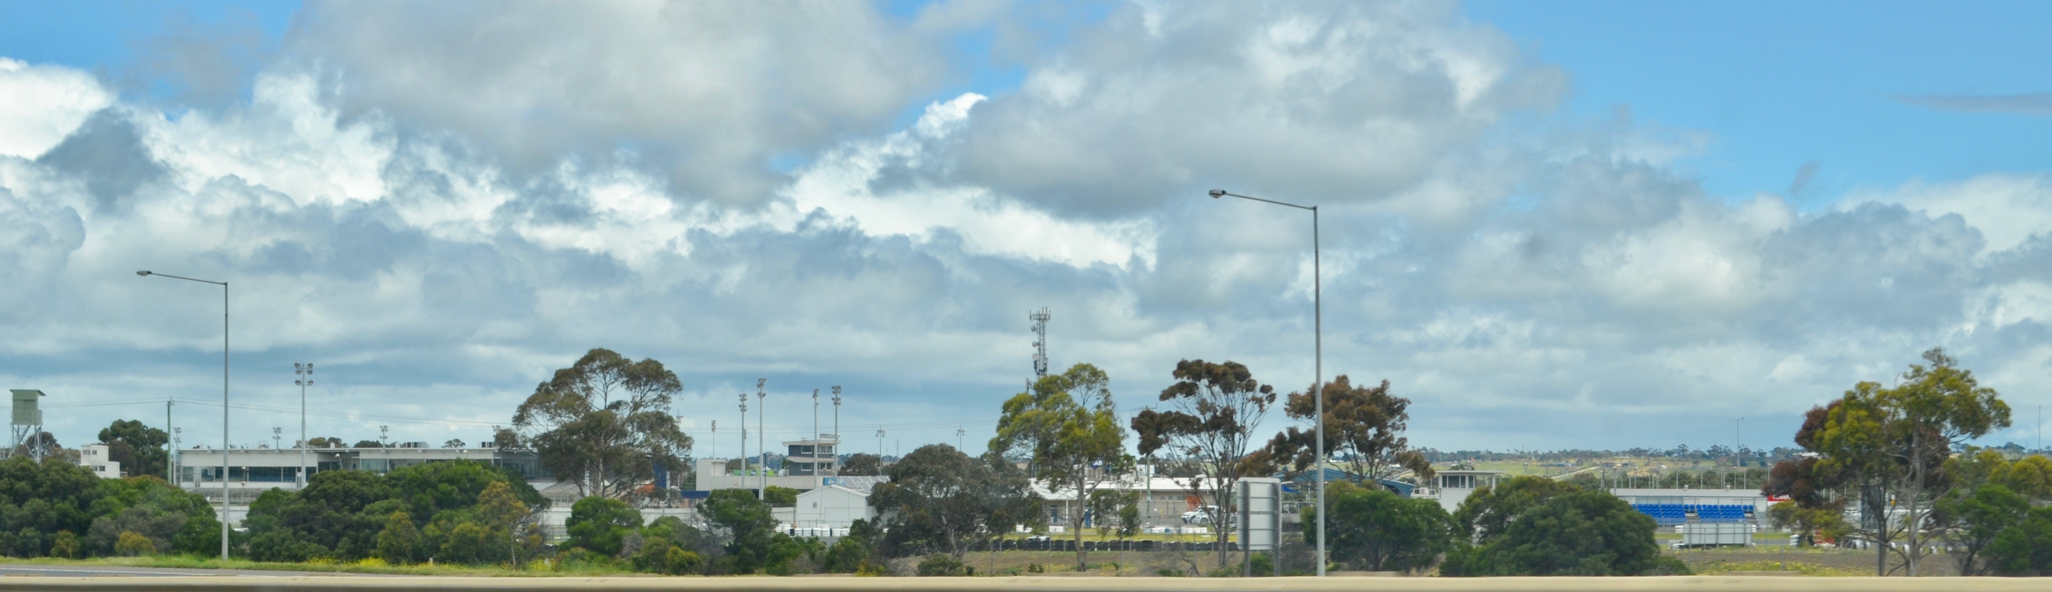
There are no direct local policies relating to advertising signage. The Advertising Sign Guidelines, City of Greater Geelong, November 1997 is an Incorporated Document pursuant to the Schedule to Clause 81.01. The provisions of this policy are not directly relevant to the circumstances associated with the subject proposal given its freeway location and the nature of surrounding development (essentially a highway / freeway environment).

View towards Beckley Park travelling on the Princes Highway towards Geelong

Background

5.1 Need for the Amendment
The Committee of Management seeks the opportunity to have major promotion signs considered for Beckley Park. These signs will provide revenue and the funds can be used to offset operating costs and support future development works. The Committee has approached and been given support by the Land Management Policy section of DELWP to facilitate this outcome.
The amendment is necessary as the present zoning provisions of the Special Use Zone (Schedule 4) do not allow the consideration of an application for major promotional signage. The change sought will insert a site specific provision that will apply only to the subject site. This provision will apply the Category 2 requirements at Clause 52.05.

5.2 Precedent
Amendment C165 to the Greater Bendigo Planning Scheme was prepared by the Minister for Planning in response to a request from the Heathcote Football and Netball Club. The amendment applied to Barrack Reserve, located in central Heathcote between High Street and McIvor Creek. The amendment was required as it would facilitate the display of promotional signage at Barrack Reserve, which would otherwise be prohibited under the advertising controls of clause 52.05. The Public Park and Recreation Zone and Urban Floodway Zone identify advertising signage requirements as Category 4 – Sensitive areas.
The amendment made the following changes:
- Amends the schedules to the Public Park and Recreation Zone and Urban Floodway Zone to identify the applicable advertising sign category for Barrack Reserve, Heathcote as Category 2.
- Provides for a planning permit to be granted for Advertising Signage.
The amendment was considered to implement the objectives of planning in Victoria for the following reason:
The amendment implements the objectives of planning in Victoria by providing an opportunity for the consideration of the ongoing display of suitable outdoor advertising signage in appropriate main road locations which will contribute to the complexity of the built environment in accordance with Section 4(1)c of the Planning and Environment Act 1987.

There are a number of parallels between the Heathcote site and what is proposed for Beckley Park. These are:
- similar public benefit outcomes in terms of funding public reserves and sporting groups;
- similar zoning restrictions (ie between the PPRZ and the SUZ4); and
- similar remedy mechanisms are proposed (ie. a site specific variation in the Schedule).
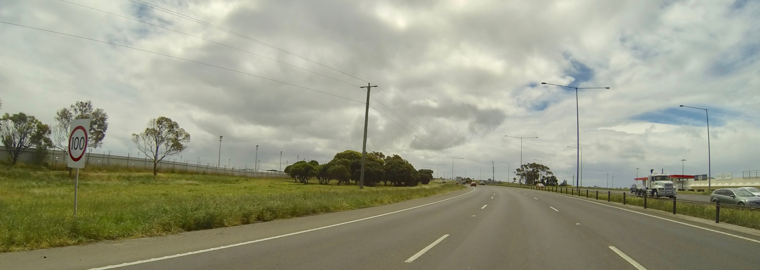

The approach to Beckley Park consists of significant road infrastructure Above, heading north towards Melbourne, Below, the Princes Hwy / Ring Road diverge
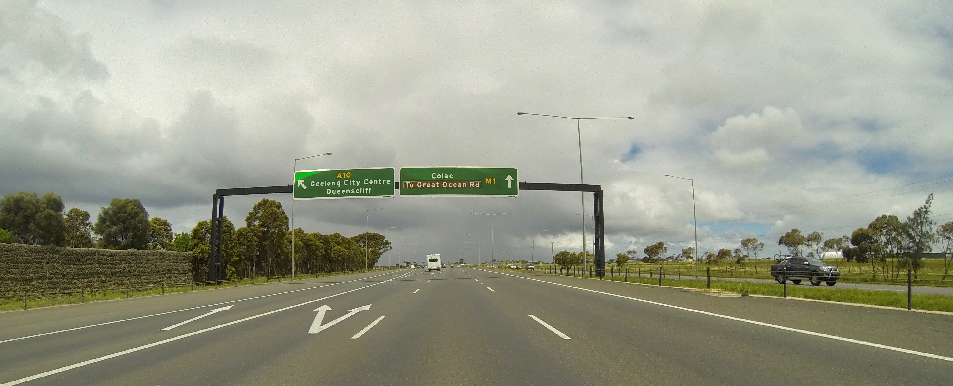

Indicative Proposal
Indicative plans have been prepared which show potential sign locations and details.
Sign 1
Sign 1 consists of a V shaped advertising display (a standard sign design for arterial roads). The sign will have display faces of 18.99m x 4.5m with a 0.6m underside cladding. The sign will have two faces. The east face (ie. displayed towards motorists travelling towards Colac) will have an electronic display face. The west face (ie. for motorists heading towards Melbourne) will be a static (not electronic) sign. The sign will have an overall height of 19.49mn. The sign will be positioned approximately mid point along the Beckley Park boundary to the Ring Road.
Sign 2
Sign 2 is a V shaped advertising display. The sign will have sign faces of 18.99m x 4.5m with a 0.6m underside cladding. The sign will have two faces. The north face (ie. displayed towards motorists travelling towards Geelong), will have an electronic display face. The south face (ie. for motorists heading towards Melbourne) will be a static (not electronic) sign. The sign will have an overall height of 19.49mn. The sign will be positioned approximately mid point along the boundary to the Princes Highway.
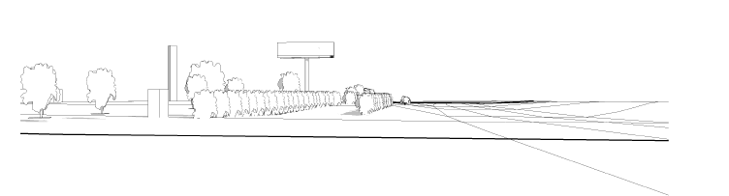

Perspective of Sign 1 travelling in a westerly direction along the Ring Road.

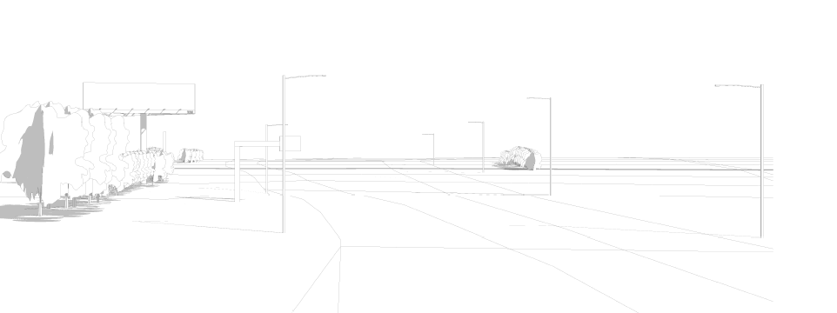

Perspective of Sign 2 travelling in a northerly direction along the Princes Highway

We note that before any major promotion signage can be erected at Beckley Park a planning permit must be issued. During the planning application process, a full assessment will be undertaken which will be subject to numerous inputs including from VicRoads. The sign proposals shown are indicative only. Approval of the amendment does not imply they will be approved.
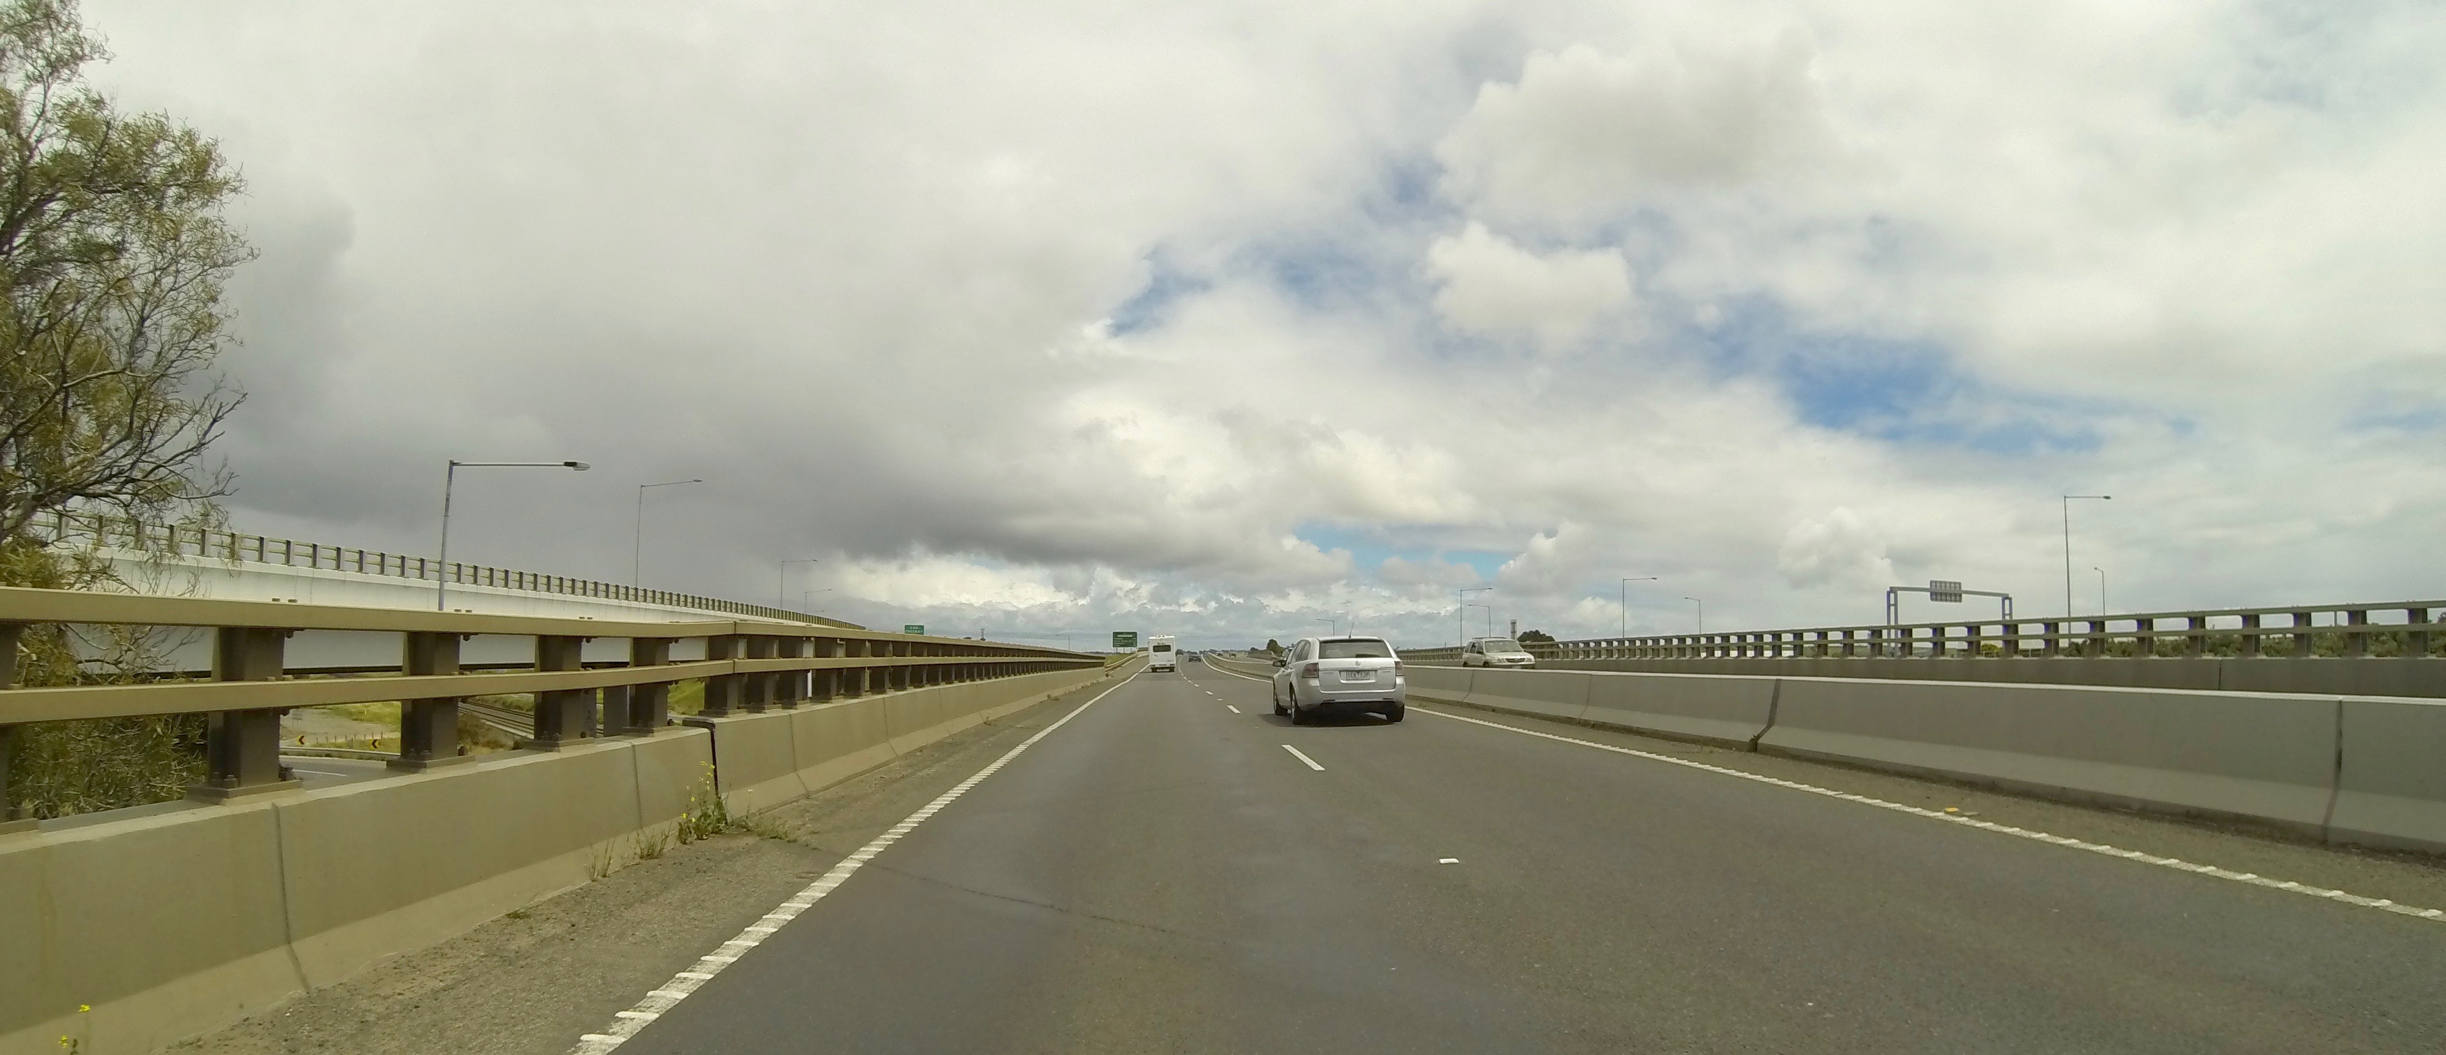

The diverge between the Princes Hwy and Ring Road involves substantial elevated structures which have a significant bearing on the driver experience

Planning Assessment

7.1 Overview
The proposed planning scheme amendment seeks to allow the consideration of major promotional signage at a significant sporting and community facility. Beckley Park is ideally suited for major promotional displays having long abuttals to two significant major transport routes. There is already major promotional signage within the vicinity and therefore the proposed signage will not introduce a foreign element. The likely position of the signage is well away from sensitive uses.
Beckley Park is an appropriate location for a major promotion signage for the following reasons.
- The likely signage locations are well separated from residential development and other sensitive land uses. They will not be a dominant visual element when viewed from these areas.
- The Princes Highway and Geelong Ring Road are main traffic routes. The site is not identified as a ‘gateway’ by the planning scheme.
- The signage will not impact on any architectural landmarks that deserve special protection.
- The display will not intrude into views of parkland or compromise the value of parkland.
- The sole viewing audience for the signage will be motorists travelling along main roads. The signage will have no presence apart from this approach.
- The adjacent buildings within the Beckley Park complex provide a physical counterpoint to the proposed signage as does the substantial highway structures and infrastructure.
- The visual impact of the signage will be limited due to its position and approach points.
- The signage will not compete with other signage on buildings or elsewhere along the road corridor, nor will it contribute to visual clutter.
- Road safety issues can be assessed at the planning permit application stage however we note there are no traffic directional signage or areas requiring high levels of driver concentration near the approaches to the signage.

7.2 Clause 52.05
The provisions of Clause 52.05-6 set out locational criteria for the display of major promotion signs. These criteria are addressed below.
Planning Scheme Provision | Response
Clause 52.05-6: Major Promotion Signs
Major promotion signs are encouraged in commercial and industrial locations in a manner which complements or enhances the character of the area. | In terms of the locational principles set out at Clause 52.05, the subject site is located within a primary transport corridor. The two main roads adjacent the site have a significant physical presence in terms of how the landscape is read and experienced. The signage relates to the main road corridor and not a typical urban area where ‘character’ or ‘streetscape’ issues are important considerations.
Major promotion signs are discouraged within open space reserves or corridors and around waterways. | Open space reserves or waterways do not abut the site.
Major promotion signs are discouraged where they will form a dominant visual element from residential areas, within a heritage place or where they will obstruct significant view-lines. | The proposed signage is not adjacent residential land. It is well distanced from residential land and Beckley Park provides an intervening area.
In areas with a strong built form character, major promotion signs are encouraged only where they are not a dominant element in the streetscape and except for transparent feature signs (such as neon signs), are discouraged from being erected on the roof of a building. | The setting is one strongly influenced by late twentieth century main road engineering. The site sits within a massive urban infrastructure element which is designed to convey large volumes of traffic at high speed.

In response to the various Planning Scheme criteria, the following is noted in support of the proposal:
- The signage is consistent with the advertising theme found along main roads within the metropolitan area and regional cities.
- As encouraged by policy, there is no advertising competition in terms of view shed.

- The visual amenity of the area can be assessed, there is no valued amenity to which the signage could cause detriment (ie. the host site or surrounds).
- The sign will not result in, or cause visual clutter.
- There is general compliance with signage provisions within the SPPF given this location.
- No valuable viewing corridors or impacts on residential amenity would occur.
- The subject site is not nominated in the planning scheme as a gateway.
Transport corridors are preferable locations for advertising signs in contrast to more sensitive sites, because of their built form and lower levels of actual or expected urban amenity. Planning policy reflected in the planning scheme contemplates the presence of significant outdoor signage in such main road locations. Planning controls seek to regulate the impact of such signage to prevent clutter, interference with prominent views or detrimental impacts on the safety or efficiency of adjacent main roads. It has now been accepted on many occasions that well designed and sited advertising signage is a legitimate element along appropriate sections of main roads and freeways.
The subject site is located adjacent two major transport corridors where long distant views are not apparent. We note the site is not at a major gateway point, landmark site or within a view protection zone, heritage or height control area. The signage will not contribute to clutter or interfere with view-lines to existing signage or notable buildings or key viewing points. The interpretation of the signage will be strongly influenced by the functional style of the main road corridor and the width of the roadway reservations which form a framing element. The proposed signage will not sit within traditional streetscapes.
The area cannot be said to have a ‘strong built form character' (a key assessment criteria identified in Clause 52.05-6) The proposed signage is for a site within two significant road corridors. The impact of signage must therefore be assessed with regards the existing character. This is a point made by VCAT in the decision of IOM Pty Ltd v Knox CC & Ors [2012] VCAT 1447 which was cited with approval in the decision IOM Pty Ltd v Knox CC [2014] VCAT 1315.
- In an application for review by the applicant company, Member Taranto provided a useful summary of ‘key principles’ emerging from other Tribunal decisions. I also adopt those principles, which are as follows:
- Proposals for major promotion signs should be assessed from a neutral rather than negative point of view (Kings Funeral Services v Greater Dandenong CC).

- An inherent quality of major promotion signs is that they are typically placed in prominent locations and of a scale to maximise their exposure — that is they are designed to be seen and attract attention to themselves (Caption Pty Ltd v Melbourne CC).
- As a matter of principle, it cannot be fairly said that major promotion signs reduce visual amenity (Wyndson Pty Ltd v Bayside CC).
- Such signs are a legitimate commercial activity (Wyndson Pty Ltd v Bayside CC).
- Major promotion signs can serve an important function in relation to public information and awareness and can add interest, colour and character to an area (Buckle Outdoor Advertising Pty Ltd v Port Phillip CC & Ors).
- The critical element is that any major promotion sign is of a scale, form and location that is appropriate in the context of the existing physical environment (Buckle Outdoor Advertising Pty Ltd v Port Phillip CC & Ors).
- Any sign must be consistent with planning policies guiding future development and have regard to potential amenity impacts on surrounding uses (Buckle Outdoor Advertising Pty Ltd v Port Phillip CC & Ors).
- In another decision, Member Taranto adopted the approach advanced by Senior Member Byard that ‘Sign cases … have to be judged on their own merits and on their own design, site context and location’. I also adopt that approach.
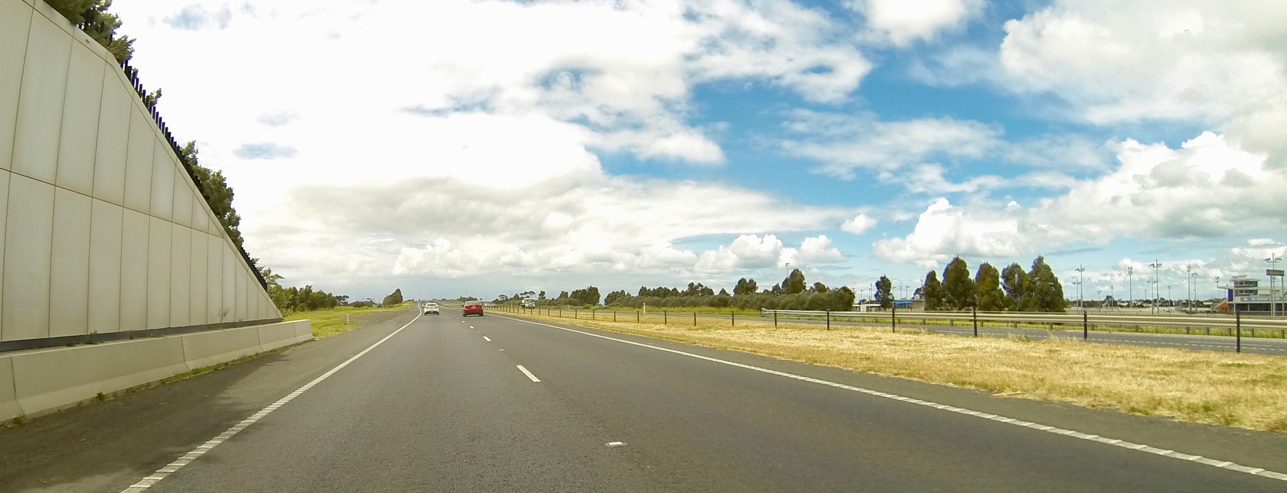
Heading east along the Ring Road with Beckley Park to right of photo

7.3 Geelong Racecourse and Showgrounds
As noted, the Special Use Zone (Schedule 4) relates to the ‘Geelong Showgrounds and Racecourse’. The Purpose of the control includes:
- To encourage the use and development of the Geelong Showgrounds and Racecourse for a range of entertainment, recreational, commercial and community activities.
- To encourage a variety of uses of the land and buildings within the Geelong Showgrounds and Racecourse facility in order to enable its usage throughout the year.
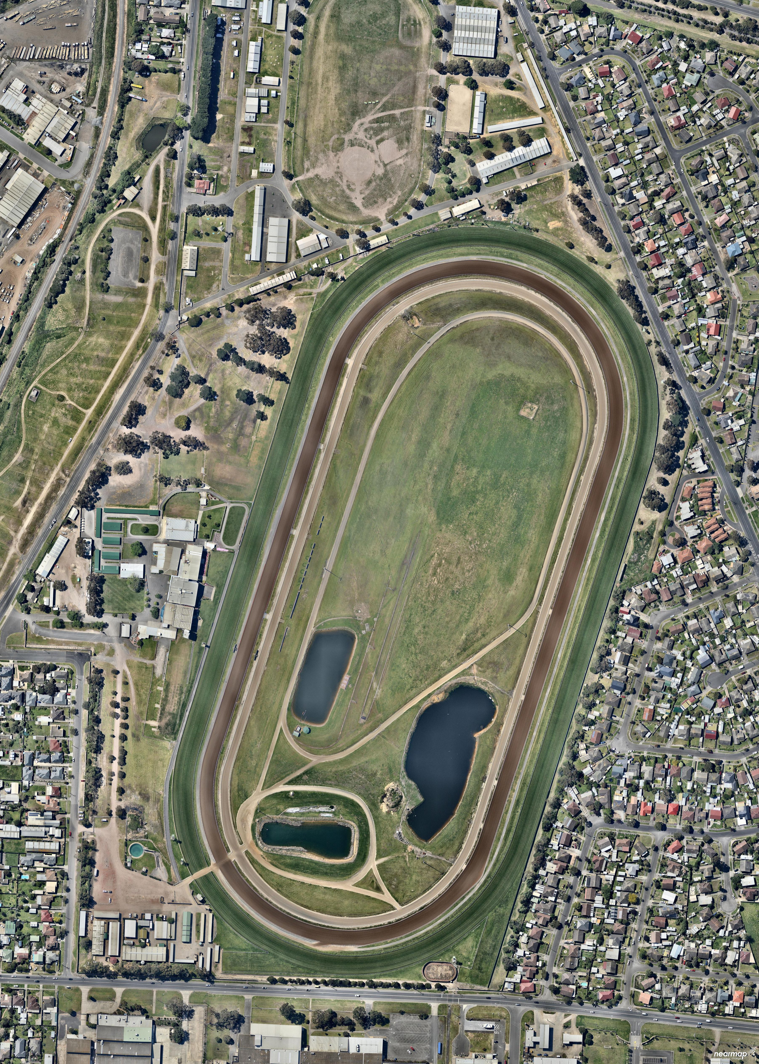
The first two Objectives relate specifically to the Geelong Showgrounds and Racecourse. Of note the land use conditions around Beckley Park are very different to those adjacent the Geelong Racecourse and the Geelong Showgrounds (see aerial below).

The Racecourse and Showgrounds are located in Breakwater a hinterland suburban location. Main roads (of the nature of the Princes Highway and Geelong Ring Road) do not abut the facilities. The predominant surrounding land uses are residential and these are low scale in character. Therefore the continued placement of signage controls within Category 3 (High amenity areas) which implies substantial restrictions is logical for the Showgrounds and Racecourse. Major promotional signage on the periphery of either the Showgrounds or Racecourse would be inconsistent with the signage siting guidelines and specifications of Clause 52.05-6. The same conclusion cannot be reached for Beckley Park.

7.4 Strategic Justification of the Amendment
Why is the Amendment required?
The amendment is required to facilitate the display of promotional signage at Beckley Park, which would otherwise be prohibited under the advertising controls of Clause 52.05. The Special Use Zone identifies advertising signage requirements as Category 3 – High amenity areas.
How does the Amendment implement the objectives of planning in Victoria?
The amendment implements the objectives of planning in Victoria by providing the opportunity for the consideration of the ongoing display of suitable outdoor advertising signage in appropriate main road locations which will contribute to the complexity of the built environment in accordance with Section 4(1)c of the Planning and Environment Act 1987.
How does the Amendment address any environmental, social and economic effects?
There are no social, economic or environmental impacts arising for the amendment.
Does the Amendment address relevant bushfire risk?
There are no relevant bushfire risks as a result of the proposed amendment.
Does the Amendment comply with the requirements of any Minister’s Direction applicable to the amendment?
The amendment is consistent with the Ministerial Direction on the Form and Content of Planning Schemes under section 7(5) of the Act.

How does the Amendment support or implement the State Planning Policy Framework and any adopted State policy?
Clause 18.01 relates to development along highways, railways and tramways. The following policy guideline is considered relevant:
- The design of transport routes and nearby areas should be planned and regulated to achieve high visual standards appropriate to the importance of the route with particular reference to landscape, the control of outdoor advertising and, where appropriate the provisions of buffer zones and resting places.
How does the Amendment support or implement the Local Planning Policy Framework, and specifically the Municipal Strategic Statement?
Clause 21.08-2 highlights the importance of the presentation of development along highways and major roads. The Clause has as an Objective:
- To improve the appearance of transport routes at key entrances to townships and urban areas.
The amendment supports the above policy and provides for appropriate direction in relation to promotional signage at Beckley Park.
Does the Amendment make proper use of the Victoria Planning Provisions?
The amendment uses the Schedule at Clause 37.01 which forms part of the VPP.
How does the Amendment address the views of any relevant agency?
The views of agencies and authorities were sought during the drafting of the amendment documents. Agencies will have an opportunity to comment on the proposed changes to the Special Use Zone – Schedule 4 during the exhibition period.
Does the Amendment address relevant requirements of the Transport Integration Act 2010?
There are no significant impacts on the transport system defined by the Transport Integration Act as a result of this amendment.

Conclusion
Beckley Park is developed with a series of significant community and recreational resources. It is located adjacent two significant transport routes. There is considerable potential to place major promotional signage adjacent these road corridors. There are no sensitive uses nearby and there is a high degree of consistency with the parameters established by Clause 52.05-6. Beckley Park shares the same zoning and signage controls as apply to the Geelong Showgrounds and Geelong Racecourse. The locational attributes and site context that applies to Beckley Park is however substantially different and far more accommodating to a major promotional sign proposal than applies to the Geelong Showgrounds and Geelong Racecourse. It is therefore appropriate that the planning controls recognise this difference.
The Committee of Management has approached and secured support from the Land Management Policy section of DELWP to pursue major promotional signage at Beckley Park. The proposed planning scheme amendment will allow this opportunity. Any future proposal for major promotional signage would be subject to the planning permit application process.
This Amendment proposes a site specific provision be inserted into Schedule 4 of the Special Use Zone to change the class of advertising Category. The amendment has limited external implications given the surrounding site context (ie. where the signs are likely to be placed).

It is considered that there is substantial strategic merit in the proposal and accordingly, it is worthy of Council’s support. On this basis, it is respectfully requested that Council seek Ministerial Authorisation to prepare a Planning Scheme Amendment to alter the controls for the subject site in accordance with the draft amendment documents which accompany this report

Peter Jewell

Town Planner
Jewell Partnership P/L

