AMENDMENT C367 to the GREATER GEELONG PLANNING SCHEME and PERMIT APPLICATION No. PP-1463-2016

2-120 MOLLERS LANE and 10 WILLOWS PLACE LEOPOLD

Part A (1) Council’s Main Submission to the Independent Panel

Panel: Sarah Carlisle (Chair), Gabby McMillan
Date: Monday 3 December 2018
Prepared by: Susan Williamson, Senior Strategic Planner and Leanne Stockley, Senior Town Planner on behalf of the City of Greater Geelong
TABLE OF CONTENTS
INTRODUCTION 4
The Amendment 4
The Main Issues 4
Summary of Council’s Part A submissions 4
The Proposed Amendment, Planning Permit and Section 173 Agreement 6
LOCATION AND CONTEXT 10
Greater Geelong and Bellarine Peninsula Context 10
Leopold Context 12
Existing zoning 16
Existing Overlays 17
Existing Building Regulations 18
BACKGROUND 19
Background to Amendment C367 19
Chronology of Events 20
Strategic Influences 20
Leopold Structure Plan 1990 20
Urban Growth Strategy 1996 22
Leopold Structure Plan 2006 22
Leopold Structure Plan September 2011 (Amended Jan 2013) 25
G21 Regional Growth Plan 2013 27
STRATEGIC CONTEXT AND ASSESSMENT 29
Strategic Assessment 29
Bellarine Peninsula Localised Planning Statement 2015 29
South East Leopold Framework Plan (2016) 35
City of Greater Geelong Settlement Strategy (October 2018) 38
Consideration against the Planning Policy Framework 40
Status of the combined amendment/permit application affecting the Eastern Ash land 49
EXHIBITION AND SUBMISSIONS 50
Council resolution to prepare and exhibit an Amendment 50
Ministerial Authorisation 50
Exhibition 51
Submissions received 51
Council resolution regarding the submissions 52
ISSUES RAISED IN SUBMISSIONS 53
Changes to the settlement boundary and impact on Bellarine Peninsula 53
Downstream stormwater impacts 54
Impact on duck hunting activities 54
Impact on Lake Connewarre 55
Provision of Open Space 55
South west corner land use 56
Transport Infrastructure Provision 56
Integration with the adjoining area to the west 57
Impacts on surrounding residential character 57
Form of the amendment 58
Form of the planning permit 58
CONCLUSION 60
APPENDICES 61
Appendix 1 – Chronology of events 61
Appendix 2 - Response to Strategic Assessment Guidelines as extracted from the Explanatory Report 63
Appendix 3a - Authorisation for C367 from the Minister’s delegate 67
Appendix 3b – Authorisation clarification advice from DELWP 14 November 2018 68
Appendix 4 – Advice from Mr Vella rescinding his submission 69
Appendix 5 – Exemption from Ministerial Direction No. 15 4(3) 70

TABLE OF FIGURES
Figure 1a and 1b – Leopold Exhibited Overlay Maps. 7
Figure 2 – Leopold Exhibited Zone map. 9
Figure 3 - Leopold in context of Geelong Region 11
Figure 4 - Leopold area map 13
Figure 5 - Aerial map of Leopold area 14
Figure 6 - Port Phillip Bay (Western Shoreline) and Bellarine Peninsula Ramsar Site 15
Figure 7 - Existing Zoning 16
Figure 8 – Existing Overlays Map 17
Figure 9 – Flood & Fire Prone Areas Map 18
Figure 10 – Leopold Structure Plan Map 1990 21
Figure 11 – Leopold Structure Plan Map 2005 24
Figure 12 – Leopold Structure Plan Map 26
Figure 13 – Extract of Settlement and Employment Growth Directions from G21 RGP 28
Figure 14 - Bellarine Peninsula Localised PS Framework Plan 32
Figure 15 – South East Leopold Framework Plan 2016 37
Figure 16 - Greater Geelong Housing Framework Plan 2036 39

INTRODUCTION
- This submission has been prepared by the Planning Authority, the City of Greater Geelong, for the Panel appointed to consider submissions about for Amendment C367 and Permit Application No PP1463/2016.

The Amendment
- In brief, the Amendment proposes to rezone land in Mollers Lane, Leopold to General Residential Zone Schedule 1, to allow residential development of the land. The permit application is for a 494 lot subdivision of the land.
- The Amendment also proposes to apply the Design and Development Overlay Schedule 43 and delete the SLO10 from the subject land. Changes to the Municipal Strategic Statement Clause 21.14 are also proposed.

The Main Issues
- The main issues that have come out of submissions are as follows:
- Changes to the settlement boundary and impact on Bellarine Peninsula
- Downstream stormwater impacts
- Land use conflict with hunting activities
- Impact on Lake Connewarre
- Transport Infrastructure provision
- South west corner land use
- Impacts on character of the surrounding area
- Form of the amendment
- Form of the permit
- Integration with the East Ash area
- Open space provision

Summary of Council’s Part A submissions
- This Council Part A (1) submission takes the Panel through what is proposed, the site context and background. It then moves to the consideration of the proposal against policy and describes the formal exhibition process. The final part of our Part A (1) submission outlines the issues arising from the submissions to the Amendment.
- Council’s Part A (2) submission contains the Council Officer Delegate Report Assessment of the Planning Permit Application. The assessment is made against planning scheme policy, clause 52.17 and Clause 56. This Part A (2) also includes the referral authority replies and an assessment of the impact of VC148 and VC154 as directed by the Panel.
- Council’s Part A (3) submission includes the track changes draft planning permit as directed by the Panel.
- Council’s Part A (4) submission summary of changes or retention of conditions as directed by the Panel.

The Proposed Amendment, Planning Permit and Section 173 Agreement
- Amendment C367 proposes the following changes to the Planning Scheme:
- Amend Clause 21.14 Bellarine Peninsula to extend the settlement boundary on the Leopold Structure Plan Map and to refer to the South East Leopold Framework Plan 2016.
- Rezone all the land in the Farming Zone to the General Residential Zone Schedule 1.
- Insert a new Schedule 43 to Clause 43.02 Design and Development Overlay that will apply to all the land being rezoned to General Residential Zone Schedule 1 and to the land at 10 Willows Place (already included in the General Residential Zone Schedule 1).
- Delete Significant Landscape Overlay Schedule 10 (Lake Connewarre Escarpment) from the land being rezoned.
- The exhibited planning scheme map and ordinance changes are available on Council’s Amendments webpage at (under the heading ‘Amendment documents’): https://www.geelongaustralia.com.au/amendments/item/8d5b4f00f8ea54f.aspx
- The amendment is accompanied by
- a draft planning permit for a subdivision creating 494 lots (only applicable to the land at 2-120 Mollers Lane).
- an agreement under Section 173 of the Planning and Environment Act 1987 to collect development contributions for community projects in Leopold (again only applicable to the land at 2-120 Mollers Lane).
- The exhibited new zone and overlay maps are shown on the following pages.
Figure 1a and 1b – Leopold Exhibited Overlay Maps.
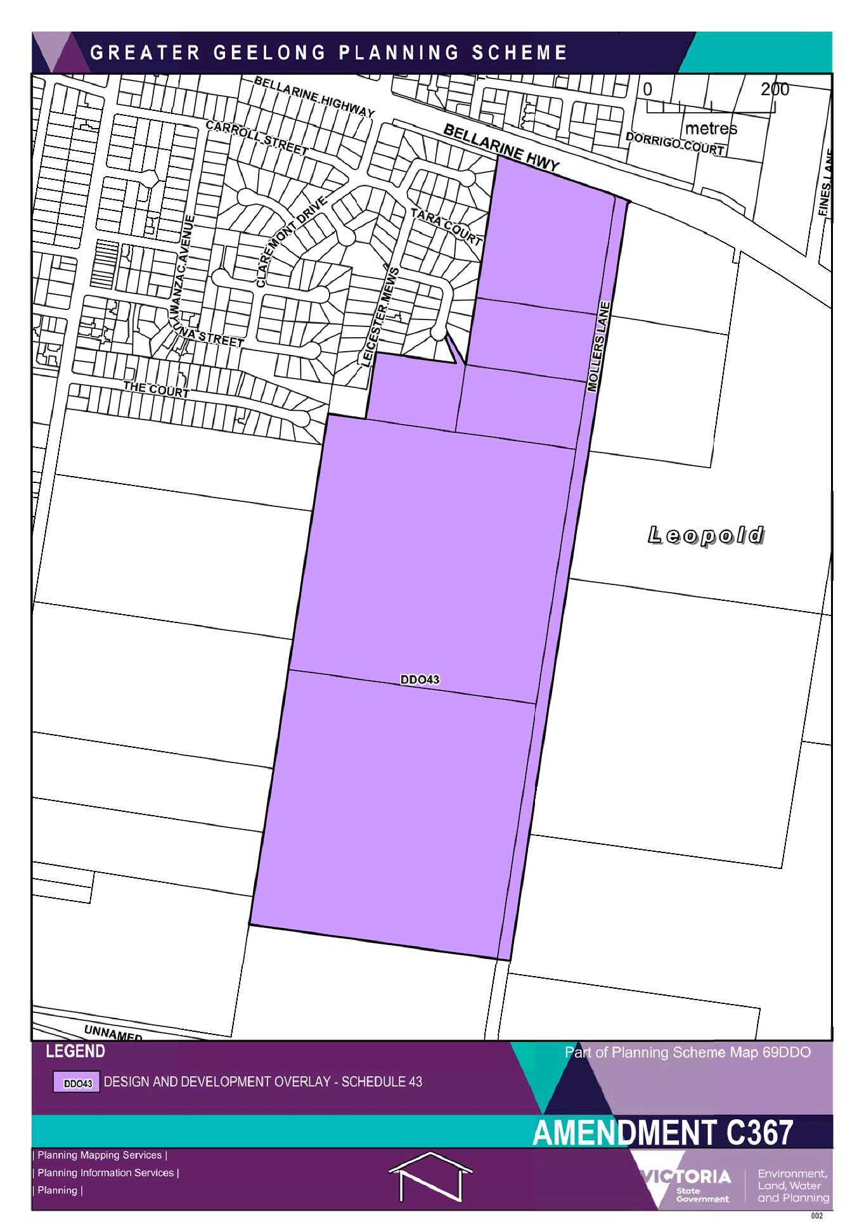
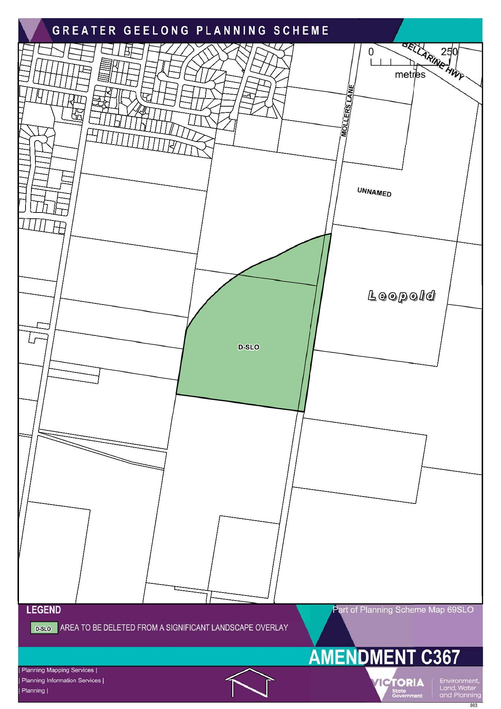
Figure 2 – Leopold Exhibited Zone map.
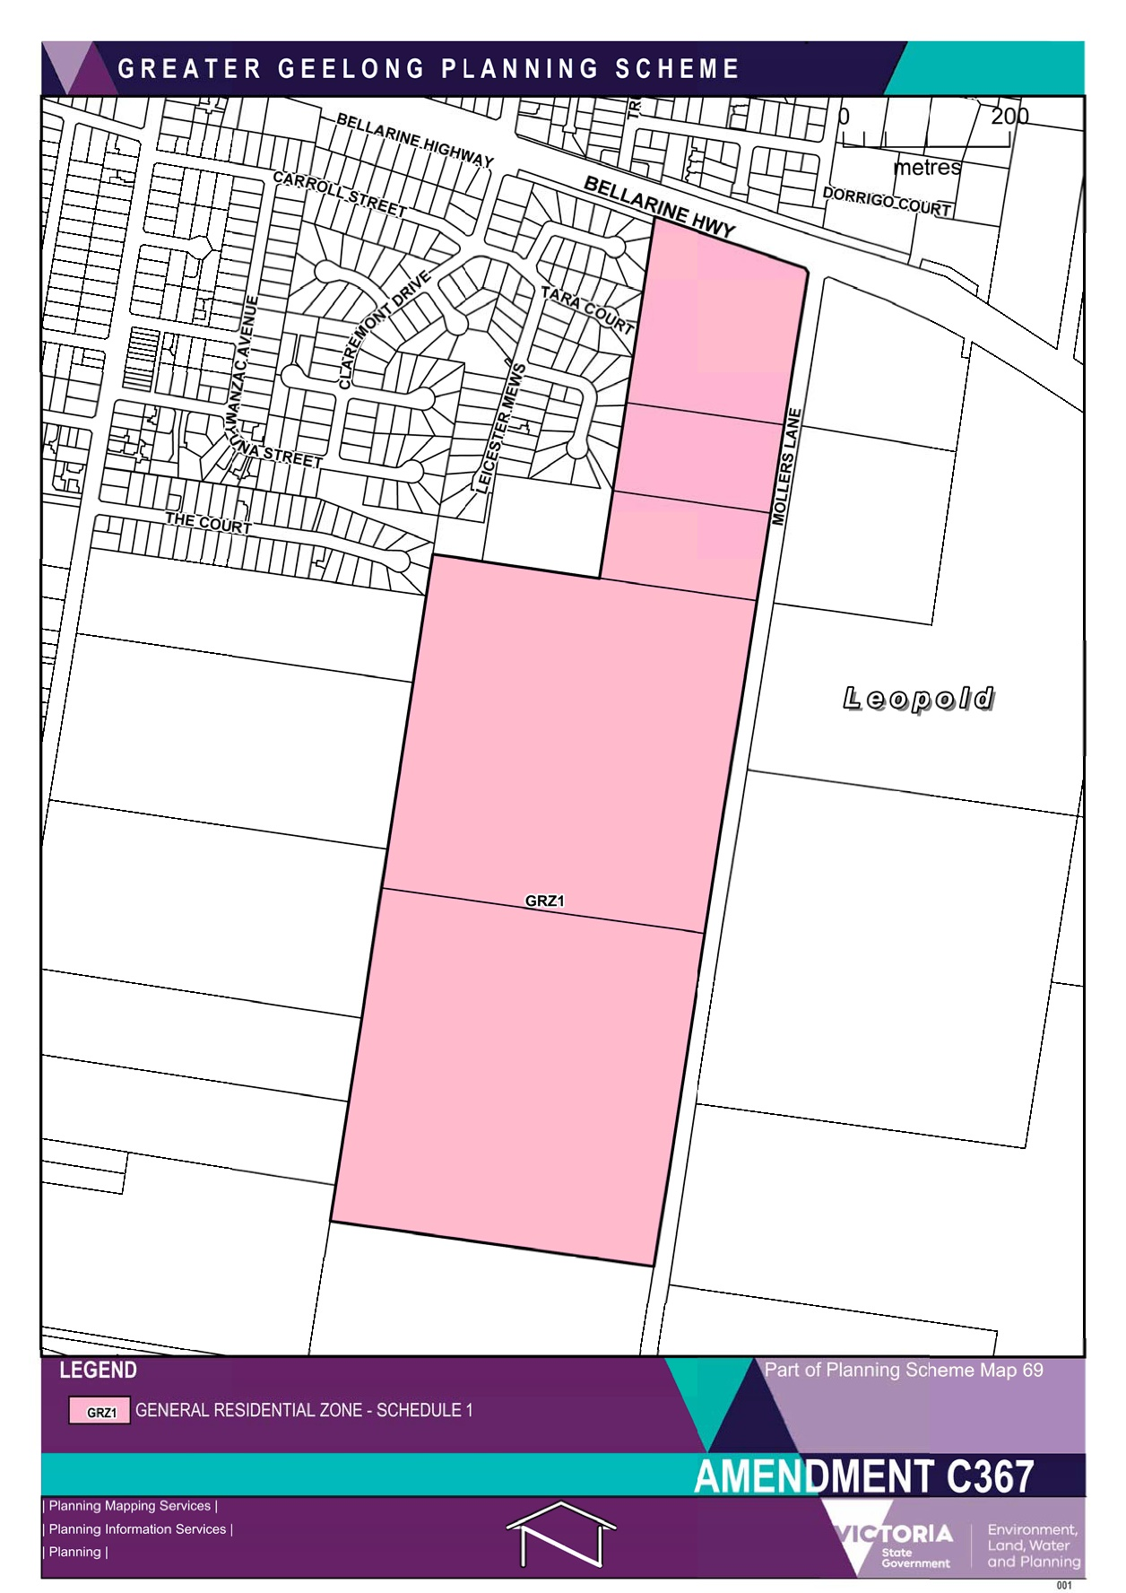

LOCATION AND CONTEXT

Greater Geelong and Bellarine Peninsula Context
- As Victoria’s second largest city in the fastest growing region, Geelong is the primary service centre in the south-western half of the state, playing a key support role to Melbourne. With its close proximity to the State’s capital, Geelong is increasingly being seen as a major urban growth location within the broader Melbourne context.
- Greater Geelong’s population has grown from 216,000 to 239,000 people over the last five years (ABS June 2017). During this time, the growth rate increased from 1.5 per cent, to 2.7 per cent. It is anticipated that Greater Geelong will continue to experience strong growth and demand for housing over a sustained period.
- The Bellarine Peninsula is located approximately 90 kilometres from Melbourne and approximately 12 kilometres to the east of the urban area of Geelong. It features significant wetland areas and open farmed landscapes with the distinct townships of Barwon Heads, Drysdale/Clifton Springs, Indented Head, Leopold, Ocean Grove, Point Lonsdale, Portarlington, Queenscliff, St Leonards and the rural living area around Wallington. Most townships are located along the coast, are popular with holiday makers, and in recent years have attracted increased numbers of permanent residents.
- Leopold is located approximately 12 kilometres to the east of Geelong. It traverses the Bellarine Highway and is bound to the north by the Portarlington Road and to the south by Lake Connewarre.
- The urban growth boundary has typically been constrained on the western side by poorly drained flood prone land beyond Melaluka Road. The eastern boundary of the town was defined in the 1990 Structure Plan but this has changed over time and residential development has since extended beyond the boundary of the previous 1990 and 2006 Structure Plans.
- The Leopold Structure Plan (2013) estimates that the population of Ocean Grove will grow by about 6,000 people between 2015 and 2031; resulting in a total population of around 20,000 people. Growth of the town will result in an extensive expansion of community, retail and industrial related activities.
- The location of the town in relation to the rest of the municipality and within the Bellarine Peninsula is indicated on Figure 3.
Figure 3 - Leopold in context of Geelong Region
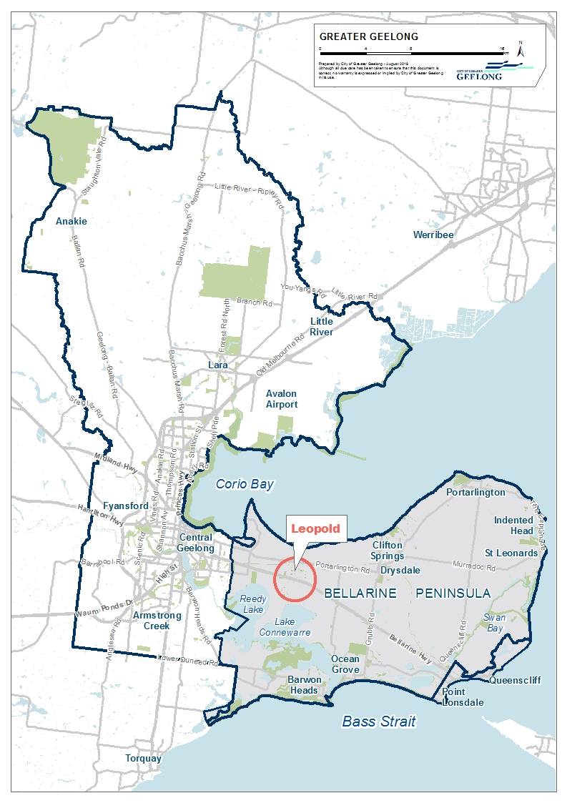

Leopold Context
- Leopold is regarded as the gateway to the Bellarine Peninsula and is well located to both the coastal townships of the Bellarine Peninsula (Ocean Grove ~15km) and central Geelong (~12km). The town is a distinct urban community located on a hillside bounded by Lake Connewarre to the south, drainage basin, wetlands and a shopping centre to the west, Port Phillip Bay to the north and farmland to the east.
- The major services within the town include a shopping centre, two small retail shopping strips, a recreation park (netball, tennis, cricket and football), primary school, kindergartens and neighbourhood centre. Leopold has a range of services to support the local community with Geelong providing higher end services. The Municipal Strategic Statement in the Greater Geelong Planning Scheme has identified Leopold as a potential sub-regional centre. A sub-regional role would see retail expanded to a level which would serve the Bellarine Peninsula.
- Leopold has been a designated growth area on the Bellarine Peninsula (along with Drysdale/Clifton Springs and Ocean Grove) however it is subject to a number of constraints in drainage, landscape values, maintaining a compact urban form and environmental values influence growth opportunities.
- Leopold is attractive to many first home buyers and families, and over 55s. It has a mostly permanent population and the majority of residents travel outside the township to work. Residents of Leopold rely almost entirely upon private cars for transport. The township has experienced strong growth due to several land releases, particularly along the southern flank of the town.
- According to the id population forecast, in 2017, the Estimated Resident Population of Leopold was 13,531. The population is forecast to grow to 18,076 by 2036 or a change of 34.07% between 2018 and 2036.
- Figures 4 and 5 map the local context of Leopold.
- To the south of the town lies the Barwon River and the Lake Connewarre system, which is a designated as part of the Port Phillip Bay (Western Shoreline) and Bellarine Peninsula RAMSAR site. Figure 6 shows the boundaries of this RAMSAR site- Reedy Lake to Barwon Heads, including Lake Connewarre, section.

Figure 4 - Leopold area map
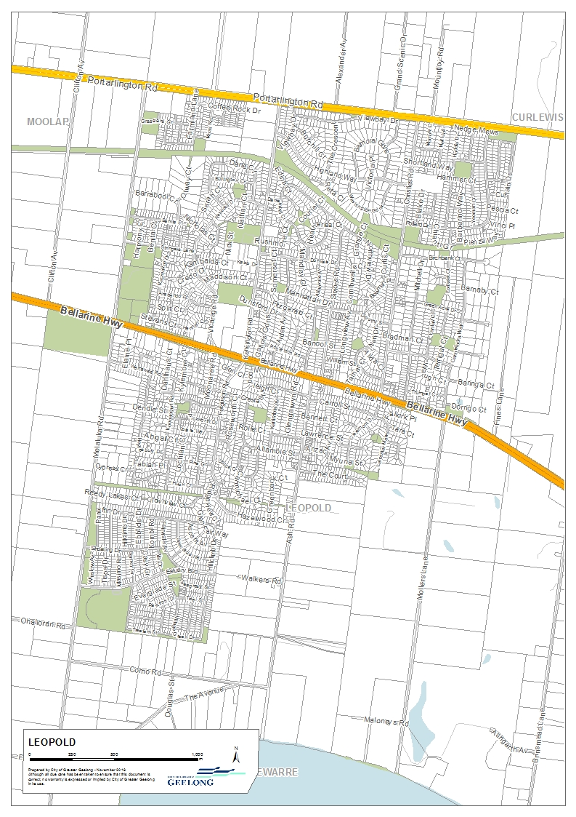
Figure 5 - Aerial map of Leopold area
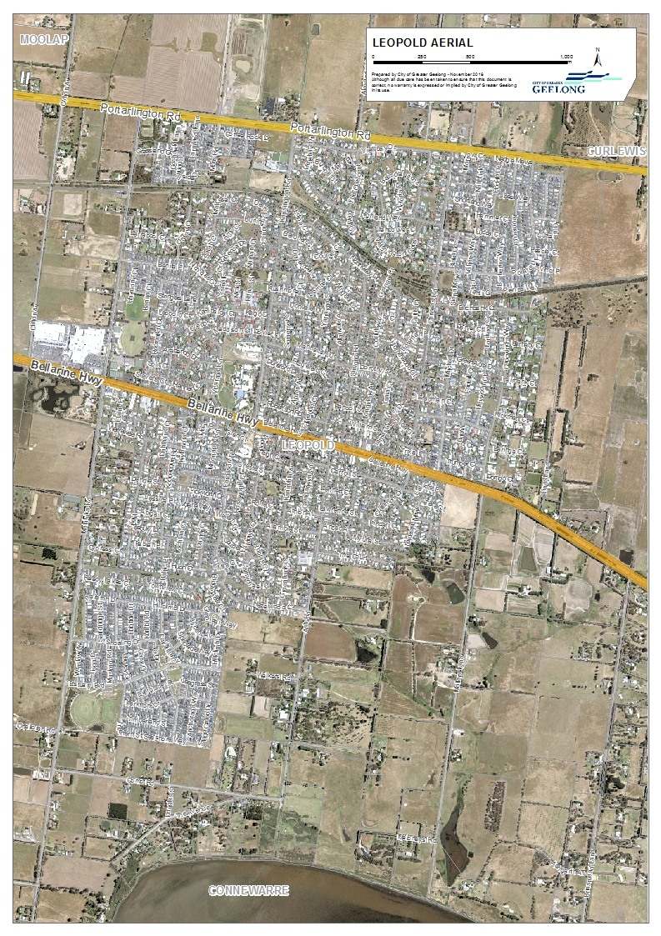

Figure 6 - Port Phillip Bay (Western Shoreline) and Bellarine Peninsula Ramsar Site

Existing zoning
- The zoning of Leopold is shown in Figure 7.
Figure 7 - Existing Zoning
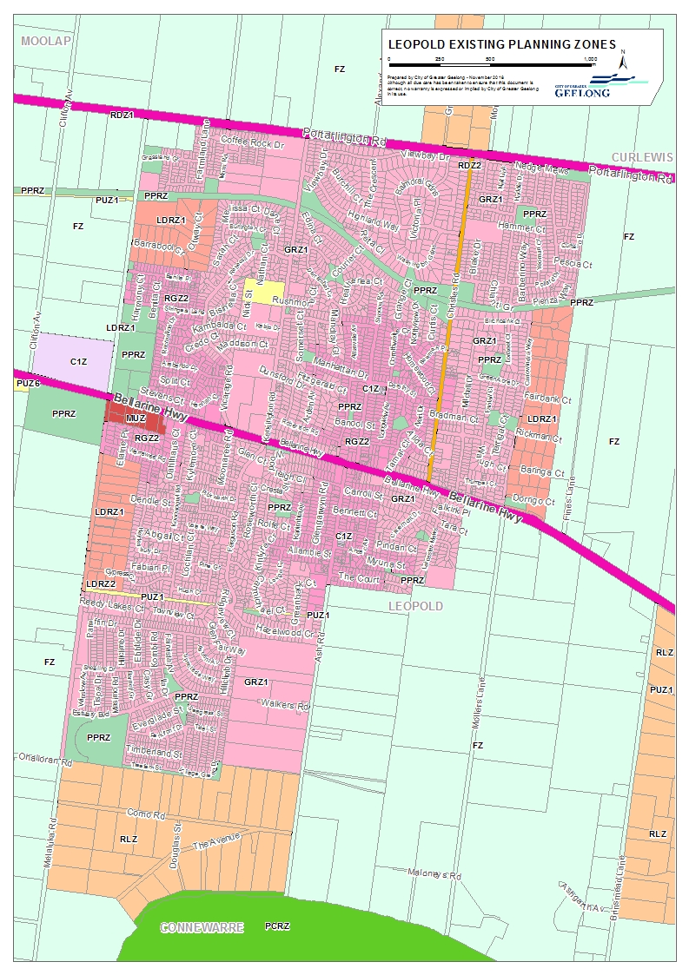

Existing Overlays
- Overlays applied to Leopold are shown in Figure 8.
Figure 8 – Existing Overlays Map
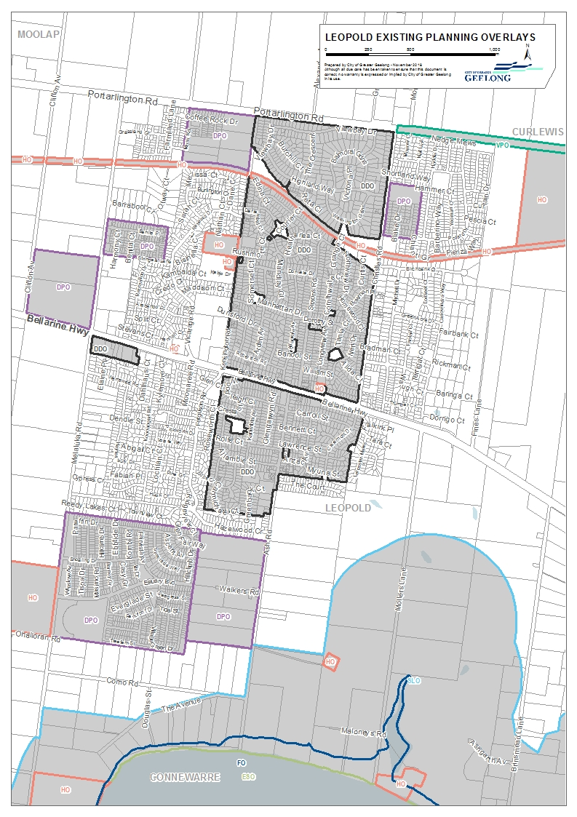

Existing Building Regulations
- The Building Regulations designate both flood and fire prone areas in Leopold as shown in Figure 9.
Figure 9 – Flood & Fire Prone Areas Map
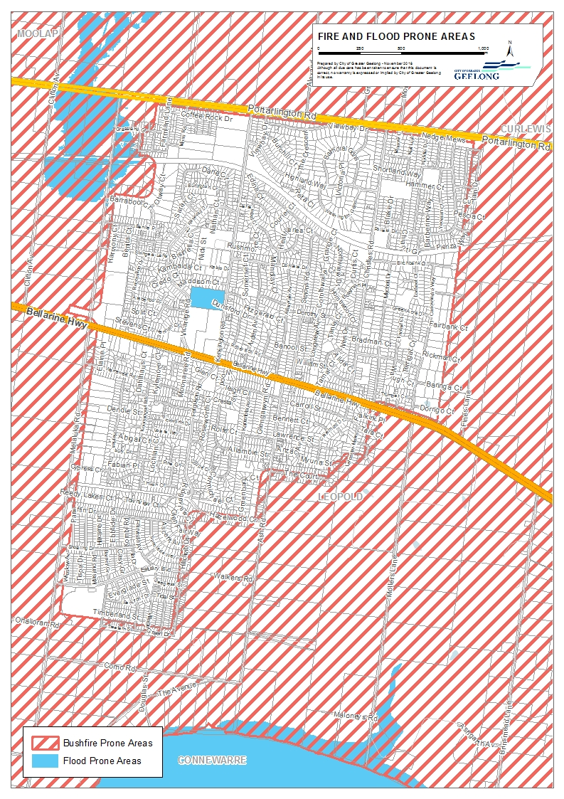

BACKGROUND

Background to Amendment C367
- Following the approval of Amendment C280 in March 2015 which rezoned to land on the west side of Ash Road Leopold to General Residential Zone 1, parties with an interest in the land between Ash Road and Mollers Lane, made approaches to the City of Greater Geelong about initiating planning scheme amendment requests. With the area being approximately 67 hectares, the real possibility of there being more than one developer interest and two development fronts, officers considered that a strategy that addressed the whole area was necessary before entertaining rezoning applications.
- In the second half of 2015, the City undertook to embark on a project to prepare a high level framework plan to guide the future rezoning and development of the next Leopold Urban Growth area – Ash Road East to Mollers Lane. The City was keen to ensure cohesive and coordinated development across this area and was to be prepared in advance of any rezoning applications being made. In December 2015 we engaged Tract Consultants to prepare the South East Leopold Growth Area Framework Plan, the project commencing in January 2016.
- Preliminary work was undertaken by officers to engage with relevant authorities such as Barwon Water and the Corangamite Catchment Management Authority (CCMA) to gain their requirements for this area, any information about area, any restrictions/opportunities for changes/additions to these area and other relevant factors/information. This provided valuable information for the consultants and the workshop.
- A workshop with landowners and Council officers was held in February 2016 to set out the parameters for the high level framework, and subsequently later in June the resulting Plan was presented to the landowners.
- On 12 December 2016, TGM Group Pty Ltd lodged with the City an application pursuant to section 96A of the Planning and Environment Act 1987 for a combined planning scheme amendment and planning permit application.
- Council on 20 September 2017 resolved to prepare and exhibit Amendment C367, consider the application for planning permit concurrently with the preparation of the Amendment, prepare a S173 Agreement for development contributions and to request Ministerial authorisation.
- In response to referral comments from various City Departments and a range of referral authorities and agencies, a revised and updated application (including supporting reports) was lodged on 29 January 2018.

Chronology of Events
- As requested in the Panel Directions, a chronology of events has been prepared, and is presented in table format at Appendix 1.

Strategic Influences

Leopold Structure Plan 1990
- This Structure Plan updated the 1978 Leopold Structure Plan as there had been significant growth in Leopold during the intervening 12 years. The Structure Plan was prepared by the Geelong Regional Commission with the assistance of the then Rural City of Bellarine Council.
- The strategy for providing growth in Leopold at that time was to retain its compact residential environment within its rural setting.
- The 1990 Plan identified the growth constraints for the town and highlighted the opportunities for new residential development. Additional future residential land was identified in two fronts south of the Bellarine Highway and in a number of areas between this Highway and the Portarlington Road. Figure 10 shows that 1990 Leopold Structure Plan map.
- Notably, the area subject to C367 is excluded from any future growth.

Figure 10 – Leopold Structure Plan Map 1990
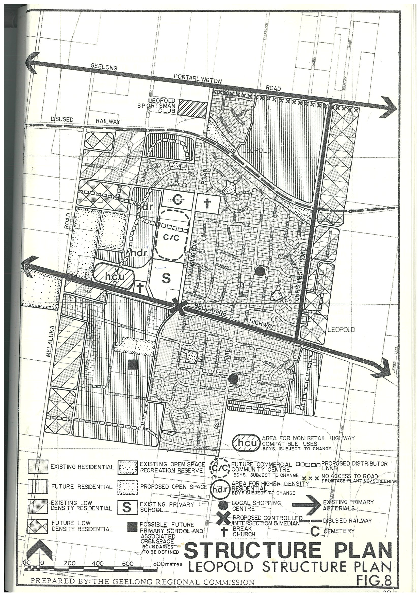

Urban Growth Strategy 1996
- The City of Greater Geelong Urban Growth Strategy was prepared during 1995 and 1996. The purpose of the Urban Growth Strategy was to determine the most suitable areas for the accommodation of urban growth to the year 2020.
- The Strategy identified the areas of Armstrong Creek, Urban Geelong, Lara, Leopold, Drysdale/Clifton Springs and Ocean Grove for urban growth.
- Relevant planning principles are stated in Section 3 (pages 13-14):
- Urban development should be restricted in catchments which drain into sensitive ecosystems such as Swan Bay, Lake Victoria and Lake Connewarre.
- The City should work towards a target of 25% of all its housing being made up of dwelling forms other than detached dwellings by 2020.
- The long standing planning policy of maintaining non-urban breaks between settlements should be upheld to foster a sense of physical identity for each of the townships outside Urban Geelong and protect the intrinsic qualities of the environs surrounding the settlements.
- Where possible, natural boundaries should form the edge of urban areas to assist in reinforcing the edge of urban centres and resisting development pressure on the fringe of existing townships and Urban Geelong.
- Urban consolidation should be actively encouraged to enable existing boundaries of townships to be maintained and increased densities that will support the provision of upgraded services.
- On 11 December 1996 the Urban Growth Strategy was formally adopted by Council.

Leopold Structure Plan 2006
- This Structure Plan was prepared by the City of Greater Geelong and adopted by Council on 28 March 2006.
- The Structure Plan included an urban growth boundary significantly greater than that provided in the 1990 Structure Plan. The boundary (at least south of the Bellarine Highway) was extended to the south and eastwards beyond Ash Road as shown in Figure 11.
- A number of areas were identified for urban expansion to meet the demand for land and match the town’s designation as an urban growth location.
- Notably, the area subject to C367 is excluded from any future growth.
Figure 11 – Leopold Structure Plan Map 2005

Leopold Structure Plan September 2011 (Amended Jan 2013)
- The Structure Plan was prepared as a partial review of the 2006 Leopold Structure Plan. The Structure Plan was subject to Planning Scheme Amendment C254 (in operation from 16 May 2013) and was re-adopted in January 2013 with changes resulting from the amendment process.
- The Structure Plan includes principles and directions in response to the key influences identified in the background report, for each of the following themes: Urban Growth; Settlement & Housing; Economic Development and Employment; Infrastructure; Natural Environment; and Rural Areas.
- An implementation plan is also included in the Structure Plan. It also addresses the review of the Structure Plan, stating that as with all other areas in the municipality the take-up of land and redevelopment within Leopold needs to be regularly monitored. It is appropriate that the Structure Plan be reviewed every five years. At the next review consideration should be given to the findings of the G21 Regional Land Use Plan and whether the settlement boundary needs to expand to accommodate further residential growth and whether further stages of the Sub-Regional Activity Centre should be released.
- The recent preparation of the Settlement Strategy will affect the timing and scope of the Structure Plan.
- The Leopold Structure Plan was adopted by Council at its Ordinary Meeting on Tuesday, 29 January 2013. Figure 12 shows the Leopold Structure Plan 2011 (Amended Jan 2013) map.
Figure 12 – Leopold Structure Plan Map
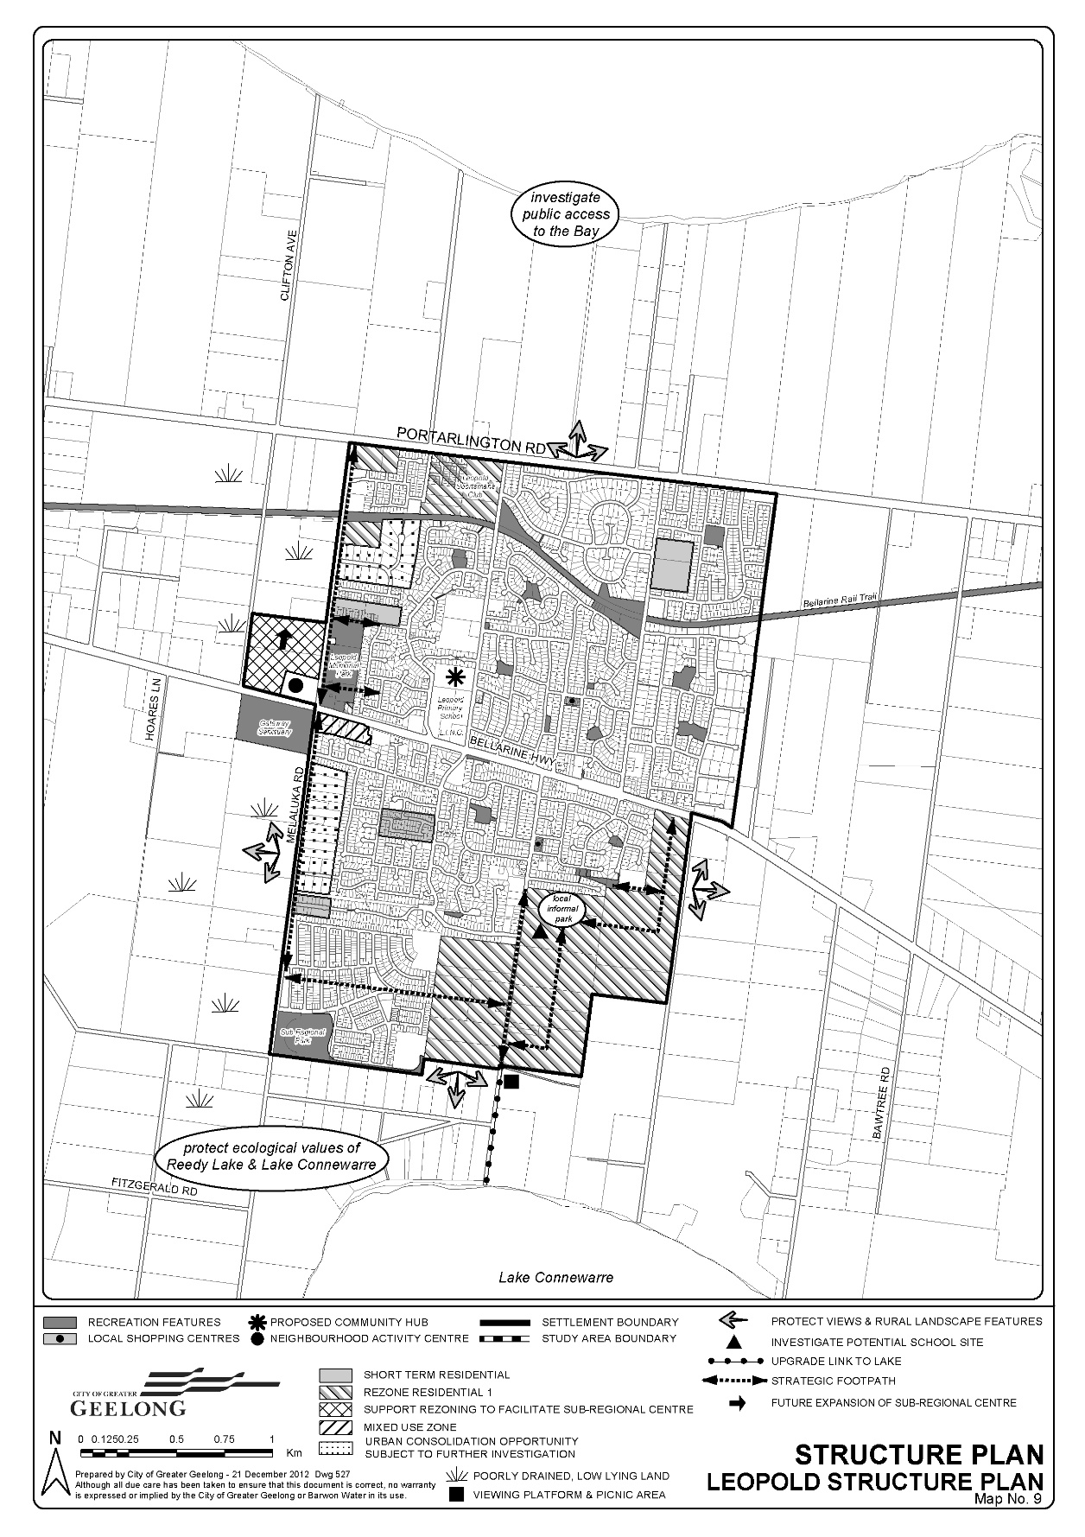
- .A copy of the adopted Leopold Structure Plan, September 2011 (Amended Jan 2013), can be found at:
https://www.geelongaustralia.com.au/common/public/documents/8ce73e199bad8f6-Leopold%20Structure%20Plan%202011%20_amended%20Jan%202013_FINAL.pdf

G21 Regional Growth Plan 2013
- The G21 Regional Growth Plan (April 2013) manages growth and land use pressures to 2050. It pulls together the strategic land use and growth planning already undertaken across the region including the G21 Geelong Region Plan, and builds on this to identify where future residential and employment growth will occur. It also identifies the key infrastructure required to manage and support this growth.
- Map 7 – Settlement and Employment Growth Directions (see Figure 13) specifically identifies Leopold as a growth location.
- To ensure a strong farmed landscape character between Geelong and Bellarine towns, encourage rural production, maintain town identities and related tourism opportunities and minimise impacts on significant wetlands and coastal views.
- Note: Settlement breaks have not been identified on Map 7 (page 27) around all settlements. The Growth Plan confirms the role and importance of settlement boundaries as identified in township structure plans. These boundaries are critical in creating breaks between settlements and preserving the natural and landscape values and setting of all towns and settlements in the region.
Figure 13 – Extract of Settlement and Employment Growth Directions from G21 RGP
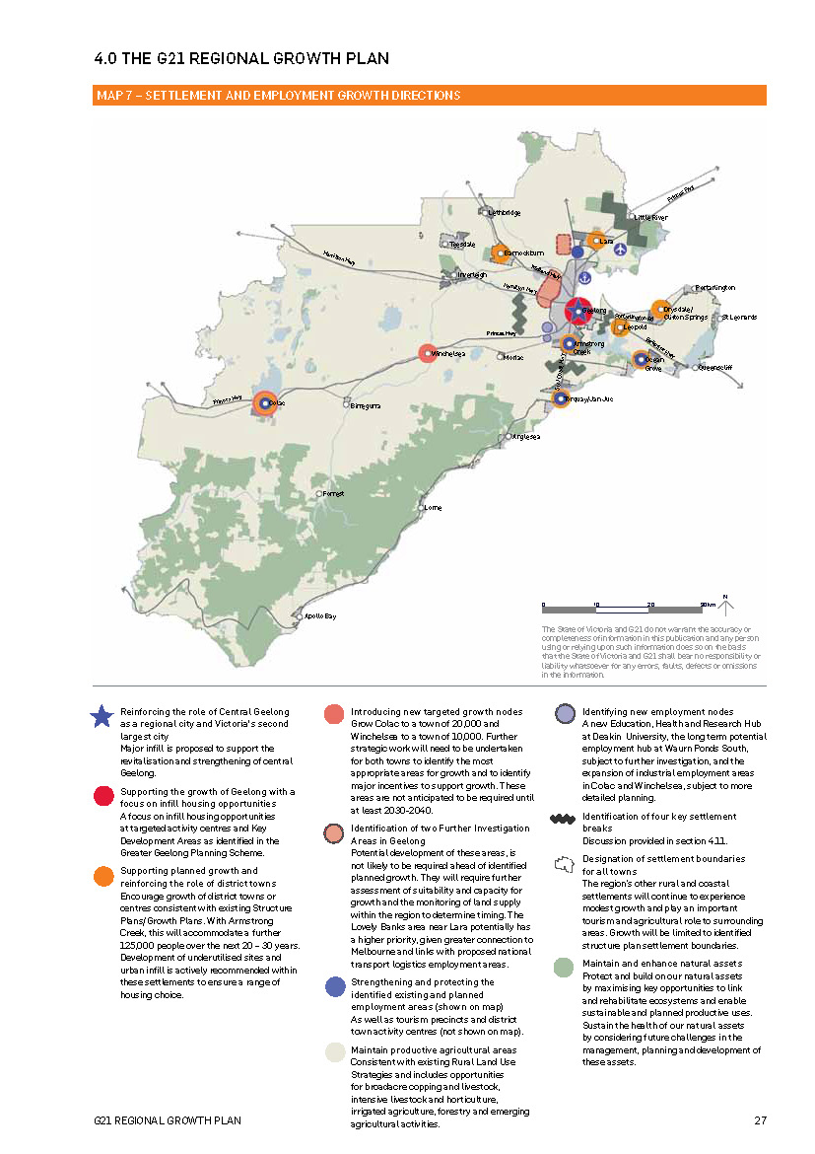

STRATEGIC CONTEXT AND ASSESSMENT

Strategic Assessment
- Minister’s Direction No. 11 requires a planning authority to evaluate and discuss how an amendment addresses a number of strategic considerations. What should be considered as part of the Direction is explained in the DELWP Practice Note 46 (May 2017): “Strategic Assessment Guidelines for preparing and evaluating planning scheme amendments.” The exhibited Explanatory Report includes a Strategic Assessment and this is the basis for the response to the Strategic Assessment Guidelines provided in Appendix 2.
- An overview of the key strategic documents will now be provided as the best context to the Panel. This will be followed by assessment of the key state and local policies.

Bellarine Peninsula Localised Planning Statement 2015
- Panel Direction 2d requires an assessment of the Amendment against the Bellarine Peninsula Localised Planning Statement.
- The Bellarine Peninsula Localised Planning Statement was developed collaboratively by the City of Greater Geelong and the Borough of Queenscliffe with support from the Department of Transport, Planning and Local Infrastructure (now the Department of Environment, Land, Water and Planning). This Localised Planning Statement builds on existing strategies and policies of both councils that are in place and relevant to the Bellarine Peninsula. The Statement was endorsed by Council in September 2014 and approved by the Minister for Planning in September 2015.
- The Localised Planning Statement is a reference document in Clause 11.03-5S of State Planning Policy Framework.
- The Bellarine Peninsula Localised Planning Statement identifies the key valued attributes of the Bellarine and puts in place objectives and strategies to ensure that they are preserved and enhanced for ongoing use by present and future generations. The Bellarine Peninsula is a valued area with significant geographic and physical features which are a distinctive part of Victoria. The Peninsula plays an important role, being highly valued for its scenic attributes, open rural landscapes, proximity to the coast, tourism role and lifestyle appeal.
- The Statement acknowledges that the attractiveness, accessibility and proximity of the area to metropolitan Melbourne means it is increasingly coming under pressure for growth and change. Leopold is characterised as one of three designated growth locations on the Bellarine Peninsula; is predominantly a residential township as an urban island within the rural setting of the Bellarine Peninsula and is the gateway to the coast.
- On the Bellarine Peninsula more broadly, the Statement identifies the significant of the visual landscape, distinct coastal settlements in rural settings, sweeping views across rolling hills, coastlines, wetlands and open farmed landscapes. Lake Connewarre is identified as a wetland of international importance under the Ramsar convention, and there is significant indigenous roadside vegetation found including along roadsides. Other key features as relevant to Leopold are strong linear vegetation features including exotic windbreaks, lookouts and walking trails and steep, low cliffs and minor escarpments at the coastal and lake edges.
- The Statement documents that “considerable strategic planning has been undertaken to provide for the managed expansion of urban areas on the Bellarine Peninsula, and townships have been planned on the basis of clear settlement boundaries. Ongoing population and employment growth within the Greater Geelong area, combined with the unique and high quality rural and coastal landscapes is contributing to increasing development pressures in rural areas of the Bellarine Peninsula. Managing growth and development is therefore critical to protecting and enhancing the significant values of the Bellarine Peninsula.”
- The Bellarine Peninsula Localised Planning Statement (BPLPS) Framework Plan is shown in Figure 14.
- Ministerial Direction No. 17 provides that in preparing an amendment affecting land in an adopted Localised Planning Statement, a planning authority must have regard to the relevant statement.
- Policy objective 1 aims to protect and enhance the rural and coastal environment on the Bellarine Peninsula and maintain non-urban breaks with open farmed landscapes between settlements. The strategies to achieve this are:
- Protect rural and coastal environments from inappropriate urban encroachment and development.
- Protect the scenic qualities of key landscape features.
- Ensure development outside of settlement boundaries (as shown in the Structure Plan maps) does not compromise the rural, environmental and landscape values of the non-urban breaks, significant views or longer term growth opportunities.
- The Amendment generally supports this objective and implements the strategies through the rezoning of land largely within the Leopold settlement boundary. The extension beyond the settlement boundary is considered a logical inclusion that ‘nestles down’ into the landscape of Mollers Lane. No longer term growth is planned for east of Mollers Lane. Retention of some established trees within the subdivision will protect the scenic quality of the area and provide amenity for the new residents.
- Policy objective 2 is to support the ongoing use of rural land on the Bellarine Peninsula for agriculture and to preserve the open farmed landscape. This will be achieved through strategies to:
- Support the establishment and ongoing use of rural areas on the Bellarine Peninsula for agricultural activities which do not impact upon the open farmed landscape including viticulture, horticulture and crop raising and grazing.
- Discourage intensive agricultural development or industrial development in rural areas on the Bellarine Peninsula that would have an adverse impact on the rural landscape.
- Ensure the development of dwellings and the excision of existing dwellings in rural areas on the Bellarine Peninsula is consistent with the use of the land for sustainable rural uses.
- Ensure new development is designed and sited to avoid compromising the open farmed landscape.
- The Amendment proposes to rezone existing Farming Zone land to residential in accordance with planning policy. As the existing farmed landscape of the subject land will be altered this objective and strategies do not apply.
Figure 14 - Bellarine Peninsula Localised PS Framework Plan
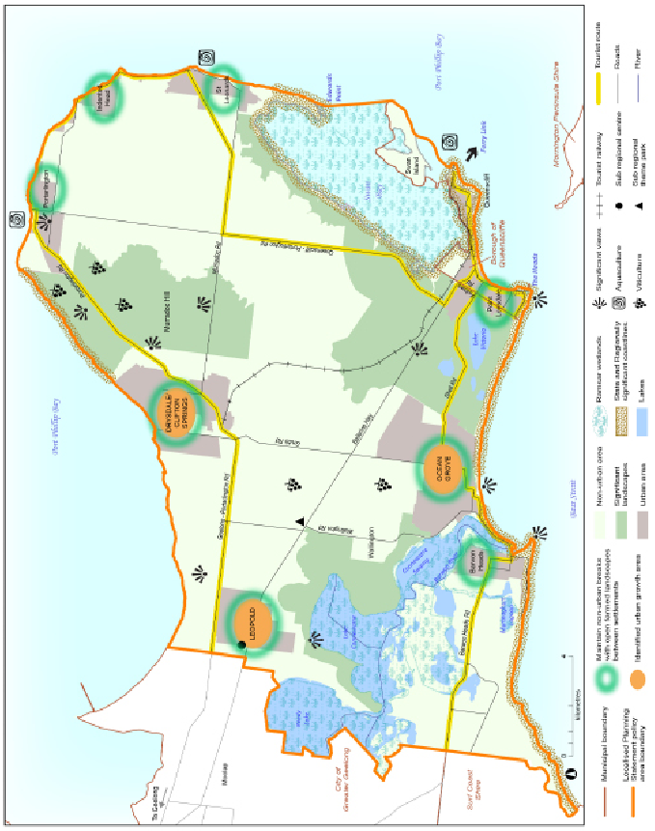
- Policy Objective 3 is to preserve and maintain the ecology of the Bellarine Peninsula’s environmentally significant coastal, wetland and vegetated areas. This will be achieved by the following strategies:
- Protect cliff, dune and foreshore areas from inappropriate development and subdivision.
- Protect and restore significant and remnant native vegetation, particularly tea tree, moonah and coastal heath.
- Ensure that new development allows for the protection of significant vegetation and/or planting around buildings and has minimal impact on roadside vegetation.
- Ensure appropriate stormwater management measures are in place to avoid adverse impacts on marine waters, lakes, wetlands and waterways.
- As the Amendment deals with land that is not part of or close to the coast it does not impact on cliffs, dunes or foreshore areas. Some remnant vegetation is unavoidably being lost as Mollers Lane will need to be widened along its western side, with offsets required. Some trees are being retained as part of the subdivision for their amenity and landscape value. The stormwater exiting the site will be treated and flow retarded to avoid adverse impacts on downstream waterways including Lake Connewarre. Very minimal impact on the Lake Connewarre foreshore is identified.
- Policy Objective 4 is to protect, preserve and enhance built heritage, cultural and urban character values and preserve the individual identity and role of townships. Strategies to achieve this are:
- Ensure that development responds to the identity and character of the individual township in which it is located.
- Protect the character of local conservation precincts, places, objects and sites and heritage areas on the Bellarine Peninsula.
- Encourage development which respects the setting of coastal settlements by providing reasonable sharing of views of the coast and foreshore and uses contemporary design that reflects existing built form.
- The proposed subdivision is reflective of contemporary residential subdivision design which is quite different to the established residential area to the west. Smaller lots, networks of open space and shared paths, integrated environmental features such as waterways, landscapes and vegetation, consideration for solar orientation, public transport connections and minimal culs-de-sac are the features of current residential design that are promoted by planning authorities. These are largely included in this proposal. Lot sizes with minimums of 450m² will be smaller than existing areas which have lots at over 600m² to 1000m² as this is reflective of current planning policy to provide 15 lots per hectare. The developed Estuary Estate off Melaluka Road and the upcoming Allure Estate on Ash Road west incorporate these features and are leading the residential character for the new southern areas of Leopold.
- These established residential areas are inward facing with no connectivity to the subject land. Combined with the varied topography and landscape features of the Mollers Lane area, this provides the opportunity for the creation of a new character for this southern area of Leopold.
- There are no local conservation precincts or sites of post-contact heritage significance in the Amendment area.
- Policy objective 5 is to facilitate the planned residential growth of Drysdale/Clifton Springs, Leopold and Ocean Grove, consistent with adopted Structure Plans and as service hubs for the Bellarine Peninsula. In all other townships, provide retail, commercial and community uses and facilities that serve the daily needs of the community and encourage street based activity and local employment. The strategies to achieve this are:
- Ensure land use and development proceeds generally in accordance with the relevant Structure Plan maps.
- Provide for a range of retail, commercial, community uses in town centres to provide services for the community and local employment opportunities in accordance with Structure Plans.
- Direct the bulk of residential growth and retail development to the designated growth locations of Drysdale/Clifton Springs, Leopold and Ocean Grove consistent with the relevant Structure Plan maps.
- Direct bulky goods retailing and industrial development to existing and future areas identified in Structure Plans.
- The Amendment supports the residential growth objective and implements the strategies. The proposed development generally accords with the Leopold Structure Plan map, albeit with the small settlement boundary extension as described earlier. No commercial, community services or bulky goods retailing is proposed as part of Amendment C367 or the planning permit.
- Policy objective 6 is to support and encourage diverse and sustainable tourism as a key economic activity in townships and in rural areas where it complements and respects the farmed rural landscape of the area, does not impact upon existing farming activities and contributes to the local economy. The strategies to achieve this are:
- Support a range of appropriately scaled and located tourism accommodation and activities within township boundaries.
- Preserve and enhance key tourism assets, in particular the built and natural environments and sporting and tourist areas.
- Support the development of rural land for tourism where the development will not compromise the farmed rural landscape.
- Ensure that tourism uses in rural areas will not compromise agricultural activities on adjoining land.
- No tourism accommodation or activities are proposed as part of C367 or the draft planning permit.

South East Leopold Framework Plan (2016)
- In 2016 the City of Greater Geelong engaged Tract Consultants to prepare a Framework Plan to guide the subsequent rezoning and development processes for the land across the South East area of Leopold that is within the settlement boundary but which is still within the Farming Zone.
- It was developed as a tool to guide future development and ensure a coordinated approach given the then and still current development pressures in Leopold. The Framework Plan was developed in consultation with landowners, Council Officers and relevant referral agencies/Government Departments who all provided input into the overall design direction for the area.
- Relevant to Amendment C367, the Framework Plan included the properties at 2-20, 22-30, 32A, 32-40, and 42-90 Mollers Lane and the northern half of the parcel at 92-120 Mollers Lane as these are all within the settlement boundary. But the Framework Plan also included the southern portion of 92-120 Mollers Lane so that the parcel in its entirety rather than a portion of it as shown in the Structure Plan. This additional area was included to better reflect drainage catchments, waterway reinstatement and to facilitate drainage and sewer servicing.
- The Framework Plan recommends key features to be incorporated into the overall future residential development of the area including linear open space reserves along the creek network, connector roads to provide east/west integration, a shared pathway network, and retention of some stands of mature trees to provide character and interest to the area. The South East Leopold Framework Plan map is shown in Figure 15.
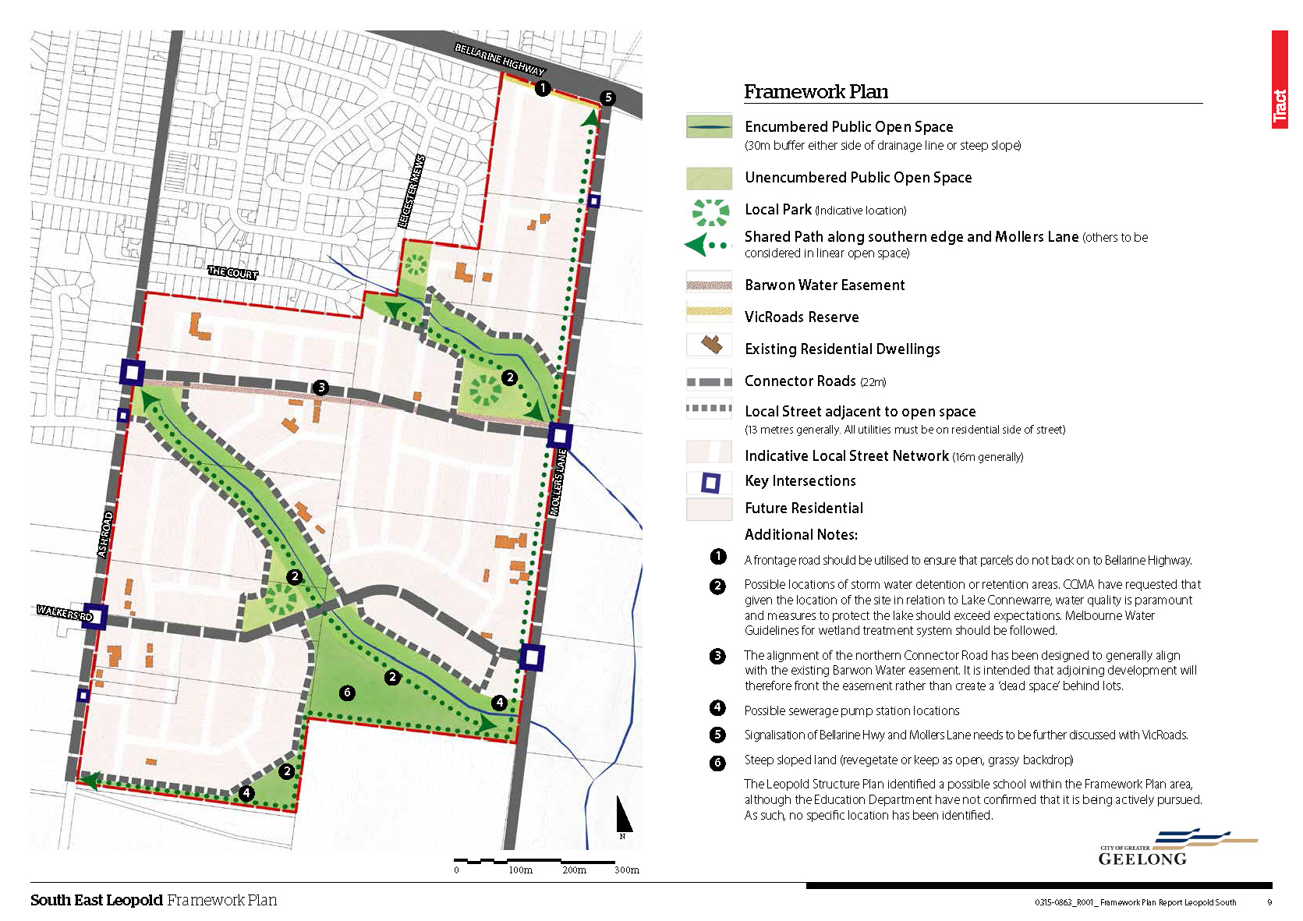
Figure 15 – South East Leopold Framework Plan 2016

- The South East Leopold Framework Plan 2016 can be accessed electronically by the following link:
https://www.geelongaustralia.com.au/common/public/documents/amendments/8d5b4f00f8ea54f-SouthEastLeopoldFrameworkPlan2016(D18-156456).PDF

City of Greater Geelong Settlement Strategy (October 2018)
- This broad Strategy has been prepared by Council officers following community consultation and was recently adopted at the 9 October 2018 Council Meeting. The Strategy will proceed to a planning scheme amendment in 2019.
- The Strategy consists of six themes: (1) Spatial Distribution of Growth & Land Supply; (2) Housing Diversity; (3) Managing Future Growth; (4) Bellarine Peninsula; (5) Permanent Settlement Boundaries; (6) Urban Consolidation and (7) Monitoring & Review.
- The Settlement Strategy has no statutory effect (at this time) however it does largely represent existing housing and growth policy positions for Leopold, the Bellarine and Geelong generally.
- Notably on the issue of Permanent Settlement Boundaries, the Settlement Strategy principle to contain growth within identified locations across the municipality has the following directions:
- Pursue options to implement permanent settlement boundaries for Greater Geelong.
- Implement permanent boundaries based generally on existing urban areas and areas already identified in policy.
- Establish a consultation process to review the appropriateness of this boundary and deal with any significant anomalies or logical inclusions.
- Place structure plan reviews on hold until the permanent boundary is known.
- Work with the state government and neighbouring councils to consider a regional approach to housing and settlement boundaries.
- With the Settlement Strategy having only recently been adopted, all of this work is ahead of the City in 2019 and 2020.
- Figure 16 shows the Greater Geelong Housing Framework Plan to 2036.
- The adopted Settlement Strategy is available on the Geelong Australia website at: https://www.geelongaustralia.com.au/strategicplanning/documents/item/8d5b438a9620da8.aspx
Figure 16 - Greater Geelong Housing Framework Plan 2036
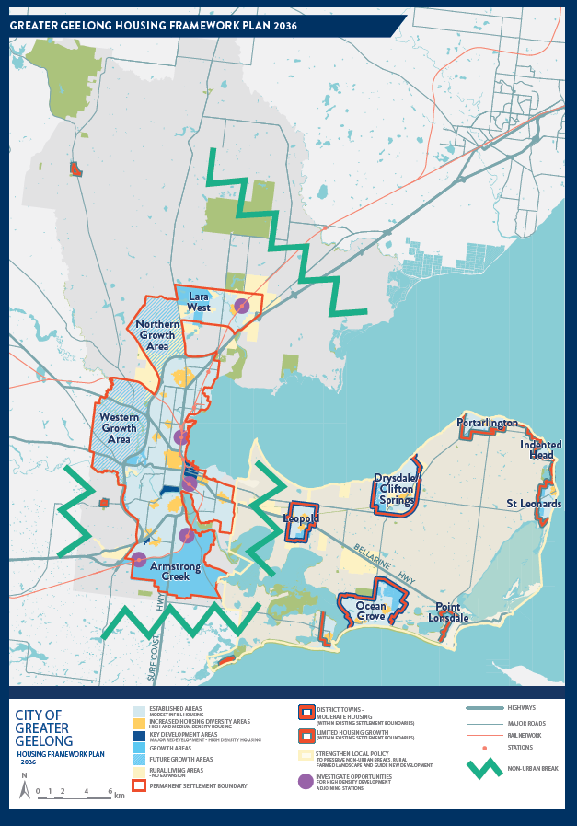

Consideration against the Planning Policy Framework
- The Amendment is consistent with and supported by relevant objectives and strategies of the [State] Planning Policy Framework as follows. Clause numbers referred to in the exhibited Explanatory Report have been changed by Amendment VC148, gazetted on 31 July 2018. The current clause numbers are cited below.
- Clause 11.01-1R Settlement – Geelong G21 includes strategies to:
- Support the growth of Bannockburn, Colac, Drysdale/Clifton Springs, Lara, Leopold, Ocean Grove and Torquay/Jan Juc as district towns by building on existing and planned infrastructure and focusing growth along key road and rail networks.
- Require a settlement boundary for all towns.
- The Geelong G21 Regional Growth Plan shows Leopold as a planned growth area or district town.
- The Amendment is consistent with this Clause as it proposes the addition of approximately 40 hectares of residentially zoned land largely within the existing settlement boundary.
- Clause 11.02-3S Sequencing of development specifies an objective to manage development sequencing so that services are available early. The Framework Plan engaged the servicing authorities, in particular Barwon Water, with their requirements incorporated into the Plan. The Amendment is consistent with this Clause as it reduces the number of sewerage pumping stations required and provides for development contributions for community infrastructure through the S173 Agreement.
- Clause 11.03-2S Growth areas specifies an objective to encourage average overall residential densities in the growth areas of a minimum of 15 lots per net development hectare. The proposed subdivision provides close to this number and is an increase on the traditional density of the established areas of Leopold in the vicinity.
- Clause 11.03-5S Distinctive areas and landscapes specifies an objective to protect and enhance the valued attributes of the distinctive areas and landscapes. A policy document that must be considered, as relevant, is the Bellarine Peninsula Localised Planning Statement (2015). The Amendment is consistent with and supports that Statement as outlined earlier in this Part A Submission.
- Clause 12.01-1S Protection of biodiversity specifies an objective to consider that impacts of any change in land or development that may affect the biodiversity value of internationally significant sites including wetlands designated udder the Ramsar Convention. The amendment will have minimal impact on the Lake Connewarre, with WSUD measures to treat stormwater exiting the site.
- Clause 12.01-2S Native vegetation management contains the objective to ensure there is no net loss of biodiversity as a result of the removal of native vegetation. The draft planning permit contains provisions for offset planting for vegetation being removed to ensure no net loss of biodiversity. Vegetation within the Mollers Lane road reserve will be removed to facilitate necessary widening of the road.
- Clause 12.03-1S River corridors, waterways, lakes and wetlands has the objective to protect and enhance river corridors, waterways, lakes and wetlands. The amendment and permit have been designed around the two waterways by including these as landscape features and the anchor for open space. Reinstatement of the waterways to become a feature of the development with vegetation planting to be included within the buffers.
- Clause 12.05-2S Landscapes contains strategies to ensure that landscape qualities are protected and enhanced by development. The Framework Plan identifies features of the landscape to be retained including vegetation. The application has demonstrated that the SLO applicable to the rezoning site can be removed with no impact on the landscape when viewed from Lake Connewarre.
- Clause 13.02-1S Bushfire planning applies to land within a designated bushfire prone area and seeks to ensure resilience of settlements through risk-based planning that priorities the protection of human life. Land on the periphery of Leopold including the subject land is within a designated bushfire prone area where minimum construction standards apply. The grassland and dispersed vegetation surrounding Leopold poses a minor level of bushfire risk. Future development of this land will minimise the bushfire risk as grassland will be gradually removed and reticulated water and other forms of infrastructure will be provided. No BMO applies. CFA conditions have been included in the permit.
- Clause 13.04-1S Contaminated and potentially contaminated land seeks to ensure that potentially contaminated land is suitable for its intended use and that contaminated land is used safely. The key strategy requires applicants to provide information on the potential for contamination if the land was known to have been used for industry, mining or the storage of chemicals, gas, wastes or liquid fuel. The amendment application was supported by an environmental assessment which has identified no contamination issue for the site allowing development to proceed.
- Clause 14.02-1S Catchment planning and management specifies strategies to assist in the protection of the catchment and water bodies. All of the strategies are relevant to this proposal:
- Consider the impacts of catchment management on downstream water quality and freshwater, coastal and marine environments.
- Retain natural drainage corridors with vegetated buffer zones at least 30 metres wide along each side of a waterway to:
- Maintain the natural drainage function, stream habitat and wildlife corridors and landscape values,
- Minimise erosion of stream banks and verges, and
- Reduce polluted surface runoff from adjacent land uses.
- Undertake measures to minimise the quantity and retard the flow of stormwater from developed areas.
- Require appropriate measures to filter sediment and wastes from stormwater prior to its discharge into waterways, including the preservation of floodplain or other land for wetlands and retention basins.
- Ensure that development at or near waterways provide for the protection and enhancement of the environmental qualities of waterways and their in stream uses.
- Ensure land use and development minimises nutrient contributions to water bodies and the potential for the development of algal blooms.
- Require appropriate measures to restrict sediment discharges from construction sites.
- Ensure planning is coordinated with the activities of catchment management authorities.
- Stormwater is to be managed through the re-instated waterways and via the incorporation of WSUD measures to reduce run-off and peak flows. Flows will be retarded to pre-development levels and nutrient and pollutant load filtered and treated before leaving the site. Conditions have been included in the planning permit to address management during construction, waterway reinstatement and drainage easements. The permit also includes conditions from the Corangamite Catchment Management Authority.
- The buffers to both waterways though do not meet the strategy of providing 30 metres wide buffers to each side, rather varying between about 22-26 metres, and even less in parts in the revised circulated overall development plan. The City and the applicant have engaged with the CCMA on the Framework Plan and the proposed amendment and draft permit, with conditions being provided.
- Clause 15.01-3S Subdivision design specifies that the design of subdivisions to achieve attractive, safe, accessible, diverse and sustainable neighbourhoods. A range of lot sizes are provided, although mostly provision of smaller lots, and a couple of medium density sites are nominated in the subdivision, all to meet the needs of different groups of people in the Leopold housing market. Car dependency can be reduced through allowance for public bus capable connector roads, the provision of shared paths for cycling and walking, and connectivity to established and developing areas of Leopold. The southern connector road is intended to connect across to Ash Road where it will connect to Walkers Road ( to become an extended Estuary Boulevard) providing a southern road link across Leopold. Installation of new bus stops on Bellarine Highway near the Mollers Lane intersection are also proposed. Landscaped streets through street tree planting are required as a condition of the planning permit.
- Clause 15.01-4S Healthy neighbourhoods seeks to ensure that neighbourhood design makes it easy for people to engage in physical activity by providing connected walking and cycling networks that promote walking and cycling as a part of daily life, accessibly located public transport stops and conveniently located public spaces for active recreation and leisure. The proposal incorporates all of these including a 1 hectare park and waterway based lineal open space, shared paths, and navigable connector roads for buses.
- Clause 15.02-1S Energy and resource efficiency has strategies to promote integration of land use and transport, encourage retention of existing vegetation and planting of new vegetation in subdivision proposals and to support low energy forms of transport. The Framework Plan engaged with a range of stakeholders to ensure an integrated urban form across the growth area, and to achieve vegetated green spaces. The Amendment and draft permit incorporates cycling and walking provision and connectivity to the public transport network. Some trees are to be retained in the subdivision but more could be achieved as outlined in the Framework Plan.
- Clause 15.03-2S Aboriginal cultural heritage seeks to ensure the protection and conservation of places of Aboriginal cultural heritage significance. The amendment addresses this through the provision of a Cultural Heritage Management Plan.
- Clause 16.01-2S Location of residential development. The rezoning of the subject land to residential is in accordance with Leopold's designation as a growth location and will supplement the supply of land in the market.
- Clause 18.01-4S Housing Affordability will be achieved through the addition of supply and choice to the Leopold market.
- Clause 18.01-1S Land use and transport planning strategy of developing integrated and accessible transport networks will be achieved through the provision of active transport networks within the area. Public transport accessibility is planned for in the subdivision. These were considerations in the preparation of the Framework Plan.
- Clause 18.01--2R Transport system - Geelong G21 seeks to support improved transit and access within Geelong and the wider region. Cycling connection to the Bellarine Rail Trail is possible from the subject area. Public transit will be provided in the future both within the estate and by new bus stops at the Mollers Lane Bellarine Highway intersection.
- Clause 18.02-1S Sustainable personal transport is all about ensuring that development promotes the use of sustainable personal transport. Active transport has been included in the subdivision design through the provision of shared paths for cycling and walking with connections to the key surrounding major roads and transit corridors. Council officers have continued discussions with TfV post the consideration of submissions and the City supports the installation of a 2.5 metre wide shared path along one side of the each of the east-west connector roads and along the length of Mollers Lane.
- Clause 18.02-2S Public transport will be made available through bus navigable connector roads, and infrastructure provision on the Bellarine Highway.
- 19.02-4S Social and cultural infrastructure seeks to provide fairer distribution of and access to, social and cultural infrastructure. The S173 Agreement contains development contributions towards social infrastructure projects within the Leopold area, possibly the developing community hub in Kensington Road, meeting the strategy of ensuring early delivery in the development process.
- Clause 19.02-6S Open space objective is to establish, manage and improve a diverse and integrated network of public open space that meets the needs of the community. Relevant strategies include:
- Ensure that open space networks:
  - Are linked, including through the provision of walking and cycling trails.
Shared paths are provided for in the Framework Plan and overall development plan.
  - Are integrated with open space from abutting subdivisions.
This is achieved in the Framework Plan through a connection of the northern waterway and corridor open space into Myuna Street, and with continuity of the southern waterway and corridor into the Ash Road east development front.
  - Incorporate, where possible, links between major parks and activity areas, along waterways and natural drainage corridors, connecting places of natural and cultural interest.
This is achieved with the open space buffers along the waterways.
  - Maintain public accessibility on public land immediately adjoining waterways and coasts.
Open space buffers along the waterways will be transferred to the City of Greater Geelong to be retained in public ownership.
- Ensure that land is set aside and developed in residential areas for local recreational use and to create pedestrian and bicycle links to commercial and community facilities.
The Framework Plan and the exhibited plans provide for a 1 hectare park in the subdivision for the recreational needs of residents. The Version 2 Overall Development Plan seeks to delete this provision.
- Improve the quality and distribution of open space and ensure long-term protection.
There is a lack of quality open space in the adjoining established residential area.
The Framework Plan seeks to connect the 'old' with the 'new' providing improved access to open space for existing and future residents.
- Ensure that urban open space provides for nature conservation, recreation and play, formal and informal sport, social interaction, opportunities to connect with nature and peace and solitude.
Some tree retention within the buffer to the northern waterway is proposed.
- Plan open space areas for multiple uses, such as community gardens, sports and recreation, active transport routes, wildlife corridors and flood storage basins.
The open space corridors will serve multiple purposes including as active transport routes, ecological corridors and passive recreation.
- Clause 19.03-1S Development and infrastructure contributions plans has the objective to facilitate the timely provision of planned infrastructure through the preparation and implementation of development contributions plans and infrastructure contributions plans. This Amendment has not been addressed in this manner, as the developer is responsible for delivering the required infrastructure. A S173 Agreement to attain development contributions for community infrastructure accompanies the Amendment.
- Clause 19.03-2S Infrastructure design and provision is about taking an integrated approach to the planning and engineering design of new subdivision. The Framework Plan responds to this policy by providing an integrated plan across a broad growth area with multiple landowners to ensure a seamless subdivision design.
- Clause 19.03-3S Integrated water management objective of sustainable water management is achieved in this Amendment. Stormwater is managed through on-site detention, with land set aside for 2 basins, filtering stormwater before it leaves the site, incorporating waterways as features of the subdivision, providing for a sewerage pumping station and managing flows to minimise impacts on downstream properties including Lake Connewarre. The views of the Catchment Management Authority were sought and included in the preparation of the Framework Plan and the Amendment.
- The Amendment is consistent with and supported by relevant objectives and strategies of the [Local] Planning Policy Framework as follows.
- 21.06-2 Urban growth seeks to retain development within defined urban growth areas and provide a mix of housing suited to the needs of a diverse range of household types. The Amendment and Framework Plan implement this.
- Clause 21.05-2 Waterways seeks to enhance and protect waterways by the appropriate management of stormwater runoff from developments. The Amendment and draft permit include measure to achieve this.
- Clause 21.05-7 Flooding seeks to protect floodplains and minimise the risk of flood damage. The draft permit includes conditions addressing stormwater leaving the site.
- Clause 21.06-3 – Urban Consolidation – provides for the consolidation of existing urban areas in a managed way, encourages an appropriate range of development densities and to improves accessibility to urban services. The Framework Plan and the Amendment implement this policy.
- Clause 21.06-4 Neighbourhood character seeks to ensure that new development positively responds to the established urban character of the area. The Amendment affects a greenfield site which will have its own character. Connections are provided into adjoining land.
- 21.08-3 Development Contributions – Encourages development to proceed in a contiguous manner which maximises the use of development and community infrastructure. The developer will be providing the necessary infrastructure and making community infrastructure contributions.
- 21.08-5 Accessibility – Recognises the need to have safe access to infrastructure for all members of the community and provide shared spaces and passive surveillance of all recreational areas. Open space is being provided as part of the subdivision, largely bound on most sides by roads.
- Clause 21.14 Bellarine Peninsula – The amendment implements the urban growth policies for Leopold and the protection of waterways including Lake Connewarre. The Amendment seeks to add to this Clause with reference to the Framework Plan.
- There are no relevant local planning policies within clause 22.

Status of the combined amendment/permit application affecting the Eastern Ash land
- Panel Direction 2g seeks clarification of the relationship of the Amendment to the land to the west referred to as the Eastern Ash land.
- Eastern Ash, through their consultant Tract, is working on background reports and investigations to support a PSA and combined planning permit application. Officers understand that this work is ongoing and that discussions have also been held between Eastern Ash and the proponent for C367. It is anticipated that an application will be lodged in 2019.
- Eastern Ash has advised the City that the application will not include all land within the growth area fronting Ash Road, with only the land at 73-85, 87-101, 103-127, 129-141 and 143-155 Ash Road to form part of the planning scheme application. The properties at 157, 159 and 161-183 Ash Road will not be included within the Eastern Ash amendment application. It is expected that a concurrent planning permit application for only the properties at 87-101 and 103-127 Ash Road will also be lodged.

EXHIBITION AND SUBMISSIONS

Council resolution to prepare and exhibit an Amendment
- Carried at the 20 September 2017 Ordinary Meeting was that Council:
1) Endorse the preparation and exhibition of Amendment C367 to the Greater Geelong Planning Scheme to rezone land at 2-120 Mollers Lane Leopold from Farming Zone to General Residential Zone 1 with an accompanying Design and Development Overlay, a change to the extent of the Significant Landscape Overlay applying to the land, and change to Clause 21.14 to extend the settlement boundary to include all of the land at 92-120 Mollers Lane and include the South East Leopold Framework Plan 2016 as a reference document;
2) Writes to the DELWP to raise citizen’s issues of concern with the behaviour of shooters at the State Game Reserve impacting on residential and other private property to the north, and to consider the future and extent of the State Game Reserve concurrently with this proposed Amendment.
3) Considers the application for a planning permit for a multi-lot subdivision, removal of native vegetation and alteration to access to a Road Zone Category 1 for 2-120 Mollers Lane Leopold concurrently with the preparation of the Amendment, in accordance with the provisions of Section 96A of the Planning and Environment Act 1987;
4) Prepares a S173 Agreement for development contributions; and
5) Requests the Minister for Planning to authorise the preparation and exhibition of Amendment C367 and Planning Permit 1463/2016.

Ministerial Authorisation
- Panel Direction 2c has sought clarification of the authorisation of C367 and whether 10 Willows Place is included.
- The City’s original authorisation request of 13 March 2018 did not specifically refer to the inclusion of 10 Willows Place in the amendment. A revised authorisation application including an updated authorisation application form was discussed with DELWP Regional Office on 27 March and lodged by email on 28 March. This application clearly outlined that the proposed amendment included application of the DDO43 to the land at 10 Willows Place.
- The Minister’s delegate authorised the Amendment preparation and exhibition on 20 April 2018 – see Appendix 3a.
- Upon enquiry with DELWP about this Panel Direction, Kim McGough, Manager – Barwon South West, Regional Planning Services, by email on 14 November 2018 has advised that the Department authorised Amendment C367 as requested by Council in its revised authorisation application form and that it was an error to exclude reference to 10 Willows Place – see Appendix 3b.
- We note that the Council resolution of 20 September 2017 did not refer to the inclusion of 10 Willows Place in the proposed amendment. We submit that this was an inadvertent error as it was the intention that 10 Willows Place should be included in the Amendment and that it was referred to within the Council report.

Exhibition
- The Amendment was exhibited between 17 May and 18 June 2018.
- Letters were sent to over 80 property owners and occupiers in the vicinity of the subject land in Leopold. Notices were placed in the Geelong Independent and the Government Gazette. The documentation was available on the Geelong Australia website.
- Submissions were accepted online until up to Monday 25 June 2018, as well one late submissions received on 11 July 2018 and one very late submission received on 17 September 2018.

Submissions received
- Exhibition of Amendment C367 resulted in a total of 17 submissions although one was subsequently withdrawn and has not been referred to the Panel. By email on 30 July 2018, Mr Vella wrote to Peter Smith, Coordinator Strategic Implementation rescinding his submission. Refer to Appendix 4.
- Of the live submissions, fourteen submissions either oppose the amendment or seek changes; one submission wholly supports the amendment; and two submissions offer no objection.

Council resolution regarding the submissions
- On 27 August 2018 the City sought an exemption from the need to comply with the requirement of Ministerial Direction No. 15 to request the appointment of a Panel within 40 business days of the closing date for submissions. On 20 September 2018 Council received the exemption from the Minister for Planning from the need to comply with this requirement, and instead was required to request a Panel by 28 February 2019. See Appendix 5.
- Under delegation from Council, the Acting Coordinator Strategic Implementation on 18 October 2018 considered a report on the submissions and made the following decision:
That Council having considered all submissions to Amendment C367 to the Greater Geelong Planning Scheme and Planning Permit Application 1463-2016, resolves to:

- Request the Minister for Planning to appoint an Independent Panel under Part 8 of the Planning and Environment Act, 1987;
- Refer all submissions to the Panel; and
- Submit to the Panel its response to the submissions generally as outlined in this report.
- In response to two extremely late submissions received on 14 and 15 November, the Coordinator Strategic Implementation on 21 November 2018 considered a report and made the following delegated decision:
That Council having considered the two late submissions to Amendment C367 to the Greater Geelong Planning Scheme and Planning Permit Application 1463-2016, resolves to:

- Refer the submissions to the Panel which has been appointed to consider submission; and
- Submit to the Panel its response to the submissions generally as outlined in this report.

ISSUES RAISED IN SUBMISSIONS
- Issues raised in the submissions are:
- Changes to the settlement boundary and impact on Bellarine Peninsula
- Downstream stormwater impacts
- Land use conflict with hunting activities
- Impact on Lake Connewarre
- Transport Infrastructure provision
- South west corner land use
- Impacts on character of the surrounding area
- Form of the amendment
- Form of the permit
- Integration with the East Ash area
- Open space provision

Changes to the settlement boundary and impact on Bellarine Peninsula
What is the issue?
- Submission #15 from the Geelong Environment Council notes that a portion of the rezoning is not within the Leopold Town boundary. The submission objects that a number of developments on the Bellarine Peninsula have taken place outside the planned boundaries. The Peninsula is subject to a large number of new houses causing this special area to contribute an excessive percentage of additional growth threatening the landscape and tourism values of the Peninsula.
- The Settlement Strategy indicates greater protection to be given to protection of the Bellarine and the Localised Planning Statement 2015 should be adhered to although there is no mechanism to implement.
- Extension of development southward along Mollers Lane beyond the current settlement boundary is raised by Submission #15. Development beyond the planned boundaries has occurred in a number of instances across the Bellarine Peninsula contrary to the Localised Planning Statement 2015.
- Development beyond the settlement boundary allows for additional growth threatening the landscape and tourism values of Bellarine Peninsula and a concern that the

Downstream stormwater impacts
What is the issue?
- The proposal will direct stormwater downstream along the waterways, through privately owned land and ultimately into Lake Connewarre. Submission #5 from Mr Chapman is concerned about the impact the addition of 60ML of water each year will have on the dam level within his property and on the Lake Connewarre. This will in turn affect the restoration of the foreshore and may increase fire risk.
- Mr Chapman also submits that an increase in water and the dam level will result in changes to the ecology of the dam - more water stored at higher levels for longer will reduce the area of muddy shoreline, decreasing the diversity of water birds whilst increasing the number of ducks. Ultimately, this will attract more hunters to the shore of Lake Connewarre and the potential for shooting into the dam and the consequences this has for resident safety.
- DELWP’s submission # 12 has raised the need to for additional WSUD measures such as additional on-site detention to be considered during detailed design. The submission further raises the need for Council to formalise ongoing land management arrangements post the development site.

Impact on duck hunting activities
What is the issue?
- Submission #4 from the Geelong Field and Game Inc and Submission #9 from the Sporting Shooters Association of Australia Victoria Ltd are keen to ensure that development does not lead to the loss of hunting opportunities at the Lake Connewarre State Game Reserve. Game hunting is a long standing and legal activity at this location and planning should take this into account when considering new residential development.
- These submissions also seek buyers to be made aware of duck hunting at Lake Connewarre and complaints about gunshot noise to be dismissed.
- Submissions #6 (Mr Chapman) and #3 (Mr Lipshut) both raise concerns about bringing new residents into the area and the risk they will face from duck hunting activities and the interruption gunshot noise will have from pre-dawn to after dusk during the March to June hunting season.

Impact on Lake Connewarre
What is the issue?
- The receiving water for this development is Lake Connewarre which is a RAMSAR site for migratory birds. Lake Connewarre is a saline environment sensitive to freshwater inflows, including the cumulative freshwater impacts. The impacts of development in its vicinity need to be carefully considered.
- Submission #3 from Mr Lipshut has raised concerns about the environmental impact on Lake Connewarre from more people using the foreshore and the implications for bird life. Similarly, Mr Chapman in Submission #5 has concerns that the addition of 60ML of water per year will increase the flooding on the Lake Connewarre foreshore, affecting foreshore restoration and potentially increasing fire risk.
- Field and Game Australia in Submission # 4 is concerned to ensure that the alterations to flow of water entering Lake Connewarre do not impact on the ecology of the Lake and in turn negatively impact on hunting opportunities and experiences.

Provision of Open Space
What is the issue?
- The proposed subdivision includes several areas of open space: corridors along the two waterways and surrounding the two detention basins, a 1ha park adjacent to the retention basin in the north and encumbered land south of the southern creek. The proponent calculates that this equates to 2.295ha or 14.99% of unencumbered open space.
- The amount of open space provided within the proposed subdivision is an issue raised in Submission #10 by the proponent and by the adjoining developer in Submission #11.
- The proponent seeks a reduction of the proposed open space contribution to 10% as specified in the schedule to clause 52.01 and to the use of the encumbered land south of the southern creek as developable land.
- Submission #11 by Eastern Ash, developer of land to the west, argues that the 10% open space should be considered across the entirety of the area subject to the Framework Plan. By this assumption, they submit that only 2.074ha of unencumbered land or 5% open space should be provided in the Eastern Ash area.

South west corner land use
What is the issue?
- Land south of the southern creek is shown in the development plan as encumbered open space and not able to be developed. Submission #10 from the proponent argues for a change to the allow development of this area.

Transport Infrastructure Provision
What is the issue?
- The proposed subdivision includes provision for off-road shared paths for active transport, signalisation of the Bellarine Highway and Mollers Lane intersection at SOC for Stage 1, two east-west connector roads that link into the Ash Road development front providing access between Mollers Lane and Ash Road, and connector roads that are capable of accommodating public buses.
- Transport for Victoria (TfV) as Submission #13 submits that development should set a good precedent for future residential growth through a network of bus capable roads and safe and connected active transport links. The submission supports the inclusion of bus capable connector road, but notes that these roads lack provision for cyclists.
- Connection to the broader active transport network, in particular the Bellarine Rail Trail via Christies Road and the provision of a safe crossing as part of the Highway intersection is encouraged. To achieve this TfV seeks the provision of 3 metre wide shared user paths on a single side of the southern and northern connector roads and on Mollers Lane (sourced from the Austroads Guide to Road Design Part 6A: Paths for Walking and Cycling 2017). The proposed shared user paths through the northern and southern waterways are supported but should be widened to 3.5metres.
- Formalising the pedestrian/cyclist connections into Myuna Street and along the southern side of the Bellarine Highway to the Claremont Drive/Christies Road intersection is required.
- Submitter #3, Mr Lipshut, has submitted that increased traffic on Mollers Lane (south of 120 Mollers Lane) will place pressure on the unsealed road creating a safety hazard and requiring constant grading. To address this impact on infrastructure, sealing of Mollers Lane all the way to the Lane’s end should be undertaken.

Integration with the adjoining area to the west
What is the issue?
- Submission 11 raises for Council consideration the future integration of the proposed subdivision of the subject land with the Ash Road development front adjoining the west of the majority of the subject land. The submission seeks that Council carefully consider whether the proposed layout may prejudice the logical subdivision of the Ash Road land holdings. This leads to the submission that consistency with ‘South East Leopold Framework Plan 2016’ should not compromise a better design outcome. The Plan was prepared as a tool to guide future development and provides a high level development framework and was prepared without substantive advice from specialist consultants.
- The issue is that land to the east along Mollers Lane is influencing the design options of the land fronting Ash Road to the west.

Impacts on surrounding residential character
- Submission 6 opposes the Amendment on the ground that the development does not integrate with the current neighbourhood character of the established residential area to the west. The submission argues that the diversity of lots is low, with not enough larger size lots provided to better reflect the current neighbourhood character along the settlement boundary of large lots transitioning into rural land. An equal number of lots in the 400-599m² and in the 600-700m² range would decrease the visual impact on the environment.

Form of the amendment
What is the issue?
- Amendment C367 includes a rezoning, application of new Design and Development Overlay schedule 43, deletion of SLO10 from the land being rezoned, and changes to the PPF affecting Leopold.
- Tract Consultants on behalf of Eastern Ash, Submission #11, submits that the City should apply the Development Plan Overlay as the Design and Development Overlay does not exempt third party notification and appeal rights. They submit that the norm in greenfields locations is generally application of the Development Plan Overlay which avoids unnecessary objections from uninformed landowners and commercial competitors, and the resultant cost and time delays associated with appeals to VCAT.
- The Submission #11 also submits that a Development Plan Overlay and development plan could readily be prepared based on the information contained in the Framework Plan and the proposed DDO43.

Form of the planning permit
What is the issue?
- A draft planning permit has been exhibited with the amendment for a staged multi-lot subdivision, removal of native vegetation, removal of easements, and alteration of access and subdivision of land adjacent to a Road Zone Category 1. Conditions have been prepared in consultation with internal City Departments ranging from waste, environment, Engineering, Recreation and Open Space and Traffic. Conditions have also been required from referral authorities including the CCMA, Powercor, Barwon Water, CFA, Public Transport Victoria, DELWP and VicRoads.
- The proponent in Submission # 10 opposes several conditions on the draft planning permit:
- Conditions 21-26 (requirements to provide water samples) are opposed as it is a broader issue that has no benchmarks and flows are also derived outside of the subject land.
- Condition 34 (Additional Environmental Investigation Peer review) is opposed as they have already provided a full environmental assessment by an appropriately qualified consultant to investigate the appropriateness of sites for residential development and the land is not defined as potentially contaminated land under Ministerial Direction No. 1.
- Condition 40 (Proposed retention of trees along the western boundary) as has already been addressed in the application and is inconsistent with the South East Leopold Framework Plan. Overall design retains an area of trees south of the creek. Retention of more trees and the potential changes to the plan of subdivision would require substantial redesign and re-advertising.
- Opposes Condition 69 (Requirement for an additional Growling Grass Frog Assessment) as previous investigations have revealed that no Growling Grass Frogs inhabit the dams. The condition could halt development for at least six months as an assessment must be undertaken during the warmer months.
- In contrast to the proponent the EPA, Submission #2, is pleased the pre-exhibition referral comments have been incorporated into the amendment and draft permit and has no concerns about the planning permit. The EPA supports the inclusion of condition 34 for a peer review of the environmental assessment. Support is also provided for Condition 13 requiring a Construction Environmental Management Plan.
- Submission #12 from DELWP has sought additional planning permit conditions on WSUD, water retardation, mitigation measures during construction and incorporation of design and landscaping features for Growling Grass Frog habitat to establish.
- TfV at Submission #13 seeks changes to the permit conditions to support their request for on-road cycling lanes along the northern and southern connector roads, an increase in the shared path widths and for the signalisation at the Highway/Mollers Lane intersection. By correspondence received on 12 November 2018, VicRoads has submitted amended permit conditions to the City for the timing and delivery of the signalised intersection.

CONCLUSION
- This completes the Part A (1) main submission of Council.

APPENDICES

Appendix 1 – Chronology of events

The following is a chronology of the key events and history relating to both urban growth at Leopold and Amendment C367 and PP-1463-2016.

DATE | EVENT/DESCRIPTION
15 Nov 1989 | Leopold Structure Plan adopted by the Rural City of Bellarine (the Responsible Authority).
22 Mar 1990 | Leopold Structure Plan 1990 adopted by the Geelong Regional Commission (the Planning Authority).
11 Dec 1996 | The City of Greater Geelong Urban Growth Strategy adopted by Council. Identified Leopold as a growth location.
28 September 2004 | Revised Leopold Structure Plan adopted by Council
18 November 2004 | C100 exhibited – implementation of the revised Structure Plan into the Planning Scheme
17 May 2005 | C100 Panel Hearing
8 November 2005 | C100 adopted by Council
28 March 2006 | Leopold Structure Plan adopted by Council
11 May 2006 | Amendment C100 notice of approval published in Government Gazette
2006 | Coastal Spaces Landscape Assessment Study 2006.
6 December 2007 | Amendment C139 exhibited – rezoning to residential of the Estuary Estate on Melaluka Road
19 June 2008 | C139 Panel Hearing
23 September 2008 | C139 adopted by Council
23 December 2008 | Amendment C139 notice of approval published in Government Gazette
27 August 2009 | C177 Exhibition – implementation of the Coastal Spaces and Landscape Assessment Study 2006
5 May 2010 | C177 Panel Hearing
24 August 2010 | C177 adopted by Council
24 February 2011 | Amendment C177 notice of approval published in the Government Gazette – introducing the SLO over land at the Bellarine Peninsula, to implement the recommendations of the Coastal Spaces Landscape Assessment Study 2006.
27 September 2011 | Leopold Structure Plan and Leopold Urban Design Framework adopted by Council.
9 February 2012 | Amendment C254 exhibited- implementation of the revised Structure Plan into the Planning Scheme
3 October 2012 | C254 Panel Hearing
29 January 2013 | C254 and The Leopold Structure Plan 2011 (amended January 2013) adopted by Council.
15 May 2013 | Amendment C254 notice of approval published in the Government Gazette
April 2013 | G21 Regional Growth Plan finalised.
9 October 2014 | C280 exhibited – rezoning of Ash Road west to residential
17 March 2018 | C280 Panel Hearing
8 December 2015 | C280 adopted by Council
8 October 2015 | VC128 notice of approval published in the Government Gazette to include the Bellarine Peninsula Localised Planning Statement as a policy guideline.
December 2015 | Council engaged Tract Consultants to prepare the South East Leopold Growth Area Framework Plan
January 2016 | Framework Plan project work commenced
22 February 2016 | Framework Plan stakeholder and landowner workshop
24 March 2016 | Amendment C280 Ash Road west notice of approval published in the Government Gazetted
June 2016 | Presentation of the Framework Plan to landowners
12 December 2016 | Section 96A application for combined amendment and permit application lodged for C367 and PP 1463/2016
January 2017 | Referral of application to internal City departments and external agencies
April – November 2017 | Discussions between applicant and officers
20 September 2017 | Council decision to prepare Amendment C367 and draft PP-1463-2016 and seek authorisation
29 January 2018 | Revised combined amendment and permit application submitted for C367 and PP-1463-2016
February 2018 | Draft permit and amendment documents prepared
13 March 2018/ revised 28 March 2018 | Council requested authorisation to prepare and exhibit Amendment C367 to the Scheme and accompanying PP-1463-2016 and S173 Agreement.
20 April 2018 | Minister’s delegate authorises amendment preparation and exhibition.
17 May – 18 June 2018 | Amendment C367 and accompanying draft permit PP-1463-2016 and S173 Agreement is exhibited.
May 2018 | The City of Greater Geelong Draft Settlement Strategy released inviting submissions.
30 July 2018 | Amendment VC148 Reforms to the Victoria Planning Provisions.
9 October 2018 | The City of Greater Geelong Settlement Strategy adopted by Council.
18 October 2018 | Council considered submissions to Amendment C367 and draft permit PP-1463-2016 and resolved to request the appointment of an independent panel to consider submissions.
18 October 2018 | Council requested the appointment of a Panel under Part 8 of the Act.
26 October 2018 | Amendment VC154 changes to the Victoria Planning Provisions
7 November 2018 | Directions Hearing held in relation to Amendment C367 and draft permit PP-1463-2016.
8 November 2018 | Panel issues timetable and directions.
15 November 2018 | Very late submission received from Echelon Planning on behalf of owners of 129 Ash Road Leopold
16 November 2018 | Revision Y2 and vegetation and arborist reports circulated
21 November 2018 | Consideration of late submissions and referral of these to Panel

Appendix 2 - Response to Strategic Assessment Guidelines as extracted from the Explanatory Report
Why is the Amendment required?
The Amendment is required to rezone land to facilitate residential growth in Leopold generally in accordance with the urban growth direction of Clause 21.14-8 Leopold Structure Plan Map. The Amendment is also required to introduce the South East Leopold Framework Plan which was drafted to guide the future development South East Leopold and extend the Leopold Urban Growth Boundary to include land at 92-120 Mollers Lane in its entirety, as only part of this lot is identified for urban growth. This extension is considered a logical inclusion as it will avoid the creation of an 8 hectare balance farming zone lot and will provide improved drainage, servicing and environmental outcomes for the area.

The Amendment is also required to include a Schedule to the Design and Development Overlay to manage the future residential development of the South East Growth Area of Leopold in the event that the planning permit accompanying this Amendment is not acted upon, and to guide future subdivision design for 10 Willows Place.
How does the Amendment implement the objectives of planning in Victoria?
Consistent with the objectives set out in Section 4 of the Planning and Environment Act 1987, the amendment:
- Provides for the fair, orderly, economic and sustainable use and development of land.
- Balances the need for new housing against the environmental constraints and opportunities of the area.
- Provides planning provisions to ensure the orderly and logical development of the land.
The proposal accords with the objectives of Planning in Victoria as set out in the Planning and Environment Act 1987 as it will provide for the rezoning and subdivision of land to achieve an orderly, well planned outcome consistent with the strategic direction of Leopold.
How does the Amendment address any environmental, social and economic effects?
The amendment will improve the environmental health of the existing creek network by its reinstatement and removal of dams, the establishment of creek habitat and the reintroduction of plant species. This will also result in improving the aesthetic and scientific values of this land.

Reinstatement of the two waterways will provide habitat and native vegetation for the area, but will be in the context of their provision as waterways and part of the broader areas of public open space.

The permit application seeks approval to remove native vegetation which is located in patches across the subject land, in particular along Mollers Lane and within the existing dams which are proposed for removal. Offsets are proposed to address the native vegetation loss. Surveys and assessment by Ecology Australia have not found any evidence of the presence of the Growling Grass Frog at the subject land.

The impact of the proposal on Lake Connewarre has been assessed and modelling shows that there is likely to be only a minimal change to a small area of wetland habitat along the foreshore of Lake Connewarre and this is unlikely to be noticed by any of the ecological components.

The Environmental Assessment has found that the land is suitable for residential development.

The amendment will provide social benefits by the establishment of an attractive residential development supported by significant tracts of open space values conveniently located within short distance to commercial and educational facilities and the picturesque Lake Connewarre. Development contributions will be allocated to community infrastructure projects within Leopold.
The amendment will also result in additional economic growth during the development of this estate and as a consequence of the expansion of the Leopold community.
Does the Amendment address relevant bushfire risk?
The land is within the bushfire prone area around the perimeter of Leopold. It is not within the Bushfire Management Overlay. The land will be developed in accordance with fire prevention requirements.
The application was referred to the CFA and no comments or requirements were received from them.
Does the Amendment comply with the requirements of any Minister’s Direction applicable to the amendment?
The amendment is consistent with the Ministerial Direction on the Form and Content of Planning Schemes under section 7(5) of the Act.
The amendment is also consistent with Ministerial Direction 11 Strategic Assessment of Amendments as the Explanatory Report includes all requirements to be met.
The amendment complies with Ministerial Direction No. 13 Managing Coastal Hazards and the Coastal Impacts of Climate Change and Ministerial Direction No. 17 Localised Planning Statements.
The amendment is also consistent with Ministerial Direction No. 15 The Planning Scheme Amendment Process.
How does the Amendment support or implement the State Planning Policy Framework and any adopted State policy?
The amendment is consistent with the intent of the State Planning Policy Framework (SPPF) and supports its implementation by:
- Clause 11 Settlement – The amendment supports this policy as it will facilitate residential growth in an orderly manner within the established township of Leopold with access to recreational, community, schooling and retail services. The amendment is delivering on the planned extension to the township identified in the Leopold Structure Plan.
- Clause 11.03 -1 Open space – The amendment and planning permit create a diverse and integrated public open space network linked via paths and trails to meet the community’s needs.
- Clause 11.07-4 Environmental assets – The amendment supports the restoration of the two waterways that traverse the area and to feature these in the design of the subdivision.
- Clause 11.07 Geelong (G21) Regional Growth – As Leopold is identified as an area to ‘Support planned growth and reinforce the role of distinct towns’, the amendment is implementing this policy.
- Clause 12.01-2 Native vegetation management – The amendment implements this policy by retaining some existing site vegetation and where clearing is required, through the implementation of off-set planting to ensure no net loss of biodiversity.
- Clause 15 Built Environment and Heritage – The amendment supports this policy as the subdivision design will enable the creation of a safe and functional urban environment centred on the restoration of two waterways and retention of some existing landscape features. The proposal will also ensure integration with the vacant land to the west and facilitate the continuation of an east-west road between Melaluka Road and Mollers Lane.
- Clause 16 – The amendment accords with this policy as it facilitates a serviced housing development within the town boundary and provides a range of lot sizes to meet the varying needs of the community.
- Clause 19.03-3 Stormwater – The amendment supports this policy as it will manage stormwater from the site through the reconstructed waterways and via incorporation of water-sensitive urban design techniques to reduce run-off and peak flows and integrate stormwater treatment. The amendment will not cause any significant negative impact on Lake Connewarre.
How does the Amendment support or implement the Local Planning Policy Framework, and specifically the Municipal Strategic Statement?
The proposal is consistent with and will implement the Local Planning Policy Framework (LPPF):
- 21.06-2 Urban growth seeks to retain development within defined urban growth areas and provide a mix of housing suited to the needs of a diverse range of household types.
- Clause 21.05-2 Waterways seeks to enhance and protect waterways by the appropriate management of stormwater runoff from developments.
- Clause 21.05-7 Flooding seeks to protect floodplains and minimise the risk of flood damage.
- Clause 21.06-3 – Urban Consolidation – provides for the consolidation of existing urban areas in a managed way, encourages an appropriate range of development densities and to improves accessibility to urban services.
- Clause 21.06-4 Neighbourhood character seeks to ensure that new development positively responds to the established urban character of the area.
- 21.08-3 Development Contributions – Encourages development to proceed in a contiguous manner which maximises the use of development and community infrastructure.
- 21.08-5 Accessibility – Recognises the need to have safe access to infrastructure for all members of the community and provide shared spaces and passive surveillance of all recreational areas.
- Clause 21.14 Bellarine Peninsula – The amendment implements the urban growth policies for Leopold and the protection of waterways including Lake Connewarre.
The amendment is consistent with the Leopold Structure Plan which identified this land as suitable for conventional residential development as the key remaining growth area within the Leopold settlement boundary. The amendment recommends a change to the settlement boundary to provide an improved drainage and infrastructure outcome.
The proposal accords with the direction for residential growth in Leopold. Leopold is a designated growth town where urban growth is expected and encouraged. The site represents a logical rezoning as it forms part of a broader area of South East Leopold identified for residential growth in the Leopold Structure Plan. The inclusion of land at 92-120 Mollers Lane in its entirety is considered to be a logical inclusion as it will allow the full enhancement of the creek consistent with the creek to the north, provide better servicing outcomes and assist with establishment of an integrated and well planned open space network. It will not compromise the visual integrity of Lake Connewarre and its surrounds.
The land will provide an integrated open space network via the provision of linear open space areas, local parks and storm water basins either adjoining or adjacent to the creeks. These features will be interconnected by a shared pathway network to provide for easy walking and cycling access throughout the estate and with opportunities to extend this network to future proposed residential land to the west (yet to be rezoned).
The proposal will also result in the restoration of the degraded creek network that traverses the subject land at two locations. This restoration work will include redefining the natural creek bed and incorporation of habitat features such as native plants to provide a positive environmental outcome. The urban design and open space approach incorporates street edged open space areas for public safety and ready access. An approved Cultural Heritage Management Plan requires the salvage of artefacts found at the subject land.
The proposed subdivision will contribute a range of lot sizes consistent with the offerings in the other recently subdivided areas of Leopold and will meet Council’s policy of 15 lots per hectare. The subject land will be drained using current best practice water sensitive urban design principles and meet Council and CCMA requirements ensuring no downstream impacts on neighbouring properties and Lake Connewarre.
Development contributions will be obtained via a Section 173 Agreement at the rate of $40,000 per hectare based on a yield of 15 lots per developable hectare. These contributions could go towards a range of infrastructure items and programs in Leopold. A draft Section 173 Agreement is exhibited with the amendment to nominate contributions to be directed towards a project(s) identified as a priority by Council’s Social Planning and Investment Department.
Does the Amendment make proper use of the Victoria Planning Provisions?
The Amendment makes proper use of the Victorian Planning Provisions by rezoning the land to the General Residential Zone 1 which is considered to be the most appropriate planning tool required to facilitate orderly development consistent with the St Leonards Structure Plan 2015. The introduction of the South East Leopold Framework Plan and Schedule 43 to the Design and Development Overlay are also considered to appropriate in this instance to guide the overall development of the South East Leopold.

Appendix 3a - Authorisation for C367 from the Minister’s delegate
From: Therese.Alexander@delwp.vic.gov.au [mailto:Therese.Alexander@delwp.vic.gov.au] On Behalf Of Kim.McGough@delwp.vic.gov.au
Sent: Friday, 20 April 2018 9:18 AM
To: Susan Williamson <SWilliamson@geelongcity.vic.gov.au>
Cc: Mark.Gregory@delwp.vic.gov.au; bart.gane@delwp.vic.gov.au; Therese.Alexander@delwp.vic.gov.au
Subject: Greater Geelong C367 Authorisation Request

Dear Susan
I refer to your council’s application for authorisation to prepare amendment C367 to the Greater Geelong Planning Scheme. The amendment proposes to proposes to rezone approximately 40 hectares of land at 2-120 Mollers Lane from Farming Zone to the General Residential Zone Schedule 1, apply a new Schedule 43 to the Design and Development Overlay, reduce the extent of the Significant Landscape Overlay Schedule 10 applying to the land, insert a revised Clause 21.14 Bellarine Peninsula to include the South East Leopold Framework Plan and to marginally extend the settlement boundary. The amendment is accompanied by a draft planning permit for a multi lot subdivision, removal of native vegetation and creation of access to land in a Road Zone Category 1.
Authorisation
Under delegation from the Minister for Planning, in accordance with section 8A of the Planning and Environment Act 1987 (the Act), I authorise your council as planning authority to prepare the amendment. No conditions have been imposed and no exemption of notice requirements have been granted.
The amendment must be submitted to the Minister for approval. The authorisation to prepare the amendment is not an indication of whether or not the amendment will ultimately be supported.
Submission
In accordance with sections 17(3) and (4) of the Act the amendment must be submitted to the Minister at least 10 business days before council first gives notice of the amendment.
Please submit the amendment electronically to planning.amendments@delwp.vic.gov.au
If you have any further queries in relation to this matter, please contact Bart Gane, Senior Regional Planner, from the departments regional office in Warrnambool on (03) 5561 9949.
Yours sincerely
Kim McGough | Manager - Barwon South West, Regional Planning Services | Statutory Planning Services
Planning | Department of Environment, Land, Water and Planning
Level 4, State Government Offices, 30-38 Little Malop Street, Geelong, Victoria 3220
T: 03 5226 4012 | M: 0417 574 822 | E: kim.mcgough@delwp.vic.gov.au

Please consider the environment before printing this email

Appendix 3b – Authorisation clarification advice from DELWP 14 November 2018
From: Kim.McGough@delwp.vic.gov.au [mailto:Kim.McGough@delwp.vic.gov.au]
Sent: Wednesday, 14 November 2018 1:45 PM
To: Susan Williamson <SWilliamson@geelongcity.vic.gov.au>
Cc: Therese.Alexander@delwp.vic.gov.au; Mark.Gregory@delwp.vic.gov.au
Subject: Fwd: Greater Geelong C367 Directions Letter

Hi Susan
Thank you for forwarding the Greater Geelong Planning Scheme Amendment C367 Panel Directions.
With regard to Panel Direction 2(c), I advise that the department has authorised proposed Amendment C367 as requested by the council in its revised Authorisation Application Form and Explanatory Report submitted on 28/3/2018 both of which clearly specify the land affected by the amendment as
2-120 Mollers Lane and 10 Willows Place, Leopold.
The department’s Authorisation email to you of 20/4/18 excluded reference to 10 Willows Place, Leopold in error.
I apologise for this unfortunate omission and any inconvenience.

Kind regards, K

Kim McGough
Manager - Barwon South West, Regional Planning Services
DELWP

Sent from my iPhone

Appendix 4 – Advice from Mr Vella rescinding his submission
From: Geelong Australia Web Publishing
Sent: Tuesday, 31 July 2018 3:30 PM
To: Peter Smith
Subject: FW: Planning Scheme Amendment Submission

From: Fred [mailto:fredv59@bigpond.com]
Sent: Monday, 30 July 2018 7:08 PM
To: Geelong Australia Web Publishing
Subject: Re: Planning Scheme Amendment Submission

Hi Peter, I have spoken to Peter Preece from the TGM group and Wellams on site on Saturday and am happy with the safeguards the council has imposed on the subdivision of water flow and quality. Therefore I am happy to rescind by submission to Amendment C367 Mollers Lane Leopold.
Thank you regards Fred.
Sent from my iPad

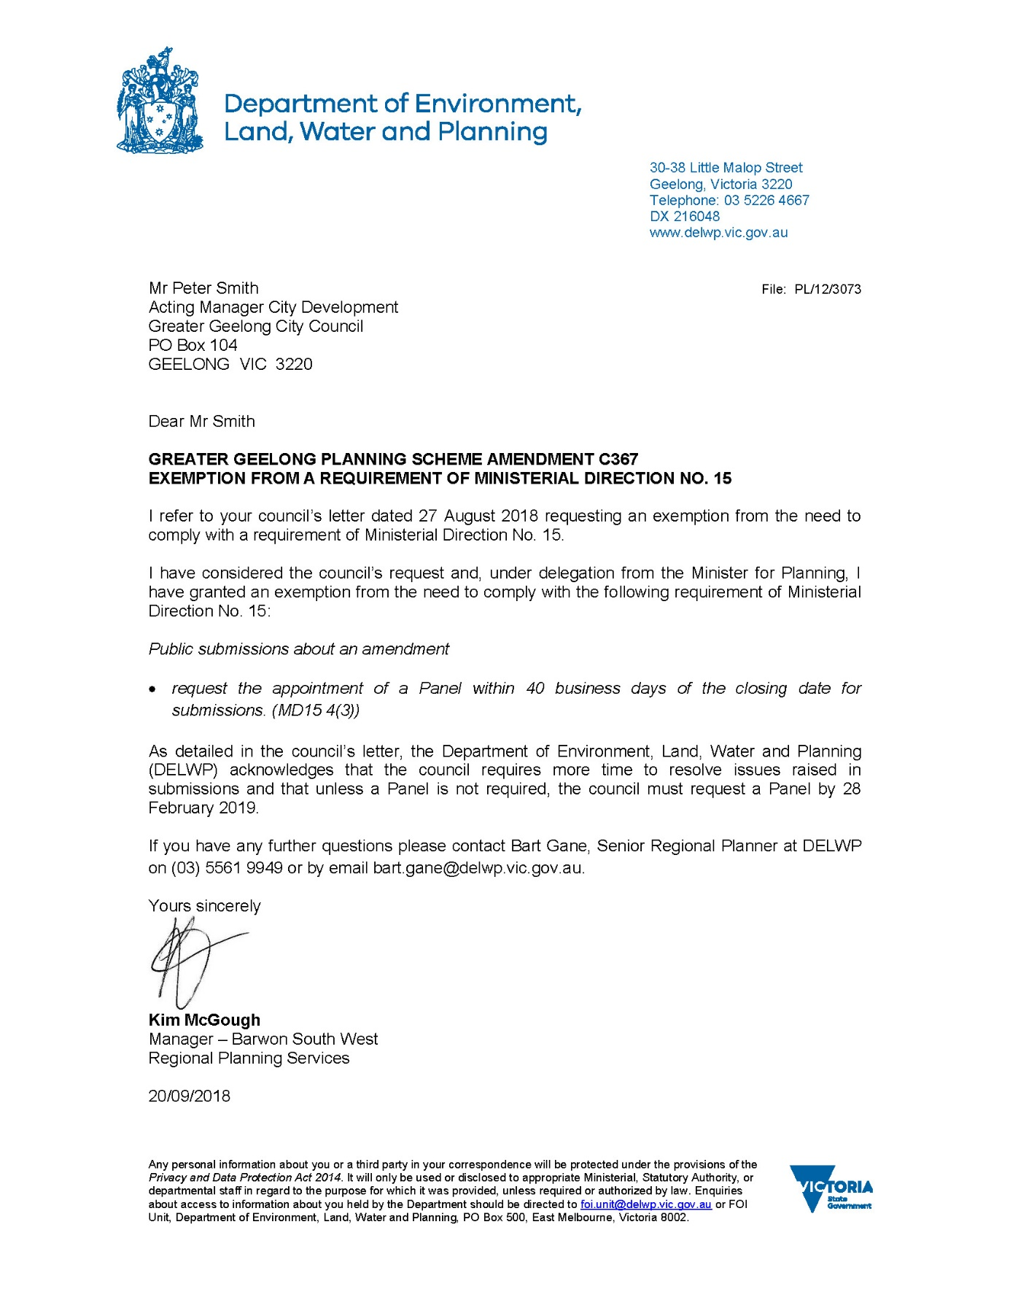
Appendix 5 – Exemption from Ministerial Direction No. 15 4(3)

