AMENDMENT C367 to the GREATER GEELONG PLANNING SCHEME and PERMIT APPLICATION No. PP-1463-2016

2-120 MOLLERS LANE, LEOPOLD

Part A (2) Statutory Planning Assessment Report

Panel: Sarah Carlisle (Chair), Gabby McMillan
Date: Monday 3 December 2018
Prepared by: Susan Williamson, Senior Strategic Planner and Leanne Stockley, Senior Town Planner on behalf of the City of Greater Geelong
Application Number: | PP-1463-2016
Responsible Officer: | Leanne Stockley
Applicant’s Name: | TGM Group Pty Ltd
Address/Title Details: | 2-120 Mollers Lane, LEOPOLD
Proposal: | Staged Multi-Lot Subdivision, Removal of Vegetation, Remove/Creation/Alterations to Easements, and Alter an Access or Subdivide Land Adjacent a Road Zone Category 1
Date Received: | 13-Dec-2016
Date Report Prepared: | November 2018
Restrictive Covenant or Section 173 Agreement: | No restrictive covenant or Section 173 agreement affects the land.
Zoning: | Farming Zone with amendment to General Residential Zone Schedule 1.
Overlays: | Significant Landscape Overlay with amendment to remove, and apply Design and Development Overlay, Schedule 43
Current Use/Development: | Generally agriculture (some dwellings and outbuildings) with place of worship, and telecommunications facility at 32-40 Moller Lane

PERMIT TRIGGER:

Zone/Overlay Clause:

Pursuant to Clause 32.08-3 of the General Residential Zone a permit is required to subdivide land.

Pursuant to Clause 52.02 of the Easements, Restrictions and Reserves provision, a permit is required to create vary or remove an easement;

Pursuant to Clause 52.17 of the Native Vegetation provisions, a permit is required to remove, destroy or lop native vegetation, including dead native vegetation;

Pursuant to Clause 52.29 of the Land Adjacent to a Road Zone, Category 1, or a Public Acquisition Overlay for a Category 1 Road provision, a permit is required to create or alter access to a road in a Road Zone, Category 1; and subdivide land adjacent to a road in a Road Zone, Category 1.

Definitions:

Subdivision is not defined or nested in the Planning Scheme.

A lot is defined as a part (consisting of one or more pieces) of any land (except a road, a reserve, or common property) shown on a plan, which can be disposed of separately and includes a unit or accessory unit on a registered plan of strata subdivision and a lot or accessory lot on a registered plan.

Subdivision is defined in the Subdivision Act 1988 as the division of land into two or more parts which can be disposed of separately.

Cultural Heritage Management Plan:

The Aboriginal Heritage Regulations 2007 specify the circumstances in which a cultural heritage management plan is required for an activity or class of activity.

A cultural heritage management plan has been supplied as part of the documentation for the application, along with the approval issued by the Wathaurung Aboriginal Corporation on 10 January 2017.

Development of the subject site is required to be undertaken in accordance with the approved Cultural heritage Management Plan and is the responsibility of the developer.

Coastal Inundation And Erosion:

Clause 13.01-2S of the SPPF requires the Responsible Authority to consider the potential coastal impacts of climate change.

Strategies include:
- In planning for possible sea level rise, an increase of 0.2 metres over current 1 in 100 year flood levels by 2040 may be used for new development in close proximity to existing development (urban infill).
- Plan for possible sea level rise of 0.8 metres by 2100, and allow for the combined effects of tides, storm surges, coastal processes and local conditions such as topography and geology when assessing risks and coastal impacts associated with climate change.
- Ensure that land subject to coastal hazards is identified and appropriately managed to ensure that future development is not at risk.
- Ensure that development or protective works that seek to respond to coastal hazard risks avoid detrimental impacts on coastal processes.
- Avoid development in identified coastal hazard areas susceptible to inundation (both river and coastal), erosion, landslip/landslide, acid sulfate soils, bushfire and geotechnical risk.

The subject site is located within close proximity of existing urban development.

Council’s data indicates that the site is unlikely to be affected by the potential coastal impacts of climate change at 2040.

Landfill Gas Risk Assessment

Before deciding on a Planning Permit application, a Responsible Authority is required to consider, amongst other things:
- Any significant effects the responsible authority considers the environment may have on the use or development [S 60(1) of the PEA].
- Clause 13.04-1S of The State Planning Policy Framework which aims to ensure that potentially contaminated land is suitable for its intended future use and development, and that contaminated land is used safely.

The EPA has adopted the “Best Practice Environmental Management, Siting, Design Operation and Rehabilitation of Landfills” (September 2010) or “Landfill BPEM.”.

The Landfill BPEM identifies that:
- Risks associated with landfill gases may occur for at least 30 years post-closure.
- Appropriate buffer distances must be maintained between the landfill and sensitive land uses. The BPEM recommends a 500 metre buffer for landfills that contained putrescible waste and 200 metres for landfills that contained non-putrescible waste.
- Where the recommended buffers are unavailable, it must be demonstrated that risks are suitably mitigated.
- All buildings and structures and associated infrastructure should be considered.

The BPEM specifies that development undertaken within a buffer distance of up to 500 metres may be at risk. As the subject site is not located within 500 metres of an identified former landfill site, a risk assessment is not required.

Developments In Bushfire Prone Areas

Clause 13.02 (Bushfire) seeks to strengthen the resilience of settlements and communities to bushfire through risk-based planning that prioritises the protection of human life.

The policy must be applied to all planning and decision making under the Planning and Environment Act 1987 relating to land which is:
- Within a designated bushfire prone area;
- Subject to a Bushfire Management Overlay; or
- Proposed to be used or developed in a way that may create a bushfire hazard.

The proposal is listed at Clause 13.02-1S as one of the uses or developments which should be considered:
- Subdivisions of more than 10 lots.
- Accommodation.
- Child care centre.
- Education centre.
- Emergency services facility.
- Hospital.
- Indoor recreation facility.
- Major sports and recreation facility.
- Place of assembly.
- Any application for development that will result in people congregating in large numbers.

The site is located within a designated bushfire prone area.

As the site is located within a designated bushfire prone area the assessment of this application has considered:
- The risk of bushfire to people, property and community infrastructure.
- Whether the implementation of appropriate bushfire protection measures to address the identified bushfire risk is necessary.
- Whether the proposal can implement bushfire protection measures without unacceptable biodiversity impacts.

The application is not expected to create a risk bushfire to people, property and community infrastructure, where development of the land with dwellings will be subject to individual Bushfire Attack Level assessment by the relevant Building Surveyor at the time. Alternatively, revocation of the Bushfire Prone status may occur at such a time as the area becomes urbanised, and the risk is deemed appropriate to be reduced.

Officer Direct Or Indirect Interest:

No Council officers have any direct or indirect interest in the matter to which this report relates, in accordance with Section 80 (C) of the Local Government Act.

PROPOSAL:

The application proposes a staged multilot subdivision of the land holdings, with the plan submitted labelled Overall Development Plan, revision U demonstrating the development of 494 lots (including two medium density lots).

Lot sizes and percentages (Lot Density and Diversity Plan, version U 14/12/2017)

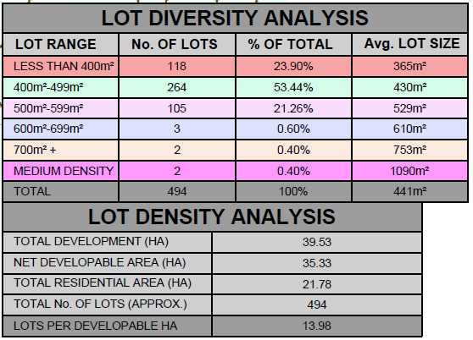

The proposal also creates two corridors through the land which are proposed to be revegetated (and realigned) waterways. The waterways will also serve the purpose of linear passive open space for walking and cycling. In addition, open space is provided adjacent the norther waterway, and incorporates a drainage basin for the retardation and treatment of stormwater from the northern portion of the overall development. The south waterway, basin and open space also serves the purpose of a buffer between urban development and the rural land and Lake Connewarre to the south of the subject land.

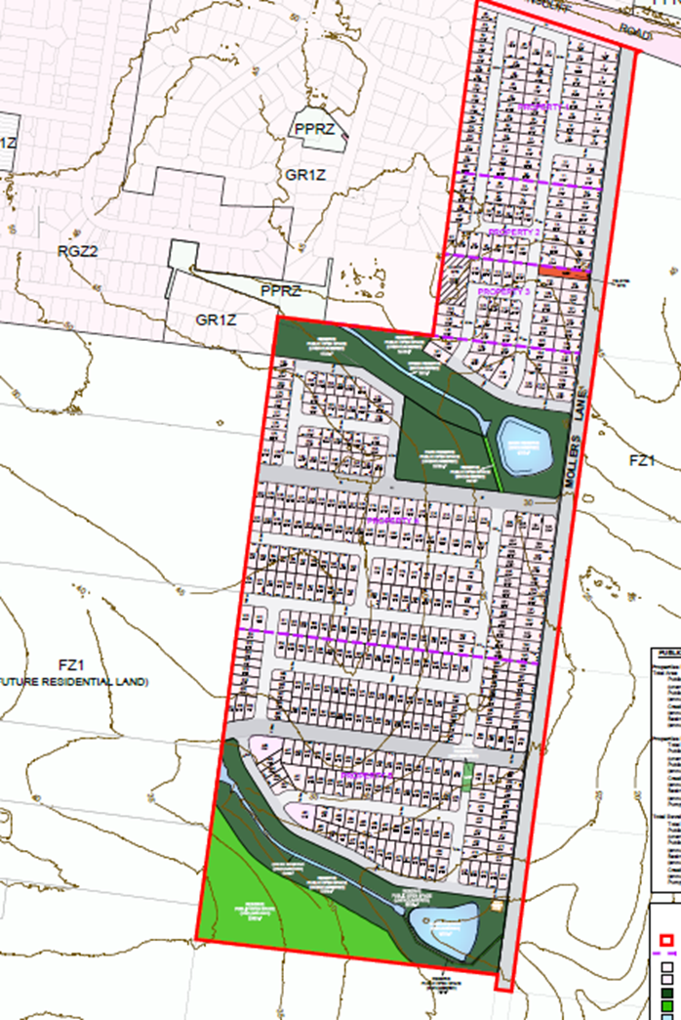

Open Space Plan, revision U, 17/01/2017

The proposal has been submitted with changes on 16 November 2018. The submission has not been made with a Section 57A (of the Planning and Environment Act 1987) request to amend a current application, as would normally be required if it is the intention to supersede a previously submitted plan, and seek a decision on the most recent submission.

The proposal submitted 16 November 2018 includes subdivision of the land to the south of the southern waterway, which was land previously identified as being encumbered open space, and has removed the open space provision adjacent the northern waterway corridor also. Effectively, all active open space provisions (or “kick-about” areas that may also have infrastructure provision such as play equipment) have been removed from the proposal. It is also noted that an additional medium density site has been added, and the church site has been removed with lots proposed.

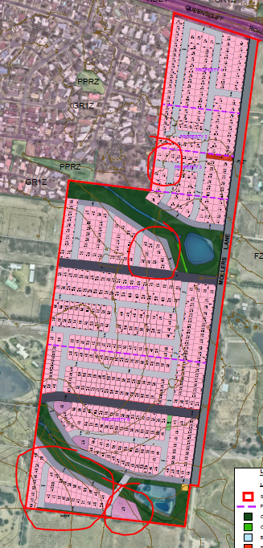

Submission made 16 November 2018 – Overall Development Plan, revision Y2

The application also proposes the removal of native vegetation to facilitate the subdivision. Vegetation to be removed includes scattered trees and patches of vegetation, identified in the revised Vegetation Assessment and Native Vegetation Removal Report (Mark Trengove Ecological Services, November 2018).

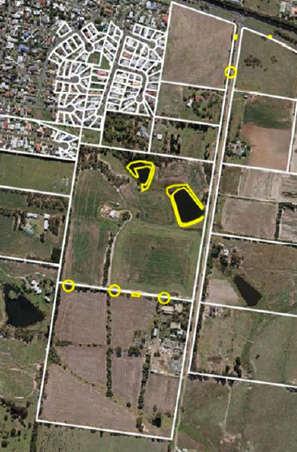
Vegetation to be removed is indicated in yellow and equates to 0.727 hectares.

The proposed subdivision area will also include the re-alignment, removal and creation of various easements within the development lots, with this being included generally in the permit pre-amble, as a permit is required for these actions under Clause 52.02.

One of the lots to be developed is adjacent the Bellarine Highway, a Road Zone Category 1. As such, the application also seeks approval for subdivision of land adjacent a road in a Road Zone Category 1 in accordance with Clause 52.29. Further, the intersection of Mollers Lane and Bellarine Highway will be altered as a result of the subdivision.

SITE/LOCALITY:

The land holdings subject to the application are addressed:
- 2-20 Mollers Lane,
- 22-30 Mollers Lane,
- 32A Mollers Lane,
- 32-40 Mollers Lane,
- 42-90 Mollers Lane and
- 92-120 Mollers Lane

The sites include agricultural uses with scattered buildings, including dwellings, a church and two telecommunications towers and associated facilities on the land at 32-40 Mollers Lane, and minor waterways and dams on 42-90, and 92-120 Mollers Lane.

The land is undulating with levels varying from 27mAHD to 49mAHD. The land size as a whole equates to 39.53 hectares with a frontage to Mollers Lane of approximately 1.2km, and frontage to Bellarine Highway of approximately 200m.

A variety of vegetation exists on the subject sites and immediately adjoining, including native vegetation, planted windrows, and garden vegetation around dwellings.

In general, the land can be described as rural land holdings immediately adjacent the residential interface with the south east portion of Leopold, with the Leopold Structure Plan map at Clause 21.14-8 indicating Mollers Lane as the eastern extent of urban growth for Leopold.

PERMIT/SITE HISTORY:

The following application history is applicable to this application:

12 December 2016 | Section 96A application for combined amendment and permit application lodged for C367 and PP 1463/2016
January 2017 | Referral of application to internal City departments and external agencies
9 April 2017 | New Ministerial Direction on the Form and Content of Planning Schemes – subsequently amended on several occasions including most recently 30 July 2018.
April – November 2017 | Discussions between applicant and officers
20 September 2017 | Council decision to prepare Amendment C367 and seek authorisation
29 January 2018 | Revised combined amendment and permit application submitted for C367 and PP 1463/2016
February 2018 | Draft permit and amendment documents prepared
13 March 2018 | Council requested authorisation to prepare and exhibit Amendment C367 to the Scheme.
20 April 2018 | Minister’s delegate authorises amendment preparation and exhibition.
17 May – 18 June 2018 | Amendment C367 is exhibited in accordance with the Act.
30 July 2018 | Amendment VC148 Reforms to the Victoria Planning Provisions.
18 October 2018 | Council considered submissions to Amendment C367 and resolved to request the appointment of an independent panel to consider submissions.
18 October 2018 | Council requested the appointment of a Panel under Part 8 of the Act.
26 October 2018 | Amendment VC154 changes to the Victoria Planning Provisions
7 November 2018 | Directions Hearing held in relation to Amendment C367.
8 November 2018 | Panel issues timetable and directions.
15 November 2018 | Very late submission received from Echelon Planning on behalf of owners of 129 Ash Road Leopold
16 November 2018 | Applicant circulates amended Overall Development Plan version Y2, Revised Native Vegetation Assessment, Arborist Report.

REFERRALS:

The following referrals were undertaken:

External

Section 55:

Authority  Department | Advice/Response/Conditions
Barwon Water  Determining Authority under Clause 66.01 | I write in response to your pre-referral in January 2017 regarding the above-mentioned Amendment C367affecting land in Leopold.  Barwon Water understands the amendment proposes to rezone land in the South East Leopold growth area generally fronting Mollers Lane to support urban development in line with the previously developed overall development plan (ODP). Barwon Water has previously provided input to the ODP, which provided an overview of our servicing requirements for the area. These comments have been updated in this advice below.  General comment  Barwon Water supports amendment C367 proceeding. We recognise that available, developable greenfield land is currently lacking in Leopold and as such, this project will facilitate additional growth and connections to our network.  Capacity to provide reticulated services Water and sewerage services can be provided to the subdivision. Specific water and sewer servicing  comments are attached as Appendix 1.  Treatment/incorporation of the Barwon Water pipeline asset into the road system As per previous advice, two large diameter water mains, referred to as the Bellarine Transfer Mains (BTM), run east west within a 10m wide easement through the development area. The BTM is of  critical importance to Barwon Water and planning for this area will need to note the presence of this easement and ensure Barwon Water has satisfactory access to its entire length. Road crossings of the pipelines may involve lowering or relocating at the developer’s expense. We note the plan of subdivision includes provision for a road reserve to be located over the water main easement. At a conceptual level, Barwon Water is comfortable with this arrangement, however we will require further details from the developer as planning progresses to ensure our requirements for these mains are adequately catered for.  Preliminary requirements are likely to include, but not be limited to:  - Location and position confirmation of the BTM and easement in relation to the road reserve.  - Depth and condition confirmation of the BTM and proposed sub grade works for the roads.  - Detailed cut/fill plans for the road reserve and location of the BTM in relation to this.  - Proposed treatments of the BTM during and post construction activities.  Ongoing consultation will be required with Barwon Water to adequately address all requirements relevant to the BTM at the developers cost.  Requirements for the plan  Other than the specific requirements of the BTM as described above, servicing advice indicates that there will be two above ground Barwon Water assets within this area which will require land set aside.  A water pressure reducing valve (PRV) will be required immediately south of the BTM on Mollers Lane, while a sewer pump station is required at the low point of the catchment on Mollers Lane. This land should be vested to Barwon Water as part of the subdivision process. These are shown indicatively on the plan below.  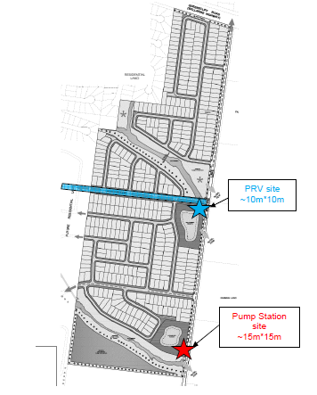  Any other servicing comments  Remaining servicing comments attached below as Appendix 1.  Any conditions for the planning permit  Applicant should apply to Barwon Water for planning permit to receive standard BW conditions for subdivision.  Appendix 1 – Barwon Water servicing requirements  Water Supply  This current advice (February 2017) supersedes previous advice.  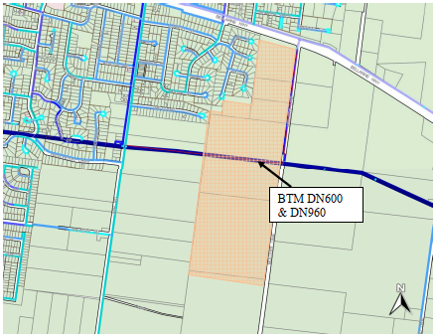  Figure 1 – Development Location and BW assets  Leopold is currently serviced with water by gravity from the Geelong system. There are existing transfer water mains running through Leopold. The DN600 and DN960 diameter Bellarine Transfer Mains (BTM) runs through Leopold and connections exist at Melaluka Road, Ash Road and Mollers Lane. There is adequate capacity in the BTM to supply the Growth Area  Bellarine Transfer Mains (BTM)  The BTM is located within the plan of subdivision. The BTM is contained within a 10m wide easement running east west through the development area. The BTM consists of two large diameter mains.  1. A DN600 that directly supplies Leopold (approximately 3m offset on the North side of the easement). The MSCL water main was constructed in 1969.  2. A DN960 (approximately 3m offset on the South side of the easement) that transfers water from the Geelong system to the townships on the Bellarine Peninsula. This includes Ocean Grove, Drysdale, Clifton Springs, Portarlington, St Leonards, Queenscliff and Point Lonsdale.  The MSCL water main was constructed in 2005. These mains are of critical importance to Barwon Water. As per previous advice the planning for this area will need to note the presence of this easement and ensure Barwon Water has satisfactory access to its entire length. Crossings of the pipelines may involve lowering or relocating at the  developer’s expense.  We note the plan of subdivision includes provision for a road reserve to be located over the water main easement. AT a conceptual level, Barwon Water is comfortable with this arrangement, however we will require further details from the developer as planning progresses to ensure our requirements on these mains are adequately catered for. Preliminary requirements are likely to include, but not be limited to:  - Location and position confirmation of the BTM and easement in relation to the road reserve.  - Depth and condition confirmation of the BTM and proposed sub grade works for the roads.  - Detailed cut/fill plans for the road reserve and location of the BTM in relation to this.  - Proposed treatments of the BTM during and post construction activities.  Ongoing consultation will be required with Barwon Water to adequately address all requirements relevant to the BTM at the developers cost.  Water Reticulation Servicing  The development area will be supplied by two distinct pressure zones (high and medium level). The zone separation will be along the northern most public open space adjacent the BTM. Refer to Figure 3.  Leopold High Level Zone  Barwon Water constructed a DN300 main in Mollers Lane in 2013 which can be used to supply the high level portion of this development area. Refer to Figure 2 & 4. A connection to the water mains in the adjacent development is preferable to provide a dual supply to the development area. Refer to Figure 2. BW have shown this connection via Leicester Mews, however would be also be open to a connection via Willows Place. This will depend on what is proposed with the existing property at 10 Willows Place and whether that driveway ultimately becomes a reserve.  Leopold Medium Level Zone  A separate DN225 water main with PRV is required to be constructed as a shared asset to service the medium level zone portion of the development. Refer to figure 2 & 4 Zone valves will be placed on the western boundary of the development to allow isolation of the medium level zone from the ultimate high level zone. An overall development servicing plan is shown in Figure 2. Ultimately the DN225 water main will extend through to Ash Road to connect to a DN300 on the Leopold high level system. A plan of the ultimate feeder mains is included as Figure 4.  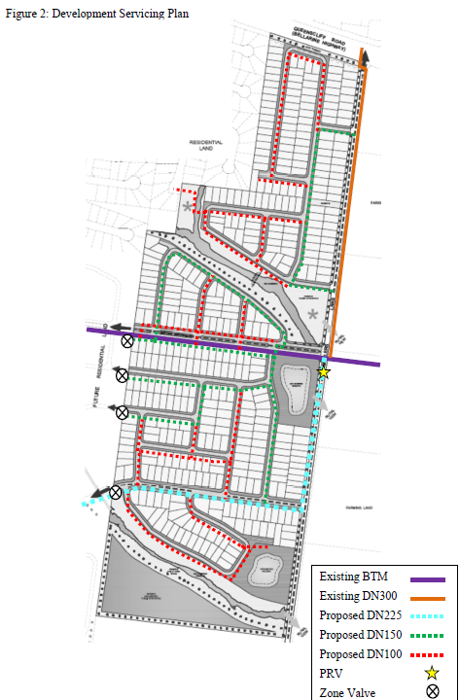  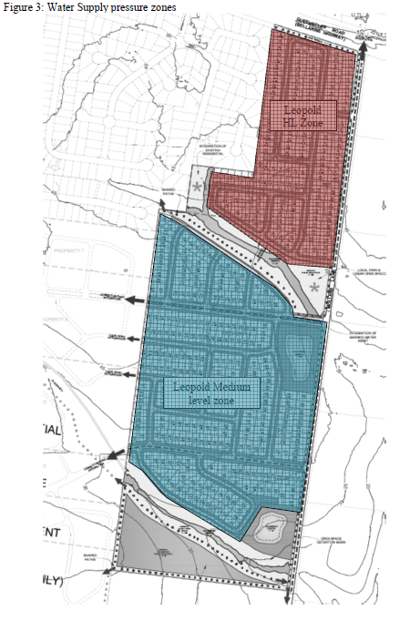  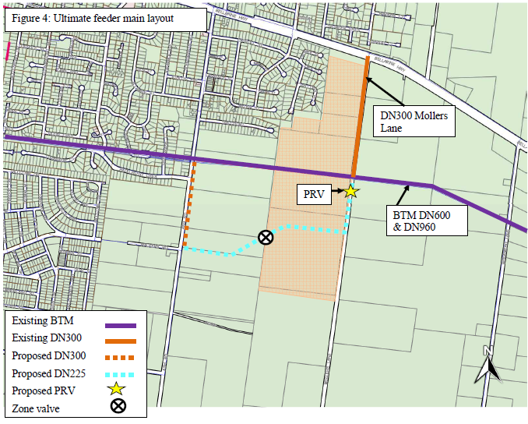  Sewerage  Barwon Water has previously commented on this site, the last comment being in August 2016. Our advice is updated here. The site generally drains via gravity towards the low point on Mollers Lane. Two pump stations are required to service the land west of Ash Road. For amendment C367, one pump station will be required on Moller’s Lane as indicated in Figure 5 below. The amendment proposes 427 lots based on a lot density of 12.3 Lots/Ha. An indicative layout of the farming land immediately east of Ash Road (i.e. not subject to this amendment) has indicated a further 370 lots, assuming a similar lot density as the subject site. A review of sewerage catchments indicated that some 86 lots in the north of the subject site could be serviced by existing sewers in the adjacent residential area to the west of the site. This represents Stages 1, 2 and most of 3. The remaining land would be serviced by two sewer pump stations. The breakdown is as follows:  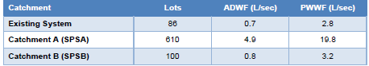  Figure 5 on the following page shows the subject site and the adjoining potential future development east of Ash Road. A sewer pump station (SPSA) is required in the south-east corner of the subject site. A smaller sewer pump station (SPSB) may be required in the south-east corner of the potential development on the east side of Ash Road (SPS B in Fig.5). There could be potential for this western catchment (with deep sewers) to gravitate to the eastern catchment, resulting in one pump station servicing approximately 710 lots. This would require further examination when more accurate levels and development plans are prepared for the western area.  The sewer pump station proposed in the south-east corner of the subject site would be considered a “Reticulation Asset” as DN225mm sewers would gravitate to it from the north (approx. 310 lots) and from the west (approx. 300 lots). The current concept for SPSA, would have a duty of approximately 20L/s and a DN150mm rising main.  The preferred alignment of the DN150mm rising main would be through both the subject site and the land to the west, and connect to a future extension of the DN225 sewer in Estuary Boulevard/Walkers Road as shown in figure 5. This alignment may pose access difficulties for the developers of the subject site if this site develops prior the land at Ash Road and Walkers Road.  Further discussion with Barwon Water will be required as to the potential delivery method for this ‘reticulation asset’. The consultant TGM has raised the possibility of a negotiated charge to cover the  construction of this asset. This needs to be further explored with Barwon Water at the time of offer.  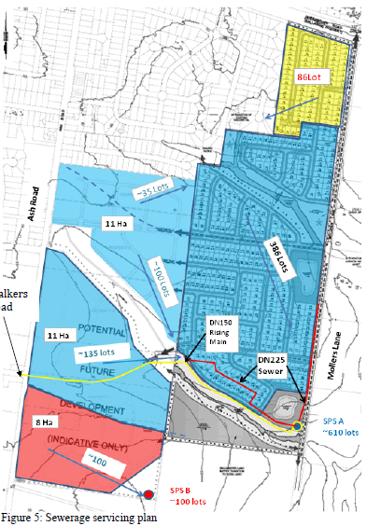  Conditions provided separately to the above response:  The conditions contained within this letter are considered draft and based on the information presented to Barwon Water. Confirmation of conditions will be undertaken when formal referral is received.  General  1. The owner shall create easements for Pipelines or Ancillary Purposes and or reserves in favour of Barwon Region Water Corporation on the plan of subdivision in accordance with Barwon Water's Land Development Manual, without cost to Barwon Water, over existing and proposed water and sewerage infrastructure within the land. If further easements or reserves are required following design of water and sewerage infrastructure these must be added to the plan of subdivision prior to seeking Barwon Water's consent to the issue of a statement of compliance for the subdivision.  2. The plan of subdivision must be referred to Barwon Water in accordance with the Subdivision Act 1988 and any subsequent amendments to the plan provided to Barwon Water.  3. Existing strategic pipelines traverse the land. Barwon Water requires the location of these pipelines to be proven prior to any works. Any works proposed in the vicinity of the pipelines will only be permitted after approved civil works planned are presented to the satisfaction of Barwon Water. Through subdivision of the land these pipelines must be located within the road reserve and not private property.  Water  1. The provision and installation of individual water services to all lots in the subdivision.  2. Reticulated water mains are required to service the proposed development. This work must be designed by a Barwon Water accredited Consulting Engineer and constructed by a Barwon Water accredited Contractor following the "Developer Works" process.  3. Additional water assets are required to service the development, which include DN225mm water mains and a Pressure Reducing Valve. Under the current Essential Services Commission (“ESC”) price determination these water assets are considered “shared” assets and to be funded by Barwon Water. Confirmation of these additional water asset requirements and funding will be determined at the time an “Offer of Conditions” is issued on the development, and in accordance with the ESC price determination applicable at the time.  4. The payment of New Customer Contributions for water for each additional connection which includes any new lot on a plan of subdivision and/ or any apartment, unit, or premises within the development that is or can be separately metered for water supply.  5. Barwon Water's records indicate that existing water services and meters are located on land within this area. A dimensioned plan showing the location of existing meters, and the location of the meter relative to the existing boundaries, and its number, are to be submitted. Private water service pipes are not permitted to cross allotment boundaries and must be plugged and abandoned at the boundaries of such allotments.  Sewer  1. The provision of sewerage services to all lots in the subdivision.  2. Reticulated sewer mains are required to service the proposed development. This work must be designed by a Barwon Water accredited Consulting Engineer and constructed by a Barwon Water accredited Contractor following the "Developer Works" process.  3. Additional sewerage assets are required to service the development, which include sewer pump-stations and rising mains. These must be designed by a Barwon Water accredited Consulting Engineer and constructed by a Barwon Water accredited Contractor following the "Developer Works" process.  4. The payment of New Customer Contributions for sewer for each additional connection which includes any new lot on a plan of subdivision and/ or any apartment, unit, or premises within the development that is or can be separately metered (for water supply).  Note: The developer is to apply to Barwon Water for details relating to costs and conditions required for the provision of water supply and sewerage services to the subdivision. It would be appreciated if all communication quote Barwon Water reference number L009993
Response:
Barwon Water made a submission post exhibition of the amendment and draft permit (below is an extract):

Barwon Water previously provided comment to this amendment on the 10 February 2017 and our advice is largely unchanged. Barwon Water has reviewed the proposed amendment and has no objections to rezoning this land from Farming Zone (FZ) to General Residential Zone 1 (GRZ1) from a servicing perspective.
The contents of attachment 8 Infrastructure & Servicing Assessment, TGM 2016, are slightly out of date. Updated servicing comments are provided below (in the response).
…

Summary
… from a servicing point of view, Barwon Water raises no objections to the planning scheme amendment C367 to rezone land at Mollers Lane Leopold. The draft Planning Permit contains appropriate clauses relating to Barwon Water. In accord with clause 104, the developer is to apply to Barwon Water for details relating to costs and conditions required for the provision of water supply and sewerage services to the subdivision.

Of note, the submission did not seek any amendments or additions of conditions to the draft permit conditions.

Authority/Department | Advice/Response/Conditions
Downer Utilities (Ausnet Gas Services)  Downer Utilities is a Determining Authority under Clause 66.01 | We advise that AusNet Services (Gas) Pty Ltd is the owner of substantial gas assets in metropolitan Melbourne and country Victoria, and that Downer – Infrastructure Services is their maintenance provider. As part of this arrangement, we provide engineering support and act as their referral authority. AusNet Services (Gas) pursuant to Section 19 (1) and 56 (1) (b) of the Planning and Environment Act 1987 has no objection to proposed planning scheme amendment and has no objection to the granting of the planning permit.
Response:
Noted

Authority  Department | Advice/Response/Conditions
Powercor  Powercor is a Determining Authority under Clause 66.01 | Powercor Australia Ltd does not object to the issue of a planning permit in respect of the above-mentioned application if the permit is subject to the following conditions:  Conditions Required By Powercor Australia Ltd  1. The plan of subdivision submitted for certification under the Subdivision Act 1988 shall be referred to Powercor Australia Ltd in accordance with Section 8 of that Act.  2. The applicant shall:-  - Provide an electricity supply to all lots in the subdivision in accordance with Powercor’s requirements and standards, including the extension, augmentation or re-arrangement of any existing electricity supply system, as required by Powercor (A payment to cover the cost of such work will be required). In the event that a supply is not provided the applicant shall provide a written undertaking to Powercor Australia Ltd that prospective purchasers will be so informed.  - Where buildings or other installations exist on the land to be subdivided and are connected to the electricity supply, they shall be brought into compliance with the Service and Installation Rules issued by the Victorian Electricity Supply Industry. You shall arrange compliance through a Registered Electrical Contractor.  - Any buildings must comply with the clearances required by the Electricity Safety (Installations) Regulations.  - Any construction work must comply with Energy Safe Victoria’s “No Go Zone” rules.  - Document in BDS-DOI (1) 2  - Set aside on the plan of subdivision for the use of Powercor Australia Ltd reserves and/or easements satisfactory to Powercor Australia Ltd where any electric substation (other than a pole mounted type) is required to service the subdivision.  Alternatively, at the discretion of Powercor Australia Ltd a lease(s) of the site(s) and for easements for associated powerlines, cables and access ways shall be provided. Such a lease shall be for a period of 30 years at a nominal rental with a right to extend the lease for a further 30 years. Powercor Australia Ltd will register such leases on the title by way of a caveat prior to the registration of the plan of subdivision.  - Provide easements satisfactory to Powercor Australia Ltd, where easements have not been otherwise provided, for all existing Powercor Australia Ltd electric lines on the land and for any new powerlines required to service the lots and adjoining land, save for lines located, or to be located, on public roads set out on the plan. These easements shall show on the plan an easement(s) in favour of "Powercor Australia Ltd" for “Power Line” pursuant to Section 88 of the Electricity Industry Act 2000.  - Obtain for the use of Powercor Australia Ltd any other easement external to the subdivision required to service the lots.  - Adjust the position of any existing easement(s) for powerlines to accord with the position of the line(s) as determined by survey.  - Obtain Powercor Australia Ltd’s approval for lot boundaries within any area affected by an easement for a powerline and for the construction of any works in such an area.  - Provide to Powercor Australia Ltd, a copy of the version of the plan of subdivision submitted for certification, which shows any amendments which have been required.
Response:
Noted

Authority Department | Advice/Response/Conditions
EPA  The EPA is not a statutory referral body under the Greater Geelong Planning Scheme for this type of application, however the advice of the authority was sought to assist Council’s decision making.  As such the authority is a recommending authority. | Thank you for your correspondence in relation to the above planning scheme amendment, referred to EPA on 23/01/2017.  Council have asked EPA for initial comments on a combined planning scheme amendment and planning permit for Mollers Lane, Leopold. The details of the Amendment include:  - Rezoning land at 2-120 Mollers Lane (41 hectares) from the Farming Zone to the General Residential 1 Zone.  - The creation of a multi-lot conventional subdivision at 2-120 Mollers Lane and 10 Willow Place Leopold consistent with relevant planning provisions of the Greater Geelong Planning Scheme.  - Revising the extent of the current SLO10.  - Applying a Schedule to the Design and Development Overlay to the subject land.  - The removal of native vegetation.  EPA offer the following comments for Council’s consideration.  Contaminated Land  EPA wishes to remind the planning authority to ensure that the recommendations of Ministerial Direction No. 1 regarding potentially contaminated land have been adhered to. Ministerial Direction No.1 states that where land has been previously used for industry, mining, or chemical storage, and is to be used for a sensitive use, as defined in the Direction, an audit is required.  An Environmental Assessment report (by Environmental Site Assessments, reference ESA/329/2016) has been provided in support of the application. The report concludes that:  - The site is not considered to be potentially contaminated;  - As per Ministerial Direction No. 1, an Environmental Audit is not required for the site; and  - The site is suitable for a medium residential land use for housing under the Geelong Planning Scheme.  The Potentially Contaminated Land General Practice Note (DSE – June 2005) recommends that an environmental audit should be required unless the proponent can demonstrate to the satisfaction of the responsible authority that the site has never been used for a potentially contaminating activity, or that other strategies or programs are in place to effectively manage any contamination.  EPA has not undertaken a technical review of the Environmental Assessment report submitted in support of this application. EPA generally does not review environmental site assessments and provide an opinion on whether an environmental audit is required, hence why EPA maintains an environmental audit system. If Council require further guidance on whether an audit is required, Council can request a peer review by a second environmental consultant, or seek advice from an EPA appointed environmental auditor.  Other Considerations  EPA also wishes to advise Council to consider reference to Urban Stormwater Best-Practice Environmental Management Guidelines CSIRO May 2006 (or other stormwater management policies) to ensure water quality is maintained in an area. EPA notes that the site is in close proximity to Lake Connewarre.  Planning Permit  EPA recommends Council consider the following condition (or a condition to this effect) for inclusion in the planning permit:  - Construction and post-construction activities must be in accordance with EPA Publication 275 Construction Techniques for Sediment Pollution Control 1991 or as amended.  Council could also consider a permit condition requiring the submission and implementation of an Environmental Management Plan for the site.  EPA Publication 960 Doing it right on subdivisions: Temporary environmental protection measures for subdivision construction sites (October 2004) highlights a range of temporary environmental protection measures, which may be employed during the construction of subdivisions. EPA Publication 480 Environmental Guidelines for Major Construction Sites (February 1996) provides a useful source document to help prepare and implement an environmental management plan for major constructions sites.  If the amendment proceeds to public exhibition EPA would welcome the opportunity to make a formal submission.
Response:
The EPA have made a submission in response to the amendment and draft permit exhibition. Their comments are below:

EPA notes the comments provided to you on 28 February 2017 on initial referral of the application, and is pleased to see that these comments have been incorporated into the amendment documents and draft planning permit.

EPA has no concerns with the proposed combined planning scheme amendment/planning permit application, and in particular supports the inclusion of condition 13 of the draft planning permit (Construction Environmental Management Plan), and reference in the draft permit to the following EPA Guidelines:
- Environmental Management Guidelines for Major Construction Sites EPA Publication 480
- Construction Techniques for Sediment and Pollution Control EPA Publication 275
- Doing it Right on Subdivisions EPA Publication 960
EPA reminds the planning authority to consider the General Practice Note on Potentially Contaminated Land, when reviewing the site assessment submitted with the application. Council must satisfy itself that the environmental conditions of land proposed to be used for a sensitive use are, or will be, suitable for that use, in accordance with Ministerial Direction No.1.

EPA supports the inclusion of condition 34 of the draft permit which prompts Council to undertake a peer review of the site assessment prior to the commencement of works.

Of note, EPA supports the inclusion of condition 34 for a peer review of the Environmental Site Assessment Reports.
Authority | Advice/Response/Conditions
CCMA  The CCMA is not a statutory referral body under the Greater Geelong Planning Scheme for this type of application, however the advice of the authority was sought to assist Council’s decision making, in this instance where two designated waterways traversed the land and were to be impacted by the proposal.  As such the authority is a recommending referral authority. | Corangamite CMA has assessed this application in accordance with its functions as the Floodplain Management Authority for the Corangamite Waterway Management District pursuant to Sections 201 to 212 of the Water Act 1989.  The Floodplain Management functions of the Authority relevant to this matter are described in Section 202 of the Water Act 1989, Clauses (1)(a), (d) and (f):  a) To find out how far floodwaters are likely to extend and how high they are likely to rise  b) to control developments that have occurred or that may be proposed for land adjoining waterways  c) to provide advice about flooding and controls on development to local councils, the Secretary to the Department and the community.  Summary and Conditions  The background and details of the Authority’s assessment of this application are detailed in Attachment A and form part of the Authority’s response.  In light of this assessment and pursuant to Section 56 of the Planning and Environment Act 1987, the Authority has no objection to the rezoning proposed in C367 and recommended that the flood extent from the 1% AEP for the developed case be adopted as a flood overlay (FO).  The following draft permit conditions are also recommended:  1. The development must demonstrate that site and access safety achieved in accordance with Australian Rainfall and Runoff Revision Project 10 Safety Criteria. Safety is defined in terms of the depth and velocity of water over the area in question during a 1% AEP flood event as follows:  a) Depth must be no greater than or equal to 0.3 metres; and  b) Velocity must be no greater than or equal to 3.0 m/s; and  c) The product of depth multiplied by velocity must be no greater than or equal to 0.3m2 per second.  2. Any alterations to the existing waterways must result in no loss of waterway stability, no loss in floodplain storage, no increase in flood levels, depth and velocity (hazard), duration of flooding or extents on other properties (adjacent, upstream and downstream) for a range of events up to and including the 1% AEP flood event.  3. It is recommended that minimum floor levels shall be no lower than 300mm above the applicable 1% AEP flood extent.  In accordance with Section 66 of the Planning and Environment Act 1987, please provide an electronic copy of the outcome of this proposal to the Authority for our records.  Property and Flood Information  Land Level information  Survey data available to the Authority indicates that the property ranges in elevation from 16.7 metres AHD4 to 49.4 metres AHD.  Please note that a licensed surveyor should be engaged to establish a suitable datum at the site to verify levels applicable to the development.  Property Flood Information and impact during 1% flood (under current climatic conditions)  Flood levels for the 1% Annual Exceedance Probability (AEP3) flood event (under current climatic conditions) have been modelled for this area. The estimated 1% flood level for the location described above is shown in Figure 1 below which was obtained from the “Site Stormwater Management Plan and Flood Impact Assessment“ submitted with the PSA documentation (appendix 7 by TGM P/L).  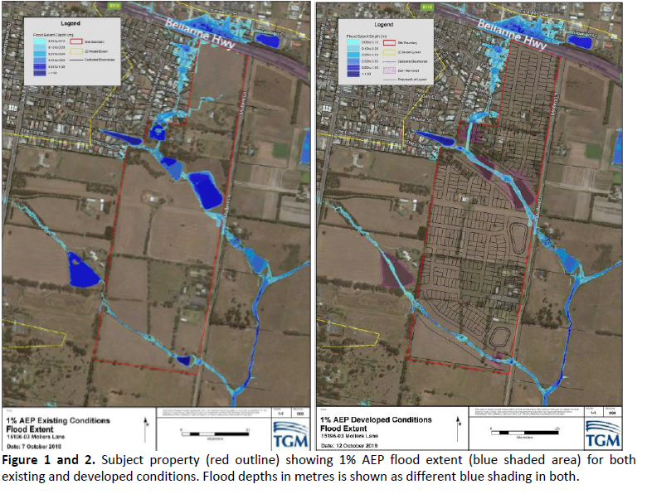  Hazard Assessment for this property  In the event of a 1% AEP flood under current climatic conditions it is likely that parts of the property would be subject to inundation from two waterways that flow south into Lake Connawarre (Figure 1).  The “Site Stormwater Management Plan and Flood Impact Assessment“ submitted with the PSA documentation (appendix 7 by TGM P/L) demonstrates that both stormwater runoff and water quality can be designed to meet best practice.  It is noted that the existing large dams on the property have been excluded in setting the base case for existing conditions. The Corangamite CMA would recommend that the base case includes the existing large dams on the waterways as this represents the current conditions and existing flood storage. Further runs will be required to demonstrate that pre and post development condition has no impact downstream and no loss of flood storage.  The proposed layout of the subdivision has allowed a minimum of 30 metre reserve retained along each side of the two waterways that traverse the property.  Subdivisions  The requirements for subdivisions from a Floodplain Management perspective are as follows:  - All new lots should be free from inundation during storm events up to and including the 1% AEP.  - The subdivision must include provision for safe evacuation and not allow the finished development to reduce the area of flow or flood storage.  - The stormwater drainage system must ensure a design philosophy of ‘zero adverse impacts’ to surrounding areas for up to and including the 1% AEP flood event.  - All streets, footpaths and cycle paths that are subject to flooding must meet the applicable flood hazard safety criteria.  Waterway buffers  Clause 14.02-1 of the Victorian Planning Provisions requires natural drainage corridors with vegetated buffer zones to be retained along each side of a waterway at least 30m wide. The waterway is defined by the bed and banks (where the top of the bank is delineated as the break of slope from the river bank to the surrounding land). This buffer is required for the following purposes:  - To allow for continuous safe vehicle and pedestrian access along the entire length of the waterway;  - To provide space for recreational and social uses; and  - To allow for future maintenance access along the river bank (e.g. weed control and storm-water system maintenance).  - This buffer helps to ensure a resilient waterway system that can effectively absorb and/or recover from damaging processes without losing its core functionality.  - It also preserves areas of the riparian zone that protect or enhance native vegetation, river health and biodiversity where present.  Where a property is covered by both the 30 metre buffer and the 1% AEP flood extent the greater of the two extents will be used to plan for development.  Designated Waterways  Please note that there are two waterways traversing the property which have been designated under the Water Act (1989). Prior to any works in, on, or over these waterways, a works on waterways application must be submitted to Corangamite CMA for assessment.  A Works on Waterway Permit from the Corangamite CMA is required for any access crossings (temporary or permanent), stormwater outlets or other works carried out on designated waterways. This permit process is required under the Water Act 1989 and is independent of the planning permit process (under the Planning and Environment Act 1987) and it is the responsibility of the person or persons proposing to undertake the works to obtain a works on waterway permit. Please note that applications for Works on Waterway Permits do not incur a fee.
Response:
The CCMA chose not to make any additional submission post exhibition of the amendment and draft permit.
As such it is considered that the conditions applied to the draft permit are sufficient and provide the appropriate protections required when developing along waterways.

Authority  Department | Advice/Response/Conditions
PTV  Head, Transport for Victoria is a determining referral authority under clause 66.02-11 | Thank you for your notification dated 24 January 2017 referring Notice of Planning Scheme Amendment C367 to Public Transport Victoria for comment. The proposed amendment seeks the following;  • Rezone the site 2— 120 Mollers Lane to General Residential Zone.  • Apply a Design and Development Overlay to the site.  The application for a planning permit proposes to;  • Subdivide the land.  • Remove native vegetation.  Whilst DEDJTR and PTV will continue to develop and review bus services in the Leopold area, including potential improvements to service frequencies, the provision to extend buses to service the site is considered to be a longer term opportunity. These reviews consider a number of issues including the likely number of users, suitability of the road network for bus operations, development of a direct and easily understood network, and connectivity with other public transport services and the costs of providing those services.  The proposed subdivision road network should be integrated with existing residential development to the west of the site. The proposed road network should provide opportunities for connectivity to Ash Road and Hazelwood Crescent to allow opportunities for future bus routes to service the area.  Public Transport Victoria does not oppose the proposed re-zoning and does not object to the proposed planning permit subject to the below conditions;  1. Before the development starts, or other time agreed in writing with Public Transport Victoria, an amended integration concept plan to the satisfaction of Public Transport Victoria, must be submitted to and approved by the Responsible Authority.  When approved, the concept plan will be endorsed and will then form part of the permit. The plan must be drawn to scale with dimensions and three copies must be provided. The plan must be generally-in accordance with the plan submitted with the application but modified to show; a. How the proposed development connects to the existing road network to the west of the site. Road links to Hazelwood Crescent, and pedestrian and cycling links to Ash Road must be demonstrated on the integration concept plan.  2. Mollers Lane and the two east — west connector roads must be constructed to accommodate public transport access for buses in accordance with the Public Transport Guidelines for Land Use and Development, to the satisfaction of Public Transport Victoria.  3 . Pursuant to Section 8 (1) (a) of the Subdivision Act 1988, only Plans of Subdivision which contain or abut a road nominated as a bus capable road within this site must be referred to Public Transport Victoria for Certification and consent to Statement of Compliance.  4. Unless otherwise agreed to in writing with Public Transport Victoria, prior to the Certification of a Plan of Subdivision, construction engineering plans, for any subdivision stages which contain or abut a road nominated as a bus capable road must be submitted to Public Transport Victoria for approval. The plan must be to the satisfaction of Public Transport Victoria and the Responsible Authority and must depict the road cross section to be constructed.  5. Unless otherwise agreed to in writing with Public Transport Victoria, prior to the issue of a Statement of Compliance for any subdivision stages that contain or abut a road nominated as bus capable, that portion of road must be constructed to accommodate public transport access for buses, and in accordance with its corresponding Cross Sections. This must be constructed to the satisfaction of and at no cost to Public Transport Victoria.  6. Any roundabouts constructed on roads designated as bus capable within the subdivision, must be designed to accommodate ultra-low floor buses, to the satisfaction of the Public Transport Victoria.  7. Intersections, slow points, splitter islands and any other local area traffic management treatments must be designed and constructed in accordance with the Public Transport Guidelines for Land Use and Development. The use of speed humps, raised platforms, one-way road narrowing and 'weave points' must not be constructed on any portion of a road identified as a potential bus route.
Response:
In response to the exhibition of the amendment and draft planning permit, Transport for Victoria have responded on behalf of PTV, and have also included comments from VicRoads. Their comments focus on pedestrian and cycle connectivity. This topic was not covered by PTV’s original response prior to exhibition.

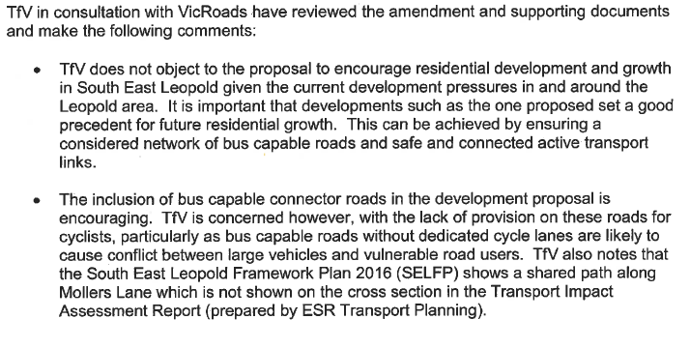
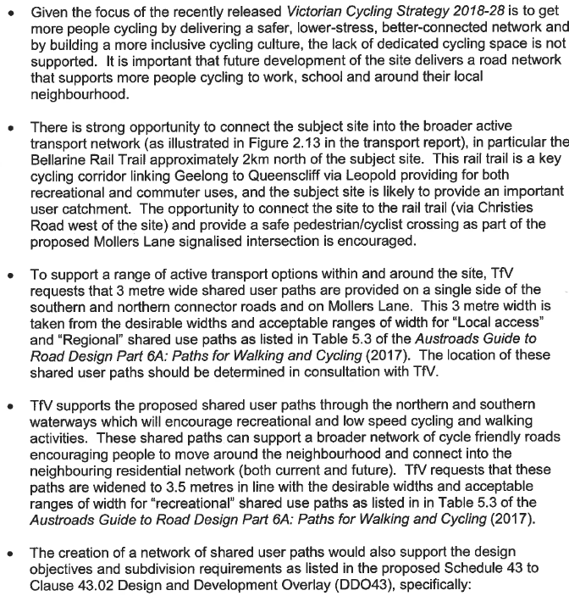

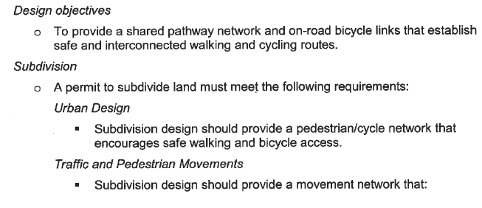
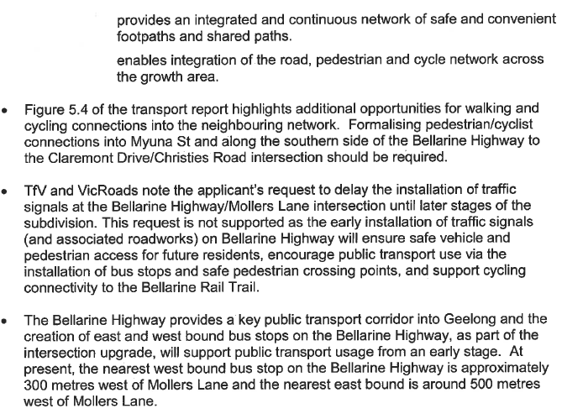
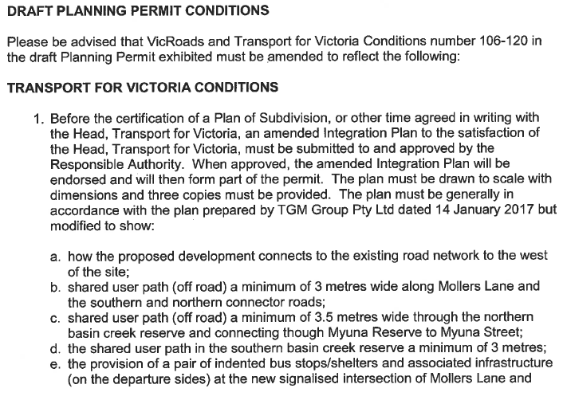
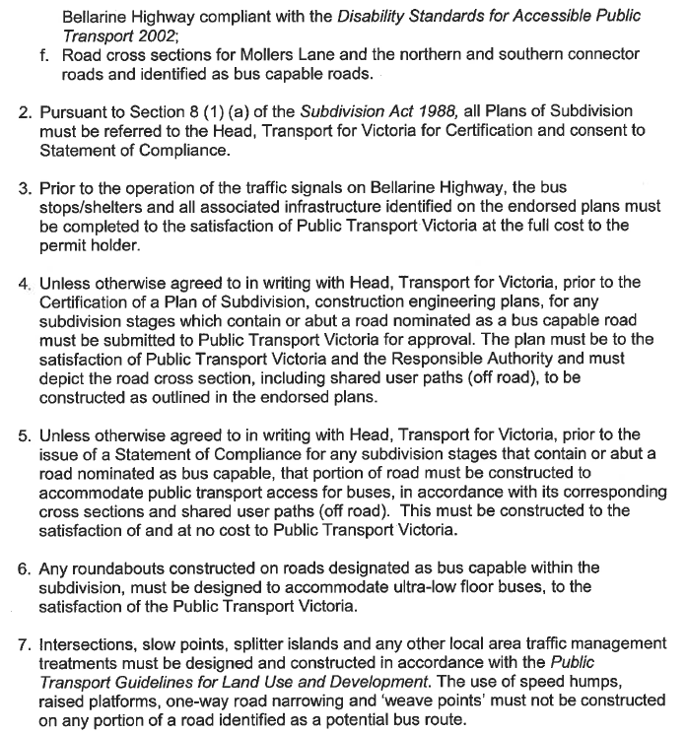

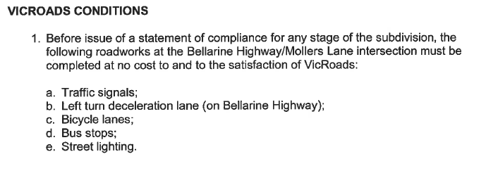
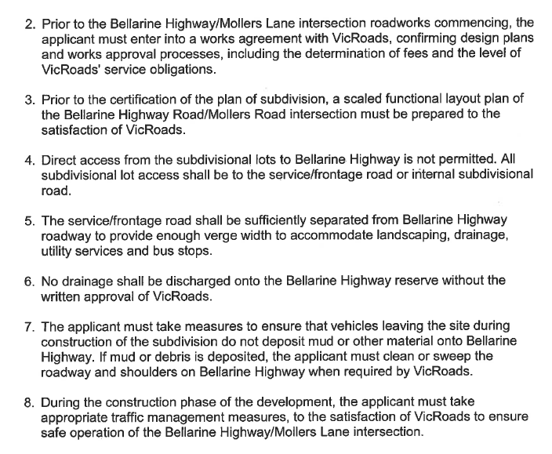

The submission will be further addressed in Council’s Part B submission to the Panel, and by TfV in their submission to the Panel.
However, it is noted that there is dispute with regard to the recommended provision of shared path infrastructure through the development, with Council’s preference being to apply the requirements of the Infrastructure Design Manual. It is expected that TfV will submit to Panel with revised conditions.
It is further noted that post the submission of TfV, VicRoads have responded independently providing revised conditions.

Authority | Advice/Response/Conditions
VicRoads

VicRoads is a determining referral authority under clauses 52.29 and 66.03.

Response:
Further to the response of TfV, it is understood that the applicant has met with VicRoads to discuss the specifics of intersection works required for Mollers Lane, Bellarine Highway. As a result of the meeting, VicRoads have issued amended conditions to be incorporated into the permit:

After further consideration of the amendment documents and discussion with the applicant,
VicRoads agrees that installation of traffic signals at Bellarine Highway/Mollers Lane
intersection will not need to be installed at the first subdivision stage.

VicRoads will now require that the traffic signals be installed prior to issuing of a statement
of compliance for 170 subdivisional lots. Based on the staging shown in the exhibited plans, the first five subdivision stages will be able to receive a statement of compliance without the traffic signal installation.

Therefore, VicRoads requests that its previous conditions in the letter dated 18 June 2018 are replaced with the following conditions:

1. Before issue of a statement of compliance for any stage of the subdivision, the following
roadworks at the Bellarine Highway/Mollers Lane intersection must be completed at no
cost to and to the satisfaction of the Roads Corporation (VicRoads):
a) Left turn deceleration lane (on Bellarine Highway)
b) Bicycle lanes
c) Bus stops
d) Street lighting

2. Before issue of a statement of compliance for 170 lots of the subdivision, the following
roadworks at the Bellarine Highway/Mollers Lane intersection must be completed at no
cost to and to the satisfaction of the Roads Corporation (VicRoads):
a) Traffic signal installation
b) Associated roadworks

3. Prior to the Bellarine Highway/Mollers Lane intersection roadworks commencing, the
applicant must enter into a works agreement with VicRoads, confirming design plans and
works approval processes, including the determination of fees and the level of VicRoads'
service obligations.

4. Prior to the certification of the plan of subdivision, a scaled functional layout plan of the
Bellarine Highway Road/Mollers Road intersection roadworks must be prepared to the
satisfaction of VicRoads.

5. Direct access from the subdivisional lots to Bellarine Highway is not permitted. All
subdivisional lot access shall be to the service/frontage road or internal subdivisional
road.

6. The service/frontage road shall be sufficiently separated from Bellarine Highway roadway to provide enough verge width to accommodate landscaping, drainage, utility services and bus stops.

7. No drainage shall be discharged onto the Bellarine Highway reserve without the written
approval of the Roads Corporation (VicRoads).

8. The applicant must take measures to ensure that vehicles leaving the site during
construction of the subdivision do not deposit mud or other material onto Bellarine
Highway. If mud or debris is deposited, the applicant must clean or sweep the roadway
& shoulders on Bellarine Highway when required by VicRoads.

9. During the construction phase of the development, the applicant must take appropriate
traffic management measures, to the satisfaction of VicRoads to ensure safe operation of
the Bellarine Highway/Mollers Lane intersection.

Please note that condition No.1 is amended and condition No.2 is a new condition. All other conditions are the same as in the letter of 18 June 2018.

VicRoads final conditions are noted.

Authority | Advice/Response/Conditions
DELWP  DELWP is a recommending referral authority under Clause 66.02-2.  Regardless of the type of assessment pathway or framework applied, the removal extent includes areas within Crown land occupied or managed by the responsible authority (ie road reserves). | The Department of Environment, Land, Water and Planning (DELWP) has considered the proposed amendment and subdivision, including specific areas that have been requested for comment by DELWP.  DELWP has reviewed the Site Stormwater Management Plan and Flood Impact Assessment (TGM Group October 2016) and the Mollers Lane, Leopold Waterways Strategy (Design Flow 30 November 2016). Stormwater from the proposed subdivision will ultimately flow to Lake Connewarre. Lake Connewarre is part of the Port Phillip Bay (Western Shoreline) and Bellarine Peninsula Ramsar site, a Matter of National Environmental Significance listed under the Commonwealth Environment Protection and Biodiversity Conservation Act 1999 (EPBC Act). In addition Lake Connewarre is a State Game Reserve managed under the Wildlife Act 1975, which requires that any alteration to flows be subject to the approval of DELWP. Lake Connewarre is managed by parks Victoria, and this letter incorporates the views of Parks Victoria.  Ecological values of the lake are dependent on its water quality and hydrological regimes. DELWP notes that stormwater is proposed to be mitigated to exceed ‘best-practice’, and that two detention/wetland areas are proposed within the site area to manage stormwater quality. DELWP’s preliminary analysis is that the proposed measures are likely to appropriately manage potential quality and flow stormwater impacts to Lake Connewarre. DELWP supports the proposed protection of the existing waterways through incorporation of buffer areas and indigenous landscaping.  Lake Connewarre is a State Game Reserve, allowing duck hunting to be undertaken. Duck hunting usage around the Mollers Lane area of Lake Connewarre is not currently significant, and in recent years the Mollers Lane access point to Lake Connewarre has been subject to closure during duck hunting season (reviewed annually). Given the distance of the proposed subdivision from Lake Connewarre, and the strategies proposed to be put in place to manage stormwater runoff from the site, DELWP and Parks Victoria do not believe that the proposed development would have a significant impact on existing duck hunting usage or duck numbers at Lake Connewarre in the vicinity of Mollers Lane.  DELWP has reviewed three Vegetation Due Diligence Assessment reports that have been prepared for the subject area (Mark Trengove Ecological Services August 2015, August 2016 and October 2015). The reports find that the vegetation in the subject area is mostly exotic, with scattered trees and degraded remnant patches present. The preliminary assessments indicate that native vegetation removal would be assessed under the Low Risk-based pathway. The proponent is recommended to design the proposed subdivision to avoid and minimise the loss of native vegetation where possible.  Based on preliminary assessment of pre-lodgement documents DELWP suggests the following conditions may be included on any permit granted to remove native vegetation:  1. To offset the removal of (to be determined) hectares of native vegetation the permit holder must secure a native vegetation offset, in accordance with the Permitted clearing of native vegetation – Biodiversity assessment guidelines (DEPI 2013) and Native vegetation gain scoring manual (DEPI 2013) as specified below:  - A general offset of (to be determined) general biodiversity equivalence units with the following attributes: o be located within the Corangamite Catchment Management Authority boundary or City of Greater Geelong municipal district  - have a strategic biodiversity score of at least (to be determined).  2. Before any native vegetation is removed, evidence that the required offset has been secured must be provided. The offset evidence can be:  - a security agreement signed by both parties, to the required standard, for the offset site or sites, including a 10 year offset management plan and/or  - an allocated credit extract from the Native Vegetation Credit Register.  3. A copy of the offset evidence will be endorsed by the responsible authority and form part of this permit. Within 30 days of endorsement of the offset evidence by the responsible authority, a copy of the endorsed offset evidence must be provided to the Department of Environment, Land, Water and Planning.  4. Before works start, the contractor must advise all persons undertaking the vegetation removal or works on site of all relevant principals and associated statutory requirements or approvals.  5. Before the vegetation removal starts, the boundaries of all vegetation to be removed and retained must be clearly marked.  6. There must be no temporary or permanent storage of any materials, vehicles or equipment within areas of native vegetation identified to be retained. All storage sites must be restricted to existing cleared areas, and must not adversely impact upon native vegetation, including the root zones of existing trees. Such sites must not be located on or near erodible surfaces, surface water runoff areas or areas infested with weeds.  The documentation for the proposal indicates that several constructed dams would be removed from the subject area. Growling Grass Frog (listed as threatened under the Flora and Fauna Guarantee Act 1988 and Vulnerable under the EPBC Act) has been recorded in the vicinity of the proposed development. A targeted survey for this species may be required. The proponent should assess the subject area for potential habitat value for Growling Grass Frog and determine the need for a targeted survey to be undertaken. Council should consider the need for it or the proponent to contact the Commonwealth Department of Environment and Energy regarding the potential for the project to require referral under the EPBC Act.  DELWP has reviewed the Significant Landscape Overlay Re-assessment (Xurban, November 2016) and is satisfied that the proposed realignment of SLO10 would not impact the objectives intended to be protected by the overlay.
Response:
The amendment was exhibited with draft conditions, including an amended (and agreed to) conditions from DELWP. The recommended condition was amended, as in its original form, it did not provide for certainty in the amount of vegetation for removal, and in turn to be offset. DELWP saw fit to use the wording “to be determined” as they felt the reports submitted with the application were “due diligence” and therefore not final.

In the period between the vegetation assessment of the subject site, and an additional assessment of road reserve vegetation to Bellarine Highway, the relevant assessment framework had been altered which resulted in the assessments producing differing offset units, that could not be collated to one offset amount. As such conditions 57 and 58 of the draft permit were used to enable the applicant to produce a revised assessment addressing all removal under the current guidelines.

In response to exhibition of the amendment and draft permit, DELWP made a submission addressing the draft planning permit:

DELWP notes that if an application were made independent of the planning scheme amendment, DELWP’s referral status is uncertain. Should the native vegetation assessment system in place prior to December 2017 be adopted, DELWP would not be a referral authority in accordance with Section 55 of the Planning and Environment Act 1987 (P&E Act), and any comments made would be in accordance with Section 52 of the P&E Act. Should the current native vegetation assessment system be used, DELWP would be a recommending referral authority in accord with Clause 66.02-2 of the Greater Geelong Planning Scheme. The following commentary is provided to assist Council in its consideration.

Native Vegetation
In December 2017 Amendment VC138 updated the requirements of Clause 52.17 of the planning scheme. The native vegetation assessment accompanying the planning permit application (2-120 Mollers Lane Leopold Vegetation Due Diligence Assessment and Biodiversity Report, Mark Trengove Ecological Services January 2018) utilises both the assessment system in place prior to December 2017 as well as the system introduced in December 2017. A single approach must be applied for all native vegetation impacted by the proposal. I note that the transitional arrangements set out in Clause 52.17-6 in the planning scheme may not directly apply to the circumstances of a combined amendment and draft permit. Nevertheless the timing would appear to support access to the transitional arrangements.

DELWP considers the Vegetation Due Diligence Assessment and Biodiversity Report lacking in detail. While a Due Diligence Assessment is helpful in guiding development design during preliminary stages, normal practice in a development of this size is for a final full biodiversity report to be produced to support a planning permit application. DELWP notes, for example, that the report does not contain an avoid/minimise statement (required should the application follow the current native vegetation assessment system) or an offset strategy.

The documentation does not provide sufficient information to enable a confident understanding of the potential impacts on native vegetation, and does not support assessment of the proposed development against the decision guidelines in the planning scheme or the issue of a permit.

DELWP recommends the following further information is sought to support the proposal prior to proceeding to any hearing:
1. A revised native vegetation assessment which consistently follows a single native vegetation assessment system: Permitted Clearing of Native Vegetation – Biodiversity Assessment Guidelines (DELWP 2013) or Guidelines for the removal, destruction or lopping of native vegetation (DELWP 2017).
2. Demonstration of the steps taken to ensure impacts on biodiversity from the removal of native vegetation have been minimised and avoided.
3. An offset strategy that details how a compliant offset will be secured to offset the biodiversity impacts associated with the removal of native vegetation.

The applicant has supplied a revised Vegetation Assessment and Native Vegetation Removal Report submitted 16 November 2018. Given the late submission of the revised report, no opportunity is available for the review by Council’s internal Environment Unit, and DELWP. As such it is recommended that the conditions contained in the draft permit for native vegetation removal be retained, with the Vegetation Assessment and Native Vegetation Removal Report submitted 16 November 2018 to be reviewed post permit as a condition to be satisfied.

DELWP also made submission regarding stormwater measures from the proposal and site:

Hydrology
Stormwater from the proposed subdivision will ultimately flow to Lake Connewarre. Lake Connewarre is part of the Port Phillip Bay (Western Shoreline) and Bellarine Peninsula Ramsar site, a Matter of National Environmental Significance listed under the Commonwealth Environment Protection and Biodiversity Conservation Act 1999 (EPBC Act). Lake Connewarre is a saline environment sensitive to freshwater inflows, including cumulative freshwater impacts from landscape scale development. The report Lake Connewarre Impact Assessment Final Report (Venant Solutions, 3 February 2017) submitted with the draft application indicates an increase in flows resulting from the proposed development. The developer should note that as Lake Connewarre Wildlife Reserve is managed under the Wildlife Act 1975, any alteration in flows proposed by the development will require a permit under this Act from the Secretary of DELWP. The need for additional Water Sensitive Urban Design measures such as additional detention basin/wetland capacity within the development area should be considered during detailed design.

DELWP notes that stormwater flow from this large scale development will feed into a dam on adjoining privately owned land, but that ongoing management arrangements for the dam are unknown. DELWP recommends that Council formalise ongoing land management responsibilities on the adjoining property and ensure water treatment design measures are incorporated within the dam.

DELWP recommends that Council ensures that planning permit conditions incorporate the following additional requirements:
  - 1. Proposed on-site wetland areas should be designed in accord with Water Sensitive Urban Design best practice to:
  - a. Retard additional stormwater volumes and rates as close to pre-development levels as possible.
  - b. Retard additional water volumes and rates during summer months.
  - c. Meet stormwater quality requirements of the City or Greater Geelong Planning Scheme (Clause 56)
  - d. Incorporate design and landscaping features that facilitate the establishment of habitat suitable for Growling Grass Frog and other fauna species

  - 2. Mitigation measures should be put in place to appropriately retard water flows and volumes during construction.

It is considered that some of the above conditions are incorporated into the draft conditions of the permit, however there is no detriment in applying the conditions as requested.

Authority | Advice/Response/Conditions
CFA  The CFA are a determining referral authority under clause 66.01 where the requirements of clause 56.09-3 are not met.  The application states that 56.09-3 can be met, relegating the CFA advice to recommending.  In addition, under Clause 13.02-1S the land is considered Bushfire Prone under the Building Act 1993. | Thank you for providing CFA notice of C367 and PP1463/2016 in accordance with section 96C of the Planning and Environment Act 1987.  CFA has assessed the proposed planning scheme amendment and planning permit application and would like to make the following comments.  Advice in relation to proposed planning scheme amendment  CFA has no objections in relation to the rezoning application.  Advice in relation to planning permit application  Hydrants  Prior to the issue of a Statement of Compliance under the Subdivision Act 1988 the following requirements must be met to the satisfaction of the CFA:  1 Above or below ground operable hydrants must be provided. The maximum distance between these hydrants and the rear of all building envelopes (or in the absence of building envelopes, the rear of the lots) must be 120 metres and the hydrants must be no more than 200 metres apart. These distances must be measured around lot boundaries.  2 The hydrants must be identified with marker posts and road reflectors as applicable to the satisfaction of the Country Fire Authority.  Note –CFA’s requirements for identification of hydrants are specified in ‘Identification of Street Hydrants for Firefighting Purposes’ available under publications on the CFA web site (www.cfa.vic.gov.au)  Roads  Roads must be constructed to a standard so that they are accessible in all weather conditions and capable of accommodating a vehicle of 15 tonnes for the trafficable road width.  1 The average grade must be no more than 1 in 7 (14.4%) (8.1 degrees) with a maximum of no more than 1 in 5 (20%) (11.3 degrees) for no more than 50 meters. Dips must have no more than a 1 in 8 (12%) (7.1 degree) entry and exit angle.  2 Curves must have a minimum inner radius of 10 metres.  3 Have a minimum trafficable width of 3.5 metres, be clear of encroachments 4 metres vertically to the satisfaction of the Responsible Authority.
Response:
CFA conditions have been included in the exhibited draft permit. No further submission from the CFA sought any revisions or other comments from the authority.

Internal Referral Units

Department | Advice/Response/Conditions
Engineering Services | This land, and the adjoining land to the west, are the subject of the South East Leopold Frameworks Plan; any development should be generally in accordance with this plan.  Drainage Principals  The main features of the subject land are two well defined gullies, considered by the CCMA to be designated waterways.  Development of the land shall be based on the following principals:  - Protect and enhance existing waterways by providing buffers in accordance with Clause 14.02  - Ensure all lots are flood free.  - Remove existing dams from waterways as the condition and structural integrity are unknown. Any new retarding basins must be off-line.  - Protect downstream farmland, waterways and Lake Connewarre from adverse impact caused by increased pollutant loads and stormwater volumes  Council has completed draft flood mapping of the 1% AEP event, which was used to inform the Framework Planning process. It is noted the majority of flooding is contained within the gullies.  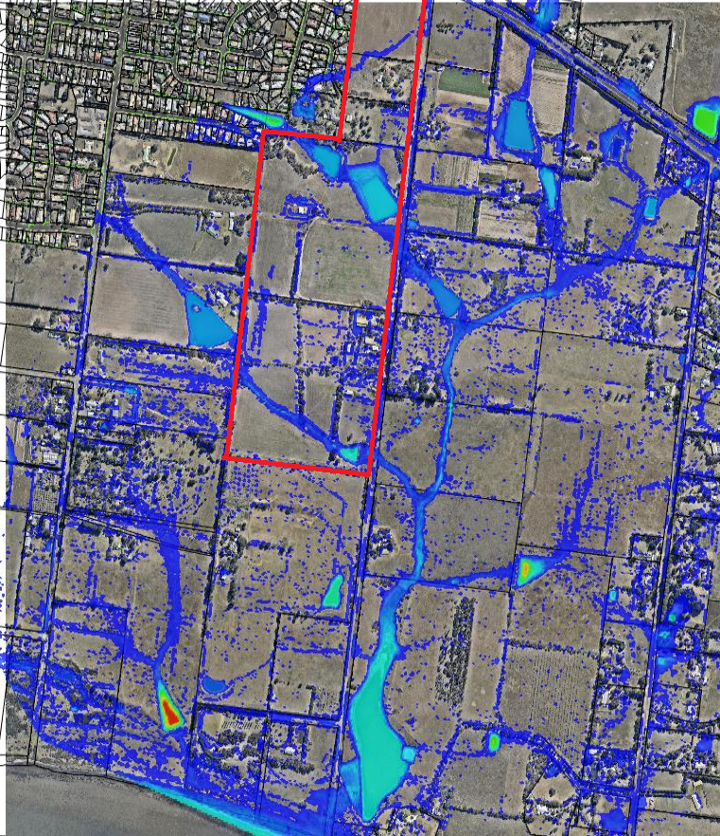  CoGG draft 1% AEP flood extent  Comments  - The methodology employed by TGM in their stormwater management plan is generally accepted. It is noted it is generally based on ARR 87 methods, with some validation using ARR 16 tools and techniques.  - There are some differences between 1% AEP peak flood extent in the TGM and CoGG models. This is generally attributable to the different style of model employed.  - As it is unknown when the land fronting Ash Road will develop, modelling should consider the dam at 103 Ash Road to be full. If the dam is still in place when construction of downstream stages commences, a safety audit including dam-break analysis, will be required.  - Section 6.4.12 indicates functional design of the detention basins has occurred. These have not been presented in the final report.  - There is no analysis of impacts on the downstream waterways, or inflow to Lake Connewarre. This has consistently been raised as an issue  - Has functional design been undertaken for the 1%AEP pipe between stage 4 (north of the waterway) and the northern basin? Issues such as the cross section of the waterway and minimum cover to the Barwon Water assets should be considered as early as possible.  - The developer will be required to replace the Mollers Lane culverts at the applicable stages of development.  - It is disappointing there has been no effort to integrate the existing Myuna Street basin into the broader drainage system and landscape masterplan. This was raised during the Framework Plan process that this would be an ideal opportunity to improve the amenity of this area and connections to the surrounding development.  - Council has specific requirements for the construction of boardwalks and similar structures within public open space. See Design Note available at: http://www.geelongaustralia.com.au/common/public/documents/8d121fc56934c8d-Design-Notes-No%209-Bridges--Boardwalks%20-%20Final%20-%20Rev%201.pdf  - It is still questioned if direct lot access is possible from Mollers Lane, particularly around 22 and 32 Mollers Lane.  APPENDIX A -  Draft Permit Conditions  The following draft conditions are offered. These are subject to addition and change as the application progresses.  Easements – Drainage  - Prior to certification of the Plan of Subdivision for each stage, easements for the purposes of ‘Drainage’ must be set aside in favour of the City of Greater Geelong, to the satisfaction of the Responsible Authority.  Fill  - Excavated material shall not be carted off the site except with the written approval of the Responsible Authority.  - No material shall be brought onto the site for use as filling within the subject area under this Permit, unless with the written approval of the Responsible Authority. Prior to any approval being issued by the Responsible Authority for imported filling to be used on the site, the applicant must submit for approval to the Responsible Authority, samples of proposed filling, details of the source of the filling, details of proposed traffic routes to be traversed, soil testing results and reports in regard to the presence of contaminants in the filling, and the suitability of filling to be placed on site.  - All areas to be filled shall be stripped of vegetation and any top soil shall be removed and stockpiled for reuse over the filled areas. Only approved filling material shall be placed on the site. The filling shall be placed in maximum 150 mm layers, or as approved otherwise by the Responsible Authority, and compacted to the applicable level for filling on allotments and within future roadways in accordance with AS3798, to the satisfaction of the Responsible Authority.  - At the completion of the bulk earthworks, and at completion of the works for each stage, all disturbed areas shall be hydro mulched with an approved seed and fertilizer mixture to the satisfaction of the Responsible Authority to suppress dust, and minimise erosion, unless approved otherwise by the Responsible Authority.  - All works must be undertaken in accordance with the recommendations of any geotechnical reports.  Engineering Plans  Prior to the commencement of site works for any stage of the subdivision, the developer is required to submit detailed road and drainage construction plans to the Responsible Authority for approval. The plans shall include details of pits and pipes sizes, finished and existing surface levels, creation of appropriate easements, detention basin(s) including any required drainage reserves, water quality treatment and connection to the legal point of discharge. The Consulting Engineer must show that the design for the drainage system complies with the requirements of the Infrastructure Design Manual and any other relevant standards. Site run-off shall be limited to equivalent pre-developed levels for rainfall events up to and including the critical 100 year ARI event. An appropriate on site detention system shall be designed to limit site run-off to the pre-developed levels to the satisfaction of the Responsible Authority.  The plans must include, but not limited to:  - The stormwater drainage system on the site must be designed such that stormwater run-off exiting the land meets the current best practice performance objectives for stormwater quality as follows:  - 80% retention of the typical annual load of suspended solids;  - 45% retention of the typical annual load of total phosphorous;  - 45% retention of the typical annual load of total nitrogen; and  - 70% retention of the typical annual load of gross pollutants.  - Major culvert augmentation/upgrades must be provided to the satisfaction of the Responsible Authority.  - Minimum finished surface levels on all lots must be 300mm above the relevant 1% AEP flood level.  - Roadwork construction details including the following:  - fully sealed pavement with kerb and channel for new internal roads;  - any external roadworks and treatments;  - concrete footpaths;  - line-marking and signage installation  Note: Detailed Road and Drainage Design Plans for any stage that result in flood levels on existing properties being adversely affected by the proposed works will not be approved for construction.  Construction Management Plan  A Construction Management Plan shall be submitted and approved by the Responsible Authority and shall address items including (but not be limited to) the following:  - The protection of all existing vegetation and waterways;  - Show access locations for construction vehicles;  - All appropriate control of site emissions during construction and the defects liability period;  - A staging plan for all construction phases including indicative dates for commencement and completion;  - Intended access for construction vehicles;  - Engineering assessment of assets that will be impacted on by construction and recommended techniques to minimise any adverse impact;  - Details of actions to be implemented to in the event of damage to abutting assets;  - Details of where construction personnel will park;  - Hours/days of construction, including deliveries. (Note: These hours must be consistent with the Environment Protection Authority (EPA) legislation/guidelines);  - Phone numbers of on-site personnel or other supervisory staff to be contactable in the event of issues arising on site;  - Details of site cleanliness and clean up regimes;  - Location of material storage;  - Dust suppression management;  - Details of measures to be maintained during the housing construction phase of development to prevent sediment entering downstream drainage infrastructure;  - Any other measures that are consistent with the following Environmental Protection Authority publications: ‘Environmental Management Guidelines for Major Construction Sites’, ‘Construction Techniques for Sediment and Pollution Control’ and ‘Doing it Right on Subdivisions’  Construction of Roadworks/ Drainage  Prior to the issuing of a Statement of Compliance for any stage of the subdivision, road and drainage works, including basin(s), must be constructed in accordance with the approved plans and specifications to the satisfaction of the Responsible Authority.  All development and works must be carried out in accordance with the Construction Management Plan endorsed under this permit, all to the satisfaction of the Responsible Authority.  The design and construction of civil infrastructure to become council assets must be approved and supervised by council. A fee of 3.25% of the cost of the works is to be paid to council for the checking and supervision of these works.  A maintenance bond of 5% of the cost of the works is to be paid to council and will be returned after successful completion of a 12 month maintenance period.  Prior to the issue of a Statement of Compliance for the relevant stage of subdivision, relevant street sign/s must be erected to the satisfaction of the Responsible Authority.  Prior to the issue of a Statement of Compliance for the relevant stage of subdivision, street lighting must be provided within the site and along external frontages in accordance with the relevant Australian Standard(s), unless otherwise agreed in writing by the Responsible Authority and unless it can be demonstrated that existing street lighting is sufficient for public safety to the satisfaction of the Responsible Authority.  During the construction phase of the development, the following conditions must be met:  a) only clean rainwater shall be discharged to the stormwater drainage system;  b) stormwater drainage system protection measures shall be installed as required to ensure that no solid waste, sediment, sand, soil, clay or stones from the premises enters the stormwater drainage system;  c) vehicle borne material from the premises shall not accumulate on the roads abutting the site;  d) all machinery and equipment must be cleaned (if required) on site and not on adjacent footpaths or roads;  e) fencing is to be fitted and installed so as to ensure safe access for pedestrians; and  f) all litter (including items such as cement bags, food packaging and plastic strapping) must be contained on site;  All to the satisfaction of the Responsible Authority.  Prior to Certification  The Plan of Subdivision submitted for certification must include all easements deemed necessary to protect existing or future drainage lines within the subject site, and any easements required between the subject site and the nominated legal point of discharge must be created to the satisfaction of the Responsible Authority.  Prior to certification of the plan of subdivision, engineering plans for the construction of new council infrastructure must be submitted to the satisfaction of the Responsible Authority for approval.  Response to version F, submitted 25/07/2017  I refer to the amended development plan 15196-100 Opt C – Rev F (TGM, 14/72017).  Key revisions include:  - Relocation of northern basin and public open space  - Piping a section of the northern waterway  - Reconfiguration of the east-west collector road  - An additional road connection to Mollers Lane  - Realignment of the southern waterway  It is understood the applicant is seeking in-principal approval for the amended layout before supplying updated supporting documentation. It is noted the CCMA have given advice on the proposed realignment of both the northern and southern waterways prior to submission to Council.  It is considered the proposed waterway changes can achieve the general principals outlined in Engineering’s previous response (March 2017), specifically:  - Protect and enhance existing waterways by providing buffers in accordance with Clause 14.02  - Ensure all lots are flood free.  - Remove existing dams from waterways as the condition and structural integrity are unknown. Any new retarding basins must be off-line.  - Protect downstream farmland, waterways and Lake Connewarre from adverse impact caused by increased pollutant loads and stormwater volumes  It is expected amended documentation include:  Amended Waterway Strategy  - Cross sections with sufficient capacity to contain flows up to and including the 1% AEP event  - Bank stability treatments to the satisfaction of the appropriate authorities  - Indicative cross sections of the southern waterway are to include the abutting road – buffers shall be sufficient to meet desirable batter slopes for maintenance purposes  - Staging of waterway remediation  Amended Stormwater Management Plan  - Concept long section for northern waterway pipe demonstrating no conflicts with transfer main  - Concept designs for retarding basins, demonstrating sufficient land is available for buffers and maintenance access  - Risk assessment of dam on southern waterway, upstream of development site.  Response to Version U, Submitted 25/01/2018  Draft Permit Conditions  The following draft conditions are offered. These are subject to addition and change as the application progresses.  Easements – Drainage  - Prior to certification of the Plan of Subdivision for each stage, easements for the purpose of ‘Drainage’ must be set aside in favour of the City of Greater Geelong, to the satisfaction of the Responsible Authority.  Fill  - Excavated material shall not be carted off the site except with the written approval of the Responsible Authority.  - No material shall be brought onto the site for use as filling within the subject area under this Permit, unless with the written approval of the Responsible Authority. Prior to any approval being issued by the Responsible Authority for imported filling to be used on the site, the applicant must submit for approval to the Responsible Authority, samples of proposed filling, details of the source of the filling, details of proposed traffic routes to be traversed, soil testing results and reports in regard to the presence of contaminants in the filling, and the suitability of filling to be placed on site.  - All areas to be filled shall be stripped of vegetation and any top soil shall be removed and stockpiled for reuse over the filled areas. Only approved filling material shall be placed on the site. The filling shall be placed in maximum 150 mm layers, or as approved otherwise by the Responsible Authority, and compacted to the applicable level for filling on allotments and within future roadways in accordance with AS3798, to the satisfaction of the Responsible Authority.  - At the completion of the bulk earthworks, and at completion of the works for each stage, all disturbed areas shall be hydro mulched with an approved seed and fertilizer mixture to the satisfaction of the Responsible Authority to suppress dust, and minimise erosion, unless approved otherwise by the Responsible Authority.  - All works must be undertaken in accordance with the recommendations of any geotechnical reports.  Engineering Plans  Prior to the commencement of site works for any stage of the subdivision, the developer is required to submit detailed road and drainage construction plans to the Responsible Authority for approval. The plans shall include details of pits and pipes sizes, finished and existing surface levels, creation of appropriate easements, detention basin(s) including any required drainage reserves, water quality treatment and connection to the legal point of discharge. The Consulting Engineer must show that the design for the drainage system complies with the requirements of the Infrastructure Design Manual and any other relevant standards. Site run-off shall be limited to equivalent pre-developed levels for rainfall events up to and including the critical 100 year ARI event, to the satisfaction of the Responsible Authority.  The plans must include, but not limited to:  - The stormwater drainage system on the site must be designed such that stormwater run-off exiting the land meets the current best practice performance objectives for stormwater quality as follows:  - 80% retention of the typical annual load of suspended solids;  - 45% retention of the typical annual load of total phosphorous;  - 45% retention of the typical annual load of total nitrogen; and  - 70% retention of the typical annual load of gross pollutants.  - Replacement and/or augmentation of the culverts in Mollers Lane  - Minimum finished surface levels on all lots must be 300mm above the relevant 1% AEP flood level.  - Detailed methodology for the removal of existing dams.  - Details of waterway remediation  Note: Detailed Road and Drainage Design Plans for any stage that result in flood levels on existing properties being adversely affected by the proposed works will not be approved for construction.  Prior to the commencement of works for each stage of the subdivision, construction plans must be submitted to and approved by the responsible authority for the full construction of roads including road reserves, design of all intersection treatments, traffic management devices, linemarking, signage, kerb and channel, vehicle crossing laybacks, road pavement and sealing and footpaths.  The plans must include;  - Construction of Mollers Lane including concrete kerb and channel, footpath and sealed road pavement where it abuts the subject site;  - Footpaths on both sides of roads unless otherwise approved;  - All footpath treatments showing DDA compliance at all designated crossing points  - Suitable road reserve cross sections to convey major drainage flows  - Turing areas suitable for the safe and efficient turning of service and emergency vehicles  To the satisfaction of the Responsible Authority  Construction Management Plan  A Construction Management Plan shall be submitted and approved by the Responsible Authority and shall address items including (but not be limited to) the following:  - The protection of all existing vegetation and waterways;  - Show access locations for construction vehicles;  - All appropriate control of site emissions during construction and the defects liability period;  - A staging plan for all construction phases including indicative dates for commencement and completion;  - Intended access for construction vehicles;  - Engineering assessment of assets that will be impacted on by construction and recommended techniques to minimise any adverse impact;  - Details of actions to be implemented to in the event of damage to abutting assets;  - Details of where construction personnel will park;  - Hours/days of construction, including deliveries. (Note: These hours must be consistent with the Environment Protection Authority (EPA) legislation/guidelines);  - Phone numbers of on-site personnel or other supervisory staff to be contactable in the event of issues arising on site;  - Details of site cleanliness and clean up regimes;  - Location of material storage;  - Dust suppression management;  - Details of measures to be maintained during the housing construction phase of development to prevent sediment entering downstream drainage infrastructure;  - Any other measures that are consistent with the following Environmental Protection Authority publications: ‘Environmental Management Guidelines for Major Construction Sites’, ‘Construction Techniques for Sediment and Pollution Control’ and ‘Doing it Right on Subdivisions’  Construction of Roadworks/ Drainage  Prior to the issuing of a Statement of Compliance for any stage of the subdivision, all road and drainage works, including basin(s), must be constructed in accordance with the approved plans and specifications to the satisfaction of the Responsible Authority.  All development and works must be carried out in accordance with the Construction Management Plan endorsed under this permit, all to the satisfaction of the Responsible Authority.  The design and construction of civil infrastructure to become council assets must be approved and supervised by council. A fee of 3.25% of the cost of the works is to be paid to council for the checking and supervision of these works.  A maintenance bond of 5% of the cost of the works is to be paid to council and will be returned after successful completion of a 12 month maintenance period for civil works.  Following Practical Completion, wetlands shall be maintained by the developer for a period of 24 months, to the satisfaction of the Responsible Authority.  Prior to the issue of a Statement of Compliance for the relevant stage of subdivision, relevant street sign/s must be erected to the satisfaction of the Responsible Authority.  Prior to the issue of a Statement of Compliance for the relevant stage of subdivision, street lighting must be provided within the site and along external frontages in accordance with the relevant Australian Standard(s), unless otherwise agreed in writing by the Responsible Authority and unless it can be demonstrated that existing street lighting is sufficient for public safety to the satisfaction of the Responsible Authority.  During the construction phase of the development, the following conditions must be met:  a) only clean rainwater shall be discharged to the stormwater drainage system;  b) stormwater drainage system protection measures shall be installed as required to ensure that no solid waste, sediment, sand, soil, clay or stones from the premises enters the stormwater drainage system;  c) vehicle borne material from the premises shall not accumulate on the roads abutting the site;  d) all machinery and equipment must be cleaned (if required) on site and not on adjacent footpaths or roads;  e) fencing is to be fitted and installed so as to ensure safe access for pedestrians; and  f) all litter must be contained on site;  All to the satisfaction of the Responsible Authority.  Prior to Certification  The Plan of Subdivision submitted for certification must include all easements deemed necessary to protect existing or future drainage lines within the subject site, and any easements required between the subject site and the nominated legal point of discharge must be created to the satisfaction of the Responsible Authority.  Prior to certification of the plan of subdivision, engineering plans for the construction of new council infrastructure must be submitted to the satisfaction of the Responsible Authority for approval.
Response:
The conditions have been integrated into the draft planning permit exhibited with the amendment. Post exhibition concerns have been raised for the impacts on downstream properties.
It is understood that there is now unresolved matters of protection/maintenance/liability of downstream waterways outside of the subject site that may be impacted by increased volume of flow (and therefore duration of flows) from the development site, through private properties and to Lake Connewarre.
In conjunction with conditions requested by Council’s Environment Unit and the CCMA it is considered that the conditions of the draft permit adequately control and can mitigate quality of stormwater discharge from the site in a safe manner however the matter posed above for volume has not been conditioned at this time, other than to control discharge at pre-development rates.
It is understood that the matter of future remediation etc to downstream private property will be separately addressed by the applicant through a permit application for the creation of easements or via Section 36 of the Subdivision Act 1988.

Post exhibition, a recent submission of version Y2 removes open space from the site, replacing with additional lots. Due to the late provision of this plan (16 November 2018), Engineering Services have not had the opportunity to comment on this latest revision.

Department | Advice/Response/Conditions
Traffic | Intersection Treatment – Bellarine Hwy/Mollers Lane  It is likely that the majority of traffic from the subject site will turn left into the Bellarine Hwy in the AM peak, and right from the Bellarine Hwy in the PM peak. The majority traffic flow during these peaks is generally westbound in the AM, eastbound in the PM. During weekends, these movements will be roughly 50-50 during the peak, which is generally an hour or two each side of midday.  The intersection is under the management of VicRoads, and it should left up to them whether to keep the existing intersections (with some minor upgrades) or to have a signalised intersection or roundabout.  Subdivision Layout  The street layout is generally satisfaction except for the cul-de-sac in the south of the site. A cul-de-sac of this type is acceptable for 2-3 lots; this example has five and is unacceptable. An appropriate design response would be to have a 13 m road reserve with a 7.3 m road leading to Mollers Lane. This also prevents back fences abutting the drainage reserve.  Public Bus Access  There is a possibility for a public bus route to use Mollers Lane and the main east-west collector road. The cross sections of these two roads will need to comply with PTV’s guidelines.  Mollers Lane Intersections  The plan of subdivision shows three intersections with Mollers Lane (a fourth needs to be provided at the southern end). All intersections will be subject to detailed designs and road safety audits.  Connection To Ash Road  There is potentially more than one road (i.e. the main east-west collector) to access Ash Road. As the majority of traffic will have destinations/origins to the west, it is likely that residents living in the western half of the subdivision will use Ash Road more than Mollers Lane. The roads to the west of the site need to be located to allow these movements to occur.  The eventual main east-west road will be the eastern extension of Estuary Bvd. The alignment of the road on the subject site needs to be checked as to confirm there will be a seamless connection without having any misalignment.  Traffic Generation  The assumptions, traffic volumes and directional splits provided in the proponent’s Transport Impact Assessment Report (ESR Transport Planning) are generally acceptable.  In the long term, it is accepted that Ash Road will function as a higher order collector road. Within the site, the main east-west road will function as a lower order collector road, as will Mollers Lane.  There does not appear to be any cross sections for the upgrading of Mollers Lane. It is recommended that the road reserve for Mollers Lane be increased to 22 m, in line with theSouth east Leopold Framework Plan.  It is preferred that the main east-west collector road is not provided with a central median strip, and that the road resembles the existing cross section of Estuary Bvd.  Planning Permit Conditions  A Local Area Traffic Management (LATM) plan must be developed with Council’s Traffic Engineering unit prior to the submitting of Stage 1 construction drawings. A Street Naming Layout plan must also be submitted after the LATM plan has been finalised to assist with street naming and house numbering.  These comments shall be deemed inexhaustible, with further comments to be made if/when the plan of subdivision is amended and future information about the road cross sections and intersections is expressed.  Response to revision F, submitted 25/07/2017  A list of concerns I have for the development are as follows:  - The traffic report mentions that Mollers Lane should be of a collector road standard, yet no cross section is provided of what is proposed  - The existing cross section of Mollers Lane changes from a flat profile, to a falling verge and with a rising verge. Cross sections will have to be provided for each example  - There are concerns about providing access to the lots with the falling verges, as the sight distance into Mollers Lane will be compromised by the grades, parked cars, etc  - There are a number of crests on Mollers Lane that affect some of the lots, i.e. lack of sight distance. This needs to be carefully assessed.  - It is assumed that Lot 462 on Mollers Lane is that containing the two mobile phone towers and associated infrastructure. This lot cannot be accessed from Mollers Lane. The existing access is from the lot’s southern side (from the access track to the Lutheran Church).  - It is recommended that another road be provided adjacent to the southern side of Lot 462. This will maintain the current access to the mobile phone towers and provide a third link road to Mollers Lane and take the likely traffic pressures off the northern-most link road  - The east-west collector road with the median strip intersects with Mollers Lane north of the low point in Mollers Lane. Lots 201, 203, 204 and 205 appear to be located in the low point, which will lead to drainage risks.  - The western end of the east-west collector road will have to be provided with a turnaround zone. This applies to all other roads that end at the western property boundary of the site.  - The median in the east-west collector road is going will be subject to asset damage from construction vehicles associated with the dwellings. The median openings also may not be sufficient for long vehicles to turn around.  - Lots 1 and 2 could be affected by the future signalisation of the Bellarine Hwy/Mollers Lane intersection  - The plan does not provide any footpath connection along the southern side of Bellarine Hwy to connect to the existing Leopold township, i.e. to Claremont Dr  - There is an existing bus stop on the southern side of Bellarine Hwy (about 85 m east of Claremont Dr) and none on the northern side. The one bus stop is remote to the subject site (300 m to the Mollers La intersection)
Response:
The draft planning permit was circulated to the internal units with the Traffic Unit raising the following matters:

Can you substitute the following condition into Condition 11 and give it a prominent bold heading:

Local Area Traffic Management (LATM) Plan

11. Unless otherwise approved in writing by the Responsible Authority, prior to lodgement of Stage 1 Construction Plans, a Local Area Traffic Management (LATM) plan must be developed for the approved subdivision with Council’s Traffic Development Engineer, and submitted to and approved by the Responsible Authority.
The LATM treatments may include, but not limited to, vehicle crossing locations, parking restrictions, signage, linemarking, traffic management devices and modified intersection priorities. The LATM treatments may also include items identified in Mollers Lane. A separate street naming plan must be provided that complements the approved LATM plan, and is to assist with road naming and house numbering, and must be to the satisfaction of the Responsible Authority.

There are a couple of other issues to do with the Plan of Subdivision and the Staging Plan:

Plan of Subdivision

The lot associated with the mobile phone towers has NOT been addressed from an access point of view. At present, the lot is only accessed from the southern side (there are two cyclone wire gates), and access from the eastern or western sides is impractical. This issue was raised in my memo to Susan, and included a recommendation to provide a road abutting the site’s southern boundary (i.e. between Mollers Lane and the north-south street to the west.

I don’t know if the owner of the facility (Telstra?) has had a chance to comment about their access requirements and the amount of land that they will require. This needs to be established before the Plan of Subdivision is endorsed. The status of the land that the telco facility sits on is also an issue; it appears that there may be some kind of leasing agreement with the Leopold Lutheran Church. Will this lot be sold to the telco, and what agreements will be in place to do so?

Staging Plan

Following on from the stage in which the telco facility sits, there is a staging plan suggesting this is Stage 13, and is surrounded by Stage 3 and Stage 1 & 4. This is unacceptable, as Mollers Lane will have to be constructed prior to Stage 4 works occurring. At the very least, the section of Mollers Lane contained in ‘Stage 13’ will have to be a part of Stage 3.

The alteration were integrated into the draft permit in subsequent revisions.

Post exhibition, a recent submission of version Y2 removes open space from the site and supplies additional lots. Due to the late provision of this plan (16 November 2018), the Traffic Unit have not had the opportunity to comment on this latest revision.

Department | Advice/Response/Conditions
Recreation and Open Space Unit | Due the size of the package of documentation (1000 pages) I have confined my comments to consideration of the Attachment 4: Overall Development Plan and Attachment 6: Landscape Master Plans.  1. The majority of unencumbered open space is proposed to be provided as linear reserves alongside encumbered drainage corridors. This is not consistent with the Framework Plan, which identifies these drainage reserves an encumbered open space, with unencumbered open space to be provided as 2 x local parks adjacent to the northern drainage reserve.  2. In accordance with the Geelong Planning Scheme Clause 56, local parks should be generally 1 hectare in area and suitably dimensioned and designed to provide for their intended use and to allow easy adaptation in response to changing community preferences. – Dimensions of the proposed parks are to be provided showing them to be a minimum of 1 Ha.  3. Drainage reserves need to identify the 1:100 inundation extent. These linear reserves are considered encumbered to a width of at least 60m as per the Framework Plan, and may be wider if there are locations where the 1:100 extent exceeds this buffer. Any open space slivers adjacent to these reserves which are designed to square-up the road network are not considered to be creditable open space.  4. There are several small pocket parks and proposed adjacent to road and drainage reserves. These are not suitable for open space purposes and are not creditable as open pace contributions nor supported in the design as they impose unreasonable maintenance obligations on Council without any commensurate broader community benefit.  5. The Overall Development Plan shows a reserve running east-west in the north –eastern section of the land. This is inconsistent with the Landscape Master Plan which identifies this parcel as an existing telecommunications facility.- Applicant to clarify.  6. The Framework Plan identifies a 30m buffer around steeply sloped land. Therefore the proposed narrow strip of open space bounding the southern steep encumbered reserve is also not creditable as open space. Despite this, the reserve needs to be developed with a 2.5m shared path to facilitate pedestrian and cyclist movements as per the Framework Plan.  7. Draft conditions will be provided upon receipt of a revised application which incorporates the above amendments.  Response to version F, submitted 25/07/2017  Our unit has a number of concerns with the latest proposed changes to the draft Overall Development Plan (ODP) which, in our opinion has failed to address a number of key issues raised within our initial referral response provided on 21 February 2017.  - The revised ODP fails to identify that the 30m buffers on either side of the waterways are considered encumbered and do not contribute toward the 10% public open space contribution required under section 52.01 of the planning scheme. These buffers are clearly identified as encumbered on the Framework Plan and are required in accordance with clause 14.02-1 of the Victorian Planning Provisions which states:  “Retain natural drainage corridors with vegetated buffer zones at least 30m wide along each side of a waterway to maintain the natural drainage function, stream habitat and wildlife corridors and landscape values, to minimise erosion of stream banks and verges and to reduce polluted surface runoff from adjacent land uses’  Given the primary purpose of these buffers is for drainage, habitat and water quality purposes, they are not suitable to be credited toward the required public open space contribution as they are not intended nor fit for this purpose.  The ODP needs to be revised to clearly distinguish between encumbered and unencumbered open space. The following are considered to be encumbered.  - Land within 30m either side of the top of the banks of a waterway.  - Land that is within the 1:100 flood extent  - Irregularly shaped open space edges which square up the boundaries surrounding drainage assets.  - And that is steeply sloped or otherwise undevelopable  - Land affected by easements or other development restrictions.  - The open space reserve to the west of the northern drainage basin is currently dimensioned at what appears to be 0.74Ha and includes large areas of encumbered waterway buffer. This reserve should be reconfigured to achieve a minimum 1Ha unencumbered space, not including any encumbered buffers around waterways or land within the 1:100 flood extent. This would be consistent with the planning scheme clause 56.05-2 standard C13 which establishes the following relevant objectives for the provision of public open space:  - Local parks within 400 metres safe walking distance of at least 95 percent of all dwellings. Where not designed to include active open space, local parks should be generally 1 hectare in area and suitably dimensioned and designed to provide for their intended use and to allow easy adaptation in response to changing community preferences.  Public open space should:  - Be provided along foreshores, streams and permanent water bodies.  - Be linked to existing or proposed future public open spaces where appropriate.  - Be integrated with floodways and encumbered land that is accessible for public  - recreation.  - Be suitable for the intended use.  - Be of an area and dimensions to allow easy adaptation to different uses in response to changing community active and passive recreational preferences.  - Maximise passive surveillance.  - Be integrated with urban water management systems, waterways and other water bodies.  - Incorporate natural and cultural features where appropriate.  - The latest plan deletes the open space previously proposed in the north west of the site. It appear this entire parcel may be considered encumbered as part of the waterway buffer. Recreation and Open Space would like to see the inclusion of an unencumbered local reserve in this proximity which integrates with the encumbered drainage reserve. This will provide public open space to service lots in the northern portion of the site which are not currently located within the desired 400m safe walking distance of a reserve.  - The applicant has suggested that the triangular parcel of land in the south of the site should be considered as unencumbered open space. It is noted that the Framework Plan designates this land as encumbered due to its steeply sloping topography. It is generally preferred that public open space be provided on relatively level ground. Steep slopes are not considered fit for open space purposes as they are unsuitable for many recreational pursuits and can be prohibitively difficult ad expensive to maintain in a safe condition. A site visit to assess the useability and safety aspects of this site would assist in determining our position on the proposed designation of this land.  - A revised land budget is requested which reflects the provision of encumbered and unencumbered open space as a percentage of the net developable area of the subdivision.  - Draft conditions will be provided upon receipt of a revised application which incorporates the above amendments.  Response to Version U, Submitted 25/01/2018  Please see below our standard conditions for an application of this type. Note that we’ve asked for an amended landscape masterplan to be provided in consultation with us and to our satisfaction. This is not aimed at tweaking the land budgets, rather to sit down with the landscape architect and the relevant internal referrals to get a positive environmental and recreational outcome in the land provided. We’ll mostly be asking for a change of path network orientation and an increase in riparian planting along the waterway corridors.  Recommended Permit Conditions (Without Prejudice)  Landscape Master Plan  Unless otherwise approved in writing by the Responsible Authority, prior to issue of Statement of Compliance for the first stage of the subdivision, a landscape master plan (incorporating a street tree master plan) for the permit area must be developed with, and submitted to the Responsible Authority for approval. When approved, the plan will be endorsed and form part of the permit. This plan must be drawn to scale with dimensions and submitted electronically and be generally in accordance with the landscape master plan submitted with the application on 29/01/2018 but modified to show:  - A vegetated buffer zone along both sides of the northern and southern drainage corridors with an average width of 60 metres.  Notes:  - Hard copy/copies of the landscape master plan must be provided at the reasonable request of the responsible authority.  - Consultation with Council’s Recreation and Open Space and Environment Units during early concept design is encouraged to help facilitate efficient approval processes.  Detailed Landscape Plans  Unless otherwise agreed in writing by the Responsible Authority, prior to the Statement of Compliance being issued for each applicable stage of the subdivision, a detailed landscape plan for the stage must be prepared and submitted to the Responsible Authority for approval. When approved, the plan will be endorsed and form part of the permit. The landscape plan must be drawn to scale with dimensions and submitted electronically. The plan must address and be consistent with the endorsed landscape master plan applying to the site and show, but not be limited to:  a) The ultimate 1% and 10% Annual Exceedance Probability storm event extents;  b) Existing vegetation that is to be retained, removed and/or lopped, as well as any other practical retention tree(s) within a reserve (excluding conservation reserves) for any stage of the development. The tree(s) must be assessed by a suitably qualified arborist to determine suitability for retention and ongoing management recommendations. The detailed landscape plan for the area in which the tree(s) are located must be informed by this arboriculture assessment and show details of tree protection zones. This assessment must be submitted to council as part of the approval process;  c) A detailed planting schedule and proposed planting layout of all areas of and adjoining open space, including proposed trees, shrubs, groundcovers and aquatic planting if applicable (with zonation detail), and showing botanical names, common names, pot sizes, sizes at maturity, quantities and densities of each plant;  d) The proposed layout, materials and finish of all finished surfaces, structures, fences abutting council reserves, maintenance vehicle access crossovers, maintenance access gates, play equipment, furniture and bike parking;  e) Detailed planting and construction drawings including site contours and any proposed changes to existing levels including any structural elements such as retaining walls;  f) Detailed planting and construction drawings of any drainage and WSUD infrastructure within public reserves;  g) Permeable fence design details for lots abutting open space reserves and Council reserves (excluding road reserves). Fencing detail must be to Council specifications;  h) Additional supporting information, such as certified structural designs or building forms;  i) The removal of existing disused structures, foundations, pipelines, farm dams or stockpiles and the eradication of weeds;  j) The proposed landscaping treatment of any road reserve abutting public open space;  k) A detailed schedule of quantities showing accurate cost estimates of each item included in the plan.  Notes:  - Hard copy/copies of the landscape master plan must be provided at the reasonable request of the responsible authority.  - Consultation with Council’s Recreation and Open Space Unit during early concept design is encouraged to help facilitate efficient approval processes.  No Utility Services on Public Open Space  Utility service substations, kiosk sites and the like must not be located on any land identified as unencumbered open space unless otherwise agreed in writing by the responsible authority. Any existing or future easements affecting all land which is to be vested in council must be clearly identified on the detailed landscape plans as per the condition above.  Completion of Landscape Works  Unless otherwise approved in writing by the Responsible Authority, the landscaping works shown on the approved landscape plan for a particular stage must be completed to the satisfaction of the Responsible Authority, prior to the issue of a Statement of Compliance for that stage.  If the Responsible Authority agrees to issue Statement of Compliance prior to the landscaping works being completed, the entire landscaping works must be bonded to the satisfaction of the Responsible Authority. The landscape works bond or bank guarantee must be 125 per cent of the estimated cost of entire landscape works as shown in the approved schedule of quantities submitted as part of the landscape plans. Unless otherwise agreed in writing by the Responsible Authority the bonded works must be completed within one year of the date of the lodgement of the bond.  A practical completion inspection is required to satisfy this condition and must be arranged by the permit holder with two weeks’ notice provided for the responsible authority. The landscape works bond will be returned on award of practical completion.  Unless otherwise approved in writing by the Responsible Authority, prior to the issue of practical completion of landscaping works, or any other time as agreed by the Responsible Authority, the following must be provided to the Responsible Authority:  a) Building permits and structural engineering compliance, as-built construction plans, and materials detail where necessary;  b) Landscaping maintenance plan  c) Schedule of Quantities showing the financial value of all hard assets  d) As-built landscaping plans in PDF and GIS-ready AutoCAD (DXF) format.  Unless otherwise agreed in writing by the Responsible Authority, a maintenance bond must be submitted to the Responsible Authority on application for practical completion of landscaping works. The maintenance bond or bank guarantee must be 125 per cent of the estimated cost of maintenance of landscape works for a two (2) year period.  Maintenance of Landscaping  The landscaping shown on any endorsed landscape plan for a particular stage must be maintained to the satisfaction of the Responsible Authority for a period of no less than two (2) years from the date of practical completion of the landscaping unless otherwise agreed in writing by the Responsible Authority. During this period, any dead, diseased or damaged plants are to be replaced and any landscaped area and hard assets are to be repaired as required to ensure the landscaping is maintained to the same standard as when practical completion was awarded.  Should the permit holder default on landscape maintenance requirements which leads to a partial or full replanting, the responsible authority will consider the extension of the maintenance period as necessary to provide for establishment of replacements.  The developer and contractors who will construct and maintain the subject reserves and associated landscaping must obtain and maintain appropriate public liability insurance (with the responsible authority’s interest noted on the certificate of insurance) over the entire reserve area for the duration of the maintenance period.  Notes:  - Unless otherwise agreed in writing, the responsible authority will not be responsible for the reserve and its assets or public liability until a handover inspection has taken place and written acceptance of handover has been issued,  - At the conclusion of the maintenance period the subject land and maintenance responsibilities will be transferred to the responsible authority. A handover inspection is required to satisfy this condition and must be organised by the permit holder with a minimum of two weeks’ notice given for onsite inspections. The landscape maintenance bond will be returned on award of handover.  - No handovers will be accepted during the summer months from 01 December to 28 February inclusive.
Response:
Draft permit conditions were circulated to the internal referral units with Recreation and Open Space requesting the following changes:
condition 41 b) i. and ii., and 41 c) i. and ii. can it be changed to read:

b) The Mexted Rimmer Northern Public Open Space Landscape Masterplan and associated cross-sections dated 23/01/2018 must be amended to:
i. Relocate the 2.5 metre shared path further away from the southern side of the waterway, to maintain a minimum 10 metre wide riparian/ecological corridor from the edge of the 1 in 100 contour;
ii. Increase the narrow riparian/ecological zone on the north side of the waterway to a minimum of 10 metres from the 1 in 100 contour;

c) The Mexted Rimmer Southern Public Open Space Landscape Masterplan and associated cross-sections dated 23/01/2018 must be amended to:
i. Relocate the 1.5 metre wide pathway along the northern side of the waterway within the road reserve;
ii. Relocate the 2.5 metre shared path further away from the southern side of the waterway, to maintain a minimum 10 metre wide riparian/ecological corridor from the edge of the 1 in 100 contour;

For condition 42 (Detailed Landscape Plans) g). Could you please delete “Fencing detail must be to Council specifications” and replace with “to our satisfaction”.

Changes were made in subsequent revisions prior to exhibition.

Post exhibition, the provision of open space continues to be disputed by the applicant. A recent submission of version Y2 removes open space from the site. Due to the late provision of this plan (16 November 2018), the Recreation and Open Space Unit have not had the opportunity to comment on this latest revision.

Department | Advice/Response/Conditions
Community Development | Density and diversity – disappointing. There is an opportunity to increase density in proximity to public open space and provide larger lots over the balance of the development area. For example townhouses, duplex, 1,2 and 3 bedroom apartments would provide a greater mix of housing diversity and potentially increase affordability. (Refer map over page – red area indicates higher density – if this can be achieved other lots can be increased in size to achieve greater housing diversity).  Integration plan - there is no road connection across the northern waterway and this divides the community. The housing area (generally stages 1, 2, 3 &13) to the north of this waterway have no connection into existing residential and the waterway reinforces this lack of connectivity. So whilst it may be difficult to integrate the proposed development with existing residential land to the immediate west of stages 1-3, it is disappointing that there has been no road connection developed to the south where an east–west connection can be achieved (refer to map excerpt showing desirable connection options in purple).  Community Infrastructure Contributions  I have found no reference in the amendment documentation in relation to projected population for the development. The overall development plan indicates a lot yield of 427. Based on current average household size and current comparable developments, a population of between 1,100 and 1,200 could be anticipated.  Council has recently invested in significant community infrastructure in Leopold. The Leopold Integrated Children’s Centre opened in 2015 and works are currently underway to construct the Leopold library and community hub. Contributions could be directed towards facilities for the neighbourhood house program (currently has no home or space), a community shed (i.e. formally known as men’s shed) or establishment of a community garden.  Response to version F, submitted 25/07/2017  The increase in lot density should be in proximity to public open space. I do not believe this is the case. Increased density should be directly opposite the open space reserves - not streets away. My concerns regarding connectivity remain.
Response:
The responses from Community Development have been forwarded to the applicant for their consideration.
It is considered that the connectivity throughout the site will be improved via the conditioned shared path network in open space corridors and along Mollers Lane. Version U of the Overall Development Plan shows density of 14 lots per hectare which is generally in accordance of Council’s preferred density of 15 lots per hectare for growth areas.
Developer contributions are being applied separately of the planning permit via a Section 173 Agreement, and open space has been provided but is in dispute given the reduced waterway corridor provisions, and recent submission of version Y2 that removes open space from the the site. Due to the late provision of this plan (16 November 2018), Community Development have not had the opportunity to comment on this latest revision.

Department | Advice/Response/Conditions
Environment Unit | You are advised the submitted documentation has been assessed and the following comments are made:  1. It is proposed to remove areas of the site covered by SLO10. The proposal also includes land to the east of the development site not forming part of the overall development. It is unclear why this land is included & it will be expected that these property owners be fully informed about the proposed changes.  The Landscape Architects engaged by the developer has recommended the overlay be relocated along the 25 metre contour. The location chosen for the relocation of the SLO boundary seems a reasonable request having regard to its distance from the actual edge of Lake Connewarre and that there are no clear open views of this waterway from the 25 metre contour. The views that are available can be softened through a requirement for a detailed site landscaping/street tree plan which involves the use of large canopy trees in selected locations.  2. A key objective in SLO10 is “protect cultural vegetation elements that positively contribute to the character of the landscape, including exotic wind breaks and feature planting around homesteads”. This is an important principle referenced in Section 3 of this response.  In respect to the XURBAN Significant Landscape Overlay Re-assessment report this Unit would have expected that a separate discussion be provided from such a consultancy on the importance of the existing planted vegetation, including the wind rows in the overall landscape, in particular having regard to the objectives of SLO10. The site is densely vegetated in certain parts and provides a significant landscape backdrop when viewed from various locations, in particular from Mollers Lane & at the end of Willows Place, Carroll Street and The Court to the north and west of the site. A detailed assessment will be required to be undertaken and informed by a Level 5 arborist assessment as outlined below.  3. Section 8.2 of the TGM report talks about Native Vegetation however there seems to be a key feature missing in the assessment of the site which has had an overall impact on the subdivisional layout submitted.  There is no reference made to the extensive areas of planted vegetation, both native and exotic, and the significance this has on the overall landscape amenity of the proposed development site. Whilst not indigenous, established mature canopy trees provide multiple benefits to a new urban community including minimising urban heat island issues, important roost and nesting sites for birds and possums, softening of the urban landscape, water quality runoff improvements and an established framework from which to develop areas of public open space.  The City has supported this approach is a number of recent DPO’s including DPO 29 (Manzeene Village in Lara) where there was a specific requirement requiring the retention, where possible, of trees of high arboricultural value. These were identified in a detailed arborist assessment report. Another one is DPO 26 which involved retaining a diverse range of trees, native and exotic, as part of the new subdivision of the Lonsdale Golf Club.  An arborist needs to be engaged to assess the mature trees across the site (excluding the indigenous vegetation assessed by Mark Trengove); the trees nominated as being of high arboricultural value identified and plotted on a plan and a detailed Tree Removal and Retention Plan submitted to fully inform Council what exactly is proposed in respect to this very important issue.  None of the plans submitted provide any details on this matter be it the Overall Development Plan, Staged Plan of Subdivision, Integration Plan or Public Open Space Landscape Masterplans.  I am aware that Melody Tierney, Environmental Planning Officer, attended a meeting/s regarding this proposal. One of Melody’s key points raised was the importance of retaining as much vegetation as possible in the subdivision design, including non-indigenous windbreaks as they are key landscape features and are a feature acknowledged in SLO10.  This does not appear to have been factored into both the reports submitted or the subdivisional layout submitted to Council.  It is interesting to note on p.8 of the South East Leopold Framework Plan it states:  “The landscape consists primarily of open farmland and paddocks with rows of trees along fence-lines and adjacent to drainage lines. There are a few mature stands of trees across the site and future development proposals are encouraged to consider their retention”.  On p.12 of the Framework Plan it states under Further Issues to be Investigated (by Council and/or as part of rezoning applications):  • “Further understand existing site flora and fauna and investigate the possibility of retaining some mature stands of trees”  Why haven’t these key requirements of the Framework Plan been taken into consideration?  4. In respect to the Landscape Masterplan, prepared by Mexted Rimmer for the two waterways running through the site the following questions/issues are raised:  • How was the width of the corridor determined?  • The Masterplan must have dimensions drawn to clearly indicate:  what the reserve width is at various key points- from road to road; the width of the waterway at its narrowest; the width between the waterway and the road at its narrowest and its widest.  • The TGM Site Stormwater Management Plan and Flood Impact Assessment states on p.31 – “The ‘Green Corridor’ is an ecological corridor, consisting of encumbered and unencumbered public open space, which provides a buffer between the urban development and natural waterway”.  The Landscape Masterplan submitted does not reflect it being an ecological corridor. It is showing it as an area dominated by grass with a few scattered trees. This is not what Council is expecting for such an important waterway corridor and the plan needs to be amended accordingly.  • The Landscape Masterplan must include the 1:10 and 1:100 flood areas.  • It needs to be clarified whether the waterways will be mostly dry, have a series of pools or be permanently full of water through weirs or a control before off-site discharge?  • It is noted on Sheets 2 of 3 and 3 of 3 of the Landscape Masterplan there are lots that directly abut Council open space reserves. This is not a preferred approach to subdivision design and consideration needs to be made for avoiding this or minimising the number of lots impacted.  5. In respect to the TGM Site Stormwater Management Plan and Flood Impact Assessment the following comments are made:  • On p. 24 there is discussion about the man made dam on the property at the bottom of the drainage catchment. It states the dam has both high flow and low flow outlet controls. The dam “creates a controlled interface between Catchment 14 and the RAMSAR wetland”.  No details have been provided in the Plan however regarding how this dam fits into the overall drainage arrangements. It is on private property, not under the control of the developers and does not form part of the rezoning and permit application. It is unclear how such a critical component of the development, being the management of urban stormwater runoff, is to be fully managed.  Details must to be provided as to how the long-term retention of this dam is to be protected and what contingencies are in place should this dam no longer be available.  • It is suggested that Parks Victoria and DELWP be given an opportunity to provide comments about the proposal, in particular they must be provided with a copy of the Venant Solutions Mollers Lane Development Lake Connewarre Impact Assessment Final Report, 3 February 2017. It is important that both State agencies provide advice on the freshwater inflows into Lake Connewarre, the implications on the State Game Reserve from a hunting perspective and the implications on the Ramsar wetland overall.  6. In respect to the DesignFlow Waterways Strategy the following comments are made  • It states on p. 2 the two online dams will be removed. No information has been provided advising whether there have been any fauna assessments undertaken to ascertain the presence of frogs and fish in the dams. There have been previous reports of Growling Grass Frog in parts of Leopold and a fauna assessment was required for the farm dams in a recent rezoning application in Leopold of Ash Road.  Considering the size of these dams and there location in the overall landscape setting having regard to Lake Connewarre such a fauna assessment should form part of the package of information provided to Council.  • On p. 3 it states the corridors will be at least 30m of vegetated buffer zone on each side of the waterway. This is not considered very wide if it is to provide a key flood mitigation role, open space role and be an ecological feature. The Landscape Masterplan does not reflect it being 30m of vegetated buffer zone.  • On p.5 it is requested that reference be made to the relevant EVC’s and the City’s Indigenous Plants Guide- Zone 3 when compiling a waterways species list.  • The Landscape Concept Plan (Figure 7) looks very landscaped and does not appear to provide a natural, ecological corridor. It is dominated by mown grass with a narrow band of plants either side of the low flow channel. As stated previously this is not acceptable and further work is required in respect to this key component of the development.  7. Vegetation Due Diligence Assessment reports by Mark Trengove Ecological Services  • A series of reports have been prepared from 2015 onwards for each of the respective private properties. I have not checked but it is assumed that the three reports cover all of the land involved with the proposed development. Is that correct?  • All of the reports place no consideration on retention of any of the vegetation, either remnant or planted. The reports are focused on what offset implications are associated with the removal of the remnant native vegetation.  • There is a limited reference to fauna as part of these reports with no consideration given to frogs and the likely presence of Growling Grass Frog.  • Once a final Tree Removal and Retention Plan is produced as part of additional work required to be undertaken it will inform the final offset calculations and the DELWP BIOR report.  8. Other Matters  • It appears there may have been an environmental assessment report undertaken by ESA but this Unit has not had time to assess its recommendations in detail. It will be critical to ascertain the suitability of the land being rezoned and what, if any, decontamination measures are recommended to be undertaken prior to any on-ground development works.  As seen by the above comments there are a number of key matters that must be resolved prior to this Unit providing its final detailed comments, comments regarding the proposed wording in the DDO and suggested planning permit conditions.  Response to version F, submitted 25/07/2017  Before this Unit provides any further comments on the latest amended version of the Overall Development Plan it is requested that a detailed response be provided addressing each of the matters previously raised back in April this year.  Upon receipt of this information this Unit will further assess the proposal and provide a detailed response to you.  At this stage it is premature for this Unit to be providing draft planning permit conditions to Leanne Stockley.  The requested information was supplied by the applicant 27/09/2017. Environment Unit response:  I refer to the additional documentation submitted to Council in response to a number of issues raised by this Unit as part of its response to this proposal.  You are advised this documentation has been assessed and the following comments are provided:  Issue 1- no comments  Issue 2- Tree retention-  It is disappointing that there is no any ability as part of the detailed design of the Mollers Lane road widening to factor in the retention of the roadside vegetation.  It is understood 10 Willow Place (Property 4) will be removed from the Overall Development Plan. It is important though that indicative connections are shown from the creek corridor into this property.  The commentary regarding the vegetation to the south-west of the dam is not supported. The response provided to you from Alistair Bain is supported. This vegetated area needs to be incorporated into the creek reserve open space network. It will form a key landscape and ecological feature in this part of the overall site.  The proposal by TGM is not supportive of the findings in the Tract South East Leopold Framework Plan in respect to retaining the mature stands of vegetation that were identified.  If this is now not going to form a key part of the Overall Development Plan then there will need to be other areas retained in lieu of these areas now being removed.  I also refer to the comment that the application proposes to set aside substantial areas of unencumbered POS in the order of 20% of the total area. It is important to note that all of these POS areas are not vegetated with canopy trees/established vegetation.  These issues were previously raised in my memo to you and Leanne dated 18th April 2017.  Issue 3- Landscape Masterplan  As per Alistairs recent comments to you and my previous memo dated 18th April there needs to be more detail provided on the creek corridors for both of the waterways.  Clause 14.02-1 of the Planning Scheme states the following-  “Retain natural drainage corridors with vegetated buffer zones at least 30m wide along each side of a waterway to maintain the natural drainage function, stream habitat and wildlife corridors and landscape values…”  The CCMA may have a particular view of this proposal but the Planning Scheme provides the policy direction and actual dimensions on what is required to be provided. The 30m is, as stated above, either of the waterway.  As per previous comments provided in my earlier memo the Landscape Masterplan needs to clearly outline in both plan and cross-sections how it will be established as an “ecological corridor” whilst also functioning as a floodway & linear open space connection.  Issue 6- Growling Grass Frog  It is noted that the survey for Growling Grass Frog was undertaken on 28th April 2016. None were heard or found however it was noted in one of the reports that suitable habitat is present within the study area for this species.  The time of the year this survey was undertaken is not considered suitable to confirm the presence or otherwise of Growling Grass Frog.  The details below is an extract from the Australian Government Significant impact guidelines for the vulnerable growling grass frog (Litoria raniformis) - Nationally threatened species and ecological communitites EPBC Act policy statement 3.14  p.7- Survey recommendations  Research from southern Victoria suggests that night time surveys are preferable to day time surveys and that ideal survey conditions include warm and windless nights in spring and summer (Heard et al. 2006):  - daytime air temperatures greater than 15ºC, with moderate to no wind, and  - night time air temperatures greater than 12ºC, with moderate to no wind.  Where it is not possible to conduct surveys in the manner recommended the precautionary principle should be used, that is failure to detect the growling grass frog should not be considered indicative of its absence.  The survey of the waterbodies at the correct time of the year should be programmed for this spring and summer as per the guidelines above to categorically confirm the presence or otherwise of this species.  Final review and conditions for draft permit:  I refer to the above proposal referred to this Unit for final comments and suggested planning permit conditions.  This Unit has already provided a number of formal responses to this proposal which culminated in a meeting held between the consultants, sub-consultants & Council officers.  At this meeting there were a number of matters discussed in respect to tree retention, the width of the waterway corridors, the establishment of the ecological corridors along the new waterways and Growling Grass Frog surveys.  A draft permit condition was provided to Chris Marshall (TGM) outlining what this Unit would be seeking in respect to surveys being done at the correct time of the year as per the Federal guidelines. No response was received from TGM regarding its acceptance of this draft condition.  As requested a final referral response is now provided which adds to the previous comments previously made and provides a number of suggested permit conditions.  Native Vegetation:  A Vegetation Due Diligence Assessment and Biodiversity Assessment Report dated May 2017, prepared by Mark Trengove Ecological Services was provided for 2-120 Mollers Lane. The areas of vegetation recorded in the proposed development area are within Location Risk A.  This report follows on from three previous reports undertaken by Mark Trengove Ecological Services-  - August 2015, Vegetation Due Diligence Assessment, 42-90 Mollers Lane, Leopold  - October 2015, Vegetation Due Diligence Assessment, 2-20 & 22-30 Mollers Lane, Leopold  - August 2016, Vegetation Due Diligence Assessment, 92-120 Mollers Lane, Leopold  The site is largely cleared associated with past farming activity. Fragmented native vegetation exists including a patch of vegetation surrounding the two constructed farm dams. The vegetation comprises fringing, emergent and submerged plant species. Non-indigenous native and exotic species also exist on the site. There were discussions about the retention of the open woodland in the NW corner of the site and this has now been retained as part of the amended overall development plan.  The total extent of native vegetation removal is 0.759 ha. The remnant patches are associated with fringing vegetation aquatic vegetation in the two dams, a small section of roadside reserve in Mollers Lane and a small patch along the southern boundary of the development site. There are also four scattered trees to be removed, three of which are along the southern boundary.  Discussions were held regarding retention of the roadside vegetation however Mollers Lane is required to be widened along the western side along with the provision of underground services. A further request was made to retain additional vegetation, including planted native vegetation, as per the Framework Plan. An amended Overall Development Plan was submitted retaining additional vegetation in the NW part of the site.  Specific permit conditions have been provided below to address all vegetation removal and retention matters.  Fauna:  A General Fauna Survey report for 2-92 Mollers Lane and General Frog Survey report for 92-120 Mollers Lane prepared by Mark Trengove Ecological Services was provided.  The surveys undertaken comprised of a Diurnal survey and Nocturnal survey.  A total of 24 fauna species (17 native & 7 exotic) were identified. No species of national, state or regional significance were identified. The General Fauna Report states that no EPBC Act or FFG Act listed fauna were recorded however suitable habitat is present for the Growling Grass Frog.  In respect to the General Frog Survey two frog species were recorded, Eastern Common Froglet and Spotted Marsh Frog. No Growling Grass Frogs were seen, heard or responded to call playback. The surveys were conducted once, on 28th April 2017 in two locations.  The timing of the Growling Grass frog survey in late April was raised as an issue. It is preferred that these specific surveys are done in summer when evening temperatures are warm and there is little wind. The Federal DEWHA Significant Impact Guidelines for the vulnerable growling grass frog, EPBC Act Policy Statement 3.14, 2009 states:  - the timing of the survey should be at the time of peak activity for the species, in this location being between November and March (calling takes place primarily between November and December however frogs may still be active until March).  - The survey should be over at least two nights under suitable conditions for a period of about one hour.  Discussions were held at the project meeting held some months ago about the Growling Grass Frog survey. This Unit indicated it would be seeking a further survey as per the above guideline requirements. It is unclear whether this has or will occur post the meeting but it was agreed a permit condition be included requiring this survey to be undertaken. A copy of a permit condition used in another subdivision in Leopold was provided by email however no feedback was received regarding the condition or agreement to its inclusion on the permit. This permit condition has been included in the list of suggested conditions below. A condition is also suggested requiring a zoologist report outlining the methodology to salvage or relocate the frogs found in the two dams as part of the dewatering process.  Stormwater Management:  As the development site drains into the Lake Connewarre, which is part of the Port Phillip Bay (Western Shoreline) and Bellarine Peninsula Ramsar site there were discussions held in the very early stages of this proposal and it was suggested by Council the applicants seek the input from specialist consultants.  Three separate reports were prepared-  Waterways Strategy, Mollers Lane, Leopold, November 2016, DesignFlow;  Mollers Lane Development, Lake Connewarre Impact Assessment, Final Report, February 2017, Venant Solutions and Mollers Lane, Leopold- Rezoning and Subdivision, Site Stormwater Management Plan & Flood Impact Assessment, TGM, October 2016.  The DesignFlow report states-  “Corridors will include at least 30m of vegetated buffer zone on each side of the waterway”.  “The waterways will consist of a low flow channel that meanders within the overall channel. It will be densely planted with vegetation suited to intermittent wetting and drying”.  The Venant Solutions report states-  “It is unlikely that development would trigger Victoria’s EES provisions due to the limited nature of impacts occurring, the low number of significant environmental assets potentially affected and the limited impacts across space”.  “Assessment shows there are potential changes to a small area of wetland habitat along the Lake Connewarre foreshore, it is unlikely to invoke the Matters of National Environmental Significance provisions of the EPBC Act”.  “The impacts to either Lake Connewarre or the Foreshore Site associated with an increase in the volume of runoff caused by the development are considered negligible and hence mitigation measures are not required”. “Mitigation of most risks identified will occur with good WSUD practice”.  The TGM report states-  “The stormwater management section of the report proves that stormwater runoff generated within the developed Mollers Lane site in Leopold can be mitigated to exceed ‘best-practice’ reductions in stormwater contaminant loadings and achieve design requirements for site discharges for the full range of storm events”.  It is noted that DELWP has provided a detailed response which includes some discussion about the potential impacts on the Ramsar listed Lake Connewarre Reserve. No specific permit conditions were included in its response addressing runoff into Lake Connewarre.  This Unit would anticipate Matt Wilson from Engineering Services to assess stormwater volumes and flood implications both on the site, Mollers Lane and the downstream properties. I am unaware of the specific conditions Matt has suggested.  This Unit has included a number of specific water quality & runoff suggested permit conditions. It is considered these are essential as all the reports submitted are relying upon the upstream basins and waterway corridors to address stormwater quality and volumes. Without permit conditions there would be no ability to measure the performance of the measures put in place. This is particularly important considering the assets created will be transferred to the City to manage. A similar approach was applied for The Estuary Estate in Leopold.  Amendment C367:  The following are some comments specifically to C367:  - The proposed SLO10 boundary must be amended to delete the land to the east of Mollers Lane that does not form part of the proposed development.  - Ensure the land parcel referred to as 10 Willows Place is excluded from the proposed amendment and planning permit.  - There are a number of suggested changes to the proposed Schedule to the Design and Development Overlay prepared by TGM as part of its submitted documentation. These changes are provided on a marked up version of the document.  Planning Permit No. 1463-2016- Suggested Permit Conditions:  The following planning permit conditions are provided addressing both general and specific environmental requirements:  Key issues to address include:  - Provision of a detailed Tree Removal and Retention Plan  - Provision of an arborist report for all trees to be retained with future POS reserves  - Minimise number of lots directly abutting POS reserves. Those that do must have permeable fencing as agreed by the Responsible Authority.  - The plans for the two constructed waterways must clearly designate and provide the actual width of the different areas along the 60 metre wide corridor (ie ecological corridor, passive POS etc)  - The need for a detailed waterway rehabilitation plan (separate to the layout plan) which outlines the various steps in establishing the corridor (ie site preparation, weed control, species and densities along the different planting zones, bank stabilisation, use of indigenous canopy trees (ie River Red Gum, Swamp Gum)  - Specific water quality monitoring requirements to prove water being discharged offsite from the WSUD basins & waterways are complying with the water quality objectives.  - Growling Grass Frog surveys to be undertaken as per the specific EPBC guidelines.  Suggested Permit Conditions:  Amended Outline Development Plan  The Outline Development Plan prepared by TGM, Version K, 20.10.2017 shall be amended to show the width of the northern side of the southern waterway increased to a minimum of 30 metres consistent with the requirements of Clause 14.02-1 of the Greater Geelong Planning Scheme.  Amended Landscape Masterplans  The Mexted Rimmer Preliminary Northern Public Open Space Landscape Masterplan and associated cross-sections dated 20.10.2017 must be amended to:  - Relocate the 1.5m footpath east of the footbridge closer to the internal road;  - Increase the narrow riparian zone on the north side of the waterway to a minimum of 10 metres;  - The use of local indigenous species based on those listed within Zone 3 of the City’s Indigenous Plants of the Geelong Region guidelines and the relevant EVC’s.  The Mexted Rimmer Preliminary Southern Public Open Space Landscape Masterplan and associated cross-sections dated 20.10.2017 must be amended to:  - Remove the pathway along the north side of the waterway between the two pedestrian boardwalks;  - Relocate the 2.5 metre wide shared path away from the edge of the waterway to establish a minimum 10 metre wide riparian zone  Fencing  - All new timber post and rail fencing shall be of a type and installed as per Council’s standard drawings.  - The two drainage reserves shall be fenced in accordance with Councils specifications.  - Any lots directly abutting a public open space reserve must have permeable fencing installed by the developer of a style and height to the satisfaction of the Responsible Authority. Details of the fencing shall be incorporated as part of the detailed landscaping plans.  - Details must be provided regarding the proposed fencing along the northern, western and southern boundaries of the public open space reserves which adjoin private properties.  Tree Retention and Removal Plan  - Prior to any tree removal being undertaken a detailed plan shall be submitted to and approved by the Responsible Authority which clearly documents the vegetation to be retained and removed. Clarification must be provided regarding the large mature trees along the common western boundary of Property Nos. 7, 8 & 9.  Arborist Required to Assess Mature Trees to be Retained  - As part of the preparation of the Tree Retention and Removal Plan a Level 5 arborist shall assess all trees to be retained which are to be located within a public open space reserve. A copy of the arborist report must accompany the final Tree Retention and Removal Plan submitted to the Responsible Authority to be endorsed as part of the permit.  No Removal of Native Vegetation  - No vegetation shall be removed other than that marked on the endorsed Tree Retention and Removal Plan to the satisfaction of the Responsible Authority.  Vegetation Protection and Removal  - Removal, including pruning, of native vegetation must be undertaken using a suitably qualified arborist and be carried out in accordance with AS4373 – 2007; ‘Pruning of Amenity Trees to the satisfaction of the Responsible Authority’. The use of an excavator, backhoe, bulldozer blade or loader to trim branches of trees is not permitted.  Prior to any vegetation removal, vegetation to be removed must be clearly marked on site and accord with the endorsed Tree Retention and Removal Plan. An inspection is required to be undertaken by the Responsible Authority prior to any removal being undertaken.  - Prior to any vegetation removal, the vegetation to be retained on site shall be fully protected by Tree Protection Fencing in accordance with AS4970-2009 Protection of Trees on Development Sites. The Tree Protection Fencing must have signs attached around the fencing which clearly states - TREE PROTECTION ZONE - No Access Permitted. An inspection is required once the Tree Protection Fencing has been erected. Please contact the City’s Environment Unit to arrange an inspection.  - All work within the drip line of any tree to be retained above or below ground must be supervised by a suitably qualified level 5 arborist to ensure that the works are done in a manner which protects and minimises damage to those trees to the satisfaction of the Responsible Authority.  - Except with the written consent of the Responsible Authority, none of the following are permitted to occur within the fenced Tree Protection Zone:  - vehicular or public pedestrian access.  - trenching or soil excavation.  - storage or dumping of tools, equipment, soil, stone or waste is to occur.  - construction of entry and exit pits for underground services.  - temporary or permanent installation of signs and utilities.  Native Vegetation Offsets  - In order to offset the removal of 0.759 hectares of native vegetation and four scattered trees approved as part of this permit, the applicant must provide a native vegetation offset that meets the following requirements, and is in accordance with the Permitted clearing of native vegetation – Biodiversity assessment guidelines and the Native vegetation gain scoring manual:  The general offset must:  - contribute gain of 0.228 general biodiversity equivalence units  - be located within the Corangamite Catchment Management Authority boundary or City of Greater Geelong municipal district  - have a strategic biodiversity score of at least 0.661.  - Before any native vegetation is removed, evidence that an offset has been secured must be provided to the satisfaction of the Responsible Authority. This offset must meet the offset requirements set out in this permit and be in accordance with the requirements of Permitted clearing of native vegetation – Biodiversity assessment guidelines and the Native vegetation gain scoring manual. Offset evidence can be either:  - a security agreement, to the required standard, for the offset site or sites, including a 10 year offset management plan or  - a credit register extract from the Native Vegetation Credit Register.  - Prior to any native vegetation removal any Credit Register Extract from the Native Vegetation Credit Register must be submitted to the Environment Unit as a formal record of the offset evidence  Fauna Protection  - Prior to the commencement of any on-ground works that impact upon the existing dams a targeted survey for Growling Grass Frog shall be undertaken to the satisfaction of the Responsible Authority in accordance with the EPBC Act Policy Statement 3.14- Significant impact guidelines for the vulnerable growling grass frog. If this species is present the applicant will be required to comply with all the requirements of the EPBC Act.  - Prior to the removal or lopping of any tree, the tree must be examined by a suitably qualified zoologist with relevant permits. If native fauna species are located, they must be salvaged and relocated to the closest suitable vegetation.  - Prior to any earthworks associated with or draining of the new stormwater basins being undertaken a consultant zoologist must provide a report outlining the methodology as to how the frogs with the existing dams are to be salvaged or relocated as part of the dewatering process.  Construction Environmental Management Plan  - Prior to works commencing a Construction Environmental Management Plan (CEMP) must be submitted to and approved by the Responsible Authority. When approved this Construction Environmental Management Plan will form part of this permit. This plan must incorporate, but is not limited to, the following information:  - The plan must address control of site emissions during construction and the defects liability period to the satisfaction of the Responsible Authority.  - The plans must include measures to be taken to ensure that no polluted water and/or sediment laden runoff is to be discharged directly or indirectly into stormwater drains or watercourses during the construction period. No polluted stormwater runoff from the development site shall impact upon the Lake Connewarre State Game Reserve Ramsar wetland.  - Any construction stockpiles, fill and machinery must be placed away from those areas supporting native vegetation and drainage lines.  - All vehicles, earthmoving equipment and other machinery must be cleaned of soil and plant material before entering and leaving the site to prevent the spread of weeds and pathogens.  - The CMP must be prepared in accordance with the EPA – Guideline for Environmental Management, Doing it Right on Subdivisions, Publication 960, September 2004 and CCF Environmental Guidelines for Civil Construction, 2010  - All development and works must be carried out in accordance with the Construction Management Plan, to the satisfaction of the Responsible Authority.  Landscape Plans  - Prior to works commencing detailed landscaping plans shall be submitted to and approved by the Responsible Authority for the two drainage reserves; the northern and southern waterway corridor reserves and the plantation reserve along Queenscliff Road. The plans must be prepared by a qualified Landscape Architect who is a member of the Australian Institute of Landscape Architects or a person with a suitable background in horticultural science or an allied field to the satisfaction of the Responsible Authority. When approved the plans will be endorsed and will form part of the permit.  The detailed plans must include details addressing:  - Plant species, numbers and planting densities;  - Areas where jute matting, rock and mulch is to be used to stabilise areas and assist with weed control;  - Maintenance access points & associated vehicular crossovers for all reserves;  - The use of larger rocks within the low flow channel to establish small pools and habitat for frogs;  - Delete the section of 2.5 metre pathway east of the boardwalk if there isn’t a footpath along Mollers Lane for it to be connected to.  - The landscaping shown on the endorsed plans must be completed prior to the issue of a Statement of Compliance for the relevant stage that drains to this reserve and must be fully maintained by the developer for a period of two years following issue of a Statement of Practical Completion by the Responsible Authority for the works. An inspection is required to satisfy this condition.  Where the landscaping works forming part of the endorsed plans are not completed to the satisfaction of the Responsible Authority prior to the applicant seeking a Statement of Compliance for a particular stage of the subdivision, the Responsible Authority may issue a Statement of Compliance where the works are appropriately bonded or covered by a bank guarantee.  Street Trees and Landscaping  - Street trees to be planted adjacent to the drainage/wetland reserves and the two waterway reserves shall be local indigenous species or others as agreed by the Responsible Authority.  - Specific details are required regarding the landscape treatment adjacent to any scattered large trees retained as part of the development  - Specific details are required regarding the landscape treatment of the southern POS reserve  Stormwater Management Plan/WSUD  - Once formal advice from the City has been provided, as part of the Practical Completion (PC) inspection, all constructed wetlands must be fully maintained by the developer for two (2) years to the satisfaction of the Responsible Authority.  Clause 56.07-4 (stormwater)  Environmental performance – stormwater pollution reduction  - The stormwater drainage system on the site must be designed so that stormwater runoff exiting the land meets the current best practice performance objectives for stormwater quality, as contained in the Urban Stormwater Best Practice Environmental Management Guidelines (Victorian Stormwater Committee, 1999) as follows:  - 80% retention of the typical annual load of suspended solids;  - 45% retention of the typical annual load of total phosphorous;  - 45% retention of the typical annual load of total nitrogen; and  - 70% retention of the typical annual load of gross pollutants.  - Up until the two constructed waterways and two stormwater treatment basins are transferred to the Responsible Authority following two years of on-going maintenance, water sampling at agreed stormwater outfall locations from the development shall be undertaken twice a year by a NATA accredited laboratory. The water sampling shall assess levels of suspended solids, total phosphorus and total nitrogen. Accurate records shall be kept of all the stormwater monitoring activities undertaken and forwarded to the Responsible Authority for its records.  - Should the water samples indicate non-compliance of the targets outlined above and as modelled in the TGM Stormwater Management Plan, remedial works must be undertaken immediately to improve the quality of the stormwater output to meet the required targets, to the satisfaction of the Responsible Authority.  - As part of the final handover process of the stormwater detention basins evidence shall be provided via a report to the Responsible Authority which documents that pre-development flows are being maintained east of Mollers Lane and into Lake Connewarre.  Due to the complexity of this rezoning and planning permit it would be greatly appreciated if a draft version of C367 and PP1463-2016 is forwarded to this Unit to review.  Response to Version U, submitted 25/01/2018  Final draft conditions were provided in December 2017. This Unit has now had an opportunity to fully review these and in particular draw upon some similar permit applications involving the rehabilitation of local waterways or drainage lines and the retention of scattered trees as part of the subdivision & road layout. The review of the conditions is very timely in light of a number of matters that have arisen since these were first drafted.  The majority of the conditions are the same however there have been amendments made to those previously provided. There are also some new conditions added to ensure there is consistency with other new urban developments. Conditions have also been amended to reflect the new plans submitted in 2018.  As discussed there is a complication with the updated Vegetation Due Diligence Assessment and Biodiversity Assessment Report prepared by MTES dated January 2018. The report includes reports from DELWP under the old 2013 Biodiversity Guidelines and the new 2017 Guidelines. Council cannot provide permit conditions using both documents. The applicant or its consultant will need to liaise directly with DELWP to resolve this matter. In light of this no specific permit conditions can be provided stating the exact offsets required. This then requires a more general condition/s to be applied. It is understood that you are liaising with DELWP regarding this matter.  I will also liaise with Susan regarding the proposed wording in the Schedule to the DDO. It is considered that the principles in the South East Leopold Framework Plan in respect to vegetation retention in the landscape has not been fully addressed by the amended plans submitted to Council. I am aware there have been discussions on this last year but don’t believe that the outcome anticipated in the Framework Plan has been realised in the latest Outline Development Plan. There is very little vegetation being retained and all of the indigenous vegetation identified on the site is proposed to be removed. The end result will establish a predominately cleared area of farmland. It is a matter worth pursing further through the amendment and panel process whereby the subdivisional layout could be amended to reflect better overall landscape amenity outcomes.  A clause similar to that within DPO29 may be appropriate-  ‘The retention, where possible, of trees of high arboricultural value to provide landscape, amenity and biodiversity value consistent with the objectives of the South East Leopold Framework Plan’.  If Susan does not support this being inserted into the DDO then it will need to be included as part of the suggested permit conditions.  It is unclear whether TGM has assessed the site implications under Clause 13.05- Bushfire, of the Planning Scheme or whether the CFA has been consulted regarding the proposed rezoning and the implications of the retained vegetation in the NW corner on the lots being created immediately adjacent to this area. There are two lots that are shown to immediately abut this vegetated area of public open space. This important matter needs to be resolved at this early stage of the planning process.  Please note: This is considered a Complex Permit Application under the current model being developed as part of the planning referral review process. As such I would like an opportunity to catch-up with you and Susan Williamson to discuss these final suggested conditions and DDO before it goes on public exhibition.  Recommended Permit Conditions (Without Prejudice)  Note: please provide conditions whether or not supporting  Amended Outline Development Plan  • The Outline Development Plan prepared by TGM, Version U, 14.12.2017 shall be amended to:  a) show the width of the open space waterway corridors increased to a minimum of 30 metres, either side of the centreline of the waterway, consistent with the requirements of Clause 14.02-1 of the Greater Geelong Planning Scheme.  b) The retention, where possible, of trees of high arboricultural value to provide landscape, amenity and biodiversity value consistent with the objectives of the South East Leopold Framework Plan.  Amended Landscape Masterplans  • The Mexted Rimmer Northern Public Open Space Landscape Masterplan and associated cross-sections dated 23.01.2018 must be amended to:  a) Relocate the 2.5 metre shared path closer to the internal road to maximise the width of the riparian/ecological corridor;  b) Increase the narrow riparian/ecological zone on the north side of the waterway to a minimum of 10 metres;  c) Use local indigenous species based on those listed within Zone 3 of the City’s Indigenous Plants of the Geelong Region guidelines and the relevant EVC’s.  d) Ensure compliance with Clause 14.02-1 of the Planning Scheme in respect to the width of the waterway corridor.  • The Mexted Rimmer Southern Public Open Space Landscape Masterplan and associated cross-sections dated 23.01.2018 must be amended to:  a) Remove the 1.5 metre wide pathway along the north side of the waterway;  b) Relocate the 2.5 metre wide shared path on the southern side away from the edge of the waterway to establish a minimum 10 metre wide riparian/ecological zone;  c) Use local indigenous species based on those listed within Zone 3 Central Bellarine Hills of the City’s Indigenous Plants of the Geelong Region guidelines and the relevant EVC’s.  d) Ensure compliance with Clause 14.02-1 of the Planning Scheme in respect to the width of the waterway corridor.  Waterway Rehabilitation Plan  • Prior to the commencement of works, a Waterway Rehabilitation Plan for the two creek corridors must be submitted to and approved by the Responsible Authority. The plan must detail the specific rehabilitation and revegetation of these ecological corridors. When approved the plan will be endorsed and then form part of the permit. The plan must include:  a) Details regarding the proposed works within the waterway and its embankments;  b) Details of all revegetation works including the use of plants listed within the City’s guidelines- Indigenous plants of the Geelong Region Zone 3 Central Bellarine Hills including plant densities, supply sizes, quantities of each plant with a note that plants must be sourced from local provenance material and site treatments;  c) The location of any stabilisation works (if required) such as rockwork and/or jute matting;  d) Details of all proposed weed control works and  e) Details of the proposed maintenance program prior to the transfer of the reserves to the City.  • Prior to the transfer to Council of the waterway corridors, all the works documented within the approved Waterway Rehabilitation Plan must be fully implemented by the developer, unless otherwise agreed in writing by the Responsible Authority. A detailed inspection shall be undertaken by Council officers upon completion of all the required on-ground works.  Fencing  • All new timber post and rail fencing shall be of a type and installed as per Council’s standard drawings.  • The two drainage reserves shall be fenced in accordance with Councils specifications.  • Any lots directly abutting a public open space reserve must have permeable fencing installed by the developer of a style and height to the satisfaction of the Responsible Authority. Details of the fencing shall be incorporated as part of the detailed landscaping plans.  • Details must be provided regarding the proposed fencing along the northern, western and southern boundaries of the public open space reserves which adjoin private properties.  Tree Retention and Removal Plan  • Prior to any tree removal being undertaken a detailed Tree Retention and Removal Plan shall be submitted to and approved by the Responsible Authority which clearly documents the vegetation to be retained and removed. Clarification must be provided regarding the large mature trees along the common western boundary of Property Nos. 7, 8 & 9.  • The Tree Retention and Removal Plan shall, where possible, retain trees of high arboricultural value to provide landscape, amenity and biodiversity value consistent with the objectives of the South East Leopold Framework Plan.  Arborist Required to Assess Mature Trees to be Retained  • As part of the preparation of the Tree Retention and Removal Plan all trees to be retained which are to be located within a public open space or road reserve must be independently assessed by a Level 5 arborist which details suitability for retention and on-going management recommendations for the tree/s. The detailed landscape plan for the area in which the tree/s are located must be informed by the arboricultural assessment. A copy of the arborist report must accompany the final Tree Retention and Removal Plan submitted to the Responsible Authority to be endorsed as part of the permit.  No Removal of Native Vegetation  • No vegetation shall be removed other than that marked on the endorsed Tree Retention and Removal Plan to the satisfaction of the Responsible Authority.  Vegetation Protection and Removal  • Removal, including pruning, of native vegetation must be undertaken using a suitably qualified arborist and be carried out in accordance with AS4373 – 2007; ‘Pruning of Amenity Trees to the satisfaction of the Responsible Authority’. The use of an excavator, backhoe, bulldozer blade or loader to trim branches of trees is not permitted.  • Prior to any vegetation removal, vegetation to be removed must be clearly marked on site and accord with the endorsed Tree Retention and Removal Plan. An inspection is required to be undertaken by the Responsible Authority prior to any removal being undertaken.  • Prior to any vegetation removal, the vegetation to be retained on site shall be fully protected by Tree Protection Fencing in accordance with AS4970-2009 Protection of Trees on Development Sites. The Tree Protection Fencing must have signs attached around the fencing which clearly states - TREE PROTECTION ZONE - No Access Permitted. An inspection is required once the Tree Protection Fencing has been erected. Please contact the City’s Environment Unit to arrange an  • Water run-off must be designed to ensure that native vegetation to be protected is not compromised, to the satisfaction of the Responsible Authority.  • All work within the drip line of any tree to be retained above or below ground must be supervised by a suitably qualified level 5 arborist to ensure that the works are done in a manner which protects and minimises damage to those trees to the satisfaction of the Responsible Authority.  Except with the written consent of the Responsible Authority, none of the following are permitted to occur within the fenced Tree Protection Zone:  1. vehicular or public pedestrian access.  2. trenching or soil excavation.  3. storage or dumping of tools, equipment, soil, stone or waste is to occur.  4. construction of entry and exit pits for underground services.  5. temporary or permanent installation of signs and utilities.  Stag Relocation Plan  • Any Eucalypt tree that has a Diameter at Breast Height >70 centimetres, and dead stags to be removed must be used as habitat for use as part of the ecological corridor rehabilitation and/or the stormwater treatment basins to the satisfaction of the Responsible Authority. These trees must be salvaged so that they can achieve maximum habitat value.  • Prior to the commencement of works for any relevant stage containing trees to be removed, a Stag Relocation Plan for each stage of subdivision must be submitted and approved by the Responsible Authority. The plan must include the following:  a) Identification of each tree proposed for relocation.  b) Species identification and size of each individual tree.  c) Identification of the relocation sites.  d) The proposed site preparation and protection measure to ensure each tree’s structural integrity and protection after relocation is maximised.  Native Vegetation Offsets  Please note: Until the matter concerning Mark Trengove’s report, as discussed earlier, is resolved with DELWP, specific permit conditions regarding the offsets required cannot be included. If the suggested conditions by Gemma Phelan (DELWP) back in November last year are to be used these will need to be amended to reflect the possibility of using the new 2017 Guidelines.  Fauna Protection  • Prior to the commencement of any on-ground works that impact upon the existing dams a targeted survey for Growling Grass Frog shall be undertaken to the satisfaction of the Responsible Authority in accordance with the EPBC Act Policy Statement 3.14- Significant impact guidelines for the vulnerable growling grass frog. If this species is present the applicant will be required to comply with all the requirements of the EPBC Act and liaise with the Commonwealth Department of Environment and Energy.  • Prior to the removal or lopping of any tree, the tree must be examined by a suitably qualified zoologist with relevant permits. If native fauna species are located, they must be salvaged and relocated to the closest suitable vegetation.  • Prior to any earthworks associated with the two stormwater treatment basins a consultant zoologist must provide a detailed report outlining the methodology as to how the frogs with the existing dams are to be salvaged or relocated as part of the dewatering process.  • The recommendations within the consultant zoologists report must be fully implemented to the satisfaction of the Responsible Authority.  Construction Environmental Management Plan  • Prior to works commencing a Construction Environmental Management Plan (CEMP) must be submitted to and approved by the Responsible Authority. When approved this Construction Environmental Management Plan will form part of this permit. This plan must incorporate, but is not limited to, the following information:  a) The plan must address control of site emissions during construction and the defects liability period to the satisfaction of the Responsible Authority.  b) The plans must include measures to be taken to ensure that no polluted water and/or sediment laden runoff is to be discharged directly or indirectly into stormwater drains or watercourses during the construction period. No polluted stormwater runoff from the development site shall impact upon the Lake Connewarre State Game Reserve Ramsar wetland.  c) Any construction stockpiles, fill and machinery must be placed away from those areas supporting native vegetation and drainage lines.  d) All vehicles, earthmoving equipment and other machinery must be cleaned of soil and plant material before entering and leaving the site to prevent the spread of weeds and pathogens.  e) The CMP must be prepared in accordance with the EPA – Guideline for Environmental Management, Doing it Right on Subdivisions, Publication 960, September 2004 and CCF Environmental Guidelines for Civil Construction, 2010  • All development and works must be carried out in accordance with the Construction Management Plan, to the satisfaction of the Responsible Authority. All sediment and erosion measures must be fully implemented prior to the commencement of earthworks on the development site.  • At the completion of the bulk earthworks and at the completion of the works for each stage, all disturbed areas must be hydro mulched with an approved seed to the satisfaction of the Responsible Authority to suppress dust and minimise erosion, unless otherwise approved by the Responsible Authority.  Stormwater Management Plan/WSUD  • Once formal advice from the City has been provided, as part of the Practical Completion (PC) inspection, the constructed stormwater treatment basins must be fully maintained by the developer for two (2) years to the satisfaction of the Responsible Authority.  • The stormwater drainage system on the site must be designed so that stormwater runoff exiting the land meets the current best practice performance objectives for stormwater quality, as contained in the Urban Stormwater Best Practice Environmental Management Guidelines (Victorian Stormwater Committee, 1999) as follows:  • 80% retention of the typical annual load of suspended solids;  • 45% retention of the typical annual load of total phosphorous;  • 45% retention of the typical annual load of total nitrogen; and  • 70% retention of the typical annual load of gross pollutants.  Stormwater Runoff  • Up until the two constructed waterways and two stormwater treatment basins are transferred to the Responsible Authority, as part of the two years of on-going maintenance, water sampling at stormwater outfall locations from the development as agreed by the Responsible Authority, shall be undertaken twice a year by a NATA accredited laboratory. The water sampling shall assess levels of suspended solids, total phosphorus and total nitrogen. Accurate records shall be kept of all the stormwater monitoring activities undertaken and forwarded to the Responsible Authority for its records.  • Should the water samples indicate non-compliance of the targets outlined above in Condition XX and as modelled in the TGM Stormwater Management Plan, remedial works must be undertaken immediately to improve the quality of the stormwater runoff to meet the required targets, to the satisfaction of the Responsible Authority.  • The recommendations within the Venant Solutions February 2017 Mollers Lane Development Lake Connewarre Impact Assessment Final Report must be fully implemented.  • As part of the final handover process of the stormwater detention basins evidence shall be provided via a report to the Responsible Authority which documents that pre-development flows are being maintained east of Mollers Lane and into Lake Connewarre.  Street Trees  The following key requirements however are requested to be included.  • Street trees to be planted adjacent to the drainage/wetland reserves and the two waterway reserves shall be local indigenous species or others as agreed by the Responsible Authority.  • Specific details are required regarding the landscape treatment adjacent to any scattered large trees retained as part of the development  Environmental Audit  May not be required depending upon the outcome from site assessment undertaken  • Prior to the commencement of any works (excluding works associated with removal of potentially contaminated material, such as fuel tanks and fill, which may be undertaken prior to or concurrent with the assessment) in areas identified (insert report reference), an Environmental Assessment must be submitted which must include an assessment of the land by a suitably qualified environmental professional detailing the level and location of any contamination. This assessment is to be peer reviewed by a suitably qualified environmental professional approved by Council. If the responsible authority is satisfied that significant levels of contamination have been found the following must be provided to the Responsible Authority, either:  a) A Certificate of Environmental Audit must be issued for the land in accordance with Part 1XD of the Environment Protection Act 1970, or  b) A Statement of Environmental Audit must be issued in accordance with Part 1XD of the Environment Protection Act 1970 stating that the environmental condition of the land are suitable for the sensitive use (with or without conditions on the use of the site).
Response:

Version 1 of draft permit conditions were circulated to the internal referral units to allow review prior to exhibition. The Environment Unit have requested the following changes in red:
Prior to the commencement of the development, including any on-ground earthworks or filling, the developer shall undertake NATA accredited laboratory water sampling at the receiving water body (Lake Connewarre) in at least two locations which are GPS located, to establish a water quality benchmark for Suspended Solids, Total phosphorus, Total nitrogen and litter. The results of this water sampling and the GPS locations where the samples are taken must be forwarded to the Responsible Authority for its records.

Up until the two constructed waterways and two stormwater treatment basins are transferred to the Responsible Authority, as part of the two years of on-going maintenance, water sampling at stormwater outfall locations from the development as agreed by the Responsible Authority, shall be undertaken twice a year by a NATA accredited laboratory. The water sampling shall assess levels of suspended solids, total phosphorus and total nitrogen. Water sampling must be undertaken within 24 hours of a rainfall event and the outfall drains must be flowing.
Accurate records shall be kept of all the stormwater monitoring activities undertaken and forwarded to the Responsible Authority for its records.

The water sampling reports must be peer reviewed, at the expense of the developer, by a suitably qualified engineering/stormwater consultant. The peer review shall compare the water quality sampling results against the benchmark water quality data for Lake Connewarre and the requirements in the Urban Stormwater-Best Practice Environmental Management Guidelines.

Should the water samples and advice from the peer review indicate non-compliance of the objectives outlined in Condition 10 a) and as modelled in the TGM Stormwater Management Plan, remedial works must be undertaken immediately to improve the quality of the stormwater runoff to meet the required targets, to the satisfaction of the Responsible Authority.

The unit have requested this based on the following reasoning:

The main purpose of them is to ensure water quality is actually being monitored & if the results are not complying with the Best Practice Stormwater Quality performance objectives (as specified in the 1999 Urban Stormwater-Best Practice Environmental Management Guidelines) in respect to Suspended Solids (SS), Total phosphorus (TP), Total nitrogen (TN) and litter, then actions must be undertaken to rectify the non-compliance.

An additional section will need to be included which states that- Prior to the commencement of the development NATA accredited laboratory water sampling shall be undertaken at the receiving water body in a minimum of two locations to establish a water quality benchmark for Suspended Solids, Total phosphorus, Total nitrogen and litter. The results of this water sampling and the GPS locations where the samples are taken must be forwarded to the Responsible Authority for its records.

This will be used to compare against when the sampling is undertaken over the two years.

There is a complication with this development as the stormwater runoff will first enter the private dam before it is discharged into Lake Connewarre. This dam may assist with reducing suspended solids and possibly other pollutants but it cannot be linked to the development. The sampling will therefore be based on the worst case scenario that the dam isn’t there & all flows discharged east of Mollers Land would flow directly into Lake Connewarre.

The suggested condition states water sampling must be done twice a year. It maybe worth also adding that sampling must be undertaken within 24 hours of a rainfall event and the outfall drains are flowing.

I agree it would be worth the water sampling reports being peer reviewed at the expense of the developer rather than impose this task upon Council officers to interpret.

The above Guidelines specify the Best Practice performance objectives or targets to be met.

In terms of the Venant Solutions report suggested condition & your suggested changes I think it is best if the Engineering Unit provide some guidance on this one.

Further alterations to wording of the conditions were undertaken in subsequent versions with Version 4 exhibited.

Post exhibition, a recent submission of version Y2 removes open space from the site, replacing with additional lots. In addition the applicant has sought to provide reports in response to draft permit conditions, specifically, an arborist report detailing the type and health of existing vegetation on site to consider retention in the subdivision, and a revised Native Vegetation assessment under the current guidelines applied under Clause 52.17.

Due to the late provision of this plan and reports (16 November 2018), the Environment Unit has not had the opportunity to comment on this latest revision.

Department | Advice/Response/Conditions
Parks Unit | Our main concern relates to the existing vegetation on the site proposed to be removed. It has not been identified as native veg however there may be trees suitable for retention. This should be investigated as the ability to retain existing veg will add to the amenity value of the area.  The remainder of our comments relate to the proposed street tree master plan and open space landscape master plan.  Angophora costata should be nominated for Mollers Lane. Should it be this developers responsibility to plant both sides of Mollers Lane?  There is an East/West road shown with a median strip, trees should be planted within this median strip.  Where open space runs along a road edge formal tree planting needs to be shown within the reserve to contribute to the streetscape avenue.  There are no tree species nominated which are not supported but there is opportunity to use larger trees in some instances due to the size of the proposed nature strip.  Below are permit conditions that can be included.  Arborist Report Required  All tree(s) proposed for retention within a road reserve or public open space (excluding conservation areas) for any stage of the development must be independently assessed by a suitably qualified Level 5 Arborist and be informed by AS4970 – 2009 Protection of Trees on Development Sites. The assessment shall be completed whilst having regard to the context of trees location and the intended setting in which it sits, the assessment report may be summarised in table format to include as a minimum:  - Tree number  - Species Identification  - Estimate age (e.g. juvenile, semi-mature, mature, over mature)  - Useful life expectancy  - Health  - Structure  - Arboricultural Significance  - Hazard ranking  - TPZ (Tree Protection Zone)  - Recommendation for retention or removal  - Comments / Remedial Actions Required  - Recommended Design Response for surrounding areas proposed for landscaping  The assessment must include a plan which accurately records tree locations and shall be submitted to the Responsible Authority for consideration.  The detailed design response for the area in which the tree(s) are located must be informed by the recommendations contained within arboricultural assessment report.  Notes  - Trees within plantations may be assessed as a group but must be individually numbered  - The arborist must be provided all relevant information that will inform the inspection / assessment, i.e. their intended location, vehicle crossovers, intersections etc.  Tree Protection Zone / Remedial Actions Required  Prior to the commencement of works for the development or that particular stage of the development, all trees approved for retention must be protected via tree protection zones installed in accordance with the arboricultural assessment and the requirements of AS4970 – 2009 Protection of Trees on Development Sites to the satisfaction of the Responsible Authority. Once approved, all tree protection measures shall not be moved or removed for the duration of the works without the knowledge or consent of the consulting arborist and/or the Responsible Authority.  Notes  An inspection is required to satisfy this condition, please contact Council’s Parks Unit on 5272 5325 to discuss this requirement and provide adequate notice of any request.  All recommended remedial actions being undertaken must be carried out in accordance with AS4373-2007 Pruning of Amenity Trees using suitably trained / qualified arboricultural staff to the satisfaction of the Responsible Authority and maintained as part of the streetscape works for all or that particular stage of the development for a period of no less than two (2) years.  Within this zone there must be no vehicular or pedestrian access, trenching, excavation, or storage of waste to the satisfaction of the Responsible Authority.  Streetscape Works  For any multi staged development a street tree master plan must be submitted to and approved by the Responsible Authority.  Prior to the Statement of Compliance being issued for each relevant stage of the subdivision, a detailed streetscape plan, prepared by a person suitably qualified in landscape design, must be submitted to and approved by the Responsible Authority.  When approved, the plan will be endorsed and will then form part of the permit. The streetscape plan must be drawn to scale with dimensions and three hard copies provided.  Where applicable, the plan must be generally in accordance to the street tree master plan and show:  - The layout of proposed new planting in all road reserves and traffic management devices (e.g. medians, islands, and roundabouts)  - Details of all other infrastructure within the road reserve (e.g. underground services, street lights, stormwater pits, fire plugs etc)  - A detailed planting schedule of all proposed trees and plants including botanical names, common names, pot sizes, sizes at maturity and quantities for each species  - All proposed street tree planting using semi-advanced trees with a minimum container size of 45 litres  - Tree placement on secondary lot frontages using no more than two (2) trees that grow to an estimated size at maturity of no greater than 5 x 4m  - All proposed groundcover & shrub planting with a minimum container size of 150mm  - The maintenance schedule for all proposed planting  Notes  - Streetscape plans must be submitted to the Responsible Authority for approval separately to adjoining land including Council reserves.  - Proposed entry signage must not be located on public land.  - Landscape treatments within traffic control devices such as medians and roundabouts are subject to specific control measures.  - Where applicable in multi-staged developments the Street Tree Master Plan may form part of the Landscape Master Plan  - Street tree species selection within the master plan is subject to approval by Powercor in accordance with the requirements of the Distribution Construction Standard, Underground Trenching. Tree location and species type shall be determined, in consultation with CitiPower/Powercor, based on the specific site and the ability of the tree to both enhance the local amenity and co-exist with utility services infrastructure – with all trees to be identified on a ‘master services plan’ provided by the party planting the trees.  The applicant must obtain and provide evidence to the Responsible Authority that Powercor has been consulted and has agreed with the proposed street tree species palette.  Completion of Streetscape Works  Unless otherwise approved in writing by the responsible authority, prior to the issue of Statement of Compliance for a particular stage of development all streetscape works shown on the endorsed streetscape plans for that stage must be completed to the satisfaction of the responsible authority.  Where streetscape works forming part of the endorsed plans are not completed to the satisfaction of the Responsible Authority prior to the applicant seeking a Statement of Compliance for all, or a particular stage of a subdivision, the developer may request the approved Streetscape Plan to be appropriately bonded or covered by a bank guarantee. Estimates must be professionally costed and submitted to the Responsible Authority for approval, once approved the bonds or bank guarantees must be submitted to the Responsible Authority separately prior to Statement of Compliance being awarded.  - The incomplete streetscape works bond or bank guarantee must be 125 per cent of the estimated cost of incomplete streetscape works.  - The maintenance bond or bank guarantee must be 100% of the estimated cost of maintenance activities for a two (2) year period.  Notes  - A practical completion is required to satisfy this condition and must be organised by the permit holder with two weeks’ notice given for onsite inspections. The incomplete works bond will be returned once practical completion has been awarded.  - Works bonded as outstanding must be enacted within one (1) year of statement of compliance being awarded.  Maintenance of Streetscape Works  All works must be maintained to the satisfaction of the Responsible Authority for a period of two (2) years from the date of practical completion. During this period, any dead, diseased or damaged plants are to be repaired or replaced as required.  Where the landscape works are bonded, the maintenance period will commence from the date that the works are awarded Practical Completion by the Responsible Authority.  A maintenance bond to the value of 100% of the cost of works must be submitted to the responsible authority on application for practical completion of landscaping works to be retained until such time that the works have been accepted by Council for handover.  Works that have achieved practical completion will be randomly inspected throughout the maintenance period. Works deemed by the Responsible Authority as being inappropriately maintained or established will not be accepted and will remain on maintenance until such time that the Responsible Authority deems it acceptable.  Notes  - A handover inspection is required to satisfy this condition and must be organised by the permit holder with two weeks’ notice given for onsite inspections. The maintenance bond will be returned on acceptance of handover.  - No handovers will be accepted during the summer period, between 30 November and 1 March.
Response:
An investigation into the ability to retain existing vegetation with in the subdivision has remained a point of inquiry for this proposal and is reflected in the draft permit conditions. The applicant has opposed this requirement due to the possibility that the subdivision may need to be redesigned, possibly resulting in a loss of developable area, or significant (undesired) changes.

Post exhibition, the applicant formally requested (letter to Council dated 14/06/2018) the removal of condition 40 as they believed the requirement is unjustifiable. Council officer’s did not support the removal of the condition and believed the requirement was not onerous and the investigation to retain trees in the subdivision is an applicable step to providing an appropriate planning outcome.

Further to this, the applicant has made a recent submission of version Y2 of the development plan which removes open space from the site, replacing with additional lots. In addition the applicant has sought to provide reports in response to draft permit conditions, specifically, an arborist report detailing the type and health of existing vegetation on site to consider retention in the subdivision, and a revised Native Vegetation assessment under the current guidelines applied under Clause 52.17.

Due to the late provision of this plan and reports (16 November 2018), the Parks Unit has not had the opportunity to comment on this latest revision and reporting and as such it is considered that the condition should remain until appropriate consideration of the submission can be made.

Should the draft conditions progress to a permit approval, the reports can be considered as submissions seeking compliance with permit conditions.

Authority/Department | Advice/Response/Conditions
Waste Services | - Prior to the issue of a Statement of Compliance for the relevant stage of the subdivision, relevant street signs must be erected to the satisfaction of the Responsible Authority, including any signs required to prevent parking on the street on days of recycling and waste kerbside collections to allow the collection contractor to service the courts and streets.  - For the Staged construction of the development the waste and recycling kerbside collection trucks shall not be required to reverse a distance greater than 20 metres. Temporary turnarounds must be provided at the end of each temporary dead end road of each stage where the reversing distance exceeds 20 metres. The temporary dead end turnaround of each stage must be maintained by the applicant until the connecting road network is completed and the kerbside collection trucks can undertake all collections in a forward motion.  - A carriageway easement must be provided over any private property that is required to create the Temporary Hammerhead Turnaround at the dead end of a street or streets. The required hammerhead length is 26.5 metres and a width of 5.5 to 6 metres. The use of private property driveways to create a hammerhead is acceptable and must be approved by the Responsible Authority unless other options are agreed to and approved by the Responsible Authority. The carriageway easement over the private property must remain in place for the duration that the temporary turnaround is required.  - If any Cul de sacs are to be created they must be a minimum of 21 metres from face of kerb to face of kerb no parking signs to apply on the day of residential kerbside collection.  - Unless otherwise agreed to in writing the developer must provide to the satisfaction Responsible Authority bin pads on the through street for properties which front onto a Place (a short cul de sac without a turning circle). Bin pads must also be provided for bins from the properties whose frontage is used for the bin pads.
Response:
Conditions are considered appropriate and were integrated into the draft permit for exhibition.

AMENDMENT OF THE PROPOSAL PRIOR TO PUBLIC NOTIFICATION:

The amendment documents and planning application were revised by the applicant in response to comments received by both internal and external referral agencies. The submission included Overall Development Plan revision U which was the version exhibited. The revisions were submitted 29 January 2018.

PUBLIC NOTIFICATION:

The planning permit application was formally notified under the planning scheme amendment exhibition process.

AMENDMENT OF THE APPLICATION FOLLOWING PUBLIC NOTIFICATION

The applicant has submitted a revised overall development plan on 16 November 2018, labelled version Y2.

The revision includes the following changes:
- Deletion of open space areas to both the north waterway corridor, and south of the southern corridor;
- Deletion of existing church site;
- Addition of 47 lots to these areas, including an additional medium density site labelled lot 507 adjacent the south basin.

The submission also included:
- Revised Native Vegetation Assessment (to comply with current assessment framework);
- Arborist Report, assessing the health and retention value of vegetation – limited to three areas of the subject site.

The amendments have been made late in the assessment process, and are considered significant. The submissions have not been reviewed by relevant internal or external referral authorities.

The amendments are significant and it is considered that re-notification would be undertaken if the application was following simply a statutory process for a stand-alone planning application (ie not associated with a planning scheme amendment). In addition, the requested changes would be required to be submitted with an application form under Section 57A of the Planning and Environment Act 1987.

THE PLANNING POLICY FRAMEWORK (PPF):

Planning Scheme Amendments
On 31 July 2018 and subsequent to the lodgement of the application, amendment VC148 resulted in the following changes to the Scheme:
- Deleting the State Planning Policy Framework (SPPF) and replacing it with a new integrated Planning Policy Framework (PPF) in Clauses 10 to 19.
- Deleting Clauses 1.0 (Preliminary) 2.0 (User Guide).
- Moving the planning scheme purposes from Clause 1.0 to new Clause 01 (Purposes of this planning scheme) and inserting new Clause 00 (Purpose and Vision).
- Moving the operational provisions for the Local Planning Policy Framework (LPPF) to new Clauses 23.02 and 23.03 and inserting a new Clause 23.01 to explain the relationship between the LPPF and the PPF.
- Amending provisions (including schedules) to update references to the new MPS and PPF and as a result of the restructure and reorganising of provisions.
- Organising particular provisions into three new categories at Clauses 51, 52 and 53.
- Inserting a new section, ‘Operational provisions’ (Clauses 70 to 74) that consolidates operational, administrative and other provisions.
- Amending Clause 52.29 (Land Adjacent to a Road Zone 1, Category 1, or a Public Acquisition Overlay for a Category 1 Road) to exempt an application from notice and review requirements and to clarify permit exemptions.
- Amending Clause 52.06 (Car parking) to change the planning permit requirements and number of spaces to be provided in certain circumstances.
- Making consequential changes to the schedules of applicable particular provisions in planning schemes, including inserting new schedules.

On 26 October 2018 and subsequent to the lodgement of the application, amendment VC154 resulted in the following changes to the Scheme:

- Amending Clause 14.02-1S (Catchment management and planning) to delete the policy guidelines and insert new policy documents.
- Deleting Clause 14.02-3S (Water conservation) and integrating these policy statements into a new Clause 19.03-3S (Integrated water management).
- Amending Clause 19.03-3S (Water supply, sewerage and drainage) to update and broaden water, drainage and stormwater policies to integrated water management policies, and to rename the provision to ‘Integrated water management’.
- Deleting Clause 19.03-4S (Stormwater) and integrating this policy into the new Clause 19.03- 3S (Integrated water management), with consequential renumbering throughout Clause 19.03.
- Inserting a new particular provision at Clause 53.18 for ‘Stormwater management in urban development’.
- Amending Clause 55 (Two or more dwellings on a lot and residential buildings) to provide transitional provisions for residential development applications to be assessed against the Clause 55 provisions as they existed before the approval date of Amendment VC154.
- Amending Clause 55.03-4 (Permeability) to rename the standard 'Permeability and stormwater management’ and amend the standard to include a new stormwater purpose, requirements and decision guidelines.
- Amending Clause 55.07 (Apartment developments), Clause 56.07 (Integrated water management) and Clause 58.03 (Site layout) to generally align with the new particular provision.
- Amending Clause 73.01 (General terms) to insert a new general term and definition for ‘stormwater’.

Impact of recent Amendments on the proposal

VC148
Generally, Amendment VC148 has been undertaken as Stage 2 of the roll out of reforms for Victoria Planning Provisions. The key changes to the planning scheme have been implemented to:
- Restructured the VPP, including VicSmart integration.
- Introduced a new integrated Planning Policy Framework (PPF) and enables future introduction of a Municipal Planning Strategy for each planning scheme.
- Improved the structure and operation of specific zones, overlays and particular provisions (e.g. Heritage Overlay and new Specific Controls Overlay).

The amendment VC148 did not result in any significant changes to the planning policy framework that would alter the assessment of the proposal.

VC154
As described in the explanatory report to VC154:

Amendment VC154 implements initiatives from Plan Melbourne 2017-2050 and Water for Victoria – Water Plan to enable the planning system to better manage water, stormwater and drainage in urban development. This will provide for improved water quality and a reduction in overall nutrient quantities in the water cycle, ultimately benefiting Victorian waterways.

Amendment VC154 implements these initiatives by modifying the Planning Policy Framework (PPF) to reflect integrated water management objectives and by introducing a new particular provision for stormwater management in urban development.

In context with the proposal for assessment, the Amendment has strengthened the importance of successfully addressing the impacts of, and management of urban development on waterways and associated systems. Prior to the gazettal of VC154, the application had been assessed with caution due to the vicinity and eventual outfall of storm water to Lake Connewarre. It is considered that a high benchmark has been set via the draft permit conditions, and in context with the changes to relevant planning permit policy, it is considered that the draft conditions are supported by the revised policy.

Relevant Planning Policy Framework

The following Planning Policies are applicable to this application:

Clause 11.00 – Settlement
Clause 11.01-1R - Settlement - Geelong G21
Clause 11.02-1S – Supply of Urban Land
Clause 11.02-3S - Sequencing of Development
Clause 11.03-2S – Growth Areas
Clause 11.03-6S - Regional and local places

The proposed development of the land for residential use is supported by the above planning policies. The proposal supplies satisfactory development density for the location with access to facilities and opportunities for employment available in greater Geelong and the Bellarine. Generally, the proposal meets the strategic direction of settlement based planning policy.

Clause 12.01-1S - Protection of biodiversity
Clause 12.01-2S - Native vegetation management
Clause 12.03-1S - River corridors, waterways, lakes and wetlands

The application has undertaken the required assessment with regards to avoid, minimise, and ultimately offset and native vegetation on the site that cannot be retained, in accordance with the planning policy.

Consideration of the policy for protection of biodiversity and water systems is paramount for this proposal, with Clause 12.01-1S asking the Responsible Authority to “Avoid impacts of land use and development on important areas of biodiversity”, and “Consider impacts of any change in land use or development that may affect the biodiversity value
of national parks and conservation reserves or nationally and internationally significant sites.”

Clause 13.02-1S - Bushfire planning
Clause 13.04-1S - Contaminated and potentially contaminated land

The draft planning permit ensures development in this location will proceed in accordance with the policies for protection from bushfire, and ensuring development can proceed in areas of possible soil contamination by requiring review of due diligence reporting by the applicant, in accordance with Ministerial Direction No.1 – Potentially Contaminated Land.

Clause 14.02-1S - Catchment planning and management
Clause 14.02-2S - Water quality

As noted earlier VC154 amended clauses in order to strengthen the objectives in the planning scheme for management and control of impacts of development on water systems. Specifically, this proposal has sought not to respond fully to the strategy of Clause 14.02-1S to:

Retain natural drainage corridors with vegetated buffer zones at least 30 metres wide along each side of a waterway to:
- Maintain the natural drainage function, stream habitat and wildlife corridors and landscape values,
- Minimise erosion of stream banks and verges, and
- Reduce polluted surface runoff from adjacent land uses.

The proposal provides less than the recommended buffers to the two waterways.

Additional strategies of Clause 14.02-1S provide support for the position of the draft permit conditions to ensure discharge from the development is regulated in a way that protects the downstream Lake Connewarre from impacts related to the development.

Clause 15.01-1S - Urban design
Clause 15.01-3S - Subdivision Design
Clause 15.01-4S - Healthy neighbourhoods
Clause 15.01-5S - Neighbourhood Character
Clause 15.02-1S - Energy and resource efficiency
Clause 15.03-2S - Aboriginal cultural heritage

Generally, the proposed subdivision layout provides for a functional neighbourhood with access throughout the street network and access to passive open space along waterway corridors. Lot sizes vary with opportunities for the development of a variety of housing forms that can achieve positive energy efficiency for occupants.

Of concern is the most recent submission of Overall Development Plan, revision Y2 that is not supported by clause 15.01-4s for the provision of Healthy Neighbourhoods. Revision Y2 has removed provision of open space that provide for active recreation opportunities with this revision providing the minimum in accordance with Clause 52.01 of 10%, this being located along the waterway corridors. Given the provision is also not outside the recommended minimum 30m vegetated buffer recommendations of clause 14.02-1S above, it is also considered that the proposal has not successfully provided unencumbered open space needed for recreational needs of the community.

The proposal has also not adequately responded to the strategy of Clause 15.02-1S to “Encourage retention of existing vegetation and planting of new vegetation as part of development and subdivision proposals”. A meagre attempt has been made to address this strategy, noting the recently submitted arborist report (submitted 16 November 2018) investigating the health and possible retention of trees on the site, only addressed vegetation in three locations, and did not take a holistic approach to integration of existing vegetation into the subdivision layout proposed.

Clause 16.01-1S - Integrated housing
Clause 16.01-2S - Location of residential development
Clause 16.01-2R - Location of residential development - Geelong G21
Clause 16.01-4S - Housing Affordability

The proposal accords with the strategic direction of the planning policies under Clause 16 where the location is identified for residential development, and provision of supply to the housing market will assist in creating greater affordability.

Clause 18.01-1S - Land use and transport planning
Clause 18.01-2R -Transport system - Geelong G21
Clause 18.02-1S - Sustainable personal transport
Clause 18.02-2S - Public Transport
Clause 18.02-3S - Road system

The proposal generally accords with the strategic policies of Clause 18 for the provision of infrastructure to facilitate transport choice for community members.

Clause 19.02-6S - Open space
Clause 19.03-2S - Infrastructure design and provision
Clause 19.03-3S - Integrated water management

The proposal fails to respond appropriately to Clause 19.02-6S for Open Space, where version Y2 of the Overall Development Plan has reduced opportunities for active recreation for community members. Version Y2 provides for passive open space only, inside vegetated buffer areas of the waterways.

In addition the policy includes strategies to:
- Ensure that urban open space provides for nature conservation, recreation and play, formal and informal sport, social interaction, opportunities to connect with nature and peace and solitude.
- Accommodate community sports facilities in a way that is not detrimental to other park activities.
- Ensure open space provision is fair and equitable with the aim of providing access that meets the needs of all members of the community, regardless of age, gender, ability or a person’s location.
- Provide new parkland in growth areas and in areas that have an undersupply of parkland.

The proposal is lacking in its response to the policy.

Relevant Municipal Strategic Statement Policy

The following policies of the Municipal Strategic Statement are applicable to this application:

Clause 21.05-2 - Waterways
Clause 21.05-6 - Natural resource management
Clause 21.06-2 - Urban growth
Clause 21.08-2 - Transport
Clause 21.08-3 - Development contributions
Clause 21.08-4 - Open space
Clause 21.14 - The Bellarine Peninsula

As noted earlier, the proposal submitted 16 November 2018 labelled version Y2 has exposed the proposal to instances where the proposal does not accord with the relevant planning policy.

In context with the MSS policies of the Planning Scheme, the proposal is generally supported for the development of residential subdivision in Leopold, however the specific provisions of open space are lacking.

Draft planning permit conditions support the provision of best practice Water Sensitive Urban Design Principles, with conditions ensuring impacts to Lake Connewarre are managed to a high standard in accordance with policies.

Local Planning Policy Framework
There are no relevant Local Planning Policy Framework for consideration.

Zones and Overlays

The associated planning scheme amendment seeks to apply the General Residential Zone, Schedule 1, and the Design and Development Overlay and specific schedule to the land. In addition, the Significant landscape Overlay which affects a portion of the land is proposed to be removed.

Councils Part B submission will provide discussion of the strategic merit of these actions.

However, with regard to the consideration of the proposal under the zone provisions, it is important to consider the mandatory requirements of the General Residential Zone, specifically requirements for Garden Area under Clause 32.08-3:

An application to subdivide land that would create a vacant lot less than 400 square metres capable of development for a dwelling or residential building, must ensure that each vacant lot created less than 400 square metres contains at least 25 percent as garden area. This does not apply to a lot created by an application to subdivide land where that lot is created in accordance with:
- An approved precinct structure plan or an equivalent strategic plan;
- An incorporated plan or approved development plan; or
- A permit for development.

In accordance with the Garden Area requirements at the time of the drafting of the planning permit for exhibition, Garden Area was to be applied to any vacant lot created by subdivision.

However, Amendment VC143 (gazetted 15 May 2018) amended this requirement to only apply to vacant lots of less than 400sqm. As such the draft planning permit condition 4 will be amended to reflect this change in policy.

Relevant Particular Provisions

The following Particular Provisions are applicable to this application:

Clause 52.02 - Easements, restrictions and reserves
Purpose
To enable the removal and variation of an easement or restrictions to enable a use or development that complies with the planning scheme after the interests of affected people are considered.

The proposal includes seeking approval for the removal of easements to which the subject sites are affected by a number. These easements will become redundant with the development of the subdivision, as such allowing removal is considered appropriate.

Clause 52.17 - Native Vegetation
Purpose
To ensure that there is no net loss to biodiversity as a result of the removal, destruction or lopping of native vegetation. This is achieved by applying the following three step approach in accordance with the Guidelines for the removal, destruction or lopping of native vegetation (Department of Environment, Land, Water and Planning, 2017) (the Guidelines):
1. Avoid the removal, destruction or lopping of native vegetation.
2. Minimise impacts from the removal, destruction or lopping of native vegetation that cannot be avoided.
3. Provide an offset to compensate for the biodiversity impact if a permit is granted to remove, destroy or lop native vegetation.

To manage the removal, destruction or lopping of native vegetation to minimise land and water degradation.

The original submissions in accordance with the policy for 52.17 (at the time) resulted in two reports submitted under different assessment frameworks. As such, with agreement of DELWP, draft conditions included in the planning permit exhibited sought to require a revised report be submitted addressing the total vegetation removal under the current framework.

The applicant has recently submitted this revised Vegetation Assessment and Native Vegetation Removal Report (Mark Trengove, November 2018). The late submission has not allowed for this report to be reviewed by Council’s Environment Unit or DELWP at the time of writing. Should the amendment progress, and the permit approved for issue, the submitted report can be assessed in accordance with the conditions of the permit.

Key components of the report for consideration are:

The removal of native vegetation cannot be avoided or minimised as:
- Mollers Lane is proposed to be widened and thus trees within the reserve will be removed.
- Existing Dams will be removed as they are not suitable to be retained in the public realm.
- Remaining scattered trees do not form a continuous area able to practically be retained in a reserve within the subdivision.

The total extent of native vegetation is 0.727 ha. Vegetation offset requirements (assuming a permit of the removal all the native vegetation was granted) are as follows:
- 0.196 biodiversity equivalence units,
- To be achieved within the CCMA region,
- With a minimum strategic biodiversity score of 0.321.
- 5 large trees,

In accordance with the requirements of Guidelines for the removal, destruction or lopping of native vegetation, the following assessment is provided against the decision guidelines of table 6:

Decision Guideline 1
Efforts to avoid the removal of, and minimise the impacts on, native vegetation should be commensurate with the biodiversity and other values of the native vegetation, and should focus on areas of native vegetation that have the most value. Taking this into account consider whether:
- the site has been subject to a regional or landscape scale strategic planning process that appropriately avoided and minimised impacts on native vegetation
- the proposed use or development has been appropriately sited or designed to avoid and minimise impacts on native vegetation
- feasible opportunities exist to further avoid and minimise impacts on native vegetation without undermining the key objectives of the proposal.

The vegetation to be affected is not part of a regional or landscape scale strategic planning process. The subject site as a whole it is located in an area recognised for future urban growth, and generally located outside of any overlay that recognises the landscape of being of high biodiversity importance. Notwithstanding the portion included in the Significant Landscape Overlay, the areas for removal of vegetation are outside of this and cannot be avoided due to the required infrastructure of road and drainage infrastructure.

As considered in the Vegetation Assessment and Native Vegetation Removal Report (Mark Trengove, November 2018), the vegetation for removal is not in continuous areas and as such have low habitat value for associated flora or fauna.

Decision Guideline 2
The role of native vegetation to be removed in:
- Protecting water quality and waterway and riparian ecosystems, particularly within 30 metres of a wetland or waterway in a special water supply catchment area listed in the Catchment and Land Protection Act 1994.

- Preventing land degradation, including soil erosion, salination, acidity, instability and water logging particularly:
- where ground slopes are more than 20 per cent
- on land which is subject to soil erosion or slippage
- in harsh environments, such as coastal or alpine areas.

- Preventing adverse effects on groundwater quality, particularly on land:
- where groundwater recharge to saline water tables occurs
- that is in proximity to a discharge area
- that is a known recharge area.

As noted, the vegetation is not in continuous areas and therefore is unlikely to have a role in supporting other ecosystem qualities.

Decision Guideline 3
The need to manage native vegetation to preserve identified landscape values.

The vegetation is not located in any areas with recognised landscape values.

Decision Guideline 4
Whether any part of the native vegetation to be removed, destroyed or lopped is protected under the Aboriginal Heritage Act 2006.

The vegetation to be removed is not known to be protected under the Aboriginal Heritage Act 2006.

Decision Guideline 5
The need to remove, destroy or lop native vegetation to create defendable space to reduce the risk of bushfire to life and property, having regard to other available bushfire risk mitigation measures.

The need to remove the vegetation is not associated with providing defendable space to reduce the risk of bushfire.

Decision Guideline 6
Whether the native vegetation to be removed is in accordance with any Property Vegetation Plan that applies to the site.

No Property Vegetation Plan applies to the site.

Decision Guideline 7
Whether an offset that meets the offset requirements for the native vegetation to be removed has been identified and can be secured in accordance with the Guidelines.

The Vegetation Assessment and Native Vegetation Removal Report (Mark Trengove, November 2018, pg 21) has indicated the following, “Vegetation offsets are to be achieved by purchasing a 3rd party offset, pending planning permit conditions.”

No specific offset statement has been provided.

Clause 52.29 - Land adjacent to a road zone, category 1, or a public acquisition overlay for a category 1 road
Purpose
- To ensure appropriate access to identified roads.
- To ensure appropriate subdivision of land adjacent to identified roads.

The application and amendment has been referred to the roads authority with VicRoads supplying conditions for the draft planning permit, and an amended version to be incorporated post exhibition.

Clause 53.01 - Public open space contribution and subdivision
A person who proposes to subdivide land must make a contribution to the council for public open space in an amount specified in the schedule to this clause (being a percentage of the land intended to be used for residential, industrial or commercial purposes, or a percentage of the site value of such land, or a combination of both). If no amount is specified, a contribution for public open space may still be required under section 18 of the Subdivision Act 1988.

In accordance with the schedule to the clause, the developer must contribute at least 10% of the value of the land in cash or land for the provision of open space facilities to the community.

As mentioned previously, revision Y2 provides open space at the minimum extent, however it is the form in which it is supplied in this plan that renders the proposal not in accordance with a number of other provisions of the planning scheme. Public Open Space should be provided in a way that it allows access for a diverse range of the community, and encourages active use as well as passive, or pedestrian corridors.

Clause 56 - ResCode Assessment – Subdivision

Title & Objective | Complies / Does Not Comply / Variation Required
56.01-1 SUBDIVISION SITE AND CONTEXT DESCRIPTION  The site and context description may use a site plan, photographs or other techniques and  must accurately describe the site and surrounding area  56.01-2 SUBDIVISION DESIGN RESPONSE  The design response must explain how the proposed design:  - Derives from and responds to the site and context description.  - Responds to any site and context features for the area identified in a local planning policy or a Neighbourhood Character Overlay.  - Responds to any relevant objective, policy, strategy or plan set out for the area in this scheme.  - Meets the relevant objectives of Clause 56. | ✓ Complies  The submitted documentation satisfactorily addresses the requirement
C1  STRATEGIC IMPLEMENTATION OBJECTIVE  To ensure that the layout and design of a subdivision is consistent with and implements any objective, policy, strategy or plan for the area set out in this scheme. | ✓ Complies  The proposal meets the strategic direction for development of residential subdivision generally in accordance Leopold South East Framework Plan
C2  COMPACT AND WALKABLE NEIGHBOURHOODS OBJECTIVES  To create compact neighbourhoods that are oriented around easy walking distances to activity centres, schools and community facilities, public open space and public transport.  To allow easy movement through and between neighbourhoods for all people. | ✗ Does not comply  The walkability of the subdivision layout is acceptable, however connectivity with key facilities and infrastructure is questionable.  The subdivision is removed from an activity centre and does not make provision for one within the development. Likewise, no provision is made for education or community facilities.  It is anticipated that passive transport will be integrated into the road network and waterway corridors, however there is a lack of provision of open space for active recreation.
C3  ACTIVITY CENTRE OBJECTIVE  To provide for mixed-use activity centres, including neighbourhood activity centres, of appropriate area and location. | - N/A  No activity centre provided
C4  PLANNING FOR COMMUNITY FACILITIES OBJECTIVE  To provide appropriately located sites for community facilities including schools, libraries, preschools and childcare, health services, police and fire stations, recreation and sports facilities. | - N/A  No community facilities provided
C5  BUILT ENVIRONMENT OBJECTIVE  To create urban places with identity and character. | ✓ Complies  Lot layout and variation will allow for continued development of south Leopold in accordance with the desired character of the community
C6  Neighbourhood Character Objective  To design subdivisions that respond to neighbourhood character | ✓ Complies  Lot layout and variation will allow for continued development of south Leopold in accordance with the desired character of the community.  It is noted that the subdivision has not been design holistically to integrate significant vegetation that could be retained
C7  LOT DIVERSITY AND DISTRIBUTION OBJECTIVES  To achieve housing densities that support compact and walkable neighbourhoods and the efficient provision of public transport services.  To provide higher housing densities within walking distance of neighbourhood centres.  To achieve increased housing densities in designated growth areas.  To provide a range of lot sizes to suit a variety of dwelling and household types. | ✓ Complies  Lot sizes are varied with widths and depth allowing for variation in occupation and styles of development.  The lot layouts are walkable, but removed from key service centres in Leopold.  Public transport services will be provided along key connector roads.
C8  LOT AREA AND BUILDING ENVELOPES OBJECTIVE  To provide lots with areas and dimensions that enable the appropriate siting and construction of a dwelling, solar access, private open space, vehicle access and parking, water management, easements and the retention of significant vegetation and site features. | ✓ Complies  Lots exceed 300sqm and indicate lot widths of greater than 9m, allowing for the development of dwellings without the requirement for building envelopes.
C9  SOLAR ORIENTATION OF LOTS OBJECTIVE  To provide good solar orientation of lots and solar access for future dwellings. | ✓ Complies  The majority of lots are provided in accordance with the standard, and can be developed with dwellings to provide appropriate solar efficiencies and amenities to occupants.
C10  STREET ORIENTATION OBJECTIVE  To provide a lot layout that contributes to community social interaction, personal safety and property security. | ✓ Complies
C11  COMMON AREA OBJECTIVES  To identify common areas and the purpose for which the area is commonly held.  To ensure the provision of common area is appropriate and that necessary management arrangements are in place.  To maintain direct public access throughout the neighbourhood street network. | - N/A
C12  INTEGRATED URBAN LANDSCAPE OBJECTIVES  To provide attractive and continuous landscaping in streets and public open spaces that contribute to the character and identity of new neighbourhoods and urban places or to existing or preferred neighbourhood character in existing urban areas.  To incorporate natural and cultural features in the design of streets and public open space where appropriate.  To protect and enhance native habitat and discourage the planting and spread of noxious weeds.  To provide for integrated water management systems and contribute to drinking water conservation. | ✓ Complies  Landscape plans have been submitted with the proposal, however the recent submission of revision Y2 of the Overall Development Plan has not been accompanied by revised landscaping designs in accordance with the revisions.
C13  PUBLIC OPEN SPACE PROVISION OBJECTIVES  To provide a variety of open spaces with links to other open spaces and regional parks where possible.  To ensure that public open space of appropriate quality and quantity is provided in convenient locations to meet the recreational and social needs of the community.  To support active and healthy communities. | ✗ Does not comply  The public open space demonstrated in revision Y2 does not meet the standard.  Specifically, active open space areas, or local parks have be removed from the development plan, therefore not complying with point three of Standard C13:  Local parks within 400 metres safe walking distance of at least 95 percent of all dwellings.  Where not designed to include active open space, local parks should be generally 1 hectare in area and suitably dimensioned and designed to provide for their intended use and to allow easy adaptation in response to changing community preferences.  The proposed layout does not meet the recreation needs of a healthy and active community.
C14  INTEGRATED MOBILITY OBJECTIVES  To achieve an urban structure where compact and walkable neighbourhoods are clustered to support larger activity centres on the Principal Public Transport Network in Metropolitan Melbourne and on the regional public transport network outside Metropolitan Melbourne.  To provide for walking (including persons with impaired mobility), cycling, public transport and other motor vehicles in an integrated manner.  To contribute to reduced car dependence, improved energy efficiency, reduced greenhouse gas emissions and reduced air pollution. | ✓ Complies  The subdivision layout, road and shared path network shall allow for opportunities passive mobility and be integrated for satisfactory use by all transport users.
C15  WALKING AND CYCLING NETWORK OBJECTIVES  To contribute to community health and well being by encouraging walking and cycling as part of the daily lives of residents, employees and visitors.  To provide safe and direct movement through and between neighbourhoods by pedestrians and cyclists.  To reduce car use, greenhouse gas emissions and air pollution. | ✓ Complies  As above
C16  PUBLIC TRANSPORT NETWORK OBJECTIVES  To provide an arterial road and neighbourhood street network that supports a direct, efficient and safe public transport system.  To encourage maximum use of public transport. | ✓ Complies  Public transport opportunities will be available through the collector streets of the development.
C17  NEIGHBOURHOOD STREET NETWORK OBJECTIVE  To provide for direct, safe and easy movement through and between neighbourhoods for pedestrians, cyclists, public transport and other motor vehicles using the neighbourhood street network. | ✓ Complies  Direct, safe and easy movement is available via the proposed street network
C18  WALKING AND CYCLING NETWORK DETAIL OBJECTIVES  To design and construct footpaths, shared path and cycle path networks that are safe, comfortable, well constructed and accessible for people with disabilities.  To design footpaths to accommodate wheelchairs, prams, scooters and other footpath bound vehicles. | ✓ Complies  The shared path and footpath provisions within the subdivision will be constructed in accordance with the adopted Infrastructure Design Manual.
C19  PUBLIC TRANSPORT NETWORK DETAIL OBJECTIVES  To provide for the safe, efficient operation of public transport and the comfort and convenience of public transport users.  To provide public transport stops that are accessible to people with disabilities. | ✓ Complies  Public Transport stops will be supplied in accordance with the requirements of the transport authority.
C20  NEIGHBOURHOOD STREET NETWORK DETAIL OBJECTIVE  To design and construct street carriageways and verges so that the street geometry and traffic speeds provide an accessible and safe neighbourhood street system for all users. | ✓ Complies  Street construction will be in accordance with the adopted Infrastructure Design Manual.
C21  LOT ACCESS OBJECTIVE  To provide for safe vehicle access between roads and lots. | ✓ Complies  All lots can gain access to local streets in accordance with Council specifications
C22  DRINKING WATER SUPPLY OBJECTIVES  To reduce the use of drinking water.  To provide an adequate, cost-effective supply of drinking water. | ✓ Complies
C23  REUSED AND RECYCLED WATER OBJECTIVE  To provide for the substitution of drinking water for non-drinking purposes with reused and recycled water. | - N/A in this location
C24  WASTE WATER MANAGEMENT OBJECTIVE  To provide a waste water system that is adequate for the maintenance of public health and the management of effluent in an environmentally friendly manner. | ✓ Complies
C25  STORMWATER MANAGEMENT OBJECTIVES  To minimise damage to properties and inconvenience to residents from stormwater.  To ensure that the street operates adequately during major storm events and provides for public  safety.  To minimise increases in stormwater and protect the environmental values and physical  characteristics of receiving waters from degradation by stormwater.  To encourage stormwater management that maximises the retention and reuse of stormwater.  To encourage stormwater management that contributes to cooling, local habitat improvements and provision of attractive and enjoyable spaces. | ✓ Complies with conditions  Standards of relevance  The stormwater management system must be:  - Designed and managed in accordance with the requirements and to the satisfaction of the relevant drainage authority.  - Designed to meet the current best practice performance objectives for stormwater quality as contained in the Urban Stormwater - Best Practice Environmental Management Guidelines (Victorian Stormwater Committee, 1999).  - Designed to ensure that flows downstream of the subdivision site are restricted to pre-development levels unless increased flows are approved by the relevant drainage authority and there are no detrimental downstream impacts.  The design of the local drainage network should:  - Ensure stormwater is retarded to a standard required by the responsible drainage authority.  Council is the relevant drainage authority and has applied conditions to the draft permit in a manner that seeks to manage the outfall from the site in such a way that the development shall not cause detriment to Lake Connewarre.  It is considered that the conditions are a significant tool in achieving the objectives of clause 56.07-3.
C26  SITE MANAGEMENT OBJECTIVES  To protect drainage infrastructure and receiving waters from sedimentation and contamination.  To protect the site and surrounding area from environmental degradation or nuisance prior to and during construction of subdivision works.  To encourage the reuse of materials from the site and recycled materials in the construction of subdivisions where practical. | ✓ Complies  Conditions applied to the draft permit seek to control impacts during construction.
C27  SHARED TRENCHING OBJECTIVES  To maximise the opportunities for shared trenching.  To minimise constraints on landscaping within street reserves. | ✓ Complies  Will be achieved where possible
C28  ELECTRICITY, TELECOMMUNICATIONS AND GAS OBJECTIVES  To provide public utilities to each lot in a timely, efficient and cost effective manner.  To reduce greenhouse gas emissions by supporting generation and use of electricity from renewable sources. | ✓ Complies  Can be supplied in accordance with the relevant authorities
C29  FIRE HYDRANTS OBJECTIVE  To provide fire hydrants and fire plugs in positions that enable fire fighters to access water safely, effectively and efficiently. | ✓ Complies with conditions supplied by CFA
C30  PUBLIC LIGHTING OBJECTIVE  To provide public lighting to ensure the safety of pedestrians, cyclists and vehicles.  To provide pedestrians with a sense of personal safety at night.  To contribute to reducing greenhouse gas emissions and to saving energy. | ✓ Complies  Will be supplied

Clause 65.02 - Approval of an application to subdivide land
Before deciding on an application to subdivide land, the responsible authority must also consider, as appropriate:
- The suitability of the land for subdivision.
- The existing use and possible future development of the land and nearby land.
- The availability of subdivided land in the locality, and the need for the creation of further lots.
- The effect of development on the use or development of other land which has a common means of drainage.
- The subdivision pattern having regard to the physical characteristics of the land including existing vegetation.
- The density of the proposed development.
- The area and dimensions of each lot in the subdivision.
- The layout of roads having regard to their function and relationship to existing roads.
- The movement of pedestrians and vehicles throughout the subdivision and the ease of access to all lots.
- The provision and location of reserves for public open space and other community facilities.
- The staging of the subdivision.
- The design and siting of buildings having regard to safety and the risk of spread of fire.
- The provision of off-street parking.
- The availability and provision of utility services, including water, sewerage, drainage, electricity and gas.
- If the land is not sewered and no provision has been made for the land to be sewered, the capacity of the land to treat and retain all sewage and sullage within the boundaries of each lot.
- Whether, in relation to subdivision plans, native vegetation can be protected through subdivision and siting of open space areas.

In conclusion, and response to the decision guidelines of Clause 65.02, it can be considered that the proposal is in accordance with the strategic direction for residential growth in the Leopold township.

The location is identified for residential growth and in the future, will provide supply of lots in accordance with the identified need for the centre. The proposed subdivision is not likely to result in land use conflict with the surrounding Farming Zone land with Mollers Lane, and the southern open space of version U Overall Development Plan providing for a buffer interface between the two land uses. Version Y2 of the plan has removed this southern buffer.

With regards to the drainage proposed for the development, in context with the drainage functions on other land holdings, the outfall through private property is somewhat unresolved with investigation still to be conducted regarding the effects of increased volume flowing through natural drainage corridors, to Lake Connewarre. The application of easements through private property will most likely result in order to allow the drainage authority to undertake works to maintain appropriate flows downstream.

Generally, the proposed subdivision provides a satisfactory density of lots per hectare, with road and pedestrian networks satisfying infrastructure provision requirements. Of note, scant consideration has been given to incorporating existing vegetation into the subdivision layout.

Servicing facilities can be provided to the development, however the layout proposed in Version Y2 is lacking in open space provision to service the community needs for varied recreation opportunities.

