AMENDMENT C386 AND PLANNING PERMIT PP720-2018, RESOLUTION TO EXHIBIT UNDER DELEGATION
To: Peter Schembri – Acting Coordinator Strategic Implementation
From: Barry Gough – Strategic Planner
Subject: Resolution to exhibit an amendment under delegation
File number: C386 / PP720-2018

Purpose
The purpose of this report is to seek a Council resolution (under delegation) to prepare and exhibit Amendment C386 and draft Planning Permit PP-720-2018 subject to authorisation by the Minister for Planning.
Summary
- The Amendment has been made by Sincock Planning on behalf of Covenant College, Geelong, which is the owner of the school which operates on the adjoining land at 105 Creamery Road, Bell Post Hill.
- The Amendment applies to a 3.237Ha portion of land being part of the land at 65 Creamery Road, Bell Post Hill. The Amendment proposes to re-zone the land to the Special Use Zone Schedule 15 (SUZ15) for a private education centre, as shown on Attachment 1
- The land to be re-zoned and the existing school, to the east, are shown on the Aerial photo at Attachment 2, the existing zoning being shown on Attachment 3.The planning permit applies to all of the land at 105 Creamery Road Bell Post Hill and the portion of the land at 65 Creamery Road which is the subject of the Amendment.
- The Planning Permit seeks subdivision of the land to be re-zoned and consolidation of that land with the land at 105 Creamery Road, which is already zoned SUZ15.
Recommendation
That Council:
- supports the preparation and exhibition of Amendment C386 to the Greater Geelong Planning Scheme to rezone a portion of the land at 65 Creamery Road Bell Post Hill from Farming Zone to Special Use Zone – Schedule 15;
- considers the application for a planning permit for a two-lot subdivision on the land at 65 Creamery Road and its consolidation with the land at 105 Creamery Road Bell Post Hill concurrently with the preparation of the Amendment, in accordance with the provisions of Section 96A of the Planning and Environment Act 1987; and

- requests the Minister for Planning to authorise the preparation and exhibition of Amendment C386 and Planning Permit PP720-2018
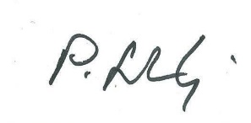
Approved as a resolution of Council by Council’s delegate: P.Schembri

Date: 19 September 2018

Background
The Amendment is sought to re-zone the land to facilitate the long term expansion and growth of Covenant College. A planning permit for subdivision is required so as to enable the re-zoning, as it is not possible under the Victoria Planning Provisions to re-zone land such that a single parcel would be in two zones.
The application has been made with the knowledge and support of the owner of the land that is to be re-zoned and subdivided.
The impetus for the application at this time relates to the requirement of a Federal Government grant that the land to be purchase with grant monies be zoned in a manner that allows for it to be used and developed for educational purposes, consistent with the basis of the grant. In order to be eligible to receive the grant it is necessary for the school to be able to provide certainty in relation to planning use rights.
Discussion
The land is located within the Fyansford portion of the identified Western urban growth area consistent with the mapped Geelong G21 Regional Growth Plan, at Clause 11.01-1R of the planning scheme. The purchase and re-zoning will ensure that the ability of the school to expand to accommodate the future growth in demand which is anticipated to occur in the area.
The proposed re-zoning and subdivision will result in a good planning outcome, in that it is consistent with the identified long term needs of Covenant College and will ensure that the required land is available and appropriately zoned for that purpose.
There will be no adverse impacts on the balance of the lot which will remain in the farming zone, which is currently cropped in conjunction with adjoining land in the farming zone, as can be seen on the Aerial photograph at Attachment 2. This land will retain a frontage of 81.60 metres to Creamery Road, as identified on the Plan of Subdivision at Attachment 4.
It is proposed to rezone the site to Special Use Zone Schedule 15, (SUZ15), recently introduced by Amendment C286, which permits Private Education Centre as an as-of-right use.
The Table of uses within the Schedule includes the uses of ‘education centre’, ‘library’, ‘place of worship’ and ‘hall’ in Section 1 – permit not required subject to the condition that it must form part of, or be ancillary to the education centre or religious institution. Other uses such as ‘accommodation’, ‘place of assembly’, ‘office’ and ‘outdoor recreation facility’ are Section 2- permit required uses.
All buildings and works will require planning permission in the new schedule. This will provide Council with the ability to consider any impacts of development which may subsequently be proposed on nearby properties.

Financial Implications
The proposed re-zoning and planning permit will have no financial implications for Council.
Stakeholder Consultation and Communication
All landowners and occupiers, prescribed Ministers and other relevant agencies will be directly notified during the statutory exhibition period. The broader community will be notified through notices in local newspapers and the City of Greater Geelong website.
Policy/Legal/Statutory Implications
Consistent with the objectives set out in Section 4 of the Planning and Environment Act 1987, the amendment:
- Provides for the fair, orderly, economic and sustainable use and development of the land;
- Balances the need for the future growth of Covenant College in the context of the identified future urban development proposed for the area; and
- Uses appropriate planning provisions for consistent and orderly consideration of future development applications across the entire school site, both existing and proposed.
The proposal accords with the objectives of Planning in Victoria as set out in the planning and Environment Act 1987 as it will provide for re-zoning and subdivision of land to achieve an orderly, well planned outcome consistent with the requirements of the Act.
In particular, the Amendment is supported by the following elements of the Planning Scheme.
Clause 11.01-1R Settlement – Geelong G21
Strategies
Specifically to: “Provide for long term growth options that build on existing infrastructure, including two further investigation areas north and west of Geelong.”
The land to be re-zoned and the school are both located within the identified further investigation area to the west of Geelong. The amendment provides for future needs for the educational facility and makes better utilisation of land, enabling the school to expand immediately adjacent to the existing school, therefore utilising existing infrastructure including buildings, vehicle access and parking areas. It ensures that the needs of the school are clearly identified such that future residential growth does not compromise the potential for the school to grow and accommodate the needs of the school community.
Clause 11.09 Geelong – The amendment supports the objective to build and support diversity, knowledge and innovation by supporting the future growth and expansion of Covenant College and protecting its future in this location.
Clause 19.02 Community infrastructure – The amendment supports the policy by planning for long term growth in an area where future demand is likely and where existing facilities can be better utilised.
Specifically 19.02-2S Education facilities, which includes a Strategy: “Consider demographic trends, existing and future demand requirements and the integration of facilities into communities in planning for the location of education and early childhood facilities.”
Clause 21.07 Economic development and employment – The amendment supports the growth of an established and well recognised school in the local community without impacting the agricultural productivity of farming land given the small size of the rural parcel and its location within a defined future growth area of Geelong that brings with it likely residential development in the medium to long term.
Alignment to City Plan
The proposed Amendment C386 supports both the Growing our Economy and Sustainable Built and Natural Environment strategic directions of City Plan.
Officer Direct or Indirect Interest
No Council officers involved in the preparation of this report have any direct or indirect interest in the matter to which this report relates, in accordance with Section 80 (c) of the Local Government Act.
Risk Assessment
There are no identified risks associated with implementing the recommendation contained in this report.
Environmental Implications
No environmental implications arise from the proposed re-zoning and subdivision.
Any future development of the re-zoned land will be required to obtain all planning and building permits, consistent with the provisions of the zone and schedule and the Building Act.

Appendix 3 – Proposed Zoning
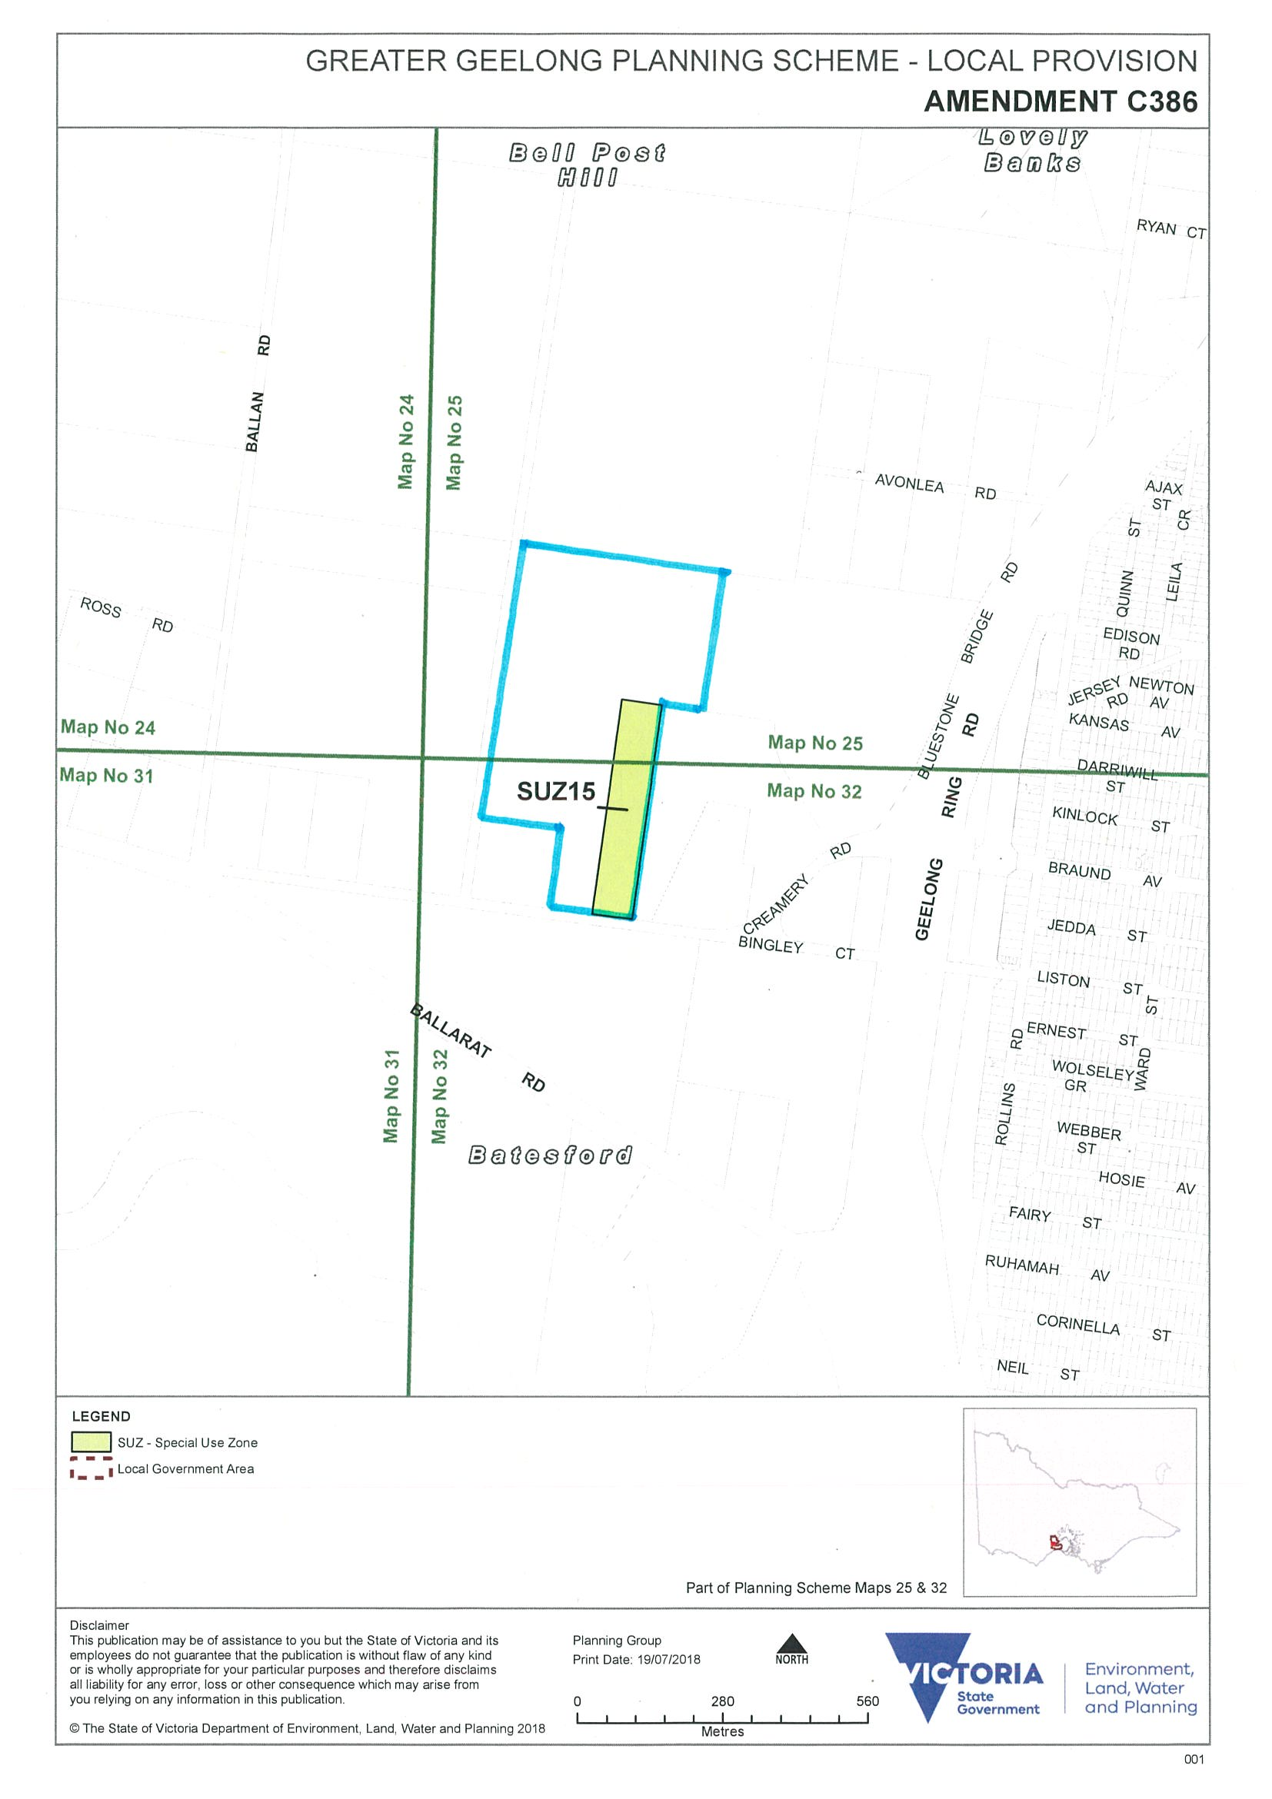

Appendix 2 – Aerial photo
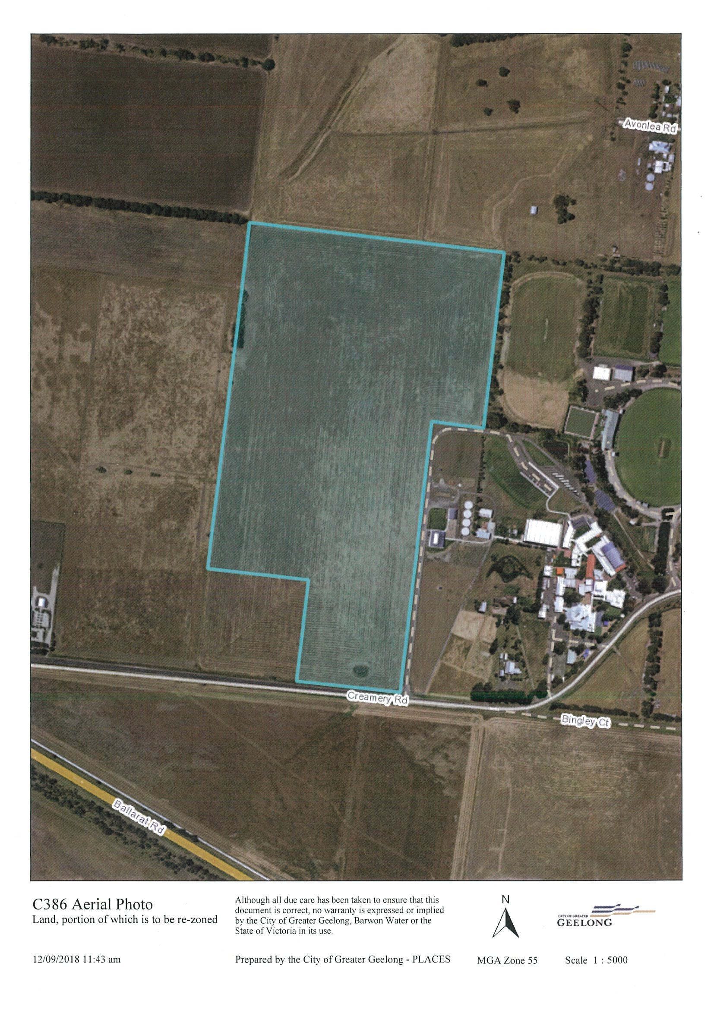
Appendix 3 – Existing zoning
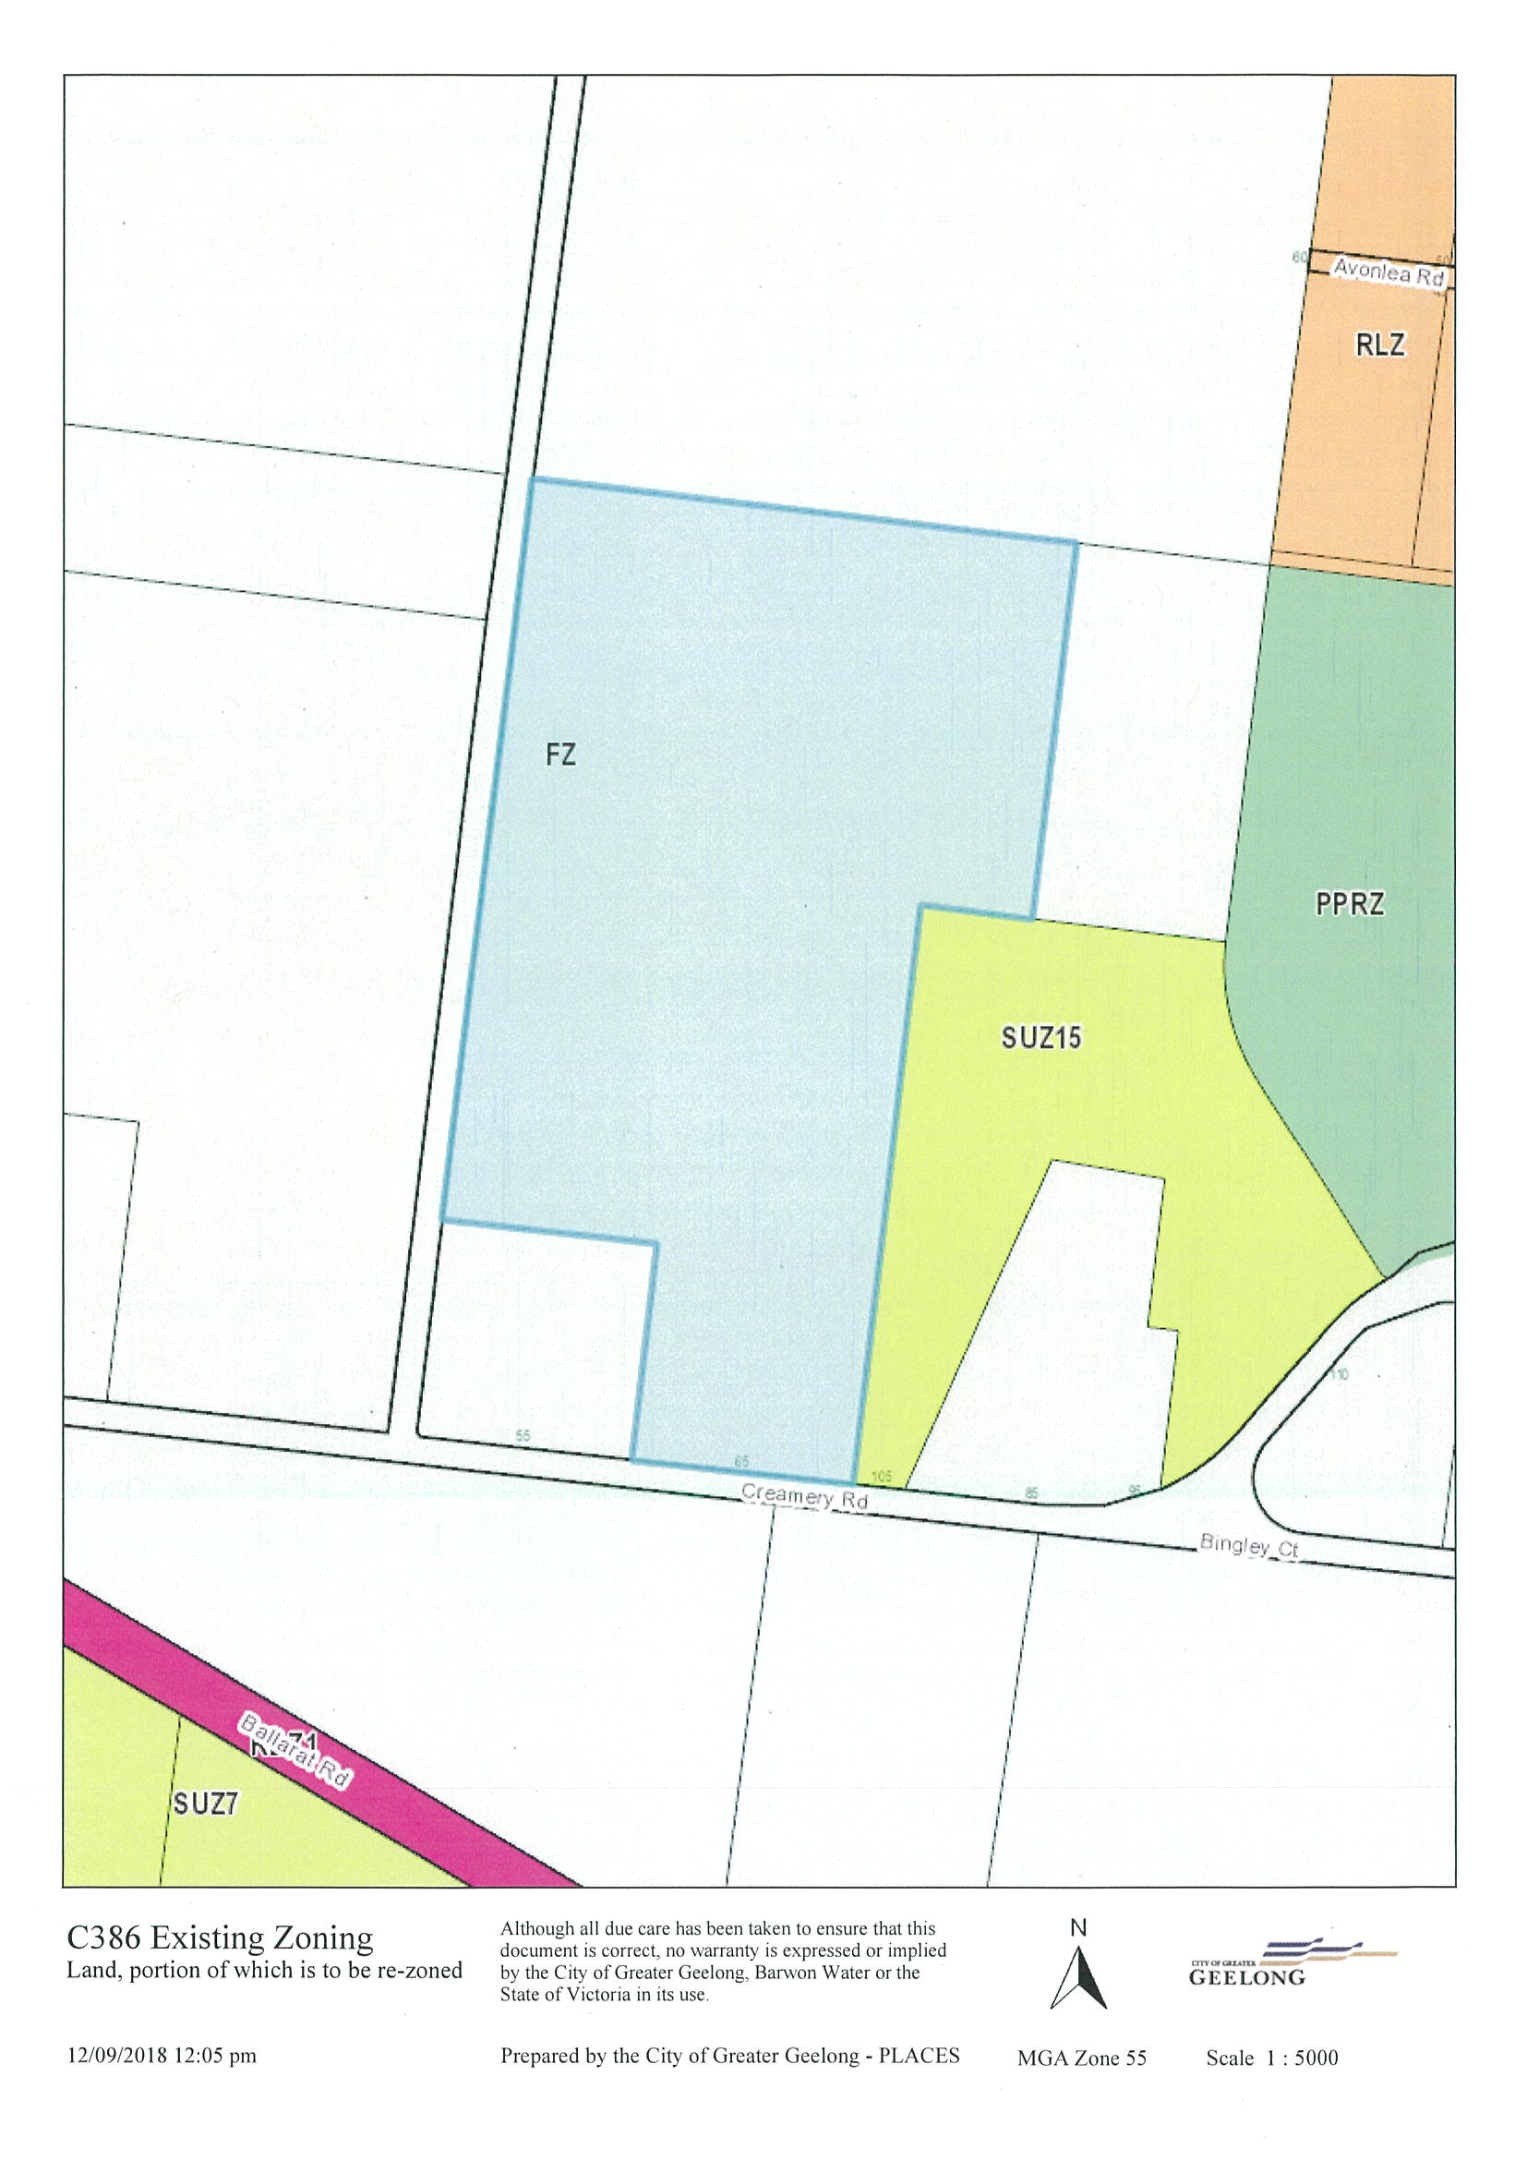
Appendix 4 – Plan of Subdivision
