GREATER GEELONG PLANNING SCHEME AMENDMENT C394ggee

Bellarine Peninsula and Corio Bay – Land Subject to Inundation Overlay

Part A Submission to the Independent Panel

Panel: Sarah Carlisle (Chair), Geoffrey Carruthers
Date: 21 February 2020
Prepared by: Peter Smith, Coordinator Strategic Implementation
City of Greater Geelong

Contents
Introduction 3
Summary of the amendment 3
A. STRATEGIC CONTEXT SUMMARY 5
Relevant planning policies 5
Relevant planning controls 6
Other relevant amendments 10
Potential LSIO Coastal Update Amendment 10
B. AUTHORISATION 14
C. MAPPING CHANGES 17
Technical GIS issues with polygons 17
Removal of LSIO in Barwon Estuary due to DEWLP requirements 17
Delaying application of LSIO to the Point Lonsdale area 17
D. ISSUES RAISED IN SUBMISSIONS 19
Impact on property values 19
Insurance costs 20
Valuation of land and rates 20
Need for coastal protection works 20
Floor levels and building heights 20
Government agency submissions 20
Criticism of technical basis 21
Timing of sea level rise projections 22
Requests to remove properties from overlay 22
E. CHANGES IN RESPONSE TO SUBMISSIONS 23
F. OTHER STRATEGIC MATERIAL 24
APPENDICES 25
Appendix 1 – Minister’s delegate authorisation letter 26
Appendix 2 – Difference between LSIO2 maps and LCHA maps 28
Appendix 2 – Maps showing difference between LSIO2 and LCHA extents 30
LIST OF FIGURES
Figure 1 – Breakdown of LSIO2 properties by zone 7
Figure 2 – Barwon Heads – SBO/LSIO2 overlap 8
Figure 3 – Portarlington – SBO/LSIO2 overlap 8
Figure 4 – Newcomb and Moolap – SBO/LSIO2 overlap 9
Figure 5 – North Shore – SBO/LSIO2 overlap 9
Figure 6 – Settlement Strategy Recommendations for Bellarine Peninsula 12
Figure 7 - Housing Framework Plan (Settlement Strategy) 13
Figure 8 – Original extent of LSIO proposed for Barwon estuary, Lake Connewarre 14
Figure 9 – Changes to LSIO2 extent as a result of authorisation 16

Introduction
- This Part A submission has been prepared by the Planning Authority, the City of Greater Geelong in response to the Panel Directions issued on 18 December 2019 which states:
Council must circulate a Part A submission to parties on the distribution list by 4.00pm on Friday 21 February 2020 that includes:
- A summary of the strategic context, including:
(i) relevant planning policies and controls
(ii) other amendments that may be under preparation or recently approved that may impact on the Amendment.
- A summary of the conditions of authorisation, and how those conditions have been met (in particular, the rationale for removing properties subject to an existing Flood Overlay from this Amendment).
- An explanation of any differences in the mapping of the 1% AEP + 0.8m sea level rise flood extents for each Compartment in the Coastal Hazard Assessment and the proposed mapping of the LSIO2.
- A summary of the main issues raised in submissions.
- Any changes Council proposes to make to the Amendment in response to submissions, including those suggested by DELWP in Submission No. 15.
- Any other strategic material that Council intends to rely upon in support of the Amendment that has not yet been provided, or that might assist the Panel in its consideration of the Amendment.
- The structure of this Part A submission follows the above Panel Direction. A further “Part B” submission will be presented at the Panel Hearing starting on 28 February 2020. The Panel has directed that Council’s Part B submission includes:
- An explanation as to what, if any, of the recommendations in the Coastal Hazard Assessment to reduce uncertainty and fill information gaps have been implemented.
- Council’s response to the issues raised in submissions.
- Council’s response to expert evidence.
- Any further changes Council proposes to make to the Amendment in response to expert evidence or submissions.

Summary of the amendment
- The Amendment proposes to implement the Bellarine Peninsula - Corio Bay Local Coastal Hazard Assessment December 2015 (LCHA). It includes policy changes to the Municipal Strategic Statement, introduces a new Land Subject to Inundation Overlay (LSIO) schedule and applies the LSIO to properties identified as being subject to future flood events and sea level rise.
- Specifically, the Amendment seeks to:
- amend Clause 21.05 Natural Environment to refer to the Bellarine Peninsula - Corio Bay Local Coastal Hazard Assessment December 2015 and include a new objective and strategy at Clause 21.05-5 Climate Change relating to coastal impacts of climate change
- introduce a new Schedule 2 to Clause 44.04 Land Subject to Inundation Overlay titled “Coastal Inundation and Hazard” (LSIO2)
- apply the Land Subject to Inundation Overlay Schedule 2 (LSIO2) to land identified in the Bellarine Peninsula - Corio Bay Local Coastal Hazard Assessment December 2015 as being inundated by the combined effects of the 1% Average Event Probability (AEP) flood event plus 0.8 metre sea level rise
- amend the Schedule to Clause 72.03 to update the list of maps forming part of the scheme.
- The Amendment applies to private and public land along the coastline of the Bellarine Peninsula and Corio Bay.
- The LSIO2 overlay will apply to 1614 coastal properties on the Bellarine Peninsula and Corio Bay at Avalon, Lara, Corio, Geelong, East Geelong, Newcomb, Moolap, Leopold, Bellarine, Portarlington, Indented Head, St Leonards, Swan Bay, Ocean Grove, Wallington, Barwon Heads, Connewarre and Breamlea.

STRATEGIC CONTEXT SUMMARY

Relevant planning policies
State policy
- The Amendment supports the following state policies from the Planning Policy Framework:
- Clause 13.01-2S Coastal inundation and erosion – the Amendment achieves the policy objective “to plan for and manage the potential coastal impacts of climate change” and implements the following strategies:
- Plan for sea level rise of not less than 0.8 metres by 2100 and allow for the combined effects of tides, storm surges, coastal processes and local conditions such as topography and geology when assessing risks and coastal impacts associated with climate change.
- Ensure that land subject to coastal hazards is identified and appropriately managed to ensure that future development is not at risk.
- Avoid development in identified coastal hazard areas susceptible to inundation.
The clause allows for the use of an interim benchmark of 0.2 metres by 2040 in infill areas if desired. C394 proposes to apply the LSIO based on 0.8m sea level rise + 1%AEP storm surge. However, the criteria to be used by the Catchment Management Authority to assess permit applications triggered by the overlay and set floor levels will use interim levels for infill development. This will be explained further in the Part B submission and at the hearing.
- Clause 13.03-1S Floodplain management – the Amendment meets the objective to assist in the protection of:
- Life, property and community infrastructure from flood hazard.
- The natural flood carrying capacity of rivers, streams and floodways.
- The flood storage function of floodplains and waterways.
- Floodplain areas of environmental significance or of importance to river health.
and implements the strategies to:
- Identify land affected by flooding, including land inundated by the 1 in 100 year flood event or as determined by the floodplain management authority in planning schemes
- Avoid intensifying the impact of flooding through inappropriately located use and development.
Local Policy
- The Amendment supports and implements the following policies from the Local Planning Policy Framework:
- Clause 21.05-4 Coastal environments – including the objectives:
- To protect, maintain and enhance the coast, estuaries and marine environment.
- To respect and manage coastal processes.
and a relevant strategy:
- Setback future land use and development from coastal areas, estuaries and coastal wetlands to provide a buffer which is adequate to accommodate coastal recession and the landward migration of coastal wetland vegetation communities such as mangroves and salt marshes.
- Clause 21.05-5 Climate change – including the objective:
- To plan for and adapt to the impacts of climate change.
and a relevant strategy:
- Avoid land use and development within areas considered at risk of coastal erosion or inundation from flooding, storm surge or rising sea levels.
- Clause 21.05-7 Flooding – has relevant objectives:
- To protect floodplains.
- To minimise the potential for damage and risks to public safety and property from flooding.

Relevant planning controls
Existing zones
- The properties affected by the proposed LSIO2 are in a broad range of zones including residential, rural, public and commercial zones.
- A breakdown of the number of properties by zone is in Figure 1. Of the total 1600 properties there are 1244 properties in residential zones within the townships and urban areas of the Bellarine Peninsula and urban Geelong.

Figure 1 – Breakdown of LSIO2 properties by zone
Zone | Properties
ACTIVITY CENTRE ZONE - SCHEDULE 1 | 1
COMMONWEALTH LAND NOT CONTROLLED BY PLANNING SCHEME | 5
FARMING ZONE | 87
GENERAL RESIDENTIAL ZONE - SCHEDULE 1 | 54
GENERAL RESIDENTIAL ZONE - SCHEDULE 2 | 837
INDUSTRIAL 1 ZONE | 41
INDUSTRIAL 2 ZONE | 7
MIXED USE ZONE | 5
NEIGHBOURHOOD RESIDENTIAL ZONE - SCHEDULE 5 | 263
NEIGHBOURHOOD RESIDENTIAL ZONE - SCHEDULE 6 | 88
PORT ZONE | 6
PUBLIC CONSERVATION AND RESOURCE ZONE | 84
PUBLIC PARK AND RECREATION ZONE | 56
PUBLIC USE ZONE - SERVICE AND UTILITY | 5
PUBLIC USE ZONE - TRANSPORT | 2
RESIDENTIAL GROWTH ZONE - SCHEDULE 3 | 2
ROAD ZONE - CATEGORY 1 | 1
RURAL CONSERVATION ZONE - SCHEDULE 6 | 6
RURAL CONSERVATION ZONE - SCHEDULE 7 | 8
RURAL CONSERVATION ZONE - SCHEDULE 8 | 1
RURAL LIVING ZONE | 4
SPECIAL USE ZONE - SCHEDULE 1 | 37
Total | 1600

Existing overlays
- There are a range of existing overlays affecting the land proposed for the LSIO2 including: Environmental Significance Overlay, Significant Landscape Overlay, Design and Development Overlay, Heritage Overlay, Development Plan Overlay and the Special Building Overlay.
Special Building Overlay (SBO)
- The SBO is the most relevant overlay as it also deals with flooding albeit it from the stormwater system. The SBO coincides with the proposed LSIO2 at a number of properties in Barwon Heads, Portarlington, Newcomb, Moolap and North Shore as shown in the figures below.
Figure 2 – Barwon Heads – SBO/LSIO2 overlap
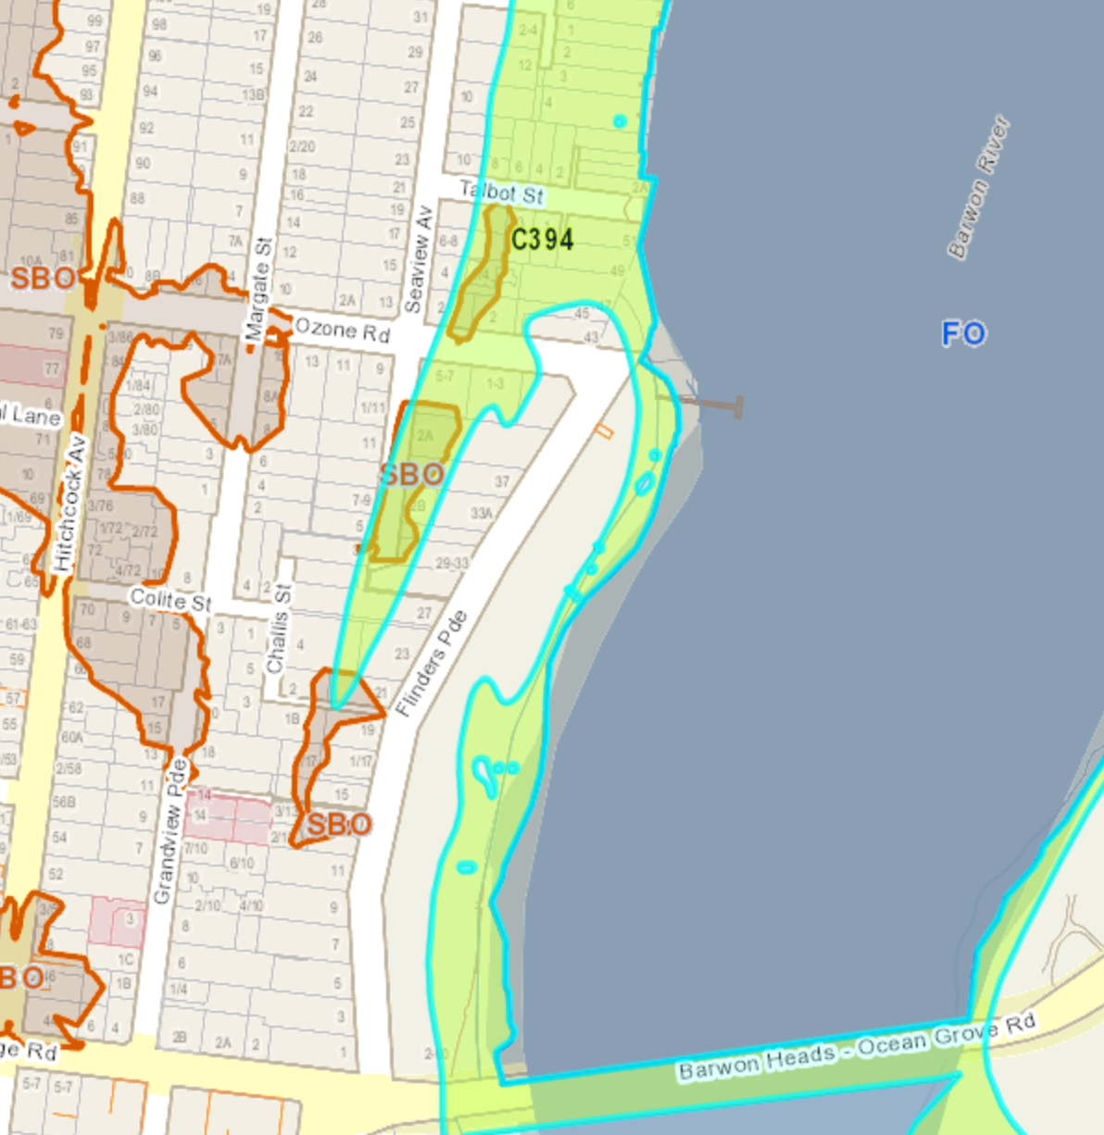
Legend: LSIO2 - light blue outline, SBO - red outline

Figure 3 – Portarlington – SBO/LSIO2 overlap
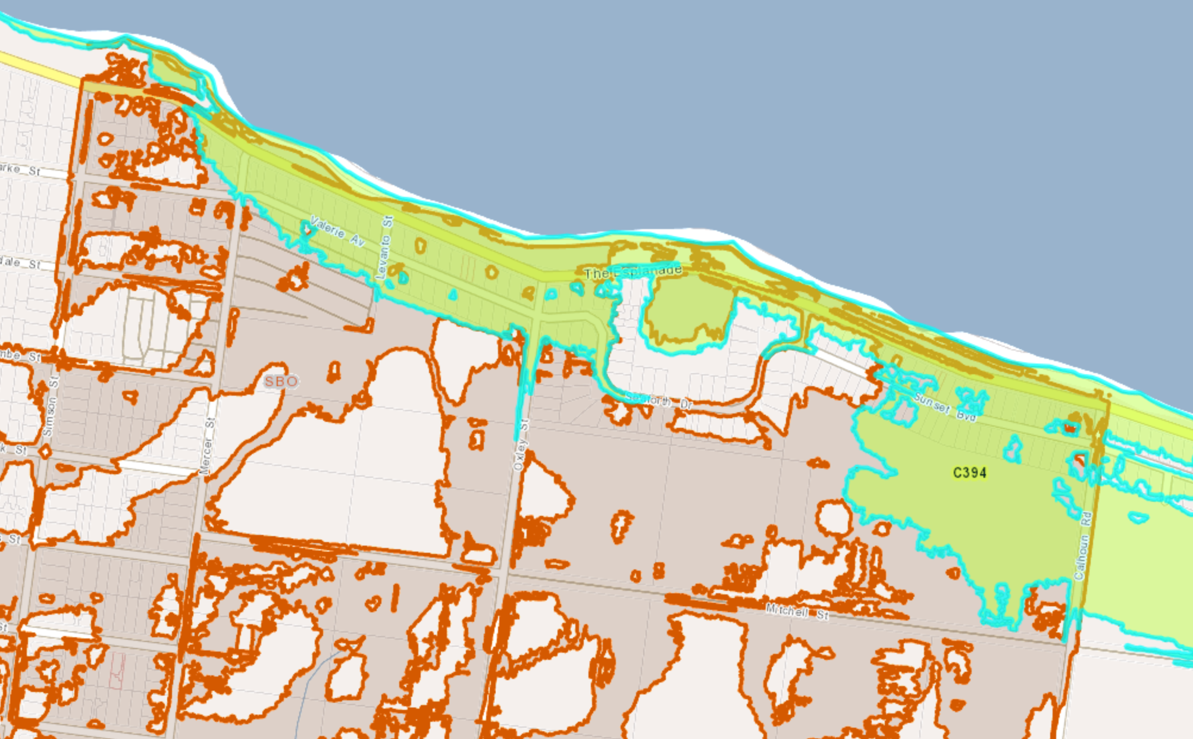
Figure 4 – Newcomb and Moolap – SBO/LSIO2 overlap
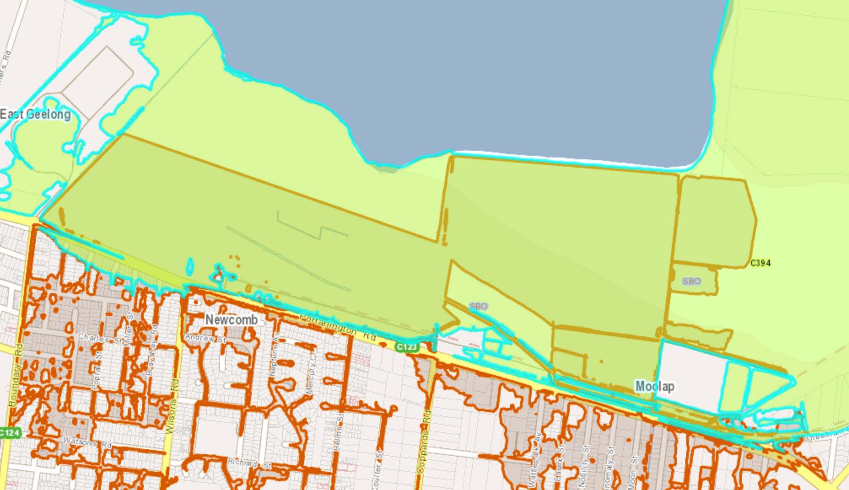

Figure 5 – North Shore – SBO/LSIO2 overlap
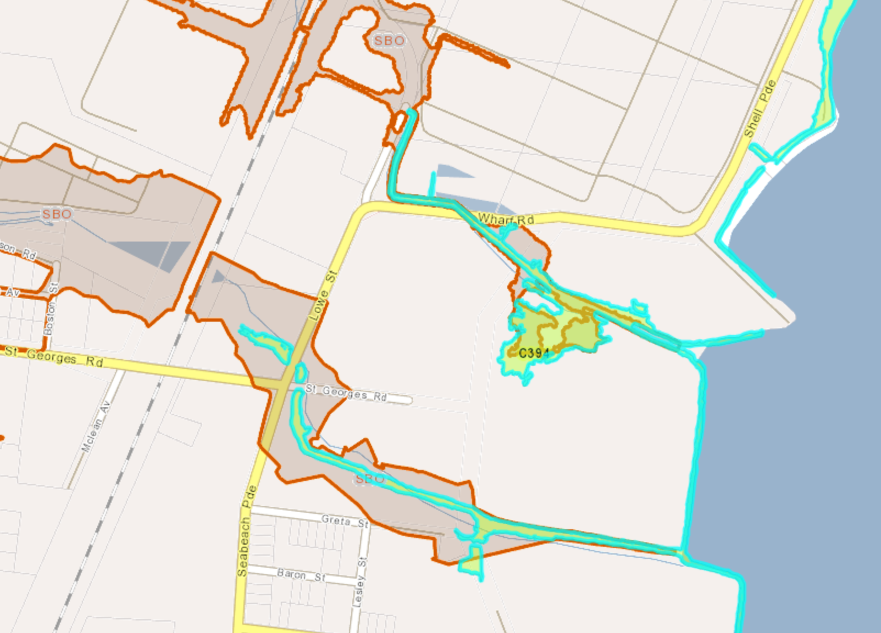

Other relevant amendments
- The Panel has requested information on other amendments that may be under preparation or recently approved that may impact on the Amendment, which is provided below.

Potential LSIO Coastal Update Amendment
- DELWP started looking at changes to the LSIO and other planning scheme provisions in 2018, a project named the “LSIO Coastal Update”.
- As part of the LSIO Coastal Update project delivery, DELWP Planning Systems are consulting with coastal councils, Catchments Management Authorities (CMAs) and relevant representative agencies and departments on:
- how best to include the coastal thematic in the wording of Clause 44.04 (e.g. ‘Purpose’)
- other potential ‘non-structural’ changes to the LSIO, which could be considered as part of this update
- other improvements to the operation and application of the LSIO to coastal areas, which will inform future transformative changes to planning policy.
- A workshop was held on Thursday 25 October with relevant DELWP divisions, partner councils and coastal CMAs. The workshop included an overview of recent changes to the strategic setting and Victoria Planning Provisions relating to coastal planning and hazard management. The workshop discussion focused on:
- Clause 13.01 Climate Change Impacts
- Clause 13.03 Floodplains
- Clause 44.01 Erosion Management Overlay
- Clause 43.04 Land Subject to Inundation Overlay
- Recommendations and feedback received at the workshop informed draft planning provisions which were circulated to stakeholders for further feedback.
- Project objectives are to:
- Confirm the LSIO’s applicability to coastal areas
- Support the use of the LSIO in the management and mitigation of coastal inundation
- Project outputs will also contribute to ongoing and future transformative changes to planning policy.
- Advice from DELWP as at February 2020 is that the changes (to the LSIO and coastal inundation policy) will be subject to a VC amendment after the Marine and Coastal Policy is approved some time in 2020.
Amendment C395 Settlement Strategy
- Amendment C395 implements a new municipal Settlement Strategy and planning frameworks plans for the Northern and Western Geelong Growth Areas at Lovely Banks and Batesford.
- The purpose of the strategy is: to analyse future housing needs and trends; to develop a clear policy framework that will guide planning and decision-making and to help us meet Greater Geelong’s future housing needs. The strategy is intended to address municipal housing needs until 2036.
- In relation to the Bellarine Peninsula the strategy proposes to decrease the share of housing development over time and re-direct greenfield growth to the growth areas at Geelong. It proposes to move towards permanent settlement boundaries for towns on the Bellarine. This will reduce pressure for coastal township expansion and coastal development and hence is relevant to this amendment which deals with coastal inundation.
- Figure 6 is an extract showing the key directions for the Bellarine Peninsula and Figure 7 is the overall Housing Framework Plan showing existing settlement boundaries.
- A parallel and relevant process (although not an amendment) is the Bellarine Peninsula Distinctive Areas and Landscape project being undertaken by the State Government. This is likely to implement permanent settlement boundaries to the towns on the Bellarine which will help achieve the vision of Council’s Settlement Strategy and Amendment C395.

Figure 6 – Settlement Strategy Recommendations for Bellarine Peninsula
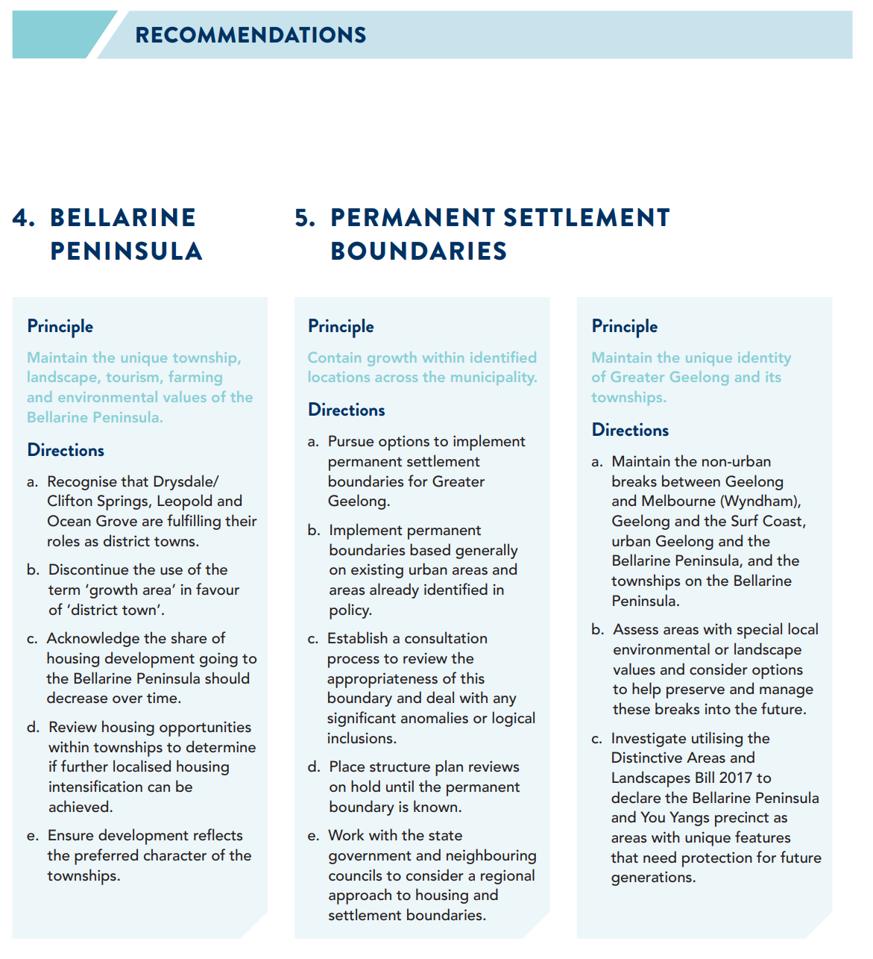

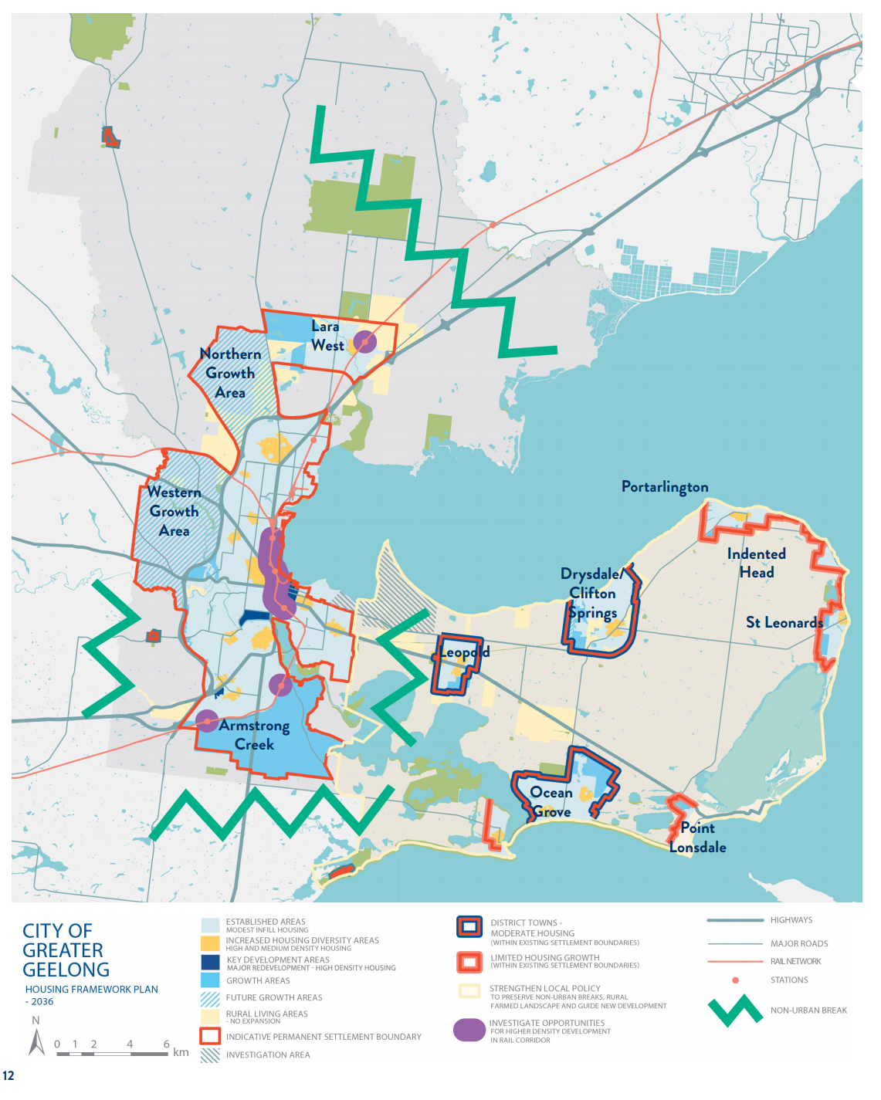
Figure 7 - Housing Framework Plan (Settlement Strategy)

AUTHORISATION
- The Panel has requested a summary of the conditions of authorisation, and how those conditions have been met (in particular, the rationale for removing properties subject to an existing Flood Overlay from this Amendment).
- On 14 May 2019 Council resolved to:
- Support the preparation and exhibition of Amendment C394 to the Greater Geelong Planning Scheme to:
(a) Amend Clause 21.05 to refer to the Bellarine Peninsula - Corio Bay Local Coastal Hazard Assessment and make minor policy changes;
(b) Introduce Schedule 2 to the Land Subject to Inundation Overlay titled “Coastal Inundation and Hazard” (LSIO2) based on Attachment 4; and
(c) Apply the new LSIO2 to land identified as being inundated by the 1% AEP flood event plus 0.8 metre sea level rise (maps in Attachment 5).
- Request the Minister for Planning to authorise the preparation and exhibition of Amendment C394; and
- Support the future consideration of applying the LSIO2 to the Point Lonsdale area when further modelling is undertaken that includes The Point waterway system.
- The maps in the 14 May 2019 Council report had the LSIO2 being applied to 1726 properties around the City’s coast. Map 8 showed the LSIO2 extending into the Barwon River estuary, Lake Connewarre and Reedy Lake as per the LCHA inundation report maps – see Figure 8 below.
Figure 8 – Original extent of LSIO proposed for Barwon estuary, Lake Connewarre
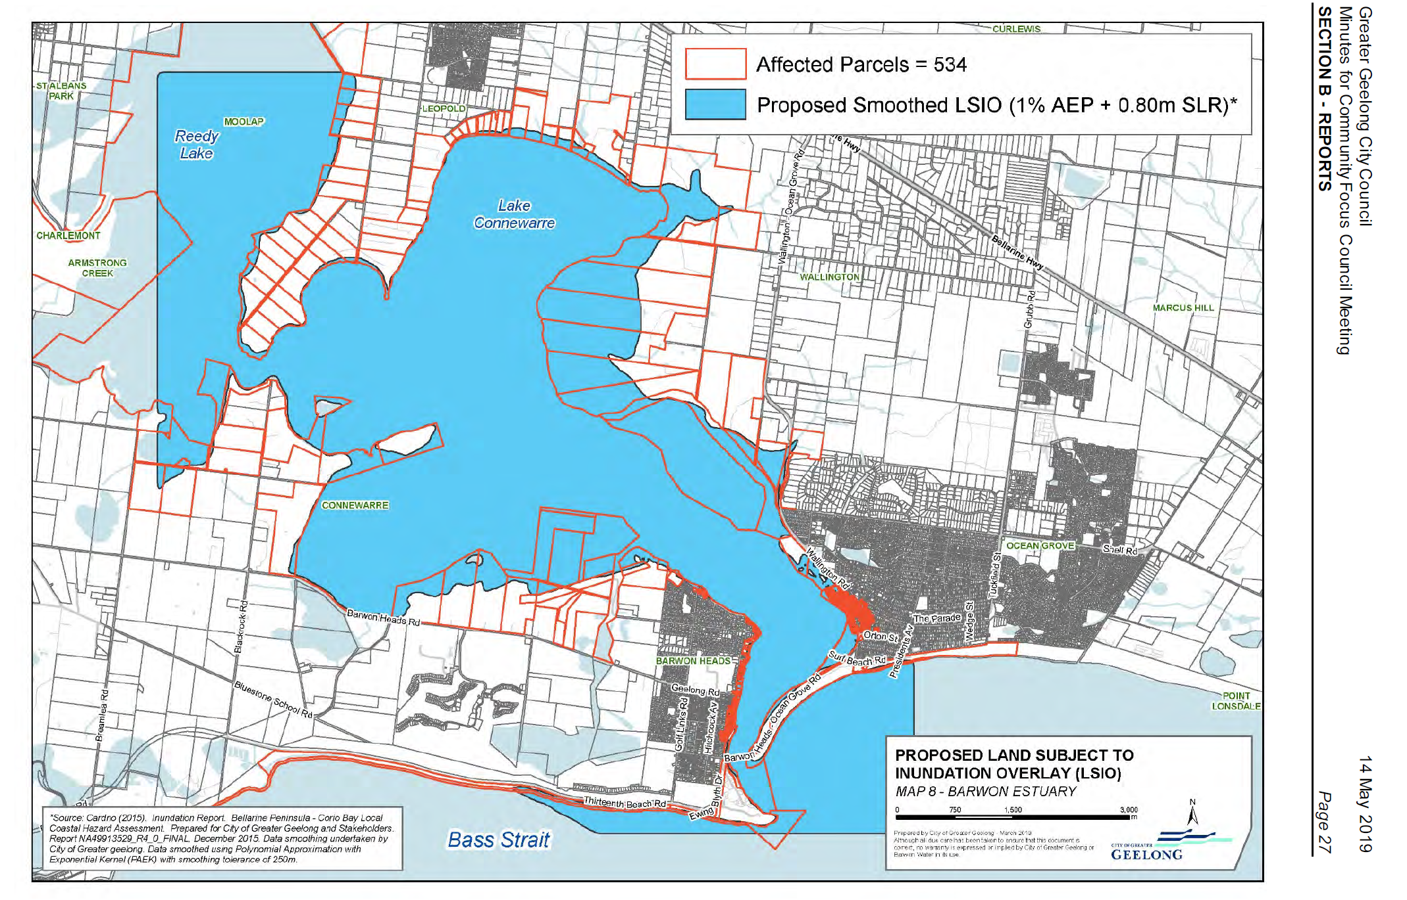
- Based on the Council resolution, authorisation was requested from DELWP on 17 May 2019.
- The DELWP planner dealing with the application advised that that he had “undertaken a preliminary assessment of the proposed amendment and notice that the LSIO2 will be applied to some areas where the FO currently applies (e.g. Barwon Heads estuary and Lake Connewarre). The amendment does not include any deletion maps to delete the FO … please clarify if it its council’s intention to replace the FO with the LSIO? Council should have regard to Planning Practice Note No. 12 in selecting the appropriate flood provisions.”
- A series of emails and discussions occurred about whether it was appropriate for two different flood overlays to apply to the same property.
- By email to DELWP on 6 June 2019 Council advised:
- “The main overlap on land is on Farming Zone properties around Lake Connewarre and Reedy Lake. It’s not really an issue in the residential areas of Barwon Heads / Ocean Grove.
- ..we believe that both overlays can and should apply. The FO is for higher risk flooding and relates to the Barwon River flooding… The LSIO2 is for future coastal inundation flooding from 0.8m sea level rise and is a different overlay to the FO.
- … one of the goals of the Our Coast project was to publicly identify all properties that may be affected by sea level rise in the planning scheme. Legal advice form the MAV is that we have a duty of care to do this…. This is another strong reason to apply it regardless of overlap with the FO.
- However, if our authorisation was conditional on no overlay overlaps we would trim back the LSIO to avoid the FO.
- The LSIO therefore wouldn’t apply to any properties around Lake Connewarre/ Reedy Lake. But it would be applied to 436 residential properties in Barwon Heads and Ocean Grove…..”
- The CCMAs preference was “for all overlays (i.e. FO, LSIO and LSIO2) being preferred to overlap. This recognises the different types of flooding and their associated hazards. If DELWP are unable to do this then the FO should remain and the LSIO/LSIO2 remain as fringe flooding.”
- The end result is that authorisation was issued by DELWP – see Appendix 1 – requiring no overlap between the proposed LSIO2 and existing FO and LSIO. The changes are demonstrated in Figure 9 below.
Figure 9 – Changes to LSIO2 extent as a result of authorisation
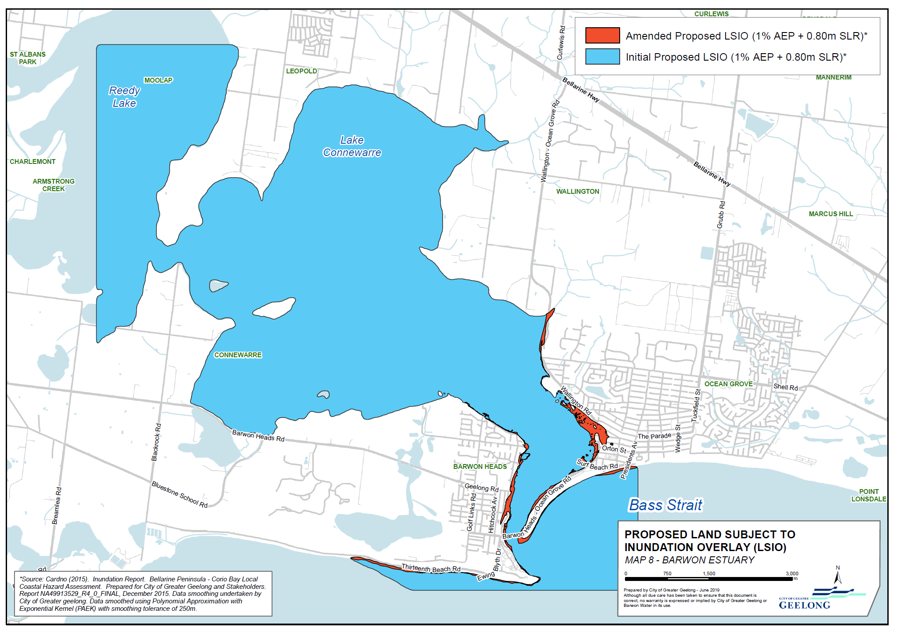
- Public exhibition occurred in July/August 2019 with the exhibited LSIO2 overlay affecting reduced 1614 coastal properties on the Bellarine Peninsula and Corio Bay. This is a reduction in approximately 100 properties – predominately farming properties and Crown land - around Lake Connewarre, Reedy Lake and the Barwon River estuary. However, these properties are still subject to flood overlays relating to riverine inundation

MAPPING CHANGES
- The Panel has requested an explanation of any differences in the mapping of the 1% AEP + 0.8m sea level rise flood extents for each Compartment in the Coastal Hazard Assessment and the proposed mapping of the LSIO2.
- In preparing the proposed maps showing the LSIO extent for C394ggee, it was necessary for several areas of the proposed LSIO to differ from the inundation extent mapped in the Cardno (2015) Bellarine Peninsula - Corio Bay Local Costal Hazard Assessment (LCHA).
- A detailed description of the changes by compartment is in Appendix 2. There are nine supplementary maps highlighting these areas of difference in Appendix 3.
- The key reasons for the changes to the maps include:

Technical GIS issues with polygons
- Prior to exhibition, DELWP mapping services advised that the Local Coastal Hazard Assessment dataset contained too many polygons to be compliant with their mapping system. As such, small changes were required to simplify the inundation extent for it to be suitable as an LSIO. This process was applied to all compartments of the LCHA.
- This simplification of the LCHA dataset involved the removal of some small areas outside of the primary inundation area and small gaps within the primary inundation area of each compartment.
- For example, in Compartment 9: North Corio Bay to Point Wilson, this process reduced the number of polygons from 709 to 46. However, in general the overall extent remains the same.

Removal of LSIO in Barwon Estuary due to DEWLP requirements
- This issue was described in detail in section B. of this submission

Delaying application of LSIO to the Point Lonsdale area
- This issue is described in the Council report (minutes) of 14 May 2019 as follows.
- The Point residential development (previously Stockland) at Point Lonsdale includes a waterway system that will drain this part of Point Lonsdale. The development was subject to a combined Environmental Effects Statement, Amendment (C150) and Planning Permit approximately 10 years ago. As part of this process modelling was undertaken to show how the new waterway system would function under sea level rise and storm surge events. The mapping at the time showed that The Point residential area and some existing residential areas in Point Lonsdale would also benefit from this waterway system as it would reduce the flood impact.
- At the time the Our Coast mapping was undertaken The Point waterway was not in existence and hence was not picked up as a topographical feature or part of the drainage system. The mapping produced therefore doesn’t take into account this waterway .
- It is proposed that further mapping be undertaken that includes the new waterway and the LSIO2 be applied later under a separate planning scheme amendment.
- The City will also continue to liaise with the Borough of Queenscliffe as its part of Point Lonsdale township is also affected by potential sea level rise. Ideally an overlay would be applied as part of a joint amendment involving both municipalities.

ISSUES RAISED IN SUBMISSIONS
- The Panel has requested a summary of the main issues raised in submissions.
- The amendment was exhibited from 11 July 2019 to 12 August 2019.
- As a result of exhibition, a total of 43 submissions were received. Of these 39 submissions objected and 4 submissions either supported, did not object or provided comments.
- Most submissions related to specific properties with the most submissions coming from St Leonards (11 submissions) followed by Portarlington (7), Indented Head (5) and Ocean Grove (4).
- The key issues raised in submissions can be grouped under the following themes:
- Impact on property values
- Insurance costs
- Valuation of land and rates
- Need for coastal protection works
- Floor levels and building heights
- Government agency submissions
- Criticism of technical basis
- Timeline of sea level rise projections
- Requests to remove properties from overlay
- A full summary of and response to all the submissions is in the Council report of 26 November 2019. A summary of the key issues form the Council report is provided below.

Impact on property values
- Eighteen submissions were received regarding the potential reduction in property values because of the overlay. Another seven submissions were received noting the potential impact on the future value, usability and resale of the property. Submissions also outlined difficultly to obtain financing for future purchases as the LSIO will be within the Section 32 contract of sale and higher construction costs associated with the redevelopment of properties due to the requirements of the LSIO.

Insurance costs
- Four submissions identified the potential increase in insurance premiums or difficulty to obtain insurance coverage because of properties now being within the LSIO.

Valuation of land and rates
- Six submissions linked a reduction in property values associated with the proposed amendment with impacts upon Council rates. The submitters propose that properties situated within the LSIO should be revalued with rate reductions in line with reduced property values.

Need for coastal protection works
- Council received submissions stating that the planning scheme alone will not result in changes to reduce the impact of possible inundation. A total of ten submissions have raised questions and concerns with what measures could or should be undertaken to ensure the potential impact of sea level rise is mitigated, with suggestions generally being for the construction of new or improved hard infrastructure such as sea walls.
- Others believe that finances should be provided to construct defences to protect foreshore properties and public infrastructure from the rising threat of climate change.
- One submitter believes there are more pressing projects such as surfacing of dirt roads in Portarlington which should be prioritised over an issue that may happen within the next 80 years.

Floor levels and building heights
- Some submissions were concerned that as a result of the proposed amendment requiring some buildings to be constructed at a higher floor level to accommodate potential inundation on a property, existing planning controls should be amended to accommodate any change.
- The submissions infer that as dwellings may be required to consider an additional floor height of 0.8 metres the maximum permissible building height (roof) of any building under other overlays should increase by 0.8 metres to circumvent the requirement of a planning permit.

Government agency submissions
- Submitter 3 (Barwon Water) has recommended support of the proposed amendment subject to several requested changes:
- Addition of the following permit exclusion: Buildings and works undertaken by a public authority relating to watercourse management, environmental improvements or infrastructure services.
- That a standard permit require the overflow relief gully (ORG) be 150mm above the flood level.
- Consideration be given to how the flood risk will impact the servicing requirements. For example, the relationship between flood risk and the infrastructure servicing the development which may be located beyond the boundaries of the property.
- Submitter 10 (Corangamite Catchment Management Authority) supports the Amendment and provides a six-page submission providing background and relevant information (see Attachment 5). The CCMA states that it is supportive of Amendment C394 and will work closely with Council and other key stakeholders to ensure orderly planning outcomes are achieved.
- Submitter 15 (Department of Environment, Land, Water and Planning (DELWP)) supports the amendment and suggests some minor wording improvements as follows:
- At Section 3.0 of the proposed LSIO2 Schedule relating to exemptions, DELWP suggests new wording: Works that have been granted consent under the Marine and Coastal Act 2018 or the Crown Land (Reserves) Act 1978 and are conducted by a Public Land Manager or Committee of Management appointed under the Crown Land (Reserves) Act 1978.
- The first point to Section 5 of the proposed LSIO2 Schedule relating to decision guidelines be amended to read as follows: The views of the relevant Catchment Management Authority.

Criticism of technical basis
- Nine submissions questioned the technical information contained within the Our Coast Report, the methods used and the accuracy of this information and the meaning of inundation.
- One submitter pointed out that the majority of the area from the south of Franzel Ave to the rear/south of Turner Court at Portarlington does not warrant inclusion in this proposed overlay. The submitters state the Portarlington Structure Plan (p,56) shows this area falls outside of any estimated future inundation risks.
- One submitter stated that the proposed amendment does not mention the Moolap Coastal Planning Framework.
- A submission raised whether the information obtained within the Our Coast Report utilised the contour intervals prior to the development of Swan View Estate or if the information was obtained from the finished floor levels from the survey company that subdivided the land within the estate.

Timing of sea level rise projections
- Twelve submissions raised issues with the timeline of the projected impact of sea level rise and inundation. Many of the submissions had an issue with the timeframe of predicted inundation at 2100 with the view that the evidence to support these levels was inaccurate and suggestions were made that the report should be updated every 15 to 20 years.

Requests to remove properties from overlay
- The following properties/areas have made submissions requesting to be removed from the overlay:
- 22 Ord Street St Leonards
- 18 Ord Street St Leonards
- The area from the south of Franzel Ave to the rear / south of Turner Court
- 475 The Esplanade St Leonards
- 11 Manning Street St Leonards
- 15 Spratt Street Portarlington.

CHANGES IN RESPONSE TO SUBMISSIONS
- The Panel has requested any changes Council proposes to make to the Amendment in response to submissions, including those suggested by DELWP in Submission No. 15.
- Council accepts DELWP changes (as below) to the LSIO2 schedule and will provide a marked-up version of the schedule at the panel hearing:
- At Section 3.0 of the proposed LSIO2 Schedule relating to exemptions, DELWP suggests new wording: Works that have been granted consent under the Marine and Coastal Act 2018 or the Crown Land (Reserves) Act 1978 and are conducted by a Public Land Manager or Committee of Management appointed under the Crown Land (Reserves) Act 1978.
- The first point to Section 5 of the proposed LSIO2 Schedule relating to decision guidelines be amended to read as follows: The views of the relevant Catchment Management Authority.

OTHER STRATEGIC MATERIAL
- The Panel has requested any other strategic material that Council intends to rely upon in support of the Amendment that has not yet been provided, or that might assist the Panel in its consideration of the Amendment.
- The following documents will be referred to at the hearing and have been posted on the C394 webpage under “Panel Hearing Documents”:
- Bellarine Peninsula – Corio Bay Local Coastal Hazard Assessment Greater Geelong and Queenscliffe Planning Schemes Implementation (2017) prepared by John Keaney and Michael Kirsch.
- City of Greater Geelong Planning Response to Sea Level Rise (2019) prepared by Hansen Partnership for Municipal Association of Victoria
- Guidelines for Coastal Catchment Management Authorities: assessing development in relation to sea level rise (2012).
- There is also a range of material on the Our Coast website including the LCHA inundation report and other material prepared as part of the overall project.
- Other strategic material accessible from State Government websites is as follows:
- PPN12 Applying the Flood Provisions in Planning Schemes (2015).
- Victorian Coastal Strategy (2014)
- Draft Marine and Coastal Policy 2019
- Bellarine Peninsula Distinctive Area and Landscape process

APPENDICES

Appendix 1 – Minister’s delegate authorisation letter

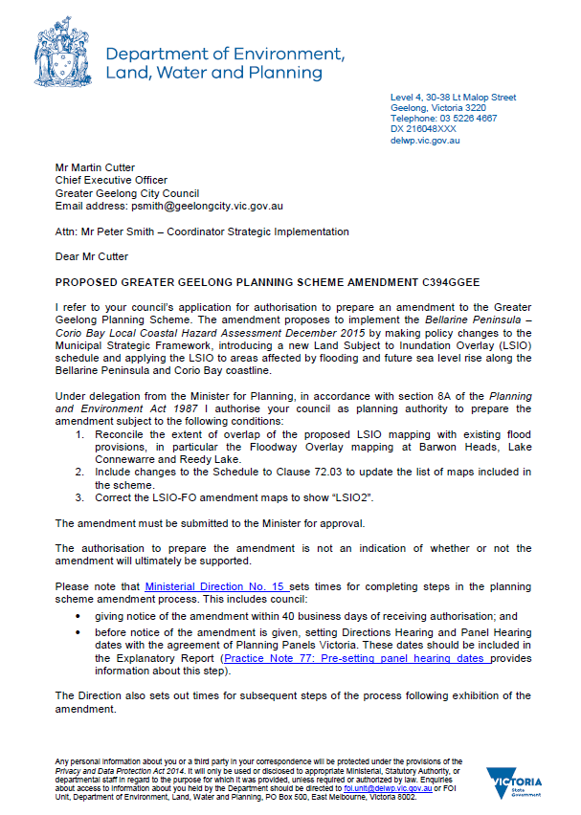
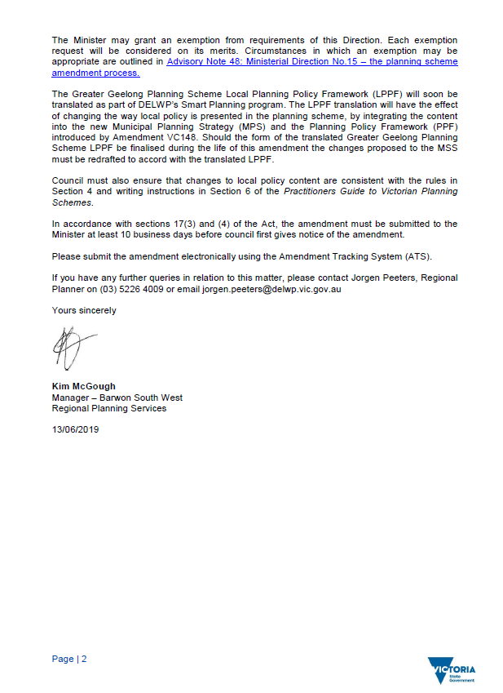

Appendix 2 – Difference between LSIO2 maps and LCHA maps

A breakdown by compartment, of the areas of difference, the map(s) where this change is visible and an explanation of why this difference is required is as follows:
Compartment 9: North Corio Bay to Point Wilson (Visible on Maps 1, 2)
Areas of Difference
- Simplification Process resulted in small differences between the Amendment and LCHA inundation extents.
- The LCHA inundation area of Limeburners Lagoon/Hovells Creek, North of the Princes Highway was not included in the amendment. This area does not intersect with any private land. A second factor in this decision is that a flood study of the Lara area is currently being prepared, which may provide further information for this area.
Compartment 8: Stingaree Bay to Geelong (Visible on Maps 3, 4)
Areas of Difference
- Simplification Process resulted in small differences between the Amendment and LCHA inundation extents.
- The LCHA inundation area at 6/8 Eastern Beach Rd is not included in the amendment. At the time that the LCHA modelling was undertaken there was a building under construction. This involved a large excavated area. The topology of this area has since changed, making the modelling for this specific area of inundation redundant.
Compartment 7: Portarlington to Point Henry (Visible on Maps 4, 5)
Areas of Difference
- Simplification Process resulted in small differences between the Amendment and LCHA inundation extents.
Compartment 6: Point Edwards to Portarlington (Visible on Maps 5, 6)
Areas of Difference
- Simplification Process resulted in small differences between the Amendment and LCHA inundation extents.
Compartment 5: Point Lonsdale to Point Edwards (Visible on Maps 6, 7)
Areas of Difference
- Simplification Process resulted in small differences between the Amendment and LCHA inundation extents.
- The LCHA inundation area South of Bellarine Rail Trail, from Point Lonsdale to the Eastern edge of Ocean Grove was not included in the amendment. Since the LCHA modelling was completed, a waterway system is being constructed as part of The Point development. The waterway will help drain this part of Point Lonsdale and is predicted to reduce the extent of inundation from sea level rise. As a result, this area needs to be remodelled.
- Area outside of the City of Greater Geelong is not included in the amendment.

Compartment 4: Ocean Grove to Point Lonsdale (Visible on Map 7, 8)
Areas of Difference
- Simplification Process resulted in small differences between the Amendment and LCHA inundation extents.
- The LCHA inundation extent of this compartment has jagged edges and required smoothing to be suitable for use as an LSIO. The smoothing method employed was Polynomial Approximation with Exponential Kernel (PAEK) with a smoothing tolerance of 250m. This process resulted in small differences between the Amendment and LCHA inundation extents.
Compartment 3: Barwon Heads, Barwon Estuary and Lake Connewarre (Visible on Map 8)
Areas of Difference
- Simplification Process resulted in small differences between the Amendment and LCHA inundation extents.
- The LCHA inundation area along the Barwon River, extending up through Lake Connewarre and in to Reedy Lake was not included in the amendment at the request of DELWP due to existing Land Subject to Inundation and Floodway Overlays apply in this area.
- The LCHA inundation extent of this compartment has jagged edges and required smoothing to be suitable for use as an LSIO. The smoothing method employed was Polynomial Approximation with Exponential Kernel (PAEK) with a smoothing tolerance of 250m. This process resulted in small differences between the Amendment and LCHA inundation extents.
Compartment 2: Blue Rocks to Barwon Estuary (Visible on Map 9)
Areas of Difference
- Simplification Process resulted in small differences between the Amendment and LCHA inundation extents.
- The LCHA inundation extent of this compartment has jagged edges and required smoothing to be suitable for use as an LSIO. The smoothing method employed was Polynomial Approximation with Exponential Kernel (PAEK) with a smoothing tolerance of 250m. This process resulted in small differences between the Amendment and LCHA inundation extents.
Compartment 1: Breamlea to Blue Rocks (Visible on Map 9)
Areas of Difference
- Simplification Process resulted in small differences between the Amendment and LCHA inundation extents.
- The LCHA inundation extent of this compartment has jagged edges and required smoothing to be suitable for use as an LSIO. The smoothing method employed was Polynomial Approximation with Exponential Kernel (PAEK) with a smoothing tolerance of 250m. This process resulted in small differences between the Amendment and LCHA inundation extents.
- Area outside of the City of Greater Geelong is not included in the amendment.

Appendix 2 – Maps showing difference between LSIO2 and LCHA extents

