GREATER GEELONG PLANNING SCHEME AMENDMENT C394ggee

Bellarine Peninsula and Corio Bay – Land Subject to Inundation Overlay

Part B Submission to the Independent Panel

Panel: Sarah Carlisle (Chair), Geoffrey Carruthers
Date: 28 February 2020
Prepared by: Peter Smith, Coordinator Strategic Implementation
City of Greater Geelong

Contents
A. INTRODUCTION 3
Introduction 3
Summary of the amendment 3
Summary of Council’s position 4
B. BACKGROUND AND SUPPORTING MATERIAL 5
Bellarine Peninsula - Corio Bay Local Coastal Hazard Assessment (Our Coast Project) 5
Bellarine Peninsula – Corio Bay LCHA Planning Scheme Implementation (Keaney & Kirsch 2017) 6
City of Greater Geelong Planning Response to Sea Level Rise (2019) prepared by Hansen Partnership for Municipal Association of Victoria 7
Port Phillip Bay Coastal Hazard Assessment 8
Precedents in other parts of Victoria 9
C. IMPLEMENTATION OF LCHA RECOMMENDATIONS 10
Area wide management recommendations (7.3) 10
Further Coastal Management Studies (7.4) 12
D. RESPONSE TO ISSUES RAISED IN SUBMISSIONS 14
Impact on property values 14
Insurance costs 15
Valuation of land and rates 15
Need for coastal protection works 15
Floor levels and building heights 16
Criticism of technical basis 18
Timing of sea level rise projections 18
E. RESPONSE TO EXPERT EVIDENCE 20
F. FURTHER CHANGES IN RESPONSE TO EXPERT EVIDENCE OR SUBMISSIONS 22
G. CONCLUSION 23
APPENDICES 24
Appendix 1 – Planning Response to Sea Level Rise (Extract from Hansen/ MAV 2019) 25
Appendix 2 – Extracts from LCHA re Further Work 26
Appendix 3 – Revised LSIO2 Schedule 28
LIST OF FIGURES
Figure 1 – Overview map of areas subject to proposed LSIO2 4
Figure 2 – Steps in Planning for Sea Level Rise (Hansen 2019) 8
Figure 3 – Map showing recently acquired LiDAR data 11
Table 1. Summary of assessment criteria under proposed LSIO2 overlay (from CCMA) 21

INTRODUCTION

Introduction
- This submission has been prepared by the Planning Authority, the City of Greater Geelong. This Part B submission provides further background on the Amendment and then responds to the 18 December 2019 Panel Direction, which requires:
- An explanation as to what, if any, of the recommendations in the Coastal Hazard Assessment to reduce uncertainty and fill information gaps have been implemented.
- Council’s response to the issues raised in submissions.
- Council’s response to expert evidence.
- Any further changes Council proposes to make to the Amendment in response to expert evidence or submissions.

Summary of the amendment
- The Amendment proposes to implement the Bellarine Peninsula - Corio Bay Local Coastal Hazard Assessment December 2015 (LCHA). It includes policy changes to the Municipal Strategic Statement, introduces a new Land Subject to Inundation Overlay (LSIO) schedule and applies the LSIO to properties identified as being subject to future flood events and sea level rise.
- Specifically, the Amendment seeks to:
- amend Clause 21.05 Natural Environment to refer to the Bellarine Peninsula - Corio Bay Local Coastal Hazard Assessment December 2015 and include a new objective and strategy at Clause 21.05-5 Climate Change relating to coastal impacts of climate change;
- introduce a new Schedule 2 to Clause 44.04 Land Subject to Inundation Overlay titled “Coastal Inundation and Hazard” (LSIO2);
- apply the Land Subject to Inundation Overlay Schedule 2 (LSIO2) to land identified in the Bellarine Peninsula - Corio Bay Local Coastal Hazard Assessment December 2015 as being inundated by the combined effects of the 1% Average Event Probability (AEP) flood event plus 0.8 metre sea level rise; and
- amend the Schedule to Clause 72.03 to update the list of maps forming part of the scheme.
- The Amendment applies to private and public land along the coastline of the Bellarine Peninsula and Corio Bay.
- The LSIO2 overlay will apply to 1614 coastal properties on the Bellarine Peninsula and Corio Bay at Avalon, Lara, Corio, Geelong, East Geelong, Newcomb, Moolap, Leopold, Bellarine, Portarlington, Indented Head, St Leonards, Swan Bay, Ocean Grove, Wallington, Barwon Heads, Connewarre and Breamlea.
- An overview map of the areas subject to the LSIO2 is in Figure 1 below.
Figure 1 – Overview map of areas subject to proposed LSIO2

Summary of Council’s position
- Council submits that the Amendment is well founded in planning policy, is based on the best available scientific research and evidence and has not been seriously challenged by affected parties. The Amendment has the full support of the relevant government departments and authorities and we seek the Panel’s endorsement of both the LSIO2 and the policy changes proposed.

BACKGROUND AND SUPPORTING MATERIAL
- Council’s Part A submission, the two Council reports of 14 May 2019 and 26 September 2019 and the C394 website provide extensive information and background to the amendment. This section of the Part B submission provides further information and summaries of the Our Coast project and other relevant reports, studies, and amendments relating to coastal climate change impacts and planning control.

Bellarine Peninsula - Corio Bay Local Coastal Hazard Assessment (Our Coast Project)
- The Our Coast project is a Victorian Government funded initiative and covers the area from Breamlea to Point Wilson. It expands on two previous climate change coastal research projects undertaken by the CSIRO and the Victorian Government (Future Coasts). The Our Coast assessment is known as a “3rd pass” assessment.
- The Our Coast Senior Partnership Group has guided the preparation of the Bellarine Corio Bay Local Coastal Hazard Assessment and the amendment.
- Agencies involved are: City of Greater Geelong, Borough of Queenscliffe, Department of Land Water Environment and Planning, Corangamite Catchment Management Authority, Barwon Coast Committee of Management and Bellarine Bayside Committee of Management.
- The Our Coast website states:
“Our climate is changing as a result of global warming. These changes will exacerbate existing coastal hazards such as rising sea levels, storm surges and coastal erosion. The Our Coast project brought local Councils and their communities together to plan for these changes…. the Geelong and Bellarine Peninsula region is one of four Victorian coastal regions to undertake Local Coastal Hazard Assessments.”
- The Bellarine Peninsula and Corio Bay LCHA has involved three key steps:
- Phase 1 - The Geelong-Queenscliff Coastal Mapping Project – identified areas exposed to erosion and inundation hazards with future sea level rise. This involved a technical assessment of coastal data looking at hazards including catchment inundation, storm surge and erosion; and resulted in a series of hazard maps showing inundation in a range of severe weather events and sea level rise scenarios. The erosion component was not proceeded with following a peer review.
- Phase 2 – The Geelong-Queenscliff Coastal Climate Change Risk Assessment - This assessment identified the impact of inundation hazards identified in the Geelong-Queenscliff Coastal Mapping project on coastal communities and adjoining natural areas. In particular, it investigated and prioritised risks to private, public, environmental and social/cultural assets.
- Phase 3 – Geelong-Queenscliff Coastal Adaptation Program - This phase is investigating adaptation solutions and responses to the coastal hazards and risks identified in the earlier stages of the Our Coast program. This project falls within the Phase 3 process.
- The Our Coast project includes descriptions of potential adaptation measures that could protect parts of the Bellarine and Corio Bay from sea level rise with examples including:
- Constructing a higher seawall at Ocean Grove
- Raising seaside roads at Portarlington
- Raising the railway line at Point Lonsdale
- Back flow valves on stormwater outlets at Barwon Heads.
- However, the aspect of Our Coast that is ready for planning scheme implementation is the Local Coastal Hazard Assessment (LCHA) Inundation Report prepared by Cardno and the associated flood modelling and mapping of different sea level rise and storm event scenarios. This is the aspect that Amendment C394 is seeking to implement.

Bellarine Peninsula – Corio Bay LCHA Planning Scheme Implementation (Keaney & Kirsch 2017)
- In 2017 the Our Coast group engaged two experienced planning consultants who are also current and former VCAT and Panel members - John Keaney and Michael Kirsch - to provide options on Planning Scheme implementation for City of Greater Geelong and Borough of Queenscliffe.
- The key element of the LCHA to be implemented is the mapping of coastal inundation based on a 1% Annual Exceedance Probability (AEP) + 0.8m sea level rise. This standard approximates the State policy to “Plan for possible sea level rise of 0.8 metres by 2100...”
- Keaney and Kirsch reviewed the various ‘Planning Scheme’ options that are available to implement this mapping and to apply a set of planning scheme controls. The key outcomes of the review are:
- A preferred planning scheme approach to managing sea level rises based on including all land within the 1% AEP + 0.8m SLR area as identified in the LCHA in a Land Subject to Inundation Overlay (LSIO).
- A draft LSIO schedule (exempting minor buildings and works from permission), a draft Local Planning Policy and draft changes to the two Municipal Strategic Statements.
- The approach taken with Amendment C394 directly follows the advice of the Keaney and Kirsch report with some fine tuning to the LSIO schedule.

City of Greater Geelong Planning Response to Sea Level Rise (2019) prepared by Hansen Partnership for Municipal Association of Victoria
- The purpose of this document is to provide the City of Greater Geelong with recommended planning responses to sea level rise and associated hazards (including inundation and erosion) that will occur as a result of climate change along the municipality’s Port Phillip Bay coastline.
- The report has been prepared as part of the Port Phillip Bay Coastal Planning Project, which is being undertaken by the Municipal Association of Victoria (MAV) in conjunction with the Association of Bayside Municipalities (ABM), an association of the ten municipalities that abut Port Phillip Bay. The aim of the project is to assist the ten Councils around Port Phillip Bay to develop a consistent approach to addressing climate change hazards in land use planning.
- The Hansen report provides guidance on the steps involved preparing a planning response to sea level rise – see the flowchart in Figure 2 (from Hansen p.8). It also provides an excellent and up to date resource on current planning around sea level rise in Victoria. It has specific information on the City of Greater Geelong coast including maps of zones, overlays, coastal management arrangements, coastal conditions and descriptions of existing physical works and programs.
- The Hansen report is very supportive of Greater Geelong’s approach and the progress made and at page 40 (see extract in Appendix 1) states: “Geelong is ahead of the other bayside municipalities involved in this project and has already prepared a Local Coastal Hazard Assessment and undertaken community consultation as part of the OurCoast project. Council has also prepared a draft planning scheme amendment. The work completed as part of OurCoast and this project means that as opposed to the Stage 1 response for the rest of the municipalities, Geelong’s Municipal Plan forms part of a Stage 3 response as outlined on page 8.”
Figure 2 – Steps in Planning for Sea Level Rise (Hansen 2019)
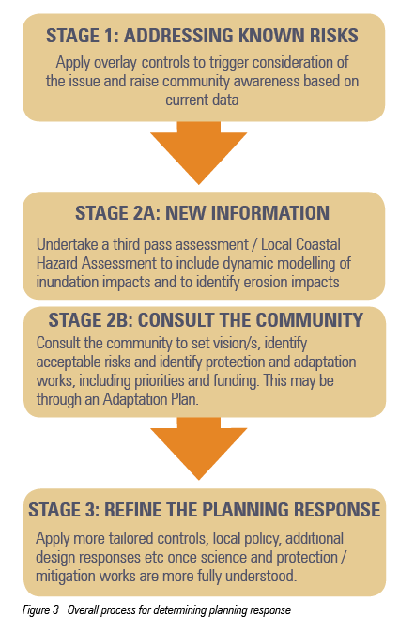
- The report provides strategic support for Amendment C394. In relation to the LSIO 2 the report states: “a new schedule (Schedule 2) to the LSIO is recommended to be introduced into the Greater Geelong Planning Scheme” and “The draft schedule is generally consistent with that proposed in other bayside municipalities as part of this project”.
- Hansen also supports the C394 changes to local policy at Clause 21.05 saying: “It is recommended a local policy is introduced into the planning scheme to support overlay controls for identified hazards” and “That policy is generally consistent with that recommended for other bayside municipalities involved in this project”.
- The Hansen report includes copies of earlier draft C394 maps, schedules and policy changes in its Appendices.

Port Phillip Bay Coastal Hazard Assessment
- The City of Greater Geelong and the Borough of Queenscliffe are 2 of the 10 municipalities that are covered in part by the Port Phillip Bay Coastal Hazard Assessment (PPBCHA), release of final report is scheduled for mid 2020. The PPBCHA is discussed further under section C of this submission.

Precedents in other parts of Victoria
- Amendment C394 is a large amendment for the City due to the number of coastal residential properties affected. The City is showing leadership in moving to implement sea level rise mapping but there are also other parts of the State where the LSIO has been successfully applied.
- Five other planning scheme amendments have been exhibited and subject to Panel reports and subsequently applied the LSIO to areas affected by future sea level rise of 0.8m as follows:
- South Gippsland Amendment C81 - applied the LSIO to areas affected by inland flooding and current and predicted coastal inundation, and introduced supporting policy. The LSIO was applied to areas within the predicted 0.8m sea level rise by 2100
- Bass Coast Amendment C82 - applied the LSIO to areas affected by riverine flooding and predicted coastal inundation, and introduced supporting policy. Initiated by the Bass Coast Shire Council, West Gippsland Catchment Management Authority and Melbourne Water, and was approved following a Panel Hearing in 2014. The exhibited LSIO was applied to areas within the predicted 0.8m sea level rise by 2100.
- Moyne Amendment C54 - implemented Stage 1 of the Port Fairy Floodplain Management Plan, and introduced new flood mapping, through the use of the FO and LSIO, together with a new ‘flooding’ policy and Local Floodplain Development Plan. This amendment was approved in December 2014;
- Moyne Planning Scheme Amendment C60 - implemented the Port Fairy West Structure Plan and applied the LSIO based on the Future Coasts Port Fairy LCHA 2013. This amendment was the subject of a Panel Hearing held in 2016. The LSIO mapping was based on available modelling and was applied to the area within the predicted 0.8m sea level rise. This amendment was approved in October 2016;
- Mornington Peninsula Amendment C216 – affecting Westernport Bay in particular around Hastings. It applied the LSIO based on the Western Port Local Coastal Hazard Assessment mapping at 0.8m sea level rise. It was subject to a Panel report of August 2018 and was approved in March 2019.

IMPLEMENTATION OF LCHA RECOMMENDATIONS
- The Panel has directed that Council provide an explanation as to what, if any, of the recommendations in the Local Coastal Hazard Assessment (LCHA) to reduce uncertainty and fill information gaps have been implemented.
- The LCHA at pages 120 and 121 has both Area wide management recommendations (section 7.3) and Further Coastal Management Studies (section 7.4) (see Appendix 2 of this submission for a copy of these sections).
- The LCHA was prepared approximately 5 years ago and there has been work undertaken since both under the Our Coast umbrella and directly by the Council. Responses to the LCHA recommendations are provided below and have been complied with assistance from officers from Council’s environment and engineering departments.

Area wide management recommendations (7.3)
- Establishment of a thorough monitoring program for the overall study area that is consistent between management organisations, beach profiling will be a key aspect of this. This should be undertaken in conjunction with DELWP.
- The City of Greater Geelong has established a beach monitoring program for a limited number of sites, these are Ramblers Foreshore near Portarlington and Edgewater Beach Clifton Springs. Other coastal land managers within the Greater Geelong municipality such as Bellarine Bayside and Barwon Coast Committees of Management have also established beach monitoring programs. All monitoring programs are undertaken differently and are not coordinated, however all data is in a form that allows for an assessment on how different sections of coast are responding to seasonal conditions and determine annual variations. DELWP have provided some guidance through the development of a beach monitoring guide, however they have not coordinated the process.
- Beach profiling is generally undertaken seasonally at a limited number of sites. Drones collect aerial imagery that is processed using photogrammetric techniques to generate beach profiles and calculate volumes of sand moving along beaches.
- An additional LiDAR dataset has been captured in 2019, however this only covers a section of the study area (see Figure 3 below) and is yet to be used in any assessment of beach morphodynamics or changes to beach profiles and volume calculations.
Figure 3 – Map showing recently acquired LiDAR data
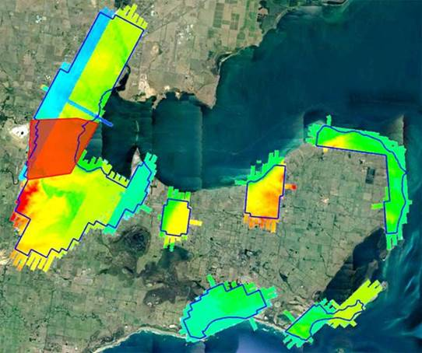
- Aerial photography is captured every 6 months or so, as well as having the ongoing access to Nearmap
- Recommend that this study is updated every 5-10 years to incorporate revised sea-level rise guidance and measured increases, monitor findings to ensure better certainty in the inundation hazard assessments and review and consider coastal management changes where action has been taken and works carried out.
- The City of Greater Geelong and the Borough of Queenscliffe are 2 of the 10 municipalities that are covered in part by the Port Phillip Bay Coastal Hazard Assessment (PPBCHA), release of final report is schedule for mid 2020.
- The PPBCHA will provide new data that will enable a comparison with the extent of the coastal inundation from the Bellarine Peninsula and Corio Bay Coastal Hazard Assessment. The PPBCHA has incorporated revised sea-level rise guidance and measured increases as well as monitoring findings to ensure better certainty in the inundation hazard assessments.
- Further work being undertaken by the City of Greater Geelong and the Borough of Queenscliffe as part of the Coastal Inundation and Catchment Flooding Adaptation Emergency Response Planning project will review and consider coastal inundation where management has changed, action has been taken and works carried out.
- Investigations of groundwater to be undertaken in future assessments.
- The PPBCHA has undertaken further investigations in relation to groundwater, results will be available with the release of final report is schedule for mid 2020.

Further Coastal Management Studies (7.4)
- Compilation of asset registers within the defined hazard areas and investigate the risk to key assets based on likelihood and consequence.
- Following the delivery of the Inundation Report a risk assessment was undertaken to identify the impact on public infrastructure, private property and environmental values under peak water level events (storm tides) and 6 sea-level rise scenarios. This involved compiling asset registers and integrating them with the defined hazard areas to quantify the number, length and area of assets that would be effected. Preliminary investigations were carried out to determine the consequence of these assets being impacted, however further work is required to comprehensively understand impacts to vulnerable communities and local neighbourhoods.
- Determination options to manage and minimise risk and evaluate these options using quadruple bottom line method, considering technical, social, environmental, and economic implications of each to determine prioritised, costed and responsibility stated list of coastal management actions for State and local government as well as local land managers.
- This will be addressed as part of a current project being undertaken by the City of Greater Geelong and the Borough of Queenscliffe, the Coastal Inundation and Catchment Flooding Adaptation Emergency Response Planning project.
- Actions should be compiled into new coastal zone management plans for each area, which will address a wider range of coastal related issues (not just technical) or incorporated into revised versions of the current coastal management plans. Part of the review process should be the revisiting of previous management plan actions to determine which actions have and have not been undertaken and why, their effectiveness, and any implementation issues experienced by local managers. This will aid in informing and guiding future management practices. This is key to effective adaptive management.
- High level coastal management plans have recently been prepared by the Barwon Coast and Bellarine Bayside foreshore committees of management, these plans are in still in draft form and do not go into the detail of determining management options to manage and minimise risk from inundation hazards. It is envisaged that this will be undertaken as part of the master planning process for specific coastal management units. The City of Greater Geelong and the Borough of Queenscliffe are yet to commence the preparation of new coastal management plans for their respective coastal jurisdictions. Existing coastal management plans for the City of Greater Geelong’s jurisdiction were prepared approximately 10 years ago and are considered out of date. It is expected that the City of Greater Geelong and the Borough of Queenscliffe will commence the preparation of new coastal management plans in 2021.

RESPONSE TO ISSUES RAISED IN SUBMISSIONS
- The key issues raised in submissions can be grouped under the following themes:
- Impact on property values
- Insurance costs
- Valuation of land and rates
- Need for coastal protection works
- Floor levels and building heights
- Government agency submissions
- Criticism of technical basis
- Timeline of sea level rise projections
- Requests to remove properties from overlay
- The following is a summary of, and response to, the substantive or key issues raised in submissions. With regard to localised or individual issues (including requests to remove properties from overlay) Council relies on the responses provided in the Council minutes of 26 Nov 2019.

Impact on property values
- Issues raised include: potential reduction in property values because of the overlay; potential impact on the future value, usability and resale of the property; difficultly to obtain financing for future purchases as LSIO will be on Section 32 contract of sale; and higher redevelopment costs due to LSIO requirements.
Response
- As outlined in the “Frequently asked questions” documentation exhibited with this amendment: designation of an area as ‘subject to inundation’ does not cause or change the likelihood of flooding but recognises the existing condition of land and its potential to be inundated in storm tide events and when sea levels rise. The value of any property is determined by the complex interplay of many different factors such as location, streetscape and amenity, and it is difficult to assign what effect if any, the identification of land as liable to flooding may have on the value of a property.
- As stated in Flood Victoria 2018 “Most banks and lending institutions do not account for flood risks when assessing loan applications unless there is a very significant risk of flooding to the property”.
- Whilst the overlay is likely to require floor levels of new buildings to be constructed at a higher level than dwellings outside of a LSIO, the construction costs associated with these requirements are unlikely to be of a significant amount to prohibit future development. It is noted that many properties in the proposed LSIO are currently situated within Special Building Overlays and also Flood Prone Areas under the Building Regulations which require dwellings to be constructed at a higher level than dwellings outside of Flood Prone Areas.

Insurance costs
- Submissions identified the potential increase in insurance premiums or difficulty to obtain insurance coverage because of properties now being within the LSIO.
Response
- Insurance premiums are likely to be based upon the latest available flood studies rather than Planning Scheme controls. The insurance industry has its own National Flood database where this information is obtained from.

Valuation of land and rates
- Submissions linked a reduction in property values due to the amendment with impacts upon Council rates and propose that properties within the LSIO be revalued with rate reductions in line with reduced property values.
Response
- In previous instances where an independent planning panel has been asked to consider and report on submissions opposing the application of a flooding overlay, the issue of property devaluation has been considered and rejected by the panel (Reference: Stonington, 2018 Amendment C221 FAQs )
- Council rates are based upon the Capital Improved Value (CIV) of each property, with the valuation determined by the Valuer General of Victoria through contract valuers done in line with valuation best practice. Any changes in value are based upon market sales and any valuation changes are meant to reflect that.

Need for coastal protection works
- Submissions state that the planning scheme alone will not result reduce the impact of possible inundation. Submitters want mitigation action and protective works such as new sea walls and other defences.
Response
- The proposed introduction of the LSIO intends to reduce the impact of possible inundation by requiring planning permission for certain buildings and works on properties that are subject to inundation and reducing the potential risk associated with sea level rise by the year 2100.
- The Our Coast project website does include descriptions of potential adaptation measures that could protect parts of the Bellarine and Corio Bay from sea level rise with examples including:
- Constructing a higher seawall at Ocean Grove
- Raising seaside roads at Portarlington
- Raising the railway line at Point Lonsdale
- Back flow valves on stormwater outlets at Barwon Heads.
- It is recognised that hard infrastructure (seawalls, etc.) could significantly change the nature of the coast (including amenity and access) and would not occur without significant community consultation.
- The aspect of Our Coast that is ready for implementation is the Local Coastal Hazard Assessment (LCHA) prepared by Cardno and the associated flood modelling and mapping of different sea level rise and storm event scenarios.
- This is the aspect that Amendment C394 is seeking to implement. In some cases the overlay mapping does take into account potential adaptation measures.
- For instance, the LCHA mapping showed isolated pockets of land some distance from the coast at Barwon Heads (around Hitchcock Ave) as being inundated. This is due to sea water backing up the stormwater outlets under extreme tides and storm surge.
- However, it is anticipated that backflow valves on the stormwater outlets can be installed in the future to address this issue and as a result the overlay is not being applied to these properties.

Floor levels and building heights
- Submissions include concerns that the LSIO will requiring floor levels of buildings to be higher floor to accommodate potential inundation and that existing planning controls should be amended to accommodate any change. For instance, as dwellings may need an additional floor height of 0.8 metres the maximum building height (roof) of any building under other overlays should increase by 0.8 metres.
Response
- The proposed change to controls would require an amendment to overlays such as the DDO14 and DDO19 to increase the maximum building height with which no planning permit would be required from 7.5 metres in height above natural ground level to 8.3 metres.
- This change is not supported and is beyond the scope of the amendment C394.
- However, while overlays such as DDO14 do not allow additional building height to be added to take into account increased floor levels, this issue is provided for in the residential zones. For instance the General Residential Zone has the following provision at clause 32.08-10:
“Building height if land is subject to inundation
If the land is in a Special Building Overlay, Land Subject to Inundation Overlay or is land liable to inundation the maximum building height specified in the zone or schedule to the zone is the vertical distance from the minimum floor level determined by the relevant drainage authority or floodplain management authority to the roof or parapet at any point.”
Barwon Water
- Submitter 3 (Barwon Water) recommended support of the proposed amendment with minor changes.
Response
- The suggested amendments sought by Barwon Water have been considered and no changes are recommended as a result. There are already a wide range of exemption under the state LSIO clause (44.04) and the LSIO schedule.
Corangamite Catchment Management Authority
- Submitter 10, the Corangamite Catchment Management Authority (CCMA) states that it is supportive of Amendment C394 and will work closely with Council and other key stakeholders to ensure orderly planning outcomes are achieved.
Response
- The supportive comments of the CCMA are significant, particularly as it will be a referral authority for permit applications triggered by the LSIO2. Council officers have worked closely with the CCMA and post exhibition conducted a joint site tour of areas on the Bellarine Peninsula affected by the overlay.
- The CCMA is developing guidelines which will specify how they will respond to different classes of application and set floor levels, these are described later in this Part B submission.
Department of Environment, Land, Water and Planning
- Submitter 15 (Department of Environment, Land, Water and Planning (DELWP)) supports the amendment and suggests some minor wording improvements.
Response
- The supportive comments from DELWP are welcomed by the City and the proposed suggested amendments sought are supported in full and discussed further in Section F of this Part B submission.

Criticism of technical basis
- Submissions questioned the technical information in the Our Coast Report, the methods used and the accuracy of this information and the meaning of inundation.
Response
- The data and accuracy of the information contained within the Bellarine Peninsula – Corio Bay Local Coastal Hazard Assessment – Inundation Report 2015 (the “Our Coast” report) is known as the third pass assessment with previous assessments undertaken by the CSIRO for the Commonwealth and State Governments starting in 2009.
- The Our Coast Report is considered to provide suitable informed and well researched information about the extent of coastal hazards and the impacts on the coastal environments subsequent risk and mitigation assessments.
- The information contained with the report has provided the City of Greater Geelong with sufficient information to provide the policy support required for the proposed implementation of the LSIO to affected properties.
- The amendment is based on modelling prepared by expert consultants that reflects state policy requirements. The process of measurements used within the Our Coast Report and survey heights used to perform this study have been undertaken within a tolerance that is an acceptable best practice used within the engineering industry.

Timing of sea level rise projections
- Submissions raised issues with the 2100 timeline of the projected impact of sea level rise and inundation.

Response
- The Intergovernmental Panel on Climate Change Fourth Assessment Report 2007 (IPCC) projected sea-levels will rise by around 0.8 metres by the end of the century, and that larger rises cannot be ruled out. On the basis of the IPCC report, Victorian Government policy requires all councils to plan for a 0.8 metre sea level rise by the year 2100.
- According to City of Greater Geelong Planning Response to Sea Level Rise (2019) prepared by Hansen Partnership for the MAV, the IPCC Fifth Assessment Report (2014) presented a range of projections of global sea level rise to 2100. Based on current emissions, the world is presently on track to meet the higher scenario identified in that report, which ranges from an increase of 0.52m to 0.98m. The IPCC is due to issue a Sixth Assessment Report in 2021/22, which will consider more fully the impacts of climate change on the world’s oceans (a separate paper is being prepared, to be released in 2019).
- In addition to the above, the Our Coast Report recommended that “this study is updated every 5-10 years to incorporate revised sea-level rise guidance and measured increases, monitoring findings to ensure better certainty in the inundation hazard assessments and review and consider coastal management changes where action has been taken and works carried out”.
- The primary role of the LSIO is to ensure buildings and works respond to existing and future inundation risks. Given a 50 year ‘Normal’ design life for new buildings (Handbook: Durability in Buildings including Plumbing Installations, ABCB, 2015) it is appropriate to consider the longer timeframe. Design responses can be varied depending on the scope of works proposed, e.g. lower floor levels for non-habitable/non-critical/temporary buildings.
- Modelling of natural hazards is a dynamic process and better information typically becomes available as time goes on. This does not mean the modelling work to date is invalid and should be disregarded.

RESPONSE TO EXPERT EVIDENCE
- Council adopts the evidence of Dr Provis. It provides an excellent summary of the inundation mapping and LCHA that is the underlying basis of the Amendment.
- Dr Provis outlines the project uncertainties and how these were overcome in section 2.4 of this report.
- The following statement by Dr Provis at p.8 of this evidence describes the uncertainty which is acknowledged by Council: “This type of assessment uses the best scientific practice to produce the best outcomes possible with the information available. The results are fit for a defined purpose, but are not to a level of detail to facilitate detailed design. The purpose of this study is to inform strategic flood and erosion management decisions and provide an insight into what may happen in future. The LSIO2 is an appropriate use, however the application of the LSIO2 must take account of these uncertainties.”
- Dr Provis at section 4. Other Considerations provides comments on the use of the LSIO for planning for coastal inundation. He describes imposing the LSIO2 “as very conservative and the risk of inundation is well below the 1% annual exceedance probability. This factor needs to be considered in the application of the LSIO 2.” (p.13)
- Council acknowledges that this is a conservative approach however it is the approach recommended by State government and previous planning panels. Dr Provis and this Panel can also take some comfort from the approach that the CCMA will be taking when providing advice on permit applications triggered by the LSIO2 (if or when it becomes part of the planning scheme). This approach is to be very conservative and stringent with greenfield sites and proposals that seek intensification but more nuanced and less stringent (in terms of floor levels) for infill sites in existing residential and commercial areas.
- A table from the CCMA’s submission to be presented later in this Panel hearing is provided below (with the permission of Dr Taylor from the CCMA).

Table 1. Summary of assessment criteria under proposed LSIO2 overlay (from CCMA)
Development Type | LSIO2 assessment criteria once amendment is implemented  CCMA
 | Minimum Flood and Floor Level Assessment Criteria | Minimum Access Depth Assessment Criteria (maximum allowable depth = 0.3m)
(i) Intensification in existing (urban) residential areas and Greenfield areas | 1% AEP storm surge flood level with 0.8m sea level rise  + 0.3m freeboard | 1% AEP storm surge flood level with 0.8m sea level rise
(ii) Single/replacement dwelling/commercial building in existing residential area | Current 1% AEP + 0.7m freeboard  (freeboard includes 0.4m sea level rise based on 50 year timeframe estimate for building life span, with 0.3m freeboard) | Current 1% AEP storm surge flood level

- Dr Provis in expressing his reservations about the LSIO, which Council acknowledges is not a perfect fit for coastal inundation, states at p.16 “I believe the risks associated with coastal inundation and coastal erosion would be better dealt with by means of a separate overlay, for example a “Coastal Management Overlay””.
- Council agrees that it would be best practice if the State Government were to provide a specific planning tool such as suggested by Dr Provis to deal with sea level rise and the associated coastal inundation and hazard. However, it is beyond the scope of this Amendment to seek changes to the Victoria Planning Provisions.
- Such an approach was recommended by Coastal Climate Change Advisory Committee in its 2010 report which recommended “a new Coastal Hazard Overlay (CHO) should be developed to identify and communicate coastal risk and hazard to 2100…” However, in 2012 the Response from the Minister for Planning was not supportive – see Action 7.

FURTHER CHANGES IN RESPONSE TO EXPERT EVIDENCE OR SUBMISSIONS
- As referred to in the Part A submission Council accepts the DELWP changes (as below) to the LSIO2 schedule and a marked-up version of the schedule is in Appendix 3.
- At Section 3.0 of the proposed LSIO2 Schedule relating to exemptions, DELWP suggests new wording: Works that have been granted consent under the Marine and Coastal Act 2018 or the Crown Land (Reserves) Act 1978 and are conducted by a Public Land Manager or Committee of Management appointed under the Crown Land (Reserves) Act 1978.
- The first point to Section 5 of the proposed LSIO2 Schedule relating to decision guidelines be amended to read as follows: The views of the relevant Catchment Management Authority.

CONCLUSION
- Council reiterates its opening submission that the Amendment is well founded in planning policy, is based on the best available scientific research and evidence and has not been seriously challenged by affected parties. As has been demonstrated the Amendment is well supported by the two key agencies being DELWP and the CCMA.
- The Amendment is an important step forward by providing a land use planning response to the impact of climate change on the coastline of the Bellarine Peninsula and Corio Bay. On this basis, we seek the Panel’s support for the Amendment.

APPENDICES

Appendix 1 – Planning Response to Sea Level Rise (Extract from Hansen/ MAV 2019)
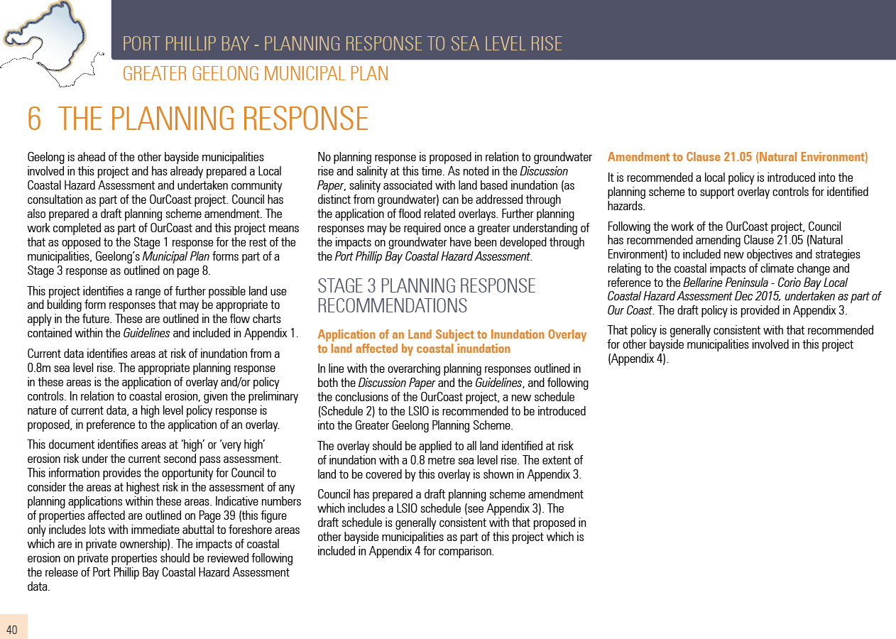

Appendix 2 – Extracts from LCHA re Further Work
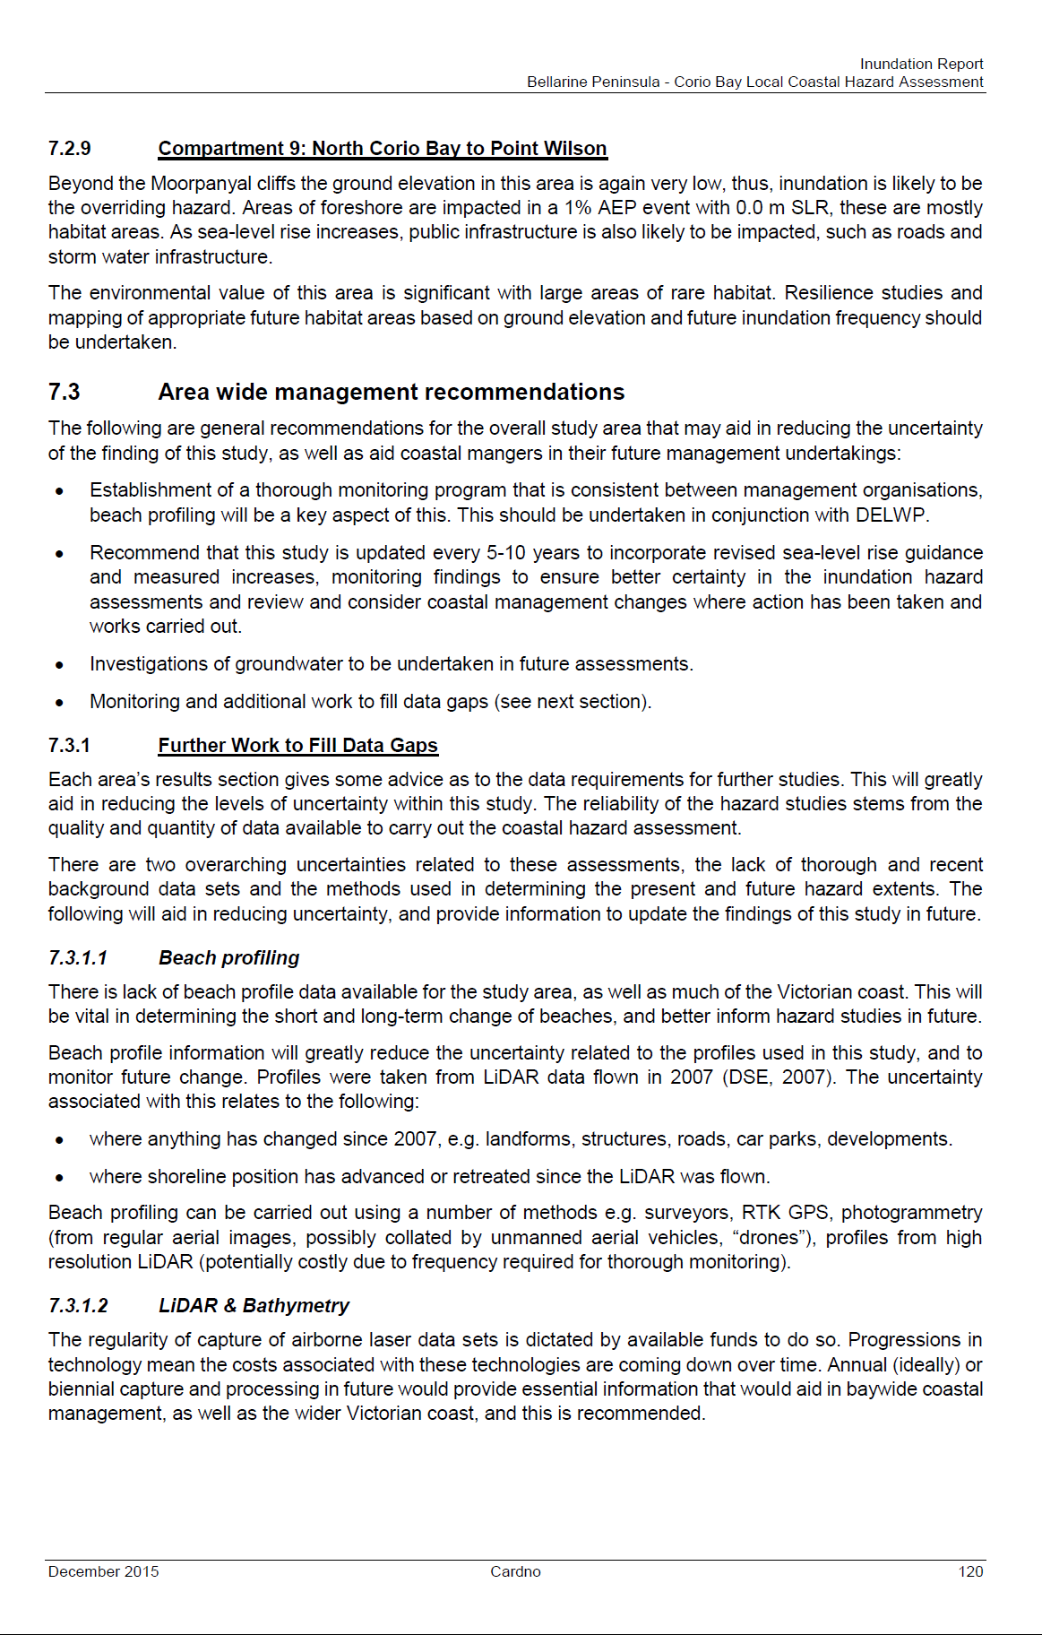
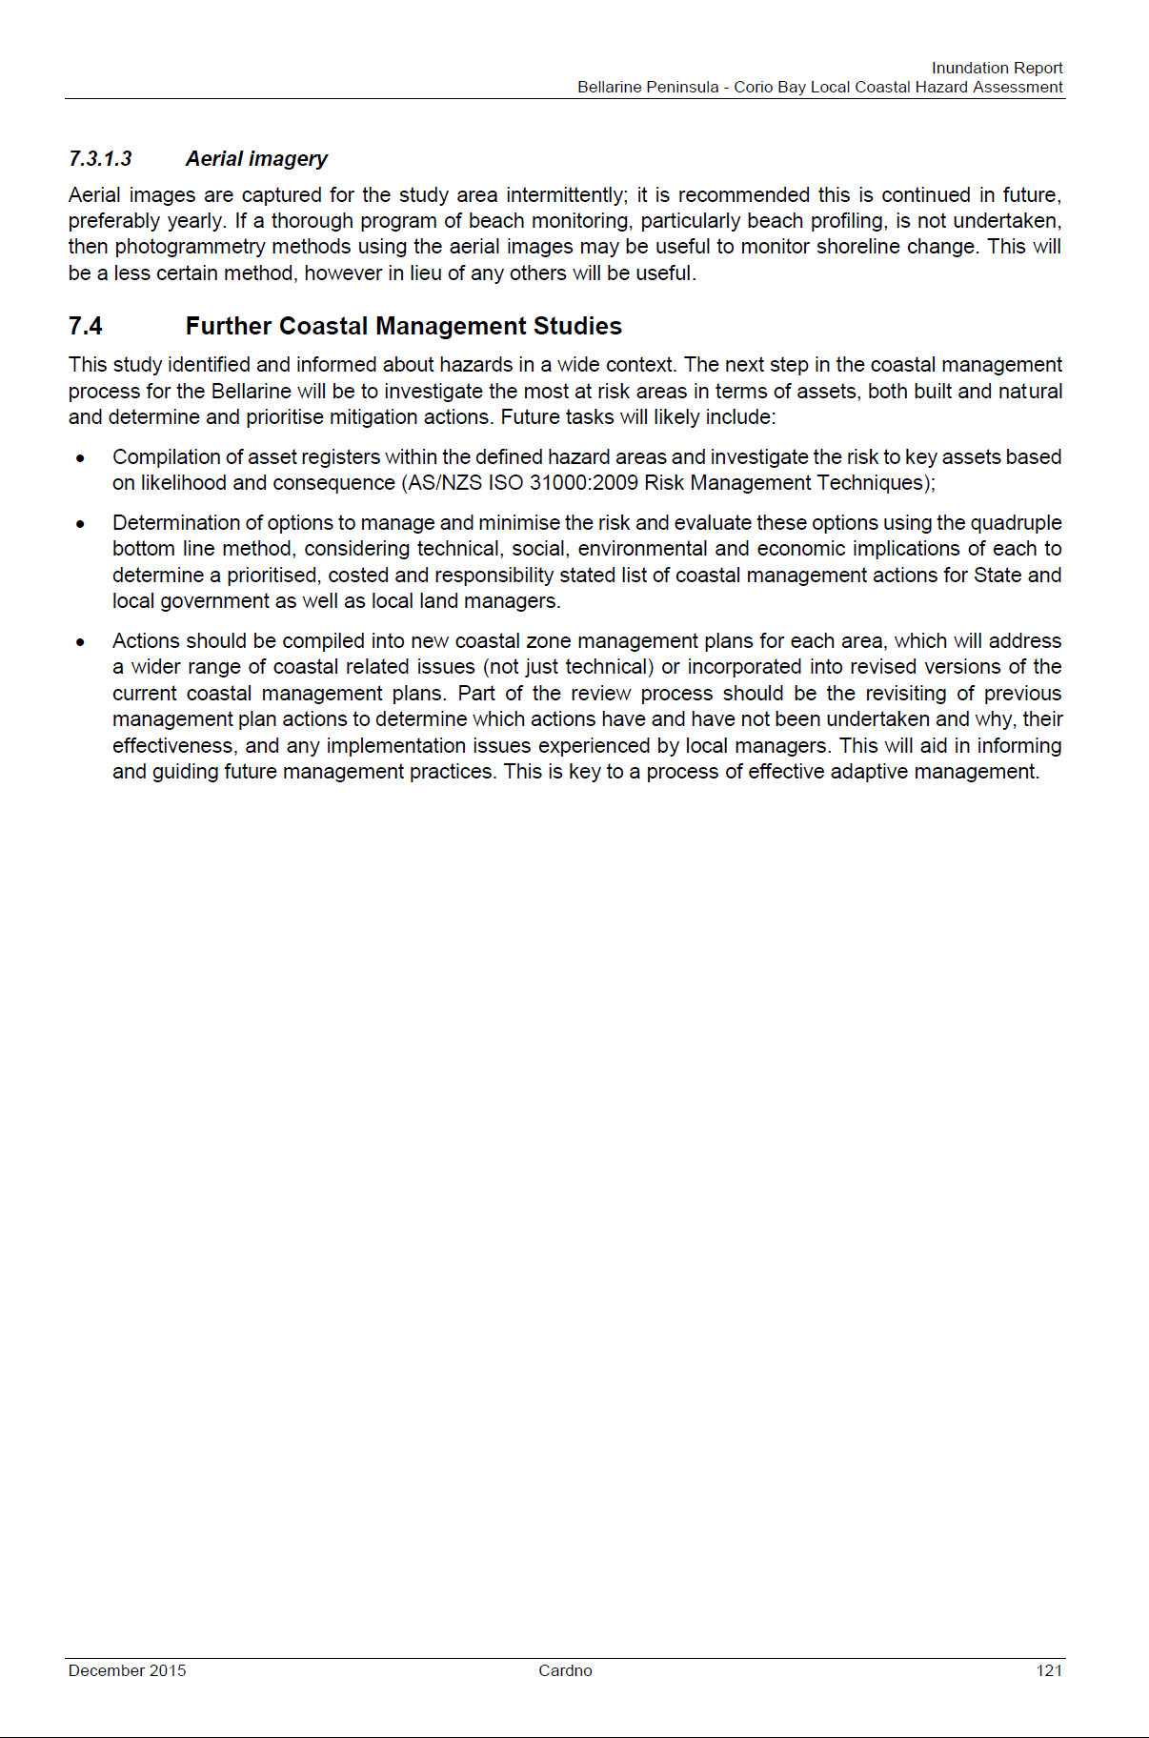

Appendix 3 – Revised LSIO2 Schedule
