11.03
31/07/2018
VC148

PLANNING FOR PLACES

11.03-1S
03/02/2022
VC199

Activity centres
Objective
To encourage the concentration of major retail, residential, commercial, administrative, entertainment and cultural developments into activity centres that are highly accessible to the community.
Strategies
Build up activity centres as a focus for high-quality development, activity and living by developing a network of activity centres that:
Comprises a range of centres that differ in size and function.
Is a focus for business, shopping, working, leisure and community facilities. Provides different types of housing, including forms of higher density housing. Is connected by transport.
Maximises choices in services, employment and social interaction.
Support the role and function of each centre in the context of its classification, the policies for housing intensification, and development of the public transport network.
Undertake strategic planning for the use and development of land in and around activity centres. Give clear direction on preferred locations for investment.
Encourage a diversity of housing types at higher densities in and around activity centres.
Reduce the number of private motorised trips by concentrating activities that generate high numbers of (non-freight) trips in highly accessible activity centres.
Improve access by walking, cycling and public transport to services and facilities.
Support the continued growth and diversification of activity centres to give communities access to a wide range of goods and services, provide local employment and support local economies.
Encourage economic activity and business synergies.
Improve the social, economic and environmental performance and amenity of activity centres.
Policy documents
Consider as relevant:
Urban Design Guidelines for Victoria (Department of Environment, Land, Water and Planning, 2017)
Apartment Design Guidelines for Victoria (Department of Environment, Land, Water and Planning, 2021)
Precinct Structure Planning Guidelines (Victorian Planning Authority, 2021)

11.03-1L
07/07/2022
C417ggee

Activity centres in Greater Geelong
Objectives
To support the role and function of centres in the Geelong Retail Centre Hierarchy. To support continued diversification of retail centres over time.
General strategies
Encourage a mix of retail, office, cafes, higher density housing, education and community facilities to locate within centres, but particularly in Regional (Central Geelong), Sub-regional and Town Centres.
Support accommodation uses above ground level floor space in retail and activity centres subject to provision of parking and access requirements to meet the needs of users.
Direct entertainment and cultural activities to Central Geelong and support local events in other centres.
Encourage the redevelopment of car parking areas for commercial and residential uses where adequate car parking to meet the needs of existing and future uses can be achieved.
Support increased intensity and vertical growth of centres to encourage expansion and to reduce the need to develop new centres.
Retail hierarchy strategies
Direct new retail development to existing centres, consistent with the role and function described in the Geelong Retail Centre Hierarchy at Clause 02.03-1.
Support the development of discount department stores in Central Geelong and sub-regional centres over lower order centres.
Encourage development that supports a diversity of retail forms across the hierarchy.
Ensure planned centres in growth area are consistent with the role, function, size and type of centre as set out in the Geelong Retail Centre Hierarchy at Clause 02.03-1.
Residential Growth Zone land strategies
Ensure that retail use and development on land within the Residential Growth Zone: Has a functional relationship with an existing activity centre.
Is designed and sited to operate without amenity impacts to neighbouring residents.
Commercial and industrial land strategies
Encourage retail use and development in industrial areas only if associated with an industrial use occurring on the land or where it will meet the needs of people employed in the area.
Encourage use and development that will provide for strategic employment land.
Ensure that use or development for a new or expanded supermarket-based centre within the Commercial 2 Zone or Industrial 3 Zone:
Does not have a significant economic impact on a nearby centre(s) identified within the Geelong Retail Centre Hierarchy at Clause 02.03-1.
Provides a net community benefit.
Restricted retail uses strategies
Direct restricted retail use and development to nominated restricted retail precincts as identified in the Geelong Retail Centre Hierarchy at Clause 02.03-1.

Support the development of smaller scale, higher density restricted retail uses such as homewares within activity centres.
Policy document
Consider as relevant:
City of Greater Geelong Retail Strategy 2020-2036 (City of Greater Geelong and SGS Economics and Planning, August 2020)

11.03-2S
04/05/2022
VC210

Growth areas
Objective
To locate urban growth close to transport corridors and services and provide efficient and effective infrastructure to create sustainability benefits while protecting primary production, major sources of raw materials and valued environmental areas.
Strategies
Concentrate urban expansion into growth areas that are served by high-capacity public transport. Implement the strategic directions in the Growth Area Framework Plans.
Encourage average overall residential densities in the growth areas of a minimum of 15 dwellings per net developable hectare, and over time, seek an overall increase in residential densities to more than 20 dwellings per net developable hectare.
Deliver timely and adequate provision of public transport and local and regional infrastructure and services, in line with a preferred sequence of land release.
Provide for significant amounts of local employment opportunities and in some areas, provide large scale industrial or other more regional employment generators.
Create a network of mixed-use activity centres that are high quality, well designed and create a sense of place.
Provide a diversity of housing type and distribution.
Retain unique characteristics of established areas impacted by growth.
Protect and manage natural resources and areas of heritage, cultural and environmental significance.
Create well planned, easy to maintain and safe streets and neighbourhoods that reduce opportunities for crime, improve perceptions of safety and increase levels of community participation.
Develop Growth Area Framework Plans that will: Include objectives for each growth area.
Identify the long term pattern of urban growth.
Identify the location of broad urban development types, for example activity centre, residential, employment, freight centres and mixed use employment.
Identify the boundaries of individual communities, landscape values and, as appropriate, the need for discrete urban breaks and how land uses in these breaks will be managed.
Identify transport networks and options for investigation, such as future railway lines and stations, freight activity centres, freeways and arterial roads.
Identify the location of open space to be retained for recreation, and/or biodiversity protection and/or flood risk reduction purposes guided and directed by regional biodiversity conservation strategies.
Show significant waterways as opportunities for creating linear trails, along with areas required to be retained for biodiversity protection and/or flood risk reduction purposes.
Identify appropriate uses for constrained areas, including quarry buffers.
Develop precinct structure plans consistent with the Precinct Structure Planning Guidelines
(Victorian Planning Authority, 2021) approved by the Minister for Planning to: Establish a sense of place and community.
Create greater housing choice, diversity and affordable places to live. Create highly accessible and vibrant activity centres.

Provide for local employment and business activity. Provide better transport choices.
Respond to climate change and increase environmental sustainability. Deliver accessible, integrated and adaptable community infrastructure.
Policy documents
Consider as relevant:
Any applicable Growth Area Framework Plans (Department of Sustainability and Environment, 2006)
Precinct Structure Planning Guidelines (Victorian Planning Authority, 2021)
Ministerial Direction No. 12 – Urban Growth Areas

11.03-3S
31/07/2018
VC148

Peri-urban areas
Objective
To manage growth in peri-urban areas to protect and enhance their identified valued attributes.
Strategies
Identify and protect areas that are strategically important for the environment, biodiversity, landscape, open space, water, agriculture, energy, recreation, tourism, environment, cultural heritage, infrastructure, extractive and other natural resources.
Provide for development in established settlements that have capacity for growth having regard to complex ecosystems, landscapes, agricultural and recreational activities including in Warragul-Drouin, Bacchus Marsh, Torquay-Jan Juc, Gisborne, Kyneton, Wonthaggi, Kilmore, Broadford, Seymour and Ballan and other towns identified by Regional Growth Plans as having potential for growth.
Establish growth boundaries for peri-urban towns to avoid urban sprawl and protect agricultural land and environmental assets.
Enhance the character, identity, attractiveness and amenity of peri-urban towns. Prevent dispersed settlement and provide for non-urban breaks between urban areas.
Ensure development is linked to the timely and viable provision of physical and social infrastructure. Improve connections to regional and metropolitan transport services.

11.03-4S
20/03/2023
VC229

Coastal settlement
Objective
To plan for sustainable coastal development.
Strategies
Plan and manage coastal population growth and increased visitation so that impacts do not cause unsustainable use of coastal resources.
Support a network of diverse coastal settlements that provide for a broad range of housing types, economic opportunities and services.
Identify a clear settlement boundary around coastal settlements to ensure that growth in coastal areas is planned and coastal values are protected. Where no settlement boundary is identified, the extent of a settlement is defined by the extent of existing urban zoned land and any land identified on a plan in the planning scheme for future urban settlement.
Minimise linear urban sprawl along the coastal edge and ribbon development in rural landscapes. Protect areas between settlements for non-urban use.
Limit development in identified coastal hazard areas, on ridgelines, primary coastal dune systems, shorelines of estuaries, wetlands and low-lying coastal areas, or where coastal processes may be detrimentally impacted.
Encourage the restructure of old and inappropriate subdivisions to reduce development impacts on the environment.
Ensure a sustainable water supply, stormwater management and sewerage treatment for all development.
Minimise the quantity and enhance the quality of stormwater discharge from new development into the ocean, bays and estuaries.
Prevent the development of new residential canal estates.
Policy documents
Consider as relevant:
G21 Regional Growth Plan (Geelong Region Alliance, 2013)
Gippsland Regional Growth Plan (Victorian Government, 2014)
Great South Coast Regional Growth Plan (Victorian Government, 2014)
Marine and Coastal Policy (Department of Environment, Land, Water and Planning, 2020)
Marine and Coastal Strategy (Department of Environment, Land, Water and Planning, 2022)
Siting and Design Guidelines for Structures on the Victorian Coast (Department of Environment, Land, Water and Planning, 2020)

11.03-5S
30/04/2021
VC185

Distinctive areas and landscapes
Objective
To recognise the importance of distinctive areas and landscapes to the people of Victoria and protect and enhance the valued attributes of identified or declared distinctive areas and landscapes.
Strategies
Recognise the unique features and special characteristics of these areas and landscapes.
Implement the strategic directions of approved Localised Planning Statements and Statements of Planning Policy.
Integrate policy development, implementation and decision-making for declared areas under Statements of Planning policy.
Recognise the important role these areas play in the state as tourist destinations. Protect the identified key values and activities of these areas.
Enhance conservation of the environment, including the unique habitats, ecosystems and biodiversity of these areas.
Support use and development where it enhances the valued characteristics of these areas.
Avoid use and development that could undermine the long-term natural or non-urban use of land in these areas.
Protect areas that are important for food production.
Policy documents
Consider as relevant:
Bellarine Peninsula Localised Planning Statement (Victorian Government, 2015) Macedon Ranges Statement of Planning Policy (Victorian Government, 2019) Mornington Peninsula Localised Planning Statement (Victorian Government, 2014) Yarra Ranges Localised Planning Statement (Victorian Government, 2017)

11.03-5R
20/03/2023
VC229

The Great Ocean Road region
Objective
To manage the sustainable development of the Great Ocean Road region.
Strategies
Protect public land and parks and identified significant landscapes in the Great Ocean Road region. Ensure development responds to the identified landscape character of the area.
Manage the growth of towns by:
Respecting the character of coastal towns and promoting best practice design for new development.
Directing urban growth to strategically identified areas.
Manage the impact of development on catchments and coastal areas.
Manage the impact of development on the environmental and cultural values of the area. Improve the management of access and transport by:
Managing the Great Ocean Road for tourism and regional access. Enhancing the safety and travelling experience of the Great Ocean Road.
Improving the safety and operational performance of the inland routes from the Princes Highway to the Great Ocean Road.
Providing travel choices to and in the region.
Encourage sustainable tourism and resource use by:
Developing a network of tourism opportunities throughout the region.
Supporting tourism activities that provide environmental, economic and social benefits. Supporting the land use and transport needs of key regional industries including tourism. Using natural resources with care.
Policy documents
Consider as relevant:
Marine and Coastal Policy (Department of Environment, Land, Water and Planning, 2020)
Marine and Coastal Strategy (Department of Environment, Land, Water and Planning, 2022)
The Great Ocean Road Region Landscape Assessment Study (Department of Sustainability and Environment, 2003)
The Great Ocean Road Region - A Land Use and Transport Strategy (Department of Sustainability and Environment, 2004)

11.03-6S
31/07/2018
VC148

Regional and local places
Objective
To facilitate integrated place-based planning.
Strategies
Integrate relevant planning considerations to provide specific direction for the planning of sites, places, neighbourhoods and towns.
Consider the distinctive characteristics and needs of regional and local places in planning for future land use and development.

11.03-6L-01
13/06/2025
C478ggee

Bellarine Peninsula
Policy application
This policy applies to land shown on the following maps forming part of this clause: St Leonards Structure Plan Map
Portarlington Structure Plan Map Indented Head Structure Plan Map Ocean Grove Structure Plan Map Leopold Structure Plan Map Barwon Heads Structure Plan Map
Drysdale/Clifton Springs Structure Plan Map Jetty Road Urban Growth Plan Map
Point Lonsdale Structure Plan Map
Objectives
To ensure development responds to the identity and preferred character of the individual township in which it is located.
To provide attractive and sustainable industrial, commercial, retail, agricultural and tourism development in designated locations, to service the wider Bellarine community.
General strategies
Support the district towns of Ocean Grove, Drysdale/Clifton Springs and Leopold to fulfil their role as service hubs for the Bellarine Peninsula.
Ensure all other townships provide retail, commercial and community uses and facilities that serve the daily needs of the community.
Retain the land surrounding each town as rural breaks and for its agricultural and scenic values.
St Leonards strategies
Support a mix of retail, commercial, community and entertainment uses within the town centre. Encourage development that respects the coastal landscape setting of St Leonards by:
Providing reasonable sharing of views of the coast and foreshore.
Promoting contemporary design that reflects the existing scale, setbacks, spacing, forms and materials of the buildings in the locality.
Ensuring that development allows for the protection of significant vegetation or planting around buildings and has minimal impact on roadside vegetation.
Support the on-going management, enhancement and sensitive development of the foreshore, Salt Lagoon Wildlife Reserve and Edwards Point State Faunal Reserve.
Protect the scenic qualities of Murradoc Hill and Swan Bay.
Support the development of a focal building, comprising retail and tourist related activities, at the south west corner of Murradoc and Bluff Roads.
Support the development of Growth Areas 1 and 2 identified on the St Leonards Structure Plan map.
Facilitate development of a community facility including an Early Years Learning Centre, preferably at 1345 Murradoc Road.
Integrate the town centre and pier-foreshore area.

Portarlington strategies
Support the on-going management, enhancement and sensitive development of the foreshore, including a place making project for the main activity node, Point Richards Flora and Fauna Reserve.
Encourage development that respects the coastal landscape setting of Portarlington by:
Providing reasonable sharing of views of the coast and foreshore, where a view has been identified in an overlay.
Promoting contemporary design that reflects the existing scale, setbacks, spacing, forms and materials of the buildings in the locality.
Ensuring that development allows for the protection of significant vegetation or planting around buildings and has minimal impact on roadside vegetation.
Support the establishment of a Portarlington Community Hub. Support the redevelopment of the Country Fire Authority fire station.
Support the integration of the Portarlington town centre and pier-foreshore area. Support the development of the development opportunity sites including:
Development of a focal building at 22-34 Newcombe Street, Portarlington.
Redevelopment of the rear of 40-42 Newcombe Street in a manner that is sympathetic to and maintains the heritage context of the site.
Redevelopment of land between Newcombe Street, Fenwick Street, Harding Street and Brown Street to improve pedestrian connectivity by creating a two-way rear lane system and additional shop front activation.
Support development in the Portarlington town centre incorporating accommodation uses above ground level retail floor space, where such development meets all parking and access requirements.
Support the use and development of 33-41 Mercer Street, Portarlington for aged care living.
Indented Head strategies
Encourage development that respects the coastal landscape setting of Indented Head, by:
Providing reasonable sharing of views of the coast and foreshore, where a view has been identified in an overlay.
Promoting contemporary design that reflects the existing scale, setbacks, spacing, forms and materials of the buildings in the locality.
Ensuring that development allows for the protection of significant vegetation or planting around buildings and has minimal impact on roadside vegetation.
Ocean Grove strategies
Contain urban development within the defined settlement boundary identified on the Ocean Grove Structure Plan map.
Encourage development that respects the coastal landscape setting of Ocean Grove, by: Providing reasonable sharing of views of the coast and foreshore.
Promoting contemporary design that reflects the existing scale, setbacks, spacing, forms and materials of the buildings in the locality.
Ensuring that development allows for the protection of significant trees or planting around buildings and has minimal impact on roadside vegetation.
Support the continued development of the north-east growth area as shown on the Structure Plan map.

Encourage a range of accommodation and housing options, including aged care within and adjacent to the Town Centre and other activity centres.
Ensure development avoids detrimental impacts on environmental assets including the coast, Buckley Park Foreshore Reserve, Goandra Estate, Ocean Grove Nature Reserve, Begola Wetlands, Barwon River/Lake Conneware and the Lake Victoria Wetlands.
Support the Town Centre as the primary retail centre for Ocean Grove by providing for a range of retail, business and accommodation uses.
Ensure that the supply of car parking in the Town Centre increases commensurate with parking demands from development.
Preserve The Terrace as the potential long-term arterial route through the Town Centre.
Support the development of a new Neighbourhood Activity Centre, including community uses, in the north-east growth area adjacent to Grubb Road.
Support the development of the restricted retail and industrial precincts within the north-east growth area.
Support the development of a strategic footpath network for the town that provides permeable and safe routes to key destinations and services.
Encourage developments to assist in the establishment of a safe bicycle-pedestrian path network around the town connecting the foreshore, river, nature reserve, and Grubb, Banks and Bonnyvale Roads as shown on the Structure Plan map.
Encourage development to contribute to the improvement of open spaces and key pedestrian links.
Encourage a range of appropriately scaled and located tourism accommodation and activities, including opportunities for revitalisation of existing uses.
Support further development of existing caravan parks and accommodation uses in residential areas, particularly those close to the beach and river, to provide a broader range of accommodation type and mix.
Encourage a range of appropriately scaled tourism related activities on the rural periphery of the town that are complementary to the environmental and rural setting.
Support the duplication of Grubb Road in a manner that preserves significant roadside vegetation, provides an attractive town entry, safe crossing points, pedestrian/cycle paths and undergrounding of powerlines.
Support the provision of community and social infrastructure commensurate with population growth.
Leopold strategies
Support Leopold as a Sub-Regional Retail Activity Centre for the Bellarine Peninsula, that also provides local community, recreational and employment facilities to Leopold’s residents.
Retain Leopold as an ‘urban island’, supporting urban growth contained within the settlement boundary to preserve the surrounding rural hinterland.
Support the development of the Ash Road Growth Area and other areas identified for residential development on the Leopold Structure Plan map.
Support increased housing densities around the Sub-Regional Retail Activity Centre and the neighbourhood shopping centres at Ash Road and Dorothy Street.
Encourage the northerly expansion of the Sub-Regional Retail Activity Centre, ensuring any development integrates with the existing centre and surrounding community facilities, and enhances its appearance and functionality.
Support the local convenience role of the Ash Road and Dorothy Street neighbourhood shopping centres, whilst restricting any future expansion of these centres.

Support the development of Council’s Kensington Road Community Hub to provide a wide range of community, health, education and civic services/facilities.
Encourage the creation of an additional local mixed-use centre on the south east corner of Bellarine Highway and Melaluka Road. Any redevelopment of this site could accommodate restaurants,
convenience shops, offices and residential development.
Provide public open space in residential areas to cater for the passive and active recreation needs of the community.
Facilitate an improved transport network that includes better traffic movements, pedestrian and cyclist linkages and public transport options.
Protect environmentally sensitive areas including Lake Connewarre and Reedy Lake from detrimental impacts of development.
Barwon Heads strategies
Maintain a compact urban form and avoid outward sprawl by ensuring that urban development does not occur outside of the defined settlement boundary shown on the Barwon Heads Structure Plan map.
Protect the unique character of Barwon Heads as a coastal village located within a sensitive environment and significant landscape setting.
Protect the very low density residential character of the Warrenbeen Court area to ensure that development has minimal impact on the indigenous vegetation and landscape character of the area.
Reinforce the Hitchcock Avenue shopping centre as the focus of retail activity in Barwon Heads.
Restrict new retail development within the existing town centre and discourage the use of land for industry and warehouse uses.
Support the development of Stage 3 of the 13th Beach Resort as a focus for golf that excludes residential development and provides net environmental benefits.
Facilitate the upgrading of the Barwon Heads Village Park and foreshore reserves in accordance with established master plans.
Protect existing street trees and where possible informal landscaping in streets.
Support development of tourist accommodation around the Barwon Heads town centre, including improvement of accommodation diversity.
Drysdale/Clifton Springs strategies
Contain urban development within the defined settlement boundary identified on the Drysdale/Clifton Springs Structure Plan map.
Support the development of the Jetty Road Urban Growth Area and other areas identified for residential development on the Structure Plan map.
Reinforce the Drysdale town centre as the primary retail centre including the development of an additional supermarket on the south side of Murradoc Road.
Provide for the expansion of the Drysdale town centre to the east along Murradoc Road.
Locate future service business or industrial development in the identified precinct along Murradoc Road extending to the Drysdale Bypass.
Design development opposite or close to the Drysdale Bypass to minimise back fencing as viewed from the Bypass.
Co-locate and integrate future education, community and recreation facilities to enhance their accessibility and to maximise joint use wherever possible.
Develop the Council owned Palmerston Street site and the Drysdale Regional Community and Cultural Hub for community and recreation purposes.

Locate development of short-term tourist accommodation at the Curlewis Golf Course at the eastern end of the course close to the Jetty Road Urban Growth Area.
Facilitate additional bicycle and pedestrian opportunities throughout the townships including new footpaths and bicycle lanes.
Support the creation of consolidated parking areas in the town centre.
Point Lonsdale strategies
Support low-scale tourism opportunities on designated land identified on the Point Lonsdale Structure Plan map.
Support development that strengthens the township’s coastal village character and landscape setting by requiring an architectural and urban design response that includes:
Low scale forms.
Articulation (materials, openings or features such as decks, balconies, wide eaves or canopies). Contemporary design.
Use of materials such as timber, corrugated iron, weatherboard or light coloured render.
Limited site coverage and provision of front and side setbacks that reflect existing neighbourhood patterns and provide opportunities for maintenance and planting of native coastal and indigenous vegetation.
Ensure that urban street works associated with development contribute to the implementation of the identified primary and secondary pedestrian/cycle routes and are designed to complement the informal coastal streetscape character.
Policy documents
Consider as relevant:
Bellarine Peninsula Strategic Plan (City of Greater Geelong, 2006)
Ocean Grove Structure Plan (City of Greater Geelong, 2015 amended 2016) Ocean Grove Urban Design Framework (City of Greater Geelong, 2014) Portarlington Structure Plan (City of Greater Geelong, 2016 amended 2017) Indented Head Structure Plan (City of Greater Geelong, 2016)
St Leonards Structure Plan (City of Greater Geelong, 2015)
Leopold Structure Plan (City of Greater Geelong, 2011 amended 2013) Leopold Urban Design Framework (City of Greater Geelong, 2011) Barwon Heads Structure Plan (City of Greater Geelong, 2017)
Drysdale Clifton Springs Structure Plan (City of Greater Geelong, 2010)
Jetty Road Urban Growth Plan (City of Greater Geelong, 2007 amended 2008)
Coastal Spaces Landscape Assessment Study- Municipal reference document (Planisphere, 2006)
Point Lonsdale Structure Plan (Planisphere, 2009 amended 2011).
Drysdale Urban Design Framework (City of Greater Geelong, 2012)
Drysdale Bypass Access Management Strategy (VicRoads, 2017)
City of Greater Geelong Settlement Strategy (City of Greater Geelong, August 2020)

Expiry
This policy will expire on 7 July 2027.
St Leonards Structure Plan Map
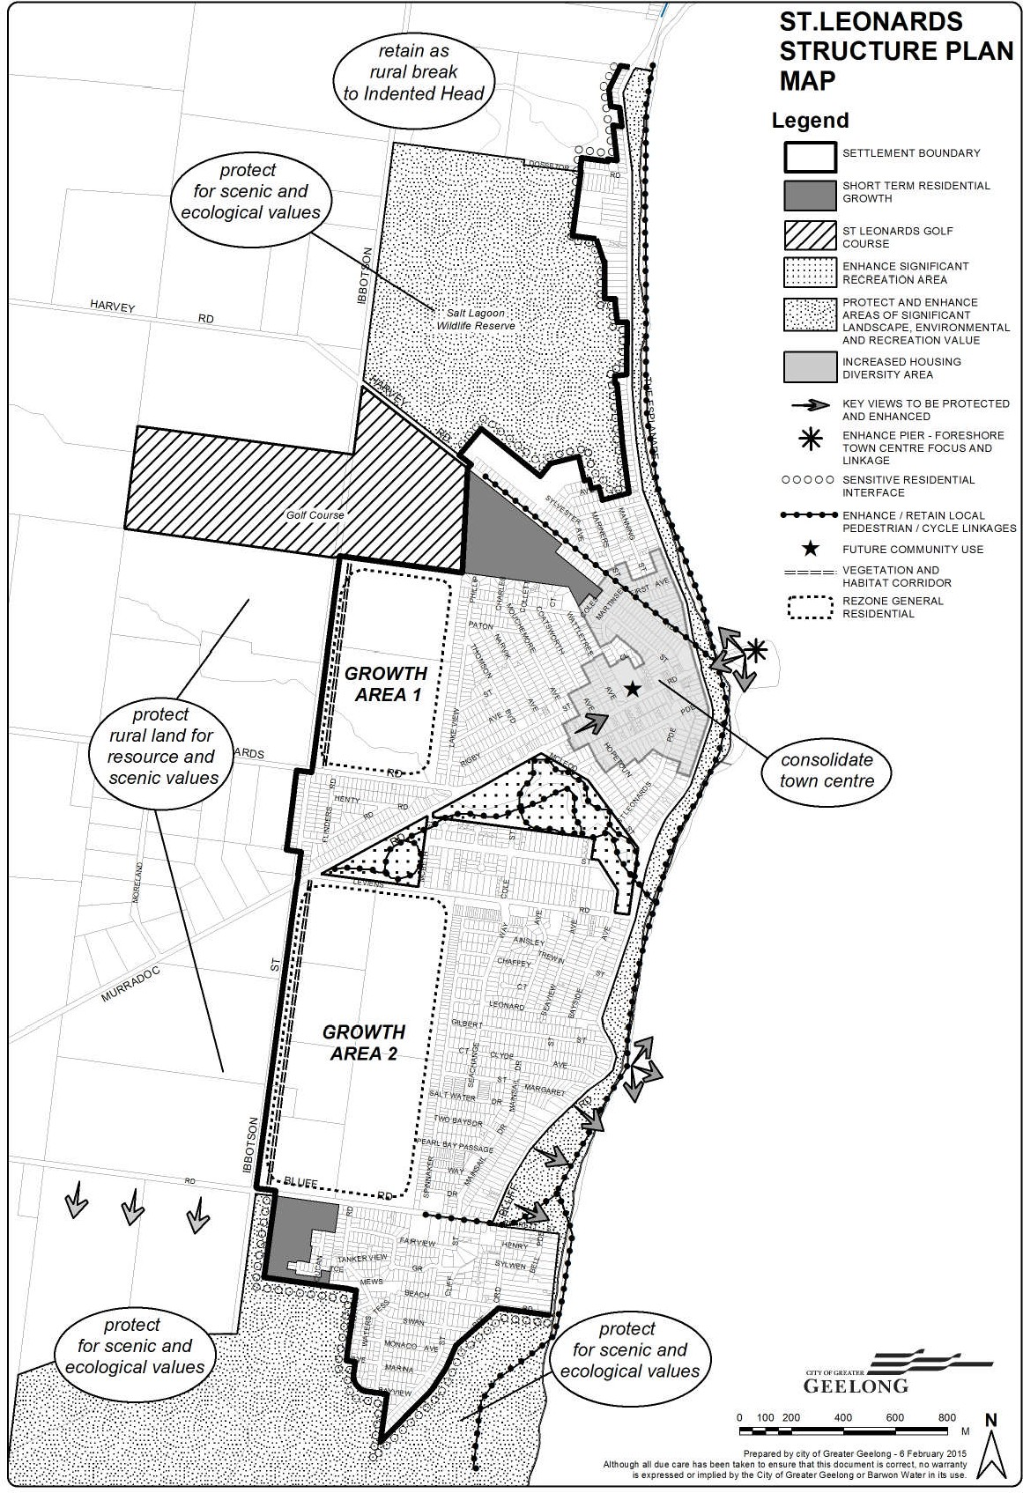

Portarlington Structure Plan Map
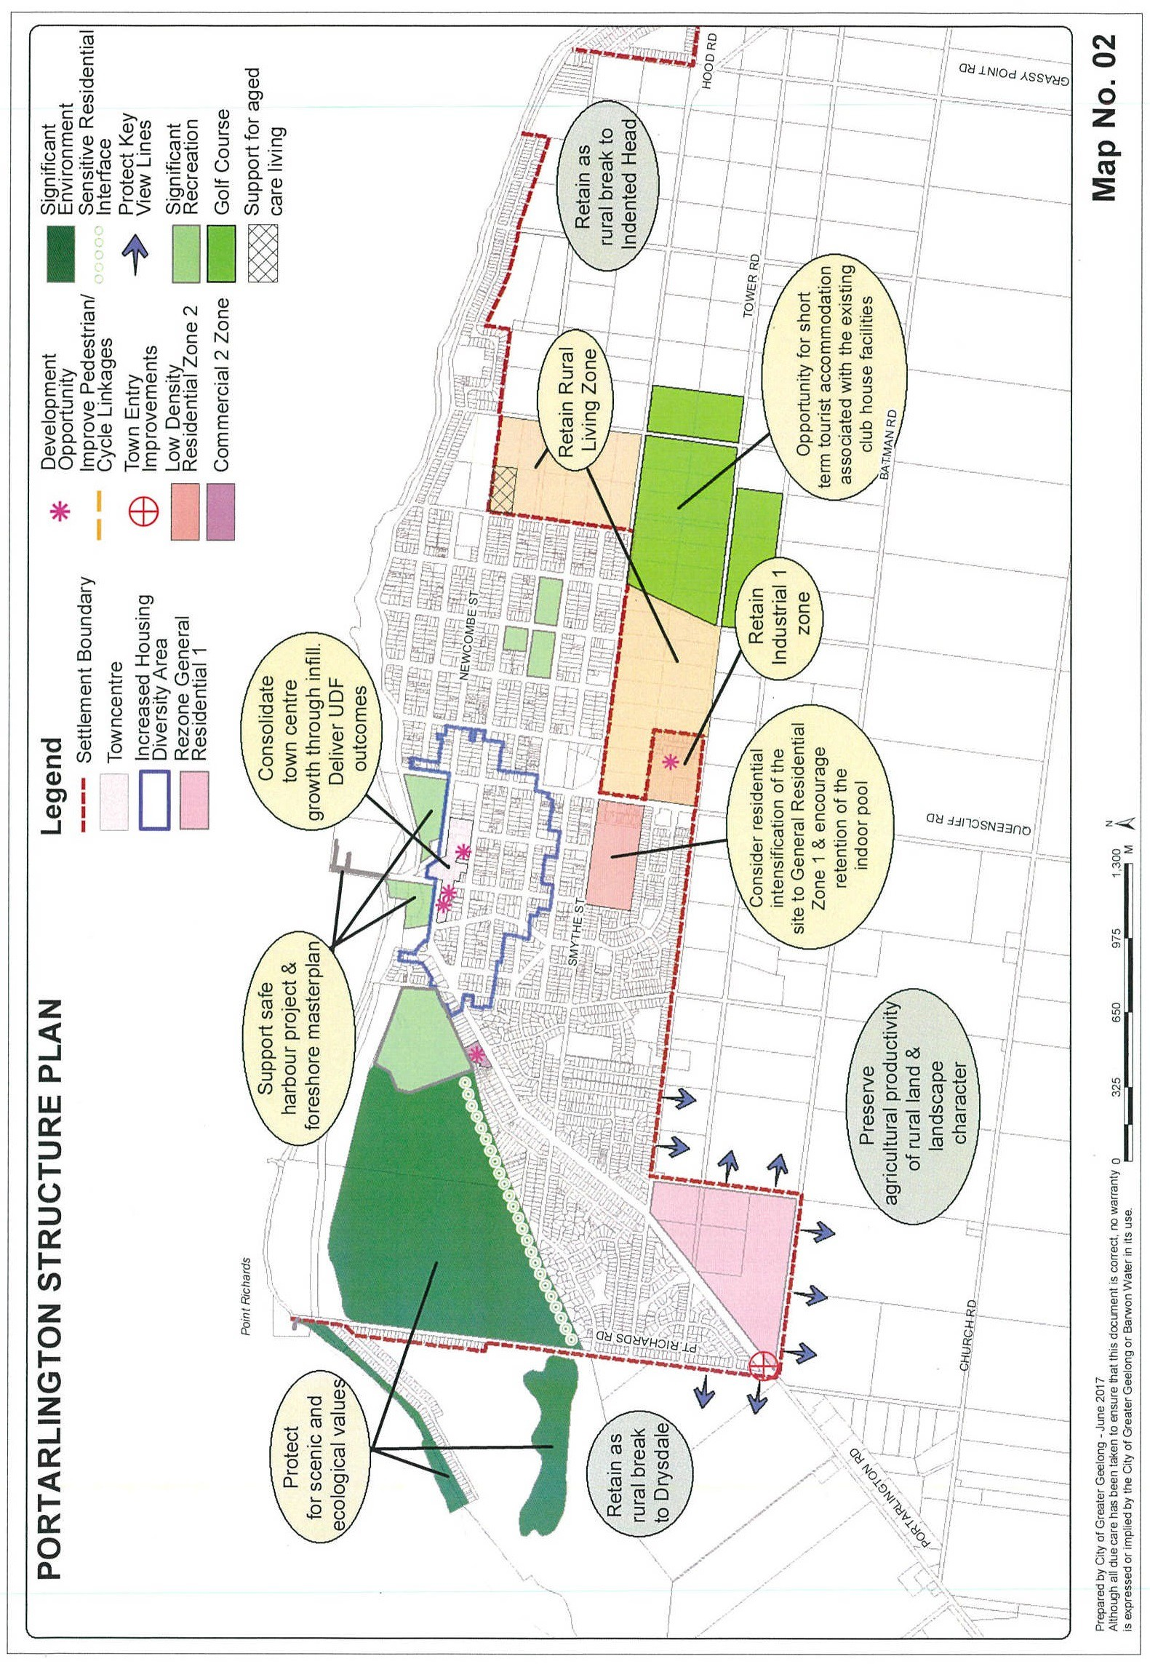

Indented Head Structure Plan Map
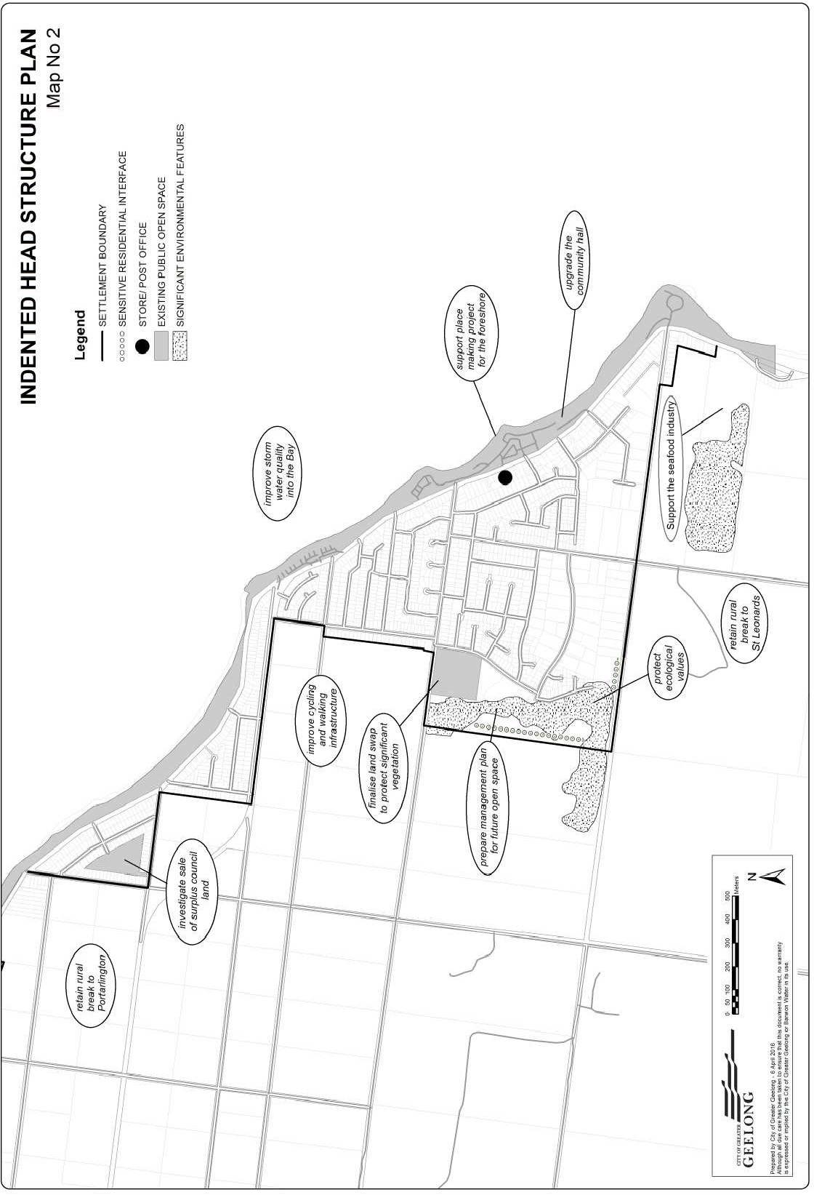

Ocean Grove Structure Plan Map
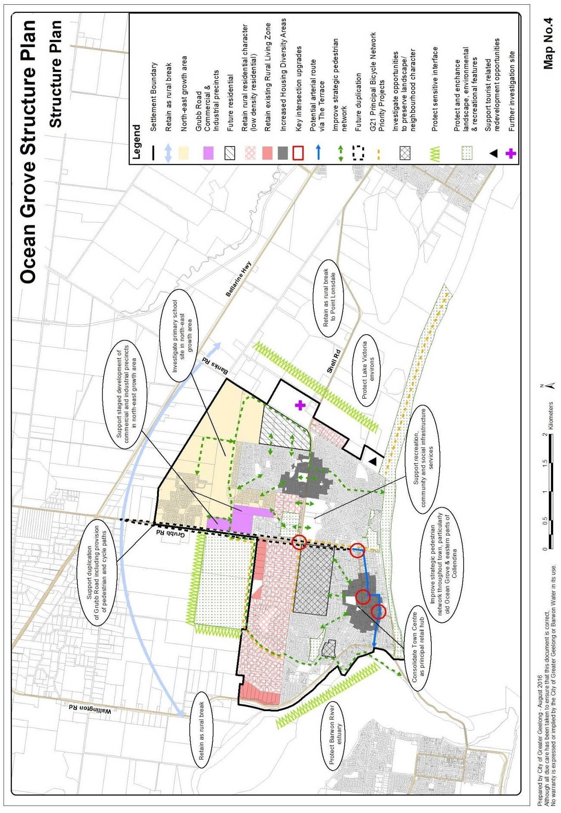

Leopold Structure Plan Map
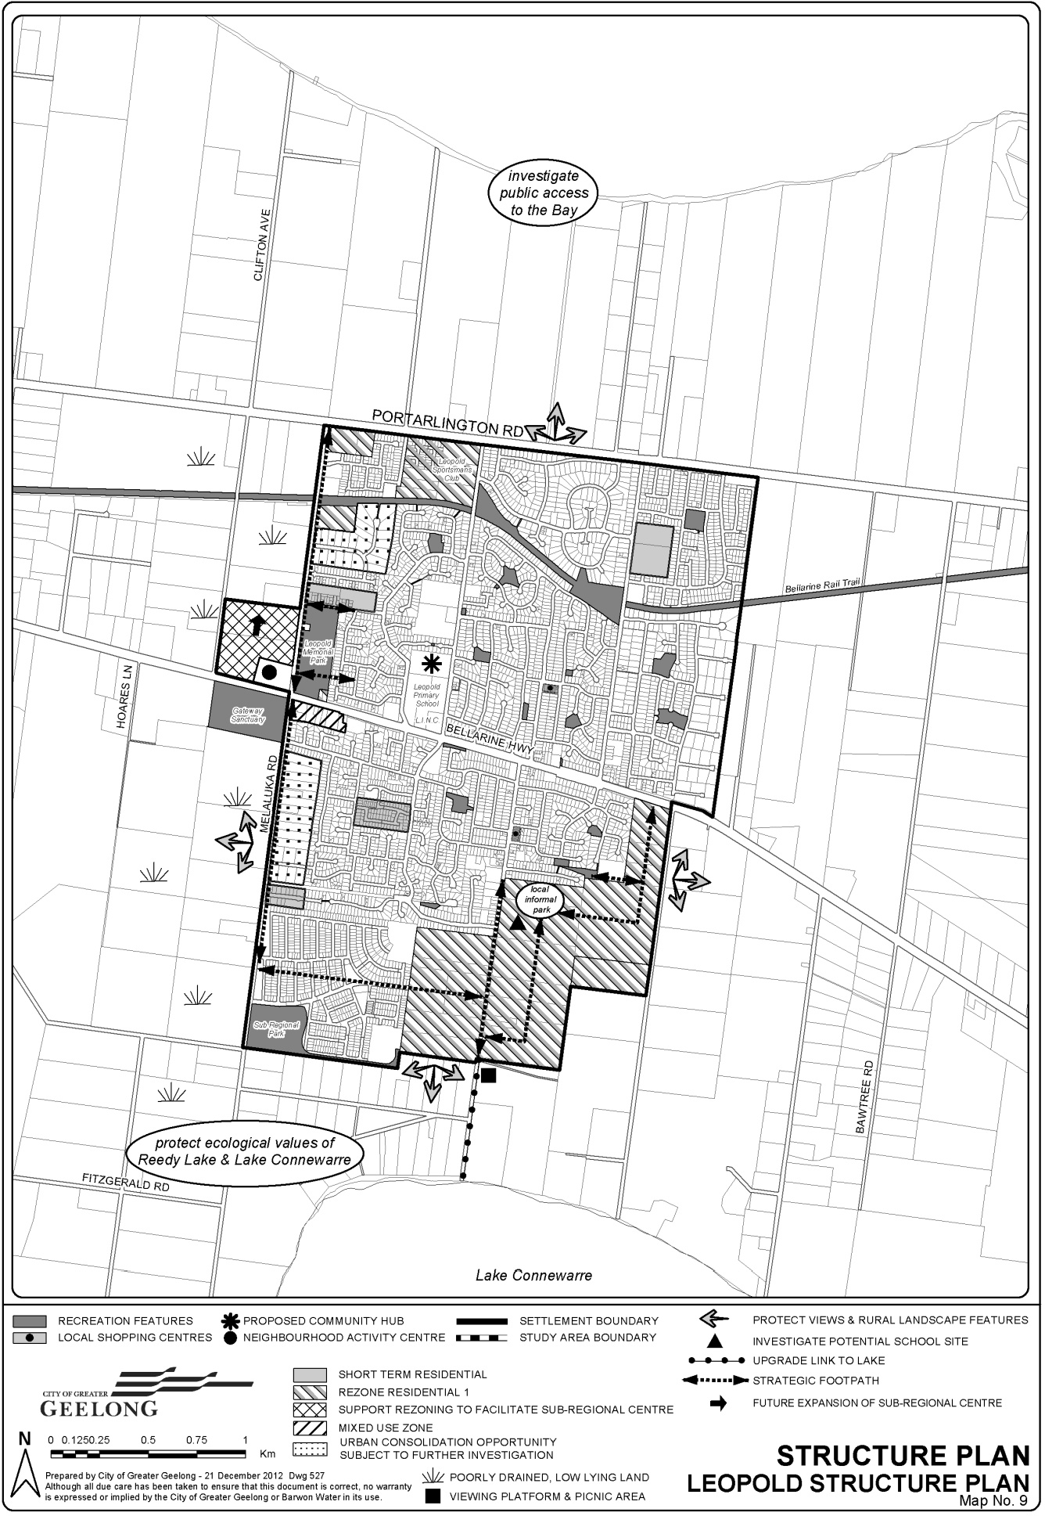

Barwon Heads Structure Plan Map
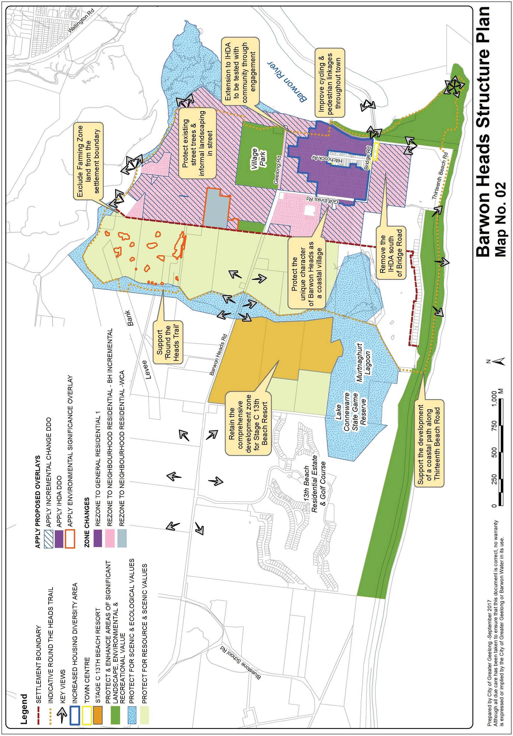

Drysdale/Clifton Springs Structure Plan Map
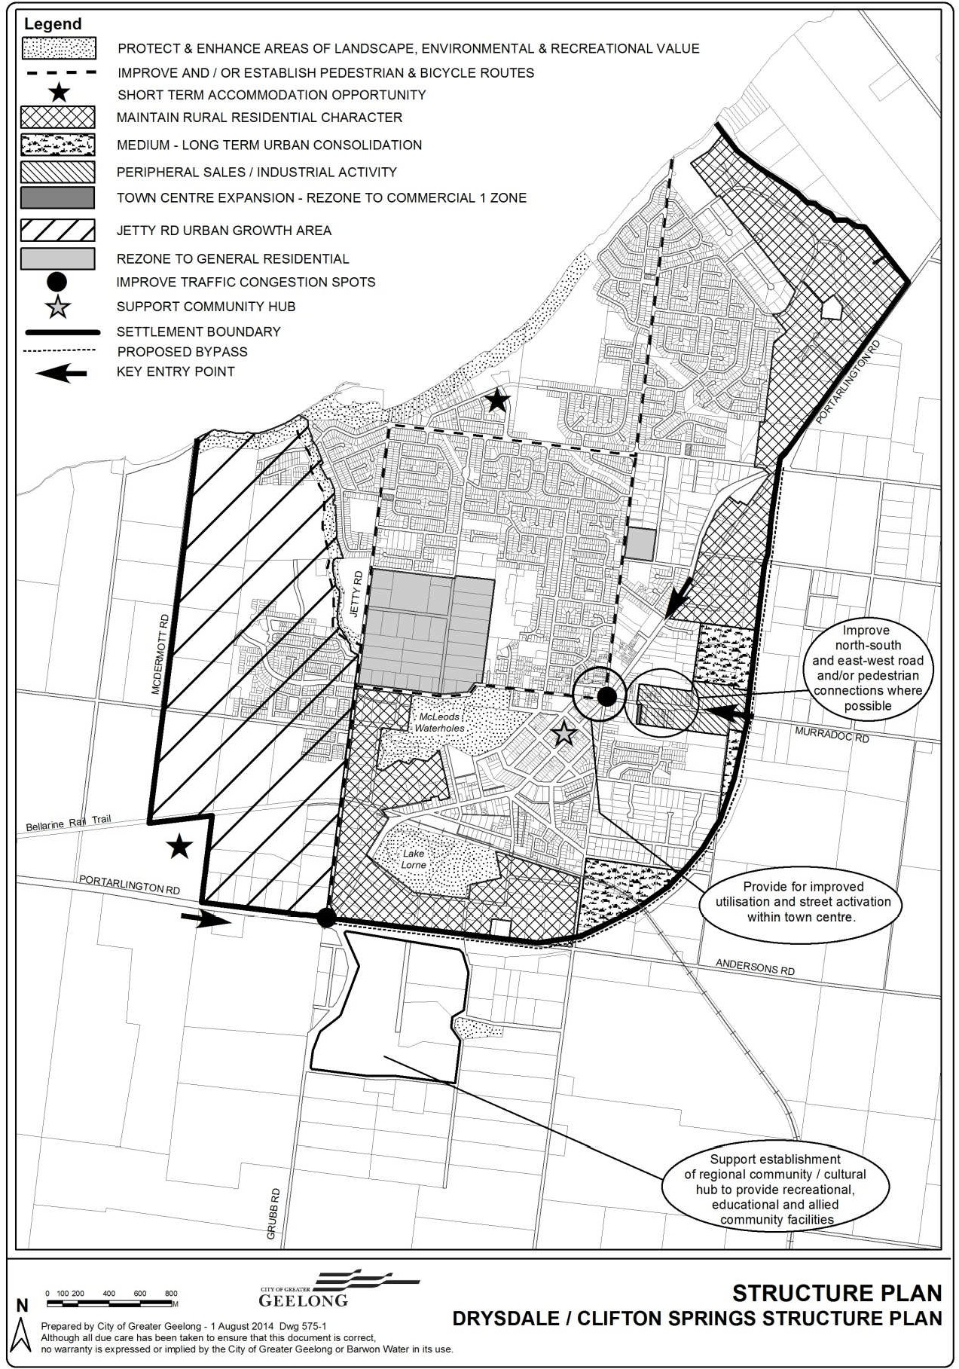

Jetty Road Urban Growth Plan Map
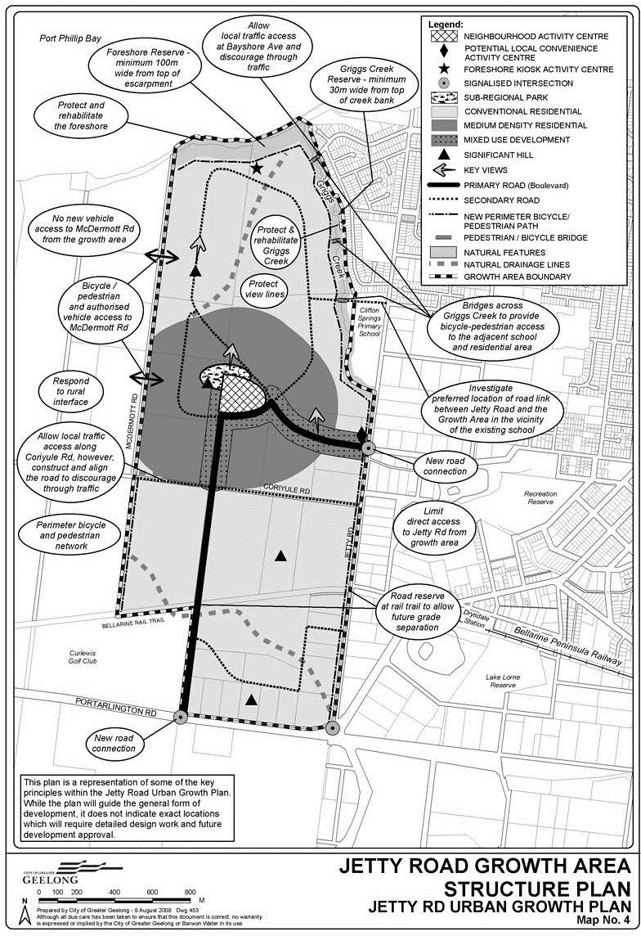

Point Lonsdale Structure Plan Map
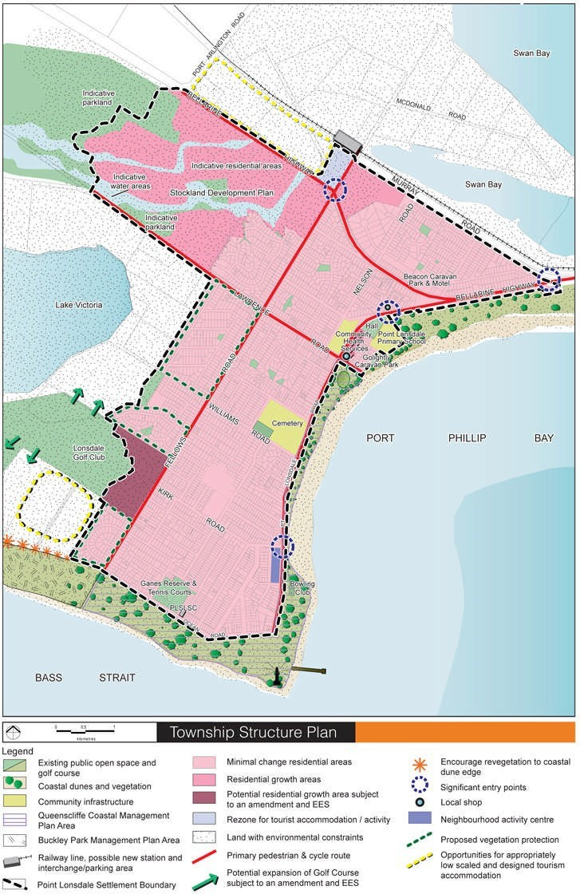

11.03-6L-02
13/06/2025
C478ggee

Corio Norlane
Policy application
This policy applies to land identified in the Corio Norlane Framework Plan Map.
Objective
To facilitate the urban renewal of the Corio Norlane area.
Strategies
Encourage increased housing diversity areas around the Corio Sub-Regional Activity Centre, Bell Post Shopping Centre, North Shore Station and local shopping centres.
Encourage the redevelopment of school sites subject to closure for residential development (where not required for a community use in need of a larger site).
Support the ongoing improvement and expansion of the Corio Sub-Regional Activity Centre, and the development of retail, offices, cafes/restaurants and health services around the centre.
Improve the role, function and presentation of retail activity centres through measures such as supporting a diverse mix of uses and the use of public art to enhance their presentation and create a sense of place.
Encourage the development of the Waterworld Precinct as a multi-purpose community precinct that includes dedicated arts and culture spaces within a “landmark” building.
Facilitate the redevelopment and rezoning of land no longer required for commercial use in local shopping centres for housing and other compatible uses.
Limit intensification of residential development within the North Shore residential area close to heavy industrial land uses.
Support the development of health and support services, including potential expansion of facilities within the Corio ‘heart’ area.
Improve the amenity and safety of local reserves and parks and consider for trade poorly configured parks that do not contribute to the permeability of neighbourhoods.
Encourage the upgrade of ageing drainage infrastructure to better manage impacts resulting from stormwater flooding.
Facilitate the provision of a safe and attractive active transport network to access destinations in Corio and Norlane.
Policy document
Consider as relevant:
Corio Norlane Structure Plan (City of Greater Geelong and Department of Planning and Community Development, 2012)
Expiry
This policy will expire on 7 July 2027.

Corio Norlane Framework Plan Map
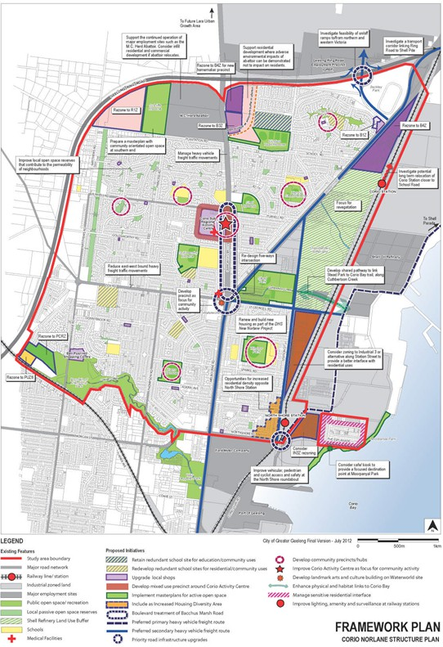

11.03-6L-03
07/07/2022
C417ggee

Moolap-Point Henry
Policy application
This policy applies to land within the Moolap Coastal Strategic Framework Plan Map.
Objectives
To facilitate the transformation of Moolap-Point Henry into a safe, sustainable, integrated, connected, accessible and attractive place to live, work and visit.
To encourage development that integrates with and provides an interface to adjoining precincts and surrounding areas, including the settlement break between eastern Geelong and the Bellarine Peninsula.
To encourage land use and development that maintains or enhances environmental values and responds to environmental risks.
Strategies
Support residential and tourism use and development in the Point Henry Precinct, including medium-high density residential development, tourist accommodation and facilities, and complementary commercial and community facilities, water access and boating infrastructure.
Designate the Wetlands and Former Saltworks Precinct for conservation purposes and public open space, with complementary infrastructure and tourism, research and culture/heritage facilities.
Support residential use and development at a range of densities in the Moolap East Precinct, with complementary community, retail and commercial facilities, open space and transport links following the relocation of Dow Chemical and site remediation.
Support industrial activities and commercial businesses in the Southern Precinct to provide local services and employment.
Site and design buildings, infrastructure and coastal facilities to minimise impacts on the environmental, landscape, cultural heritage and biodiversity values of the wetlands, coastal environs and Moolapio grasslands.
Site and design land use and development to respond to potential risks from environmental hazards and climate change, including flooding, acid sulfate soils, sea level rise, coastal erosion and retreat, ground contamination and groundwater salinity.
Provide landscaping and interface treatments to Portarlington Road and Clifton Avenue that are sympathetic to the rural landscapes and green break between Moolap and Leopold.
Provide a movement network that provides for convenient and safe access and is integrated with the existing network and surrounding areas.
Plan for drainage and stormwater management to take a whole of catchment approach that maintains water quality and includes water sensitive urban design.
Encourage environmentally sustainable and water sensitive design that responds to the land’s context, natural features and constraints.
Include landscaping and interface treatments that avoid adverse impacts between industry and existing and future residential uses and conservation areas.
Encourage urban and building design that responds to the coastal setting and establishes a unique character.
Facilitate the necessary clean-up, rehabilitation and remediation of former industrial uses and landfill sites.
Support interim land use and development, consistent with the zoning of the land, where the ultimate land use and development outcomes for the land are not prejudiced.

Support the continuation of Dow Chemical in the Moolap East Precinct until this industry chooses to relocate and the precinct transitions to residential.
Policy guidelines
Consider as relevant:
Whether interim land use and development proposals would prejudice the ultimate transition to future land use, having regard to:
- The expected timing of the transition to future land use.
- The potential adverse impacts on the environment including contamination.
- Potential land use conflicts, adverse amenity impacts or other off-site impacts.
- The need for provision and ongoing maintenance of new infrastructure.
- The extent, lifecycle and implications of significant investment in infrastructure, services or buildings.
- Whether any conditions are required to limit the extent, nature and expiry of proposals that may prejudice the future land use directions.
Whether the use or development is consistent with the provisions of the Mines (Aluminium Agreement) Act 1961, where applicable.
Policy document
Consider as relevant:
Moolap Coastal Strategic Framework Plan (Department of Environment, Land, Water and Planning, 2019)

Moolap Coastal Strategic Framework Plan Map
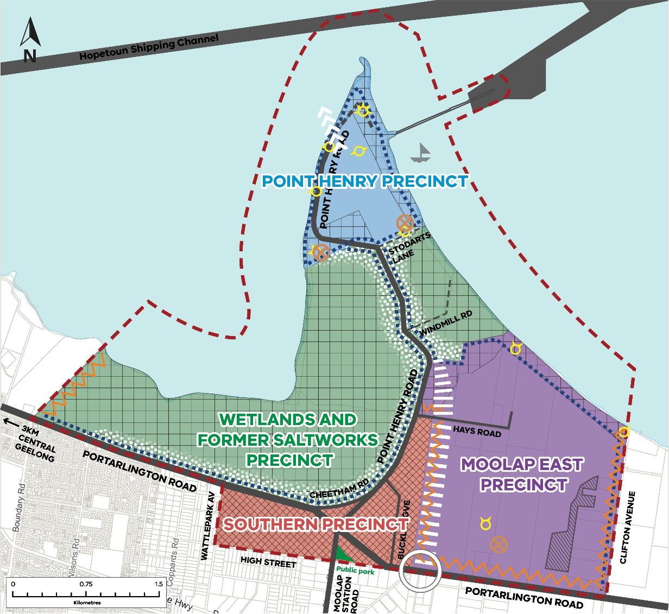

11.03-6L-04
07/07/2023
C458ggee

West Fyans - Fyans Street
Policy application
This policy applies to the land identified in the West Fyans – Fyans Street Precinct Structure Plan Area Map.
General strategy
Ensure that development enhances the visual relationship with public open space areas, including the Barwon River.
Open space precinct 1 strategies
Support community and recreation use and development.
Support tourist-related use and development in identified locations as shown on the West Fyans – Fyans Street Precinct Structure Plan Area Map.
Design and site development to enhance the open space qualities of the area including the Barwon River Corridor.
Business park precinct 2 strategy
Encourage uses that contribute to the development of the business park including manufacturing, office and active recreation uses.
Residential interface precinct 3A strategies
Direct commercial uses to West Fyans Street including office and retail development that could include housing at upper levels.
In the Residential and Mixed Use Zones support the development of housing, including medium density housing, in a manner which responds to the existing housing stock’s modest scale, built form and setbacks.
Within Industrial 1 zoned areas support a range of activities complementary to the long-term mixed-use vision for the area including office, service industry and leisure and recreation activities.
Discourage industrial uses that do not meet Clause 53.10 buffer requirements.
Mixed use precinct 3B strategies
Within the Commercial Node support a mix of accommodation and commercial activity including retail, food and drink premises, office, community and recreation uses.
In the West Fyans Street area, west of Pakington Street encourage a mix of office and retail uses and opportunities for upper level housing.
In the West Fyans Street area, east of Pakington Street encourage restricted retail and other commercial uses.
Encourage medium to high density residential development in the remainder of the precinct with opportunities for small-scale non-residential uses such as arts and crafts, leisure and recreation, home-based offices and medical offices.
Design development to provide for or improve pedestrian and bicycle linkages to the Rutland Street extension connecting to Pakington Street.
Mixed use precinct 4 strategies
Within the Commercial Node support a mix of accommodation and commercial activity including retail, food and drink premises, office, community and recreation uses.
Limit non-residential uses outside the Industrial 1 Zone and the Commercial Node to areas with convenient access to and from the river environment.

Encourage medium to high density residential development in the remainder of the precinct.
Within Industrial 1 zoned areas support a range of activities complementary to the long-term
mixed-use vision for the area including office, service industry, leisure and recreation activities. Discourage industrial uses that do not meet Clause 53.10 buffer requirements.
Promote the adaptive reuse of heritage buildings including the former heritage woollen mills.
Design development to provide for or improve pedestrian and bicycle linkages to the river environment and the Rutland Street extension connecting to Pakington Street.
Business precinct 5 strategy
Maintain this precinct as the focus for restricted retail premises.
Industrial precinct 6 strategies
Discourage the use of land for offensive industries and restricted retail activity.
Encourage the use of land for warehousing, service and non-offensive industries and office uses.
Mixed use - high density residential precinct 7 strategies
Direct restricted retail uses to Moorabool Street and larger commercial uses to Moorabool and Fyans Streets at ground level and encourage housing at upper levels.
Encourage medium to high density residential uses south of Little Fyans Street with higher density housing adjacent to Barwon Terrace.
Support a range of office, warehousing, non-offensive industrial and service industry uses north of Little Fyans Street.
Support commercial uses including food and drink premises, offices, arts and crafts and leisure and recreation activities at ground and first floor levels adjacent to Barwon Terrace and Yarra Street.
Policy document
Consider as relevant:
West Fyans –Fyans Street Precinct Structure Plan (City of Greater Geelong, 2009)

West Fyans – Fyans Street Precinct Structure Plan Area Map
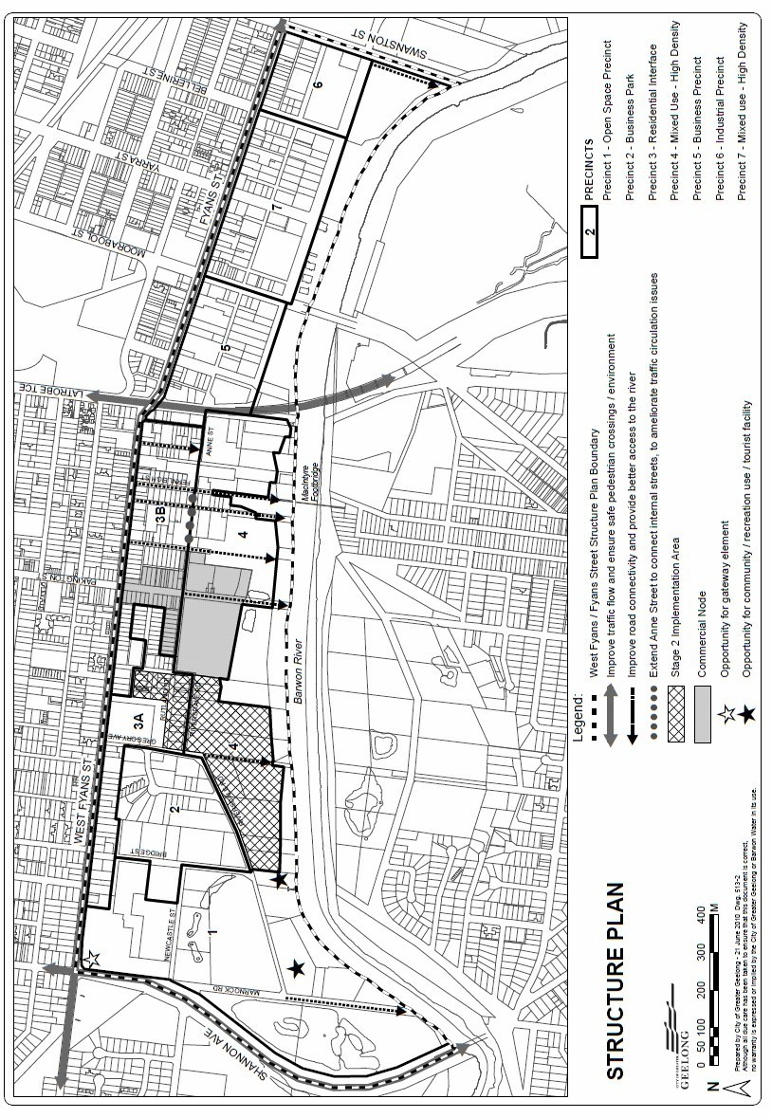

11.03-6L-06
--/--/----
Proposed C433ggee

Pakington Street Geelong West
Policy application
This policy applies to land within the Pakington Street Urban Design Framework Plan Map.

All precincts

Objectives
To enable the development of a vibrant, compact and thriving urban village.
To provide greater housing diversity and a range of housing typologies while respecting the amenity and heritage values of surrounding residential areas.
To facilitate sustainable development outcomes, including urban greening, green street corridors, increased canopy cover, and water sensitive urban design.
To facilitate a network of streets and public spaces which offer safe and accessible environments for pedestrians and cyclists.
To enhance the sense of identity and place throughout the three precincts and improve their connections to each other and key attractors such as Central Geelong.
Encourage precincts and sub-precincts with distinct identities that contribute to the whole.
Strategies
Encourage a diversity of housing types, including the provision of social and affordable housing. Facilitate active and public transport links to Central Geelong.
Design buildings that are sensitive to the surrounding context.
Create engaging streets and laneways that improve pedestrian permeability and encourage opportunities for active and public transport.
Integrate landscape as a key driver of building design through the provision of functional open spaces (e.g. central courtyards) and landscaped setbacks to the front and rear of buildings.
Encourage the installation of public art, including event and breakout spaces and on blank facades, to contribute to the identity, activation and interest of streets and open spaces.
Provide wayfinding and signage to connect pedestrians and cyclists to key destinations including Central Geelong, railway station and the waterfront.
Pakington North Precinct Objectives
To support a vibrant mix of retail, entertainment, services, and residential functions which establishes the Pakington North Precinct as a destination and strengthens its connection to the remainder of Pakington Street, Geelong West.
To provide a transition to the low scale character of the surrounding residential area and to the Heritage Core Precinct.
To facilitate new public open spaces and pedestrian connections.
To protect the rail sidings yard at 28–64 Pakington Street as an essential site for the operation of rail services in Geelong.
Strategies
Facilitate new open space within large sites such as Pakington Strand
Encourage retention of existing heritage design elements in buildings and street infrastructure, whilst creating Pakington North’s own distinct character.
Heritage Core Precinct Objective
To provide attractive and comfortable urban public spaces and support the precincts function as a community hub and meeting place.

Strategies
Retain and enhance the built form elements that contribute to the recognised urban design character of the Heritage Core Precinct.
Encourage high-quality public realm outcomes through upgraded kerb and channel, footpath paving, landscaping, bicycle parking and street furniture that do not negatively impact existing on-street parking supply.
Provide a pocket park in the area between the Town Hall and Library and upgrade the existing pocket park on Yuille Street.
Gordon Avenue Precinct Objectives
To create a vibrant, mid-rise precinct which transitions from the low scale character of the surrounding residential area to the future high-density scale of Central Geelong.
To develop a safe and attractive connecting corridor between Central Geelong and Geelong’s established western suburbs.
Strategies
Encourage fine-grain retail frontages in the west end of the precinct.
Facilitate the transition of the central area into a diverse residential precinct with complementary retail and commercial uses to increase the resident population and activity.
Provide setbacks to Gordon Avenue to facilitate street planting and tree canopy cover.
Encourage landscaped setbacks along Latrobe Terrace to protect internal amenity at the ground floor and contribute to the improvement of the public realm along major traffic routes.
Encourage opportunities for pedestrian permeability and public open space.
Pakington Strand Objective
To encourage a coordinated, master planned approach to the redevelopment of Pakington Strand as a Strategic Site informed by the Indicative Concept Plan.
Strategies
Deliver landscaped areas surrounding the Ropeworks Shed ensuring activation and responding to the heritage context.
Ensure opportunities to deliver car parking for public use within the basement, rear or podium of new developments, where appropriate, with any podium parking to be wrapped with active uses on primary interfaces with the public realm.

Indicative Concept Plan for Pakington Strand
[Editing Note: Remove indicative open space location in SE corner]
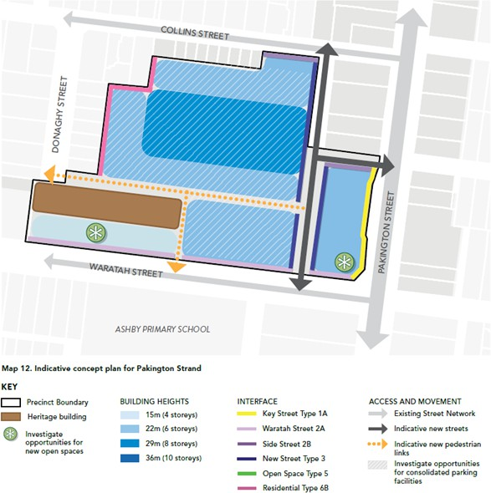

Policy documents
Consider as relevant:
Pakington Street and Gordon Avenue Urban Design Framework (City of Greater Geelong, May 2024)
Pakington North Urban Design Framework (City of Greater Geelong, May 2024)

Pakington Street Urban Design Framework Plan Map
