--/--/----
Proposed C433ggee

SCHEDULE 56 TO CLAUSE 43.02 DESIGN AND DEVELOPMENT OVERLAY
Shown on the planning scheme map as DDO56.
GORDON AVENUE PRECINCT

1.0
--/--/----
Proposed C433ggee

Design objectives
To implement the Pakington Street and Gordon Avenue Urban Design Framework (City of Greater Geelong, May 2024).
To create a vibrant and sustainable mid-rise precinct with a variety of building typologies which supports a diverse and inclusive community.
To ensure high quality architectural design that integrates landscaping, maintains solar access and ensures comfortable wind conditions within the public realm.
To provide a mix of small and medium scale tenancies with activated street frontage to Gordon Avenue, and generous landscaping at residential interfaces to contribute to urban cooling and greening, biodiversity and create a visual buffer.
To ensure development appropriately transitions to sensitive interfaces such as heritage and established low scale residential sites and open spaces.

2.0
--/--/----
Proposed C433ggee

Buildings and works
The following buildings and works requirements apply to an application to construct a building or construct or carry out works.
A permit may be granted to vary a discretionary requirement expressed with the term ‘should’.
A permit cannot be granted to vary a requirement expressed with the term ‘must’.
A permit cannot be amended (unless the amendment does not increase the extent of non-compliance) for buildings and works that do not meet a requirement expressed with the term ‘must’.
Building and floor heights
Development should not exceed the preferred maximum building heights specified in Map 1 to this schedule.
Provided that the below criteria are met, the preferred maximum building height does not include architectural features, masts and building services. Roof top mechanical equipment such as plant rooms, lift overruns, solar collectors and other such equipment should be sited so achieve all of
the following:
Not more than 50% of the roof area is occupied by equipment (other than solar panel or greening);
The equipment is set back on all sides, no less than 3 metres from the edge of the building, or otherwise located to minimise additional overshadowing and reduce visual impact;
The equipment does not exceed the height limit by more than 3.6 metres; and The equipment and screening is integrated into the design of the building;
to the satisfaction of the Responsibly Authority.
Buildings should provide the floor-to-floor heights set out in Table 1.
Table 1: Floor-to-floor heights

Floor
Use
Minimum floor-to-floor
dimension

Ground
All
4.0 metres

Level 1 and above
Residential
3.2 metres

Non-residential (including car parking)
3.5 metres

Street Interfaces
Development should not exceed the preferred maximum street wall heights specified in Table 3 to this schedule.
Development must meet the mandatory ground level setbacks specified in Table 3.
Development should meet the other street interface requirements specified in Table 3.
Table 3: Street interface
[Editing Note: Mandatory minimum ground level setback to Gordon Avenue and Pakington Street – all other streets have Preferred minimum ground level setback.]

Street interface | Mandatory minimum ground level setback | Preferred maximum street wall or podium height | Preferred minimum setback above street wall/podium
Latrobe Terrace | 6 metres | None specified | 3 metres
Madden Avenue | 0 metres | None specified | None specified
Gordon Avenue | 3 metres | 15 metres | 3 metres
Pakington Street | 0 metres | 8 metres | 5 metres
Ripley Street | 2 metres | 8 metres | 5 metres
Residential Streets (Autumn Street, Spring Street, Western Street, Halstead Place, Coronation Street, Villamanta Place) | 3 metres | 8 metres | 3 metres
Other Interfaces
Development should provide the minimum setbacks specified in Figures 1-2.
Figure 1. Direct residential
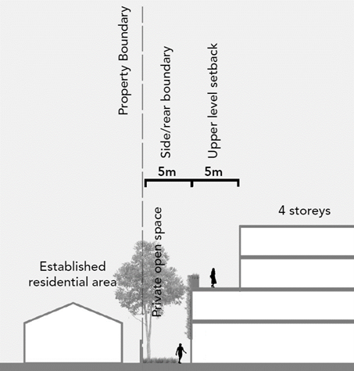
Figure 2. Future Park Interface
[Editing Note: ground floor building setback 2m from proposed open space]
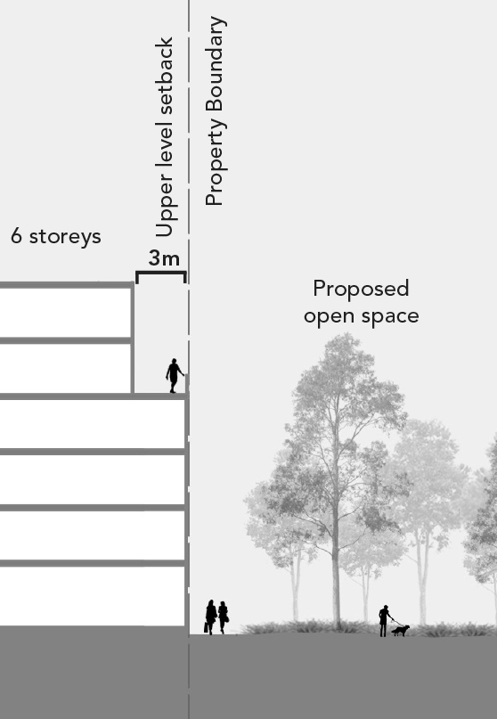
Laneways
Encourage the provision of new laneways and streets generally in the locations shown on Map 1.
Development should provide the minimum setbacks specified in Figures 3-5.

Figure 3. Laneway interface ( existing laneways and 3m pedestrian links)
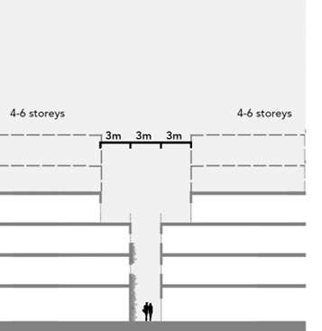

Figure 4. Laneway interface (6m laneways)
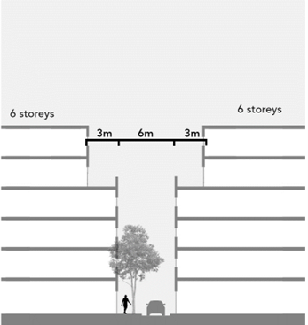
Figure 5. Laneway interface (10m laneways)
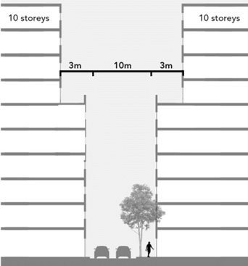

Building separation
Balconies should not encroach into side setbacks.
Where a site abuts another site subject to this schedule, , the minimum side setback at Figures 6 applies.
Figure 6. Preferred side separation for buildings built to boundary
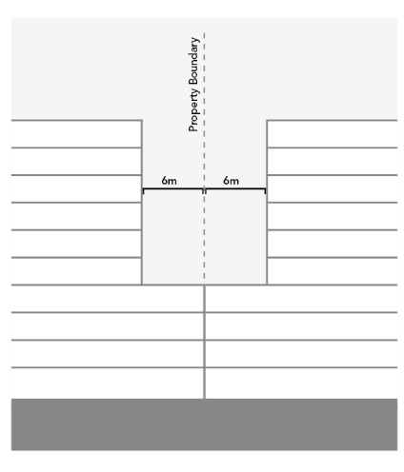
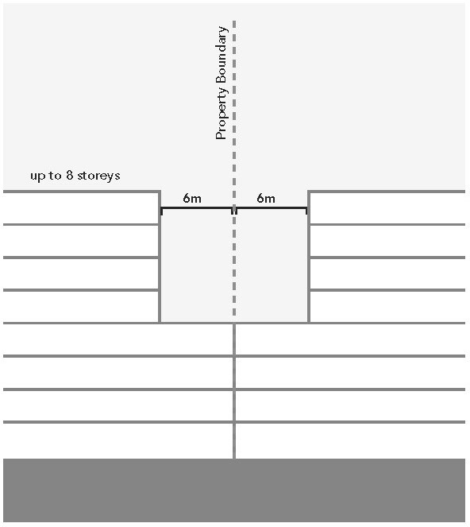
[Editing Note: Diagram above left replaced with diagram above right showing additional two more levels and removing the text “up to 10 storeys.”]

[Editing Note: Diagram deleted]

Figure 7. Preferred side separation for buildings not built to boundary
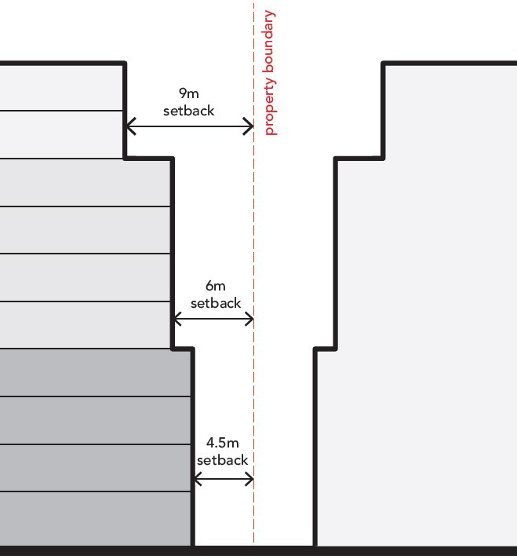

Building design
Encourage developments at corner sites to address both street interfaces.
Encourage the use of natural, tactile, and visually interesting materials and façade articulation
Create visual interest in upper levels and ensure passive surveillance of the public realm.
Ensure passive surveillance and activation of developments that directly abut or are adjacent to public open spaces.
Incorporate an interim façade strategy when blank walls are visually prominent while adjoining properties are being realised.
Encourage integrated screening measures that manage on and off site amenity outcomes.
Incorporate façade design and lighting that enhances safety and security after hours including along main streets, side streets and laneways.
Minimise the potential for off-site impacts, including from noise, fumes, odour or vibrations, through the use of setbacks, acoustic barriers, high performance glazing, internal layout, or other relevant measures.
Integrate landscaping with building design by incorporating green walls, green roofs, roof top gardens, landscaped balconies and functional courtyards to enhance biodiversity and visual amenity.

Encourage the provision of functional open spaces (e.g. central courtyards) and landscaped areas with deep soil planting to support canopy trees around buildings.

Active frontages

Encourage visual and physical permeability between the building and the street by incorporating measures such as doors facing the street, operable windows and direct residential access for ground level residences
Ensure ground floor activity through façade and internal layout to facilitate visual and physical access between the building and adjoining public realm,
Avoid concealed alcoves, recessed nooks and hidden entrances that affect safety.
Clearly distinguish residential and commercial entrances.
Ensure laneways and pedestrian links are publicly accessible, safe (comply with Crime Prevention Through Environmental Design guidelines), receive adequate access to sunlight and are open to the sky.
Provide gates and other structures associated with security, vehicle access or servicing points that are integrated into the building design and provide visual permeability.
Encourage landscaping in front setbacks to improve ground-floor amenity and facilitate the transition between the public and private realms.
Allow a maximum 75% glazing on any façade and provide 50% visually permeable balcony balustrades.
Solar access, wind and weather
Incorporate weather protection such as awnings, openings and architectural detail that are well detailed and attractive when viewed from the street.
Ensure weather protection measures do not impinge existing or future street trees.
Limit overshadowing impacts on the existing private open space of adjacent residential properties.
Avoid overshadowing of the southern footpath on Autumn Street, Gordon Avenue and Spring Street between 11am and 2pm on 22 September.
Avoid overshadowing of more than 50% of public open space between 11am and 2pm on 22 September.
Address wind gust management in building design, without the need for additional protective screens, incidental add-ons and landscaping in public spaces.
Buildings and works with an overall height equal to, or greater than 16 metres:
- Must not cause unsafe wind conditions as specified in Table 4 on public land, publicly accessible areas on private land, private open space and communal open space; and
- Should achieve comfortable wind conditions as specified in Table 4 on public land, publicly accessible areas on private land, private open space and communal open space.

Table 4: Wind effects requirements
Wind condition Requirement

Comfortable wind conditions
Hourly mean wind speed or gust equivalent mean speed (3 second gust wind speed divided by 1.85), from all wind directions combined with probability of exceedance less than 20% of the time, equal to or less than:
- metres per second for sitting areas,
- metres per second for standing areas,
- metres per second for walking areas

Wind condition Requirement

Unsafe wind conditions
Annual maximum 3 second gust wind speed exceeding 20 metres per second with a probability of exceedance of 0.1% considering at least 16 wind directions.

Access, parking and services
Consolidate vehicular access points for parking and loading to minimise the number of crossovers.
Avoid direct access to Latrobe Terrace (where possible) and utilise rear laneways for access and servicing, where required.
Encourage car parking within basements where possible and the provision of shared car parking facilities. Where car parking is provided above ground, ensure it is sleeved with active uses along street frontages and located to minimise impacts on footpaths.
Design off-street car parking facilities to have flexible electric vehicle charging spaces. Electric charging stations should be equipped with at least 50kw charging facilities.
Services, loading and waste areas should be located away from main streets and public spaces and where possible within basements or upper levels. Access doors to any waste, parking or loading area should be designed as an integrated element of the building.
Integrate plant equipment and services into the built form design. Avoid locating services on Gordon Avenue and Latrobe Terrace and grouping them together to create long inactive edges. Service cabinets should not visually dominate street frontages and should use high quality materials.
Design and locate gates which do not impede on public land.

Site coverage
Development should not exceed the preferred maximum site coverage specified in Map 2 to this schedule.
Exemption from notice and review
An application or construct a building or construct or carry out works which accords with the height, setback and interface requirements of this clause is exempt from the notice requirements of section 52(1)(a), (b) and (d), the decision requirements of section 64(1), (2) and (3) and the
review rights of section 82(1) of the Act. This exemption does not apply to land within 30 metres of land (not a road) which is in a residential zone.

3.0
--/--/----
Proposed C433ggee

Subdivision
The subdivision of land should not prevent the development of land in accordance with the objectives of this Schedule.
Exemption from notice and review
An application to subdivide land is exempt from the notice requirements of section 52(1)(a), (b) and (d), the decision requirements of section 64(1), (2) and (3) and the review rights of section 82(1) of the Act.

4.0
--/--/----
Proposed C433ggee

Signs
None specified.

5.0
--/--/----
Proposed C433ggee

Application requirements
The following application requirements apply to an application for a permit under Clause 43.02, in addition to those specified elsewhere in the scheme, and must accompany an application, as appropriate, to the satisfaction of the Responsible Authority:
An Urban Context Report and Design Response demonstrating how the proposal responds to the design objectives and buildings and works requirement of this schedule and implements recommendations from other technical reports.
Streetscape elevations showing the existing streetscape, and how the development sits within the streetscape and a three-dimensional perspective which shows the development in the context of adjacent development in the street.
A Wind Report prepared by a suitably qualified person for buildings exceeding a height of 16 metres (5 storeys). The report should address appropriate mitigation measures to achieve safe and comfortable wind conditions, consider level of wind at ground level and its impacts on pedestrian amenity, identify publicly accessible areas for sitting, standing or walking and demonstrate that the development does not require street trees or screening elements to mitigate wind.
A Stormwater Management Plan demonstrating potential for reuse of stormwater for onsite purposes such as landscaping and other non-portable purposes, provision for limiting maximum flows discharged from the site under storm events and incorporation of WSUD principles where possible.
An Environmental Management Plan prepared by a suitably qualified person that demonstrates how the development provides for environmentally sustainable design measures.
A Traffic Impact Assessment Report prepared by suitably qualified traffic engineer that assesses and minimises the impacts of traffic and parking within the precinct and promotes sustainable transport modes.
Plans, elevations, and section drawings including for any car parking at or above ground level to show finished floor levels and a statement by a suitably qualified engineer that demonstrates the capacity for adaptation to alternative uses.
A Landscape Plan detailing proposed hard and soft landscape elements, plant schedule, plant container details and maintenance and irrigation systems.
Shadow diagrams to show existing and proposed shadows at hourly intervals to demonstrate compliance with the solar acess requirements contained in this schedule.

Any application for development of land for a dwelling, , should provide an Affordable Housing Delivery Strategy to the satisfaction of the responsible authority which sets out the location and type (housing
type/density/size) of the affordable housing to be delivered, the method of implementation, and proposed staging which ensures affordable housing is provided in a timely manner as development occurs.
Any application for subdivision or development of land for Accommodation, Education centre (other than Tertiary institution and Employment training centre) or Hospital, must be accompanied by an acoustic assessment report prepared by a qualified acoustic engineer or
other suitably skilled person to the satisfaction of the responsible authority which:
– Applies the following noise objectives:
Not greater than 35 dB LAeq,8h when measured within a sleeping area between 10pm and 6am.
Not greater than 40 dB LAeq,16h when measured within a living area between 6am and 10pm.

For areas other than sleeping and living areas, not greater than the median value of the range of recommended designed sound levels of Australian Standard AS/NZ 2107:2016 (Acoustics– Recommended design sound level and reverberation times for building interiors).
Train airborne noise received at new residential or other noise sensitive uses is attenuated to achieve a noise level of 55 dBA, Lmax in bedrooms at night and a noise level of 60 dBA, Lmax in living areas. These noise levels are to be measured at the expected occupancy position(s) in the space relevant to the noise of interest with doors and windows closed. The preferred positions are at least 1 metre from the walls or other
major reflecting surface, 1.2 metres to 1.5 metres above the floor and about 1.5 metres from windows.
-The measurements should be undertaken using a ‘fast’ meter
time weighting and must be achieved for 95% of train pass-bys (i.e. 5%, 1 in 20 trains may exceed).
– Noise levels should be assessed:
Considering the cumulative noise from all sources impacting on the proposal including road traffic, railway, industry and commercial noise, as well as planned other potential noise sources;
Industrial noise received at new residential or other noise sensitive uses achieves internal noise levels assessed in accordance with the Noise Protocol (EPA Publication 1826.4) with the implementation of an indoor adjustment of 20 dB, while allowing for operable windows. These noise levels are to be measured internally at the expected occupancy
position(s) in the space relevant to the noise of interest with doors and windows closed. The preferred positions are at least 1 metre from the walls or other major reflecting surface, 1.2 metres to 1.5 metres above the floor and about 1.5 metres from windows;
Operation of the rail sidings yard with respect to EPA Pub. 1826.4 Noise Protocol, where any new proposed sensitive uses constitutes the Agent of Change, and as such measures must be undertaken at sensitive uses to maintain EPA Pub. 1826.4 conformance of rail sidings yard; and
In unfurnished rooms with a finished floor and the windows closed and be based on average external noise levels measured as part of a noise level assessment.
- Addresses noise compatible design for buildings, with siting, orientation, and internal layout, to be considered prior to setting building envelope performance requirements.
- Addresses potential noise character (such as tonality, impulsiveness or intermittency)
wherever relevant, including through the application of adjustments to the internal noise levels that are determined using the procedures to adjust industry noise levels of the Noise Protocol.

6.0
--/--/----
Proposed C433ggee

Decision guidelines
The following decision guidelines apply to an application for a permit under Clause 43.02, in addition to those specified in Clause 43.02 and elsewhere in the scheme which must be considered, as appropriate, by the Responsible Authority:
Whether the development adequately manages visual and internal amenity and appropriately transitions to adjoining public open spaces, sensitive residential areas, heritage places or sites.
Whether the proposed design treatment and material selection for the development is sympathetic to adjoining heritage places or sites and transitions appropriately from the Heritage Core.
Whether the application includes an Affordable Housing Delivery Strategy to the satisfaction of the responsible authority.

Whether the development incorporates acoustic treatments to limit the impacts from noise from all current and potential noise generating sources such as railway operations, traffic and commercial activities.
Whether the development contributes to an active and permeable streetscape, provides acceptable solar access to specified locations, incorporates weather protection elements, and makes a positive contribution to the public realm.
Whether the development avoids blank walls, alcoves and recesses that provide hiding places or collect dirt and litter.
Whether the development achieves design excellence by providing high quality innovative architecture, landscape and urban design and provides community benefit.

Whether the development achieves comfortable wind conditions.
Whether the development is consistent with the Pakington Street and Gordon Avenue Urban Design Framework (City of Greater Geelong, May 2024).

Variations to preferred requirements
Where an application proposes to exceed, or vary a preferred requirement under a discretionary control contained within this schedule consider:
Whether the design objectives have been met.
Whether the development exceeds the minimum 5 star Greenstar rating for Environmentally Sustainable Design (ESD).
Whether the development results in, or substantially facilitates, the delivery of appropriately secured community benefits including:
- Incorporation of social or affordable housing.
- Upgrades or delivery of new local infrastructure including public spaces to meet the needs of the community and provide spaces for residents to linger and enjoy.
- Provision of pedestrian links or public open space in excess of any minimum requirement in this Scheme.
Whether development results in adverse offsite impacts such as visual bulk, overlooking and overshadowing to adjoining residential properties and the public realm.
Whether the proposal presents, or substantially facilitates an improved architectural and urban design outcome.

Map 1 to Schedule 56 to Clause 43.02
[Editing Note: Remove storeys from key]
[Editing Note: Revise key: reference to the two different laneway widths (10m and 6m) to be replaced with single reference to ‘Indicative new laneway]

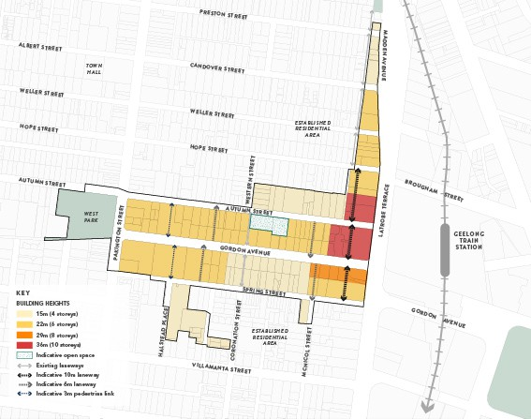
Map 2 to Schedule 56 to Clause 43.02
[Editing Note: 60% site coverage to be changed to 70%)
