The City Of
Greater Geelong

SALEYARDS COMPREHENSIVE DEVELOPMENT PLAN

  - may 2022
  - 28 NOVEMBER 2022 – Panel Version Day 2

Contents
How to read this document 3
Outcomes 4
Vision 4
Objectives 4
Plan 1 – Future Urban Structure 5
Implementation 6
Land use 6
Built form, building design and siting 7
Landscape and open space 13
Integrated transport 15
Integrated Water Management and sustainability 17
Infrastructure and staging 19
Land budget 24
Street cross sections and plan 25
Background documents 33
Glossary 34

List of tables
Table 1 – Precinct Infrastructure Plan 21
Table 2 – Summary land use budget 24

How to read this document
The Saleyards Comprehensive Development Plan (CDP) is a long term plan to facilitate the redevelopment of the Saleyards Precinct, and must be read in conjunction with the provisions within Clause 37.02 Comprehensive Development Zone (CDZ) and Schedule 4 (CDZ4) within the Greater Geelong Planning Scheme (Planning Scheme).
The CDP is incorporated into the Planning Scheme, and as such, it forms part of the Planning Scheme. It implements the Saleyards Precinct Plan (City of Greater Geelong, June 2021), which was adopted by Council on 22 June 2021.
A planning permit application and planning permit must implement the outcomes of the CDP. The outcomes are expressed as the Vision and Objectives in Part 1 of this CDP.
The way in which the various elements of the CDP are to be applied is as follows:
- Vision and Objectives: The vision and objectives must be complied with.
- Future Urban Structure: Future development of the site must be generally in accordance with the Future Urban Structure of the site as shown on Plan 1, to the satisfaction of the Responsible Authority. Minor variations may be permitted by the responsible authority, provided the overall vision and objectives for the development of the site are achieved.
- Requirements: All requirements must be complied with.
- Guidelines: All guidelines should be complied with. Guidelines outline matters that should be taken into account in the planning and design of a development.

Outcomes

Vision

The precinct will be a high quality and sustainable addition to the local urban fabric. It will provide more than four hectares of publicly accessible open space and will accommodate 1000 - 1300 residents .

The precinct will provide diverse forms of housing that will help meet existing and future local housing demand. It will include a component of affordable housing.

The interface of the precinct with industrial land will be managed through noise attenuation measures and requirements for specific building materials, such as double glazing.

The movement network and building design will prioritise the pedestrian and cycling experience.

The precinct will provide a significant addition to the adjacent network of public open spaces providing places for relaxation and recreation. Street trees and landscaping in public spaces supplemented by landscaping on private land will contribute to the leafy green feel of the precinct.

A mixed-use area will provide approximately 1800sqm of retail on the ground floor and be adjacent to an urban plaza space. The plaza will be located on the southern side of the street to utilise the northerly aspect to encourage outdoor dining.

The precinct will incorporate environmentally sustainable design features and the retention of heritage fabric will provide opportunities for interpretation and adaptive reuse of materials.

Objectives
O1 | To establish a compact high quality and sustainable urban village with predominantly residential development supplemented by associated commercial and community services in a higher density environment
O2 | To provide spacious public open space that links to the surrounding open space network.
O3 | To maintain and enhance the heritage values of the former Geelong Saleyards.
O4 | To connect to surrounding streets.
O5 | To enhance pedestrian and bicycle networks through the precinct.
O6 | To create a community node off Weddell Street with range of uses for the precinct.
O7 | To provide for higher density housing for a diversity of households, including affordable housing.
O8 | To achieve a diversity in building types and architectural expression.
O9 | To encourage best practice environmentally sensitive design.
O10 | To ensure the orderly and integrated development of the precinct.

Plan 1 – Future Urban Structure
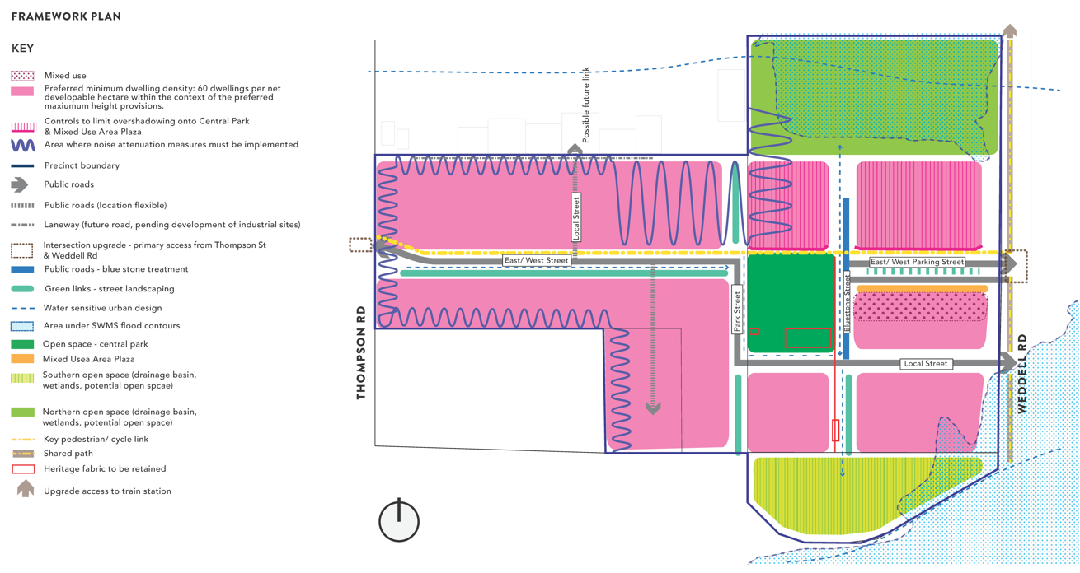

Implementation

Land use

Requirements
R1 | Land uses must be generally in accordance with Plan 1
R2 | Land uses must not include a drive through facility.
R3 | Non-residential land uses must be compatible with the intended residential use of the precinct.

Guidelines
G1 | Non-residential uses within the precinct, either individually or collectively, should not have a significant negative economic impact on any nearby centre.
G2 | Land uses outside the Mixed Use area shown on Plan 1 should be primarily residential.
G3 | Non-residential uses outside the Mixed Use area should be located along East-West Street.
G4 | Land uses at ground level in the Mixed Use area shown in Plan 1 should be those uses which promote on-street activity such as outdoor dining.
G5 | Accommodation and office uses should be located at upper levels (above ground floor) within the area shown on Plan 1 as Mixed Use area.

Built form, building design and siting

Requirements
R4 | Development (including subdivision) must not prejudice the development of the area generally in accordance with Plan 1 .
R5 | 60% of dwellings must achieve accessibility standard D17 at clause 58.05-1 .
R7 | Loading, storage, refuse areas and building services including domestic services, utilities and waste management facilities must be concealed and integrated into building design and not visible from public areas.
R8 | Built form and development must be oriented toward and overlook adjoining public and private roads and open space.
R9 | The minimum floor level of all buildings within the ‘Area under SWMS flood contours‘ (1% Annual Exceedance Probability Flood Extent) shown on Plan 1 – Future Urban Structure must be no lower than minimum development levels determined in the Geelong Saleyards Precinct Surface Water Management Strategy (BMT, April 2021), unless otherwise agreed to by the responsible authority.
R10 | Acoustic attenuation measures must be provided to any noise sensitive accommodation to reduce noise levels in accordance with the following:  - Environment Protection Regulations under the Environment Protection Act 2017  - Noise Limit Assessment Protocol for the Control of Noise from Commercial, Industrial and Trade Premises and Entertainment Venues (Publication 1826.2, Environment Protection Authority, March 2021)

Guidelines
G6 | An application for development of land for dwelling including a dwelling where it is provided as part of a mixed use development should provide affordable housing in accordance with G7 and G8.  This does not apply to:  - where any other provision of the Greater Geelong Planning Scheme, or the Planning and Environment Act 1987 (or any other Act), requires an affordable housing contribution to be made in respect of the proposed development.  - to land in respect of which an agreement with the responsible authority has already been entered into for the provision of affordable housing;  - to the development of land for which a contribution to affordable housing has already been provided to the satisfaction of the responsible authority consistent with G6 – G8;  - to the development of land for less than three dwellings; and  - to an application for buildings or works to an existing dwelling, provided the number of dwellings is not increased.  - .
G7 | Affordable housing should be provided as follows:  - as a transfer of dwellings to an affordable housing association under the Housing Act 1983 or the City of Greater Geelong Affordable Housing Trust at the rate of 5% of the total number of dwellings proposed on the land in the application, for zero consideration (Primary Obligation); or  - a monetary contribution to the City of Greater Geelong Affordable Housing Trust which is of equal value (as independently assessed) to the Primary Obligation; or  - through a combination of the options a and b above; or  - in any other way as agreed between the permit applicant and the responsible authority.  Social housing, should be provided as a transfer of dwellings to an affordable housing association under the Housing Act 1983 or the City of Greater Geelong Affordable Housing Trust at the rate of 5% of the total number of dwellings proposed on the land in the application, for zero consideration. (Primary Obligation)  Alternatively an Affordable Housing Contribution may be made to City of Greater Geelong Affordable Housing Trust which is of equal to the value (as independently assessed) of the Primary Obligation.  Alternatively a combination of the two options may be provided.
G8 | Social and Affordable housing delivered in accordance with this CDP should :  - be delivered within the land to which the planning permit application applies or if agreed by the responsible authority within another part of the precinct to which this CDP applies;  - be functionally and physically indistinguishable from other dwellings within the development;  - Be distributed across the development; and  - provide a mix of housing types to respond to local housing needs.
G9 | Preferred minimum dwelling density  Buildings should achieve a minimum dwelling density of 60 dwellings per net developable hectare.
G10 | .  Residential applications should include a diversity of dwelling sizes including a mix of one, two and three bedrooms across a range of typologies including apartments and townhouses.
G11 | Preferred maximum building heights  Buildings should not exceed the following building heights:  - 22 metres or 6 storeys (whichever is lesser) if located directly adjacent to Thompson Road, Central Park, Mixed Use Area Plaza, the Northern and Southern Open Space all as shown on Plan 1 – Future Urban Structure, or the golf course adjacent to the southern boundary of the Precinct  - 15 metres or 4 storeys (whichever is lesser) in all other areas .  Building height does not include non-structural elements that project above the building height and service equipment including plant rooms, lift overruns, structures associated with green roof areas, screens to service areas or other such equipment provided that all of the following criteria are met:  - the total roof area occupied by the service equipment (other than solar panels) is minimised;  - the service equipment is located in a position on the roof so as to minimise its visibility from the public realm;  - the non-structural elements and service equipment do not cause additional overshadowing of secluded private open space of neighbouring residential zoned properties and public spaces;  - the non-structural elements and service equipment do not extend higher than 2.4 metres above the maximum building height; and  - the non-structural elements and service equipment are integrated into the design of the building to the satisfaction of the responsible authority.
G12 | Preferred minimum setbacks  Development should be configured to minimise the impact of overshadowing on the public realm (such as overshadowing on the southern footpath of the east west street) where no overshadowing standard is provided in this CDP  Except within the area shown as Mixed Use Area in Plan 1, or on land with a frontage to a laneway buildings should meet the following minimum setbacks:  - Any part of a building up to 15 metres above natural ground level: 3 metres  - Any part of a building more than 15 metres above natural ground level: 7 metres
G13 | A mix of building types should be provided that demonstrate a diversity of architectural styles, materials and form within each street and street block.
G14 | Articulation should be provided to break up continuous built form and visual bulk, such as through building separation, landscaping, fenestration, balconies, recessions and protrusions and materials.
G15 | Development above 4 storeys should be recessive and incorporate measures to minimise its visual prominence from the public realm.  Use massing or articulation or changes of surface treatment, or a combination of these, to relate building height to the scale of its surrounds, and to diminish visual bulk.  The height of any portion of the new development which is located on a secondary setback should be guided by its’ visual impact and off-site amenity impacts on surrounding properties such as overshadowing, visual bulk, day lighting to habitable rooms and overlooking
G16 | Prominent facades of all buildings visible from streets and open space should comprise a variety of materials and textures.
G17 | Buildings which have more than one street frontage or which also adjoin open space should address both streets and open space.
G18 | Active frontages at street level should be provided in mixed-use development.
G19 | Vehicle access should be provided by rear loaded, or basement carparking, particularly for land which has a frontage to East-West Street and local streets, to avoid visual impact of vehicle entrances and conflict with pedestrians.
G20 | Built form should maximise safety and utilise Crime Prevention Through Environmental Design (CPTED) principles.

G21
G22 | All buildings and works within the Heritage Overlay should demonstrate how the relevant Conservation Policies of the Geelong Sale Yards Weddell Road, North Geelong Conservation Management Plan (Rowe and Jacobs, 2007) have been achieved.

Mixed use area as shown on Map Plan 1

Guidelines
G24 | Buildings should be built to the street frontages (zero setback).
G26 | Buildings which have a frontage to to the public realm should incorporate a high standard of urban design treatment and activation.  Encourage development that articulates all visible building frontages.  Discourage blank building walls along street frontages or where visible from streets and other public spaces.
G27 | Buildings on the east and west corners of the Mixed Use area as shown on Plan 1 should provide emphasis on street corners and demonstrate a high quality architecture as a gateway to the precinct.
G28 | The frontage at ground level to office or accommodation above ground floor should not exceed 2 metres,
G29 | The total combined amount of shop leasable floor space within the Mixed Use area should not exceed 1800 square metres at ground level.
G30 | Buildings should include fine grain detail including door openings not less than 12 metres apart and windows, as well as projections and recessions and use of different materials.
G31 | Elevations that are blank and clad in a single material visible from the public realm should be avoided.
G32 | Buildings should include awnings and shade canopies to provide weather protection.
G33 | Buildings should provide for shops and food and drink premises at ground floor level, with active frontages to the plaza and streets to the east and west, including space for outdoor dining.

Development abutting open space as shown on Map Plan 1

Requirements
R11 | Central park  At no given time may more than 30% of Central Park be overshadowed by built form.
R12 | Mixed use area plaza  At the winter solstice (June 21) between 11:00am and 2:00pm, no additional shadow is to be cast over the Mixed Use Plaza .

Guidelines
G34 | Buildings should take advantage of views to open space.

Landscape and open space
Landscape and trees

R13 | Provide the plaza spaces as shown on Plan 1 to provide shade, shelter, greenery, seating, and outdoor dining opportunities.

Guidelines
G35 | Trees more than 5 metres in height and in generally good condition should be retained on public and private land where possible and incorporated into the landscape design for any of their shade, amenity, character, habitat and conservation values.
G36 | Planting in roads, streets and laneways should achieve a minimum of 25 per cent canopy coverage and 40 per cent in publicly accessible parking areas and open space.
G37 | Street trees and trees in open space should be:  - Larger species wherever space allows (to facilitate canopy cover).  - Appropriate in size to nature strips and built form.  - Consistent with any guidance provided on the relevant street cross section and plan within this Comprehensive Development Plan.
G38 | The landscape design of the precinct should integrate the design of the front gardens with the design of the streets.
G39 | Landscaping should be appropriate to the site and current and future climate conditions.
G40 | Water sensitive urban design features should be incorporated into public landscapes.
G41 | Design of public open space should ensure universal access.
G42 | High quality landscaping should be provided for all public realm areas, including key pedestrian and cycling routes and key entry points, using a variety of hard and soft landscaping materials for shade and visual interest.

Open space

Requirements
R14 | Provide the open space shown as Central Park generally in accordance with Plan 1 and Table 2 – Summary land use budget.
R15 | Provide for the incorporation and interpretation of heritage elements in open space, including fabric identified to be retained in the Saleyards Precinct Plan (City of Greater Geelong, June 2021).

Guidelines
G43 | Linear green links/spaces should be provided generally in accordance with Plan 1 and Table 2 – Summary land use budget.
G44 | All public open space and green links should be a useable size and configuration .

Integrated transport
Transport

Requirements
R16 | A staggered main east-west street must be provided that intersects with Central Park designed so as to avoid it being a direct through road.
R17 | One vehicular access off Thompsons Road and two access points on Weddell Road must be provided generally in accordance with Plan 1.
R18 | There must be no vehicle access to lots from Thompsons Road or Weddell Road.
R19 | There must be no vehicle access across the Mixed use area plaza as shown on Plan 1 or from the adjacent road reserve to the east or west.

Guidelines
G45 | Intersection treatment at Thompson Road access should safely manage anticipated vehicular traffic and improve pedestrian and cyclist safety and amenity.
G46 | Safe sight lines should be provided to the proposed Thompson Road intersection.
G47 | The design of streets and public areas should be generally in accordance with the street cross sections and plans within this Comprehensive Development Plan.
G48 | Communal car share spaces associated with a car share scheme should be provided as part of any request to reduce car parking requirements.
G49 | An internal road network with a high level of access for all non-vehicular traffic and adequate access for vehicular traffic should be provided.
G50 | Any application to reduce carparking requirements in the Mixed Use area as shown in Plan 1 should be considered on a centre wide basis and any car parking which is provided must be provided as a shared parking area within the Mixed Use area.
G51 | Street design should comply with Crime Prevention Through Environmental Design principles and incorporate appropriate lighting.
G52 | Streets should be designed to provide views to parkland within the site including at termination points.
G53 | Vehicle traffic speeds should be minimised through narrow traffic lanes and large canopy tree planting.

Walking and cycling

Requirements
R20 | Pedestrian connections must be provided to bus stops in Thompsons Road.
R21 | Key junctions must be designed to prioritise pedestrian and cycle movements.
R22 | A shared pedestrian/cycle path must be provided along the main east-west street and north side of the Central park.

Guidelines
G54 | Pedestrian paths should be provided generally in accordance with consistent with the cross sections and plans within this Comprehensive Development Plan or as otherwise agreed with the responsible authority.
G55 | Road reserves should be scaled and detailed to promote pedestrian and cyclist safety and movement.
G56 | Pedestrian and cyclist priority should be provided through continuous footpaths at accessible grades and shared pedestrian/cycle ways.

Integrated Water Management and sustainability

Requirements
R23 | Stormwater drainage for the precinct must be provided so as to comply with the following stormwater pollutant objectives and pollutant reduction targets.  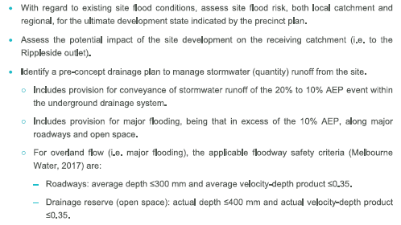  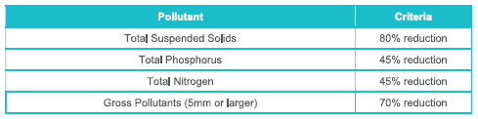

Guidelines
G57 | All development, including subdivision, should have regard to the Geelong Saleyards Precinct Surface Water Management Strategy (BMT, April 2021).
G58 | The bioretention systems and wetlands should be constructed and established in accordance with:  - Biofiltration systems in Development Services Schemes Guideline (Melbourne Water, September 2020).  - Wetland design manual (Melbourne Water, 2017).  - Construction and establishment guidelines: swales, bioretention systems and wetlands guideline (Water by Design, 2010b).
G60 | A range of Water Sensitive Urban Design initiatives to limit runoff from roofs, structures and impermeable surfaces should be provided.
 | .
G62 | Development should not unreasonably overshadow existing or proposed rooftop solar energy systems.
G63 | Infrastructure for electric vehicle charging should be provided to enable each car space in a development to have access to charging facilities. (future proofing)
G64 | 25 per cent of car parking spaces in apartments or mixed-use developments should be provided with electric vehicle charging facilities and reserved for electric vehicles.
G65 | 5 per cent of car parking spaces in apartments or mixed-use developments should be reserved for small and/or shared vehicles.
G66 | All development should incorporate building or landscape elements that reduce the impact of the urban heat island effect across 70 per cent of the site area.

Infrastructure and staging

Infrastructure delivery

Requirements
R24 | Development must provide and meet the total cost of providing the following infrastructure.Where there is an agreement in place which provides for the implementation of a Shared Infrastructure Funding Plan the infrastructure listed in that Shared Infrastructure Funding Plan is to be provided in accordance with that agreement. in which case the provisions of that agreement will prevail:  - All items listed in Table 1 – Precinct Infrastructure Plan which are not part of the Shared Infrastructure Funding Plan.  - Local streets.  - Landscaping, and where reasonably required by the municipal council, fencing of abutting streets and roads.  - Intersection works and appropriate traffic management measures along arterial roads, connector streets and local streets.  - Local pedestrian and shared bicycle paths along local roads and connector streets, utilities easements, local streets, waterways and within local parks including intersections and crossing points.  - Bicycle parking.  - Appropriately scaled lighting along all roads, shared bicycle and pedestrian paths and traversing the open space network.  - Local drainage system and water quality systems.  - Noise attenuation .
R## | Where there is an agreement in place which provides for the implementation of a Shared Infrastructure Funding Plan the infrastructure listed in that Shared Infrastructure Funding Plan is to be provided in accordance with that agreement.

Guidelines
G67 | Utility services should be placed in locations that will maximise tree planting opportunities.

Development staging

Requirements
R25 | Development staging must provide for the timely and coordinated provision and delivery of:  - All infrastructure items listed in Table 1 – Precinct Infrastructure Plan.  - Drainage infrastructure.  - Major utility service assets.  - Road reservations, public open space and construction.  - Street links between properties, constructed to the property boundary.  - Connection of the pedestrian and bicycle network to key destinations within and outside the precinct from the early stages of development.  - Infrastructure identified in an agreement implementing a Shared Infrastructure Funding Plan
R26 | Staging will be determined largely by the development proposals on land and the availability of infrastructure services. Development applications must demonstrate how the development will:  - Deliver the infrastructure listed in Table 1 – Precinct Infrastructure Plan.  - Give effect to any agreement to implement a Shared Infrastructure Funding Plan.  - Integrate with adjoining developments, including the timely provision of road and walking/cycling path connections, to a practical extent.  - Provide for public open space in the early stages of development.  - Provide sealed road access to each new allotment and constructed to an appropriate standard.  - Deliver any utility service assets, including confirmation of the agreed approach and timing by the relevant service provider.
Precinct infrastructure plan

The Precinct Infrastructure Plan (PIP) sets out the infrastructure and services required to meet the needs of proposed development within the precinct. The infrastructure items and services are to be provided through a number of mechanisms including:
- Development works by developers.
- Agreement under section 173 of the Planning and Environment Act 1987.
- Utility service provider requirements.
- The Shared Infrastructure Funding Plan (SIFP).
- Capital works projects by Council.
- Works-in-kind (WIK) projects undertaken by developers on behalf of Council.

Table 1 – Precinct Infrastructure Plan

Project category | Title |  | Project description | Delivery lead | Timing/Trigger | Included in SIFP
ROAD
ROAD | Pedestrian Crossing Upgrade |  | Wombat Crossing (with curb outstands) to be placed mid-way along Weddell Road. | Shared Item | To be delivered in early stages of the eastern side development area fronting onto Weddell Road or as determined by Council | Yes
ROAD | Pedestrian Crossing Upgrade |  | 3 x Pedestrian Refuge Islands to be placed at Hepner Place, at the northern end of Weddell Road and Backwell Streets | Shared Item | Hepner Place triggered by early stages of the western development area fronting onto Thompson Road or as determined by Council.  Weddell Road triggered by the early stages of either the eastern or western development areas (whichever comes first) or as determined by Council.  Backwell Street triggered by the early stages of either the eastern or western development areas (whichever comes first) or as determined by Council | Yes
ROAD | East/West Road |  | East West Road through the Saleyards Development, including shared user path and greenlink | Local Item | As required by the development at permit application stage as determined by Council | No
ROAD | Thompson Road Intersection |  | Delivery of a Main Intersection Access from Thompson Road | Local Item | As required by the development at permit application stage as determined by Council and if required Department of Transport | No
ROAD | Weddell Road Intersection |  | Delivery of a Main Intersection Access from Weddell Road | Local Item | As required by the development at permit application stage as determined by Council | No
DRAINAGE
DRAINAGE | Northern Drainage Basin |  | Construction of the Northern Drainage Asset | Shared Item | At the first stage requiring the items delivery or as determined by Council | Yes
DRAINAGE | Southern Drainage Basin |  | Construction of the Southern Drainage Asset | Shared Item | At the first stage requiring the items delivery or as determined by Council | Yes
PUBLIC TRANSPORT
PUBLIC TRANSPORT | Bus Stop Relocation |  | Potential Bus stop Relocation - Thompson Road | Local Item | As determined by Council and Department of Transport at permit application stage | No
PUBLIC TRANSPORT | Bus Stop Upgrades | Upgrade to Bus stops (Weddell Road and north side of Ballarat Road) |  | Local Item | As determined by Council and Department of Transport at permit application stage | No
TRAILS
TRAILS | Shared User Path | Shared user path on western side of Weddell Road between Ballarat Road and Victoria Street, and Landscaping |  | Shared Item | To be delivered in early stages of the eastern development area fronting onto Weddell Road or as determined by Council | Yes
TRAILS | Shared User Path | Shared user path on south side of Victoria Street between Weddell Road and Thompsons Road and Landscaping |  | Shared Item | To be delivered in early stages of either the western or eastern development areas (whichever comes first) or as determined by Council | Yes
TRAILS | Footpath | Pedestrian Path upgrade on eastern side of Weddell Road between 138 Weddell Road and Victoria Street |  | Shared Item | To be delivered in early stages of the eastern side development area fronting onto Weddell Road or as determined by Council | Yes
TRAILS | Footpath | Pedestrian Path Upgrade on the northern side of Ballarat Road from Thompsons Road to the bus stop |  | Shared Item | To be delivered in early stages of the western development area fronting onto Thompson Road or as determined by Council | Yes
OPEN SPACE
OPENSPACE | Central park | Landscape and Embellishment Works required within Central Park |  | Shared Item | To be delivered alongside the delivery of properties as specified in the Shared Infrastructure Funding Plan or as determined by Council | Yes
OPENSPACE | Linear Pocket Parks | Linear pocket parks (2) providing connection to public open space |  | Local Item | As required by the development at permit application stage as determined by Council | No
OPENSPACE | East/West Green Link | Green link through the precinct |  | Local Item | As required by the development at permit application stage as determined by Council | No
OPENSPACE | Bluestone Pedestrian Priority Road | Passive open space with heritage bluestone encumbrance |  | Local Item | As required by the development at permit application stage as determined by Council | No
OTHER
ACOUSTIC WALL | Acoustic Wall - Industrial | Construction of Acoustic Walls |  | Local Item | As required by the development at permit application stage as determined by Council | No
PLAZA | PLAZA | Delivery of the Mixed Use Plaza |  | Local Item | As required by the development at permit application stage as determined by Council | No
PLAZA | PLAZA | Delivery of the Western Plaza |  | Local Item | As required by the development at permit application stage as determined by Council | No

Land budget

Table 2 – Summary land use budget

Description | Hectares | % of total | % of NDA
Total precinct area | 12.51 ha
Unencumbered open space
Central park (minus heritage elements) | 0.45 ha | 3.6% | 5.0%
Encumbered open space
Heritage elements in Central park | 0.05 ha | 0.5% | 0.6%
Total encumbered open space | 0.05 ha | 0.5% | 0.6%
Drainage
Drainage | 2.96 ha | 23.7% | 32.8%
Net Developable Area | 9.04 ha | 72.2%

Street cross sections and plan
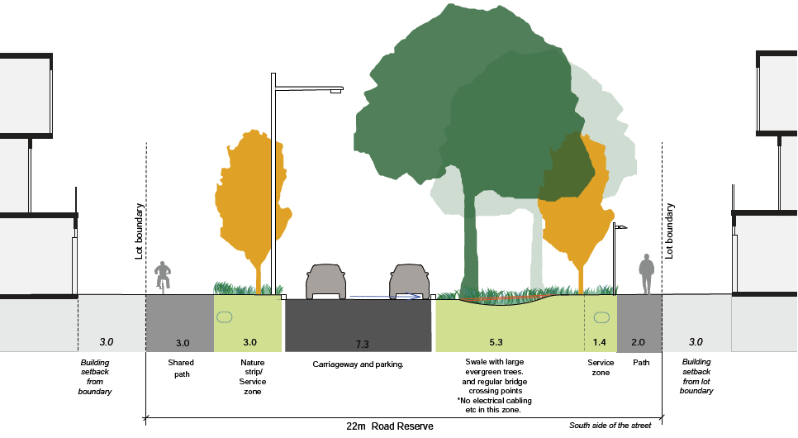
Main East West Road with swale

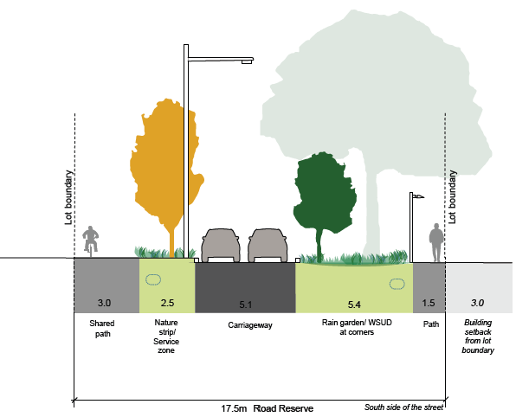
Main East West Road with raingardens dispersed at each street corner and centre of block
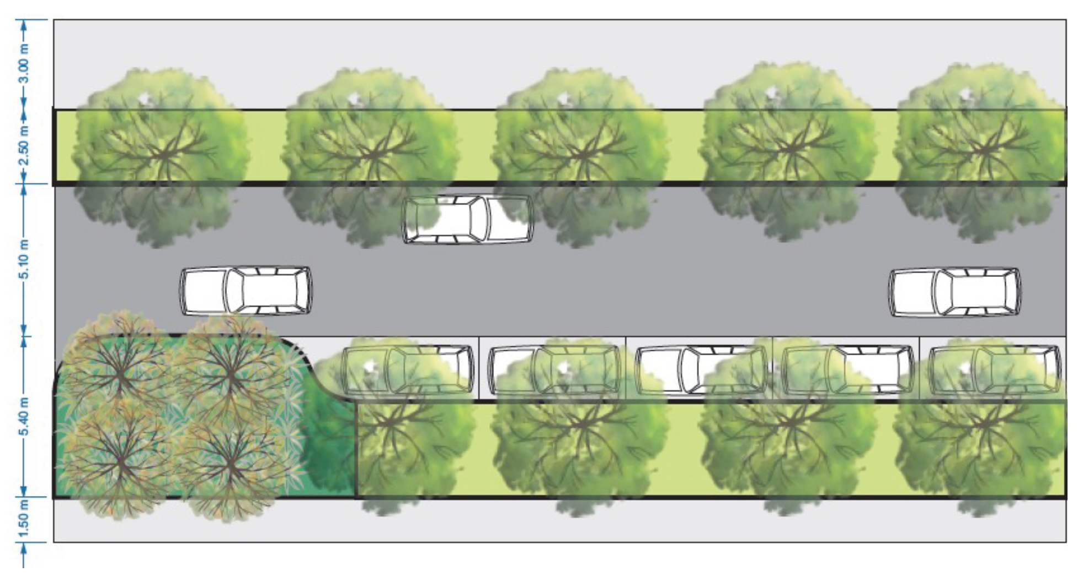
Plan 3 - Main East West Road with raingardens dispersed at each street corner and centre of block

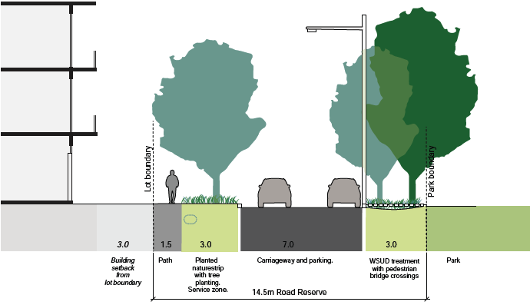
Park Street (west side of Central park)
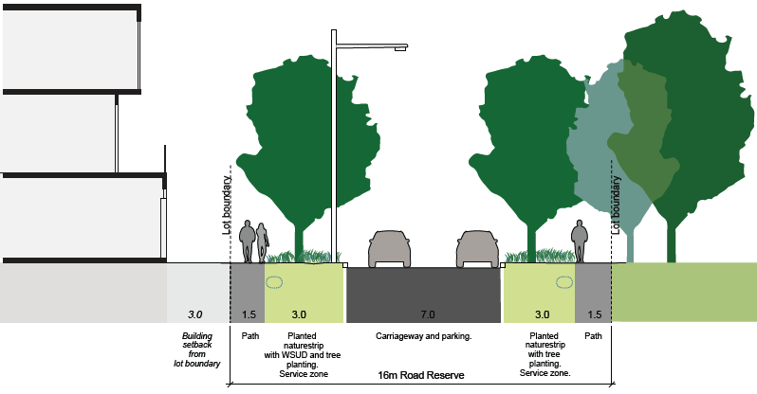
Park Street (south side of Central park)

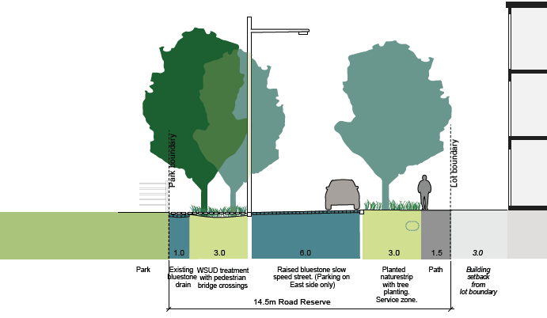
Bluestone street

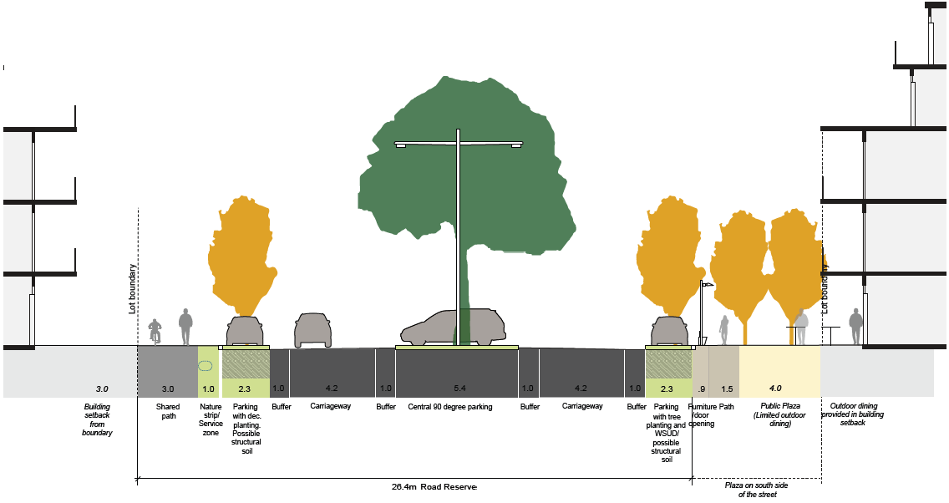
East west parking street

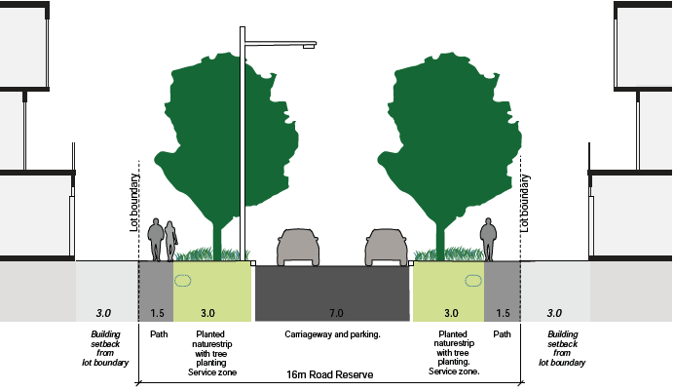
Local streets

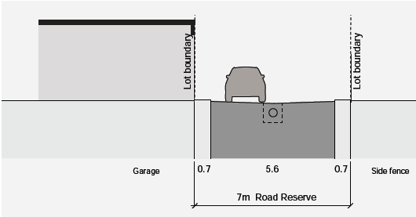

Laneway with garaging on one side only

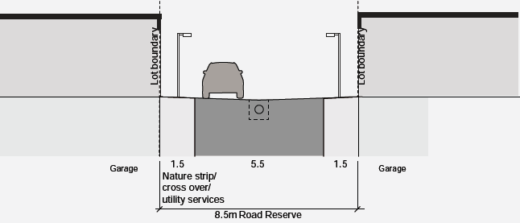
Laneway with garaging on both sides

Background documents

Geelong Saleyards Precinct Surface Water Management Strategy (BMT, April 2021).

Providing social housing as essential infrastructure in Geelong’s Saleyards precinct (SGS, March 2022)

Saleyards Precinct Plan (City of Greater Geelong, June 2021)

Glossary

Affordable housing
Has the same meaning as in section 3AA of the Planning and Environment Act 1987.

Encumbered open space
Open space that is constrained by features such as:
- environmental risks such as flooding and landslip
- infrastructure and easements, such as utilities and drainage;
- retarding basins or wetlands
- contamination or landfill
- habitat conservation and native vegetation
- heritage values
- waterways and drainage
- buffer areas
- steep slopes

Land budget table
A table setting out the total Precinct Area, net developable area and constituent land uses proposed within the precinct.

Unencumbered open space
Land set aside for open space that, if not set aside for open space, would be ‘developable’, or unconstrained for private development.

Net Developable Area
Land in the Precinct available for private development including local and connector streets. It is the precinct area minus open space and encumbered land, including encumbered open space.

Precinct
All land shown within the precinct boundary in Plan 1 – Future Urban Structure.

